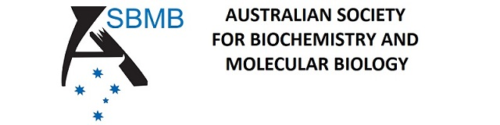

APPLICATION FORM FOR THE BOOMERANG AWARD
A. Formatting: A4 paper setting, double-spacing and 12 point Times New Roman font.
Any application failing to comply with formatting requirements and maximum specified space limits (see below) will be removed from further consideration.
B. Supporters: Each applicant must ask two supporters to each provide referee reports attached online by email directly to the Secretary (d.ng1@uq.edu.au).
The report by each Supporter is to contain an evaluation of:
i. the Applicant’s research achievements and current research interests
ii. the quality of the proposed activities (in addition to the symposium presentation at the meeting) for which the Award is sought.

C. Application Details: Applicants should submit their Application containing their details, numbered in the following order, and not exceeding the maximum specified space limits.
1. Application Form. Complete the online form and be ready to upload your applicatio document which should include the following:

2. Educational qualifications. [0.5 page]
Institution(s), qualification(s), year(s).

3. Proposed use of the Award. [1 page]
The Award contributes funding to attend the next ASBMB annual scientific conference (usually ComBio) and present a Symposium talk, and to visit at least one other Australian city to present a seminar.

4. Current research activities. [1 page]
Describe your current research and its relevance to your application for the Award.

5. Previous achievements.
Scholarships, awards, commendations, etc.

6. Refereed publications (can be single-spaced).
List all publications in peer-reviewed publications.

7. Conference abstracts.
List all proceedings, abstracts and poster presentations at international or national conferences, meetings or workshops. Indicate if you were the presenting author, or if someone else presented your work.

8. Any other evidence that you feel will enhance your case, including description of any career disruption. [1 page]

9. A photocopy of your highest degree certificate or dated documentary evidence of that degree.

10. Evidence of membership of a recognised Australian scientific society for at least 2 continuous years.

