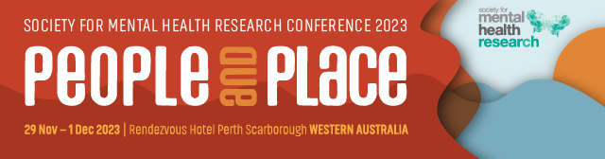

SMHR Founders Medal 2023

This award was named in honour of the four founders of SMHR: Professors Scott Henderson, Issy Pilowsky, Graham Burrows and Peter Beaumont. The medal is awarded to persons who, over their entire careers, have made a contribution of significance to mental health research.
Nominee

Title
Name
Institution/s
Position/s
Current member of SMHR? | Yes No
Is the Nominee aware of the nomination? | Yes No
Is the Nominee available to present at  the 2023 SMHR Annual Conference? | Yes No

Nominator

Title
Name
Institution/s
Position/s
Current member of SMHR? | Yes No
Relationship to nominee?

Criteria for Founders Medal
The nominee will be a financial member of SMHR at the time of nomination. This award is evaluated using NHMRC category descriptors for track record and is based on publications, grants, impact and contribution to SMHR. These details are to be provided by the Nominator. These criteria are judged by the SMHR Executive Committee.

Details of Award
The awardee will be presented with a medal and a certificate and payment of conference registration fees at the 2023 annual SMHR conference. The awardee will be featured on the SMHR website.

Obligations
The successful applicant is required to present at the 2023 SMHR Conference in. The time and place for the presentation is determined in consultation with the Conference Local Organising Committee.

Award Sponsor
Society for Mental Health Research

Nominator’s statement
Statement of contribution to and impact on mental health research (500 words)

Statement of contribution to SMHR (200 words)

Publications and their impact (200 words)

Grant history and significance (200 words)

Nominations should be sent with subject heading “SMHR Founders Medal 2023” to:
The SMHR Association Office via – smhr@wsm.com.au

Due date: 15 September 2023 by 5pm AEST

Applications must be made on this form and will not be accepted after the deadline.

The successful applicants will be advised by early October 2023.

