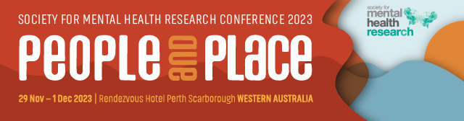

SMHR Oration Award 2023

This award is bestowed to persons who are prominent or rising to prominence in the Australian and New Zealand mental health research community.
Nominee

Title
Name
Institution/s
Position/s
Current member of SMHR? | Yes | No
Is the Nominee aware of the nomination? | Yes | No
Is the Nominee available to  present an Oration at the 2023 SMHR Annual Conference? | Yes | No

Nominator

Title
Name
Institution/s
Position/s

Current member of SMHR? | Yes No
Relationship to nominee?

Criteria for the Award
The award is evaluated using NHMRC category descriptors for track record and is based on publications, grants and impact. These details are to be provided by the Nominator. These criteria are judged by the SMHR Executive Committee.

Details of Award
The awardee will be presented with a medal and a certificate and payment of conference registration fees at the 2023 annual SMHR conference. The awardee will be featured on the SMHR website.

Obligations
The successful applicant is required to present an oration at the 2023 SMHR Conference. The time and place for the presentation is determined in consultation with the Conference Local Organising Committee.

Nominator’s statement

Statement of contribution to and impact on mental health research (500 words)

Publications and their impact (200 words)

Grant history and significance (200 words)

Nominations should be sent with subject heading “Oration Award” to:
The SMHR Association Office via – smhr@wsm.com.au

Due date: 15 September 2023 by 5pm AEST

Applications must be made on this form and will not be accepted after the deadline.

The successful applicants will be advised by early October 2023.

