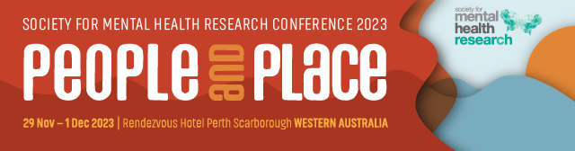

Rising Star Award 2023

This award is bestowed to a “Rising Star” in mental health research. That is, a person whose work is beginning to make a significant impact on the national and international scene, reflecting either scientific excellence or public impact (or both).
Nominee

Title
Name
Institution/s
Position/s
Current member of SMHR? | Yes No
Is the Nominee able to attend the 2023  SMHR Annual Conference? | Yes No
Date PhD Conferred
Criteria for the Award

The nominee will be a current financial SMHR member. The award is evaluated using NHMRC category descriptors for track record and is based on publications, grants, and impact. It is expected that the nominee is at least 2 years and less than 7 years (as at 31st March 2023) from the date of the letter advising that their doctoral thesis was passed, unless career disruptions exist. Contribution to SMHR will also be considered.

Details of the Award

The award includes a certificate and payment of conference registration fees at the 2023 annual SMHR conference. The awardee will be featured on the SMHR website, and asked to participate in a short podcast about their work that will be posted on the SMHR website.

Obligations

The award winner will attend the 2023 Conference. They will also be given the option of presenting at the 2023 Conference in Perth.

Explain any career disruptions (200 words)

Contribution to SMHR (200 words)

Curriculum Vitae (1 page)

Include the following: career summary, research grants and fellowships, impact of research, collaborations and community engagement, and professional involvement.

Publication 1

Reason for selection:

Publication 2

Reason for selection:

Reason for selection:

Publication 4

Reason for selection:

Reason for selection:

Nominations should be sent with subject heading “Rising Star Award” to:
The SMHR Association Office via – smhr@wsm.com.au

Due date: 15 September 2023 by 5pm AEST

Applications must be made on this form and will not be accepted after the deadline.

The successful applicants will be advised by early October 2023.

