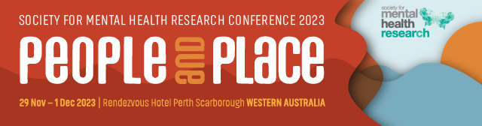

Lived Experience Research Medal

Recognises people with lived experience of mental health issues leading mental health research. Presented to the lived experience researcher who is judged to best meet the selection criteria based on a short written submission to the judging panel.
In 2023, this award will be presented to the lived experience researcher who is judged to best meet the selection criteria based on a short written submission to the judging panel.
Nominee

Title
Name
Institution/s
Position/s
Current member of SMHR? | Yes No
Is the Nominee able to attend the 2023  SMHR Annual Conference? | Yes No
Date PhD Conferred
Criteria for the Award

Applicants with and without an academic background are encouraged to apply.

Details of the Award

The award includes a medal, $1000 prize money and payment of conference registration fees at the 2023 annual SMHR conference. The awardee and their work will be featured on the SMHR website.

.

Explain how your lived experience of mental health issues has informed your mental health research (maximum 500 words)

Contribution to SMHR (maximum 200 words)

Curriculum Vitae (1 page)

Include the following: career summary, research grants and fellowships, impact of research, collaborations and community engagement, and professional involvement.

Explain any career disruptions (if relevant) (maximum 200 words)

Publication 1

Reason for selection:

Publication 2

Reason for selection:

Reason for selection:

Publication 4

Reason for selection:

Reason for selection:

Nominations to be sent to:
The SMHR Association Office via – smhr@wsm.com.au

Due date: Friday 15 September 2023, 5pm AEST

Applications must be made on this form and will not be accepted after the deadline.

The successful applicants will be advised by early October 2023.

