The Ritman Scholarship
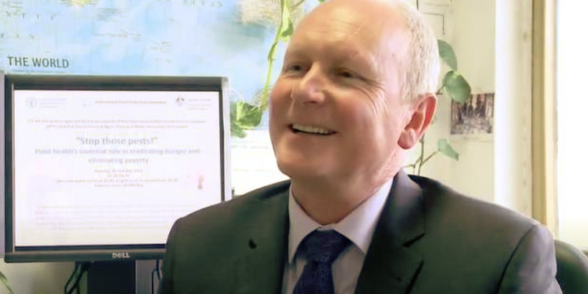

Dr Kim Ritman was a foundation member of PBRI and Australia’s Chief Plant Protection Officer. He had a distinguished career in Plant Health, championing early career researchers to build scientific capability in plant biosecurity.
To honour Kim’s efforts, the PBRI members are supporting the Ritman Scholarship to recognise students with a commitment to plant health.
The scholarship will support students to attend the PBRI Symposium on 8 & 9 May 2024. The recipients will present a short presentation on their field of research and its importance to plant health.
The scholarship will be used to cover Symposium registration fees, travel, meals, and accommodation costs. The scholars will also co-convene the Plant Health Student Network for the duration of the scholarship (two years).
Current Ritman scholars have summarised their experience below.
“Becoming a Ritman Scholar and co-organising the Plant Health Student Network meetings provided me with various opportunities for professional development and to meet (and work with) many inspiring people. By organising the online meetings, attending the PBRI symposium and the Kansas State University “Plant Biosecurity in Theory and Practice” workshop as a Ritman Scholar, not only did I gain a better understanding of the plant biosecurity system in Australia and other countries, but I also developed operational skills that are valuable to the work I do post-PhD. I feel really privileged to have had this opportunity during my PhD where I learned so much in a fun and supportive environment with the other three Ritman Scholars”. - Bianca Rodrigues Jardim (La Trobe University, Plant Health Australia).
“Receiving the Ritman Scholarship and working in collaboration with other scholars, to establish the Plant Health Student Network has been a true highlight of my PhD journey. Over the last two years, the Ritman Scholarship has presented many opportunities, allowing us to travel and present at conferences, meet countless inspiring plant health researchers and policy makers, and bring together a group of over 200 students and early career researchers in plant health from around the globe. Some specific highlights have included: working with global plant biosecurity organisations such as Euphresco for the International Day of Plant Health, presenting on the Plant Health Student Network within a UN Food and Agriculture Organisation meeting, working with and forming friendships with other Ritman Scholars, and of course attending and presenting on my own research at the PBRI Symposium”. Rebecca Degnan (University of Queensland)
“Receiving the Ritman Scholarship has been a truly rewarding experience, and if you are considering applying, I would highly recommend it! Attending the 2022 PBRI symposium and sharing my PhD research allowed me to consider a broader perspective on my work and learn about the development of innovative technology in the biosecurity research sector. It was a great experience to engage with plant health professionals from across research, government, and industry sectors who generously offered advice and encouragement. Developing the Plant Health Student Network has been another fantastic experience, and it has been incredibly motivating to be part of a community of passionate students and early career researchers. I am excited to see what is next for the Ritman Scholarship and the Plant Health Student Network and am incredibly grateful for all the opportunities this award has offered me”. Salome Wilson (The Australian National University)

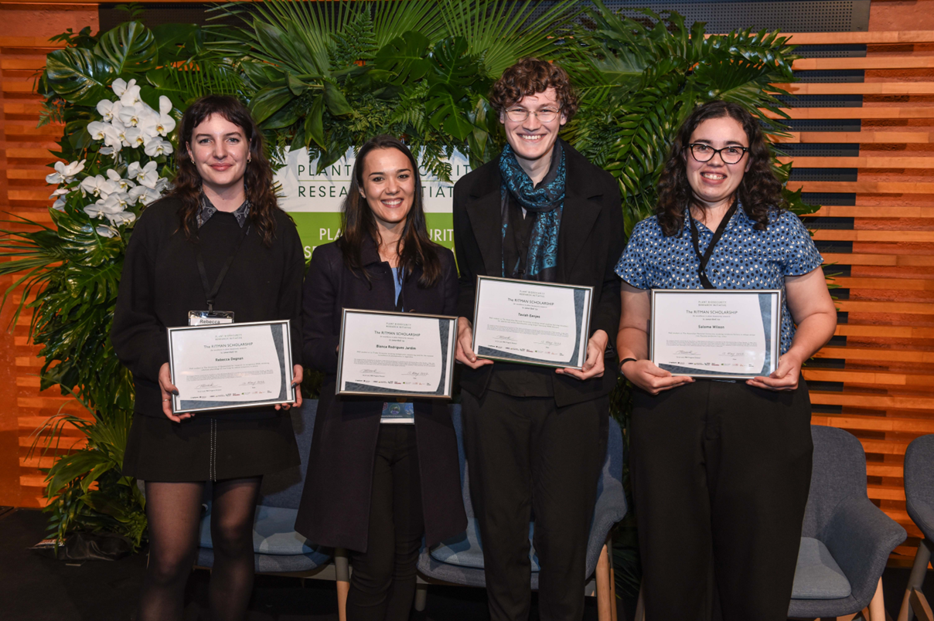
The 2022 Ritman Scholars Rebecca Degnan, Bianca Rodrigues Jardim, Fable Eenjes and Salome Wilson (LtoR)

Ritman Scholarship Applicants must:
- Be a full-time post-graduate student working on a plant biosecurity related topic.
- Provide an abstract of their post-graduate research (up to 300 words).
- Provide a brief biography (up to 250 words) detailing their interest in plant biosecurity and why they would like to attend the conference.
- Confirm approval to attend the Symposium from a university or research supervisor.
- Co-organise a quarterly student network meeting with a focus on plant health careers.
Applications must be completed in the form below and emailed to the PBRI Program Director jo.luck@horticulture.com.au
Applications close at 6 pm ADST, 15 March 2024.
Ritman Scholarship
Student Details
Name
Email Address
Phone
University and Department
Abstract (up to 300 words)

Biography (up to 250 words) including your research interests in plant health and why you would like to attend the PBRI Symposium.

☐ I confirm I will co-convene the plant health student network meetings each quarter for the duration of this scholarship (May 2024- May 2026).

Name | Signature | Date

Student Supervisor Declaration
Supervisor Statement of Support
Provide a brief statement supporting the student’s attendance at this conference and their role leading the Plant Health Student Network
☐ I confirm that I approve attendance at the conference and the student’s participation in PBRI network meetings and events.
Supervisor Name | Signature | Date

