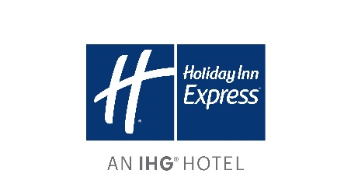

Hotel Name:

Name of Guest(s): Arrival Date: Departure Date:
Confirmation Number:

METHOD OF PAYMENT Credit Card Type: Cardholder's Full Name:

CREDIT CARD CHARGE AUTHORISATION

Cardholder's Contact Number:

Credit Card Number: (last 4 digits only)
You will be contacted by phone to confirm the rest of the card details

Expire Date: Cardholder's Signature:
Contact phone number to verify card details:

CHARGE BACK

[ | ] Room Only | [ | ] All Charges
[ | ] Room and Food | [ | ] Dry Cleaning
[ | ] Non-Alcoholic Beverages | [ | ] Telephone calls
[ | ] Alcoholic Beverages | [ | ] Other (please specify)

*Please note credit card transactions will incur a Credit Card Surcharge of 1.5% for Visa, Mastercard and Amex,3.0% for DC and JCB

INVOICE TO BE MAILED TO:

Company:

Postal Address:

or Email:
Print block letters please

