**Waste 2017 Abstract Submission**

**Mobile Community Recycling Service**

*My presentation is relevant to the following topic area(s).*

🞎 Circular economy 🞎 Overseas experiences

🞎 Collection (inc MUD’s, transient population areas) ✓ Problem/Hazardous waste (inc asbestos, clinical &

🞎 Container Deposit Schemes medical, ocean plastics, paint, tyres etc)

🞎 Economics (inc business cases, data gathering, 🞎 Product Stewardship

monitoring performance) 🞎 Regional issues

🞎 Education (inc community engagement) 🞎 Recycling (inc CRC’s, collection)

🞎 E-Waste 🞎 Regulations and levies

🞎 Grants (outcomes and processes) 🞎 Social enterprise

🞎 Infrastructure (inc major waste grants, EfW, organics) 🞎 State based issues (eg. Fit for the Future NSW)

🞎 Innovative projects (case studies preferred) 🞎 Technology

🞎 Landfill (inc operations, regulations) 🞎 Tenders and contracts

🞎 Litter and/or illegal dumping (inc litter initiatives) 🞎 Other 🞎 Organics (inc collection, processing)

**Presenter information**

**Presenter name:** Daniel Anderson

**Presenter position:** Manager Environment and Resource Recovery

**Presenter organisation:** Cumberland Council

**Presenter email address:** [daniel.anderson@cumberland.nsw.gov.au](mailto:daniel.anderson@cumberland.nsw.gov.au)

**Presenter phone number:** 9840 9805

**Presenter mobile number:** 0427190526

**Presenter name:** Matthew Curtis

**Presenter position:** Southern NSW Area Manager

**Presenter organisation:** Resource Recovery Australia

**Presenter email address:** [matthew.curtis@resourcerecovery.org.au](mailto:matthew.curtis@resourcerecovery.org.au)

**Presenter phone number:** 02 6554 9471

**Presenter mobile number:** 0407 898 246

**Biography**

Daniel Anderson currently holds the position of Manager Environment and Resource Recovery at Cumberland Council and has over 12 years local government experience having previously worked for Holroyd, Blacktown and Marrickville Councils. He holds tertiary qualifications in Environment and Natural Resource Management.

During his career Daniel has developed expertise in managing problem waste types such as Asbestos and more recently implementing the first Mobile Community Recycling Service in Australia.

Matthew Curtis is currently the Southern NSW Area Manager for Resource Recovery Australia. Matthew has been a part of Resource Recovery Australia since 2005 and has enjoyed the opportunities, experience and knowledge gained over the past 11 years.

**Abstract Summary**

The Mobile Community Recycling Service aims to provide residents of Cumberland and City of Parramatta Council an easy and safe way to dispose of their unwanted problem wastes. The program has provided increased level of safety to the community and council by diverting 37,000kgs of problem waste from the domestic waste stream.

The project is collaboration between Cumberland and City of Parramatta Councils as well and the NSW EPA and Resource Recovery Australia.

**Abstract**

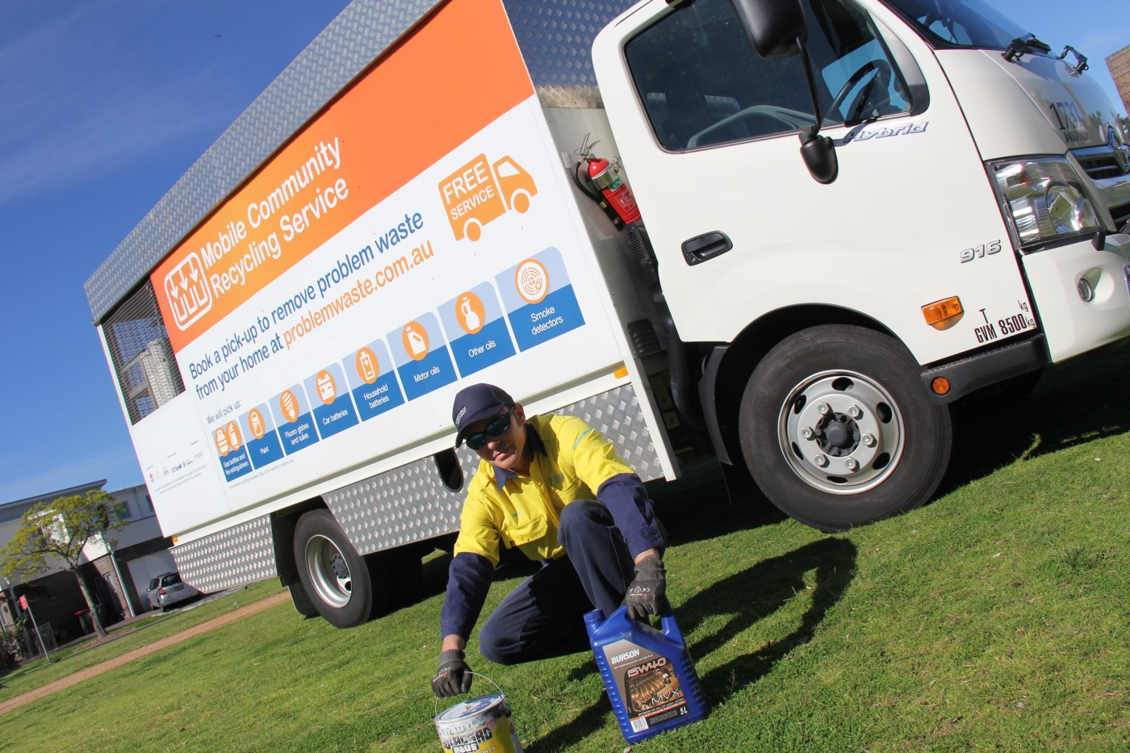

The Mobile Community Recycling Service (MCRS) is a unique program, with no known equivalents that are currently operating in Australia. The service was launched in April 2016 and specifically designed to provide a safe and convenient way for residents to dispose of hazardous materials (problem wastes) frequently identified in the domestic waste stream, these materials include:

* LPG gas bottles
* Water based paint
* Oil based paint
* Smoke detectors
* Fire extinguishers
* Automotive batteries
* Household batteries
* Fluorescent light globes

A dedicated website has been developed ([www.problemwaste.com.au](http://www.problemwaste.com.au)) for residents to access the service via an online booking facility. Once a resident makes a booking it is processed using specialised software, each booking is verified and a daily run sheet is sent to a mobile device used by the collection crew.

The vehicle used to facilitate collection has been custom manufactured specifically for this program, it is a result of a collaboration with the NSW Environment Protection Authority and the operator of the service Resource Recovery Australia. The vehicle complies with all relevant standards and legislation including the Australian Dangerous Goods Code of Practice. Materials are then safely transported back to Council’s Depot at Guildford West whereby Toxfree collect the material as part of the EPA’s Community Recycling Centre Contract.

The service is operated by Resource Recovery Australia as part of their ‘Waste to Wages’ employment opportunities program.

To date the service has collected more than 37,000kgs of problem waste and facilitated more than 700 bookings.

The program has so far won two awards-

* *2016 The Australian Waste and Recycling Innovation Award*
* *2016 Metropool Local Government Risk Management Award*

The project is funded by both the EPA’s Waste Less Recycle More Initiative and partnering councils Cumberland and the City of Parramatta.

A promotional video of the service can be viewed using the following link (please note, the statistics used in the video are not current)

<https://www.dropbox.com/sh/aejnkbj2ehkqi04/AADWnnTru9ZGijFgrD_4gE_-a?dl=0&preview=160729_MCRS_FINAL_1630.mov>