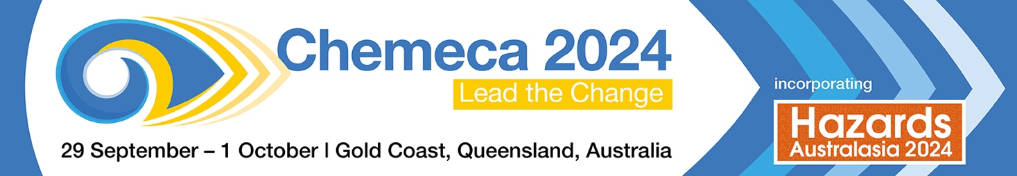

Speaker/Author Agreement

By submitting an abstract, paper, presentation and/or other materials (Works) for Chemeca 2024 you acknowledge that you are accepting the CHEMECA 2024 Speaker/Author Agreement as stated below.

Terms and Conditions
- In consideration of the opportunity to have the Works considered for publication and/or presentation, you acknowledge and agree that certain rights are required to be granted to Institution of Chemical Engineers (ABN 75 112 253 040), by each different category of author, which are as follows:
  - For all authors that are not covered by (b) below, you agree to assign copyright in the Works, as set out below.
  - For all authors that are employees of an Australian or Foreign Government and whose employer owns the copyright in the Works, you agree to procure the grant of a non-exclusive Licence in the Works, as set out below.
- You acknowledge and agree that if you assign copyright in the Works to Institution of Chemical Engineers in accordance with 1(a) above:
  - you retain all proprietary rights other than copyright, such as patent and trade mark rights and rights to any process of procedure described in the Works;
  - Institution of Chemical Engineers may publish, reproduce, distribute, adapt, and licence any third party to do any or all of the above, the Works for the full period of copyright throughout the world, in all forms and all media (including but not limited to granting a licence to RMIT Training Pty Ltd for the purposes of publishing the Works on the Informit Engineering Collection database);
  - Institution of Chemical Engineers grants to you a perpetual, royalty free license to use the Works for the following non-commercial purposes:
    - to include the Works in full or in part in a thesis or dissertation;
    - to photocopy or make electronic copies of the Works for personal use, including for your own classroom use, or for the personal use of colleagues;
    - to prepare derivative works; and
    - to have the metadata and abstract of the Works uploaded to open archive repositories; provided that acknowledgement is made of Institution of Chemical Engineers as publisher.
  - you may request Institution of Chemical Engineers to consent to the granting of a licence for all uses not included above, including the authorisation of third parties to reproduce or otherwise use all or part of the Works (including figures and tables).
- You acknowledge and agree that if you grant Institution of Chemical Engineers a Licence in the Works in accordance with 1(b) above:
  - the relevant employer will retain copyright ownership of the Works; and
  - you have obtained in writing consent from the relevant employer, the right to grant and do grant Institution of Chemical Engineers a non-exclusive, irrevocable, perpetual, royalty free licence with a right to sub-licence to third parties, to use and distribute the Works in any format (including in hardcopy, or digitally or electronically) and for any purpose (including but not limited to granting a sub-licence to RMIT Training Pty Ltd for the purposes of publishing the Works on the Informit Engineering Collection database).
- You agree that if you perform or present any of the Works you:
  - consent to Institution of Chemical Engineers recording and broadcasting your performance or presentation in any form, whether by way of webinar, photography, video, film, tape, digital recording or any other medium or technology and such recording may be used, dealt with, distributed and licensed by Institution of Chemical Engineers without any obligation on Institution of Chemical Engineers part to pay fees or royalty; and
  - grant to Institution of Chemical Engineers all rights to use, reproduce, publish, communicate to the public and adapt, and to disclose to any person, your name, image, likeness, voice, biographical information and other identifying features in connection with the recording of any such presentation or performance.
- By submitting the Works, you warrant that:
  - all information that you provide regarding academic and other qualifications and expertise is true, complete and not misleading;
  - the Works will not infringe the rights of any third party, or contravene any law or give rise to any liability to make any royalty or payments to any person, or otherwise expose Institution of Chemical Engineers to any action, claim, demand or proceedings by any third party;
  - if any co-author owns copyright in the Works, authorisation has been granted by them for you to sign this agreement as agent on their behalf and to agree on their behalf to the order of names in the publication of the Works; and
  - if you and/or any co-author’s employer own copyright in the Works, you have obtained in writing the relevant employers’ consent to grant a licence (if an Australian or Foreign Government employer) or the right to assign copyright (all other copyright owners) in the Works on the terms of this agreement.

