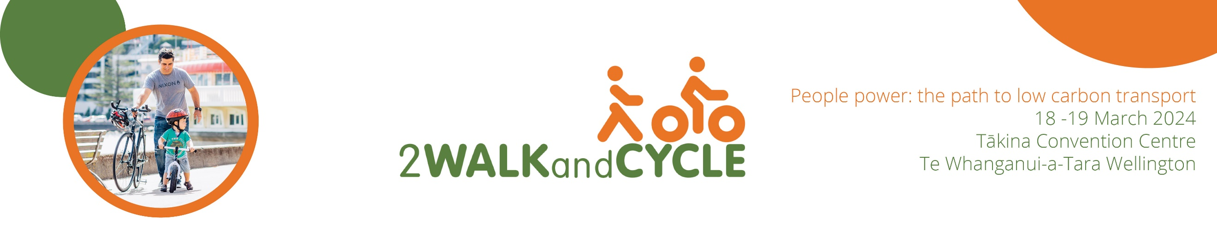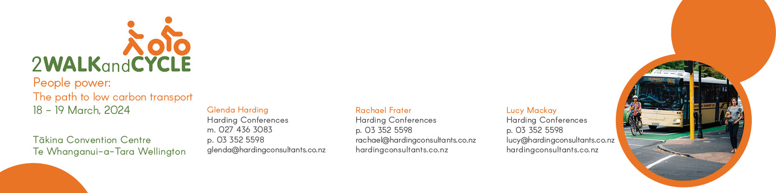

**Why don’t more people cycle?**

Dr Stephen Wood, Cycling Action Network, Spokes Canterbury

After more than fifty years of cycling in urban and rural places in Aotearoa, I often wonder why more people don’t take up cycling.

I examine some of the possible reasons, the risks and the perception of risk, societal expectations, provision of infrastructure, competition for space on roading corridors, how current legislation contributes, and the fact that even after decades of providing cycle infrastructure – many projects still look like retrofits or afterthoughts.

Not all people that cycle want or expect the same sort of cycle infrastructure, so there is benefit in providing cycle infrastructure with choices. In some environments, there is a challenge in finding routes to suit your needs. Some of these issues have remained the same over time and some have changed with new technologies and attitudes.

Much of my riding has been alone, but recent involvement with supporting cyclists in group rides has given me a fresh perspective to some of these issues. I’ve led or guided groups of people riding roads or routes that they may not be confident riding alone.

I’ve been part of cycle advocacy groups on and off for about 40 years, but often find myself with a different take on things to other cycle advocates. Often solutions for cycling infrastucture that work well in high use areas of our cities are not the best solutions in suburban, small town or rural spaces. I’ll share some techniques I use for cycling in these different places, and explain why riding in a group is very different from riding solo.