BLENDING INFORMATION FOR NEW RESILIENCE INSIGHTS

AUTHORS: Stuart Woods, BE, MET, MEngNZ
Principal Transport Planner
New Zealand Transport Agency
T: 03 964 2825
E: stuart.woods@nzta.govt.nz

Catriona O’Neill, BA, MA (GIS)
Geospatial Manager
New Zealand Transport Agency
T: 04 890 4743
E: catriona.oneill@nzta.govt.nz

ABSTRACT

Knowing where to prioritise its resources and investment to address locations with potential resilience-related issues is important for the New Zealand Transport Agency. In the wake of recent disruptive events, the Agency wants to more consistently target resilience risk and minimise the impacts of network outages.
The Transport Agency did not have a national framework to indicate locational priorities for managing natural hazards. In the absence of such an approach for the relative priority of corridors, resilience project proposals were developed in isolation with regional teams relying on their local knowledge of the network, often highlighting their issues on paper maps, and sought to show that their issues were peculiarly important and vital.
A nationally consistent assessment framework was needed to compare locations and understand the relative risk associated with natural hazards and the criticality of the location.
In response, the Transport Agency commissioned the development of a tool which could provide a map-based assessment showing a national prioritisation of the network to natural hazard risks. This tool takes geospatial information on high frequency events and low frequency natural hazards and the criticality of the corridor, and re-purposes it through a blending analytic to provide new insights.
To deliver this project, the Agency collaborated with geospatial vendors to produce a hazard prioritisation modelling tool. This tool was created so as to enable future in-house updates, improvements to methodology and data-sets, and be re-purposed for different needs
This paper outlines the data sources used noting their strengths and weaknesses, details the methodology developed, requirements of the tool delivery and tells the tool development story. It concludes with the learnings, criticisms and recent plans to improve the tool.

Presenter: Stuart Woods
INTRODUCTION

Knowing where to prioritise its resources and investment to address locations with potential resilience-related issues is important for the New Zealand Transport Agency (the Agency). In the wake of recent disruptive events, the Agency wants to more consistently target prioritised resilience risks so as to minimise the number and duration of network outages.

The Transport Agency did not have a means to determine the natural hazard location priorities for all key hazard types across New Zealand. It was determined as part of an Agency business improvement process project that there was a need to develop a nationally consistent assessment framework to compare locations and understand the relative risk associated with natural hazards and the criticality of the location.

The Agency already had a range of natural hazards data sources for low frequency and high frequency hazards across the State highway network, which allowed consideration of the relative acuteness and exposure to various natural hazards disruptions individually. The Agency also has adopted the One Road Network Classification (ONRC) (Road Efficiency Group, n.d.) system which allows a general understanding of the relative importance or criticality of each section of State highway.

This paper outlines the problem, the conceptualised solution, details the methodology developed, and tells the tool development story. It concludes with the learnings, criticisms and recent plans to improve the tool.

CONTEXT

The Agency established the Resilience Project (a business improvement project) in 2013 to strengthen resilience of the Agency and the state highway network. The project’s overarching outcome was to:
- Preserve and quickly restore access to the network in the face of unplanned events, enabling customers to complete their journeys

This objective was supported by objectives:
- Increase robustness and improve alternate routes (network redundancy)
- Decreasing recovery times on the network following disruptive events – from natural hazards, and unplanned events
- Improve the overall experience for our customers

The programme focussed on three work-stream areas: business continuity plans, emergency response and business case support/infrastructure planning.

The Infrastructure Planning work-stream focussed on providing tools and guidance for Business Cases (NZ Transport Agency, 2018) which were seeking to deal with resilience related problems. A key consideration for resilience programme development through the Business Case process is to be able to indicate the relative importance and priority of a location’s resilience problem in the context of all resilience problems across New Zealand. That is, the Agency needs to know where the natural hazard “hotspots” are and where it needs to ensure that it has “its ducks in a row”.

However, previously there was no national approach or reference source. In the absence of such an approach for the relative priority of corridors, resilience project proposals were developed in isolation with regional teams relying on their local knowledge of the network, often highlighting their issues on paper maps, and seeking to show that their issues were peculiarly important and vital.

It was in the Infrastructure Planning work-stream that the problem of identifying and prioritising the locational hotspots around the country was assigned. This would be a key reference and evidence base to include particularly in the Point of Entry phase of the Business Case programme development.

The Agency has a range of databases and information related to many aspects of resilience, although they are not all consistently input to, complete or useful. Of interest to the project team for this tool were information related to hazard event risk exposure and the criticality of the various sections of the network.

Although the Agency did not have a comprehensive integrated data set on all-hazards exposure assessment, it did have information on low frequency event assessments, expenditure on maintenance contract responses to regular network outages and the classifications of the network to the ONRC system.

CONCEPTUALISATION

The project team considered that a geospatial tool and associated GIS-based map set would be the best solution to provide the analysis and presentation of results. The Agency’s geospatial team assisted in developing a Terms of Reference for the provision of an FME model, creation of the supporting geospatial datasets, training and user guidance documentation to deliver on this solution. This tool combines geospatial information on high frequency natural hazards and low frequency natural hazards and assesses it against the criticality of the corridor, and re-purposes it through a blending analytic to provide new insights.

The proposed methodology of the tool was developed by the project team prior to engaging with the external tool developers. In concept it can be considered in four stages, as outlined below:

- High Frequency Hazard Event Score

In this stage, data has been taken from the Agency’s RAMM databases through a query of the maintenance cost types closest representing activities associated with responding to high frequency natural hazard disruptions. These activity cost areas related to works on “Slips”, “Flooding” and “Ice and Frost”. These data for each link were to be combined to give a rating score for “high frequency natural hazards”. The proposed means to combine and give the ratings to the High Frequency event costs relates to using 4 cost bands for each of the three hazard types presented at a particular location and assigning a score to each band

Score | Type A: Slip | Type B: Flooding | Type C: Ice and Frost
0 | $0 | $0 | $0
1 | >$0 - $S1 | >$0 – $F1 | >$0 – $I1
2 | $S1 - $S2 | $F1 – $F2 | $I1 – $I2
3 | $S2 – $S3 | $F2 – $F3 | $I2 – $I3
4 | $S3 - $S4 | $F3 – $F4 | $I3 – $I4
Table 1: High Frequency Cost Scores
The three activity type scores for a particular location are added together to give a combined high frequency score between 0 and 12. This combined high frequency score is then put into bands according to the following table:

Total of component Type band scores | Colour code for High Frequency exposure | High Frequency Exposure Band Score
0-2 | Green | A (Very low)
3-6 | Yellow | B (Low)
7-8 | Amber | C (Moderate)
9-12 | Red | D (High)
Table 2: High Frequency Exposure Band Score
- Low Frequency Hazard Event Rating

The Low Frequency Hazard Event ratings were derived from querying results from a recent study for the Agency by Opus which provided detailed assessments of the potential impacts and maximum disruption by segment for the entire State highway network from four major natural hazards (at a particular return period): Earthquakes, Volcanoes, Hurricane/Major Storm and Tsunami.

The worst case disruption rating from the four major hazards (assessed from the worst network condition and duration of outage) was assigned to each segment of State highway. This rating is described within a regime of 7 descriptors:

- None
- Limited
- Moderate
- High
- Severe
- Extreme
- Catastrophic

- Natural Hazard Exposure Score

This third stage merged the High Frequency Hazard Event Score with the Low Frequency Hazard Event Rating from the “Resilience Project” Low Frequency Hazard Exposure maps from the previous sections into a Hazard Exposure Score/band, using the table below.

 | High Frequency Band Score
Low Frequency Rating | A  (Very Low) | B  (Low) | C  (Moderate) | D  (High)
None | I | I | I | I
Limited | I | I | II | II
Moderate | I | II | II | III
High | I | II | III | IV
Severe | I | II | III | IV
Extreme | I | III | IV | V
Catastrophic | I | III | IV | V
Table 3: Combined Natural Hazard Exposure Score
- Resilience Prioritisation Score

The fourth stage takes the Combined Hazard Exposure scores from the previous stage and assesses them against the criticality of the segment. For the purposes of this national scan tool, the criticality of the segment or corridor is assumed to be the ONRC classification for that segment, as outlined in the table below:

ONRC classification | Criticality scale
National or high volume | Vital
Regional or Arterial | Major
Primary or secondary collector | Significant
Other | Low
Table 4: Criticality Score
This process produces a non-dimensional “Resilience Hazard Exposure Prioritisation Score” of the relative importance of the natural hazard resilience issues on the State highway segments across New Zealand. This will identify the segments or corridors which should be addressed first when considering resilience, without indicating whether there are pre-existing and satisfactory measures already in place or inferring any particular strategic responses that should exist for that segment or corridor.

The process using the Combined Hazard Exposure score and the ONRC classification to produce the “Resilience Hazard Exposure Prioritisation Score” used the following table:

 | Criticality
Exposure Score | Low | Significant | Major | Vital
I | RP0 | RP0 | RP0 | RP0
II | RP1 | RP1 | RP1 | RP1
III | RP1 | RP1 | RP2 | RP2
IV | RP1 | RP2 | RP2 | RP3
V | RP1 | RP2 | RP3 | RP3
Table 5: Resilience Exposure Prioritisation Score
The “RP” score for each link along with the contributing assessment stage scores were then assigned to the link in a geospatial database and mapped onto the State highway Centreline maps to provide a visual report of the RP scores nationally.

DELIVERY

Outsourced development

The tool development and initial results were competitively outsourced and principally delivered through the Agency’s Geospatial vendor panel.

The vendor contract sought to provide a model (GIS-based tool) and 2 geospatial datasets, including:
- Create a reusable FME model where existing Agency GIS datasets described above and provided by the Agency could be used as inputs.
- Develop user guidance documentation on how to use the model
- Provide training to the geospatial team of this model
- Use the FME model to generate the first 2 geospatial datasets of differing levels of segmentation detail (fine grained and big picture).

The preferred developer vendor, Beca, summarised the tool process map in the following graphic:

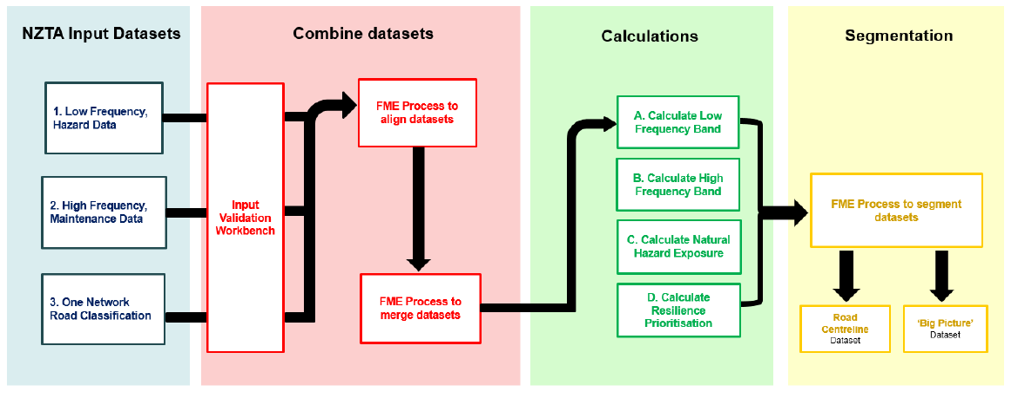
Figure 1: Developer process map of the tool methodology
Added Value Propositions

The vendors were also invited to propose any value-add components that they would see as being beneficial to the Agency over and above what had been requested in the tender documentation.

Beca identified a number of opportunities for extra value through additional features, largely based on additional flexibility in the model. The following ones were ultimately added to the scope:

- Features to validate the input datasets, assisting with an initial checking of the datasets which will be used in the calculation. This will support the evaluation of future datasets for their conformance with the tolerances of the model.
- Features to allow for additional input parameters to modify the classification of the data. This will, amongst other options, allow for the adjustment of the bands used to classify the data.
- Features to allow for additional parameters to modify the output segmentation of the data (i.e. how the network is broken up into segments). Options for different segmentation breaks could include urban areas of various sizes or ONRC intersections above certain intersecting ONRC hierarchy classes.

Key development challenges: Merging Datasets

The merging process involved the segmentation along the road network centreline to split it where the datasets have start or end points, so that the ratings can be added to gain the high frequency score for each sub-segment. This is best illustrated in figure 2 below. In the example, the first (left hand side) dataset 1 segment is sub-divided at the segment 1 - segment 2 intersection of dataset 2 and the (bottom) output high frequency segment is made up of attribute A from dataset 1, attribute 1 from dataset 2 and attribute x from dataset 3.

Complexity existed in this process due to differing approaches taken in the creation of the input databases such as how centrelines were dealt with on- and off-ramps at interchanges or where roads changed between 2 and 4 lane cross-sections. This was largely resolved by placing buffers around the centreline, and establishing a series of rules for how to break the segments up and how to assign the attribute scores within each buffered area.

This resulted in a more fine grained segmentation than any of the individual data sets.
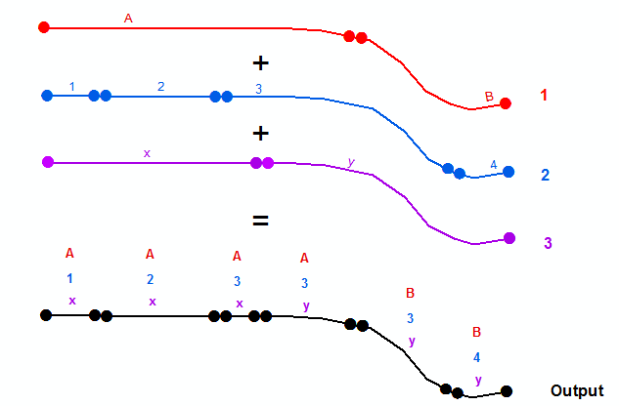
Figure 2: Data set merging process
This approach was applied in principle for a number of the other assessed attributes to be calculated, including:

- Disruption State Rating

- High Frequency Band Scores

- Combined Natural Hazard Exposure Rating

- Resilience Hazard Exposure Prioritisation Rating

Key development challenges: Segment Reporting

The reporting of the analysis was provided at two levels of granularity of segments. The more detailed level of reporting used the sub-segments developed through the merging of the datasets and calculation processes as the basis of result reporting. The results, contributing data and assessment scores were assigned to each segment’s link data, which are reported through pop-up information boxes in the GIS maps (see figure 3 below).

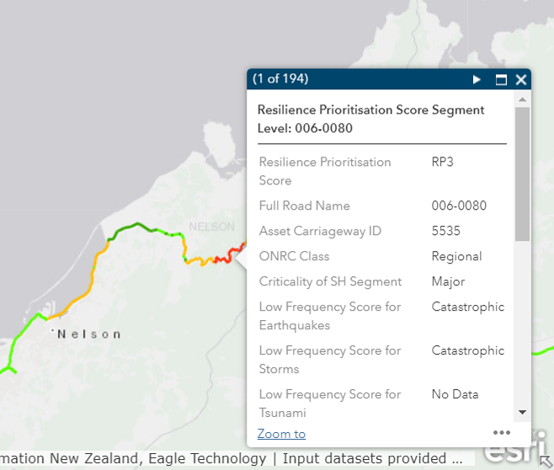
Figure 3: Example of link pop-up information box
For the lower level of granularity (big picture), segments were split at towns (to understand risk for community to community journeys) and by ONRC sections (to understand risk aligned to ONRC Customer Levels of Service) (see figure 4 below).
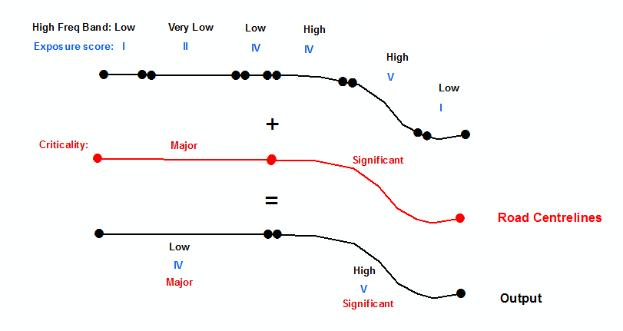
Figure 4: Network segmentation process
By splitting the roads at towns and intersections the tool is able to create lengths which are logical for both rural and urban areas. Rural sections of roads will have longer stretches of road whereas urban areas will generally have smaller segmentation, which is rational for natural hazard corridor investment and planning.

Due to the longer lengths of the ‘big picture’ dataset, the attribution reporting is slightly different and includes additional attributes which highlight the percentage of the segment length which contributed to the scores and provides a sense of the range and distribution of scores within the longer segment.

Verification

Verification of the model and input and output datasets was undertaken at specific points in the model development process. This was undertaken independently and reported by Beca as a key output of the contract. The verification steps included:

- Aligning datasets: To confirm that the model snaps the resilience datasets to the correct road centre line without misrepresenting the location.
- Merging datasets: To verify that the model splits the datasets into logical segments and that all attributes are maintained.
- Calculating attribution: To check that the attribution calculations are correct as per the Scope.
- Segmentation: To assess the segmentation process logic and confirm that the ‘worst case’ attribute is applied to segments. To confirm that the Road Centreline segmentation is maintained as per the ONRC input dataset.

The verification process, undertaken via 12 tests using granular outputs and “big picture” outputs, passed all tests following minor updates to the model.

RESULTS AND ROLL OUT

The deliverables of the contract (the tool, the two initial data sets of results at the two detail levels, the training and user manual) were all successfully delivered on time to the Agency despite a tight time frame.

Following receipt of the outputs, the Agency considered that the verification results and output files were sufficiently robust that it was worth loading the maps onto its internal and external GIS maps sites for feedback and initial piloting, as the Resilience Project was coming to a close (Internal: https://maphub.nzta.govt.nz/view/?appid=7c3ae49240884a32bcdf8671ec5a3df1l; external: https://nzta.maps.arcgis.com/apps/MapSeries/index.html?appid=5a6163ead34e4fdab638e4a0d6282bd2 ). This allowed future users the ability to review at an early stage for feedback, and where appropriate start to use the outputs. The following two figures show the maps and information provided, taken from the internal Agency version of the tool focussed around the Nelson area.

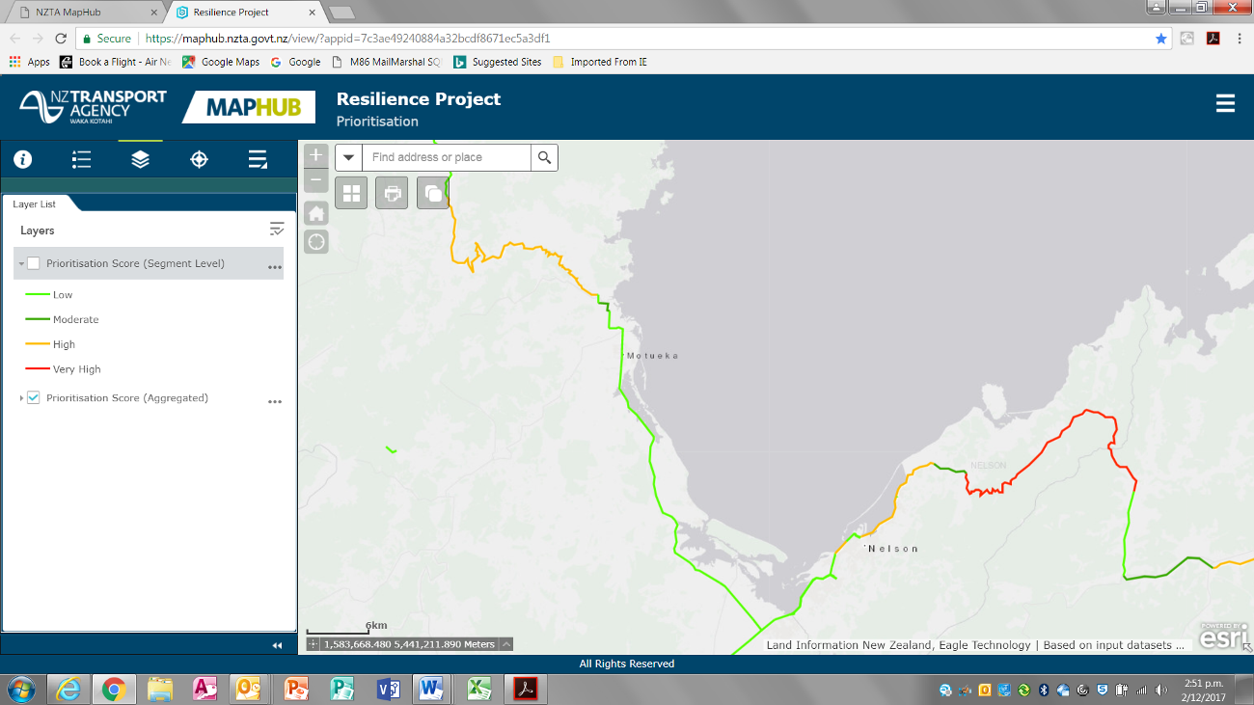
Figure 5: Screenshot of the “Big Picture” results around the Nelson area

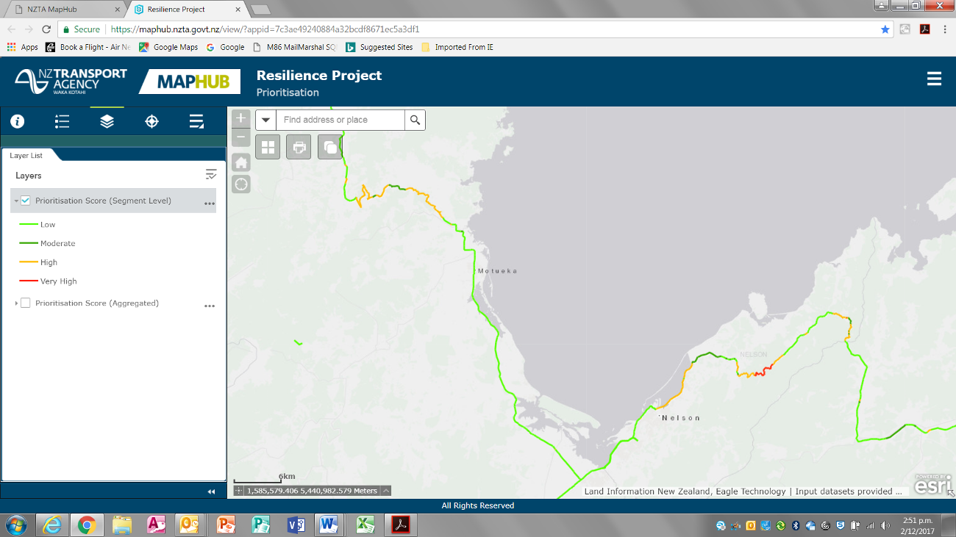
Figure 6: Screenshot of the “Fine Grained” results around the Nelson area

As part of the initial checking and proofing of the results, the tool was presented as part of a series of Resilience Project roadshows at 5 Agency offices. The roadshows presented a wide range of tools and processes developed through the Resilience Business Improvement Project.

One of the queries raised at the Roadshows was whether the use of RAMM System database costs were appropriate for identifying problem areas as it may over-estimate the significance of areas that have ‘solved’ their problems after investing heavily at the site already, and not identifying unrevealed sites.

The first part of this query overlooks the basic premise of the tool, which was to identify the relative priority of areas which appeared both exposed to natural hazards and were important, so that the high priority areas could be investigated in a rational order to see if further investigations or interventions may be warranted. Expenditure at a site flags that there at least was an issue (and may still be) so it is worth investigating the site further. Additionally this part of the tool is assessing high frequency events and although not a perfect data set which could never pick up unrevealed problems, it is likely that with an appropriate number of years of data queried, most high frequency event problem sites nearby will be picked up, particularly as part of the “big picture” outputs.

A key concern was raised during the Wellington roadshow, where local staff noted that all the highways in that region were showing up as “green” or of low priority. This is clearly not the case, as Wellington has a number of known significant Resilience hotspots across its network, such as the Rimutaka Hill and State Highway 1 on the Kapiti Coast.

The initial investigations into why this result was occurring in the Wellington network have shown up two likely causes. In both potential causes, the model itself appears to be operating correctly. The possible causes are:
- Input data for the high frequency events: the data used for the high frequency events was sourced from a query of the fields in the RAMM database associated with the costs incurred in three high frequency disruption response activities. However, due to the nature of the payment schedule from the successful Wellington maintenance contract tender, no costs are assigned into those activity areas. This means that even when activities are undertaken to deal with the high frequency disruptions, the costs are allocated elsewhere in the RAMM database and the high frequency events costs are not recognised under the queried RAMM fields used in the tool.
- The heat map table used to combine the high frequency and low frequency hazard ratings (Table 3 above) may need amending. The table used shows a green or rating of I for all cells under the “very low” rating for high frequency events, irrespective of the low frequency rating. There may be a case to amend the lower cells in this column, perhaps to a yellow (II) rating for the lower two or three cells (severe to catastrophic ratings).

Consequently, the Wellington roadshow attendees reasonably asked “Is it appropriate to release the Hotspots Prioritisation maps when output results are not showing known problem areas in the Wellington region – what is the plan?”

In response to this concern, the Resilience Prioritisation Tool maps have been left up on the web maps but now have a warning on the screen that if a region appears to be all green/low priority, then there may be an issue with the data for high frequency/low impact events and that this matter is still a work in progress. Further investigation of pop-up information tables of individual links is recommended to gain insight into the priority issues.

No other problems or issues were raised or uncovered during the Roadshows or subsequent work with the maps.

NEXT STEPS

As noted in the previous section, further improvements are required to the tool particularly in response to the feedback received at the Roadshows.

The main improvements relate to resolving the high frequency input assessments. Recent investigations searching for an alternative data source have not been successful; only two nationwide databases have been raised in the various discussions held around the Agency – the RAMM database and the TREIS database. Neither of these is considered to be consistently or comprehensively used across all regions, with differences across the country in how the data is captured and recorded in RAMM - some regions having excellent RAMM data in potentially useful fields but held differently in other regions; and similarly TREIS is used extensively and rigorously in some regions and differently in others. Ongoing discussions and investigations are occurring with various database owners and champions and the Agency geospatial team to explore alternative solutions to this issue.

Similarly, some tasks are being scoped with the geospatial team to sensitivity test the results through amending some of the process tables in the tool, such as table 3 (Combined Natural Hazard Exposure Score), to test if some simple amendments may provide improved results.

CONCLUSIONS

Prior to the development of this tool, business case studies had often only been using TREIS data as inputs for identifying and quantifying resilience problem spots. This gave little recognition or context to the low frequency events, as the TREIS data presented usually only covered the most recent 5 years and thus would likely miss most events of medium to low frequency. Nor did it provide a ready and consistent assessment of the situation nationally of the natural hazard exposure and criticality of the corridor.

The development of this tool has shown that by blending information from existing databases and references, it is possible to create an automated and objective prioritisation tool that identifies the relative priority of corridors in the face of resilience problems.

The roll out of the initial tool outputs has shown that there are areas for improvement, particularly in the area of high frequency input data, and that there is opportunity to explore further improvements (e.g. sensitivity tests) now that a basic operating GIS tool has been shown to work.

Thus overall, it can be concluded that valuable benefits and improvements to the Agency’s resilience work programme can be gained from this successful proof of concept through blending information for new resilience insights.

REFERENCES

Road Efficiency Group (n.d.). One Network Road Classification, viewed 14 February 2018, <http://www.nzta.govt.nz/roads-and-rail/road-efficiency-group/onrc/>
NZ Transport Agency (2018). Business Case Approach to Project Development, viewed 14 February 2018, https://www.nzta.govt.nz/roads-and-rail/highways-information-portal/processes/

ACKNOWLEDGEMENTS

The authors would like to thank the NZ Transport Agency Resilience Project team who contributed to the concept of the tool and supported through the roll out process. We would also acknowledge the BECA GIS vendor panel team for their assistance and collaboration in developing the tool. Finally we would like to thank the NZ Transport Agency leaders who supported and guided the Resilience project in exploring these new initiatives and in the promotion of it through this paper.

Feature Manipulation Engine – a platform that streamlines the translation of spatial data between geometric and digital formats
Road Assessment and Maintenance Management: see https://www.nzta.govt.nz/resources/road-assessment-and-maintenance-management/
The Agency has other criticality methodology for assessing the Criticality of network links, but it has not been used to assess the entire network at this point and requires considerable local information gathering to undertake.
Traffic Road Event Information System

