Paper Title: Traffic Modelling Applications Then, Now, Tomorrow

Authors
- Ali Syed

Service Line Coordinator (AUS, NZ, UK, ME) - Transport Modelling
GHD
Ali.syed@ghd.com

- Simon Ginn

Independent Consultant
simon.ginn747@gmail.com

Simon Ginn will be the ‘Presenter’.
Simon Ginn’s abstract submitted at the earlier stage of submission.
How conventional modelling will change with the gradual introduction of driverless vehicles?
‘Driverless vehicles are going to fundamentally change how we model our cities in the future. Transport modelling as we know it today is likely to change a lot!
A driverless vehicle with its on-board computers will, in real time, always find the shortest path from A to B. It will also update other driverless vehicles with its own route about any congestion or accidents it has encountered. When a driverless vehicle comes to an intersection it can give way to other vehicles both with drivers and driverless, over time we might not need signalised intersections. A driverless vehicle will effectively have its own traffic modelling algorithm model built in! So will traffic modellers be needed in next 20-30 years? They might be working for the car manufacturers to ensure basic algorithmic equations of shortest paths are built into the cars. Strategic modelling will still play an important part to plan future network changes but it will be able to access much better real time information about car movements and approved urban developments’
The traffic modelling software and associated data calibration and validation will change with the emerging driverless vehicles. We believe that machine learning languages to predict future road network needs will be the new traffic modelling tool.

Introduction
Autonomous vehicles are going to fundamentally change how we model our cities in the future. Transport modelling as we know it today is likely to change a lot with time. This paper utilises a typical traffic modelling project completed in 2017 as an example. The paper will then provide an additional simplified example of how the typical modelling exercise today for modal allocation and shift, will change in its methodology, data gathering and even the problem definition by 2040. We have also covered some insight into how society will embrace the autonomous vehicles and its advantages and limitations by 2040.
Autonomous vehicles will greatly improve the road networks within small to large cities. Some of the benefits include but not limited to are minimal traffic congestion, less parking needs within the cities, reduction in accidents and huge environmental benefits. An autonomous vehicle with its on-board computers will, in real time, always find the shortest path from A to B (in terms of time). It will also sync with other autonomous vehicles about any upstream/downstream congestion or road accidents it has encountered. When an autonomous vehicle comes to an intersection it can give way to other vehicles both with drivers and autonomous. Over time we might not need all the current infrastructure required for driveable vehicles. An autonomous vehicle will effectively have its own traffic modelling algorithm model built within. So will modellers be needed in the next 20-30 years? They might be working for the car manufacturers to ensure basic algorithmic equations of shortest paths are built into the vehicles. Strategic modelling will still play an important part to plan future network changes but it will be able to access much better real time information about car movements and approved urban developments.

Society is going to be a main "driver" in the future of traffic modelling moving forward. The new traffic modelling software now include all the necessary algorithms and modules to undertake analysis on autonomous vehicles additional to most commonly used vehicle types. Thus it will be easier to quantify the impacts of autonomous vehicles on the road network.

Transport Modelling – GHD’s Project EXAMPLE

As part of the economic analysis of the Townsville Eastern Access Rail Corridor (TEARC) project, GHD Pty Ltd (GHD) performed a detailed modelling exercise to evaluate the impact of different rail configurations and volume scenarios on the road traffic network of the study area. GHD developed two detailed traffic models to evaluate the impact of different train traffic scenarios on the road traffic of the South Townsville area and the Port of Townsville.

The main goal of this modelling exercise was to develop calibrated hybrid (single ‘critical day’ 24 hour) seasonal traffic model to estimate the changes in vehicle delays caused by rail traffic under the current and TEARC infrastructure cases for the three traffic demand scenarios. The modelling extent of this exercise was defined in a way to provide appropriate coverage over the affected road network area by the rail traffic, generated by the GHD rail operations network model, and also to identify any future re-routing behaviour that maybe caused by the level crossings’ delay on the road traffic network. The main modelling inputs are detailed in Figure 1 along with project traffic modelling methodology presented within Figure 2.

Inputs
- Transport Strategic Model - Demand Matrices.
- Data Analysis – Traffic counts, STREAMS Data and Travel time survey data.
- Aimsun Model – Network enhancements required.
- Train data - A sample day was shortlisted for each train traffic scenario.
- 2017 and three horizon years (2022, 2027 and 2037)

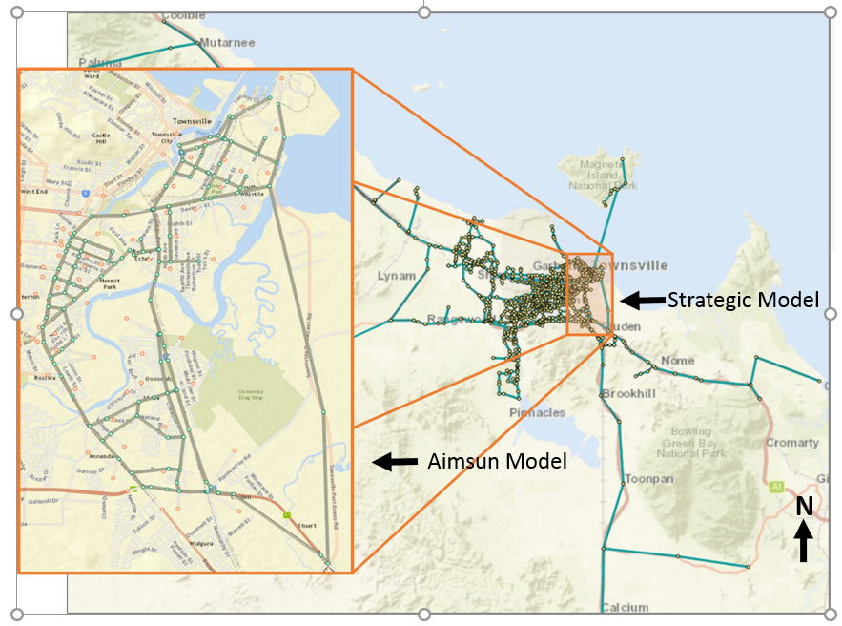

Figure 1 Model Inputs

Modelling Methodology

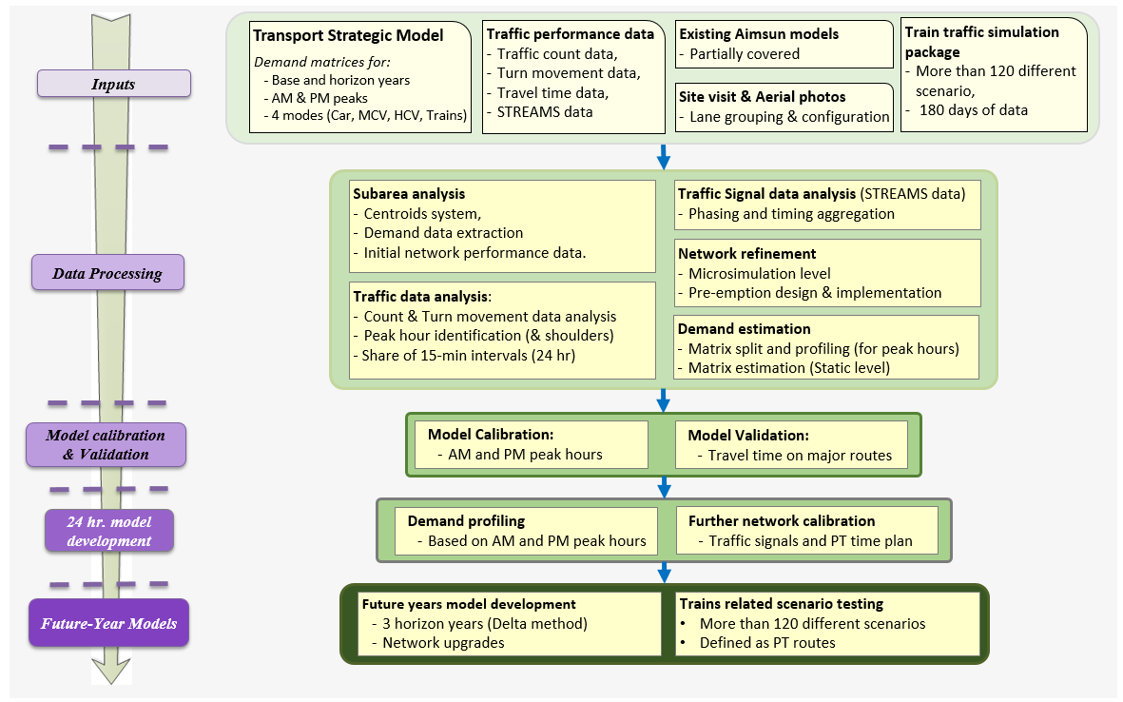
Figure 2 Modelling Methodology

The processing of the modelling results showed that the TEARC project will be able to significantly reduce the total travel time and distance of road traffic of the study area. The processing of modelling results showed that the year 2037 modelling results do have some underlying issues, which are mainly caused by the optimistic and aggressive Townsville Council assumptions for traffic growth in the strategic model, which resulted in gridlocks and non-converged runs for the scenarios of the 2037 horizon year. This leads to inconsistent model outcomes when we introduce trains to an already saturated traffic environment.

The new residential development of Rocky Spring on the southern side of Townsville is expected to come on-line in 2022 which will add traffic to already congested network. The outputs of the analysis shows that the implementation of TEARC will significantly support the road network for the future years of 2022 and 2027. With the understanding that the road network will have difficulties supporting forward traffic demand in the study area (specifically for peak hours), the development of the TEARC project will be a meaningful support for the existing road network in responding to the future traffic demand of the study area, and potential to delay/reduce the need for capital works improvements in the area.

Lessons Learned
- Importance of correct calibration of link and turn movement capacities based on the actual performance of the study area
- Reaction time at stop
- Reaction time at Traffic Light
- Accurate performance of yellow box in adjacency of each other should be checked manually
- Stop line definition
- Yellow box area adjustment
- Importance of keeping communication between the microsimulation model and the strategic model of the study area
- Delta method (recommended by TMR)
- Innovative combination of loop detectors can be employed for the implementation of different pre-emption designs (especially dealing with different type of trains)

Transport Modelling – Next Steps

The traffic modelling exercise undertaken by GHD for TEARC project was completed using a modelling software which is capable of mesoscopic and microsimulation modelling. It is now 2040 and the autonomous vehicles prevails occupying 70% of the mode share compared to drivable vehicles. The original traffic model back in 2017 was seeking to calibrate and validate the model with 24-hour data, this today in 2040 is readily available from the computerised systems in every autonomous vehicle. The data is so accurate that it is providing constant data dumps in real time at key strategic data hubs/collection points throughout the study area. Effectively the modelling software is now redundant as every autonomous vehicle is communicating back to central communication hub i.e. data analysis is undertaken automatically. What is now required in 2040 is a version of modelling software that can take this real-time data and forecast and predict traffic delays for autonomous vehicles for short/long term planning horizons out to 2060.

In a similar way the modelling of rail operation network will also be providing real time data back to a central hub of all operational movements and delays for the current network for 2040. In modelling terms this data will be utilised to predict any future volumes and delays in highly informed manner. The modelling software will now have to take the form of analysing multiple data sets in real time and historically using advanced machine learning techniques. These machine learning techniques will highly probably have to use the system of cell replication where the model learns from past road network performance and start to predict accurately how the future road network will perform.

Like all traffic models including these future machine learning based models, there will be limitations. In the early years of 2040, it is reasonable to assume that at least 30% of all vehicular movements will be still undertaken by driveable vehicles with some elements of data export and retrieval. As a consequence, the machine learning models will need to calibrate and validate part of the network to predict as accurately how these driveable vehicles will still operate in the network out to 2060. However, as we predict further forward, the driveable vehicles will occupy an increasingly smaller percentage of the road space.

The days of the traditional engineering modeller may be numbered with the advent of machine learning. It is going to be the domain of the data analyst and machine language specialist that is more likely to originate from the schools of mathematics operational research and statistical analysis rather than the schools of engineering. Accordingly, the schools of engineering will adapt their courses to focus on machine learning style techniques as well.

How society will change with the advent of Autonomous vehicles?

It is now the morning of 20th February 2040 in Christchurch, New Zealand with a typical 4-person family living in the outer suburb of Rolleston. Mum is getting the kids ready for school but she does not require a personal vehicle to drop them at school. The shared Uber autonomous vehicle is due to pick them up from their home in the morning and drive each of the two children to their respective school in Christchurch where they will be dropped off in an allocated area for autonomous vehicles. In the meantime, mum is getting reading for work and so is dad. Dad is about to get in to family SUV which has full autonomous options and will be taken to the local train station at Rolleston to catch an express rail service to Christchurch CBD. The autonomous SUV will then return to the home to take mum to her place of work. This typical 4-member family now only own one vehicle and relies on Uber style shared Autonomous vehicles for all other trips. Additionally, the autonomous vehicles will further enhance the road safety for cyclist by ensuring the minimum gap (legislation in Australia) of 1 meter separation distance is always adhere to. Figure 3 and Figure 4 provide examples of autonomous vehicles in 2040.

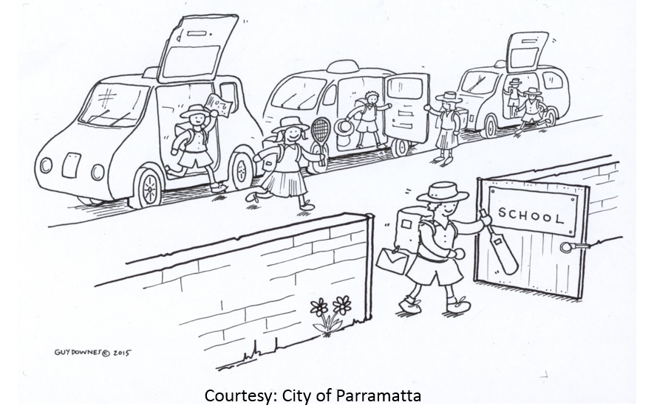
Figure 3 Autonomous Vehicles for Schools

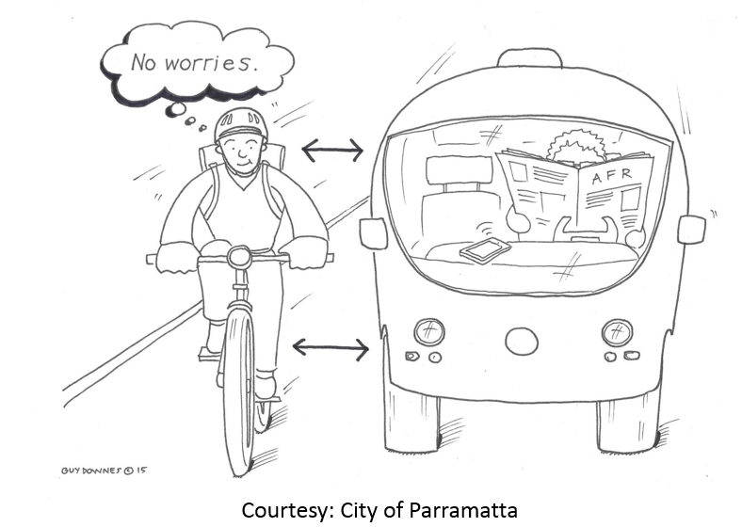
1 m
1 m

Figure 4 Cyclist & Autonomous Vehicles

It is not just a typical family who is getting benefits out of the autonomous vehicles but seniors who can now remain longer in their own family home even though in the past few years the health system has required them to relinquish their driver license and cease to operate any more a driveable car. These seniors can now own their own or access an autonomous vehicle for all their personal trips.
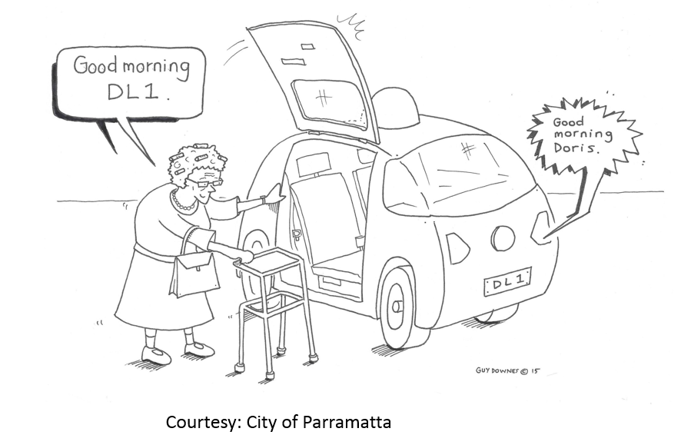
Figure 5 Autonomous Vehicles - Seniors

Just imagine what an autonomous car could do for you, your immediate and extended family in 2040!

Conclusion

The advent of the autonomous vehicles is going to fundamentally change the society but for us as transportation engineers, modellers and planners we must adapt! The modelling software and associated data calibration and validation will change with the introduction of autonomous vehicles on our roads. Real time access from data hubs and collection points along all major road network hierarchies will prevail. Machine learning to predict future road network needs will be the new modelling tool. With machine learning will come a need for data analyst, mathematician and statistician that will operate alone or will form part of our future engineers’ core functions. Putting it very simply, our engineers and the universities that train them must adapt and be ready to embrace machine learning to replicate and predict future traffic modelling.

References

1. Townsville Eastern Access Rail Corridor (TEARC) Traffic Modelling Report (2017)

2. Simon Ginn (2017), Presentation on Autonomous vehicles at Institute of Public Works Engineering Australasia (IPWEA)

