Planning, design and development of liveable cities

**Monday 11 November, 1:40pm**

Steven will challenge the conference to think about a braver approach to city shaping, creating places, spaces and economies that make healthy, happy cities with healthy happy communities.

Steven Burgess, Director, Complete Streets Pty Ltd

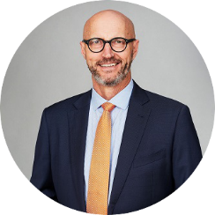

Steven Burgess is one of Australasia’s leading voices regarding people-focused urban movement and quality places.

Steven’s expertise is based on 30 years’ experience as an engineer and urban strategist. His passion is creating cities for people that can be sustained by vital local economies.