**PRIORITISATION OF BIKE AND RIDE SITES**

**(This paper has been peer reviewed)**

Luke Christensen

Senior Transport Planner

BSurv, MUP

MRCagney

Member, Transportation Group NZ

lchristensen@mrcagney.com

**ABSTRACT**

Investment in Bike and Ride facilities are growing in popularity as governments seek to widen catchments for public transport and leverage the growing popularity of cycling. Too often, however, these can be provided in an ad-hoc manner resulting in disappointing levels of uptake.

This presentation outlines a new approach for selecting ideal locations for proposed Bike and Ride facilities, developed by MRCagney for use in Canberra in 2018.

Through an international best practice literature review, a series of principles was developed for the selection and planning of Bike and Ride locations in Canberra. These principles then fed into a scoring methodology, making use of spatial data and public transport utilisation data specific to Canberra’s network. The tool then allowed a ranking of top sites for Bike and Ride in each suburb to be produced. Key findings from the research were that a combination of high-quality supporting bike infrastructure, and rapid public transport services would lead to the highest uptake.

While developed specifically for Canberra, the methodology used in this project could easily be translated to cities in New Zealand seeking to implement Bike and Ride facilities.

# **INTRODUCTION**

MRCagney was engaged by Transport Canberra to investigate the location of Bike and Ride facilities as part of the implementation of the new bus (short-term) and light rail (medium to long-term) networks.

The objective of this project is to establish guiding principles and approaches that can be used to inform what, where and how Bike and Ride facilities can be used to improve public transport access and ridership.

This report provides an overview of the Bike and Ride project, covering the literature review, principles, prioritisation process and recommendations for next steps.

First, we summarise best practices from local and overseas experiences with Bike and Ride, including investigating why cities develop Bike and Ride, and what makes Bike and Ride successful. This includes looking at higher-level factors such as placement of facilities relative to different types of public transport, as well as considering how Bike and Ride facilities should be designed and managed to increase uptake. A discussion on the suitability of Bike and Ride for Canberra, and consideration of where it might be most successful is also included.

In the later sections we describe the process undertaken to prioritise Bike and Ride sites. This starts by describing the high-level principles, based on the research summarised in previous sections. We then outline the longlisting and shortlisting process, followed by a description of the 18 shortlisted new sites.

We then provide some high-level recommendations that come out of our findings. Key recommendations include:

* Monitoring of both existing and new Bike and Ride sites to better inform decision making;
* Collection of more data would allow the methodology proposed to be tested and improved.

**BEST PRACTICE OVERVIEW**

This section provides a summary ‘best practice overview’ of Bike and Ride, which addresses the following:

* Why develop Bike and Ride facilities?
* Success factors for Bike and Ride.
* Design and management of Bike and Ride

**Why develop Bike and Ride Facilities**

A literature review was conducted to understand the key reasons Bike and Ride facilities were constructed. This covered North American, European and Australia sources. Key reasons found were:

* Overcoming the first and last mile issues associated with public transport, as Bike and Ride can significantly increase the catchment of public transport stops (TRB, 2012);
* Lower costs (financial and environmental) than other forms of station access, especially Park and Ride (Cervevo, 2013);
* Reduced demand to bring bicycles on board public transport vehicles, especially when bike space onboard reaches capacity, or causes issues with other customers (Cervevo, 2013);
* To grow mode share for both cycling (which is seen to have significant health benefits) as well as public transport (Cervevo, 2013); and
* Bike and Ride can increase the competitiveness of public transport against the private vehicle, due to reductions in time taken to access stops, and avoidance of feeder buses for short trips to rapid transit (Martens, 2004).

**Success factors for Bike and Ride**

Studies have identified key reasons why Bike and Ride can be successful in certain locations. Bike and Ride is seen to be the most successful in the Netherlands, where the mode share of cycling for public transport access trips is 25% (Martens, 2007). Key reasons for this are:

* Very high overall bike mode share of 27%;
* Cities have invested in connected networks of safe cycling facilities, which include separated facilities on most streets, as well as off-road paths and traffic calmed local streets;
* Good public transport networks, with a range of fast, frequent transport including trains, Light Rail, Metro and bus services;
* Provision of sufficient and attractive bicycle parking, ranging from large-scale purpose-built facilities at major stations to simple bike racks at local public transport stops;
* Bike and Ride facilities located adjacent to rapid public transport stops; and
* Bike rental services at key destination stations for egress trips.

Bike and Ride shares are much lower in more suburban contexts in North America and Australia. However, even within the same city, bike access shares can vary significantly based on local conditions. A study of BART stations in the San Francisco Bay Area found the following factors contribute towards high Bike and Ride mode shares (Cervevo, 2013):

* The type of the area the station was located in. Stations in denser areas, with more walkable streets, good street grids and some mixed-use generally performed better;
* Plentiful, well-located, safe and secure bike parking, including a mix of secure lockers and/or cages as well as more basic bike racks;
* Investment in safe cycling facilities within the 3-kilometre radius surrounding the station. This includes separated bike lanes and traffic calmed streets; and
* Simple, legible and well-lit paths from the adjacent street to bike lockers, and then to the platform.

Melbourne is one city in Australia that has implemented an extensive Bike and Ride program and has documented this publicly (Martin et al, 2009). This Bike and Ride program was developed after concern about overcrowding being exacerbated by the number of bicycles on peak time services, with a peak time bicycle ban initially attempted to overcome this issue. Bike and Ride sites were prioritised by the following factors:

* Demand for bike parking, measured by use of existing formal and informal bike parking;
* Safety of the station, including presence of staff and CCTV;
* The cycling catchment around stations; and
* Cycling access into the station precinct.

Analysis conducted in the year after implementation found the most well utilised Bike and Ride sites had these common factors:

* Presence of cycle lanes nearby, including off-road paths and on-road cycle lanes; and
* Good residential catchments with connected street networks.

The Bike and Rides co-located along with Park and Ride upgrades were deemed to be less successful, as these stations did not meet the other success factors. Therefore, the research urged caution in applying blanket policies of investing in Bike and Ride when Park and Ride upgrades were undertaken.

**Design and management of Bike and Ride**

The design and management of Bike and Ride needs to be carefully thought through to ensure facilities meet the needs of users. There are many design factors that can influence the success of a particular Bike and Ride facility. The following factors need to be considered:

* The type of bike parking. These can range from basic bicycle hoops, right up to staffed facilities with secure bike cages and accompanying maintenance facilities and changing rooms;
* Users requirements for safety, which is influenced by the fear of crime, as well as the value of the bike being parked;
* The exact siting of the Bike and Ride relative to bike routes to and from the facility, as well as accessibility between the Bike and Ride facility and the common departure stop;
* User profile, including whether bikes are parked for short times (a few hours) or longer periods (whole working day), as well as if people are parking their bike daily, or just occasionally;
* Barriers to use of the Bike and Ride facility, such as registration requirements, waiting lists and the need for a local transit card;
* If the Bike and Ride facilities can be reserved by users for select periods (i.e. monthly or yearly) or whether they operate on a first-come, first-served basis on any particular day; and
* The mix of different types of Bike and Ride facilities provided at each stop, and how this is influenced by various factors.
* Requirements for maintenance and upkeep. For example, certain types of bike parking require a locksmith to visit the site to provide access for new users.

The four key forms of Bike and Ride facilities are as follows:

* **Basic bike racks** – low costs (circa $10,000 for a 5 uncovered bike racks installed on a concrete slab), but low security and no automatic monitoring of usage;
* **Bike lockers** – good levels of security, but low utilisation as lockers generally reserved by a single user;
* **Bike cages** – goods levels of security, but high cost (upwards of $50,000 to $65,000 for 10 to 20 bike parks) and impact, and barriers to usage as registration required; and
* **Bike stations** – best levels of security and user experience, though come at very high cost (circa $500,000) as often a large purpose-built facility is required.

Note that costs should be seen as indicative only, and vary significantly depending on site conditions, impact on adjacent facilities, civil works required to connect power or telecommunications and if extensions are required to cycleways to connect to the Bike and Ride facility.

**CANBERRA CONTEXT**

This section considers whether Canberra is a suitable city for the expansion of Bike and Ride, based upon the success factors outlined in section 2. The following success factors for uptake of Bike and Ride will be considered:

* Presence of a Rapid Transit network;
* Existing cycle usage;
* Supporting cycle infrastructure; and
* Urban structure.

**Rapid Transit Network**

Canberra’s Rapid bus network was implemented in early 2019 as part of bus network redesign project. The Rapid network is the city’s public transport backbone of rapid and frequent services. This will consist of one Light Rail route and 9 Rapid bus routes. The Rapid network is well placed to support the use of Bike and Ride, due to the fast, direct and frequent nature of the services.

The Rapid network cannot directly reach all Canberrans and it is supported by a network of local services that feed the Rapid network at major interchanges. However, due to the nature of the street network in some suburbs and the need to retain a high degree of coverage, many of these routes will be slow and infrequent. Therefore, in many suburbs of Canberra, the combination of Bike and Ride and a Rapid bus or LRT route will offer a faster journey time than using a combination of walking and public transport, and be able to match the journey time offered by Park and Ride facilities.

**Existing cycle usage**

Canberra is often seen as Australia’s cycling city. Census data shows that Canberra has the highest active mode share amongst Australian capital cities, with 8.4% of people walking or cycling to work on census day in 2016. The National Cycling Participation survey results suggest there is a significant potential market for Bike and Ride in Canberra, with more than half of the population having access to a bicycle and most of these people using it for transport (as opposed to recreation) at least semi-regularly.

**Cycle infrastructure**

Canberra has an extensive network of cycle routes. On-road cycle lanes are provided on major arterials, including most key commuter routes into the city centre as well as other major arterials. However, these are less likely to be used by potential Bike and Ride users since they only appeal to a small range of users who can tolerate riding next to traffic. More importantly, there is also a significant network of off-road paths throughout much of Canberra. These off-road cycle paths are likely to offer the best potential access for Bike and Ride users, given they offer comfortable and safe riding opportunities that are attractive to a wide demographic and are understood to be well used by local people for transport trips and recreational trips.

**Existing Bike and Ride facilities**

Transport Canberra currently offers bike parking at 27 bus stops across Canberra, which consists of:

* 19 locations with bike racks, with generally 5 bike racks per location. Some are sheltered, while others are uncovered;
* 6 locations with bike lockers; and
* 6 locations with bike cages.

All but three of the locations are along the Blue and Red Rapid routes, which are two core bus corridors in Canberra. Of the other three, two are on other routes with branded services and one in the outer northern suburb of Ngunnawal, which is served by local routes only.

The City to Gungahlin Light Rail project is due to be completed by the end of 2018. It is understood that new bicycle racks will be installed at all new Light Rail stops, largely on the verge rather than in the median. The Light Rail vehicles are also being designed to take bikes onboard, with each vehicle able to accommodate four bicycles.

**Urban structure**

Canberra has a unique urban structure, being an entirely planned city, a trend which has largely continued to this day. The initial plan by Walter Burley Griffin plan is still clearly evident in the central areas. There is a clear hierarchy of centres across the city, with each of these centres supporting the surrounding residential catchment. The development style of Canberra suburbs has followed wider trends in city planning. Many suburbs in Canberra were developed with indirect street networks, supplemented by a supporting network of off-road cycle paths. This causes issues for bus routes. However, the network of off-road paths often provides much more direct routes than the street network. Suburbs built in recent decades are much denser with grid street networks. Over the last 20 years, density has increased in the city centre and surrounds and this trend is now spreading to other suburban centres.

**LONG LISTING METHODOLOGY**

The long-listing methodology is based on the principles in the literature review. There will be 3156 bus stops served by the new bus network in Canberra, plus 13 stops served by the City to Gungahlin Light Rail project, so it is necessary to refine the number of bus stops being assessed. This will allow a more in-depth assessment to be conducted on a short-list of bus stops. Given this is an early high-level assessment, not all planning principles were able to be considered. Evidence from the working paper is clear that two key areas are important for high level site selection:

1. Bike and Rides are located alongside frequent and Rapid public transport services; and
2. Bike and Rides have located in close proximity to cycle infrastructure.

Furthermore, these assessments can be carried out efficiently on the longlist of stops without concern that suitable stops are excluded.

In Canberra, the Rapid network (comprising Light Rail and Rapid bus routes 2 to 10) is the appropriate network to use as the ‘Rapid and frequent network’. This Rapid network is the Transport Canberra ‘New Network’, as publicly released in October 2018, and expected to be implemented in early 2019. Therefore, the first step was to filter out all stops that were not served by Rapid buses or the future Light Rail network. This reduced the number of stops being considered from 3156 to 477.

The second criteria applied was proximity to cycling infrastructure. For this we used the cycle lane network as outlined in the ACT ‘Tracks and Trails’ data file, supplied by Transport Canberra. This network consists of the Principal and Main Routes in Cycling Network 18, as well as other off-road shared paths and separated bikeways. This network does not include on-road painted cycle lanes, as these facilities are not suitable for bike riders of all ages and abilities, and Bike and Ride needs to be accessed by the largest possible market in order to be successful. All bus stops that did not have a cycle facility within 500 metres were excluded. This reduced the number of stops to be considered from 477 to 302.

To further rationalise consideration, stop pairs were grouped. This was done by pairing stops where they were located within 100 metres of each other. This further reduced the number of sites under consideration from 302 to 159.

**SHORT-LISTING METHODOLOGY**

**Introduction**

The short-listing methodology outlined below is designed to create an initial prioritised list of sites for Bike and Ride investment. However, it should be noted that further refinement will be required to ensure appropriate regional distribution, consideration of typology and consideration of site-specific factors.

The short-listing methodology is based upon the best practice review outlined in previous sections. Four key principles for successful Bike and Ride have been created to ensure sites are prioritised appropriately. The principles build upon the longlisting process, but allow for more detailed scoring of sites. These are:

1. Locate Bike and Ride along existing or planned frequent public transport service or important public transport hub;
2. Prioritise Bike and Ride sites located in higher density areas;
3. Locate Bike and Ride sites in areas with good access to local, safe cycling routes; and
4. Locate Bike and Ride sites in areas where there is higher usage of cycling.

For each of the principles, one or two criteria have been created that allow a quantitative assessment of each of the sites using data either available publicly or data supplied by the ACT government. The calculation also needs to be readily done using GIS software, and ideally easily replicable so can be applied to many sites automatically, rather than manually.

**MCA Criteria**

The MCA Criteria used for assessment of the shortlist are described in Table 1 below.

Table 1: MCA Criteria used for Bike and Ride shortlisting

|  | **Criteria** | **Key Measures** | **Assessment Criteria (1 = Low, 5 = High)** |
| --- | --- | --- | --- |
| **1** | Locate Bike and Ride along existing or planned frequent public transport service or important public transport hub | * Facility should be located along stations/stops on the frequent bus network, light rail line or major public transport hub with peak services * Priority for the facility to be located along public transport routes that serve the City Centre, given higher public transport demands sin the City Centre. * Frequency of public transport services | Headway of public transport services in the morning peak period   1. More than 10 minutes (stops without City Centre bound services) 2. 7-10 minutes (stops without City Centre bound services) 3. More than 10 minutes (stops including routes to City Centre) 4. 7-10 minutes (stops including routes to City Centre) 5. 6 minutes or less |
| **2** | Prioritise Bike and Ride sites located in higher density areas | * Areas with higher population, will have a larger catchment of potential users. | Population within 2 km of the stop.   1. 1. Population <= 5,000 2. 2. Population > 5,000 AND <= 10,000 3. 3. Population > 10,000 AND <= 15,000 4. 4. Population > 15,000 AND <= 20,000 5. 5. Population > 20,000 |
| **3** | Locate Bike and Ride sites in areas with good access to local, safe cycling routes. | * Two separate criteria are used to distinguish between access to cycle infrastructure from the stop, and coverage of cycle infrastructure in the usual cycling catchment of the stop. * Stops that are located along safe cycle routes will be ‘on the way’ for people using bike paths, so minimal detours and footpath riding will be required. Where the stop is located further from bike paths, supporting investments in extending shared paths may be required. * More cycling routes in the area, will give more people easy access to the Bike and Ride site. | Distance to safe cycling route   1. Cycle Lane Distance > 400m 2. Cycle Lane Distance >300m AND <= 400m 3. Cycle Lane Distance > 200m AND <= 300m 4. Cycle Lane Distance > 100m AND<= 200m 5. <= 100m   Length of safe cycling routes within a 3 kilometre radius   1. Cycle Lane Length <= 10km 2. Cycle Lane Length > 10km AND <= 20km 3. Cycle Lane Length > 20km AND <= 30km 4. Cycle Lane Length > 30km AND <= 40km 5. Cycle Lane Length > 40km |
| **4** | Locate Bike and Ride sites in areas where there is higher usage of cycling. | * Bike and Ride will be more successful where there is higher use of cycling. * The key way we have are measuring this are the cycle mode share data from the census. * Usage of bike racks on buses can be useful to signify where there is higher usage of bikes, which stops people prefer to cycle too, and also where people may park their park if bike racks are full. | Weighted average census cycling mode share in SA1 areas within a 2km radius.   1. Cycle Mode share <= 0.5% 2. Cycle Mode share > 0.5% AND <= 2.5% 3. Cycle Mode share > 2.5% AND <= 5% 4. Cycle Mode share > 5% AND <= 10% 5. Cycle Mode share > 10%   Tagged annual recorded uses of bike racks on buses at the stop(s).   1. Bike Rack Usage <= 10 2. Bike Rack Usage > 10 AND <= 50 3. Bike Rack Usage > 50 AND <= 100 4. Bike Rack Usage > 100 AND <= 500 5. Bike Rack Usage > 500 |

The short listing produced a prioritised list of all 159 potential Bike and Ride sites, which can be seen in Figure 1 below. However, there was still significant duplication between adjacent sites. Therefore, to produce an initial shortlist the top sites in each suburb of Canberra were chosen. This identified a shortlist of 49 potential Bike and Ride sites.

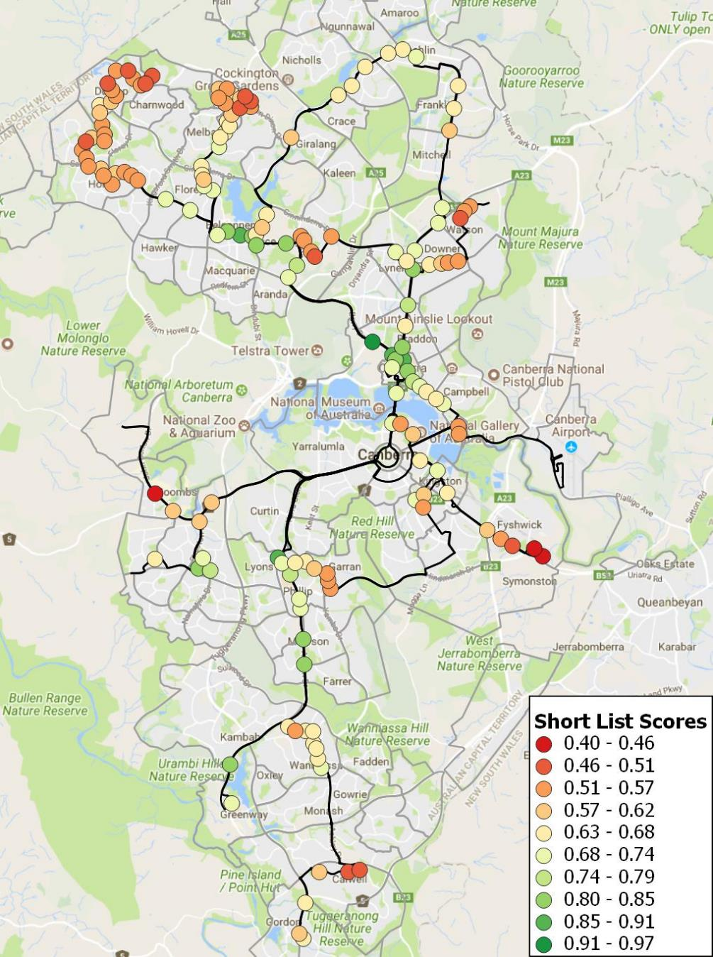

Figure 1: Scoring of Bike and Ride sites in Canberra overlaid with Rapid bus routes (black) and local bus routes (grey).

**CONCLUSIONS**

The methodology above outlines a process for prioritising Bike and Ride sites in Canberra, informed by best practice, and based on available data. However, due to data limitations, this methodology has not been tested against real world performance of bike and ride sites. Implementation of the proposals outlined would allow this methodology to be tested against real world performance and amended based on outcomes.

Unfortunately, data for bike parking at public transport stops rarely appears to be collected, and if is collected is not made public or shared between transport authorities. Collected of data regarding access mode to public transport stops and stations, and periodic measuring of bike parking at stations would help better understand the importance of this mode, as well as the success factors that lead to differences in usage within cities.

Data regarding usage of bicycles in the area is also an issue. The only broadly available geographic data on bicycle usage is from the census, which covers trips to and from work or education only. This is likely to bias the bicycle usage data towards suburbs in close proximity to the city centre or other major employment hubs. This data may not fairly represent suburbs where bicycles are used extensively for errands or short recreational trips around the neighbourhood, as these suburbs which are good potential candidates for Bike and Ride. The only other data source is from applications such as Strava, but this is likely to also be biased towards longer distance commuter and training riders, who are not a key market for Bike and Ride.

For the most part, the analysis can be transferred to other cities, particularly in Australia and New Zealand, given data utilised commonly collected in cities. The main data gap is likely to be the data for usage of bikes on board public transport vehicles, which is either not allowed or not collected in many cities.

**REFERENCES**

CERVEVO, ROBERT et al, Bike-and-Ride: Build it and they will come (2013), Journal of Public Transportation, Vol. 16, No. 4

MARTENS, KAREL (2004) The bicycle as a feedering mode: experience from three European countries. Transportation Research Part D 9 (2007) 281-294

MARTENS, KAREL (2007) Promoting bike-and-ride: the Dutch experience. Transportation Research Part A 41 (2007) 326-338.

MARTIN, S &, DEN HOLLANDER, JASON, (2009) Parkiteer – Secure Bike Parking at Public Transport Nodes in Melbourne, Proceedings of Australasian Transport Research Forum 2009, Auckland, NZ

TRANSPORTATION RESEARCH BOARD (2012) Guidelines for Providing Access to Public Transportation Stations, Transit Cooperative Research Program Report 153