**A40 Outcome Delivery Plan – London, United Kingdom**

**AUTHOR:**

**Mehmet Ahmet,**

BSc (Hons), MSc, CMILT

Auckland Transport Planning Team Leader, Jacobs

Mehmet.Ahmet@jacobs.com

**ABSTRACT**

The A40 corridor in London is critical for traffic and freight movement and operates close to and often above capacity during the peak periods The A40 Corridor has an average of 50,000 vehicles per day which is within the top 10% of London’s busiest roads in each direction. Therefore, congestion, delay and journey time reliability issues are common along this stretch of road.

There is also significant severance for cyclists and pedestrians both moving along the corridor and crossing it along this very busy corridor.

Following the United Kingdom Business Case approach, the study firstly focused on understanding the issues, challenges, constraints and opportunities along the A40 Corridor between the Hanger Lane Gyratory and Savoy Circus. This was then followed by the identification and strategic assessment of a long-list of intervention options to meet the key outcomes for the A40 Corridor in this area. The long-list of options was sifted using a simple Value Assessment Framework (VAF) Tool to record the outcome of discussions.

During the sifting process the stakeholders also categorised the shortlisted interventions into Grade Separation Options, the At-grade Option and the Hybrid Option (combination of both).

The short-listed options brought forward where the design was refined to reflect the objectives of providing improved urban realm facilities but also facilitating development as part of the overall improvements.

This paper details the purpose for creating a masterplan and how development opportunities could be facilitated through this change. This paper describes the process undertaken to gain collective agreement on the vision and programme for change and highlights the importance of a collaborative and strategic approach for developing an integrated transport network and ‘blueprint’.

**INTRODUCTION**

The Roads Task Force (RTF) was set up by the Mayor of London in 2012 to tackle the challenges facing London’s streets and roads.

The RTF was published in July 2013 and addressed what was needed in the short, medium and long term to enable London as a city to be able to accommodate its growing population. In relation to this, the RTF identified different constraints related to traffic and congestion problems that would affect the development of the city.

As a response to this report, Transport for London (TfL) stated they would undertake different strategic studies with the main aim of finding corridors where measures can be applied with the objective of not only relieving congestion and connecting the city in a more effective way, but also increasing the space for living and urban realm improvements in a spaces never utilised before, alongside with improving the facilities for cyclist.

The A40 corridor was identified as a suitable location for such improvements, as increased capacity is required here to ease the existing congestion. The local area is affected by the negative impact of the A40 where the severe congestion limits planned and potential development in the wider area. These issues affect not only people living in the area, but also vehicles on the roads, public transport, cyclists and pedestrians. This study was to be used to inform a Strategic Business Case for a TfL A40 Corridor Investment Plan and feed into Local Borough Transport Plans, Old Oak and Park Royal Development Corporation Local Plan (OPDC) and Development Infrastructure Funding Study (DIF) as highlighted in the study interfaces shown in **Table 1**.

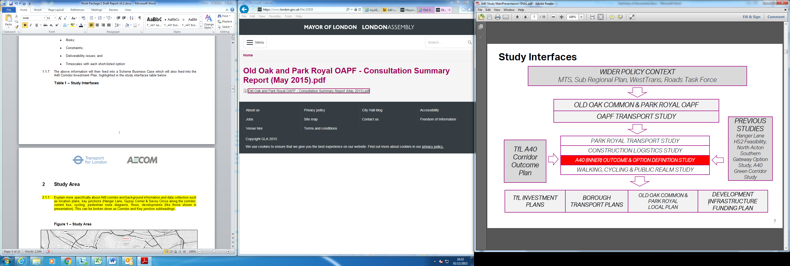

Table 1: Study Interfaces

The core study area started at Hanger Lane Gyratory and extended to Wood Lane junction. The key intersections of interest are Hanger Lane Gyratory, Gypsy Corner and Savoy Circus for which the identification of key challenges, opportunities, constraints and options will be reported on below.

**Figure 1** shows the A40 corridor location, the core study area and extended study area.

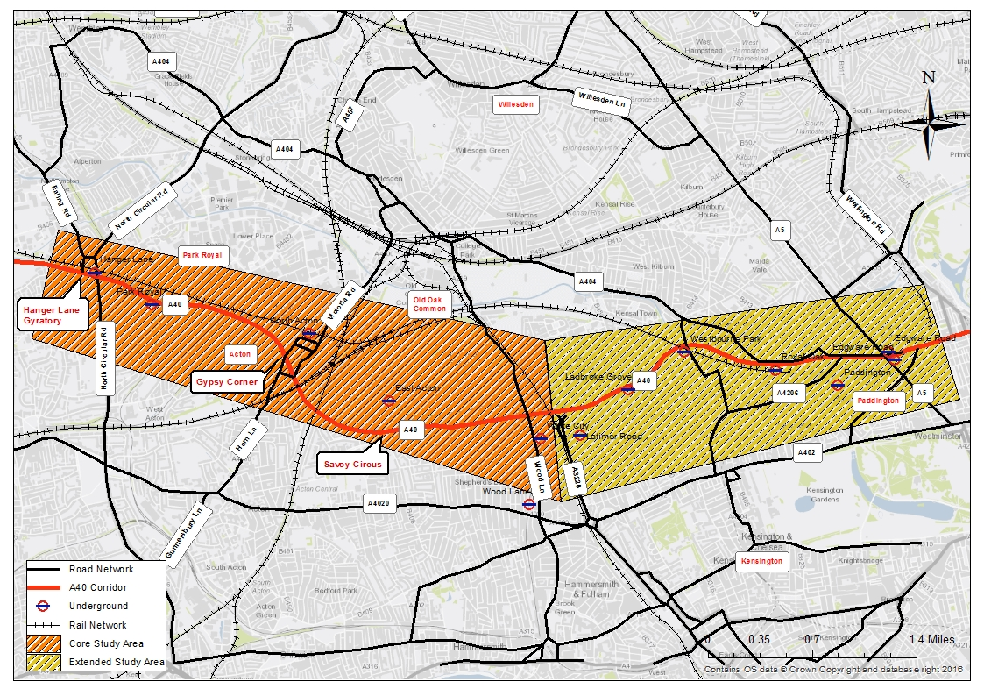

**Figure 1: The Study Area**

The majority of the A40 within the study area is three lanes in each direction. This narrows to two through lanes at the major intersections and widens to up to five lanes in some locations when including the lanes for turning movements. The core study area includes three large gyratories/intersections each with their own congestion and connectivity issues. Hanger Lane Gyratory is a heavily trafficked six arm, grade-separated junction with an adjacent Underground Station. Gypsy Corner is a one-way gyratory made up of a number of local roads. Savoy Circus is an at-grade four-arm signalised junction.

BACKGROUND INFORMATION

The A40 corridor is critical for traffic and freight movement and currently operates close to and often above capacity during the peak periods. The A40 within the study area carries an average of 50,000 vehicles per day in each direction. This is within the top 10% of London’s busiest roads. Congestion, delays and journey time reliability issues are common along this stretch of road. High traffic volumes on the A40 result in high levels of local emissions and noise, significantly impacting on the local residents and businesses.

Movement Patterns – Multi Modal Considerations

The movement patterns and stress along the A40 corridor are shown in **Figures 2** & **3** below.

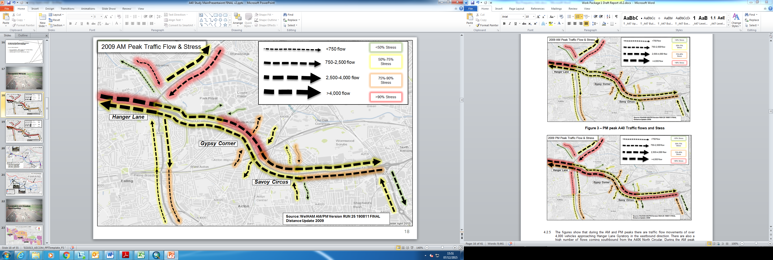

Figure 2: Existing AM peak A40 Traffic flows and Stress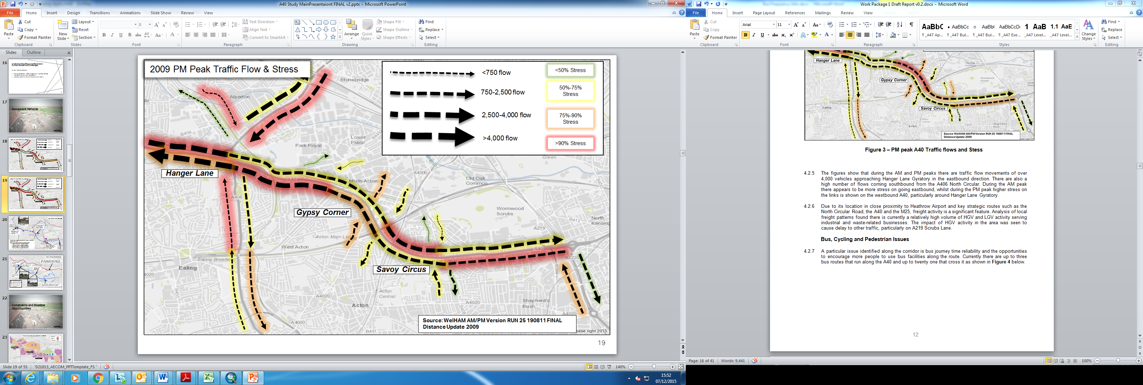

Figure 3: Existing PM peak A40 Traffic flows and Stress

The movement figures above show that during the AM and PM peaks there are traffic flow movements of over 4,000 vehicles approaching Hanger Lane Gyratory in the eastbound direction. There are also a high number of flows coming southbound from the A406 North Circular. During the AM peak there appears to be more stress on going eastbound, whilst during the PM peak higher stress on the links is shown on the westbound A40, particularly around Hanger Lane Gyratory.

Due to its location in close proximity to Heathrow Airport and key strategic routes such as the North Circular Road, the A40 and the M25, freight activity is a significant feature. Analysis of local freight patterns found there is currently a high volume of HGV and LGV activity serving industrial and waste-related businesses along the corridor.

Like any busy corridor there is significant severance for cyclists wanting to either ride along (east-west movements) or through (north-south movements) the A40 study area. The A40 and its major intersections within the study area are also a significant form of severance for pedestrian movement. Although a combination of at-grade, subways and bridges provide several crossings for pedestrians across the core study area the quality of many of these crossings is generally poor and there are large sections with no pedestrian facilities.

Cycling accessibility is considered to be a key issue according to the policy documents such as the Mayors Strategy (2010) and Sub Regional Transport Plans. In general there is significant severance for cyclists wanting to either cycle along (east-west movements) or through (north-south movements) the A40 study area. This is particularly significant as there are a number of tube stations to the north and south of the A40 which are likely to generate and attract significant movements close by.

A particular issue identified along the corridor is bus journey time reliability and the opportunities to encourage more people to use bus facilities along the route. Currently there are up to three bus routes that run along the A40 and up to 21 that cross it.

In addition, and other competing factors local roads can sometimes be used as rat runs by people attempting to avoid the congestion on the A40. The added pressure brought about by this rat running increases the stress on the network. The network of local access roads is also limited and, with narrow lanes and poor sight lines, does not meet current highway design standards

And lastly, due to the canal and railway lines, there are limited opportunities to navigate north-south, which adds to the severance of the area.

THE ISSUES ON THE CORRIDOR

Understanding the issues was vital in order to identify a long-list of options and produce intervention packages that could be considered to help improve the transport situation within the study area and also consolidate against potential future forecasted conditions.

The current issues and challenges faced were identified at a corridor level. The issues included:

* The A40 Corridor was identified to be within the top 10% of London’s busiest roads, with an average of 50,000 vehicles per day per direction. Congestion, delay and journey time reliability issues are common along this stretch of the road.
* Due to the A40 being in close proximity to Heathrow Airport and key strategic routes, freight activity was identified as a significant feature. This has a notable impact in the area causing delays to other traffic.
* Collectively, the identified development sites in Old Oak and Park Royal are projected to deliver approximately 25,500 homes and up to 65,000 jobs. There is likely to be a significant impact on the road network should all this development be realised.
* Bus journey time reliability was identified as an issue as well as the opportunities to encourage more people to use bus facilities across the corridor.
* There is significant severance for cyclists and pedestrians along the route. In particular this was an issue for cyclists wanting to either ride along (east-west movements) or through (north-south movements) the A40. There are a total of 38 pedestrian crossings within the study area. The quality of many of these crossings is generally poor and there are large sections with no facilities. As development and growth opportunities come forward, demands for pedestrian movements, particularly north-south, are likely to increase.
* Local roads are sometimes used as rat-runs by people attempting to avoid the congestion on the A40.This rat-running increases the stresses on the network. The network and capacity of the local roads is limited, often with narrow lanes and poor sight lines, and in some cases it does not meet current highway design standards.
* Poor air quality associated with the congestion along the corridor was also identified as an important issue.

PROJECT PROCESS AND STAKEHOLDER INVOLVEMENT

A number of workshops were conducted with key stakeholders throughout the study to establish common objectives but also at key milestones to get as much input as possible into the design process so they were able to influence the process.

The option development for the corridor adopted a strong stakeholder engagement approach from the start, involving interviews, meetings and workshops with:

* Transport for London Property Department and Surface Transport
* Local Authority partners
* Imperial College / Colleges / Schools
* Developers
* Local Residents
* Members of Parliament and Local Councillors
* Transport Operators
* Cycling and walking user groups

Interviews with key stakeholders were undertaken to capture each stakeholder’s local knowledge within the study area, explain the project’s scope and to discuss and refine the project objectives.

This engagement and workshop approach defined the project objectives; problem and benefits; evaluation framework and guided long list and short list options and project outcomes. **Figure 4** represents the overall project process for development of the options.

Figure 4: Study and Business Case Process

**UNDERSTANDING THE PROBLEM AND SETTING THE OBJECTIVES**

A common set of corridor objectives were agreed upon to evaluate whether traffic solutions would to the meet needs of the corridor. The agreed corridor objectives are shown in **Table 2**.

|  |
| --- |
| Agreed Corridor Objectives |
| Maintaining core movement function   * Maintain as a key route for freight and construction based traffic. * Manage and regulate flow and capacity into central London |
| Delivering connectivity and capacity enhancements to support existing and planned new homes and jobs in growth areas   * Reduce severance across the A40 and support improved access from and across the A40 to planned growth areas, particularly for buses, cyclists and pedestrians. |
| Improving the environment, safety and asset quality   * Reduce the impacts of noise and improving air quality along the A40. * Reduce collisions, particularly among vulnerable road users. * Maintain high quality assets. |

**Table 2: A40 Corridor Objectives Agreed During Stakeholder Engagement**

A number of constraints were identified at the first stakeholder event with the key policy makers of the governing authorities. The constraints included:

* The high number of housing and commercial developments along the route;
* The planned introduction of the A40 North Action – Paddington Cycle Super Highway;
* Several major railway crossings; and
* The limited availability of space particularly, for tunnelling e.g. this will impose limitations on space for construction sites and tunnel portals.

We then drilled down further to intersection level specific challenges and objectives. **Table 3** summarises the key junction challenges as well as the objectives that were identified.

|  |  |  |
| --- | --- | --- |
| Key Intersections | Challenges | Objectives |
| Hanger Lane Gyratory | Different challenges ranging from capacity problems to severance issues | Maintain A406 / A40 Interchange Function |
| Improve pedestrian / cycle access to London Underground Stations |
| Improve/ enhance Bus Interchanges |
| Gypsy Corner | Severance is a key issue at this junction | Improve pedestrian crossings |
| Improve North/South Bus movements |
| Enhance public realm |
| Improve facilities for pedestrians and cyclists |
| Improve links between mainline and underground stations |
| Savoy Circus | This junction was noted for its lack of pedestrian and cycle friendly movements and facilities | Improve pedestrian crossings |
| Improve North/South Bus movements |
| Improve Place Function of Local Centre |
| Improve facilities for pedestrians and cyclists |

**Table 3: Key Junction Challenges and Objectives**

**LONG LIST OF OPTIONS**

As part of the study one of the key outcomes was to identify a long list of potential short to long term highway improvement options that could help deliver the key objectives set out at the beginning of the project and address the forecast growth pressures.

In order to assess against the corridor objectives and aspirations for the study a number of themes were established which would help facilitate the packaging of the options. The themes were:

1. **Low level interventions** – short term/quick win options – consisted of minor widening and simple upgrades
2. **At-Grade Intersection Interventions** – medium term options - closing certain roads in order to improve pedestrian and cycling severance or considerable changes to the operation of the junction such as signal optimisation
3. **Lane Management** - considered corridor wide solutions investigating tidal flow lanes during peak times, variable speed limits and the introduction of bus or freight priority lanes, increase footway widening and designated cycle routes.
4. **Grade Separation** - more complex, heavy structured and larger scale enhancement schemes at the key intersections. The grade separation options primarily focused on improving capacity at the intersections so incorporated ideas ranging from fly overs, fly unders, multi-level lane approaches and gyratory reconfiguration or removals.
5. **Tunnel/Realignment of the A40** - long term and high cost options that are likely to remove a significant volume of traffic on the A40 with the anticipation that the A40 would be reduced in capacity allowing for surface transport interventions to improve severance, place making and public realm at ground level.

The evaluation of the long list against the project objectives and an assessment of whether the options can address the project problems resulted in taking forward 29 options to the short list for further investigation.

VALUE ASSESSMENT FRAMEWORK AND SHORTLIST

The sifting process was considered as packages along the A40 corridor in order to maximise the overall impact of these potential improvements in terms of capacity, public realm and public transport issues identified.

The long-list of options was sifted using the Value Assessment Framework (VAF) Tool, which was developed by the Study in order to qualitatively assess the benefits, impacts, broad costs and deliverability of the options. The recommended shortlist of options was comprised of three options at each of the intersections and it was assessed against its related themes. **Figure 5** below summarises the process undertaken to shortlist the options.

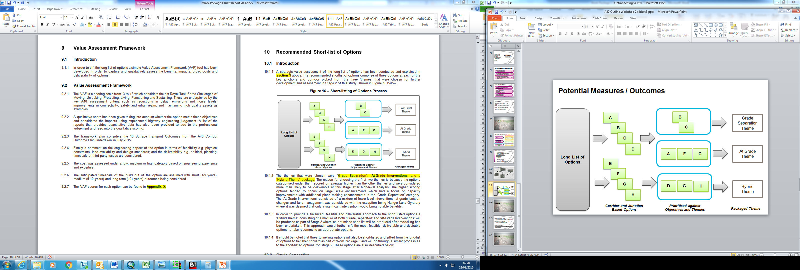

Figure 5: Shortlisting of Options Process

A VAF qualitative score (from -3 to +3) was given to each of the options, considering the six Road Task Force (RTF) Challenges of Moving, Unlocking, Protecting, Living, Functioning and Sustaining. These were underpinned by the key A40 assessment criteria such as reductions in delay, emissions and noise levels; improvements in connectivity, safety and urban realm; and maintaining high quality assets as examples. These were scored with the key stakeholders discussion before shortlisting.

As shown in Figure 5 above the preferred themes from the long list of options were **‘Grade Separation’**, **‘At-Grade Interventions’** and a **‘Hybrid Theme’** package. The reason for the choice of the first two themes is because the options categorised under them scored on average higher than the other themes and were considered more than likely to be deliverable at this stage of the assessment. The higher scoring options tended to focus on large scale enhancements which had a focus on capacity improvements with additional place making enhancements in the ‘Grade Separation’ category. The ‘At-Grade Interventions’ consisted of a mixture of lower level interventions, at-grade junction changes and lane management was considered with the exception being Hanger Lane Gyratory where it was deemed that only a significant intervention would bring notable benefits.

In order to provide a balanced, feasible and deliverable approach to the short listed options a ‘Hybrid Theme’ consisting of a mixture of both ‘Grade Separated’ and ‘At-Grade Interventions’ was produced and where the options were going to be optimised following the modelling exercise.

An economic appraisal was also completed for all short listed options and those options that achieved a positive BCR above 1.5 were eventually taken forward as they achieved the highest travel time savings for public transport users and lowest general vehicle disbenefits based upon the Saturn modelling results. But also in general the wider positive impacts of the place making opportunities with making changes to the network on the surface.

**Shortlist: Grade Separation Scheme Options**

The highest scoring grade separation themed options were chosen as part of the VAF process. The following options were short-listed at each of the key intersections:

* Hanger Lane – Gyratory Removal
* Gypsy Corner – Fly under
* Savoy Circus – Fly under

At Hanger Lane Gyratory this scored highest out of all the options consider at this location. The reason for such as high score is that it could potentially reduce congestion and delay considerably if a tunnel were to be built between the A40 (W) off slip and A406 (N). With the west bridge being removed this would allow for considerable land re-take available for either the public realm or re-development. The improvement to facilities such as new pedestrian subways and at-grade crossings means this option also scores highly against pedestrian and cyclist criteria. There may be some feasibility and deliverability issues associated with this option as the portal entrance on the west side, exit on the east side and tunnel alignment is indicative and therefore more detail would be needed before confirmation of alignment is achieved.

The option at Gypsy Corner scored highest out of all the other grade separation categorised theme options for this location. The option scored highly in terms of it’s potential to reduce congestion and delay to general traffic users. Opportunities to increase the development footprint as a result of reduced carriageway footprint at surface level and wider footways improving conditions for pedestrians and cyclists meant it scored highly in those categories of the VAF. In terms of the deliverability of this option more work would need to be done to consider the entrance/exit lengths of the fly under and construction phasing may be complex, potentially causing disruption to locals and through traffic.

At Savoy Circus the Fly under was one of the highest scoring options out of all the themes considered. The option scored had similar scoring to Gypsy Corner in terms of the potential improvements to congestion, land gain for redevelopment/regeneration and pedestrian/cyclist improvements. Similar deliverability issues are apparent at Savoy Circus in relation to construction phasing and the length of the fly under which are indicative at this stage.

**Shortlist: At-Grade Intervention Scheme Options**

The At-Grade Intervention Scheme consists of those junction options which scored highly in categories which did not feature tunnel/realignment of the A40 and grade separation. The options short-listed are shown below:

* Hanger Lane – Partial Gyratory Removal
* Gypsy Corner – Close Local Road to General Traffic
* Savoy Circus – A40 Retained Reduced Capacity for Pedestrian/Cyclist Benefit

It was considered that Hanger Lane Gyratory would need significant intervention in order for the potential beneficial impacts to be achieved; therefore the option for Partial Gyratory Removal was chosen as it scored second highest out of all Hanger Lane Gyratory options. This option scored particularly highly on the ‘Moving’ and ‘Living’ RTF challenge criteria, meaning this option is likely to improve junction capacity relative to the existing layout, having potential to deliver local journey time benefits, reduce queuing; although further modelling work would be necessary to quantify this. Land to the west could become public space or redeveloped which makes this option score highly. Significant restructuring of the western and eastern bridges may make construction and phasing quite difficult.

At Gypsy Corner the next highest scoring option after tunnel/realignment of the A40 and grade separation was the closure of Wales Farm Road to General Traffic. This option scored highly in terms of ‘Protecting’ and ‘Living’ particularly because it introduces new bus lanes and cycle facilities along Wales Farm Road and removes traffic on the busy road which would improve safety and perception of safety. Even though this option does not necessarily have any major engineering infrastructure changes the closure of Wales Farm road could cause political and local unrest as access would be considerably reduced.

The option scoring highest after tunnel/realignment of the A40 and grade separation at Savoy Circus was the reduced road capacity for cars/hcv’s and to transfer this spaces for pedestrian/cyclist benefit. This option scored particularly high in ‘Protecting’ and ‘Living’ categories as having the A40 reduced in lanes would provide shorter crossing distances for pedestrians and cyclists which would improve safety and perception of safety. This option is unlikely to have any engineering complications and may lead to opportunities for additional land for developers.

It was also noted and discussed with stakeholders that there was the potential for lane management options along the A40 corridor to be incorporated into these schemes.

**CONCLUSIONS AND KEY LESSONS LEARNT**

This study demonstrated that the business case process is an effective means of testing multiple options for their ability to solve agree problems and deliver desired benefits. As noted above, the process is heavily reliant upon stakeholder engagement and works best when the project stakeholders commit to the project and are in attendance. While the modelling and economic appraisal is an important part of the business case analysis, it is only one part of it and should not be relied upon as the deciding factor in selecting between options. Instead, the option that best addresses the problem, objectives and delivers the desired benefits should be selected as the preferred option.

Some of the key lessons throughout the process of developing the business case with Transport for London was the collaborative partnership developed between the us, the consultant and the client. This did involve working outside of the scope on many occasions because of the complexity of certain decisions that needed to be made throughout. However, this did improve the relationship as we had a common understanding of the risks that we had commercially on the project but this in turn built in an inner trust amongst the team with an improved project outcome.

As this paper set out there were multiple organisations involved with different needs and requests. These all had to be managed and was challenging at times and in the beginning there was many guarded discussions between the different groups. Overtime as the project progressed the stakeholders came together to reach a consensus on the challenges as most of these were shared amongst the group, this was not realised at the start of this process. This collaboration and teamwork has been beneficial from a project perspective but should also prove invaluable going forward on a variety of projects, initiatives and overall communication between organisations.

As part of the business case approach it was critically important to take an integrated multi-modal network approach (as opposed to a corridor by corridor approach) when planning the transport system as all modes are interrelated and are competing for the same valuable space. Failure to take a multi-modal approach is likely to result in sub-optimal solutions and is likely to jeopardise the delivery of all transport networks. For example, in the absence of a network approach, priority measures as noted by one of the stakeholders may not be provided for any transport mode which will compromise reliability, safety and overall resilience of the transport system.

Having clear objectives and buy with any planning project is also very important. The objectives and principles were fundamental to selecting the preferred option which delivered the best outcomes from a transport and place making perspective. In undertaking a process to reconcile the competing interests, the setting of agreed principles allows different parties to agree to a process for reconciling the overlaps. The clearer and non-competing objectives from reconciled networks allow Network Operating Plans to make improvements and refinements to improve all modes

The optioneering development, which is at the heart of the business case process, must be robust and comprehensive in order to be effective. In fact, it is important to note that the project outcomes, critical success factors and supporting evaluation criteria should always be agreed upon and be fully vetted with stakeholders as one of the first steps before any options are even conceived. During the option development process, we have found that taking an unconstrained approach to option generation workshops but having a strong lead to manage matters innovates thinking and is encouraged to ensure that all options are considered.

With all business cases modelling does play a role in the decision making. For this business case we were at the right level of design for modelling to give some meaningful information. Testing the key differences between travel times is a good indicator but also more importantly testing in the economics assessment of the land development potential was also a key differentiator for the best scoring option. We worked jointly with the Transport for London’s modelling and economics team to develop the metrics for the modelling so we were able to capture this information.

Ensuring constant communication also avoided poor situational awareness on the project. We would have weekly briefings through a dashboard and every two weeks’ project updates. Dissemination of the information was key amongst the different teams working on their aspects of work.

And lastly Customer Focus was at the forefront of everything, especially for Transport for London who are a front facing authority with the public. In order to develop innovative and best practice solutions it is vital that the customer is, at the forefront of the thinking. In particular, we found that it is important to define with the project team and stakeholders who the customers are - whether it is commuters, tourists or more focused on people on bikes or public transport users. This focus on the customer enables the wider understanding of day-to-day customer operations and the development of a variety of options that may not have been otherwise considered. In order to capture customer impacts, we also developed a number of customer oriented evaluation criteria to ensure that the desired customer outcomes are being considered through the evaluation process.

The above ingredients from delivery of the A40 project means that any project can be successfully delivered if you have the ground rules in place first where ever you are.