A step change in level crossing safety

Dr Shane Turner, National Specialist – Road Safety
PhD, Civil Engineering, University of Canterbury & BE (Hons), University of Auckland
Stantec New Zealand, 6 Hazeldean Road, Hazeldean Business Park, Christchurch
E-Mail: shane.turner@stantec.com
Eddie Cook
CPEng, CMEngNZ
Project Engineer – Level Crossings, KiwiRail
E-Mail: eddie.cook@kiwirail.co.nz
Shaun Bosher, Transport Engineer
BE, MET, University of Canterbury
Stantec New Zealand, 6 Hazeldean Road, Hazeldean Business Park, Christchurch
E-Mail: shaun.bosher@stantec.com
ABSTRACT
Railway level crossings should be a key focus of the safer system approach as the consequence of crashes involving trains is often death or serious injury. While the number of deaths and serious injuries at level crossings in New Zealand is relatively low compared with the overall road toll, it is alarming that the proportion of crashes involving vulnerable pedestrians and cyclists at level crossings has been increasing. In the past KiwiRail has relied primarily on the ALCAM crash estimation model to identify and assess unsafe road and pedestrian crossings for treatment. While ALCAM is one of the better developed level crossing models internationally, it does have it's limitations when used alone. The ALCAM documentation specifies that other information such as incident and crash data and the opinions of locomotive engineers should be considered in assessing risk, but in practice it rarely has recieved equal importance with the ALCAM risk ratings. Hence KiwiRail has recently developed a wider assessment process that includes such factors, called Level Crossing Safety Impact Assessments (LCSIA), to better understand the crash risks at its curent level crossings and to assess both new crossings and major changes to existing crossings for the 'now' and into the future. It does this by adding 1) an assessment of historic incidents (near misses and crashes), 2) locomotive and Road Controling Authority (RCA) engineers opinions and 3) an additional site safety assessment to the existing ALCAM risk rating, to create a Level Crossing Safety Score (LCSS). This paper outlines the new process, the learnings that have occurred during 2016/17 as it has been applied at over 80 crossings and how the industry has been upskilled in this area through the LCSIA training. The intention being to create a safer network of level crossings around New Zealand.

ACKNOWLEDGMENTS
The authors would like to acknowledge KiwiRail and the New Zealand Transport Agency who have funded a number of ‘safer system’ project associated with level crossing safety, including the development of the LCSIA process and the guidelines that provide advice on how to improve the safety of pedestrians and cyclists at level crossings.

INTRODUCTION
There are about 1300 road, 750 pedestrian and a large number of private level crossings in New Zealand. While there are relatively few motor vehicle and pedestrian crashes at level crossings (compared with the rest of the road network), the consequence of a crash at a level crossing is often severe (serious injury or fatality) and often draws media attention.
Given the high consequences of level crossing crashes, it is important that level crossings, are managed using the same “safe system” approach that is applied to other transport infrastructure. Namely, it is important to remember that humans make mistakes (but shouldn’t be disproportionately punished for them) and are vulnerable to injury (requiring a focus on harm minimisation). Applying this thinking to level crossings involves considering the behavioural aspect of human interactions with crossings and applying appropriate infrastructure (e.g. engineering, vehicle technology) or non-infrastructure (e.g. education, enforcement) treatments to each site. A shared responsibility is required to address safety (incl. rail operators, road controlling authorities, system users, etc.).
A number of high profile level crossing fatalities has increased the focus on level crossing safety over the last five years. In October 2016, the Transport Accident Investigation Commission (TAIC) added “safety for pedestrians and vehicles using level crossings” to its watch-list of pressing concerns (TAIC 2016). In particular, TAIC noted that the process for assessing risk at pedestrian (and bicycle) crossings was not keeping pace with infrastructure changes and increasing patronage on metropolitan passenger trains. The increasing use of railway corridors for shared use and cycle paths has also lead to an increase in pedestrians and cyclists using these corridors and the level crossings along them.
To help objectively assess level crossing (existing, modified and new) risk, and respond appropriately, KiwiRail has developed a new assessment process called the Level Crossing Safety Impact Assessment (LCSIA). A key component of this is a new risk scoring system called the Level Crossing Safety Score (LCSS). In addition to the traditional ALCAM (level crossing risk model) score, the LCSS also looks at three additional data sources associated with crash risk: historical crash and incident data, safety observations made by locomotive engineers and road controlling authority (RCA) engineers, and a more detailed site safety assessment that considers the crossing and surrounding transport network. In addition to a risk assessment, the LCSIA also identified any safety issues that need to be considered at an existing site or as part of a crossing upgrade, ideally through a formal safety audit process.
KiwiRail requires that an LCSIA is completed for all level crossings that are modified/ upgraded or impacted by increasing usage. Examples of increased usage include, increase in train frequencies, increase in pedestrians and cycle usage due to construction of a railway corridor cycleway or increase in vehicles due to new land-use development. A LCSIA needs to be prepared and approved prior to the construction of any planned change to level crossings or any operational changes (e.g. increase in train frequency).
This paper outlines the LCSIA process and also the lessons that have been learnt from undertaking LCSIA at over 70 pedestrian and vehicle level crossings around New Zealand. The authors of this paper were involved in preparing the LCSIA guidelines. This paper does include extracts from this guideline.

LCSIA CRITERIA AND ITS LINK TO NZ LEGISLATION ON RAILWAY CROSSING
KiwiRail has developed two criteria for use in assessing level crossing safety. The first criterion (Criterion 1) is that the Level Crossing Safety Score (LCSS) of new and modified level crossings should be ‘Low’ or ‘Medium-Low’. Only at these low risk levels are the health and safety requirements as specified in the Railways Act 2005 (“the Act”) deemed to be meet. The main purpose of “the Act” is to promote the safety of rail operations and to clarify the law relating to management of the railway corridor. Following recent updates, it now also incorporates aspects of the Health and Safety at Work Act 2015.
When considering the safety of rail operations in the Act, a key concept is that of “reasonably practicable”, which is defined as:
In this Act, unless the context otherwise requires, reasonably practicable, in relation to a duty to ensure health and safety or to protect property, means that which is, or was, at a particular time, reasonably able to be done in relation to ensuring health and safety or the protection of property, taking into account and weighing up all relevant matters, including—
(a) the likelihood of the hazard or the risk concerned occurring; and
(b) the degree of harm or damage that might result from the hazard or risk; and
(c) what the person concerned knows, or ought reasonably to know, about—
(i) the hazard or risk; and
(ii) ways of eliminating or minimising the risk; and
(d) the availability and suitability of ways to eliminate or minimise the risk; and
(e) after assessing the extent of the risk and the available ways of eliminating or minimising the risk, the cost associated with available ways of eliminating or minimising the risk, including whether the cost is grossly disproportionate to the risk.
The Act also defines “level crossings” to include both where “a railway line crosses a road on the same level” or where “the public is permitted to cross a railway line on the same level”. The latter can therefore include crossings that are only accessible by people walking or cycling. Hence both vehicle and pedestrian/cyclists crossings are addressed by the Act.
When undertaking a LCSIA the analyst needs to identify what improvements are required to achieve a ‘Low’ and ‘Medium-Low’ risk score at each crossing assessed. Where ½ arm barriers at vehicle crossings or automatic gates at pedestrian crossings do not achieve this low level of risk then the recommendation is either closure of the crossing or grade separation of the crossing. In many locations it is neither ‘reasonably practicable’ to close the crossing or grade separate, in most cases due to cost. Closure of the crossing may also deter walking and cycling trips due to the increased travel distances, which is undesirable.
When Criteria 1 is not achieved then Criteria 2 should be meet. Criteria 2 is a risk score for the modified crossing that is lower than the existing level crossing. For example, if the train frequency is increased at a crossing by 50%, then improvements should be made so that the LCSS in the after situation is lower than the existing crossing with less trains. Where a barrier treatment is already in place then only closure or grade separation can normally reduce the risk.
LCSIA PROCESS
The following section is a summary of the process detailed in the Level Crossing Risk Assessment Guide (KiwiRail, 2017b). Figure 1 shows the general process for undertaking LCSIA’s, at new and modified pedestrian and vehicle crossings. It needs to commence with a meeting with KiwiRail to explain what is proposed and end with a LCSIA report being submitted to KiwiRail for approval and discussion.
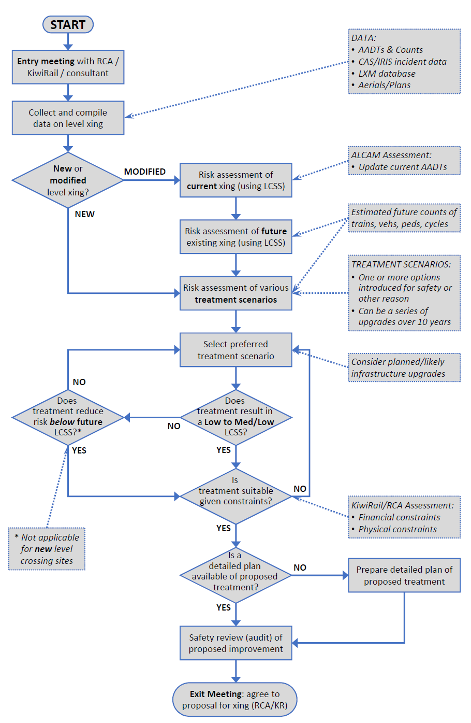
Figure 1: LCSIA Process for new and modified existing level crossings
The LCSIA report provides both the RCA and KiwiRail with an understanding of the road and rail safety risks at the site and what changes should (and could) be made to make the crossing as safe as reasonably practicable.

Risk Assessment Methodology
The elements of the LCSIA methodology include:
- Selecting the appropriate team members to undertake the assessment
- Site visit with a RCA Engineer and KiwiRail representative (locomotive engineer)
- An assessment of current conditions at the level crossing (for existing crossings). A site visit to understand the current site conditions and surrounding road network
- Review of the proposed ‘change in use’ activity to the level crossing, whether they be physical changes or changes in traffic volumes e.g. a new development nearby
- Complete the Site Specific Safety Score (SSSS) Assessment
- Identify and specify any safety issues at the existing crossing (including maintenance issues) and with the proposed design / upgrade
- Calculation of the LCSS for the existing crossing conditions and for the proposed design / upgrade
- Development of a list of improvements / modifications to the proposed design / upgrade. Undertake a LCSS assessment for the modified design
- A recommendation on the necessary changes required at the crossing in order to achieve Criteria 1 or Criteria 2

Selecting a LCSIA Safety Review Team
The Safety Review Team (SRT) consists of at least two people, with at least one of the assessors being KiwiRail LSCIA accredited, and have had no role in the design of the level crossing change. The team members need road safety experience and ideally should be familiar with the ALCAM level crossing risk model, and where valid the design of vehicle level crossings and walking and cycling facilities.

Existing Conditions at the level crossing
A site visit is undertaken for each new or modified level crossing to assess the existing conditions, review proposed changes to the crossing, undertake a safety review and develop a Site Specific Safety Score. If an ALCAM assessment is not available for the crossing (i.e. there is no record in the ALCAM Level Crossing Management (LXM) database) then a separate ALCAM field survey may need to be undertaken and a new ALCAM record produced. There should ideally be a Road Controlling Authority Engineer and a KiwiRail representative who are familiar with the crossing(s) at the site visit. They can raise safety concerns at the site and also provide a risk score out of 5 for each existing and proposed level crossing arrangement.
The following information is compiled for the existing site:
- Location diagram
- Aerial photo of the current site
- Photos of the site showing the current problems and any key points of interest
- Description of the site layout and roads / intersections / paths in close proximity to level crossing
- Description of the level crossing signal system based on the KiwiRail ‘Signalling and Interlocking (S & I)’ diagrams.
- Recent traffic, pedestrian, cyclist and train volumes. Pedestrian and cyclists counts need to be classification by age (e.g. school children) and impairment (e.g. wheel chair user) and note whether users are distracted by a mobile phone etc.

Proposed and Modified Designs at New / Upgraded Level Crossing
The LCSIA should ideally inform the design process and recommend what level and type of control devices that are required to meet Criterion 1 and Criterion 2. In many cases the applicant (i.e. the organisation or development that is increasing road user demands, increasing train demands, or making physical changes to the crossing) provides a proposed upgrade to the crossing. This proposed design is normally assessed as one of the potential upgrade options.
The SRT can also specify any additional protection measures that the applicant should consider to further reduce the risk at the crossing, e.g. automatic gates at a pedestrian shared cycle and pedestrian crossing rather than a maze with flashing lights and bells, where this is needed to achieve Criterion 1 and/or Criterion 2. This is called the modified design.

Components of the Level Crossing Safety Score (LCSS)
The risk of pedestrian and motor vehicle crashes are assessed using the Level Crossing Safety Score (LCSS). The maximum score (60 points) signifies a very unsafe crossing. This score consists of the following components:
- ALCAM Score (30 points),
- Crash and incident history (10 points),
- A site-specific safety score (SSSS) (10 points), and;
- Locomotive and RCA Engineers’ risk assessment (10 points).
Separate assessments are undertaken for the individual vehicle and pedestrian crossings. Based on these scores, the crossing is placed into risk bands as shown in Figure 2, which correspond to a five-level risk description, ranging from HIGH to LOW. The following sections explain how the individual components which make up the overall LCSS are derived. The overall ranking of the crossing is based on the sum of the four components.

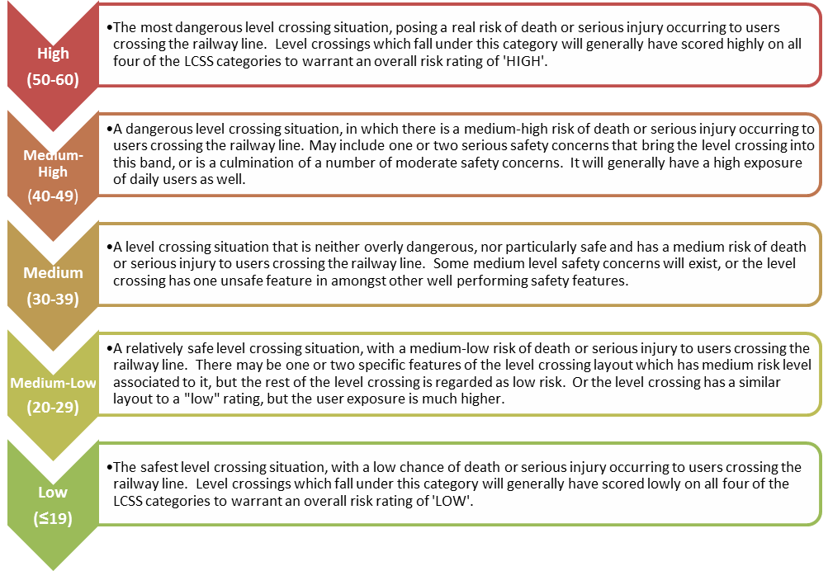
Figure 1: Level crossing safety score risk bands (KiwiRail 2017b)

ALCAM Score (Maximum 30 points)
The ALCAM risk score and risk band come from the LXM database, which includes scores and risk bands for all public and most private level crossings in Australia and New Zealand. The New Zealand jurisdiction scores for all control classes are used in the assessment. There are five ALCAM risk bands and the associated LCSS scores are presented in Table 1. As the ALCAM scoring systems for road and pedestrian crossings are different, there is a separate graduated scoring system for each, which is provided in the Guidelines (KiwiRail, 2017b).
Table 1: ALCAM likelihood risk bands (KiwiRail, 2017b)
ALCAM Jurisdiction Risk Band | LCSS  (points)
High | 25-30
Medium High | 19-24
Medium | 13-18
Medium Low | 7-12
Low | 1-6

The vehicle ALCAM score should be updated using the most recent vehicular, pedestrian, cyclist and train counts. Any site characteristics observed that may have changed since the initial ALCAM assessment was completed, can be used to update the site characteristics as they currently stand in LXM. The updated ALCAM score and risk band should then be used as the new baseline condition (Updated Existing), as all the original assessments were undertaken more than five years ago (as far back as 2008).
ALCAM assessments can be undertaken within LXM (under proposals mode) for the Proposed and Modified designs. In order to check the future risk of the level crossing based on projected user volumes, a fourth ALCAM assessment can be undertaken (changes based on the modified score) by adjusting the road user volume for the applicable ALCAM assessment. If the ALCAM risk score / band is expected to increases, then the SRT can assess higher levels of control in order to reduce the risk to an acceptable level.
Improvements to the physical control type of a level crossing site will generally have a greater impact at reducing the ALCAM risk score than other measures. For a pedestrian crossing these are usually automatic gates (including emergency egress), and flashing lights & bells. As opposed to signage, lighting or adjacent controls (i.e. road adjacent road). For a road crossing this means the installation of half arm barriers.

Crash and Incident History Analysis (Maximum 10 points)
This score is based on the number of crashes in the New Zealand CAS system, and KiwiRAP collective risk score, as well as the number of crashes and incidents reported in the KiwiRail IRIS (crash and incident) database. If the KiwiRAP score is not available in SafetyNET or the urban KiwiRAP websites, the SRT can undertake their own calculation of the collective and personal risk of the preceding five years, otherwise it can be excluded and element scored based on CAS and IRIS data alone. When there is a train vs vehicle / pedestrian fatal crash at the crossing, 10/10 points would be automatically scored for the Crash and Incident history element. The scoring system for this element is shown in Table 2. The IRIS data is most likely to yield more results than CAS (due to capturing incidents not involving a motor vehicle), and therefore will likely be the stronger guide on the score for this category. Further details on how to score each element are found in the LCSIA Guidelines.
Table 2: Crash and incident scoring process (KiwiRail 2017b)
Scenario | IRIS Data | CAS Data | KiwiRAP Data | Total score
Shared path / pedestrian crossing | 100% weighting  (1 - 10 scale) | N/A | N/A | 100% of the IRIS score
Road Score  (when KiwiRAP score is available / calculated) | 50% weighting  (1 - 10 scale) | 25% weighting  (1 - 5 scale) | 25% weighting  (1 - 5 scale) | Sum the totals out of 20 and divide by 2 for score out of 10.
Road score  (when KiwiRAP data is not available) | 67% weighting  (1 - 10 scale) | 33% weighting  (1 - 5 scale) | N/A | Sum the totals out of 15 and divide by 1.5 for a score out of 10

Site-Specific Safety Score (SSSS) (10 points)
This site-based score aims to analyse elements of the layout that are not well covered or missing from the ALCAM risk rating. Scoring systems are available for both urban and peri-urban road and pedestrian crossings (where speed limits are posted at 70 km/h and below) and rural road level crossings (where posted speed limits are > 70 km/h). The factors considered under the SSSS include:
- Evidence of distracted pedestrians and cyclists, which is becoming a more major issue
- Grounding out which can occurs when the crossing is on a hump in the road
- Large flange gaps (gap between rail and asphalt) especially at acute angle crossings
- Proportion of vulnerable users (school children) and cyclists.
It is acknowledged, that there are some subjective ratings required within the SSSS, with some scoring narratives for individual sections enabling different interpretations by different assessors. The reason why some of these were left more open to interpretation was that to use finite numbers, may imply a certain amount of accuracy / certainty that is otherwise not known (when comparing all crossings / situations nationally). Therefore it has been left to the SRT to determine the appropriate score. The SRT should describe the rationale for their risk ratings carefully and what information was used to establish the rating of each element. Further details on the scoring are provided within the Guideline.

Locomotive and RCA Engineers’ Risk Assessment (10 points)
This risk score reflects the level of death and serious injury crash risk that locomotive engineers (train drivers) and RCA engineers give to each railway crossing compared with other crossings they encounter regularly within their jurisdiction. Where possible this relative risk score should be determined by a number of different practitioners involved with the crossing. In the case of locomotive engineers this may be the opinion of several drivers that use each line. In the case of the RCA engineers, they should also consider the experience of the public (including drivers, pedestrians and cyclists), either through surveys or through an interest group representative (e.g. AA for motor vehicles and CAN for cyclists).

General Safety Review
In a similar approach to a safety audit, the LCSIA safety review team are to identify any safety issues at the current crossing, relating to the interaction of level crossing users with the rail infrastructure. The LCSIA safety review is not considered to be a replacement for formal safety audit. The general safety review is to include all safety issues ranging from missing or damaged signs through to concerns with the layout of the level crossing and surrounding road. For example, queues of vehicles waiting to turn right into a major access or side-road that extend across the level crossing may not have been identified through the ALCAM site inspection process, but have significant safety implications on the crossing.
All significant safety issues identified by the SRT during the site visit, must be specified in the LCSIA report. Significant issues include vegetation blocking view lines, poor level crossing surfacing, large flange gaps, incorrect or missing signage, etc. The applicant is required to pass on all such comments to the safety audit team. Any maintenance issues should be communicated to KiwiRail or the relevant RCA.
summary of lcsia undertaken to date and lesson learnt
Over the first 18 months of the new process (June 2016 to end of 2017),as the process was evolving, LCSIAs where completed at 31 road level crossings and 50 pedestrian/shared paths. The sites varied from rural to busy urban areas. Each assessment was unique with varying characteristics and scores. This section discusses some of the key lessons learnt from undertaking the assessments.
A key element of the assessment is the ALCAM score. An analysis undertaken for KiwiRail of over 30 level crossings in Christchurch and Wellington identified a number of faults with the New Zealand ALCAM data. So a first step in any LCSIA is to check the ALCAM data and correct it where possible, to produce a ‘updated existing’ ALCAM score. An extra benefit of the LCSIA process is that it will improve the quality of the ALCAM data-base (LXM) over time. KiwiRail have also taken other steps to improve the quality of the ALCAM data and to keep it up-to-date.
The ALCAM score were also not available for all crossings, especially pedestrian crossings in peri-urban areas, even where pedestrians were already crossing the tracks. In such situations an ALCAM survey has to be undertaken. The collection of ALCAM data often created delays due to the limited number of ALCAM certified practioners. Recently this has been addressed by increasing the pool of ALCAM surveyors through new training courses.
An analysis of pedestrian data at level crossings in the ALCAM LXM database showed that counts appear to only be available in Auckland. Everywhere else in the country the default count of 100 pedestrians and cyclists per day has been used. Even in Auckland the counts were estimated using short duration (peak periods) counts and many were out of date, i.e. four or more years old. Hence at most pedestrian crossings there is a requirement to collect pedestrian and cycle count data. In addition to the counts themselves other important information like the proportion of school children and disabled is collected. This additional information is used in the development of an ALCAM scores for each crossing. The preferred data collection approach recommended is at least one full day count (7am to 6pm) collected from video. Ideally traffic count data should also be updated when doing a LCSIA.
Having a video of each crossing allows the assessor to also look at the behaviour of pedestrians and pick-up any distraction issues such as pedestrians using their cellphones or cyclists with headphones, which is a factor considered in the wider LCSIA. KiwiRail also have a count program that is collecting additional pedestrian and cycle count data at sites where it is suspected that there are greater than 100 per day, to help prioritise sites for treatment nationally and fill this gap in the ALCAM data.
In situations where there is a parallel or crossing cycleway, it is important to understand the origin and destination or desired line of the pedestrians and cyclist crossing the level crossing, to understand the risks at each site. For example if there is a strong diagonal movement across the crossing then cyclists or pedestrians may choose to cross the railway line at an angle rather than at the correct closing place. This information should be obtained at the same time as pedestrian volumes data is being collected.
As already highlighted some of the existing data in ALCAM requires updating. Information that needs updating often includes pedestrian volumes, train speeds, train numbers, vehicle AADT, passenger numbers, and carriage numbers. Train speeds in particular have a large impact on the ALCAM score and are often inaccurate in ALCAM. In some places temporary speed changes are in effect due to the need for track maintenance. However in ALCAM the standard train speeds should be used as this reflects the ongoing risk at the crossing. As part of updating the ALCAM data we recommend that assessors discuss this with KiwiRail.
Rural road level crossings require an understanding of the road users, especially heavy vehicle types (logging/dairy) and the nearby activity. For example nearby side roads that attract a lot of heavy vehicles could result in queuing at or over the level crossing. It is also important to consider the high-speed environment and horizontal and vertical alignments of crossings. For example, a loss of control vehicle on a crossing approach curved could potentially taking out the barrier arm components.
In urban areas it is important to be aware of nearby railway stations and shunting activities that can increase risk especially of a second train coming when there are two or more tracks. Second train coming can be an issue were one train, potentially at nearby stations or in shunting yards, triggers the crossing bells, lights and barriers, and a pedestrian attempts to cross but does not see the second train approaching the crossing. KiwiRail is looking at visual and verbal warnings to alert pedestrians and motorists to another train approaching.
Our experience with developing improvement options for level crossings involving footpaths, cycle-ways and shared paths is that it can be challenging to fit in the necessary infrastructure. In some places mazes and automatic gates can-not be easily be fitted in within the road and rail designations and land purchase is required. Consideration also needs to be given to stacking room for the maze or automatic gates at busy cycleways. This was a key issue at one of the crossings assessed due to a nearby side-road. There are also benefits at cycleways of having automatic gates rather than mazes as during normal operation the cyclists can travel straight through the crossing when there are automatic gates while at mazes they have to wind around the alignment at all times, even when the mazes are larger to accommodate cyclists.
Difficulties can also occur when a vehicle and pedestrian/cycle crossing have different levels of control. The most common being where the vehicle crossing has a barrier and the pedestrian crossing does not. In several situations the cyclists are required to use the vehicle crossing but we know that they may choose to use an uncontrolled footpath to avoid the barrier when they believe they can bet the train. This is particularly common where the desire-line is to cross at the pedestrians crossing on the opposite side of the road to where the cyclists would normal cross to link-up with a sideroad.
Another situation where this imbalance may occur is on rural cycleways, where there is an adjoining local road that has not barrier control while the cycleway has a maze or automatic gates. In these situations it is important that the is a fenced off track for cyclists leading into the crossing, so that cyclists don’t just bypass the maze or automatic gates by using the vehicle (roadway) crossing.
The general safety assessor side of LCSIA is also important for picking up unique situations at crossings noting that as a model ALCAM can-not pick up all faults. For example, there are a number of driveways near urban level crossings where drivers can exit onto the level crossing on the track side of the barrier arms. In such circumstances it can also be hard for the driver to see the flashing lights, and hence the only warning they get is the bells, which they may or may-not hear depending on whether there is other noise in the vehicle. Ideally in these situations drivers should be banned from turning onto the crossing, through a turning ban, or alternatively a set of flashing lights should face the exiting driver. While these matters may not always impact on the ALCAM score they should never-the-less be addressed during and LCSIA assessment and follow up in the safety audit.
FINAL REMARKS/SUMMARY
The new LCSIA process is leading to a step change in managing the safety of level crossings. It is doing this in a number of ways. Firstly it brings together not only the ALCAM risk scores but also incident and crash data from the site along with the safety opinions of the locomotive and RCA engineers. The locomotive and RCA engineers having the own experience of using the crossing and also having access to the public and other engineers views on the safety of the crossing. It also adds a more detailed review of a number of the roadway and pedestrians/cyclist related impacts of the crossing, beyond that provided in ALCAM. Specifically looking at network impacts like traffic queuing across the line and observations of pedestrian distraction.
The LCSIA process also looks at broader safety issues that might impact on the crossing, such as marking and signage condition. The opinions of the locomotive and RCA engineers in identifying these issues is important, as they have a better understanding of how the crossing operates. A key reason for doing this assessment is to capture key issues that need to be considered as part of the safety audit process.
The LCSIA process also provides an opportunity to review and update the ALCAM data for each crossing, which in many cases may now be out-of-date. Of particular importance in the assessments is the pedestrian, cyclist and motor-vehicle counts that change over-time, but that are very important in ranking the risk of the crossing.
One area that is going to receive further attention by KiwiRail in the short to medium term are details around the trains using each line, including numbers of trains per day, length of trains and train speeds. The data for many railway lines is out-of-date, and needs to be updated. When undergoing an LCSIA pay careful attention to this information and seek to update where necessary directly from KiwiRail.
‘Second train coming’ is a key issue at level crossings with two or more tracks, and especially on metro lines where train numbers are high. This issue occurs when two or more trains cross the level crossing on a single closure period, i.e. where the bells, flashing lights and barriers are activated. In many places the pedestrians and cyclists are not controlled by a barrier and may choose to cross after the first train has gone through the crossing (or when a train is waiting at a station or part of a shunting movement), and the concern is they will not see the second train that is approaching. This illegal movement may in part be due to the frustration resulting from the FLBs and barriers being applied for long periods in peak periods on metro lines. In such circumstances the use of second train coming signage and verbal warnings should be recommended.
Careful attention needs to be paid to the design of new pedestrian crossings and especially crossing of shared use paths (pedestrians and cyclists). First it can be difficult in some places to design mazes and automatic gates while keeping the crossing as close to 90 degrees as possible. When making design compromises it is important to consult the design guidance around pedestrians and cyclists at level crossings provided in KiwiRail (2017a). It is also important to make illegal movements (such as diagonal crossings and footpath riding) across the level crossing difficult through use of planting, fencing, traffic islands and hoops. This is particularly important where the shortcut movement is a lot quicker than the correct crossing movement.
REFERENCES
KiwiRail (2017a). Rail Crossing Pedestrian/Cycle Design Guidance, Interim Version 2, May 2017 http://www.kiwirail.co.nz/uploads/Publications/RailXing-PedBikeXingDesign-RevisedGuide.pdf
KiwiRail (2017b). Level Crossing Risk Assessment (LCSIA), Interim Version 2, July 2017. http://www.kiwirail.co.nz/uploads/Publications/LevelCrossingRiskAssessmentGuide.pdf

