TRANSPORTATION 2024 CONFERENCE

LADIES MILE, QUEENSTOWN-STEP CHANGE IN GROWTH MANAGEMENT

(This paper has been peer reviewed)

Abstract
Queenstown like many high growth areas in New Zealand, is facing growing pains. Queenstown Lakes District Council (QLDC) came to the realisation that business as usual is not an option in the face of growing congestion, unaffordable housing and a low carbon future. Te Pūtahi Ladies Mile (TPLM) is on a high-profile greenfield corridor under pressure for development and sits adjacent to traditional car oriented low-density suburban housing areas developed over the past 25 years. It also forms an important gateway into Queenstown and is identified as a Priority Development Area in the Queenstown Lakes Spatial Plan 2021.
Rather than react in an ad hoc way to piecemeal car-oriented development, QLDC commenced a comprehensive masterplan “to set out a plan for the Ladies Mile area with the community at the centre of all thinking. The aim is to see Ladies Mile developed in a way that improves community outcomes. By integrating transport, community infrastructure, placemaking and design QLDC hopes to make Ladies Mile the most liveable area in Queenstown.”
In this presentation you will hear from those involved in shaping this integrated masterplan (which includes for 2,400 dwellings, schools, commercial and recreational facilities) including the challenges to create a step change to a higher density, mixed use, public transport-oriented corridor that creates a liveable community for not only the future residents and visitors to TPLM but connects with, and improve the liveability, of the existing communities in this corridor.
Following consultation and Council approval of the TPLM masterplan, you will also hear the work undertaken to implement the masterplan through a Plan Change Variation streamlined planning process and the subsequent Hearing and Commissioners recommendation report.
Finally, the next stages to commence work to deliver the TPLM is set out.
Author/Presenter
- Colin Shields, MSc (Transport Engineering), CPEng, CMEngNZ, IntPE(NZ), APEC, Senior Principal Transport Planner at Tonkin and Taylor, CShields@tonkintaylor.co.nz.
Co Authors
- Liz Simpson MREP, ANZIS, NZPI, Senior Strategic Planner Queenstown Lakes District Council, liz.simpson@QLDC.govt.nz.
- Jeff Brown MRRP, BSc, Director Brown and Co, jeff@brownandcompany.co.nz.
- Bruce Harland BTP, MUrbDes (Hons), Candor3, bruce.harland@candor3.co.nz.
- Michael Lowe MArch (Prof). Principal Urbanist at Studio Pacific Architecture, michaellowe@studiopacific.co.nz.
- Stuart Dun BLA (hons), Registered NZILA Landscape Architect. Principal Landscape Architect at Studio Pacific Architecture, stuartdun@studiopacific.co.nz.

Author Contribution Statement
Liz Simpson of QLDC was the client manager, Bruce Harland was the consultant team Project Director, Colin Shields was the transport lead, Jeff Brown was the planning lead, Stuart Dun the landscape lead and Michael Lowe the urban lead.
- TPLM overview and objectives

1.1 Background to Te Pūtahi Ladies Mile (TPLM)
TPLM is an area of key strategic importance for Queenstown (Tāhuna) and the wider lakes district. The Queenstown Lakes area is one of the fastest growing districts in NZ and this growing population puts pressure on land identified with development potential, such as the largely hazard free, flat and sunny TPLM. The TPLM site is located adjacent to SH6 (Ladies Mile), to the east of the Shotover River and to the north of the existing settlements of Shotover Country and Lake Hayes Estate, as shown in Figure 1 below:
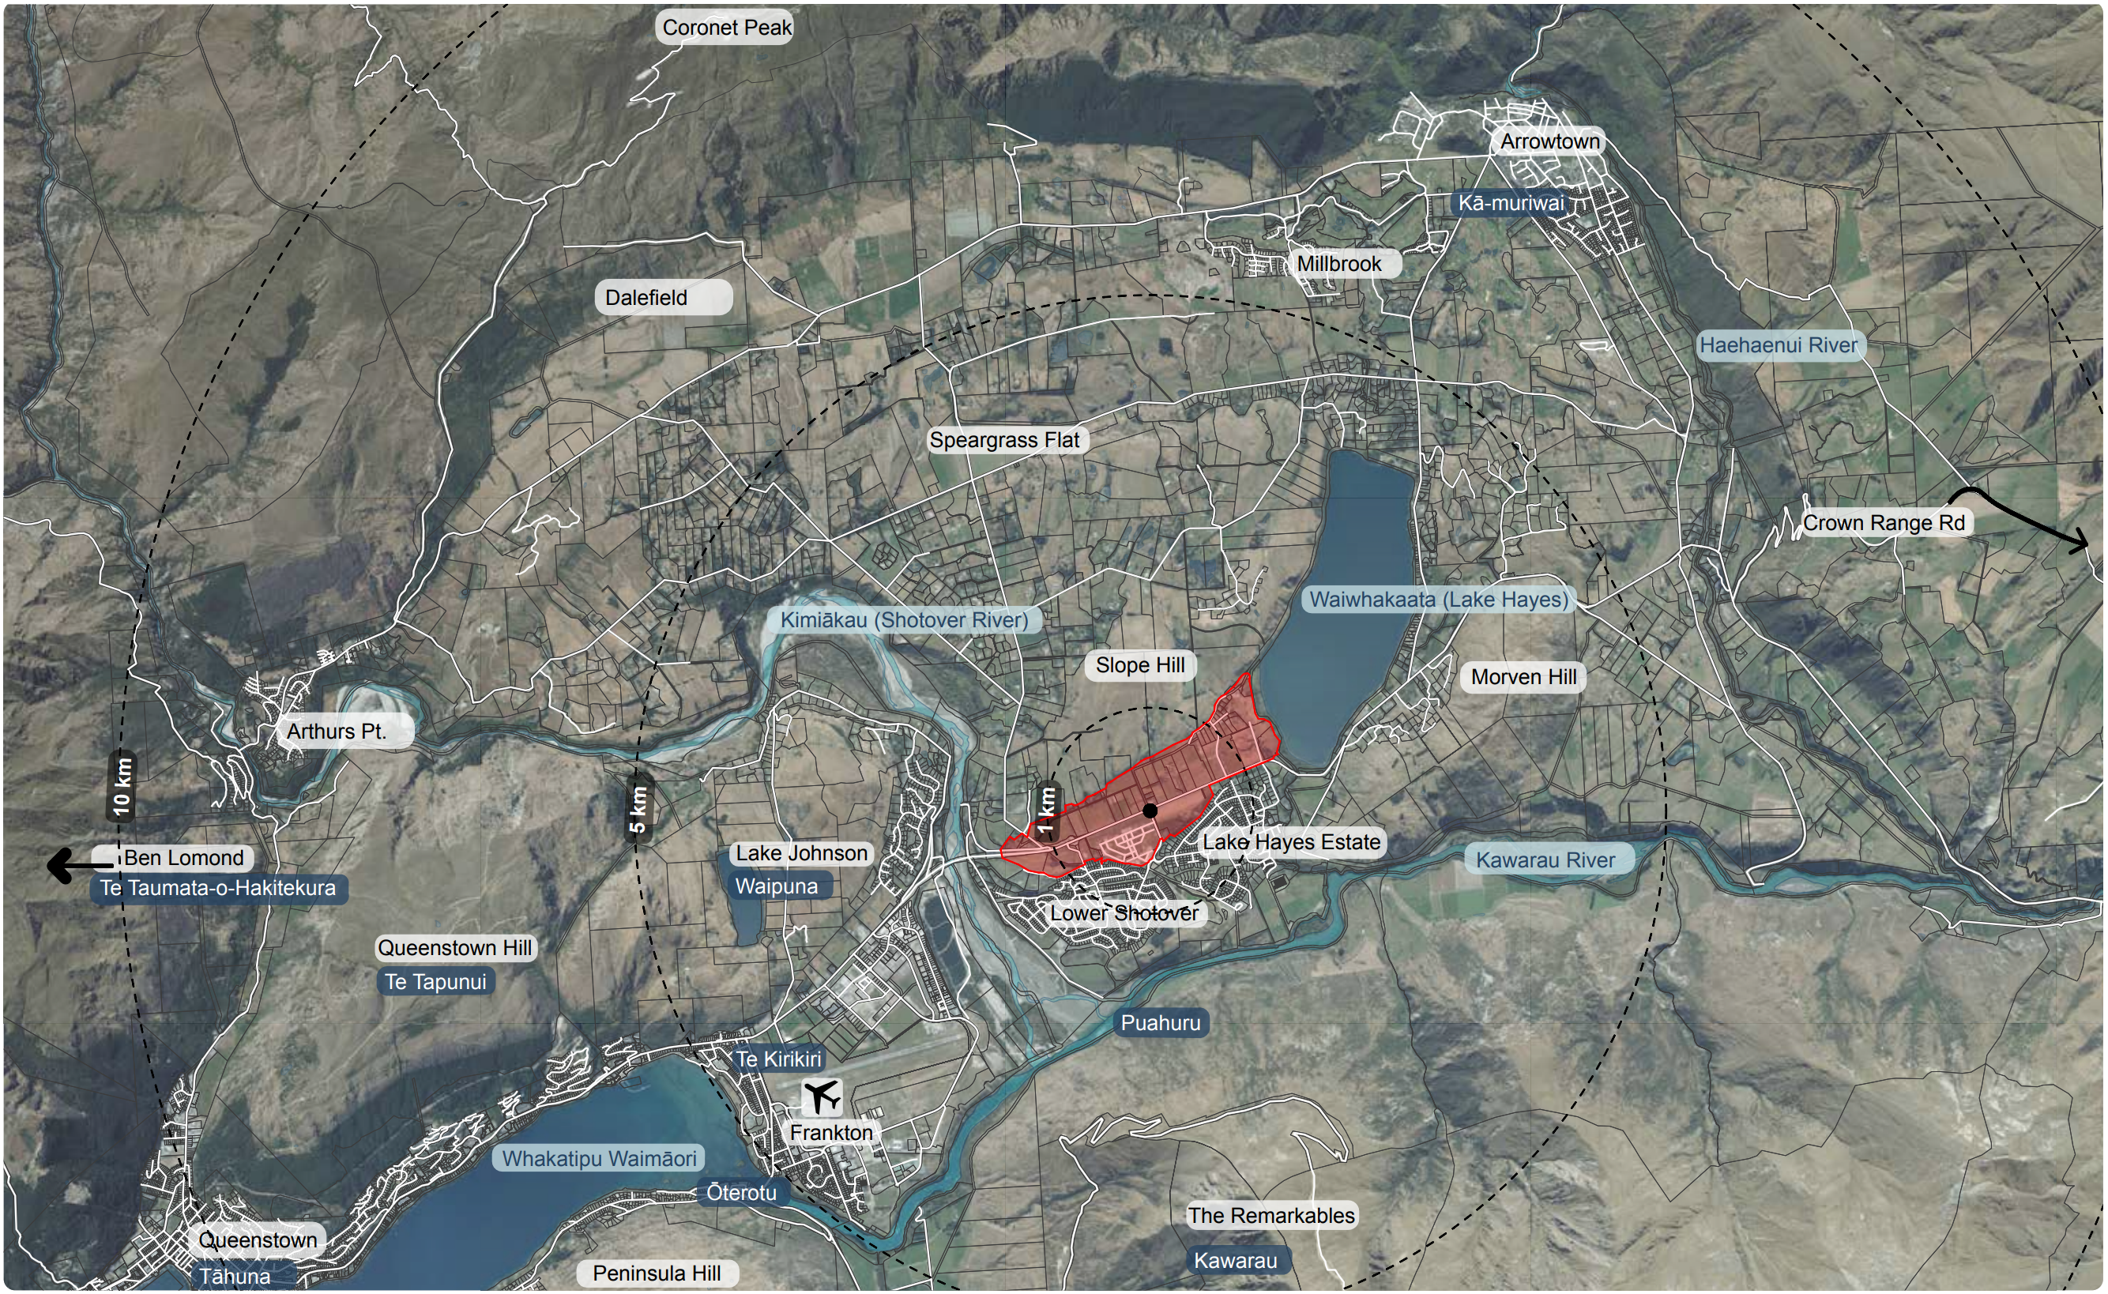
Figure 1 Location Plan

TPLM is on a high-profile greenfield corridor, under pressure for development and sits adjacent to traditional car oriented low-density suburban housing areas developed over the past 25 years. It also forms an important gateway into Queenstown and is identified as a Priority Development Area in the Queenstown Lakes Spatial Plan 2021.

Rather than react in an ad hoc way to piecemeal car-oriented development, Queenstown Lakes District Council (QLDC) commenced a comprehensive masterplan “to set out a plan for the Ladies Mile area with the community at the centre of all thinking. The aim is to see Ladies Mile developed in a way that improves community outcomes. By integrating transport, community infrastructure, placemaking and design QLDC hopes to make Ladies Mile the most liveable area in Queenstown.”

1.2 Challenges
Key challenges included that the area is a high growth area with limited growth options, lack of housing choices, lack of affordable housing and constrained landscapes which further limit growth opportunities. In addition, ensuring that medium to high density typologies would eventuate in difficult short-term market economic conditions was also seen as a challenge. There is peak period congestion particularly on the SH6 and SH6A corridors compounded by car centric suburbs. Transport modelling carried out by Way To Go (a partnership of NZTA, QLDC and Otago Regional Council (ORC) suggested that 40% of all trips between Frankton and the Queenstown Town Centre at peak times will need to be on alternative modes to private vehicles by 2028 and 60% by 2048 if the high levels of congestion and major delays are to be avoided. Finally, there are development pressures from major landowners at TPLM who signalled their intent to develop their land through submission of various resource consent applications.
Given growing congestion, unaffordable housing and a low carbon future, QLDC came to the realisation that business as usual is not an option.

1.3 Relevant Planning Policies
There are several relevant planning policies, with the key document being The Grow Well Whaiora Partnership for Queenstown Lakes, which is an Urban Growth Partnership between Central Government, Kāi Tahu, ORC and QLDC. The partnership provides a forum to align decision-making and collaboration on the long-term direction for the district. It acknowledges that the Queenstown Lakes District is facing growth-related challenges across housing, transport and the environment that may have flow-on effects nationally given the importance of the area to New Zealand’s tourism sector.
The partnership prepared and adopted the Queenstown Lakes Spatial Plan that sets the strategic direction for the district’s growth and development for the next 30 years. Promoting a consolidated and mixed-use approach to accommodating growth in the district, with future growth focusing on locations with good access to facilities, jobs and public transport. Development within these areas will require enabling of higher densities, enabling a greater mix of uses within existing urban areas and efficiently developing new urban areas that are serviced by public transport.
As shown in Figure 2 below, the Spatial Plan identified Te Pūtahi Ladies Mile (Eastern Corridor) as one of the Wakatipu’s future urban and priority development areas. As a priority development area, Te Pūtahi Ladies Mile was identified as a new transit-oriented neighbourhood offering new housing choices that would require working in partnership to deliver a public transport solution to unlock the potential of this site.
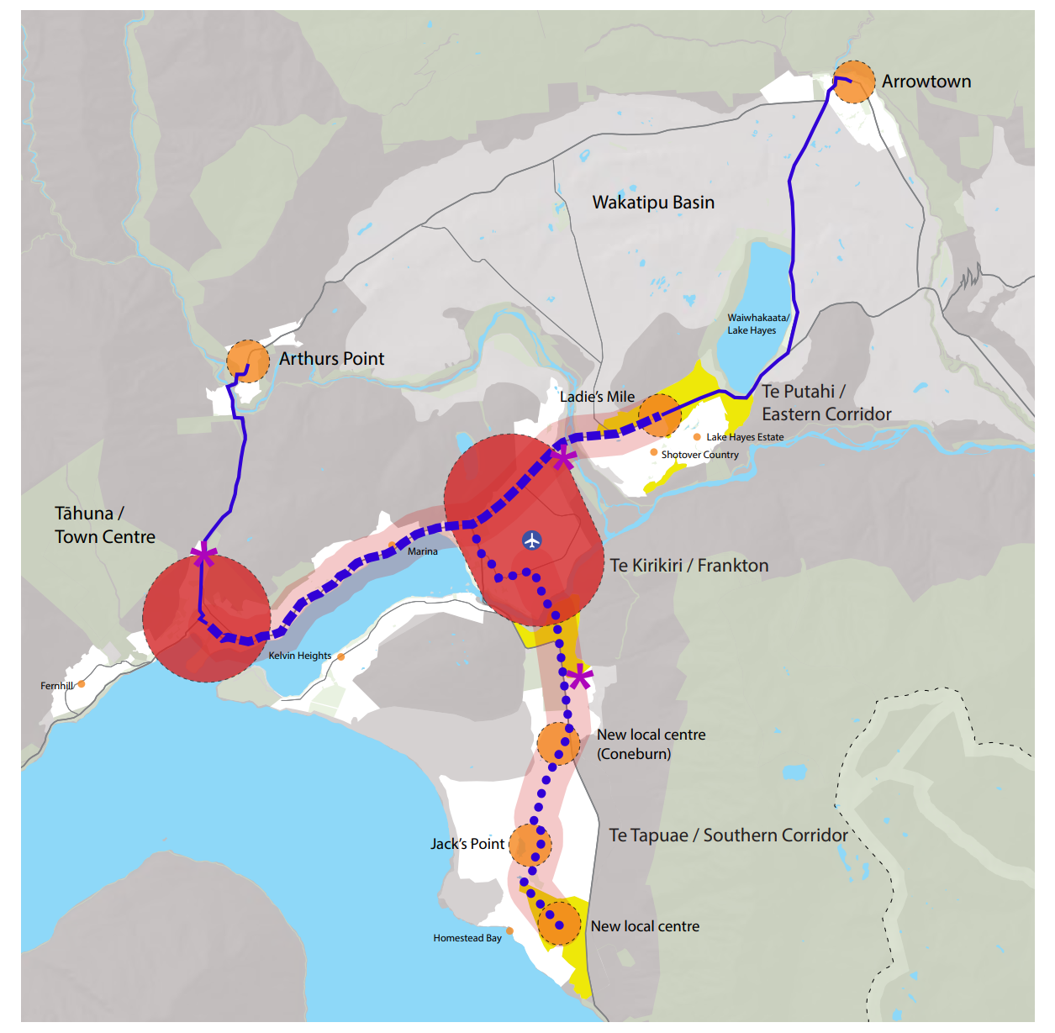
Figure 2 Grow Well Whaiora future urban and priority development areas.

1.4 Objectives
The Masterplan brief was to look at how TPLM will grow over the next 30 years and beyond, and how the Council will ensure it grows in a way that provides the community at the centre of all thinking. The aim was to see TPLM develop in a way that improved community outcomes, delivered improved transport solutions and offered a wide range of housing choices to current and future residents.
To align with the QLDC Spatial Plan strategies in areas of housing and transport choices, the TPLM Spatial Framework Principles and Key Moves was developed as an integral part of informing the final masterplan and planning provisions. The guiding design principles and key moves are summarised in Table 1 below:

Design Principles | Key Moves
Consider SH6 as a gateway to Queenstown | - SH6 is valued and considered in its role in the arrival experience into Queenstown.
Reflect a unique and enduring identity | - Maintain key views to Lake Hayes, Slope Hill and the Remarkables.  - Celebrate built and landscape heritage.
Support a healthy environment and ecology | - Establish a strong holistic landscape framework.  - Water is managed through an integrated stormwater management plan that gives effect to Te Mana o te Wai.  - Maintain ecological value of Lake Hayes wetland edge and improve connections between the lake and river.  - Support kaitiakitanga of the environment and connections to nature
Create self-sustained and connected communities | - Walkable liveable neighbourhoods with a breadth of amenity that services both existing and new neighbourhood needs including: a community and commercial heart, recreation and parks, schools, and transport options that provide new multi-modal networks through the site and integrated to the surrounding suburbs.
Enable sustainable transport networks | - Promote a step change by prioritising public transport and active mode share.  - Ensure quality and pedestrian cycle networks within Te Pūtahi and connections to trails beyond.  - Design attractive streets for people that play an active role in urban life.  - Support mode shift away from car use within the adjacent communities through improved public transport and active mode links to the new community facilities at TPLM.
Do density well, provide quality and diverse housing | - Offer a choice of lifestyles through a range of quality housing typologies, sizes and affordability.  - Establish medium/high density living to support public transport, commercial activity and community facilities.
Develop a resilient and adaptable framework | - Set out a legible and clear structure to mitigate sporadic development.  - Identify an appropriate development response that is sympathetic to the local context.
Table 1 Guiding design principles and key moves
- Work carried out

2.1 Masterplan
The TPLM Masterplan was created over a three-year period between 2020-23 and was adopted by QLDC. The Masterplan was informed by extensive community and stakeholder engagement through open days, community meetings and sessions with affected landowners and parties, which was fundamental to outcomes of the masterplan. Throughout the design process, seven Design Principles and Key Moves emerged to steer the direction of the masterplan. These translated into the proposed masterplan that included a multitude of facets which deliver on the aspiration for a well-designed neighbourhood. This neighbourhood provides for everyday needs and promotes a strong sense of place and identity and supports a healthy environment and ecology by responding to the unique attributes of the site.
Key aspects of the masterplan include
- Walkable mixed-use neighbourhood catchment. The masterplan has been laid out in a way that prioritises people’s access to a range of everyday needs. Most of the site is within a 1 km walking distance of the centrally located town centre commercial hub, schools and within 500 m of high-frequency public transport. The plan incorporates a variety of open spaces including two neighbourhood parks, a community park and a large-scale sports hub. The plan enables up to 2,400 medium and high-density dwellings and will deliver the required population threshold to help achieve the proposed public transport service provision and viability of new amenities. This is critical to achieving the mode-shift targets. TPLM provides the much-needed amenity and transport connectivity to support surrounding existing low-density suburban neighbourhoods.
- High-quality multi-modal transport – As shown in Figure 3, the masterplan utilises a network and hierarchy of internal streets with high quality separated walking and cycleways that connect to key amenities, including bus stops that provide connections to high frequency public transport services.
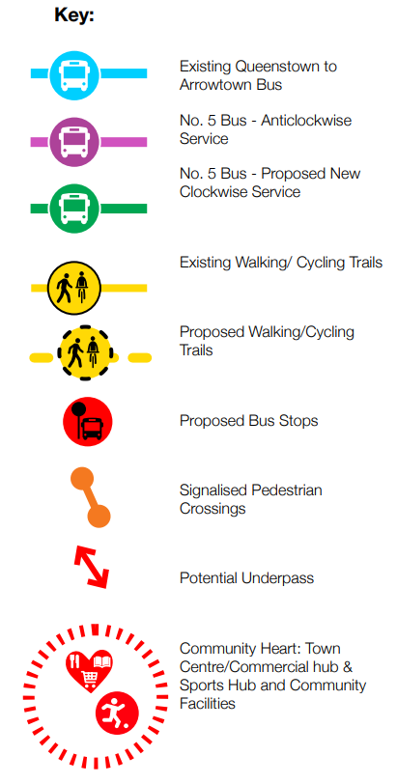
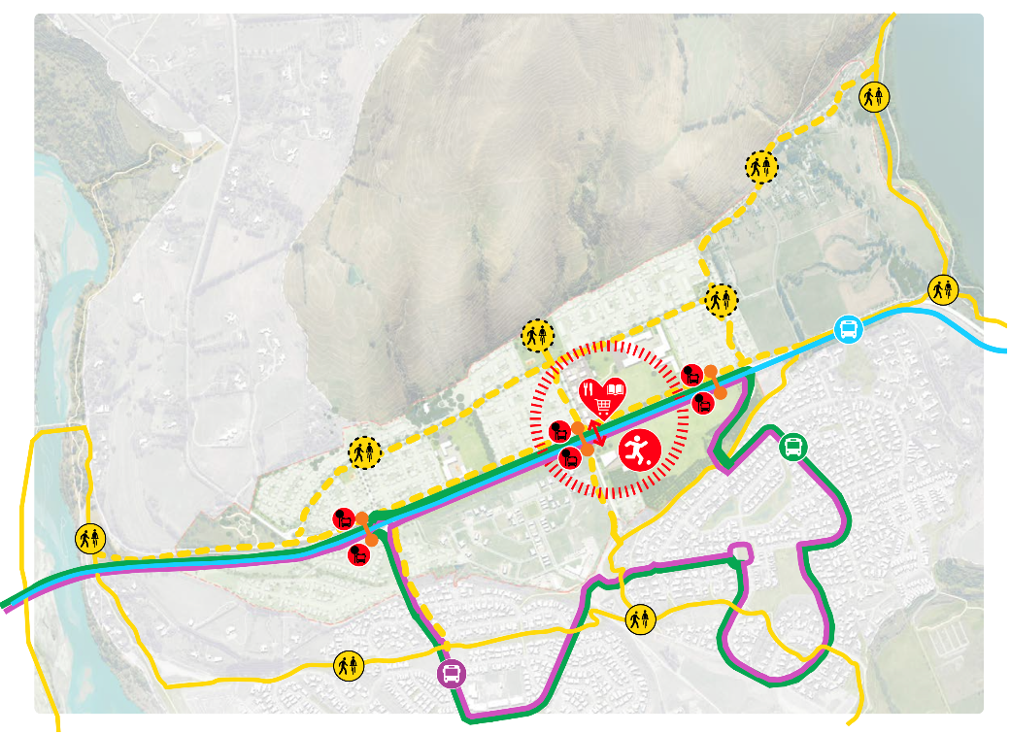
Figure 3 TPLM masterplan Transport Strategy

- Responds to sense of place and environment - As shown in Figure 4 below, building heights are shaped to respond to aspects and views. The integrated stormwater management plan and open spaces create long views to valued landscape outlooks.

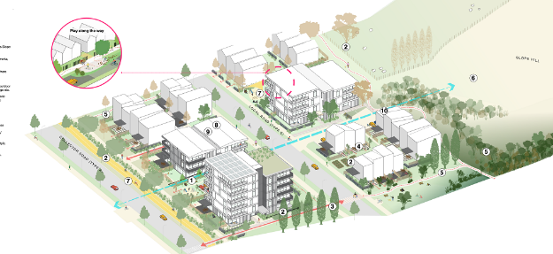
Figure 4 Building heights
- Place-responsive landscaped transport corridor for SH6 (the major transport connection) that celebrates the urban morphology gateway aspect of a highly visible rural environment densifying as approaching Queenstown from the east. As shown in Figure 5, the Masterplan responds to the unique landscape environment by controlling development heights to maintain important views to the surrounding mountains.

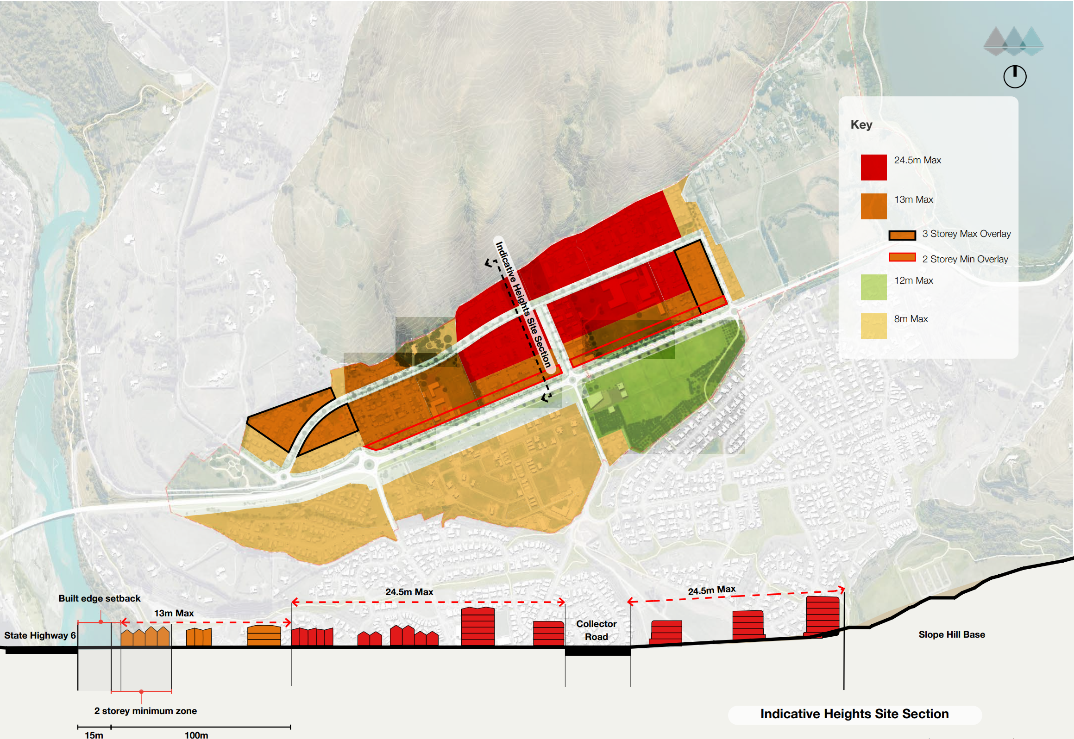
Figure 4 TPLM Masterplan development heights

- Efficient land use – As shown in Figure 5, the Masterplan ensures consolidated growth with a long-term approach to density which does not enable a proliferation of more single lot, car orientated stand-alone housing. Minimum density standards of 40 dwellings/ha and walkable neighbourhoods provide a critical population mass that will support public transport and social infrastructure.
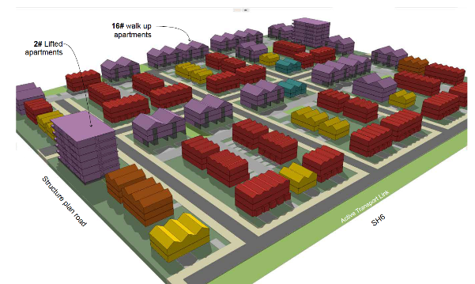
Figure 5 Masterplan residential massing

- Bespoke plan change provisions. Bespoke provisions for well-landscaped and quality urban design of buildings, landscape, and public spaces raise the bar on historical planning controls yet balances developer flexibility with urban design quality controls of built outcomes. They also provide a planning pathway that ensures a consolidated development approach to design and Council consenting. For example, the provisions favour utilisation of shared amenity such as communal parking, open spaces and efficient site planning that use larger site landholdings and avoid single lot subdivision.

2.2 Plan Change notification
The Plan Change through, the Streamlined Planning Process (SPP) was notified in April 2023. Key aspects of the Plan Change included:
- New Te Pūtahi Ladies Mile Zone – includes a Structure Plan informed by the Masterplan. Several precincts within the proposed new Te Pūtahi Ladies Mile Zone were also introduced including a Commercial precinct, low, medium and high-density precincts and an open space precinct.
- Minimum residential densities of 40 dwellings/ha and 60 dwellings/ha to be achieved in the medium and high-density residential precincts respectively (otherwise non-complying).
- Significant building bulk, including six level buildings allowed in the high-density precinct.
- Most development requires resource consent (including design assessment) to ensure that quality-built form and environmental outcomes are achieved.
- Maximum limits on car parking.
- Triggers for transport infrastructure (e.g. bus stops, active mode links, bus lanes and active mode crossings of SH6) which must be in place before development occupation. This infrastructure is necessary to ensure that the mode shift away from private vehicles (as discussed in 3.3 below) is achieved from day one.
- Structure Plan requires key spatial elements to be followed across multiple landownerships (e.g. public transport infrastructure, walking and cycle connections and open space). This not only provides certainty to all landowners, but is crucial to achieving the coherent integrated urban development and transport outcomes anticipated in this important growth corridor.

2.3 Plan Change amendments
A Council Hearing into the Plan Change was held in December 2023. The draft Panel recommendation to the Minister for approval was issued for comment in March 2024, with a final Panel recommendation to be submitted to the Minister for the Environment by June 2024. Critically, the Panel have not made changes to the fundamentals of the Masterplan.
Changes to the Plan provisions though were made by the Panel and the most significant changes the Panel made to the Council’s version of the provisions were:
- The reduction of the density minima for the medium and high-density residential precincts to 40 units/ha (net) in each precinct, with no maximum density. The high densities proposed were considered to be difficult to achieve in the current market.
- The addition of a significant extension to the TPLM Zone at its western end, to add potential capacity for additional residential units.
- The addition of a new standard that only applies after 1,100 residential units are already established in the Zone, requiring assessment of the traffic effects arising from further residential development if a high school is not yet established or is not likely to be established in the Zone.
- Removal of maximum residential car parking standards with the Panel of the view that not limiting residential parking would undermine that future passenger transport investment.

3 Key learnings and best practice

3.1 Partnership Approach
The Grow Well Whaiora Partnership Governance Group recognised there was an opportunity to accelerate the delivery of the Masterplan, which would require a carefully planned, co-ordinated and sustained approach across the Grow Well Whaiora partners. It was acknowledged that a “business as usual” approach would not achieve the strategic direction of the Spatial Plan or the Te Pūtahi Ladies Mile Masterplan. As a result, the Te Pūtahi Ladies Mile Taskforce (QLDC/Ministry of Housing and Urban Development/Kāinga Ora/NZTA/ORC) was established to help implement the Masterplan, acknowledging that each of the Grow Well Whaiora partners had a role to play in its successful implementation.
The Te Pūtahi Ladies Mile taskforce have the following core tasks; supporting the delivery of the preferred planning outcome, updated schedule of key inputs, explore barriers and advise on possible solutions (e.g., transport interventions, infrastructure funding (including social)), delivery of affordable housing and what other tools can be explored.
Landowners are a key component to TPLM, and delivery of the masterplan and they were consulted early, and throughout the development of the masterplan, including one-on-one meetings. Working with multiple landowners poses several challenges as they may not all be on the same page at the same time, but through the process of a comprehensive masterplan exercise there becomes a realisation that the whole is greater than the sum of the parts. The adoption of the masterplan (and ultimately the plan change) provides considerable certainty to all landowners in terms of their future planning and decision making.
Iwi were involved initially as part of the QLDC Spatial Plan partnership and selection of TPLM site as Priority Development Area and then throughout the Masterplan development, for example through development of an integrated stormwater solution.

3.2 Infrastructure funding
Funding is an essential component of being able to implement the Masterplan, there is essential infrastructure that is required to service the new Te Pūtahi Ladies Mile Zone which includes water and wastewater trunk infrastructure, stormwater management areas and several transport related interventions.
Whilst the Masterplan process was about ensuring that land use supported the move to public transport and reduce car dependency, the Masterplan highlighted the benefit of what can be achieved through strategic planning, but there is still a need to undertake the relevant funding, planning and business case processes with the relevant agencies.
Funding will be a combination of Crown (e.g. Queenstown Transport Package), as well as developer and QLDC/ORC funding, which will require Council and the developers to work together on resolving infrastructure funding especially given the competing demands of the district regarding three waters funding and the current QLDC debt ceilings. As a result, the Te Pūtahi Ladies Mile taskforce is exploring possible solutions such as a City Deals approach (which are long-term agreements between different levels of government about deciding, delivering and funding economic development and infrastructure initiatives within a defined local area), alongside developer agreements to be able to deliver on the necessary solutions.

3.3 Mode Choice and Transport connectivity
The overall vision for the Masterplan Transport Strategy for TPLM was to create an accessible, healthy, safe and sustainable TPLM community by reducing reliance on car use, by providing a well-connected street network to local community facilities and investment in active and public transport modes so that walking, cycling and bus use were everyone’s first travel choice. To achieve this, the demand to use public transport and active modes must be met by the provision of PT services and active mode links from day one of occupation of the site. Mode choice for the masterplan residents and visitors and mode shift at the adjacent communities is essential to the success of the masterplan.
To implement this vision, the transport interventions identified within the Masterplan Transport Strategy were included in the TPLM Plan Variation provisions along with appropriate triggers for implementation. These triggers related to transport works including internal street and SH6 cross section provisions (with active mode links and crossings, bus lanes and bus stops), minimum cycle parking and end of trip facilities and access to TPLM provided via upgrades to two intersections to traffic signals and one new roundabout. By linking the provision of these transport interventions to triggers relating to first occupation of development, ensured that the necessary PT and active mode infrastructure was in place from day one.
Outside of the developer’s control though are the Plan Change transport interventions which require investment by the Way To Go partners including wider network bus lane and active mode improvements and speed limit changes. Furthermore, enhanced bus services will need to be funded and provided by ORC.
One transport demand management measure included in the draft Plan Change provisions related to maximum car parking standards. However, Submitters at the Hearing questioned the need for these and the Commission Panel removed these from the Plan provisions.
Key to the masterplan was not only considering connectivity within the masterplan area but also provide key community facilities and active and PT mode connectivity with the adjacent Shotover Country and Lake Hayes Estate communities as shown in Figure 6 below. Currently these are car dominated communities, with low bus use and no bus priority measures and the location of the majority of key community facilities requires residents to drive west over the Shotover Bridge to Frankton. This increases overall congestion and car dependency.
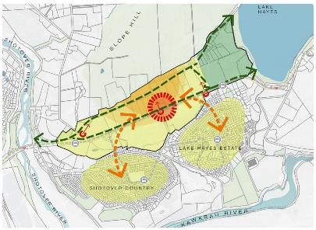
Figure 6 Connectivity with adjacent communities

3.4 Planning process to implement the masterplan
The Streamlined Planning Process (SPP) is available to local authorities as a means for speeding up a plan change process and to avoid procedural delays, particularly from litigation. This can and often arises from the normal plan change processes available under the RMA. The SPP process imposes strict procedural timeframes and does not include an appeal phase (other than judicial review on matters of law). This is balanced by requiring the Council to undertake meaningful consultation with all stakeholders prior to formal lodgement of the SPP application, in addition to notification for submissions, further submissions and a hearing.
In the TPLM case the Council “front-loaded” the community consultation as it formulated the masterplan and TPLM plan provisions, over a period of two years. The formal SPP process itself, from lodgement to the Minister to final recommendation from the independent Hearings Panel, took 20 months. This is a significant reduction in the formal process time compared to the RMA first schedule processes, which can often take more than 5 years to complete. This procedural streamlining has allowed the Council and the community and other stakeholders to benefit sooner from the TPLM provisions. The provisions will (along with parallel initiatives) facilitate significant changes to the transport network through roading upgrades and active and public transport mode infrastructure, which are required to precede the much-needed housing and other urban development to accommodate Queenstown’s rapid growth.
The SPP process, and the Council’s initiative in unlocking the TPLM land holistically through the masterplan and SPP, has avoided what would otherwise have been ad hoc, piecemeal development without a focus on ensuring that transport infrastructure planning is undertaken holistically and strongly aligned with urban expansion.

3.5 Next stages
The next stages of work include continuing to work with the TPLM Partners such as the Way To Go and Grow Well Whaiora Partners to enable development to proceed through infrastructure funding and also to continue to work closely with the landowners and developers to facilitate smooth integration and implementation of development within TPLM.

4 Conclusions and recommendations
Queenstown, like many high growth areas in New Zealand, is facing growing pains. Queenstown Lakes District Council (QLDC) came to the realisation that business as usual is not an option in the face of growing congestion, unaffordable housing and a low carbon future. Te Pūtahi Ladies Mile (TPLM) is on a high-profile greenfield corridor under pressure for development and sits adjacent to traditional car oriented low-density suburban housing areas developed over the past 25 years. It also forms an important gateway into Queenstown and is identified as a Priority Development Area in the Queenstown Lakes Spatial Plan 2021.
Rather than react in an ad hoc way to piecemeal car-oriented development, QLDC commenced a comprehensive masterplan “to set out a plan for the Ladies Mile area with the community at the centre of all thinking. The aim is to see Ladies Mile developed in a way that improves community outcomes. By integrating transport, community infrastructure, placemaking and design QLDC hopes to make Ladies Mile the most liveable area in Queenstown.”
Key learnings from development of the TPLM Masterplan and Plan Change, (which the Plan Change Hearing Panel did not fundamentally change) includes:
- Partnership approach with key stakeholders is essential for delivery along with communication and engagement throughout the process with Landowners and the community.
- Clear Masterplan design principles and objectives including a focus on walkable mixed-use neighbourhood catchments, provision of high-quality multi-modal transport, respond to sense of place, environment and landscape and an efficient use of land.
- Infrastructure funding is an essential component of being able to implement the Masterplan and the Plan Change approval is required to give certainty to funders to programme the required funding.
- Mode choice for the masterplan residents and visitors and mode shift at the adjacent communities is essential to the success of the masterplan. The Plan Change included triggers for transport infrastructure (e.g. bus stops, active mode links, bus lanes and active mode crossings of SH6) which must be in place before development occupation. However, certainty of partner’s investment in some of the other required transport infrastructure is outside the control of the developers.
- The Plan Change Structure Plan requires key spatial elements to be followed across multiple landownerships.
- The SPP resulted in a significant reduction in the formal process time compared to the RMA first schedule processes. This procedural streamlining has allowed the Council and the community and other stakeholders to benefit sooner from the TPLM provisions. The provisions will (along with parallel initiatives) facilitate significant changes to the transport network through roading upgrades and active and public transport mode infrastructure, which are required to precede the much-needed housing and other urban development to accommodate Queenstown’s rapid growth.
Overall, the masterplan and SPP process, and the Council’s initiative in unlocking the TPLM land holistically, has avoided what would otherwise have been ad hoc, piecemeal development without a focus on ensuring that transport infrastructure planning is undertaken holistically and strongly aligned with urban expansion.

