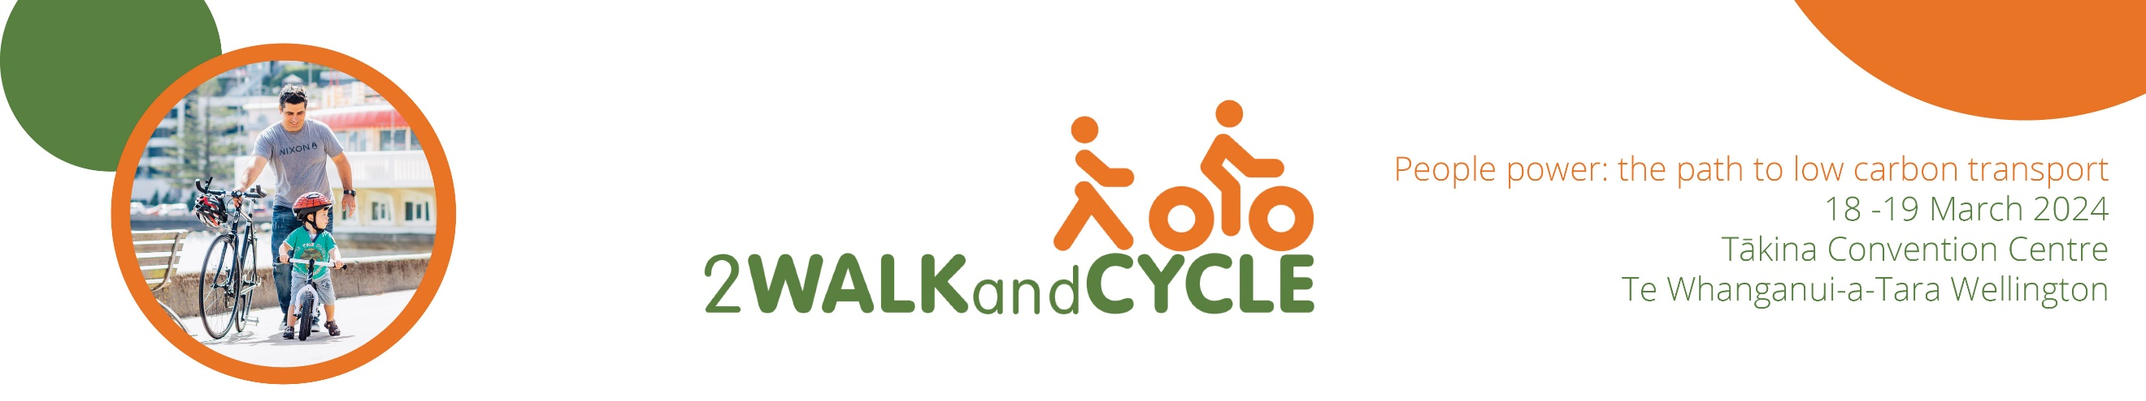
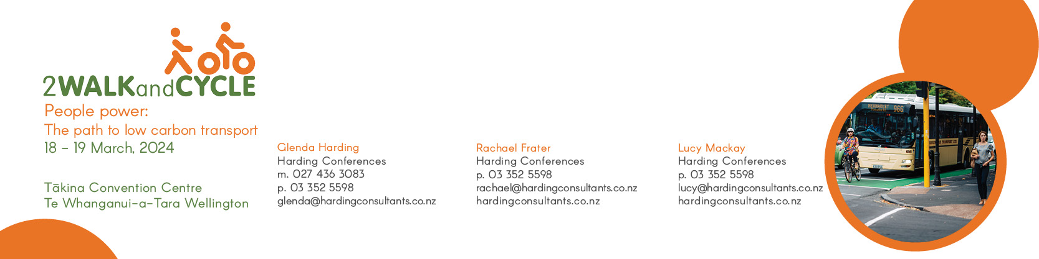
Winning hearts and minds using digital media and better stories
Patrick Morgan, Cycling Action Network
We face huge opportunities to build a better world, where everyone gets a fair go, and our communities are strong and resilient. Better transport choices are an essential tool as we race to decarbonise our towns and cities, enable affordable mobility, and tackle inequality. Our task has never been more urgent.
But change can be hard. How do we overcome the status quo bias? How do we win public support for safe and attractive streets?
In this interactive workshop, you will learn how to build support for change, using digital tools and face to face campaigning.
Focusing on successful bike advocacy, we'll cover:
- messaging and framing: selling the cake, not the ingredients
- linking digital story telling with face to face campaigning
- building trust between advocates and councils
- making zero-budget videos for social media success.
We'll share lessons from recent campaigns:
- winning at the submissions game
- Bike Life video series
- ride along videos
- direct action campaigning: picnics in parks, people-protected bike lanes
Whether you're an advocate, Councillor, or transport professional, you will come away with new tricks and ideas.

