**EQUITABLE BUS SERVICE CAPACITY FOR SCHOOLS**

[This paper has not been peer reviewed]

**Authors:**

Fraser Barrons, Service Performance Manager at Auckland Transport, BA in Economics, [Fraser.barrons@at.govt.nz](mailto:Fraser.barrons@at.govt.nz)

Madie Aghili, Network/ Transport Planner at Auckland Transport,

MSc in Urban Design/ Spatial Design, BA in Urban Planning,

[Madie.aghili@at.govt.nz](mailto:Madie.aghili@at.govt.nz)

**Abstract**

This practice paper aims to present a review of methodology used to measure school bus capacity in Auckland. It will identify limitations in the current methodology that might have resulted in service deficiencies for some school routes. A new methodology is proposed which is expected to improve capacity analytics and lead to a more equitable outcome specifically for school children.

School bus services in Auckland only account for 3% of the overall bus services. According to the current methodology for school bus analytics, there are only three school bus trips out of 474 which have a persistent capacity issue. However, 10% of all bus capacity complaints are related to school bus services. This relatively significant number of complaints has led to a review of methods used to identify when a bus service reaches “real” full capacity from a child’s point of view.

Certificate of loading (COL) is a key metric to identify the number of passengers allowed on a bus before it is considered at full capacity. The NZTA has different COLs for primary, intermediate and secondary students. This is different again for adult passengers on urban route services as only one COL is considered.

This paper will present analysis of school services covering; trip performance, reliability, models of bus and their COLs, observations around passengers and their behaviour, bus driver behaviour, safety, new insights, revised methodology and impacts of the revised methodology.

It is expected that this revised methodology would lead to identifying genuine capacity issues among school services, that will more accurately reflect genuine passenger satisfaction and feedback.

**INTRODUCTION**

School buses play an important role in New Zealand’s education system each day by transporting kids to and from school. Based on our data, around 17,500 students ride on school buses in Auckland each day.

Reduced school kids’ independence to travel to and from schools can have some significant implications for their families with potential effects on their overall wellbeing. In absence of independent travel options, parents are more likely to be required to accompany their kids to school by any travel mode, though it is more likely for kids to be driven to their school. This will add extra demand on time and resources. In lower decile areas, this can have greater effects on those families that are less prosperous. Some of the constraints that parents may encounter due to their work requirements will limit their access to job opportunities (e.g. if they have to attend work on a shift basis) (Perry, 2018). Considering this, Auckland Transport’s school bus services are significant in this respect. These services not only provide for a more targeted groups, but also give a greater confidence to parents for safer travel options. Parents perceptions of safety are far more important in determining kids’ travel choices to schools.

In Auckland, some parents believe Auckland Transport had underestimated the number of students that would be riding some school services (Lawrence & Dunlop, 2019).

Auckland Transport (AT) has proven capacity methodology and analytics around Urban Bus service, if there is an issue it is probably due to lack of budget rather than lack of knowledge.

However, school bus capacity is worthy of closer investigation. Using current Certificate of Loading (COL) school bus analytics there are only about three school bus trips out of 474 which have a persistent capacity issue. However, 10% of all bus capacity complaints are related to school buses, where school bus only accounts for 3% of all bus service.

The certificate of loading (COL) is issued by the New Zealand Transport Agency (NZTA), for every bus in the AT fleet. This gives the maximum loadings for seated and standing for 4 categories of passenger; Adult, Secondary, Intermediate and Primary. It is determined primarily by weight which is converted into passenger types numbers.

As a result, AT assesses every school trip on an estimate of type of school that it serves. AT calls this mixed school COL. It is against this that AT measures the actual boardings and alightings on that trip to assess the capacity utility rate.

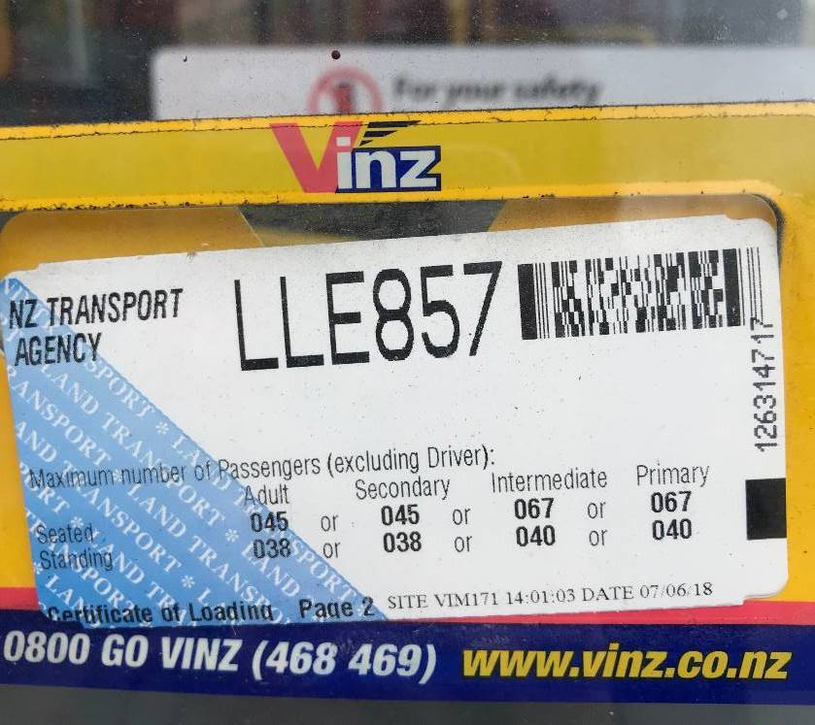

Figure 1: Example of COL

AT currently flags a capacity issue on a school a trip if that rate exceeds 100% of Mixed COL. By comparison for Urban trips AT flags an issue if a trip exceeds more than 80% of Adult COL. This is because we know at the 80% threshold the adult customer experience begins to quickly deteriorate. We have learned that it is nearly impossible to get real people to fill a bus to its maximum adult COL, and if this does happen it results in a very poor customer (even potentially hazardous) experience.

AT’s service performance team has investigated the real world of school bus capacity and referred that experience back to the capacity utility we can measure using HOP data. The key question is at what point do we acknowledge that a school bus is “full.”

Over a couple of weeks in July and August 2019 eleven school bus trips were ridden by AT personnel. The intention was to understand the real relationship between capacity use and passenger satisfaction.

The analysis is split into the following topics:

* School trips and AT.
* Trip performance, reliability.
* Models of bus and their COLs.
* Observations around passengers their behaviour and their bus.
* Bus Driver behaviour.
* Safety.
* New insights.
* Views from elsewhere.
* Overall learnings.
* New approach guidelines.
* Revised methodology.
* Impact of revised methodology.

**School trips that operate for AT**

* There are 311 unique school routes and 474 school trips per day.
* The graph below is a count of school trips by total distance. 6-14km is the distance that most trips will travel.
* Looking at HOP data, on average a child travels 7.3km per bus journey and spends 22 minutes on a bus.
* This compares to 8.8km for urban passengers who spend 33 minutes on a bus.
* This is relatively longer in time due to the higher likelihood of an urban passenger having to transfer.

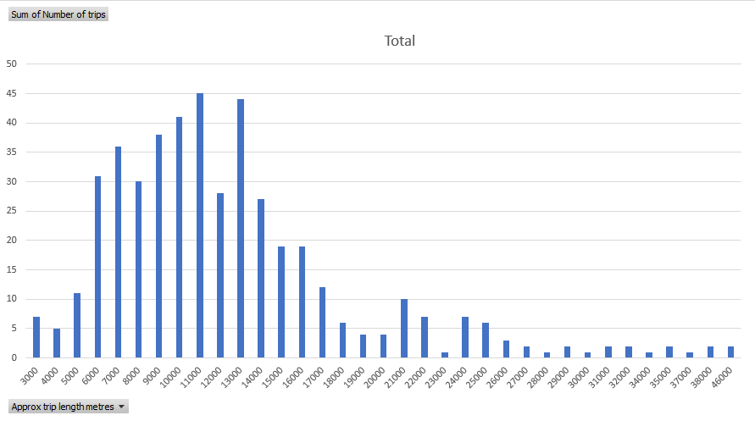

*Graph 1: School trips by total distance*

**Trip performance**

* School bus trips do not perform as punctually as urban trips. But for good reason:
  + Outbound school trips are less punctual especially as they tend to wait and depart depending on speed of loading, often controlled by school staff, and school finishing times;
  + This is especially the case for primary school trips, as they need to be corralled more.

**Models of bus and their COLs**

* The buses used were nearly all buses that are used for urban services as well. The average age of buses used is 8yrs old. By international standards this is good.
* Here is a breakdown of vehicle models used for school buses on a typical day. There are about 60 different models. Some are used more than others, and this reflects the overall fleet composition.

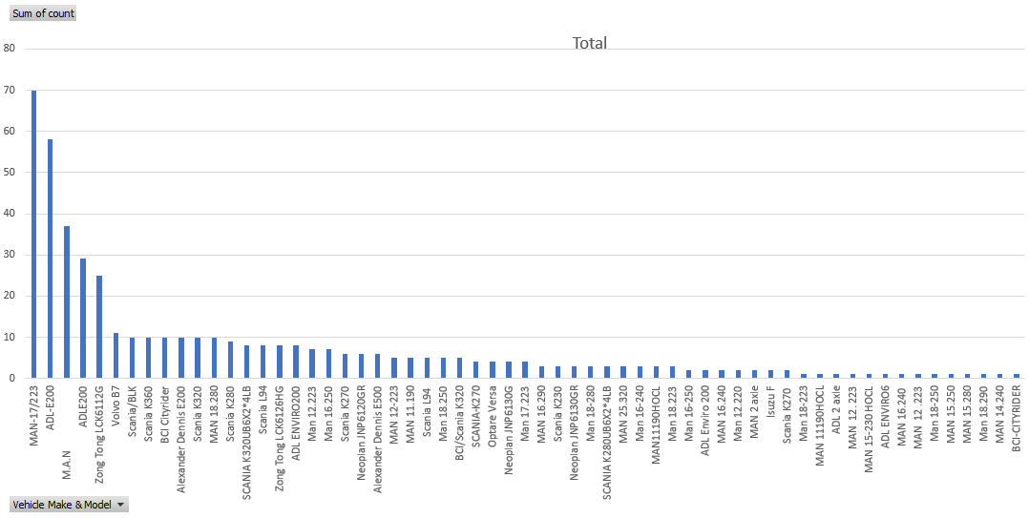

*Graph 2: Vehicle models used for school buses on a typical day*

When considering the different COLs for each model there is a clear trend:

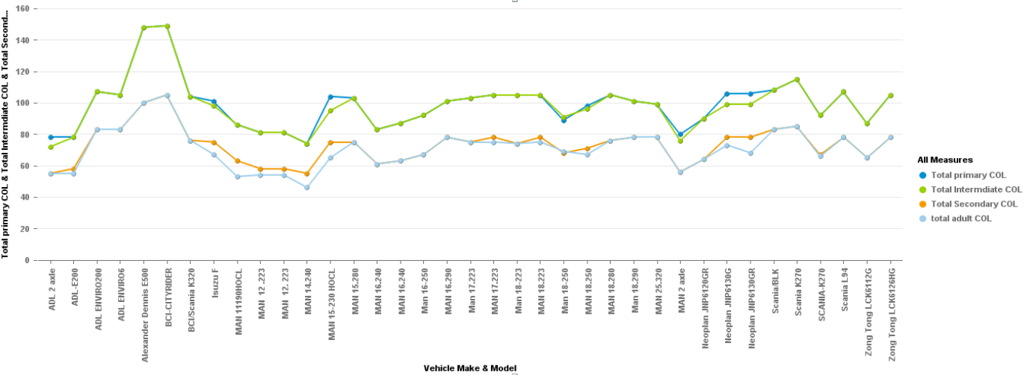

*Graph 3: Total primary/secondary/intermediate COL and bus mode*

* Primary COL and Intermediate COLs are often the same.
* Secondary and Adult COLS are often the same.
* The difference between these 2 COL groupings is 20-25 places for most models.
* This equates to approximately 30% difference across most models.

This analysis raises a question, does a primary student use 30% less seating and standing room than a secondary student?

**FINDINGS AND DISCUSSION**

**Observations around passengers their behaviour and their bus:**

**Primary and Intermediate**

* Three students per two seats were usually achieved for primary students only when they were supervised at time of boarding at the first stop.
* Even if students were seated according to the above guideline, most will leave their seats after departure.
* Primary and intermediate students often prefer to do out of seat activities.
* Intermediate students body build was not significantly different from secondary students.
* Primary students are usually very active in the bus and are more likely to show unsafe behaviours as they are more playful.
* Primary school kids are smaller, but they will usually have a bag or similar which requires space.

**General**

* The longer the trip the more likely it was for more seats to be occupied.
* Since there is no alternative service, all students board the bus regardless if it is crowded.
* Most students tend to carry backpacks or similar, which take up room:
  + This affects how they sit and move in the bus.
  + This extra baggage is much more than a typical adult on an urban service.

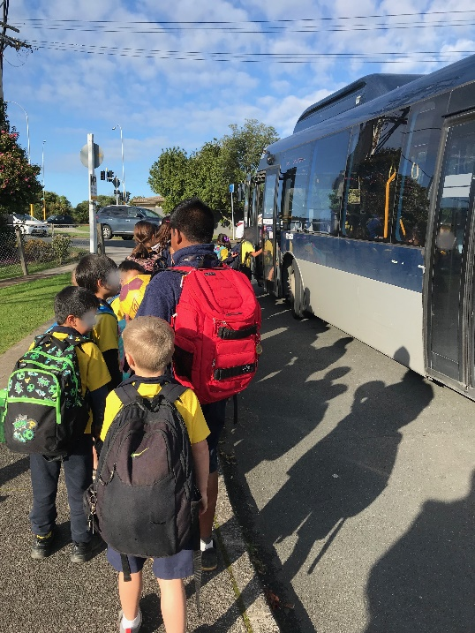



Figure : The example of kids with backpack

* The rear section of the bus is usually well utilised, which is contrary to observations for adults on urban routes. There are two main reasons:
  + The more senior kids will go to the back of the bus, to make it their space.
  + Standing is not an issue for students as the head space is relatively reasonable.
* Longer trips are generally noisier.
* Passenger satisfaction was different for primary, intermediate and secondary students.
  + Primary and intermediate students were happier when asked even if the bus was crowded. Though they had little concept of their own safety.
  + Secondary students’ satisfaction was lower than the other two student groups. When asked, they complained about the crowdedness or the noise in the bus.

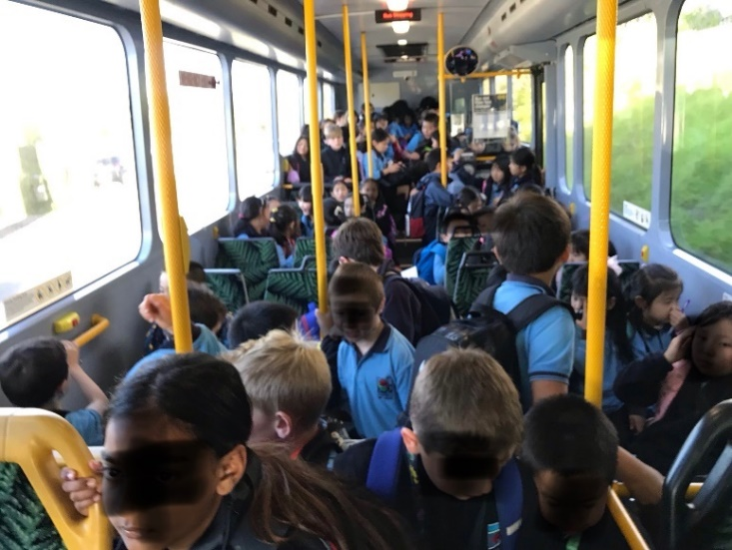



Figure : Primary & intermediate students in the bus

* Secondary children once they are old enough may often get a driving license and drive themselves and siblings to school.
* Very young primary children are rare PT travellers, parents see them as being too vulnerable. (ref. associate principal of Carmel college)

**Safety**

Students tend to exhibit unsafe behaviours while on the bus.

* Seating, standing even jumping in the luggage area.
  + Above behaviours are more likely to be observed in afternoon services than in the morning as the kids are more animated. Especially for primary and intermediate students.
* There is frequent standing while bus is in motion even if there are empty seats.
* They are more likely to engage in conversations with each other and move around the bus.
* At least one or two standees tend to breach the ‘No Standing Forward of this Area’ sign (which is located on the floor near the driver).

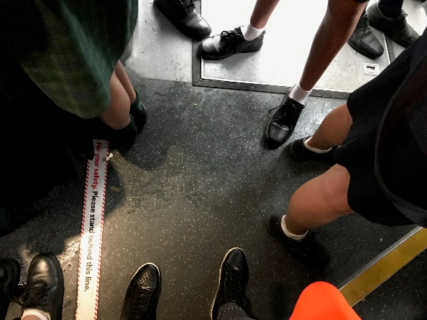

Figure 4: Students over the safety line

Figure 4: Students over the safety line

* They were observed at times sitting on the floor and luggage areas when there was clearly room to sit and stand.

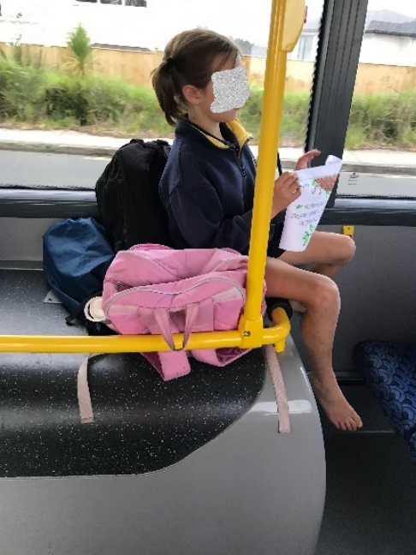

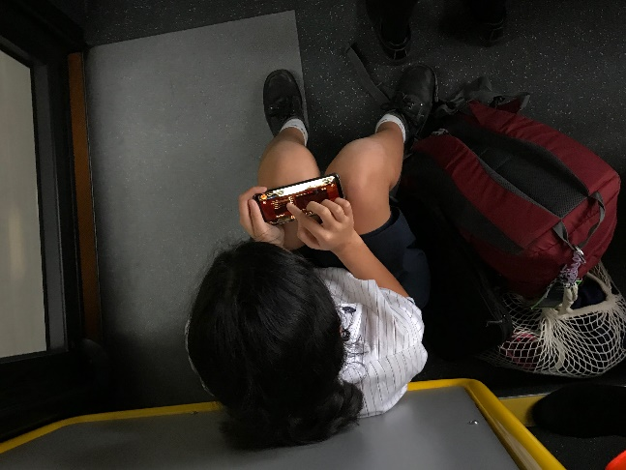

Figure 5: Primary student sitting on the floor

Figure 6: Primary student sitting on the luggage area

* Children will often kneel on seats and not look forward, so they can play with friends.

**Driver Behaviour**

* Drivers were generally less thorough than urban drivers when monitoring the tag on activity.
* Some drivers will communicate with children, particularly to remind them not to engage in unsafe activities (e.g. to sit down, not to jump).
* Some drivers only concentrated on driving.
* A few drivers said they find it more difficult to focus on driving when primary students are on board.

**Other insights**

* Undercounting in HOP data.
  + We found that some of the school trips had higher capacity usage than we measured via the HOP data.
  + The reason was that some school children did not tag on when boarding.
    - This was particularly observed in South Auckland nearly a quarter of all kids just did not tag on or pay a fare.

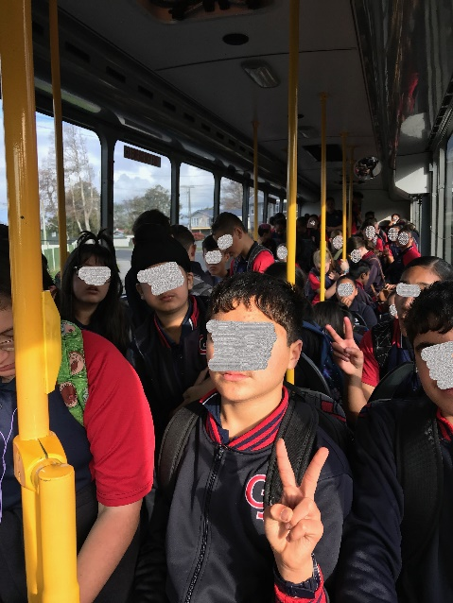

Figure 7: A quarter of these kids did not Tag on or pay

* NZTA reported last year that there were only four minor injuries for school children in New Zealand from 2013 to 2017.
  + On one observed trip, a nose bleeding was seen. The cause of the injury was not clear, and involved students refused to answer. It raises the question of how reliable injury reports are.
  + Similarly, at Carmel college, the vice principal said she could not think of an incident or injury that had taken places on their school buses. However, the children on one of their buses rattled off stories of kids being trapped in doors.
* Mixed COL values are driven by how an operator characterises the schools that a service serves. On observation we have found this often to be inaccurate.

**Key overall learnings**

* In practice the NZTA COLs for primary and intermediate do not reflect the child customer experience.
* When a bus has reached the maximum mixed COL the customer experience is very poor, even hazardous for all passenger categories.
* Primary and Intermediate COL is often much higher than secondary COL. In practice there is little difference between them.
* Younger children especially do not sit quietly and conform with the spirit of COL.
* Children often act in a way that would be considered unsafe compared to an adult.
* There is a tendency for HOP data to undercount the actual numbers of children on a bus.

**Views from elsewhere**

* It should be noted that the Ministry of Education announced last year that it has agreed to terminate the practice of allowing standing passengers on school buses (McKenzie-McLean·, 2018).

**Summary**

We believe that the current capacity method used for school buses does not reflect the real customer experience. Therefore, the threshold of what constitutes a full school bus needs to be revised.

**CAPACITY METHODOLOGY REVIEW**

**What is the most customer centric threshold to use when measuring school bus capacity?**

The intention of the capacity threshold flag is to be able to identify a trip, where capacity reaches a point, where our customers will become dissatisfied with their experience on a bus. This is currently set at 100% of mixed COL.

To do this we have taken 4 different threshold measurements and related them to the actual experience of the school buses we observed.

* 100% mixed school COL
* 80% of mixed school COL
* 80% of secondary COL
* 90% of secondary COL

It was found of these, that the closest threshold that was consistent with the observed threshold point, was 90% of secondary COL. In addition, the 90% of secondary COL had the least deviation compared to the observed threshold point. Below is a table that contains the current threshold against the preferred threshold with our observations.

The other thresholds either flagged before the observed threshold point or never flagged at all. This was the case with the 100% mixed COL which would never have flagged an issue. This is consistent with the current situation of a high level of school bus capacity complaints and a limited number of trips being flagged in our analysis.

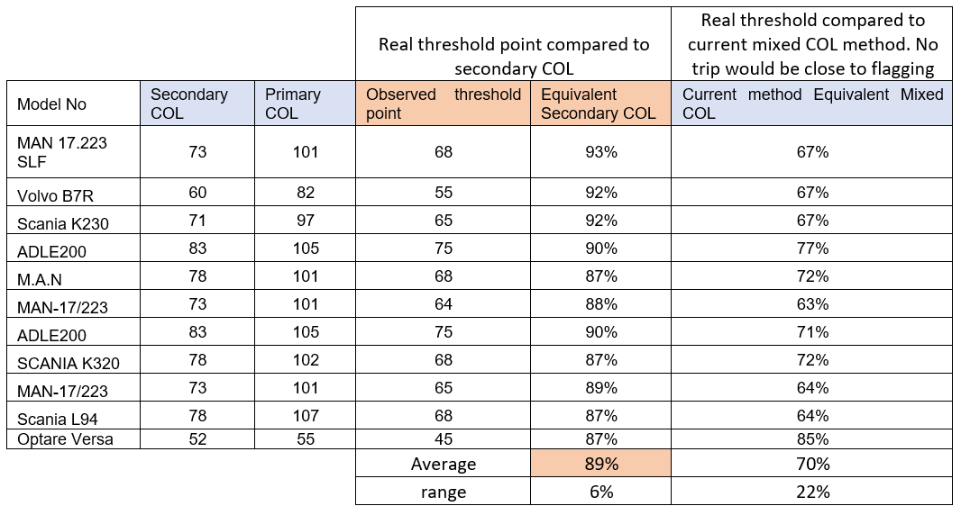

Table : contains the current threshold against the preferred threshold with our observations

**Impact of changing the method from 100% mixed COL to 90% of secondary**

If we change the method from current to 90% Secondary COL, it would be valuable to assess the impact.

As above 4 different thresholds were put in as variables.

* 100% mixed school COL
* 80% of mixed school COL
* 80% of secondary COL
* 90% of secondary COL

In addition, if a unique service hit the threshold it was then filtered by how frequently the threshold was exceeded. This was set at 20% or greater. This proves the persistency of the flag (same as urban routes).

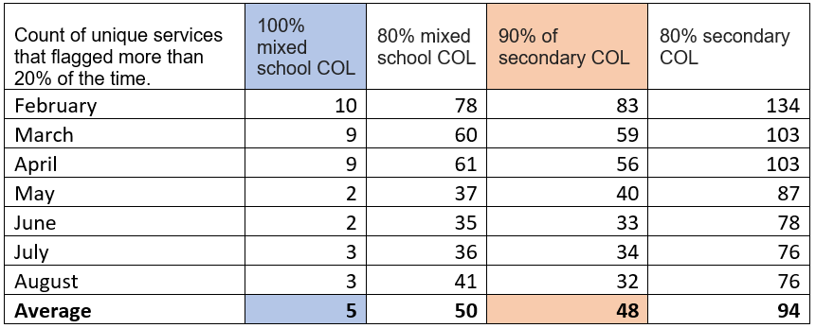

Table 2: Impact of thresholds changes in different months

Note that the count of trips decreases as the year moves on. February is by far the worst (start of school year). Interestingly the 80% mixed COL and the 90% secondary numbers are similar. However, they only share about 60% of the same trips. The mixed COL gives more false positives. With the 90% Secondary COL repeatedly being the closest to the real threshold point.

This review recommends the following:

* Secondary COL should be used for all COL.
* A school service should be considered for review if the capacity used is greater than 90% of secondary COL more than 20% of the time.
* Reporting should be set up to reflect this.
* If this was done most of the genuine school bus capacity issues would be identified.

**AUTHOR CONTRIBUTION STATEMENT**

The contribution of this paper is providing insight into the importance of periodically review of methodologies used to estimate capacity on school buses as the trends can change over time or assumptions made in a national guideline not to be relevant to a local’s needs. In this paper, we have explained the review and development a new methodology to examine school bus capacity in Auckland. We have developed a new report based on our new methodology in Business Object.

# **BIBLIOGRAPHY**

Lawrence, M. & Dunlop, R., 2019. *NZ Herald.* [Online]   
Available at: https://www.nzherald.co.nz/nz/news/article.cfm?c_id=1&objectid=12209195

McKenzie-McLean·, J., 2018. *Stuff.* [Online]   
Available at: https://www.stuff.co.nz/national/education/106738488/children-no-longer-allowed-to-stand-on-school-buses

Perry, A., 2018. *The Hechinger Report.* [Online]   
Available at: https://hechingerreport.org/the-route-school-buses-can-take-toward-racial-equity/