Planning Auckland’s Future Integrated Transport System
The purpose of this paper is to inform the transport and planning industry about Future Connect, which is Auckland’s long-term plan for the future integrated transport system). This paper outlines how it has been developed and takes a look at how it is guiding planning and investment.

Future Connect is a system planning tool that surfaces the critical system needs. It is a 10-year vision (eventually building towards 30 years), which sets out Strategic Networks for each transport mode (i.e. public transport, general traffic, freight, cycling and walking), detects the deficiencies in these networks expected in the next decade and identifies Focus Areas for further investigation. Future Connect is data driven, and the information is helping to tell better investment stories in terms of where investment is important, and where there may be gaps.

Why we need an Integrated Network Plan. A single plan is needed to cover all transport modes, which will support integrated transport planning and operations across all modes and will provide a core planning reference. Ultimately, this reference will prioritise investment towards core objectives and contribute to better value for money outcomes. While Future Connect is not a solutions tool, it will guide system planning to better connect people, places, goods and services; accelerate better travel choices; and support growth.
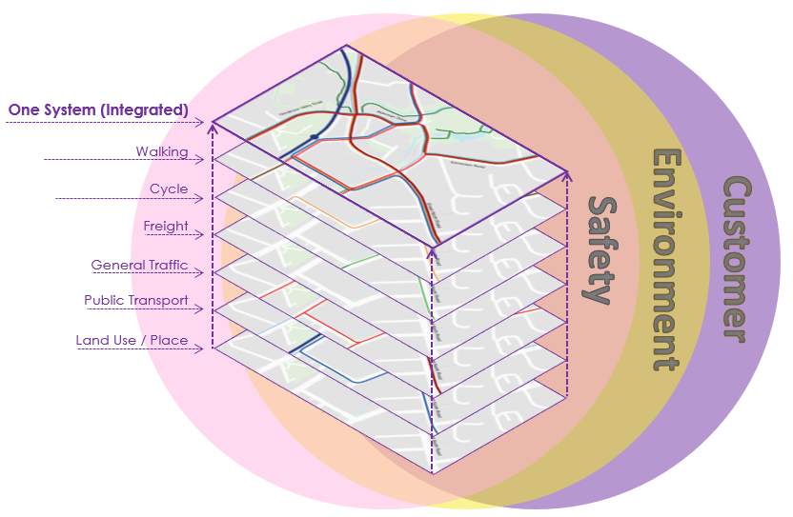
Addressing environmental and safety problems is a fundamental responsibility of transport system planning. Environmental and safety issues have been brought to the forefront through Future Connect. The data related to these issues have been analysed and addressing them are core objectives underpinning this Plan. The result will mean that projects will incorporate environmental and safety issues as core parts of their strategic mandates.

Why this matters for the transport community? Future Connect outlines Auckland’s system view through a publicly accessible mapping portal, which is informing strategic decision-making and provides planners with better guidance and data that will deliver better outcomes for strategies, plans, business cases and, ultimately, results on the ground for our customers.

