Planning Tomorrow's Auckland City Centre

Despite undergoing massive growth and change in recent years. Auckland's city centre has been hampered by disagreement amongst stakeholders as to the best way to deliver necessary transport improvements in co-ordination with wider city centre projects. Auckland Transport has achieved significant success in developing a collaborative approach with major stakeholders on an integrated way forward which will deliver a thriving city centre for tomorrow. This paper will cover the complex challenges, the unique approach taken and successful solutions achieved by Auckland Transport, for a lessons learnt approach applicable to other transport agencies.

Author/presenter:
Daniel Newcombe, City Centre & Rapid Transit Network Initiatives Manager,
Auckland Transport; MNZPI, daniel.newcombe@at.govt.nz

INTRODUCTION
Auckland's city centre has been undergoing massive growth and change in recent years, with significant increases in residential population, employment and tourist activities. Much of this growth was expected but not so quickly – for example the population target of 45,000 city centre residents was reached 17 years earlier than projected.
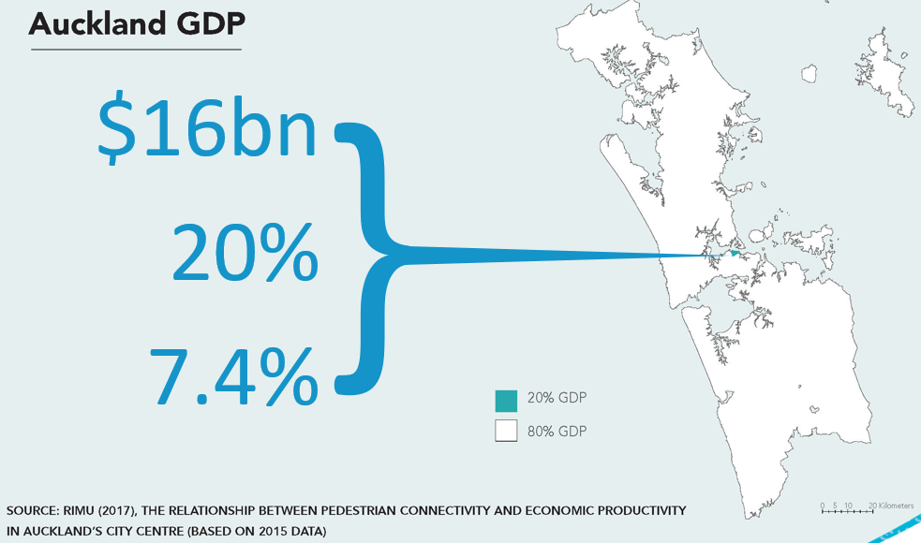
Figure 1: The economic importance of Auckland City Centre
Auckland’s city centre is an increasingly important ‘economic engine’ for both the region and the whole of New Zealand. The city centre produces 20 percent of the region’s economic value (as measured by GDP) due, in part, to the concentration of skilled and highly productive jobs. Auckland is following the international trend of highly skilled workers seeking out vibrant, mixed use city centres in which to work – and often to live and play nearby.
The rapid increase in workers and residents is transforming the way people use the city. There are more people on city streets, spending more time and doing more things. Aucklanders have embraced this re-emergence of public life across the city centre, as shown in the below graphics.
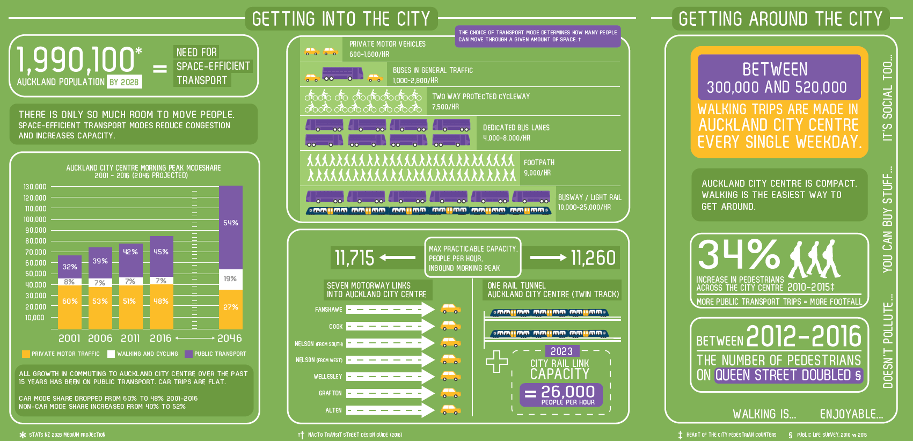
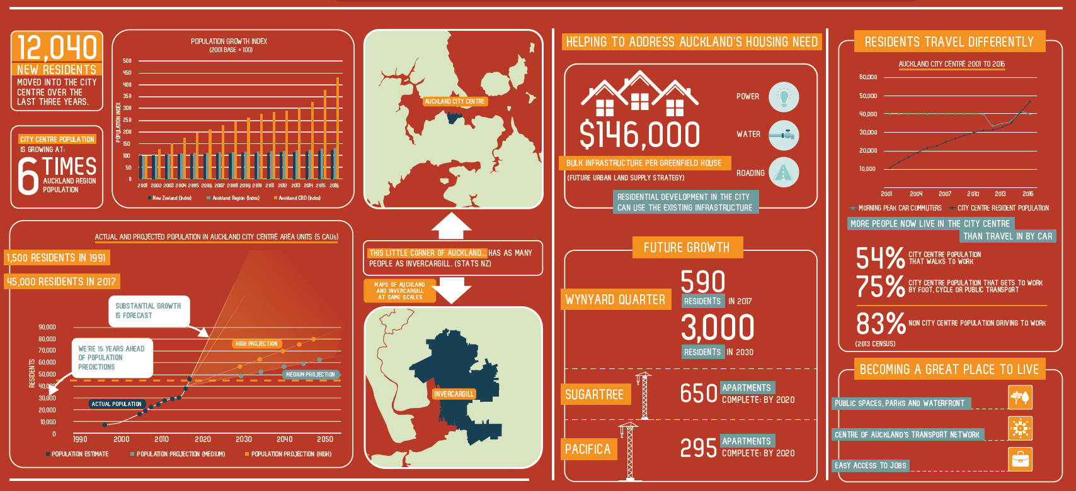
Figures 2a & b and 3a & b: Growth statistics relating to Auckland City Centre
The ongoing growth in the city centre necessitates a range of interventions and projects by relevant public bodies – notably the Council Controlled Organisations (CCOs) of Auckland Council, such as Auckland Transport (AT) and Panuku Development Auckland.
Unfortunately, for a range of reasons, there has to date been disagreement amongst stakeholders as to the best way (or whether) to deliver some of the projects – notably some significant transport improvements which require careful co-ordination with wider city centre projects.
The matter came to a head in March 2017 when the Council’s Planning Committee met to discuss emerging Auckland Transport bus projects which were considered to conflict with previous Council aspirations for the city centre – these centred on the Midtown and Downtown areas. There was a risk that decisions by AT on bus infrastructure could be seen as fundamentally undermining Council aspirations. The Committee voted to reiterate their support for those aspirations and request the relevant CCOs work collaboratively on a way forward.
This paper discusses the collaborative efforts, the complex challenges, the unique approach taken and the successful solutions achieved by AT.
CONTEXT
A small core working team made up of representatives from relevant CCOs was formed and quickly identified the need for a form of governance and reporting, if realistic progress was to be made. A Project Control Group was established, made up of manager from each CCO knowledgeable about the city centre. This group co-ordinated the relevant workstreams. An equivalent Executive Steering Group (ESG), made up of senior managers with decision-making authority, was also established to approve or make decisions on projects ahead of them being taken to the public or elected representatives, although the expectation was that issues were to be resolved before they reached the ESG.
A small core working group of key CCO personnel – which included the author – with roles in the area (sometimes referred to as a ‘tiger team’ – charged with coming up with a revised way forward) set about refreshing the implementation planning to deliver the 2012 City Centre Master Plan and the Waterfront Plan. Both spatial plans were part of a suite of place-based plans that came out of the Auckland Plan.
The working group’s refreshed planning sought to maintain the vision and direction of both plans, as well as deliver on Auckland Transport’s strategic requirements. The free and frank discussions, which challenged the thinking and assumptions of all participants, was central to the progress made. In many cases, Auckland Transport brought to the discussion an understanding of people-moving requirements, whilst Council representatives brought aspirations for people-centred urban spaces. The challenge was to collaboratively merge these elements.
The first focus was on the next phase of delivery for the Downtown waterfront corridor, Midtown area, central wharves and Wynyard Quarter. These focus areas are critical parts of Auckland’s city centre and waterfront, and all have high visibility and public interest, with competing demands and immense pressure on space. All are key to unlocking growing expectations for public transport, waterfront access and high quality public realm.
The revised implementation planning was in part based on lessons learned by Council organisations from a decade of successful project delivery and a better understanding of the challenges of development in the city centre and waterfront, the complexities of the project interdependencies and the construction sequencing.
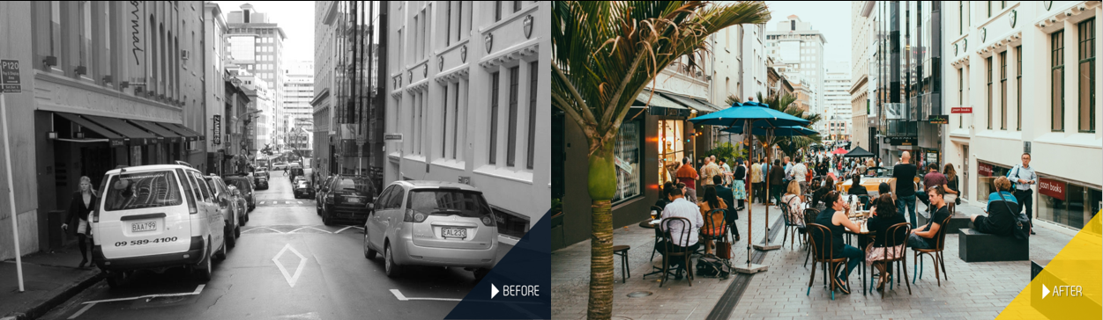
Figure 4: O’Connell St before and after a streetscape upgrade
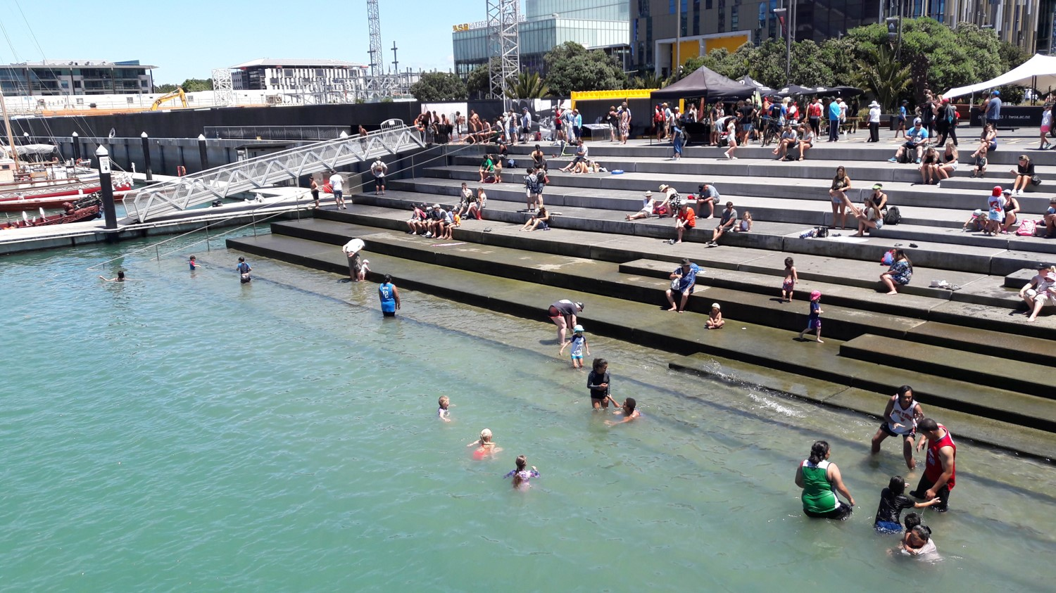
Figure 5: Public space on Auckland’s waterfront
A major factor was showing that projects are able to be delivered in co-ordination with the construction and completion of the City Rail Link, major private sector developments, and necessary infrastructure upgrades (such as the seismic upgrade of the Quay Street seawall), to enable a high quality city centre which will be especially important for upcoming major events.
A core factor in the working group discussions was that AT’s strategic city centre planning is based on all future growth in city centre access being accommodated by public transport and active modes (walking and cycling). Traffic volumes have remained static for a decade and it is expected that traffic levels will diminish in the core of the city centre as more space is provided for pedestrians, public transport and the public realm. This helped establish a view that public transport efficiency was critical and more important than vehicle space (in some cases Council staff did not see a distinction, and viewed AT as being driven primarily by traffic engineering priorities).
The collective view of the working group was also that strong ongoing growth in public transport is only able to occur if targeted capacity improvements are provided – through additional space and facilities for buses (or other high capacity modes) and additional space for ferries. So any revised implementation plans needed to provide for this, as well as higher quality urban realm in those locations.
Two areas of the city centre are outlined to show the process worked through and rationale for decision-making.
Downtown AREA
A new, coordinated programme of transport and streetscape projects was developed for the Downtown area, based around a pedestrian-focused core supported by quality public transport to the east and west, and integrated with waterfront planning. Previous discussions had been unable to form an agreement on the ideal location for buses or the best manner in which to develop the pedestrian realm.
Following lengthy discussions, new high quality facilities for bus customers are proposed in Lower Albert St for Northern and North-western Busway services, and a new Quay Street East facility for Isthmus and some Eastern services. These two facilities remove the need for buses to operate in Lower Queen Street and the central core of Quay Street, enabling these to become high quality pedestrian-focused spaces developed in collaboration with adjacent private sector developments. These spaces will therefore be able to be closed to host major waterfront or civic events, whilst the nearby bus services can continue to bring in customers for those events and ongoing city centre activities.
Additional streetscape improvements along Quay Street, building upon the City Centre Master Plan aspirations for a waterfront boulevard, will be based around the central pedestrian-focused core of Lower Queen Street and Queens Wharf, along the northern promenade and in co-ordination with major private sector developments such as Commercial Bay and the Britomart precinct. This is different to the original City Centre Master Plan design, but achieves the same urban realm improvements. An upgrade of the Quay Street seawall is an essential enabling component to create a high quality waterfront for people.
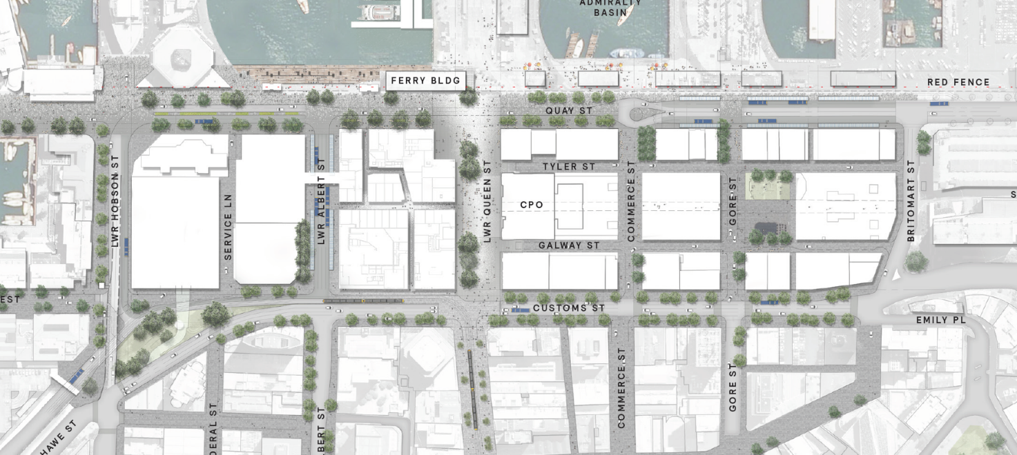
Lower Albert St bus facility
Quay St East bus facility
Figure 6: Downtown area proposal
Midtown area
Significant progress has also been made in developing a coordinated way forward for the Midtown area, which will overcome previous programme conflicts and deliver two great city streets on both Victoria Street and Wellesley Street.
Concerns were raised during previous public consultation by AT on Midtown bus route options that there was conflict between transport and streetscape planning. In particular, it was felt that buses routes onto Victoria Street would prevent the future delivery of a proposed linear park. AT has addressed these concerns by developing a new ‘crossover’ bus route option which retains major bus services on Wellesley Street and avoids the need for these on Victoria Street. This enables the staged delivery of the Victoria Street linear park (though additional funding is still required for this).
The ‘crossover’ arrangement swaps some major bus route groups using Symonds Street so that no turning is required (the East-West and North-South services simply ‘crossover’ each other). Some current Midtown services will therefore access Britomart, whilst some current Britomart services will instead cross Midtown to Wynyard Quarter. Wellesley Street will become a high quality ‘bus boulevard’, supported by a new ‘University Station’ in Grafton Gully. Wellesley Street and Victoria Street will both be busy pedestrian areas surrounded by important city centre activities, and AT and Council are committed to developing them both into great city streets.
The key decision here was for AT to expand the original extent of bus route planning from just the Midtown area to the entire city centre, opening up additional options. Secondly AT looked at a ‘best for city centre’ approach, whereby it was critical to come up with a plan that not only delivered on bus project objectives but also wider city centre planning goals.
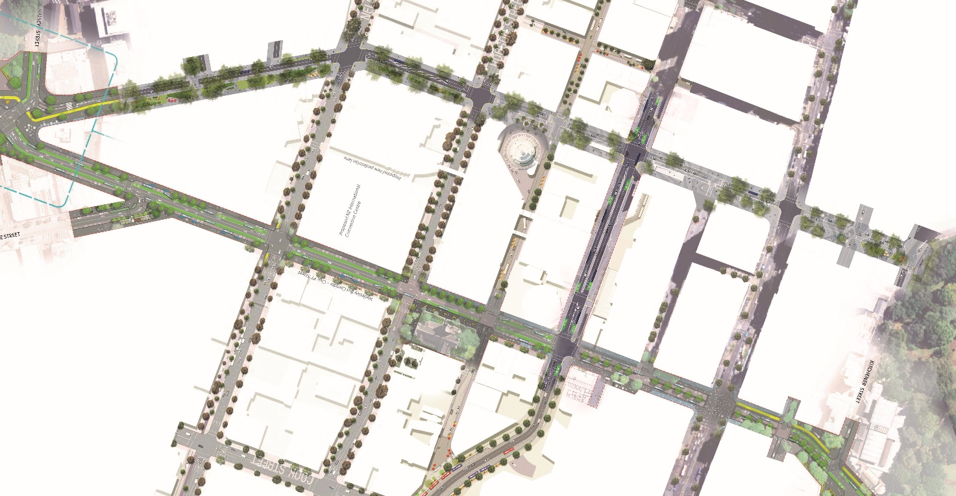
Wellesley St bus corridor
Victoria St linear park
Figure 7: Midtown area proposal
These two complementary projects on Wellesley Street and Victoria Street are to be delivered in co-ordination with planned City Rail Link construction on both streets, and in support of wider city centre public and private developments, such as future mass transit, the NZ International Convention Centre and ongoing development of the Learning Quarter.
Further consultation will occur for bus customers and with stakeholders and the public in relation to street design, however when this proposal was presented to the Planning Committee in September 2017 the progress made was greeted with a standing ovation from councillors.
Auckland Transport has funding in place for the core bus project (however the station elements of the ‘crossover’ option is likely to see the need for an increase) and there is partial funding for the Victoria Street linear park, but additional and earlier funding is required to develop both corridors to become the high quality pedestrian spaces they need to be.
MAORI ENGAGEMENT
Mana Whenua have made a significant contribution to the planning, design and development across the waterfront. The Council family will continue to work with mana whenua on the next phases of planning, design and delivery across the waterfront.
Auckland Transport has begun project-specific engagement with iwi through an existing iwi liaison forum and will continue to coordinate this with other city centre projects and their tailored iwi engagement.
IMPLEMENTATION
The transformation of Auckland’s city centre and waterfront to date has required significant council investment in planning, infrastructure and the public realm.
The next twenty years will require a similar level of commitment to investment in public infrastructure, to attract continued private development that will deliver a sustainable and inclusive city centre. As much as anything this is a reflection of the success of existing strategies.
Council staff will be developing scenarios for funding decisions as part of the Long-term Plan discussions. This will enable a better understanding of the interdependencies of projects in order to decide which projects to prioritise and fund in the 2018-2028 Long-term Plan.
It is anticipated that the first phase of public engagement will be around the 2018-2028 Long-term Plan, when the Council will be consulting on its funding priorities and 10-year programme, including all the city centre and waterfront projects.
There will be more detailed consultation and engagement for each project at the appropriate time in its planning and delivery stages, once funding and project timing is confirmed.
LEARNINGS FROM THE PROCESS
As noted earlier, the free and frank discussions of the small working group got to the core of the issues, challenging existing assumptions and seeking mutually beneficial ways forward. This involved compromise on both sides and a willingness to look for ‘best for city centre’ solutions rather than just focusing on delivery of particular projects.
The use of a small group to ‘nut things out’ rather than large workshops or complex planning sessions, was felt to be critical to the progress made.
Following the significant internal collaboration, a concerted effort was made to develop the material into a compelling narrative for sharing with the Planning Committee, the Waitematā Local Board and the City Centre Advisory Board (all are key stakeholders who had expressed concerns at the apparent lack of organizational integration). It was recognized that just having good plans wasn’t sufficient – there had to be a good explanation of the rationale for the new way forward.
A series of workshops were held which outlined the complex issues and interdependencies for these key parts of the city centre, and showed the progress in creating holistic and integrated planning and decision-making.
Some of the key points raised by stakeholders in these workshops were:
- the need to articulate the broader justification, economic and public benefits for investment in infrastructure, public open space and for major events such as the Americas Cup
- an understanding of the trade-offs and balances needed as the projects progress to implementation
- the competing demands on public spaces and the need to focus on the sequencing of projects and ensuring that projects contribute to the long term vision
- a focus on the pedestrian realm and catering for greater numbers of public transport users and providing an opportunity to deliver improved Victoria and Wellesley Streets
- the opportunity to achieve multiple outcomes such as resolving stormwater issues at the same time as upgrading of the sea wall

For any transport professional engaged in a complex environment where key projects clash or key stakeholders are unsupportive, it is critical to see transport issues within a wider context (and that includes both public and private developments). If project teams and stakeholders can’t ‘speak the same language’ or talk past each other, it will be impossible to understand each other’s perspectives.

As progress is made, it is important to carefully work agreements and collaborations up through layers of technical staff, senior staff, managers, and politicians. If buy-in isn’t received at one level it will be difficult to reach the next and trying to circumvent difficult personnel just undermines the collaborative efforts made. Additionally, many transport projects are fundamentally about land use or urban realm (i.e. improving access to areas and improving their functionality), so it is important to avoid keeping transport discussions within solely the transport sector/department.

One learning from the process was that it was not well understood that core public transport infrastructure was required in order to bring people to the city centre, and without that there was little point in upgrading the urban realm. Streetscape upgrades have little value if people are unable to access them. Conversely, integrating with good quality urban realm garners support for transport projects and makes them more successful. Hence the importance of not just focusing on a ‘transport’ project but acknowledging the benefits and interdependencies of other projects.

A final and apparently simple learning was the critical importance of developing highly visual material (especially simple videos which can be played at meetings or online) to explain the narrative and key statements. Displaying simplistic graphics and plans well is more powerful than lists of facts and figures (and more comprehendible to viewers).

Any organisation undertaking a similar process to this should acknowledge that there can be misalignments and disagreements – it is naïve to pretend that everyone can get what they want without compromise. By acknowledging this, and showing how this was moved past, stakeholders are more likely to perceive real effort and willingness to make progress.

CONCLUSION
Auckland Transport has achieved significant success in developing a collaborative approach with Auckland Council and major stakeholders on an integrated way forward which will deliver a thriving city centre.

The quickly growing location created some complex challenges, and a unique approach was required to develop collaborative and successful solutions, which hopefully can provide some lessons learnt for other transport agencies

