**WELLINGTON CABLE CAR – ELECTRIC DRIVE UPGRADE**

**AUTHORS**

Simon Fleisher, CMEngNZ, CPEng, CEng, FIMechE

Chief Executive, Wellington Cable Car Limited

[simon.fleisher@wellingtoncablecar.co.nz](mailto:simon.fleisher@wellingtoncablecar.co.nz)

Stephen Ward, CMEngNZ

Project Manager and Asset Manager, Wellington Cable Car Limited

[stephen.ward@wellingtoncablecar.co.nz](mailto:stephen.ward@wellingtoncablecar.co.nz)

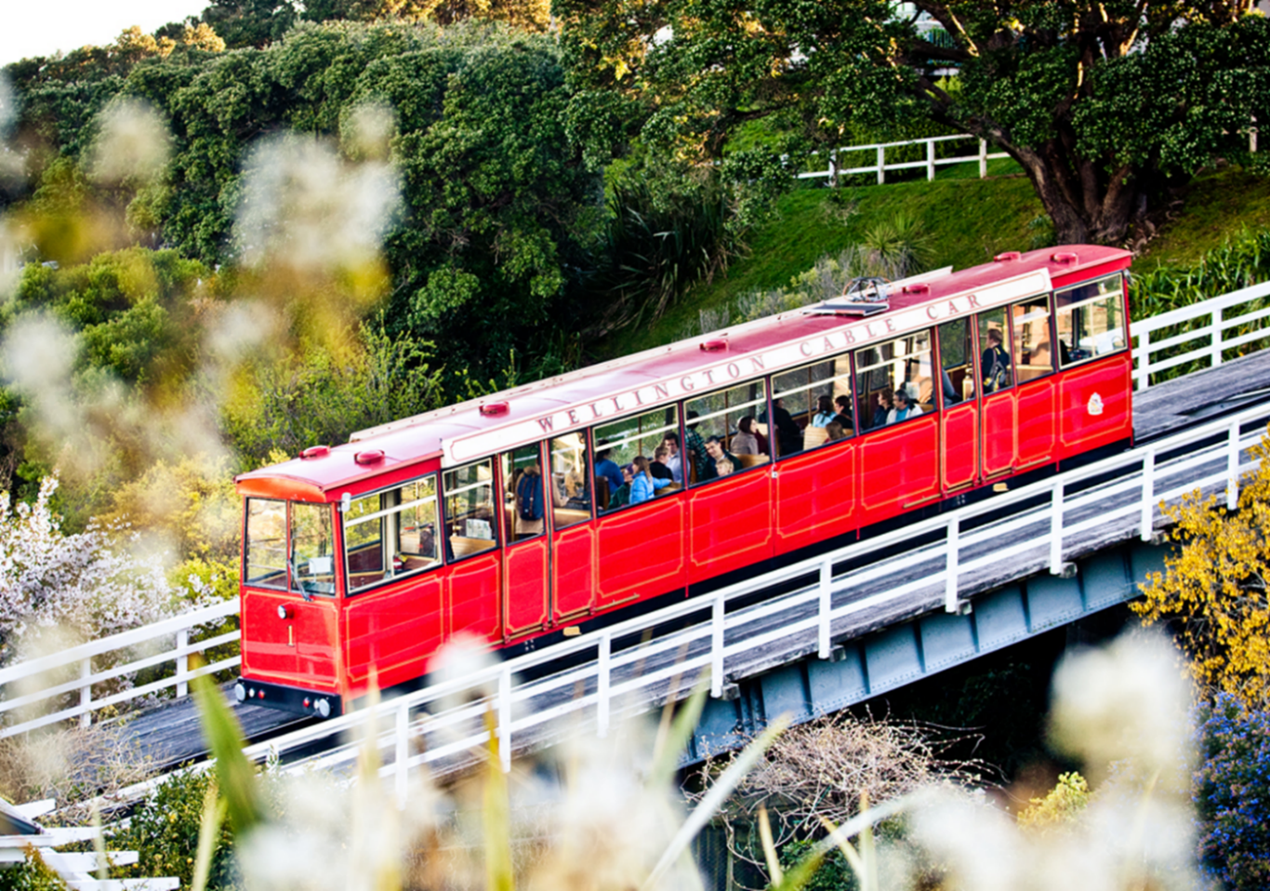

# ABSTRACT

Wellington Cable Car is a funicular railway that operates between Lambton Quay and Kelburn, carrying more than 1,000,000 passengers per year (including local residents and tourists). The current generation of Cable Car was designed and installed in 1978/79 and has served the Wellington public faithfully. However, by 2015, engineering obsolescence and limited technical support made it very challenging to maintain the expected levels of service and reliability. Wellington Cable Car Limited (WCCL), in conjunction with Doppelmayr and Wellington City Council (WCC), initiated a project to replace and upgrade the drive and control systems to enable this icon of Wellington to continue to operate safely and reliably for the foreseeable future.

The original project scope included the electric drive, mechanical transmission, control systems (including PLC and SCADA) and the main switchboard plus minor repairs to the passenger vehicles. Like many projects, as investigations continued into what was required, the “shopping list” expanded rapidly and the scope soon included major structural repair and refurbishment of the passenger vehicles and other smaller items including a major rebuild of the passenger ticket kiosk. Wellington City Council also brought forward the replacement of the overhead canopy in Cable Car Lane (which was earthquake prone) to coincide with the electric drive and control replacement.

Following a two-stage design process that was successfully concluded in 2015, a FIDIC contract was signed with Doppelmayr and manufacture commenced, in preparation for installation and commissioning during the quiet winter season in 2016. The Cable Car closed for ten weeks from 07 June 2016 and reopened on 18 August 2016 following successful completion of the upgrade that has provided another 30 years of life for the electric drive, controls, and mechanical transmission of New Zealand’s only funicular railway.

# INTRODUCTION

Wellington Cable Car is a funicular railway that operates between Lambton Quay and Kelburn, carrying more than 1,000,000 passengers per year (including residents and tourists). It is one of Wellingtons best-known tourist attractions and is the second most visited attraction in Wellington behind Te Papa (Our National Museum). The Wellington Cable Car has been operating since 1902 and has become a tourist icon. Photographs of the Cable Car are often used to promote Wellington, and it is now symbolically linked to Wellington forming part of its heritage and cultural identity as well as providing a tourist attraction and useful public transport connection.

The Wellington Cable Car continues to provide important transport, economic and cultural/heritage benefits to the region. It has now operated for over 115 years. Originally it provided an essential public transport link to the western hills above Wellington city allowing the development of new suburbs. The Cable Car has evolved into a tourist attraction closely aligned with the identity of Wellington City.

Wellington Cable Car has a track length of 612m with a slope of approximately 1 in 5, rising 120m in 5 minutes. The track has three horseshoe-shaped tunnels that are approximately 90m long and three viaducts. It connects Lambton Quay and the Kelburn Lookout in Upland Road.

The story of the Wellington Cable Car lends itself well to the conference theme of “Then, Now and Tomorrow.” In the “Then” section we will summarise the history and heritage aspects of the Cable Car. In the “Now” section we will describe a recent project to upgrade and renew the electric drive and control system. In the “Tomorrow” section we describe some of our short and medium-term plans and possible ideas for the future.

Working at Wellington Cable Car provides an opportunity to be custodians of a unique piece of transport infrastructure with a long history, which continues to: serve local commuters; promote our tourism industry and contribute to the vibrancy of our city. The aim is to preserve the heritage, provide a safe and reliable service and work towards enhancing the passenger experience.

# THEN – History and Heritage

At the end of the 19th-century residential land close to Wellington was becoming scarce. Farm land was available in the hills above the city, in Kelburn. In 1898 the Upland Estate Company was formed to develop this area for residential use.

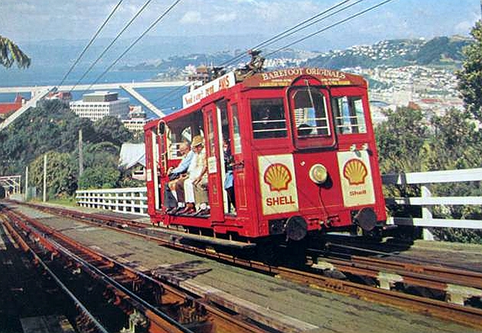However, the steep typography in the days before the motorcar was a barrier to development. Building a road was considered, but one of the developers (Martin Kennedy) suggested using a cable car to provide access up the steep hillside.

The Upland Estate Company formed the Kelburne and Karori Tramway Company to construct the cable car. The company planned to build the Cable Car and sell it to Wellington City Council when completed.

Figure 1: Wellington Cable Car – 1950 - 1970's

However, while the Council supported the objectives to increase land available for residential development, it was unwilling to commit to purchasing the Cable Car. The Tramways Act 1894 stipulated that only local authorities could construct a tramway of any description.

To resolve this, The Wellington High Levels Tramway Act 1898 was designed to “enable the Mayor, Councillors, and Citizens of the City of Wellington to acquire Power to construct a Tramway above and below Ground, and under and over the Public Reserves of the City of Wellington, and to delegate such Power.” In 1899 the council obtained an Order-in-Council authorising the WCC to build the Cable Car Tramway, which was transferred to the Kelburne and Karori Tramway Company Ltd. In December 1899 another proclamation was gazetted to give the Tramway Company the right to take land (under the Public Works Act) to build the route.

James Fulton designed the route to interfere as little as possible with existing road traffic. The dedicated route with no level crossing has contributed to the success of the Cable Car and is one of the reasons that it remains in operation today.

Fulton also decided on the method of operation which was a hybrid between a Cable Car and a Funicular.

Construction began in November 1899. Work continued both day and night including digging and blasting tunnels under existing houses. Residents complained and brought cases for compensation against the company for damage and loss of land. Claims were made of construction causing cracks in the walls of houses, and a retaining wall collapsed causing subsidence on one of the neighbouring properties.

Viaducts were also constructed using Australian hardwood, which was common for rail and road viaducts at that time. The viaducts spanned roads and what was to become Kelburn Park, now part of the Wellington town belt.

The tramway was opened on 22 February 1902. In the first days of operation, tickets were free to those interested in buying land in Kelburn.

Passenger demand was immediate and unexpectedly high. 425,000 people used the Cars in the first year of operation. Palace trams were purchased from Wellington City Council and modified for use as trailers on the uphill side of the Cable Cars. This increased seating capacity to 62.

In 1929 work began to replace the timber viaducts with steel on concrete piers. This change was completed without holding up the service, a considerable logistical achievement. Photographs of the time show that the concrete piers were constructed first.

In 1933 electricity replaced steam as the power source, allowing the removal of the ‘smoke stack’ and the steam-powered winding gear.

In 1935 the company was granted permission to remove the slipper brakes from the trailers. This decision would contribute to the forced replacement of the Cars nearly 40 years later.

The Kelburne and Karori Tramway Co became disgruntled about the Wellington City Council running buses services in competition to the Cable Car. They asked the Council to either stop competing or to purchase the Cable Car. A Supreme Court case in 1945, found that the operation of the bus services was not fully consistent with the Municipal Corporations Act 1933 and this resulted in the Council agreeing to purchase the company in December 1946.

Trams were removed from Wellington streets in 1964 which enhanced the Cable Car’s status as a tourist attraction.

In 1973 a construction worker was injured when he accidentally stepped in front of a Cable Car. This lead to an assessment of the safety of the Cable Car by the Ministry of Works, highlighting concerns about the age of the equipment and increased safety expectations from when the system was designed in 1898. The Ministry suggested that the system be renewed or even replaced.

In 1974 the Ministry of Works instructed the Wellington Transport Department to stop using the trailer carriages (which did not have brakes). They also required the timber chassis to be reinforced with steel to transmit the loads from the balance rope to the rear chassis, within six months. These requirements were intended as an interim measure to allow time for a complete upgrade including the replacement of the winding gear and Cars.

Initially, the Wellington City Council objected to the instructions of the Ministry. Public groups also formed to save the Cable Car. However, independent reports confirmed the conclusions of the Ministry identifying a lack of an automatic braking system, timber stress in the Cars and poor driver visibility. Modifications were made to try to address these concerns.

In June 1976 Wellington City Council decided to replace the Cars and the drive system. The old wooden Cars made their final run on 22 September 1978. The replacement steel framed Cars were specified with timber seats as a connection to the past and a possible way to appease those who resisted the change.

The double track was removed and replaced with a single track and a central passing loop. The intermediate stations were also replaced and relocated (where necessary) to be equidistance from the ends. Habegger supplied the new steel-framed Cars and a replacement drive system.

The new system had numerous stoppages. The service became unreliable, and passenger numbers dropped to 500,000 in 1982. In 1988 the Cars were operated on manual mode resulting in the lower Car being driven into the buffer at the Lambton Terminal. The repairs took months.

In 1991 Wellington City Council established Wellington Cable Car Limited to own and operate both the Cable Car and the overhead trolley bus network. Operations and maintenance were contracted out until 2007 then services were brought back in-house.

In 1999, at the annual survey, cracks were discovered in the lining of the middle tunnel. This prompted further investigation and core samples. A drained and anchored reinforced shotcrete lining was installed in the upper 30m length of the tunnel in December 1999.

In 2006 the station at the Lambton Terminal was upgraded, relocating the ticket box from the end of the track towards the entrance of the Terminal.

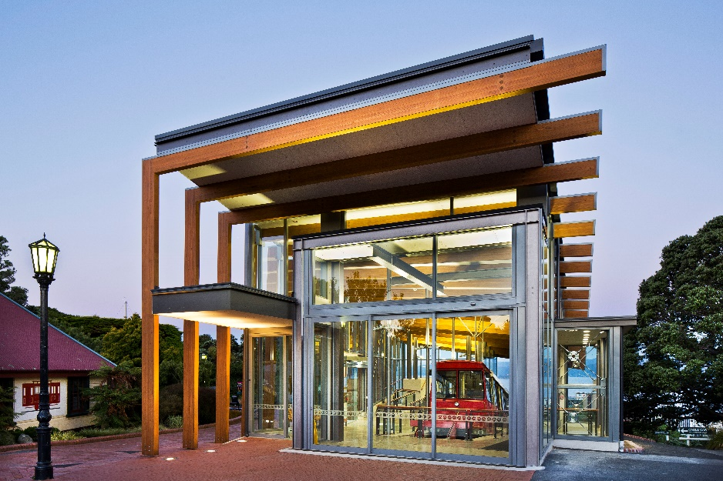In 2013 the Kelburn Terminal was completely replaced with a more enclosed building better matched to the expectations of passengers. The design uses laminated timber rafters copying the idea of the timber sleepers on the track. The new Terminal includes an elevated viewing platform to allow visitors to enjoy the views of the City and Harbour.

Figure 2: Kelburn Terminal built in 2013

# Now – Electric Drive and Controls Upgrade

Before the Electric Drive and Controls Upgrade much of the equipment dated back to 1977/78, some of which had become obsolete and difficult to maintain. Some components had been replaced resulting in equipment of different ages from a range of suppliers. Component incompatibilities resulted in the Cable Cars operating at reduced speed, particularly as the Cars approached the stations.

There were signs of corrosion on the roof panels and the possibility of corrosion on the steel framework of the Car bodies. In addition to this, the internal fit out of the Cars was dated and worn.

The main electrical switchboard in the winding room also dated back to 1977, and changes to the electrical regulations meant that it was no longer able to meet the required standard. Any changes to the switchboard would trigger the requirement to upgrade to meet the new regulations.

The office and staff facilities at the Lambton Terminal were also in need of updating and improvement.

The Ticket Kiosk needed expanding, to improve passenger flow and reduce the number of passengers queuing in Cable Car Lane.

The canopy over Cable Car Lane was badly corroded and in need of replacement.

The overall condition of the existing infrastructure together with changes in legislation and industry Standards led to the requirement for this upgrade and renewal project.

# Project Description

The main focus was the electric drive and the control system replacement. During this project, it made sense to undertake other projects that would be difficult or impossible to complete with the Cable Car in operation. The project included five main components:

1. Electric Drive and Controls replacement;
2. Replacement of main electrical switchboard;
3. Refurbishment of the Cars (including steel frame inspection and repair, roof panel replacement, exterior refinishing, replacement of internal linings, refinishing and repair of the seats, replacement of internal lighting, replacement of windows with vulcanised windows);
4. Lambton staff facilities and office upgrade; and
5. 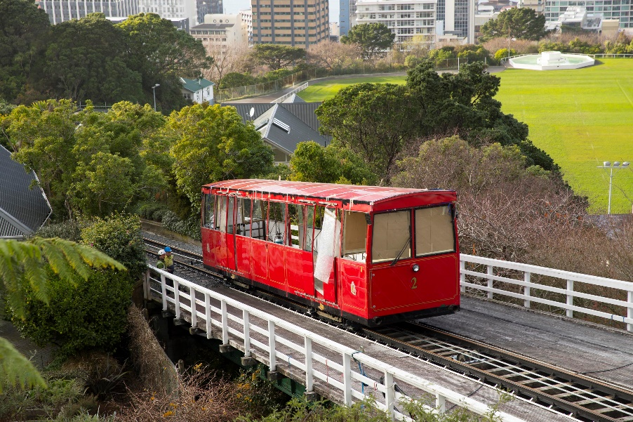Ticket kiosk replacement (completed by Hawkins for WCC as part of Cable Car Lane Upgrade.

Figure 3: Cable Car being refurbished - 2016

# Project Completion

The project was a success. The key benefits include:

* Improved future reliability;
* Improved technical support;
* Complete system documentation;
* Improved safety systems (for controls, brakes, haul rope and doors);
* New switchboard to meet current electrical regulations and with sufficient capacity for planned replacement of the Cars in 10-20 years;
* Rust in Car frames and body treated to ensure structure is robust;
* New roofs to Cars with thicker gauge steel to enhance safety if an earthquake occurs when the Cars are in one of the tunnels;
* Improved energy efficiency and installation of net metering so that WCCL gets credit for regenerative braking;
* Improved staff facilities at Lambton Quay with private office for Passenger Services Manager and additional toilet facilities; and
* Larger ticket kiosk with an additional sales position on the entry side and improve passenger flow from the relocation of entry gates.

The project was scheduled to be completed in eight weeks but took ten weeks and two days. The extra time was required to complete rust repairs on the Cars, and this work delayed the refurbishment of the Cars.

The project budget was $3,521,193. The final costs were $3,778,579. A cost overrun of 7.3% caused by additional work that emerged throughout the project (rust repairs on the Cars and additional electrical installation) and some additional tasks (replacing lighting in the Lambton Terminal, painting the interior of the winding room, etc).

The project was successful, because the work resulted in a new and improved system that meets our requirements. Projects of this scale are infrequent for WCCL, which leads to challenges setting budgets and timeframes. Although there was a modest cost overrun (7.3%) and time delay (25%), this was because additional work was identified that would improve the long-term outcomes and was best to be completed as part of this project.

1. **Electric Drive and Controls Upgrade**

The electric drive and controls upgrade was the main focus of the project, and the outcome was very successful. The electric drive and controls system is now safer and more reliable. System documentation is now complete, and we have good technical support, both in New Zealand and via an international help desk system.

Immediately after going back into service we had several teething issues. The most significant was the doors. Our suppliers revised the design of the door guides and bearing system and replaced the guides in October. After this modification, we have had very few issues.

1. 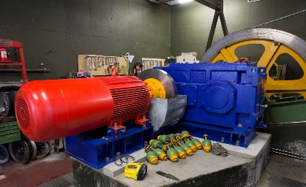**Replacement of Main Electrical Switchboard**

Figure 5: New Electric Drive

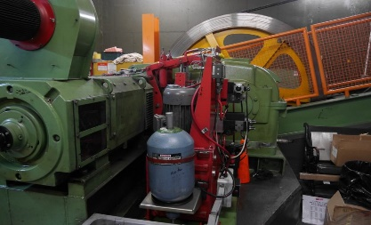The design and supply of the switchboard was arranged before the project began and the replacement switchboard arrived on site before the shutdown.   
The switchboard replacement occurred as planned; however, additional electrical work was identified during the project. The most significant of these additional tasks was the replacement of the cable supplying power from Kelburn down to the Salamanca station (180m). We also replaced the wiring and lights in the inspection pit (because the existing wiring was no longer compliant). The new switchboard meets the current electrical regulations and is sufficient to supply the future anticipated increased electrical load for the planned Car replacement

Figure 4: Old Electric Drive

An additional task added to the project was the replacement of metal halide lights in the Lambton Terminal with new LED lights. We decided to do this because of the difficulty accessing the light fittings and it was easier to do this while the Cable Car was out of service.

1. **Refurbishment of the Cars**

The Cars were refurbished to remove and treat rust in the steel framework, replace the rusting roof and improve the appearance of the Cars, both internally and externally. The project was delayed because there was additional rust in the steel frame, and our contractor had limited staff to complete these repairs. These delays meant some of the work needed to be completed at night to avoid conflict with the commissioning of the new drive and control system. The additional work to remove and treat the rust also resulted in cost increases.

The new roof panels on the Cars are of thicker gauge steel as one measure to reduce the earthquake risk to passengers if a tunnel were to collapse while a Car was inside it.

1. **Lambton Managers Office and Staff Facilities**

The modifications to the manager's office and staff facilities resulted in a significant improvement. This work involved several sub-contractors which made the health and safety management of subcontractors difficult. We noticed instances where workers were on site without the required PPE, resulting in verbal and written notification to the relevant subcontractors and our building contractor. These issues were resolved; however, concerns remained that the health and safety management of the construction work was not as robust as other components of the projects, even though no health and safety incidents were reported.

1. **Ticket Kiosk**

The ticket kiosk was completed to a stage where it was operational; however, the construction and design defects took a long time to resolve.

Because this work was completed by WCC, we were essentially outside the contractual loop; this made it difficult to get what we wanted and to get defects resolved. In addition to this, the relationship between WCC and its contractor became strained as the project progressed.

The architect was based in Auckland, which made coordinating site visits difficult. It also meant the architect could not visit the site at short notice to clarify or resolve issues as they emerged.

# Key Learnings

**Health and Safety**

WCCL have changed their site requirements for contractors to include more details on contractor’s requirements for working at height.

During the project, we replaced the floors in the Cable Car. The old floor was removed and taken to a workshop in Trentham. The old floor was used as a template to cut the new floor. In the interim plywood boards were used as a temporary floor, while work on the Cars continued. No Health and Safety incidents were reported related to this. However, with the benefit of hindsight, it would have been better to pre-cut the replacement floor based on measurements. They could have been pre-cut slightly oversized and trimmed to fit on-site, eliminating trip hazards. The decisions on this approach were made independently by a contractor, but this identifies an opportunity to question the planned approach and suggest alternatives that could reduce or eliminate hazards. There is a trade-off to be made about how much WCCL gets involved and what decisions we leave to contractors, but in hindsight, there was a safer method available to achieve the same outcome.

**Electrical Installation**

A more detailed inspection by our electrical contractors would have identified some of the issues that resulted in additional electrical costs. More detailed planning would have identified the benefits of replacing the Lambton Terminal lights with LEDs. We made good decisions as the project progressed; however, more thorough planning and prior inspection would have enabled a more accurate project budget for this work.

**Electric Drive and Controls**

The new electrical cabinets in the Cars were too high to fit below the front window. We overlooked this in the preliminary and detailed design phase of the project. A new custom-designed enclosure/cover has been made to fit into the available space which took time to be made and fitted in place. Therefore the electrical components were exposed while the interior fit-out was completed. This resulted in an additional risk from the possibility of damage to the electrical components and meant that additional work was required to fabricate the enclosure. If this had been identified earlier a more systematic approach could have been taken, which may have been quicker and lower cost. Also, the fabricated covers are difficult to remove when there is a need to reset circuit breakers, so we are now in the process of having more practical covers designed and fabricated.

**Car Refurbishment**

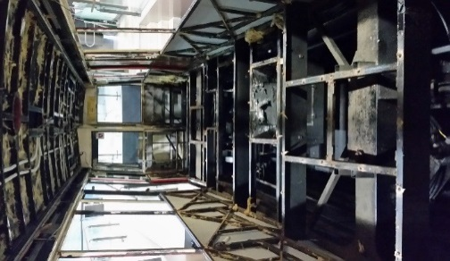The condition of the steel frame in the Cars was not well known before the project. A more comprehensive inspection may have identified the extent of the corrosion, particularly if we had inspected the floor. The areas where there was corrosion have been identified and noted, in case any inspections of the steel frames are required in the future.

The contractor responsible for the refurbishment of the Cars had limited staff with panel work experience, and therefore things slowed down when additional work was identified. A contingency plan should have been discussed in more detail to help the contractor to prepare a better response in terms of planning for more workers to be available and this would have reduced and perhaps eliminated the time delay.

Figure 4: Inside Cable Car with seats and internal linings removed (2016)

# Tomorrow – Plans/Ideas/Expectations

Our short and medium-term plans are reasonably well known; however, our longer-term planning and expectations for the future are by necessity less certain.

**Short Term Plans**

We have several small construction type projects in various stages of development to improve safety and enhance our passengers’ experience, including:

* improvements to an internal hatchway and ladder used by staff to make it safer;
* a wall mural by a local artist for our Lambton Terminal;
* installation of tactile sensors on the floor at our Lambton Terminal to improve accessibility;
* replacement of a handrail for our pedestrian overbridge at our mid station (Talavera); and
* replacement or refurbishment of our station near Victoria University (Salamanca) to improve accessibility and safety.

**Medium Term Plans**

The steel framed Cars and bogies were replaced in 1978 and are therefore now 40 years old. Although they are in good working order and are well maintained, they have a limited life. These are now planned for replacement in about 2027.

We also expect that at some time in the future auto doors or gates will be either required or expected at the stations to eliminate the chance of a passenger falling from the platforms onto the tracks. The timing for any future requirements for this remains uncertain, but in the interim, we are preparing and will consider ways to either include this or allow for it as stations are upgraded or replaced.

**Long-Term Plans**

For the longer-term decision making is more difficult. The Wellington Cable Car has been in existence since before the motor car, therefore has a long legacy. Will it outlive the motor car and become an essential public transport connection again?

While we continue to serve local users, at least half of our passengers are tourists and visitors to the City. Our financial viability is therefore linked to the continuation of tourists and cruise ships visiting the city. Will tourists continue to visit Wellington in the future and take time to ride the Cable Car and enjoy views of the city and harbour? We certainly hope so.

# CONCLUSIONS

Wellington’s iconic Cable Car is a funicular railway and one of the capital’s most popular tourist attractions. It also continues to provide an important public transport link between Kelburn and the City, as it has done since 1902. It is an important engineering achievement of historical significance.

This project successfully upgraded and renewed critical components of the infrastructure to allow the Cable Car to continue to operate reliably, meet new legislative and safety requirements and meet customer expectations.

Wellington Cable Car Limited has now implemented more systematic asset management processes and plans to responsibly manage the Cable Car now and in the future. Like all working infrastructure assets, it will continue to require investment to maintain, renew and replace plant and equipment over time.

# REFERENCES

Simon Fleisher.  *"*[*Wellington Cable Car and its Engineering Heritage*](https://www.engineeringnz.org/documents/202/fleisher_paper.pdf)*," paper presented at the 4th Australasian Engineering Heritage Conference”* (2014).

Stewart, Graham. *The Kelburn Cable Car Wellington New Zealand: celebrating 100 years of service.* Wellington: Grantham House Publishing, (2001)

Wellington City Council. *Cable Car Route – Heritage Area Lambton Quay to Upland Road*, (August 2014)

# ACKNOWLEDGEMENTS

*The authors would like to acknowledge the support of the WCCL directors Anthony Wilson and Andy Matthews for their support and guidance for this upgrade project and other infrastructure improvements at the Wellington Cable Car. Thanks also to the staff at WCCL who have assisted with the proof-reading and preparation of this report, specifically Daphne Squire, Matthew Hardy and Gavin MacIntyre.*