PRACTICE PAPER

NARROW ROADS: IMPLICATIONS FOR AUCKLAND TRANSPORT

AUTHORS

Pragati Vasisht – BE (Civil & Environmental), MEngSt (Hons) (Presenter)

Team Leader – Traffic Engineering North/West, Network Management & Safety, Auckland Transport

Email: pragati.vasisht@at.govt.nz

Mitra Prasad – BSc (Statistics & Psychology), MEngSt (Hons) (Presenter)

Principal Consent Specialist, Development Consents, Auckland Transport

Email: mitra.prasad@at.govt.nz

ABSTRACT

This paper examines, from the perspective of Auckland Transport’s role as the Road Controlling Authority, what is defined as a narrow road and the operational and maintenance implications of narrow roads compared to 'conventional' road widths.

The proposed Auckland Unitary Plan has set the blueprint for increased intensification in urban and suburban housing density in Auckland. In parallel, there has been an industry-wide push for local residential streets to be low-speed environments that prioritise safe movement of pedestrians and cyclists. A combination of these factors has resulted in new roads being developed with narrower road widths than would have been conventionally accepted. These are primarily accepted on the basis of supporting safe, low-speed environments.

Data analysis shows that narrow roads (defined to include carriageways ≤6m wide, excluding kerb and channel) are generally operating within the desirable 30km/hr design speed, in contrast with 40-50km/hr for conventional roads. However, in the absence of other traffic calming features, even a road with a narrow carriageway width and of limited length is more likely to qualify for a 40km/hr speed limit. Since there is a significant difference in trauma effects of 40km/hr and 30km/hr operating speed environment, design guidance on local residential roads must point to a combination of narrow carriageway widths and traffic calming.

Analysis also shows a clear imbalance of on-street parking on both narrow and conventional roads. Further investigation on the ‘optimum’ parking provision on a local residential street would be required, especially if this is considered as a traffic calming feature at the design stage. This is important as on-street parking provision directly affects road width and space allocation.

Narrow roads cost less for AT to maintain, compared to ‘conventional’ roads. This is only for AT-related parameters however and does not consider costs to wider Council family and other stakeholders.

INTRODUCTION

The proposed Auckland Unitary Plan (AUP) has set the blueprint for increased intensification in urban and suburban housing density in Auckland, while also setting rules for developments of a certain threshold to be served by public roads. In parallel, there has been an industry-wide push for local residential streets to be low-speed environments that prioritise safe movement of pedestrians and cyclists.

A combination of these factors has resulted in new roads being developed with both narrower road reserve and carriageway widths than would have been conventionally accepted. These narrow roads are primarily accepted on the basis of supporting safe, low-speed environments. However, practical, post-construction, operational and maintenance issues also need to be taken into account to consider the implications of accepting such infrastructure designs.

This paper examines, from the perspective of Auckland Transport’s (AT’s) role as road–controlling authority, what is defined as a narrow road and the operational and maintenance implications of narrow roads compared to 'conventional' road widths. To this end, quantitative comparison of safety and speed data, parking utilisation and maintenance costs of narrow and conventional roads is made, along with qualitative analysis of service and operational issues from narrow roads that have been highlighted to AT by end-users.

METHODOLOGY

What is a narrow road?

Prior to the release of the AUP in 2013, the District Plans of the seven former territorial authorities in the Auckland region set differing standards on the minimum road reserve widths and elements within these. Where possible, these standards have been sourced and are tabulated below. These standards generally refer to urban local roads, except Rodney District Council where the distinction between urban and rural roads is not clear.

Item | Minimum road reserve width | Minimum carriageway width | Conditions
Auckland City Council, 1995 | 12m | 9.6m | Design speed of 50km/hr and footpath only one side
Manukau City Council, 2002 | 18.2m | 7.2m | Serving no more than 30 dwellings
North Shore City Council, 2009 | 20m | 6m | Up to 60 dwelling units
Papakura District Council, 2009 | 20.5 | 6.5m | 1000 – 3000 veh/d
Rodney District Council, 2009 | 21m | 8.5m | Up to 3000 veh/d
Table 1: Minimum road reserve widths in district councils prior to establishment of AUP

While there is no official definition of a ‘narrow road’, when proposals for new local roads are received a road reserve of less than 14m and/or a carriageway of less than 6m (kerb to kerb width), is considered narrow. In general, a 14m road reserve accommodates 1.8m footpaths, 2.2m parking bays and a 3m (including channel) carriageway on both sides. In general, proposals for narrow roads are in the vicinity of 12m road reserves. Typical layout of a narrow and a conventional road is shown in Figure 1. It is observed that the main differences between a narrow road and a conventional one are:
- Dedicated service berms are removed in narrow roads. Services are underneath footpaths.
- Carriageway widths have been narrowed to 6m or less, including a typical channel width of 300mm on either side. Reference to ‘narrow road’ in the paper should be assumed to include this carriageway width.
- Parking is in indented bays and interspersed with either tree pits or rain gardens. Conventional roads provide parking within the wider carriageway.
- The gain in road space by removing service berms and narrowed carriageways is typically allocated to wider footpath and/or tree pits and rain gardens.

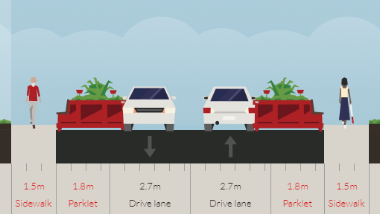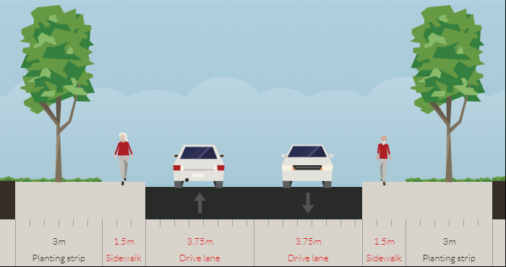
Figure 1: Typical cross-section of narrow road (left – 12m road reserve) and conventional road (right – 16.5m road reserve)

Selection criteria for sites investigated

Six conventional and six narrow roads were chosen for comparison in terms of speeds, parking utilisation, maintenance costs, and any operational issues. In selecting sites for comparison, the following criteria was considered:
- Road reserves less than 14m and/or carriageway widths less than 6.5m kerb-to-kerb. It is noted that Hihi Ave is a 16m road reserve, but has a carriageway width of 5m, which was considered worth analysing.
- Volumes less than 2000 vehicles per day. AT has released the draft Roads and Streets Framework (RASF) in parts to the wider industry, to define criteria for determining modal priorities on a given road, and the subservient Auckland Transport Design Manual (ATDM) which recommends outcome-focused road design. Roads investigated in this paper would be defined as Local Roads. The ATDM seeks to set 30km/hr as the upper limit for design speed for these. When combined with a volume of <2000 vehicles per day, such roads would be considered satisfactory for mixing of vehicular and cycling traffic due to reduced trauma effects and stopping distance compared to higher design speeds.
- Excluding sites with any traffic calming. This proved difficult with narrow roads because new developments are being required to include local area traffic management at the design stage. In addition, shorter block lengths resulting from grid layouts being recommended in the development of subdivisions, create intersections along a given length of road. This influences speeds on the mid-block on these roads as approach speeds are lowered and act as de facto traffic calming devices. However, effort was made to not include roads with traffic calming features wherever possible.
- Minimising variation in horizontal and/or vertical grades. It is noted that parts of Princes Rd and Matisse Dr have a moderate gradient, which may have influenced speeds in this section. The rest of the ten sites have relatively flat gradients.
- Excluding cul-de-sacs. It was assumed that these roads would have comparatively lower speeds by default. However, it was difficult to choose from conventional roads that were not cul-de-sacs, as historically, suburbs in Auckland have not often been designed in a grid pattern especially in the western and southern parts of the region. Cul-de-sacs have therefore been included in both narrow and conventional road layouts.
- Relatively comparable amounts of households served. The number of households served was divided by the road length to give a rough estimate of household density adjacent to a given road. Of the sites chosen, the variation of adjacent household density was relatively consistent, and therefore considered comparable for the purposes of this paper.

Of the above criteria, more weight was given to points 2 – 5 above, as these were considered to have had the largest influence on results to render them incomparable. For instance, it was not considered appropriate to compare sites with traffic calming to those without, although variations in households served would be more acceptable.

Results
Results of the speed data analysis, parking observations and maintenance costs are tabulated the next page, with discussion in the following sections.

 | Road Reserve width | Carriageway width | Road length | Dwellings |  | 85th%ile speed | 7-day ADT | Parking |  |  |  | End treatment | Traffic Calming
 |  |  |  | Served | per 100m of road | 85th%ile speed | 7-day ADT | Available | Week end | Week day | On-street parking per dwelling | End treatment | Traffic Calming

Narrow
Piper Ln | 9m | 3.6m | 138m | 14 | 10 | 27.2km/hr | 34 | 6 | 33% | 0% | 0.4 | Through | No
Teal Way | 13.5m | 6.3m | 122m | 26 | 21 | 29.0 km/hr | 97 | 6 | 183% | 150% | 0.2 | Cul-de-sac
Poaka Rd | 12m | 5m | 98m | 12 | 12 | 30.4 km/hr | 83 | 5 | 120% | 120% | 0.4 | Through | No, but another road intersects half-way.
Pohue Ave | 13.6m | 6m | 129m | 9 | 7 | 31.8 km/hr | 50 | 15 | 33% | 27% | 1.7 | Through
Harakeke Rd | 12m | 5m | 144m | 30 | 21 | 34.5 km/hr | 123 | 12 | 100% | 92% | 0.4 | Through | Raised table at northern entry.
Hihi Ave | 15.9m | 5.6m | 146m | 17 | 12 | 37.7 km/hr | 110 | 17 | 47% | 71% | 1.0 | Cul-de-sac | Surface treatment on one end.
Conventional
Malcolm St | 15.2m | 7.4m | 139m | 30 | 22 | 39.2 km/hr | 1326 | 9 | 11% | 11% | 0.3 | Through
Matisse Dr | 21m | 10.5m | 238m | 28 | 12 | 45.1 km/hr | 1423 | 44 | 11% | 14% | 1.6 | Through
Roby St | 16.5m | 8m | 253m | 33 | 13 | 45.4 km/hr | 569 | 65 | 91% | 29% | 2.0 | Through
Hereford St | 16.5m | 8m | 380m | 62 | 16 | 51.1 km/hr | 791 | 86 | 9% | 6% | 1.4 | Cul-de-sac
Kings Rd | 20.1m | 11.1m | 564m | 69 | 12 | 55.0 km/hr | 516 | 120 | 36% | 35% | 1.7 | Through
Princes Rd | 20.1m | 11.1m | 564m | 73 | 13 | 57.0 km/hr | 851 | 106 | 29% | 25% | 1.5 | Through

Table 2: Observed characteristics of conventional and narrow roads

Item | Rate per | Rate of renewal | Cost per renewal
Standard kerb and channel upstand | m | 40 | $86/m
Mountable kerb and channel | m | 40 | $92/m
Dish channel | m | 25 | $86/m
Concrete kerb blocks and channel | m | 25 | $100/m
Footpath - Concrete | m² | 40 | $80/m²
Concrete Parking Bay | m² | 25 | $95/m²
Local road pavement (<2000 vpd) | m² | 25 | $180/m²
Chip seal local road | m² | 15 | $9/m²
Asphaltic concrete local road | m² | 12 | $32/m²
Grass berm | m² | 25 | $15/m²
Street sweeping | 100m | 0.083 | $4.20/100m

Table 3: Maintenance rate of local road elements compared for conventional and narrow roads

DISCUSSION OF FINDINGS

Speed / Volume Analysis

85th% Percentile Speeds

Shown below is the comparison of speeds between narrow and conventional roads.

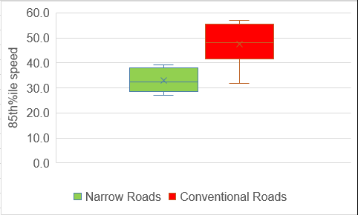
Figure 2: Comparison of 85th %ile speed

The 85thpercentile (85th%ile) speeds measured on the narrow roads are noticeably lower than those measured for the conventional streets. The mean 85th%ile speed for the narrow roads was 31.9 km/h with a standard deviation of 3.71, whereas the 85th%ile speed for the conventional roads was 48.80 km/h with a standard deviation of 6.76. With a P-value of 0.0003 for a 95% confidence interval, there is clear evidence that the 85th%ile speeds of the conventional roads is higher.

Figure 3 below sorts the roads by increasing order of 85th%ile speeds, and also compares speed profile against length of road and carriageway widths.

It is evident that narrow roads, with the exception of Hihi Ave, are generally operating within the desirable 30km/hr design speed. In contrast, conventional roads are operating within a 40-50km/hr speed environment.

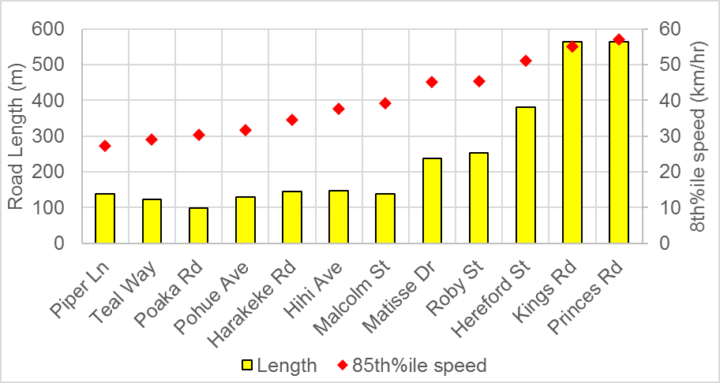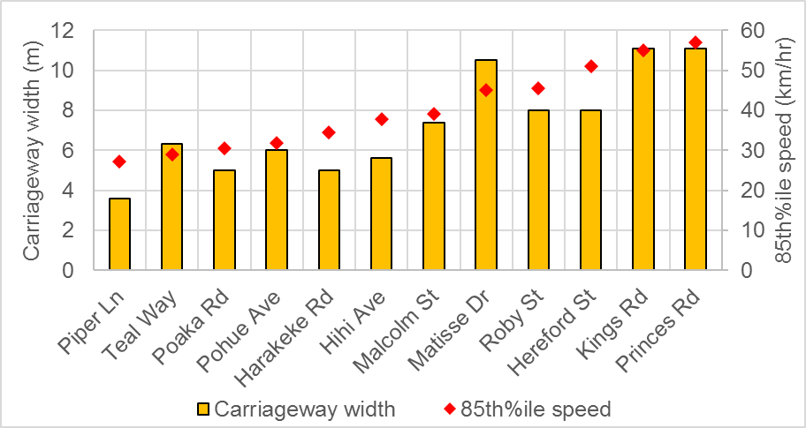
Narrow roads
Narrow roads
Figure 3: Comparison of road lengths (left) and carriageway widths (right) vs increasing order of 85th %ile speed

Furthermore, it is observed that shorter road lengths and narrower carriageways both generally co-related positively with lower speeds i.e. the shorter the length of the street and/or the narrower the carriageway, the lower the speed. However, as shown in Figure 4, road length was a slightly more reliable predictor of speed on a road, given the stronger co-relation. Though sample size is limited, the results generally support evidence that shorter lengths of road generally result in low speeds, as intersections or other physical breaks in the road create opportunities for stopping more often (Auckland Transport, 2017a).

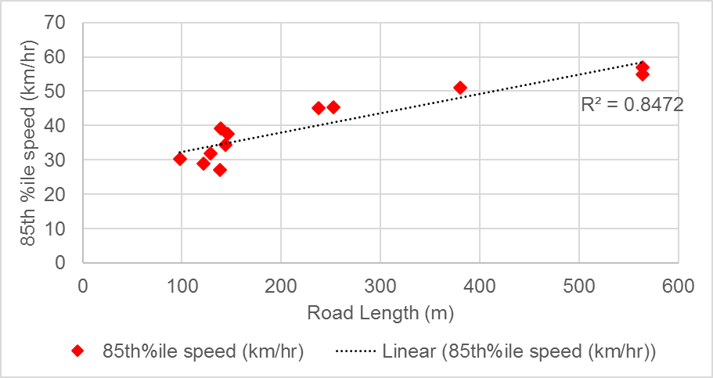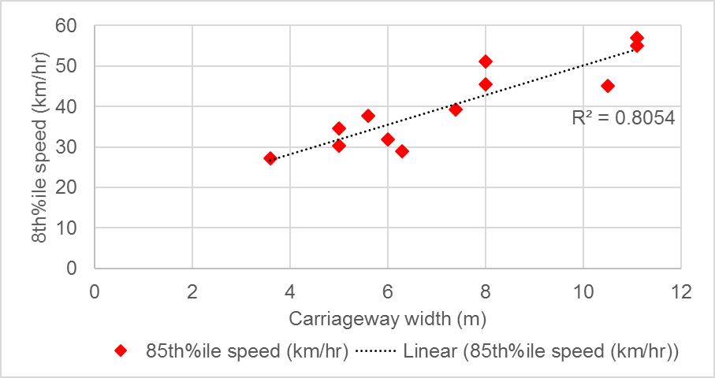
Figure 4: Co-relation between road length and carriageway width vs 85th %ile speed

Notwithstanding the above, it is important to understand any distinguishing features of the studied roads that result in such speed environments. With a 5.6m carriageway and length of 146m, the 85th%ile speed on Hihi Ave is approximately 38km/hr, in contrast to other narrow roads which are in the vicinity of 30km/hr but with comparably similar design features.

Piper Ln, Teal Way, Poaka Rd and Harakeke Rd are all fed by another local or collector road, compared to Pohue Ave and Hihi Ave which gain direct access from, or are in close proximity to, secondary arterial roads (Tapu Rd and Porchester Rd respectively). Piper Ln is also one-way road with parking on the right side of the driver (see Figure 5), which is not ‘standard’ arrangement for drivers used to two-way / two-lane roads. The horizontal alignment means that a driver’s forward visibility and/or prediction of activity in the driving lane or parking lane is also restricted. These factors could be contributing to the lower speeds.

In addition, the roads in Hobsonville Point (Teal Way, Poaka Rd and Harakeke Rd) are part of a wider master planned network, where a number of other features affect speed on the wider network, such as:
- Speed tables with basalt setts on 1:10 ramps at entry from the collector (Hobsonville Point Rd).
- Significantly tighter intersection radii of 5-6m compared to standard 10-15m.
- High parking occupancy where cars may be restricting through-movement to one-way. This is discussed further in the report.
- Other narrow roads.

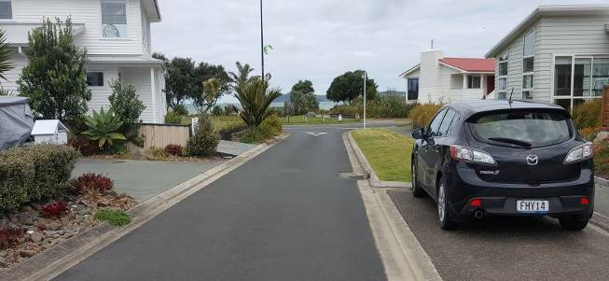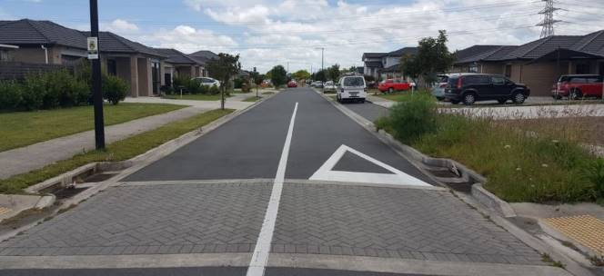
Figure 5: Parking on the right side on Piper Ln (left) and surface treatment on Hihi Ave (right)

Hihi Ave is part of the Takanini Special Housing Area (SHA), which has no vertical traffic calming features in the wider network, with only surface treatment provided at intersections as seen above. It is noted that Harakeke Rd with an 85th%ile speed of 34.5km/hr has one speed table at its end with Hobsonville Point Rd, but no parked cars reducing the through movement to one-way, unlike the other two roads in Hobsonville Point (which have speeds lower than 30km/hr). Parking is therefore a traffic calming feature in this case, although not by design. This is discussed further in the next section.

Within conventional roads, Malcolm St has the lowest 85th%ile speed at 39km/hr. The carriageway width is approximately 7m, which generally restricts movement to one-way depending on parking behaviour. It is also of the shortest length of the conventional roads at 146m. Therefore, again, parking is a traffic calming feature on this road, although ad-hoc and not by design.

Every attempt was made to choose roads that do not have traffic calming, however, it is observed that while narrow roads generally fall into the desirable 30km/hr speed zone, it is usually contributed to by other factors of design such as:
- Area-wide traffic calming
- Topography of the road (e.g. horizontal or vertical curvature)
- Location of the local road in proximity to other high-speed routes
- Length of road

Of the above, parking utilisation is notable exclusion as this cannot be accurately predicted at the design stage, and therefore future speed environment cannot be reliably predicted if on-street parking is being considered in the design.

The results therefore, cannot conclude that a narrow carriageway width, in and of itself, results in lower speeds. While it is acknowledged that the data set is limited, there is evidence to suggest that in the absence of other designed features above, even a road with a narrow carriageway width and of limited length is more likely to qualify for a 40km/hr speed limit (if a change to speed zone was being considered to legally enforce lower speeds) as seen in the case of Hihi Ave, Malcolm St, and to an extent, Harakeke Rd.

The rest of the conventional roads barely achieve an operating speed of 40km/hr, edging more towards the 50km/hr speed zone. This has significant implications for AT given that the volumes on these roads are less than 2000 vehicles per day, which is where mixed use of vehicular and cycling traffic could be considered acceptable. However, the high operating speed represents significant risk to vulnerable users in terms of the significant differences in trauma effects that the different speed zones make, as seen in Figure 6.

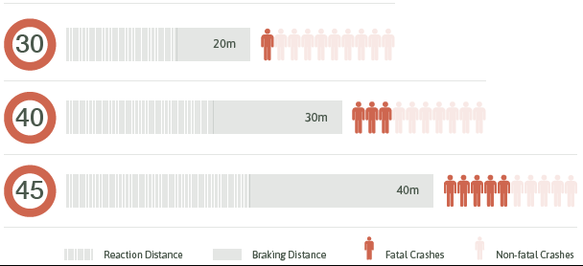
Figure 6: Effects of vehicle speeds on braking distance and fatality rates in vehicle-pedestrian collisions (Source: Auckland Transport, 2017a)

Volumes

In addition to the above, of note is the wide range in the volume of traffic between local roads that serve largely similar catchments. Figure 7 shows the sharp contrast in layout, and therefore legibility by the end-user, for roads that are essentially at a similar level on the road hierarchy (i.e. local urban road). Matisse Dr (seen on left in Figure 7) recorded 7-day average traffic volumes of approximately 1400 vehicles, compared with Harakeke Rd at 120 vehicles.

Whereas both roads provide through links for traffic, and it is accepted that the network in wider Hobsonville Point suburb is not yet complete, it is noted that narrow local roads do provide the end-user with better visual cues as to the hierarchy of the road, and therefore their expected behaviour. Site observations showed that Matisse Dr was being used as a through-route to Picasso Dr and other roads off it. Harakeke Rd could logically be used as a through-route to Kanuka Ln and other streets, however it questionable whether speeds would exceed 45km/hr as seen in Matisse Dr.

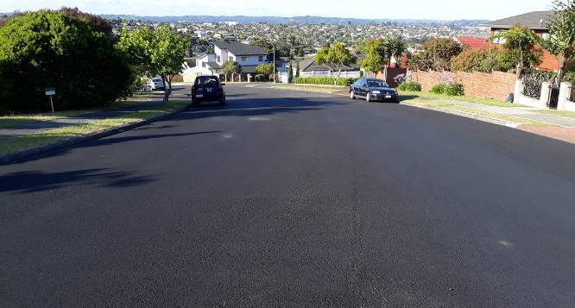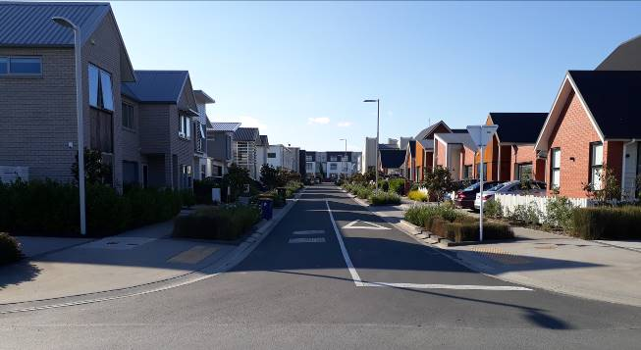
Figure 7: Conventional road Matisse Dr (left) and narrow road Harakeke Rd (right) layout design for local urban road

Implications for AT

All of the above has significant implications for AT for the following reasons.

ATDM seeks to set 30km/hr as upper limit for design speed for residential Local Streets, with one of the main drivers being reducing trauma effect, which would support walking and cycling on such streets. Results above, as a minimum, point to the fact that even when narrow road reserves and carriageway widths are being proposed, this would be better achieved with the inclusion of area-wide traffic calming (Auckland Transport, 2017b).

The majority of the local road network, which needs to be supported for walking and cycling, is arguably designed as a conventional road which is generally operating within the 50km/hr zone. Legibility of the network to achieve 30km/hr is poor, and speed-setting rules limit the official lowering of the speed unless design features support a natural speed of 30km/hr. Between December 2016 and 2017, AT’s Traffic Engineering department received upwards of 4500 customer requests, of which approximately 750, or 17%, related to concerns regarding excessive speeds (see below). Based on these requests and further analysis, in general 3-4 local area traffic management (LATM) schemes are implemented in Auckland’s road network annually, after competing with prioritisation against other safety schemes.

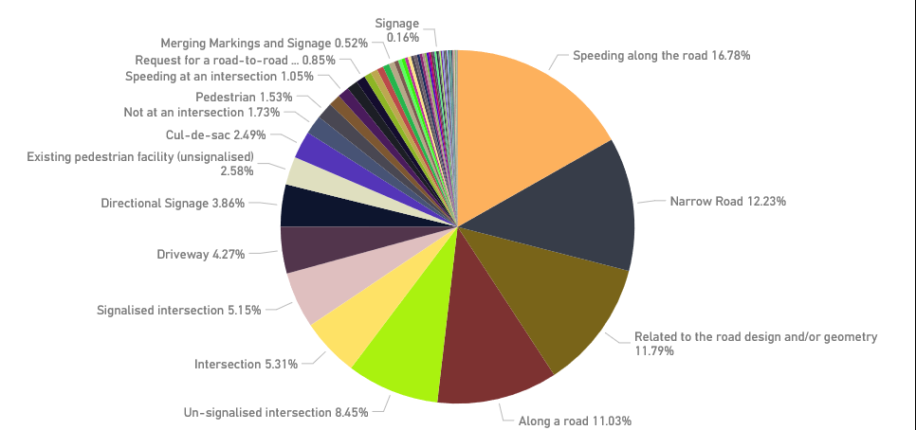
Figure 8: Customer requests received by Traffic Engineering department at AT (Dec 2016 – Dec 2017)

A strategy for systematic lowering of operating speeds in the urban road network, and potentially, a corresponding investment programme, is therefore needed. However the scale of the issue presents significant budgetary constraints. As such a programme could potentially be time-intensive, communicating safety benefits of 30km/hr zone and influencing of driver behaviour would need to be considered in the shorter term.

Parking

Parking was observed on a typical weekday (Wednesday or Thursday) and weekend for all twelve roads. On-street parking provision is compared in terms of parking occupancy and the adjacent density of housing, which has been roughly estimated as dwellings per 100m length of road.

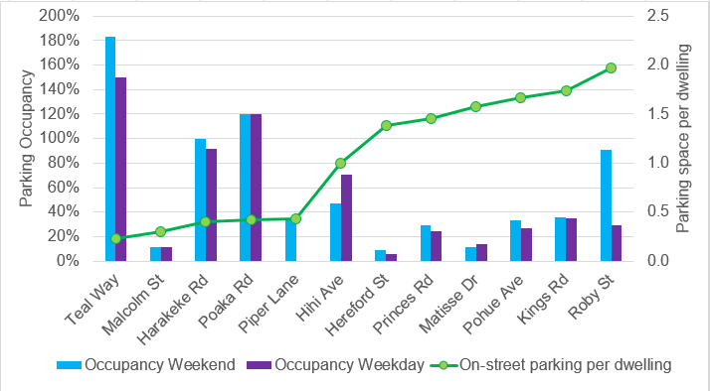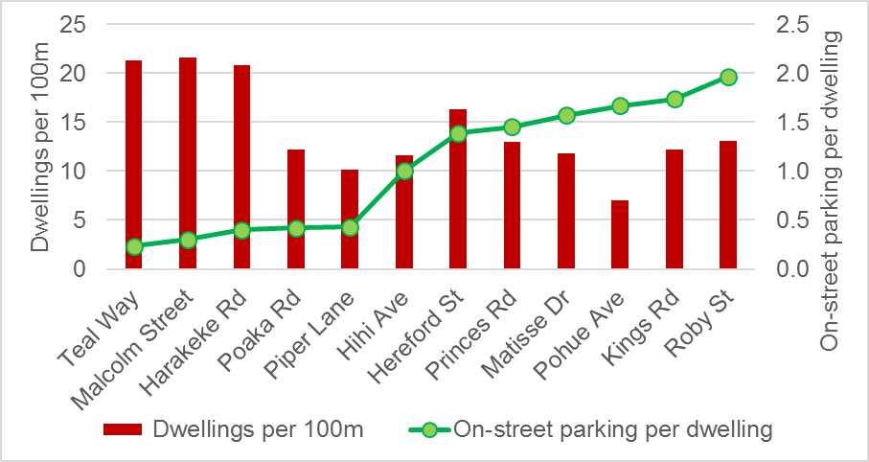
Figure 9: On-street parking rate vs parking occupancy (left) and dwellings per 100m (right). Narrow roads underlined in red.

From the above it can be seen that narrow roads have generally low on-street parking provision, which has been expressed as on-street parking spaces per dwelling served by street. The figures exceeding 100% in the graph on the left indicate parking that is occurring in spaces that are not legally available for parking e.g. in spaces between driveways where there is less than 1m clearance available from the driveway.

From both the graphs it is apparent that narrow roads are generally serving higher density areas, with comparatively lower on-street parking provision compared to conventional streets. Unsurprisingly, this is leading to very high parking occupancy. In contrast, the conventional roads clearly have an overprovision of on-street parking even when the differences in densities are taken into account. Weekend occupancy on Roby St is an outlier as there was an event in the park adjacent to an adjoining road.

The roads in Hobsonville Point – Harakeke Rd, Teal Way, and Poaka Rd – are noteworthy in particular as latter two are at the lower end of the 85th%ile speeds recorded. It was observed that the carriageway was reduced to one-way in parts due to parked cars on these roads, resulting in an ad-hoc chicane-effect. On-street parking utilisation was not a factor in the design of these roads to achieve a 30km/hr speed, which raises the question of how parking provision and utilisation is incorporated into the design to cater for adjacent land use, if at all.

Implications for AT

From the above it is clear that there is an imbalance of on-street parking provision on both narrow and conventional roads. There is some evidence to suggest that high parking utilisation does provide a traffic calming benefit, however there is little guidance available on what the ‘optimum’ parking provision on a local residential street is, especially if on-street parking is to be considered as a traffic calming feature at the design stage. On-street parking provision directly affects road width and space allocation, therefore further research and analysis is required.

Furthermore, ‘poor’ parking behaviours on narrow roads can be more pronounced than conventional roads, as there is literally less room for error. Such behaviours could include restricting the carriageway to one-way, which has an effect on lowering speeds but the public may not perceive it so. As a result, narrow streets result in a significant amount of customer requests to AT. As seen in Figure 8, AT’s Traffic Engineering department received upwards of 4500 customer requests, of which at least 500, or 12%, related to narrow roads and perceived ‘safety issues’ relating to them. Each request takes approximately 4 hours, or up to 20 hours of one engineer’s time to process, i.e. a resource-intensive exercise.

AT needs to further examine what is acceptable parking behaviour in narrow streets in particular, how this can be incorporated into the design of new roads if at all, and how the message is communicated to the end-user who is typically never involved in the design stage.

Maintenance Costs

The cost of maintaining the roads were compared in terms of items given in. All costs are given as 2017 values. Rain garden and tree pit costs were excluded from the comparison, as these water-sensitive design (WSD) features would be required for new streets regardless of street width. The size of rain gardens and tree pits is generally proportional to the impervious area drained, and therefore unaffected by carriageway widths. Street lighting, planting maintenance costs were also excluded. Also, Piper Lane was excluded from the analysis, as it is a one-way road, and the maintenance costs are not comparable to two-way roads, nor is the one-way configuration a viable alternative when considering carriageway widths in most new roads.

Costs per 100m of road, and the individual costs of roads are given in Figure 10 and Figure 11. In general it is observed that narrow roads have lower maintenance costs than conventional roads. Teal Way is the exception in this case, due mainly to the wider carriageway widths.

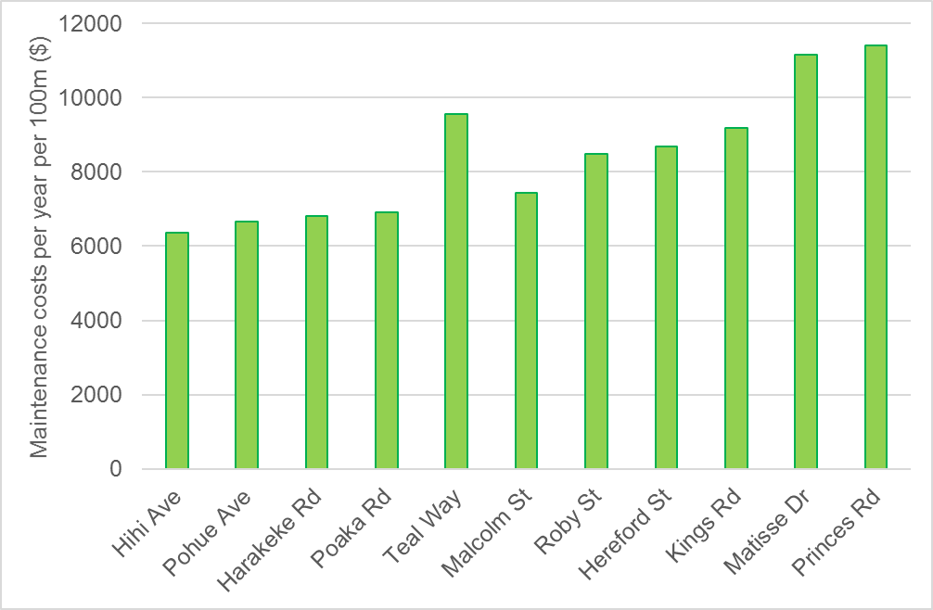
Narrow roads
Figure 10: Maintenance cost per year per 100m of road

Notwithstanding the above, this does not translate to narrow roads being cheaper to maintain in general, as a number of other issues also need to be considered in the wider perspective, such as:
- The overall number of roads. The AUP has recommended that more than 10-15 dwellings be served by a local road, which may lead to an increase overall in the number of roads, albeit of a narrow width, being vested as part of residential subdivisions. This paper does not include analysis of any such potential increase.
- If conventional roads are generally operating within a 50km/hr zone, then the potential maintenance cost would increase if and when traffic calming measures are retrofitted.
- The requirements for WSD features are taken into account in the overall costs. These can be a significant expense, although it is noted that an alternative to not including rain gardens and tree pits in road reserve could be incorporating stormwater ponds in the wider area, which are also a significant expense.
- Landscaping and amenity features which strictly speaking AT do not contribute to, but is a maintenance cost for the wider Auckland Council controlled organisations, compared to conventional streets.
- Higher maintenance costs for utility providers, which could be transferred back to the customer.

For the purposes of this paper however, the width of the road is being analysed in the context of road user safety and operational issues.

Figure 11 shows a comparison of the maintenance costs of the roading elements of each of the streets. As would be expected, longer streets have higher overall maintenance costs. For all roads, the main costs relate to the pavement renewal followed by reseal. Despite Kings Rd and Princes Rd being of identical length, the maintenance cost for Princes Rd is approximately $10,000 higher, due almost entirely to the fact that Kings Rd has chip seal and Princes Rd has an asphaltic concrete seal.

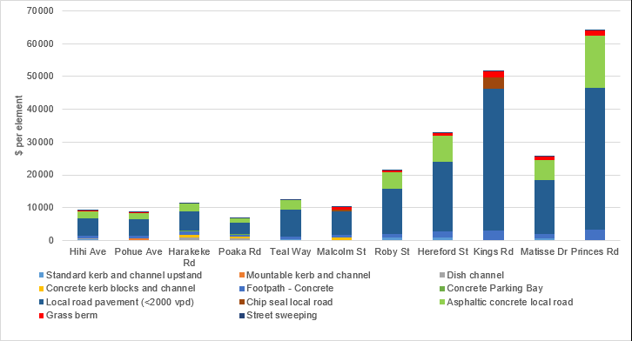
Narrow roads
Figure 11: Comparison of maintenance costs of roading elements

Limitations

The sample size of this analysis is limited. A wider sample size would have enabled a more refined analysis. Also, it is also difficult to directly compare narrow and conventional roads because traffic calming is present in some way in the former (e.g. grid patterned roads, shorter road lengths, traffic calming and narrow roads in close proximity). However, given project constraints, the sample size and comparison is considered adequate to give an indication of any issues, and where the focus of any future investigations and/or business improvements should be.

CONCLUSION

In general, narrow roads seem to have advantages in effecting lower speeds, and have lower operating costs if WSD elements are excluded. The following findings are relevant:

- Volume and Speeds: There is clear evidence that the 85th%ile speeds of the conventional roads is higher. Narrow roads are generally operating within the desirable 30km/hr design speed zone, in contrast with 40-50km/hr for conventional roads. While it is acknowledged that the data set is limited, there is evidence to suggest that in the absence of other traffic calming features, even a road with a narrow carriageway width and of limited length is more likely to qualify for a 40km/hr speed limit, as seen in the case of Hihi Ave, Malcolm St, and to an extent, Harakeke Rd. Since there is a significant difference in trauma effects of 40km/hr and the desirable 30km/hr operating speed environment, design guidance on local residential roads must point to a combination of narrow carriageway widths and traffic calming.

Further research would be required to determine what the optimum carriageway width that would result in a 30km/hr would be, if this is to be the sole ‘traffic calming feature’.

The general operation of conventional roads in a 50km/hr speed zone has significant implications for AT given that the volumes on these roads are less than 2000 vehicles per day, which is where mixed use of vehicular and cycling traffic could be considered acceptable. Physical design features would need to be retrofitted in such roads so that a 30km/hr zone can be effected. Systematic lowering of operating speeds through a capital programme would have significant budgetary implications for AT. How the benefits of lower speeds are communicated to the public through education and awareness campaigns therefore becomes crucial in the short-term.

- Parking: Analysis show a clear imbalance of on-street parking on both narrow and conventional roads. The former generally serve higher density areas with low on-street parking provision. This situation is reversed in conventional roads. Further investigation on the ‘optimum’ parking provision on a local residential street would be required, especially if on-street parking is to be considered as a traffic calming feature at the design stage. This is important as on-street parking provision directly affects road width and space allocation.

Furthermore, parking behaviours on narrow roads generate a significant volume of customer requests to AT, and therefore raising public awareness on the benefits of a lower-speed environment, and expected parking behaviour should perhaps be explored.

- Maintenance: Narrow roads cost less to maintain compared to conventional roads, mainly due to the narrow carriageway widths. This is only for AT-related parameters however and does not consider costs to wider Council family and other stakeholders.

It is acknowledged that a wider sample size would have enabled a more refined analysis, however given project constraints, the comparison is considered adequate to give an indication of any issues, and where the focus of any future investigations and/or business improvements should be.

REFERENCES

- Auckland City Council, 1995. Code of Urban Subdivision. Auckland City Council, Auckland.

- Auckland Transport, 2017a. Draft Local Path Design Guide, Auckland Transport Design Manual. Publication expected April 2018.

- Auckland Transport, 2017b. Written communication from Andy Irwin, Principal Technical Specialist – Design Office, Auckland Transport. December 2017.

- Manukau City Council, 2002. Manukau Operative District Plan 2002. Manukau City Council, Auckland.

- Papakura District Council, 2009. Development Code. Papakura District Council, Auckland.

- North Shore City Council, 2009. Infrastructure Design Standards Manual. North Shore City Council, Auckland.

- Rodney District Council, 2009. Standards for Engineering Design and Construction. Rodney District Council, Auckland.

ACKNOWLEDGEMENTS

The authors would like to thank Andy Irwin (Principal Technical Specialist – Design Office), Chris Beasley (Principal Technical Specialist – Design Office), Frans Pistorius (Principal Project Manager – Northern Road Corridor Delivery), and Cathy Bebelman (Environmental Specialist, Asset Management & Systems) for their vital inputs into this paper.

Kerb to kerb width which includes 250mm channel on either side of the carriageway.
Number of households served was divided by road length to give a rough estimate of housing density adjacent to the road.
Figures >100% indicate parking that is occurring in spaces that are not legally available for this e.g. in spaces between driveways where there is less than 1m clearance either side of the driveway.

