Transit fightback – pushback on technology hype for stronger city futures

**Wednesday 13 November, 1:00pm**

A tsunami of global media suggests autonomous vehicles and shared new mobility modes using private vehicles are solutions to the congestion, economic and environmental problems of growing cities. But much of this discussion is based on hype; the promotion of new technologies with little proof, feasibility and little basis in fact. This presentation provides new evidence that new mobility solutions using private vehicle travel remain problematic and that solutions using public transport are needed for growing cities.

Prof Graham Currie, Monash University

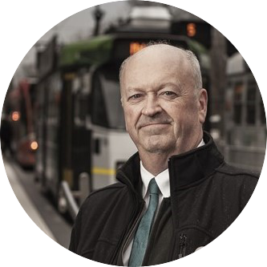Prof Currie is a renowned international Public Transport research leader and policy advisor with over 30 year's experience. He has published more research papers in leading international peer research journals in this field than any other researcher in the world. He is founder of the ‘World Transit Research’ clearinghouse (www.worldtransitresearch.info) which has consolidated all research in this field into a single accessible source and is now used by over 8,000 towns and cities in over 170 countries worldwide. Professor Currie has worked for some of the world's leading Public Transport Operators including London Transport, and he has managed numerous Public Transport research and development projects internationally.

Prof Currie’s experience spans Project Management, Demand Forecasting, Planning Methods in Public Transport, Regulatory Reviews, Efficiency and Performance Benchmarking, Training, Market Research, Investment Appraisal and Financial and Economic Analysis. Graham is also a specialist advisor to international agencies on planning transport for special events and has worked on all the summer Olympic Games since 1996 and the Hajj pilgrimage in Mekka.

Graham holds one of the worlds first full Professorships specializing in Public Transport. In this role he aims to develop knowledge and training for the public transport profession on a national and international basis. In 2015, an independent world review of academic research in the field of public transport (Heilig, Leonard & Voß, Stefan. 2015. A Scientometric Analysis of Public Transport Research. Journal of Public Transportation, 18 (2): 111-141.) found that public transport research at Monash University was the leading research group in Australia and in the top 3 in the world. In addition, Professor Currie was found to one of the most cited researchers in the field and also one of the most productive in terms of the volume of research outputs in leading research journals. In 2013 Professor Currie was lead author in a paper which won the William W Millar Award for Best Research paper in public transport at the 91st Annual Meeting of the Transportation Research Board in Washington DC USA. This is the largest transport conference in the world. In 2017 Professor Currie also won the William W Millar Award for Best Research paper in public transport at the 96th Annual Meeting of the Transportation Research Board. This means Professor Currie is the only person to have ever won this prestigious award twice. In 2017 Professor Currie was elected as a Fellow of the Academy of Technology, Science and Engineering (ATSE).