LET’S TALK ABOUT PARKING

(This paper has been peer reviewed)

Author:
Jeanette Ward,
Technical Director, Abley Ltd
MET BE (Civil) NZCE CMEngNZ CPEng
jeanette.ward@abley.com

Abstract
On-street parking plays a servicing role in some of our streets; however, its provision needs to be balanced with the other roles of our streets, and if provided it should be designed in a way that ensures people are safe from harm. On-street parking is sometimes removed when road space is reallocated, and other uses are prioritised. In some cases, there is public resistance to reducing or changing on-street parking, which can create challenges in delivering multi-modal outcomes and/or have negative safety impacts when parking is retained or provided in a suboptimal way.
There is limited New Zealand evidence available regarding the positive and negative impacts of on-street parking. A research project (soon to be published) examined the road safety and multi-modal impacts of urban on-street parking and developed strategies to help address these impacts. A literature review examined New Zealand and international research on the relationship between safety, multi-modal outcomes and parking; this included identifying approaches in planning and design guidelines that may offer mitigation strategies. A crash data analysis focused on identifying any relationships between on-street parking and safety outcomes. There were found to be several clear causes of adverse parking related safety outcomes in New Zealand.
This paper reports on the initial findings of the research and provides practical advice to transport planner and designers who are focused on outcomes relating to People, Place and Identity.

INTRODUCTION
Over the last century, many of our streets have been designed around the increasing prevalence of private vehicle movement and parking. With limited space on our road corridors, achieving multi-modal (i.e catering for a range of travel modes) outcomes often involves road space reallocation in existing streets. On-street parking is sometimes removed, and other uses of that space are prioritised, such wider footpaths, cycle facilities, bus lanes and amenity improvements. Often there is public resistance to reducing or changing on-street parking, which can create challenges in delivering multi-modal outcomes and/or have negative safety impacts when parking is retained or provided in a suboptimal way. Figure 1 shows an example of a recent street upgrade and conversion to a one-way street where on-street parking was retained due to stakeholder feedback.
While there is a growing body of data and statistics about road safety there is little data specifically and comprehensively focusing on how parking can impact the safety of other travel modes. The research undertaken sought to identify how on-street parking impacts safety, multi-modal and place outcomes and to develop strategies that contribute to improving these outcomes. It is noted that safety in the context of this research is road safety only, not safety outcomes that might arise from personal security issues. The road safety aspects focused on alignment with the Safe System approach of reducing deaths and serious injuries in road crashes. It also recognised that minor injuries, perceived safety, and inconvenience (e.g., a parked car blocking a footpath) issues can negatively impact achieving better multi-modal outcomes.
The research focused on urban on-street parking rather than off-street parking which is subject to different types of risks and management regimes. The research did not examine parking management practices in detail or examine where parking should or should not be located for economic reasons. However, it is acknowledged that there are aspects of parking management that also can improve safety, such as reducing the amount of time that drivers spend searching for car parking as this reduces the risk of conflicts. The issue of the best use of kerb side space, for example using it for parking or cycle lanes/wider footpaths was also not the focus of the research.
This paper discusses some key findings of the research and provides practical advice to transport planner and designers who are focused on outcomes relating to People, Place and Identity. The full findings and recommendations will be available with the research report is published. The structure of the paper is as follows:
- The New Zealand context
- The impacts of on-street parking
- Factors to consider when providing on-street parking
- Strategies to improve safety
- Conclusions
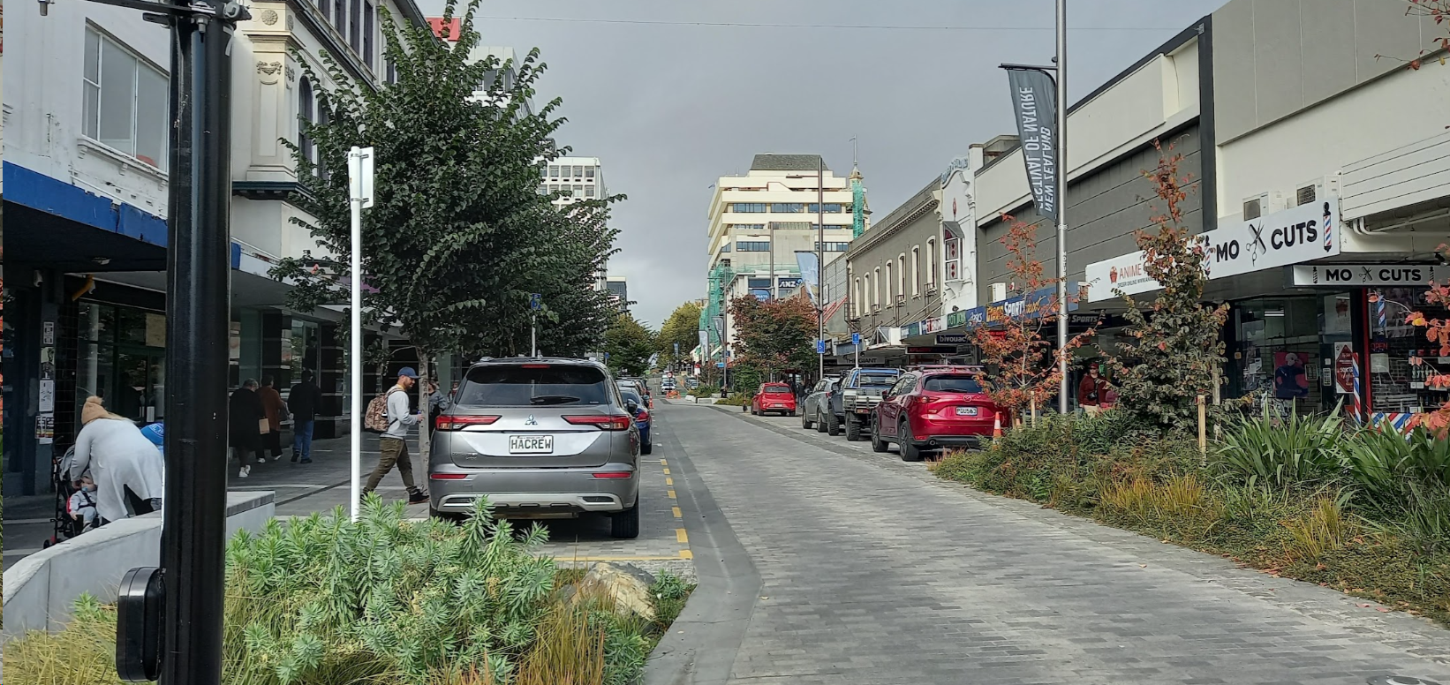

Figure 1 – On-street parking retained in a recent street upgrade

THE NEW ZEALAND CONTEXT

Parking policy and management
Good parking policy and management can contribute to better safety and multi-modal outcomes. For example, guiding where on-street parking is located through a parking space hierarchy that prioritises the types of parking in different areas or street types, can support using the road space for other uses such as cycle facilities. There are also supporting aspects such as efficient ways for people to search for parking that can reduce the number of vehicles circulating for parking, therefore reducing risk to other road users.
Road Controlling Authorities (RCAs) develop their own parking policies and management plans. Waka Kotahi’s National Parking Management Guidance (Waka Kotahi, 2021) provides RCAs with consistent, best-practice support for the management of public parking throughout New Zealand. This guidance is intended to support councils in development of parking strategies and parking management plans. It is not a design guide, but it does acknowledge that parking can contribute towards the success of a place. Parking that is poorly managed and designed can also undermine efforts to create highly liveable urban areas by, among other things, creating safety issues for other users such as pedestrians and cyclists.
Operational management of on-street parking
RCAs manage on-street car parking spaces. Parking spaces or other kerbside uses can be time restricted or allocated to certain uses. The other uses include bus stops, mobility parking, taxi or small passenger vehicle zones, motorcycle and loading zones. Each of these uses can have differing design requirements such as width and length of the space, and in the case of mobility parking step free access to the footpath. These requirements are generally well defined in standards and guidelines.
Parking restrictions and prohibitions are typically set by the RCA through ‘bylaws’. Bylaws are rules or regulations that can be made with respect to an Act, in the case of parking that is the Transport Act 1962 and Local Government Act 2002. Council RCAs generally do this by council or committee resolution while the Waka Kotahi RCA does this by published gazette. The bylaws are enforced by RCA-appointed parking enforcement officers who may issue parking notices or impose other forms of penalty, such as the towing away of illegally parked vehicles. An example of a bylaw that some RCAs have in place is the banning of parking on berms where there is a kerb.
The scale of infringement fines for parking are set by the New Zealand Government (Land Transport (Offences and Penalties) Regulations 1999). At present, the magnitude of fines is generally known by the public to be low and therefore people often risk a parking violation due to the low scale financial penalty. An increase in the scale of fines has the potential to influence behaviour but would most likely need to be in conjunction with more stringent enforcement to have the desired impact.
On-street parking layouts
In New Zealand parking on-street is usually either parallel (with the kerb or road edge) or angle (angle varies from 30 to 90 degrees) parking configuration. Some streets may have parallel parking on one side and angle parking on the other side. Angle parking can also be located in the middle of the road on very wide streets.
Parking, both parallel and angle, can be indented between kerb buildouts. The zone containing parking and the kerb buildouts is often referred to as the ‘amenity zone’. A key benefit of this arrangement is that when the parking is not being used, the street width from a driver’s perspective is less conducive to them increasing their speeds. The kerb buildout areas provide an opportunity for pedestrian crossings (reduced crossing distance and improved visibility between pedestrians and drivers), for placemaking (landscaping, seating, etc.) and for cycle parking.
Examples of the typical configurations are shown below in Figures 2 to 5.
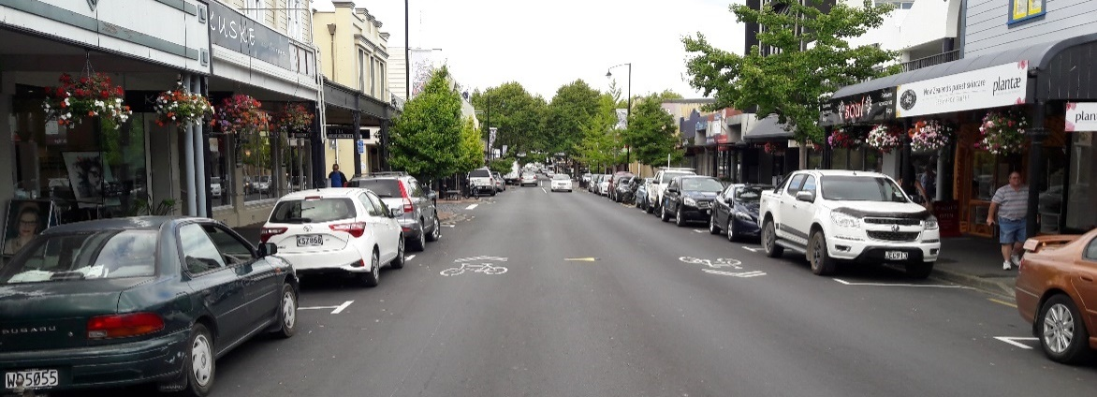
Figure 2 – Parallel parking on both sides (Nelson)
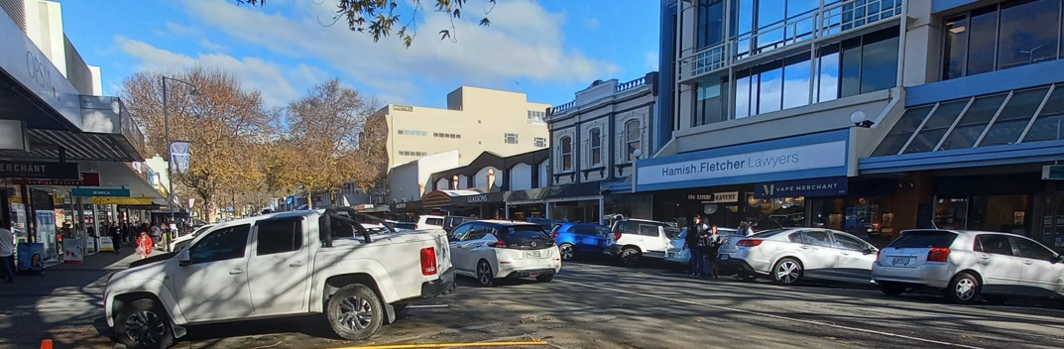
Figure 3 – Angle parking on both sides (Nelson)
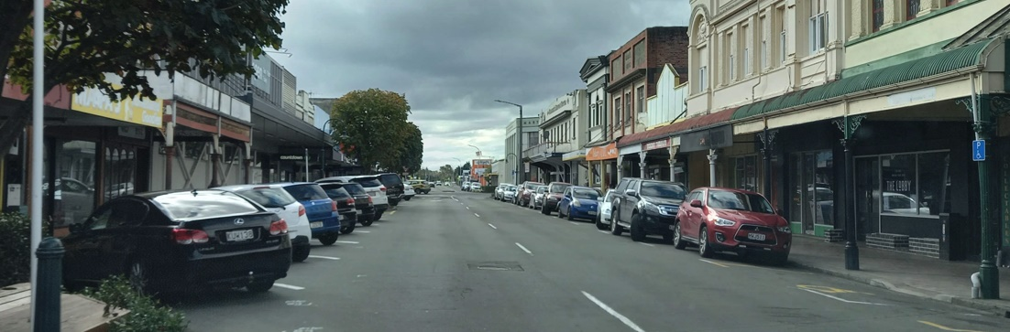
Figure 4 – Angle parking on one side, parallel parking on the other side (Marton)
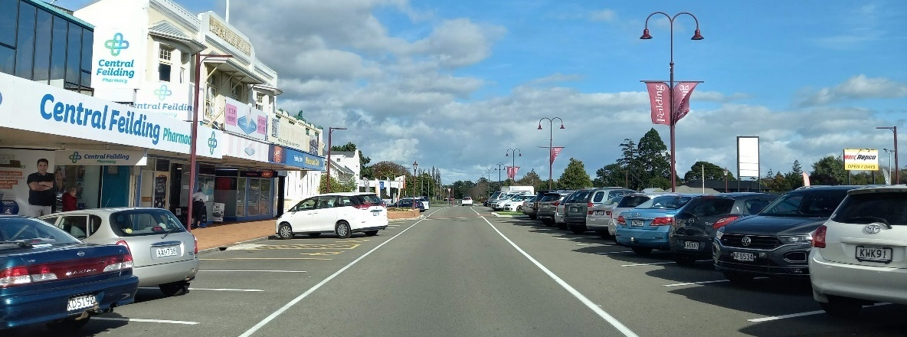
Figure 5 – Angle parking on the side (60 degree) and the middle of the road (60 degree) (Fielding)

THE IMPACTS OF ON-STREET PARKING

Overview
On-street parking can create effects that impact safety and multi-modal outcomes.
Biswas et al. (2017) undertook a review of the positive and negative effects of on-street parking, considering its effects on safety, traffic and the local economy. Their review summarises much of the literature available on this topic. A review was also conducted by Sisiopiku (2001), which reached similar conclusions.
Safety and multi-modal related impacts of on-street parking outlined in these reviews were:
- Traffic calming function – potential positive effect
- Buffer between pedestrians on the footpath and moving vehicles – potential positive effect
- Can cause crashes – definitive negative effect
- Can deter people from using active modes – potential negative effect
Traffic calming
Praburam and Koorey (2015) investigated the impact of on-street parking utilisation on 10 residential streets in Christchurch (all with 50 km/h speed limits). The streets in the study ranged from 8 to 13 metres in width. Analysis of vehicle speeds showed that as parking occupancy increased, the traffic speed fell gradually. Interpolation of the data (assuming a linear relationship) indicated that a 10% increase in parking occupancy is associated with a 1 km/h speed reduction. Speed reductions were less clear on narrow streets than on wider streets. Crash outcomes were not part of the research. The authors suggest that parking on residential streets plays a role in speed management in those environments, however the overall safety benefits are not clear, since parked vehicles can also obstruct sightlines. This research is consistent with the idea that heavily used parking decreases the optical width of the road and that road optical width influences driver travel speed (Lindenmann, 2007).
Marshall et al. (2008) found that injury crash rates per mile in low-speed environments (less than 35 mph) are lower in places where there is on-street parking compared to those with no parking, hypothesising that drivers compensate for the increased complexity of the environment. The research also showed that in higher speed environments on-street parking is associated with high injury crash rates.
Buffer for pedestrians
Compared to bicyclist safety there was comparatively little research found on pedestrian safety impacts of on-street parking. Some literature showed that on-street parking generally has a negative association with pedestrian safety or perceived pedestrian safety. None of the studies in the literature review identified that on-street parking is seen by pedestrians as an additional buffer to moving traffic. However, one design guide mentioned that an advantage of parallel parking is to create buffer to moving traffic (Auckland Transport, n.d.) and this is most likely related to the footpath width. For example, a narrow footpath, say less than 2m, next to traffic moving at 50km/hour will feel very uncomfortable and the presence of parked cars is likely to improve comfort levels.
Crashes
An analysis of the NZ Crash Analysis System data between 2017 and 2021 found that there were 14,030 urban crashes of all severities involving parked cars or because of the act of parking. This is 7.7% of all reported crashes and 2.5% of all DSIs which occurred during the 5-year period. The parking related DSIs included nine fatal crashes and 286 serious injury crashes, Table 1 shows these outcomes by mode.
Table 1 – DSI crashes by mode
Injury Severity | Pedestrian | Cycling | Motorcyclists/mopeds | Car occupants
DSI | 40 (13% of DSIs) | 73 (25% of DSIs) | 32 (11% of DSIs) | 150 (51% of DSIs)
The majority of DSI crashes involving parking were vehicle collisions with parked cars. Many of these crashes were due to loss of control, visibility being obscured (sunstrike or fog), or inattentive driving. Some were also due to the driver experiencing a medical event while driving or falling asleep at the wheel. Vulnerable road users (pedestrians, cyclists and motorcyclists) made up almost half of all serious injuries from parking related crashes and over two-thirds of all deaths in parking related crashes in this five-year period. Cycle DSI crashes related to parking are the highest for vulnerable road users.
It was found that determining the total number of crashes caused by a parked vehicle limiting visibility is difficult to quantify given the number of factor codes used for this scenario. It is also likely that crashes due to parked cars limiting visibility are not reported as such at all. There was one serious crash on a street with a one-way separated cycleway where there is parallel parking between the separated cycle lane and traffic. A car turned left into a driveway and the driver did not see the cyclist due to parked vehicles blocking the view of the cycle lane. Separated cycleways are a relatively recent development in cycle provision so there is not expected to be much crash data related to these with respect to parking interactions at this time.
It should be noted that, due to CAS under reporting rates, it is likely that the actual number of serious injuries is more than double the reported amount. One source estimates that, while 1 in 2 vehicle serious injuries are reported, only approximately 1 in 7 cyclist serious injuries and approximately 1 in 8 pedestrian serious injuries are reported in CAS (ViaStrada, 2021).
Injury claim data in relation to parking were requested from ACC for the 2017 to 2021 period. The key limitation with the data was that there was no way to differentiate between on-street and off-street parking. There is also the chance of false positives due to the nature of the way the data are extracted. Overall, there was limited alignment with the CAS data due to the way the claims are recorded.
There are several clear causes for parking related DSI outcomes in New Zealand that could allow a focus for improvement in how streets are designed and managed, and also how driver behaviour may be influenced. The key DSI outcomes are:
- Car door opening into cyclist’s path
- Cyclists colliding with parked cars
- Pedestrian crossing the road from the drivers left side and being struck by the vehicle.
Crashes - Dooring crashes
It is clear from the literature and crash data that car door opening into the path of cyclists is the main cause of cycle / parking related crashes and has the highest proportion of DSI outcomes. Available data from a range of jurisdictions (USA, Canada, Australia) suggests that car dooring crashes account from about 12% to 27% of all bicycle-motor vehicle crashes (Schimek, 2018). Most of the New Zealand crashes were due to the door hitting the cyclist and knocking them off their bike, usually into the traffic lane.
The CAS dooring crash data were compared with the findings of The University of Otago Injury Prevention Research Unit (IPRU) demonstration project that resulted in a New Zealand cyclist / dooring map (Injury Prevention Research Unit, n.d.). The purpose of the IPRU project was to determine the feasibility of developing and displaying a publicly accessible interactive web-based map of police reported dooring-related bicycle injuries among New Zealand cyclists.
IPRU used the 2007 to 2011 CAS data and found that 245 cycle dooring injuries were reported in New Zealand (mean = 49/year). These represented 6% of all cyclist injuries involving motor vehicles. They found this compared to 19.4% in Victoria, Australia. The 2017 to 2021 CAS data featured 180 dooring crashes.
The literature generally recommended reconfiguring road space to allow for wider bicycle lanes or shifting the lane to the kerb side of parking. There are likely to be opportunities to improve layouts at high-risk locations. Figure 6 shows a layout that increases the risk of dooring, extension of the no-stopping lines would improve the situation, and a design where the cycle lane is on the kerb side of parking removing the dooring risk.
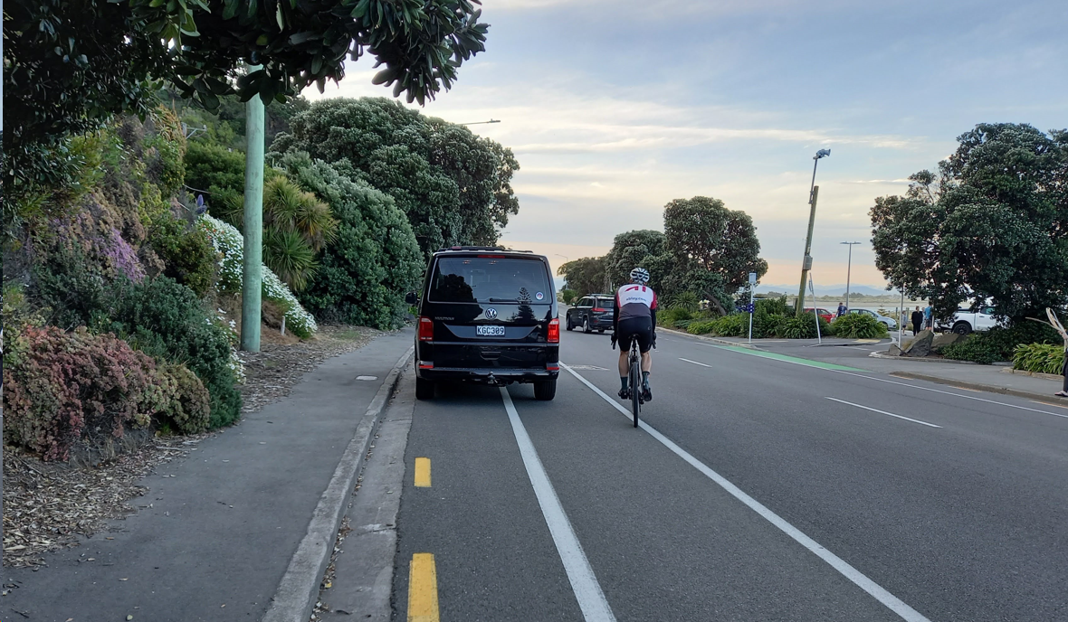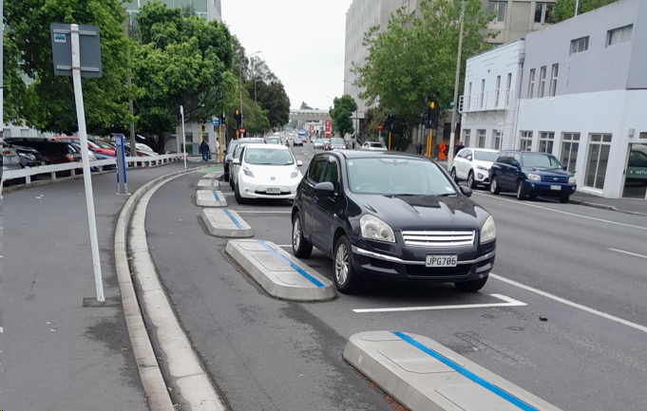

Figure 6 – Cycle lane / parking layout with high dooring risk (left) and layout that removes dooring risk (right)
Crashes - Cyclists colliding with parked cars
A cyclist colliding with a parked vehicle was also a clear crash type. Some of these crashes included illegally parked cars (e.g., cars parked in cycle lanes), parking near bends or intersections, cyclists being distracted/sunstrike, handlebars clipping wing mirrors and taking evasive action. Although there are a range of factors in this crash type, it is important in the design of streets that layouts do not increase the risk of cyclists colliding with parked cars. Figure 7 shows an example of a layout that may increase risk of cyclist colliding with a parked car due to the termination of the cycle lane and cyclists being required to merge into the traffic lane over a short length.
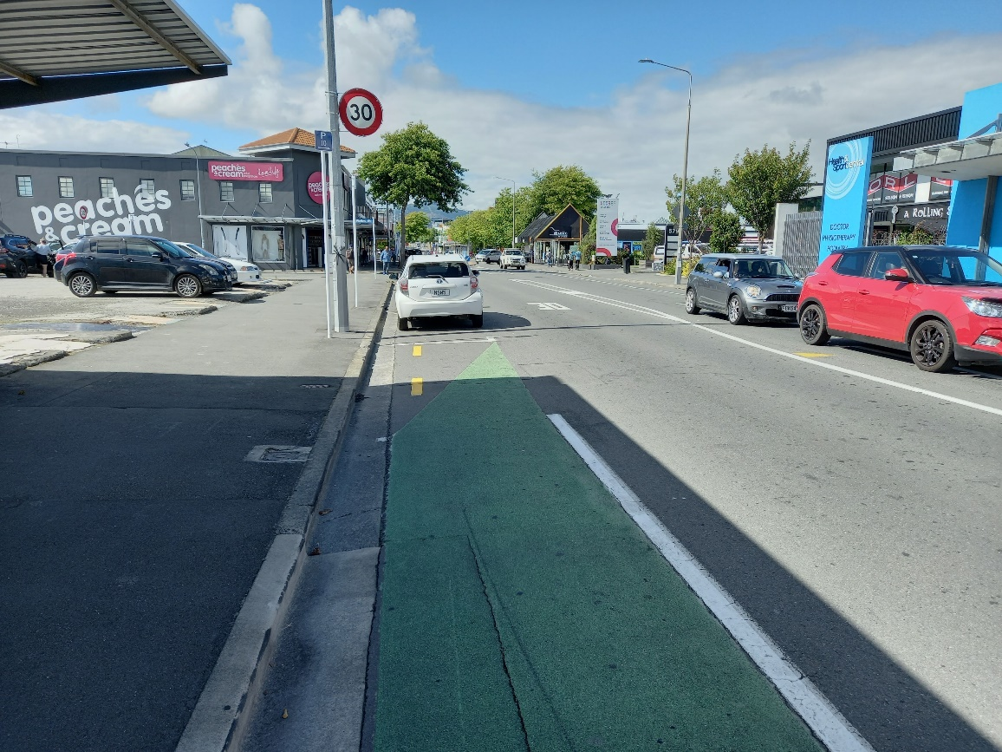

Figure 7 – Layout that may increase risk of cyclist colliding with a parked car
Crashes - Pedestrian crossing the road from the drivers left side
The highest proportion of parking related crashes involved pedestrians crossing the road (pedestrians struck when emerging on the drivers left side when crossing the road). This included streets that were lined with parked cars, potentially obstructing the driver’s view of pedestrians attempting to cross. The data did not always state whether the crash occurred at a formal pedestrian crossing facility. Many of the pedestrians in these crashes (particularly serious crashes) were children and many were near a school where buses and cars are parked on the street at the end of the school day.
Parked vehicles can obstruct the view of oncoming vehicles. Some were related to parked cars being too close to pedestrian crossings. Some crashes occurred when a person was trying to get into the vehicle from the traffic side and was hit by a passing vehicle travelling too far left. The change in vehicles in the New Zealand over time has seen more SUVs and UTEs in the fleet, these are higher than sedans by approximately 300mm. This increased height of vehicles could be contributing to decreased visibility past these vehicles when parked near intersections or pedestrian crossings.
In the case of formal crossing locations, the design can ensure visibility is not obscured. Figure 8 shows an example of appropriate no-stopping restriction on approach to crossing that allows good forward visibility of people about to use the crossing. Where people cross between parked cars lower speed environments will help reduce the injury severity if a crash were to occur.
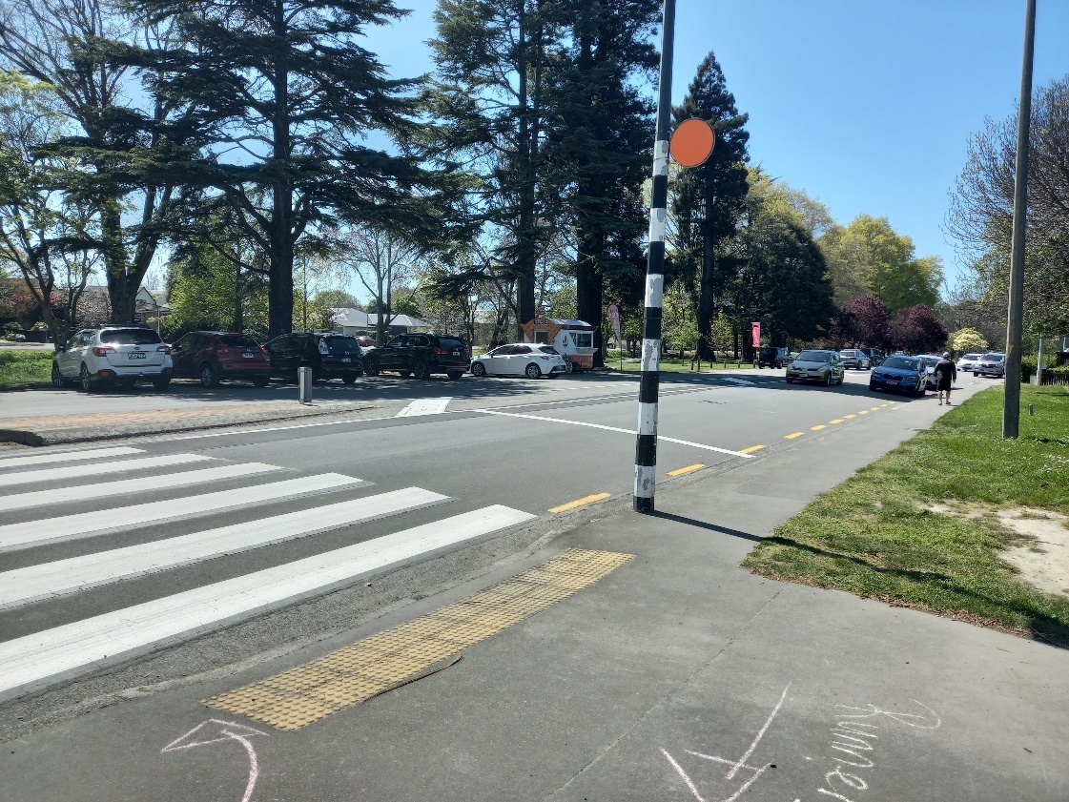
Figure 8 – Appropriate no-stopping restriction on approach to crossing
Detering people from cycling
A study sought to understand how New Zealand cyclists perceive the levels of service provided by different types of cycling infrastructure, considering complex external factors (such as motor vehicle traffic, land use, hills and environmental conditions) (Bowie et al., 2019). A further purpose of the study was to provide a user-centred approach to assess existing and proposed facilities that would enable better-informed decisions about target cycling levels of service and key factors to manage in the planning and design of cycle facilities in New Zealand. Through a series of user surveys, the study found that even when riders rated road sections with a relatively high level of service based on the experience they had on the day of their ride, they often included comments about the danger of car doors opening, vehicles being stopped in the cycle lane, and cars entering and leaving parking spaces. Other literature reported that the risk from parking deterred people from cycling.
Detering people from walking
A vehicle parked on the footpath or in a driveway can block the footpath and require footpath users to detour around this obstacle, this is difficult for someone with a mobility device. Figure 9 shows an example of driveway parking blocking the entire footpath. Parking in this manner is covered by the Road User Rule (clause 6.14) which states that a driver or person in charge of a vehicle must not stop, stand, or park the vehicle on a footpath or on a cycle path. However, this is unlikely to be enforced unless someone makes a complaint.
There is no consolidated New Zealand data on how often this occurs and what measurable impact it has on deterring people from walking. Social media posts in community forums observed by the author indicate this type of parking infringement is a regular occurrence.
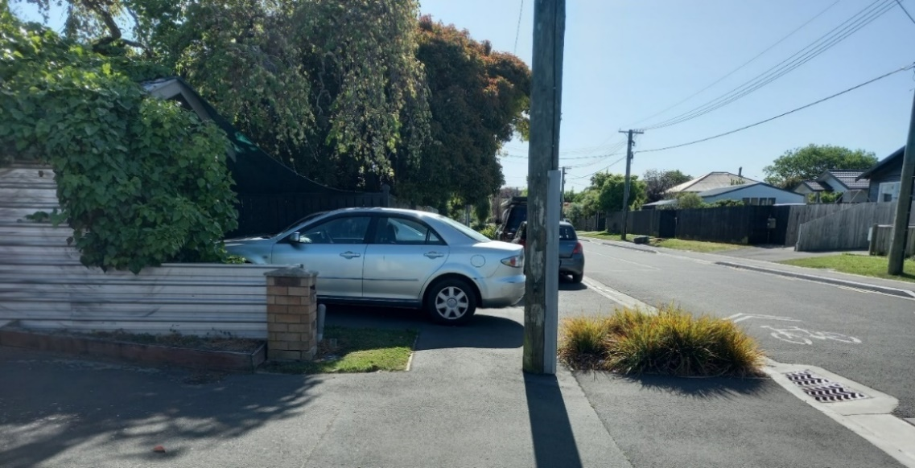
Figure 9 - Driveway parking blocking footpath

FACTORS TO CONSIDER WHEN PROVIDING ON-STREET PARKING
When designing or configuring a street layout there is a range of aspects to consider that can impact on the parking supply, management and design decisions. The supply decision is generally associated with a Parking Management Plan for the area. If parking is to be provided the key layout aspects to consider are the role of the street (movement and place), speed environment and external factors. External factors may include stakeholder influence during the design process, which can impact the parking design decisions, both in terms of supply and layout.
Table 2 outlines the advantages and disadvantages of various parking layouts that need to be considered when determining the parking layout for a street.
Table 2 Advantages and disadvantages of parking layouts that inform decision making
Parking type | Advantage | Disadvantage
Parallel parking | Has less disruption on flow of traffic  Has fewer crashes associated with manoeuvring out of parking spaces than angle parking | Accommodates fewer spaces along the kerb edge than angle parking  Creates a car door opening risk to cyclists on the road, pedestrians on the footpath, or pedestrians and cyclists on shared paths
Angle parking – 90 degrees | Provides more spaces than parallel parking  Can access the spaces from both traffic directions  Services more spaces per paid parking terminal if using walking distance as a parameter | Roadway width needs to be able to accommodate spaces  Not suitable next to a cycle lane unless there is an adequate buffer for parking manoeuvres  Crash risks when vehicles exit, whether there is a cycle lane or not
Angle parking – 30-60 degrees | Provides more spaces than parallel parking  Works better on a one-way street due to direction of access and egress | Roadway width needs to be able to accommodate spaces, this can mean that parking is only feasible on one side of the road  Depending on angle, it may be difficult for drivers parked to enter the traffic stream.  Not suitable next to a cycle lane unless there is an adequate buffer for parking manoeuvres  Crash risks when vehicles exit
Reverse in angle parking | Reduces the risk to cyclists passing behind the parking as drivers facing the road (but a buffer still recommended)  Safer for drivers and passengers accessing the rear of the vehicle, such as for loading/unloading prams/young children, shopping, etc. | This type of parking is uncommon in New Zealand and therefore may not be familiar to road users.
Angle parking in middle of the road (usually 90 degree) | Can help create a traffic calming effect but needs landscaping at intervals so that when spaces are empty the road width does not look excessively wide  Allows access from both directions of traffic | Requires very wide road reserve  Should not be used on arterial roads Pedestrians have to cross one carriageway when leaving and returning to the vehicle  Crash risks when vehicles exit

STRATEGIES TO IMPROVE SAFETY
Integral to the decision-making process on parking supply and design layouts are the safety and design strategies that need to be applied to improve road safety and multi-modal outcomes. A range of safety and design strategies to help mitigate the risk of various layouts emerged from the literature review and will be outlined in the soon to be published research. Further mitigations that are currently not in any regulations, practices or guidance were also identified. Current New Zealand guidance in relation to parking safety mitigations is generally integrated into modal specific guidance with particular attention given to pedestrian and cyclist safety.
The research identified that designs that remove parking to achieve road safety and multi-modal outcomes can then be influenced by stakeholders to the point that the design is changed and potentially compromised. This is a common issue, and regardless of how much information is provided to the decision makers, the design can be overridden by the external influences. It is likely that a range of measures will be needed to address this however, the Safe System Audit is the most commonly used and required measure, so it has the greatest potential to influence outcomes.
Many of the issues raised in the research generally relate to insufficient space for all modes including parking, this is a function of the existing standard carriageway and corridor widths in New Zealand. Addressing this involves design standards for new roads with consideration of what needs to be catered for on the range of street types.
An example of the strategies as they apply to one of the key safety risks associated with on-street parking is included below.
Dooring
A car door opening into a cyclist’s path was clearly noted in the literature review and safety analysis as a key risk for cyclists in relation to parking. Mitigating this risk requires a safe system approach as shown in Figure 10.
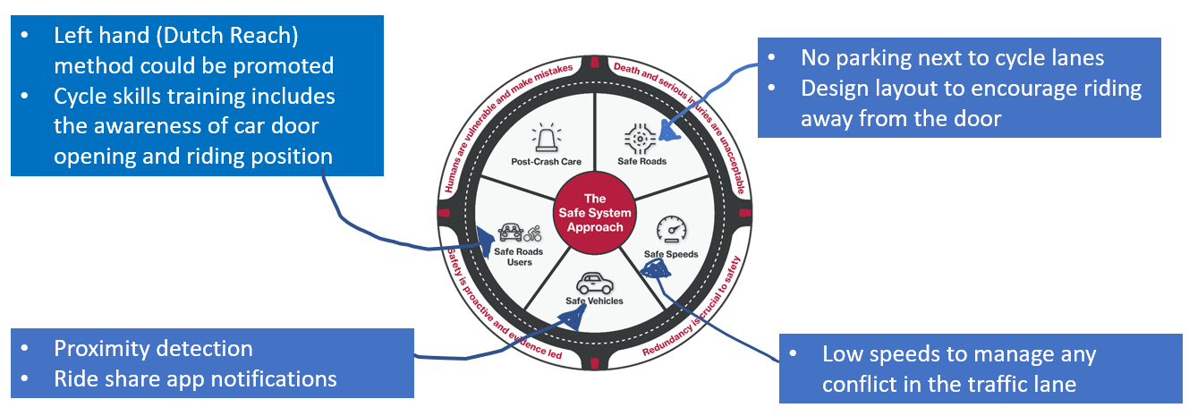
Figure 10 – Safe system approach to mitigating dooring risk
Safe roads - Measures include:
- Remove parking – this will be a key decision in the street space allocation design process
- Provide separated cycleways
- Cycle lanes located next to on-street parking should be at least 1.8m wide
- Buffer marking on cycle lanes to encourage riding away from doors
- Sharrow markings also help cyclists locate themselves away from car doors
Safe speeds – Measures include:
- Apply the safe and appropriate speed

Safe vehicles– Measures include:
- Ride share notification apps - It is noted that Uber has added messaging to customer apps when customers are being dropped off in a street with on-road cycle lanes to check for cyclists before exiting the vehicle.
- Proximity detection – It is noted that both Ford and Volkswagen are taking steps to prevent occupants in their vehicles from “dooring” cyclists and other vulnerable road users. Both companies will be implementing warning systems in more and more of their vehicles.
Safe users – Measures include
- Dutch Reach method – This is where people use their left hand to open the door, forcing them to look over their shoulder, this is mentioned in the NZ Road Code but not promoted.
- Cycle riding location training /education regarding where to ride in the cycle lane or in a traffic lane next to parking without cycle lanes.

CONCLUSIONS
As well as the safety issues found to be related to on-street parking, there are other impacts that can affect achieving good multi-modal outcomes. Illegal parking behaviours can create issues for people using cycle facilities and footpaths (particularly people with mobility impairments). It was also found that cyclists feel less safe riding in places where there are parked cars, even if there is a cycle lane. This can contribute to people choosing not to cycle.
Good parking policy and management can contribute to better safety and multi-modal outcomes. Parking management can also guide where on-street parking is located through a parking space hierarchy that prioritises the types of parking in different areas or street types. This can support using the road space for other uses such as cycle facilities.
There are various ways that parking can be provided within a street, each having advantages and disadvantages depending on the context. When people are designing streets, they have a range of parking related aspects to consider as part of the parking layout decision, including any local parking management plan, the role of the street, speed management, traffic characteristics, space available and external factors. Good street design can reduce the likelihood of a crash. The Safe System Audit process should capture any parking related safety issues and can be used by RCAs to engage with stakeholders lobbying for a design that creates a suboptimal safety outcome.
Integral to the decision-making process of parking layouts are what safety and design mitigation strategies are available to help improve road safety and multi-modal outcomes. A range of existing and potential strategies were identified in the research. Cyclist safety issues have the greatest number of strategies due to their risk in a range of cycle facility and parking layout scenarios.
A range of regulatory, driver behaviour, safety campaigns and design guidance improvement recommendations are made to help address safety issues and contribute to better multi-modal outcomes. This paper illustrates this through the example of ‘dooring’, a wider range of scenarios will be outlined in the soon to be published research.

ACKNOWLEDGEMENTS
I would like to acknowledge the inputs from the following people into the research on which this paper is based:
- Shane Turner, Abley Ltd, Christchurch
- Aini Fayaz Mansoor, Abley Ltd, Christchurch
- Lorelei Schmitt - Waka Kotahi, Principal Multi-Modal Advisor, Safe & Sustainable Standards
- Mark Edwards - Waka Kotahi, Multi-modal, Programme & Standards, Transport Services

REFERENCES
Auckland Transport. (n.d.). Transport design manual, engineering design code – Parking design, version 1. https://at.govt.nz/media/1985459/5794-tdm-engineering-design-code-parking-version-1.pdf
Bowie, C., Thomas, J., Davison, A., O’Donnell, K., & Kortegast, P. (2019). Factors affecting cycling levels of service (NZ Transport Agency research report 660). https://www.nzta.govt.nz/resources/research/reports/660/
Biswas, S., Chandra, S. & Ghosh, I. (2017). Effects of on-street parking in urban context: A critical review. Transportation in Developing Economies, 3, DOI 10.1007/s40890-017-0040-2.
Injury Prevention Research Unit (IPRU). (n.d.). NZ cylist/dooring map released by IPRU. University of Otago. https://blogs.otago.ac.nz/ipru/research/cyclistdooringmap/
Lindenmann, H. (2007). The Design of Roads and of the Road Environment in Small Rural Communities. Transportation Research Record, 2025(1), 53-62.
Marshall, W., Garrick, N., & Hansen, G. (2008). Reassessing On-Street Parking. Transportation Research Record, 2046(1), 45-52.
Praburam, G. & Koorey, G. (2015). Effect of on-street parking on traffic speeds. Paper presented at IPENZ Transportation Group Conference, Christchurch, New Zealand.
Schimek, P. (2018). Bike lanes next to on-street parking. Accident Analysis & Prevention, 120, 74-82.
Sisiopiku, V. (2001). On-street parking on state roads. ITE Annual Meeting Compendium, Washington DC
ViaStrada Ltd (2021). Safety of people travelling outside 86 vehicles. Deep dive review: First and second phase. Report for Auckland Transport, Nov 2021.
Waka Kotahi, NZ Transport Agency (2021a). National Parking Management Guidance https://www.nzta.govt.nz/roads-and-rail/national-parking-management-guidance/

