The Street through Emily’s Eyes
Mike Smith
MET (University of Canterbury), NZCE (Civil), FEngNZ, CPEng, RPEQ
National Specialist – Road Safety, Stantec
mike.a.smith@stantec.com

Abstract
Often as professionals, we look at a design with our technical eyes. We know the design guidelines and can apply them to a task. We assume that as the design may be technically correct, it is fit for purpose. But have we missed the mark for the user experience?
The provision of adding new multimodal transport facilities into existing road networks is a big challenge. With the devil being in the detail, the process of route selection, linkage of facilities along with social and network impacts has a large impact on the viability of a route or area for suitable treatments. Yet how do we know that we have considered all users?
Over time, projects have shown that we have required a special blend of assessment and technical skills to consider multimodal user needs, but also consideration of potential subconscious bias. We needed to therefore look at solutions from different angles, or different technical areas to ensure that we had a suitable solution.
We asked ourselves: Do we understand the implications of the design from the other person’s perspective?
All we have to do is ASK!
An assessment with Emily gave me insight to issues that needed consideration yet had somehow been overlooked. Emily the engineer? No, it’s better to call her Emily the insightful urban designer. Emily saw things from a different perspective. Elements such as personal safety, urban form, gender, and what is right for everyone led the discussions. Emily presented a strong case on things that were not right.
This process challenged me as a male engineer. How well did I really understand the safety issues that affected females? What about vulnerable or impaired users? Or did I just think that I knew?
Was I applying my risk acceptance as a male, assuming that it would apply to all? Did this bias affect my capacity to consider all users and influence my assessment of the design? What were the other perspectives?
Through these discussions and the applications of this thinking, a new process was born. In this presentation we will discuss how a multi-disciplinary team brought equity and diversity to the assessment process, resulting in a more inclusive design for multimodal transport facilities.

Introduction
With the rapid change in our streetscape, and the implementation of new facilities, this necessitates the need to solve difficult situations and requires robust safety and urban design considerations to ensure that the designs are inclusive for everyone.
Experiences gained through the initial development of the Christchurch City Council Major Cycleway Routes, along with the renewal of the central city streets through the earthquake recovery, exposed failings in the processes used at the time. Often the designs raised challenges that had not been explored in depth and resulted in the need for “out-of-the-box” thinking. It was the start of an exciting (and challenging) journey of learning.
It was found that with new designs, some solutions proposed within the design were first time applications, which gave rise to new challenges.
We found that the provision of new multi-modal transport facilities into existing road networks, as encountered in the MCR projects, was a big challenge. The process of route selection, linkage of facilities and social and network impacts have a large impact on the viability of a route or area for suitable treatments.
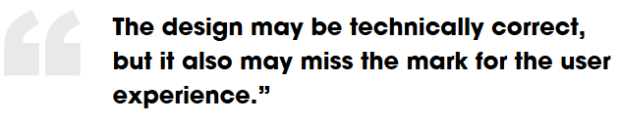
The development of new infrastructure within an existing corridor generally requires assessments from various teams and parties, and often there is a lack of cohesion between these reports, leading to conflict and confusion.
It is now well recognised that often the projects and facilities are not for “cyclists” alone and many of the facilities proposed have direct impact to all users and impacts on residents and business.
A “Complete Streets” mentality to the projects is required. But did this “Complete Streets” mentality extend to “Complete for All”?
The rapid development and implementation of Complete Streets projects in New Zealand has bought pressure on local authorities, politicians, and elected officials to consider the greater effect of a proposed facility treatment on the environment it travels through. There have been several recent examples in New Zealand where a facility has been established and subsequently the community has not been satisfied with the result.
An in-depth review of current processes considers the reasons for failure of a project (process wise), and requires the development of a process that will provide a level of confidence for road controlling authorities and political leaders that a facility is fit-for-purpose.
Sometimes new types of facilities are required to solve difficult situations. These facilities require robust safety consideration to ensure that key safety and network elements are not overlooked. Likewise, consideration of the streetscape design and function requires careful consideration of how the street will look and feel, its level of impact on the community and the interrelationship between street amenity and safety.

What is Safety?
First-time applications may require a firm and robust safety assessment by a suitably qualified team to consider the safety and functionality implications of the application. There is a lot of talk about safety, and while it is a broad term, and often used, do we really understand what “safety” is?
Road Safety Audits (RSA) are generally about the assessment of vehicle crashes, and controls required, to eliminate these crashes., however safety includes consideration of personal safety.
Crime Prevention Through Environmental Design (CPTED) is a concept that aims to reduce anti-social behaviour through designing environments that make it harder to commit crimes and reduce opportunities for crime to occur. It considers how the design interacts with the user in a safe way, addressing issues such as ambush, hidden spaces, etc.
Often this is a personal perspective, based upon our perceived threat level. As stated by Emma McInnes “…the Northwestern cycle way. It’s fine when cycling in the middle of the day with friends. But it’s poorly lit after dark, and the high fences on either side are unnerving.”
But if I am a male designer, how do I understand what this means from a female perspective. If I am able bodied, how do I understand what a design means to someone who is mobility impaired. Am I applying personal bias (and experiences) in my decision making, therefore not seeing the true concerns? As we know, this bias can be both conscious, and sub-conscious.
For a number of new projects in Christchurch we rapidly understood that maybe the system was broken. There were comments received around designs, many considering elements that were outside of the “normal” assessment requirements.
The previous process used by authorities had components of assessment separated out to various teams, often with the findings conflicting between the teams. To address this conflict, a new multi-consultancy / multi-discipline team framework was developed to undertake assessments of the major cycleway and earthquake redevelopment projects to ensure that the projects were fit for purpose and safe for all users.
This new and innovative process has been developed to directly consider the users of a project, and the effects of the project on their safety. The process considered not only the “typical” safety elements, but how a design affected the interaction of various users, and their perception of personal risk. This process is called SANF – Safety Audit and Network Functionality Framework and included the following lessons:
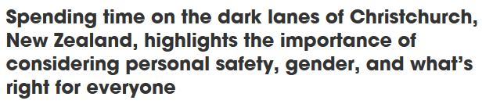
During the development of the SANF process the teams were required to assess projects from many angles. One of our first projects looked at a shared facility that ran along urban streets, and through an open reserve area that backed onto an industrial development.
Lesson number 1: was my personal sub-conscious bias affecting my assessment?
Essential to the assessment of a route section within the project was consideration of the use during the hours of darkness. As professional staff, we placed ourselves directly into that environment (at night) and considered the proposed design from many angles. What a revelation!
Here is how it went: Enter Emily.
STEP 1: Review supplied plans, and proposed route.
STEP 2: Drive to said route in the dark.
STEP 3: Stand at start of route and determine (as a team) who is going to walk through the said area.
STEP 4: Emily – “I am not going into that area any further than I can walk holding my breath”.
STEP 5: Team – Why?
Emily: ‘Cos its dark and I feel threatened with the isolation / poor observation of the area!
STEP 6: Team – “hey – good call, we agree with you – bloody dark and threatening eh!”
Needless to say, the route did not pass the test.
From that day forward, we had “The Emily Test”.

T
he Emily Test
def: Test applied to a project to consider user safety;
“The distance that a person can run holding their breath; equates to how far they can run screaming their lungs out.”
I detail the SANF process, and the formation of the SANF Framework, in other papers. For this paper, I will concentrate on the element of The Street Through Emily’s Eyes.

We don’t know what we don’t know
If we are designing facilities for all users, how well do we understand the users? Technical manuals can offer some guidance, but can this type of document articulate the personal experiences of our various users?
Do we have a cognitive barrier based upon our perspective, experiences, understandings that is founded on the “we don’t know what we don’t know” paradigm? Art Markman (Harvard Business Review), comments: “Though we often use [these] words, their meanings are usually unclear. They mask gaps in our knowledge, serving as placeholders that gloss concepts we don’t fully understand.”
Lesson Number 2: How well did I actually understand the user?
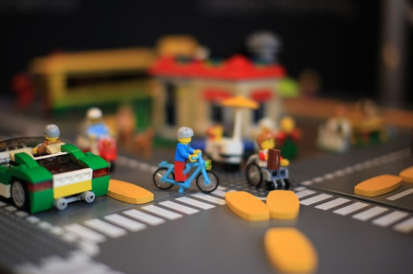
I have been part of or have been asked by clients to review Road Safety Audits (RSA) written by other professionals. While well written, many RSA reports only identify factors that the writers have expertise in, and often safety elements were not picked up, due to a lack of knowledge in that area.
This is not a criticism of the Auditors; it merely reflects that maybe the right team was not selected at the start and they did not know what they did not know. Maybe also this is predetermined right from the start when a client commissions an RSA? Do they know what to ask for?
Having completed a 5-day Safe Systems course does not make people experienced auditors. It starts them on the journey, it is not the destination. Think of it as your “L” plates.
The same principle applies when considering a robust assessment of Complete Street designs. I can look at a project from a road user safety perspective, but equally, I can look at the project from an urban design, mobility impaired, elderly, school child, visually impaired perspective as well.
Have you ever looked at a project from a gender perspective?

My Man eyes – Hindering a good design?
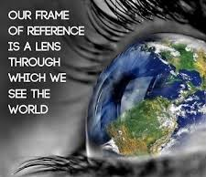
The development of the SANF process challenged me as a male engineer. How well did I really understand the safety issues that affected females? Or did I just think that I knew?
Was I applying my risk acceptance as a male, assuming that it would apply to all?
Did this bias affect my capacity to consider all users and influence my assessment of the design?
What were the other perspectives?
As you can see, there were a lot of questions.
Having Emily on the team was enlightening, for many reasons.
Her expert professional skills in urban design challenged us on what would be good for the community. Her insight as a female gave a far greater awareness on issues that affected females, but also an insight on how I needed to look at things differently. I needed to change.
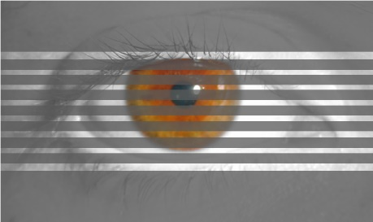
I had my male-filtered glasses on. I was missing the detail. I needed to increase my awareness, to take off the tinted glasses.
As a child we are not afraid to ask questions, yet as an adult, we often fail to ask [simple] questions, resulting in making poor or ill-informed assumptions.
We are wrong to assume that we understand another person’s perspective. Their perspective is driven by their experiences, trials, and upbringing. That can be acutely different to our own.
This perspective is not in any manual, nor easily regurgitated as part of a design. Technically correct does not mean that it is acceptable.
I learnt to ask simple questions that had context to me yet made me consider a design from another perspective.
Lesson Number 3: To consider the perspective of others, simply ask!
As detailed, Emily the Urban Designer formulated what is now known within the group as “The Emily Test”. So, what was the background?
The designers were looking at options for a cycle route. Two notable options stood out, one being along a busy road, requiring controlled crossing points and additional features, and one through a reserve. Each had challenges.
The route formed a major link between a seaside suburb and the central city. The route was considered to serve as a commuter link while passing a number of schools (primary and secondary) along the route. The route also formed a primary link for tourists and weekend recreational cyclists between residential developments and the seaside community and beaches.
Through the designer’s selection process, the option through the reserve land was understood to be easy to form, did not require a high level of controls, and was cheaper to construct. The SANF team were provided the route drawings and we commenced our assessment.
The first part of the route considered the use of a service road between the residential dwellings and a main road. Great use of the route, and enabled engagement of the street in an area of low social deprivation. This was considered a win-win outcome, as the community had felt that they were the forgotten zone, no-one would have listened to them, and therefore never expected any improvements.
The route then crossed a collector road and entered the reserve land. What a stark contrast.
The area was characterised by a land corridor that had no frontage to housing, so therefore no passive surveillance, had a line of hedging alongside the north boundary, alongside a water canal that separated the route from the adjacent road corridor. There was no lighting, and minimal vegetation removal was proposed.
Walking and cycling the route during daylight hours revealed a reserve that was defined by areas of dense planting, leading into and alongside an industrial area. Reviewing the site during daylight hours, one could be excused for thinking that on a warm sunny day, this could be a pleasant ride or walk.
However, looking at the route at night (similar to a winter evening after work / school commute), the picture changed dramatically. We found that standing in the middle of the reserve, you could scream at the top of your lungs and not a single light turned on, no-one stuck their head over the fence.

You could scream at the top of your lungs and not a single light turned on
As a middle-aged male, I was less threatened, as I felt that I had the ability to defend myself. Not so for Emily. Enter the now informed Emily Test.
In hindsight, and applying the Emily Test, our designers should have identified that personal security for more vulnerable people, school children and commuters in winter was an issue.
Were our “Man Eyes” assessments clouding our judgement, supported by a cheaper option cost, through an easy to construct route? Hindsight suggests yes.
Following the SANF assessment, the client agreed that the route was not viable for the reasons stated, and in its current form. A further assessment of the alternate routes was undertaken, with consideration of all users. While an alternate route also had issues, these were fully documented, and led the basis of design going forward.

it’s a matter of Balance
Emma comments in her blog, “As a young woman, I don’t yet feel like Auckland provides or is a safe city for me. Not necessarily because of violent crime or proximity to volcanoes, but because of a whole bunch of little things that lots of men don’t ever see or hear about.”
We are missing a key part of why we are doing a project. That is, to give everyone an environment that is safe and fit for purpose for all ages, genders and abilities.
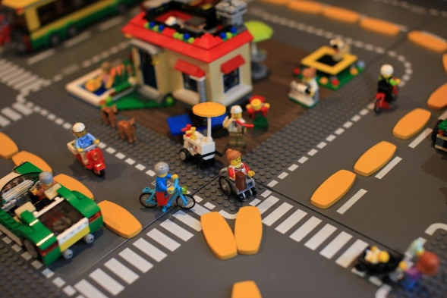
Through my experience with insightful, diverse colleagues, I have learnt balance. I now look at a project from different and diverse perspectives. I do not suggest that I fully understand the issues, but I now ask. I consult with people who have been in uncomfortable situations and can present an opposing perspective.
I value their input, because it is a view that I cannot always see, but through their understanding and guidance I am getting better at addressing the issues.
So, I now apply a basic figurative test.
Consider whether you would be comfortable for your 13-year-old daughter to walk / ride through a proposed environment. Consider also whether your view might change depending on whether it was the middle of the day, or weekend when there are not so many people around, or a dark winter’s day or evening.
If you hesitated, and had to think, then sub-consciously you had some concerns.
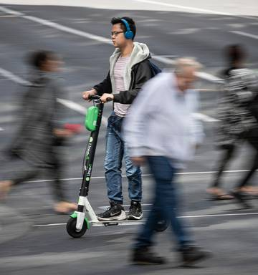
We also need to consider how our designs impact vulnerable users that we may have little contact with. We need to put ourselves in the position of the mobility impaired, visually impaired, and elderly to name a few.
Each of these user groups have very specific needs.
We are aware of recent comments in the media around the elderly and scooters on the footpath. Here we have a direct conflict between two user groups, each coming from a vastly differing perspective. The scooter user sees the device as freedom, rapid mobility, fun, exciting and fit for purpose.
Many elderly see this as threatening, fast, cause of injury, silent and deadly. Clearly two differing perspectives.
Interestingly, the same concerns of behaviours and risks are expressed by the visually impaired and the mobility impaired. How are we missing this consideration of our users?

NEED TO BE INCLUSIVE IN DESIGN AND ASSESSMENTS
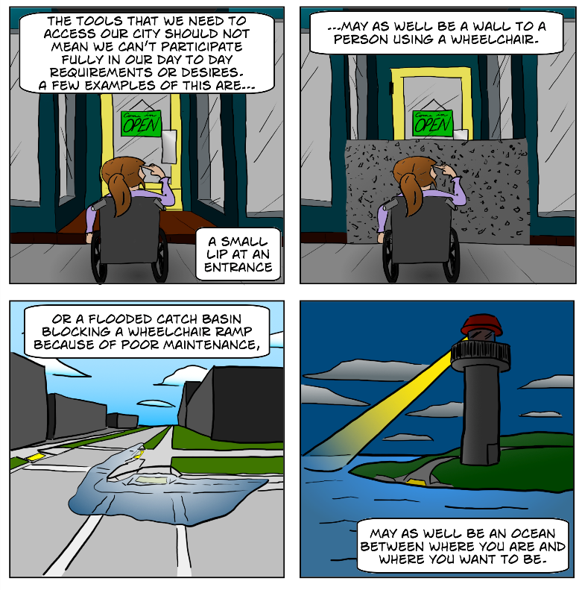
In the ideal world, we would not need to force consideration of other users. But we do not live in an ideal world.
Often, we have a need to change a streetscape through a design, but we are restricted to the current road corridor. So, we start from a potentially compromised position from day one.
Given the compromises and constraints, the challenge for us as technical experts is to arrive at a solution that is inclusive and addresses all diverse needs, which is not always easy.
Applying the SANF Framework principles to a CBD renewal project in Christchurch enabled the SANF team to articulate to the client the various concerns from the point of views of all users. The team included experts from a widely varying skill set.
© Ryan Martinson 2018
Specific questions for impaired users were identified, and the team sought feedback from the respective disability groups.
The team was able to quantify the user concerns and We should strive toapply direction to the design teams on what the actual impacts of a design would be, and how temporal and spatial separation of the various users should be considered.
Concerns from other user groups were addressed specifically, and a clearly documented trail of evaluation was provided. This enabled the client to make an informed decision and form robust discussion around compromise and design changes.
Any compromises made by the design team required it to clearly document the decisions, and the risk evaluations. The residual risks were clearly articulated, and the decision was then whether the residual risks were acceptable.
Through the application of inclusive design, we can grow our community in a safe, equitable, diverse and fair way. As an individual practitioner, we do not hold all the understanding required. We must ask for input from others early in the process, so that we are inclusive from the start.
Let us not create an environment where Emma feels threatened, feels unsafe. Let us create an environment where Emma’s needs and concerns are addressed from the outset, have the robust discussions with the community, detailing why we have gone for an inclusive design.
It is time to change the narrative of our conversations to “we want to make it safe for your children, partners and grandparents to use”.

With Clear Sight, what have we learnt?
W
ould I be comfortable with my 13-year-old daughter using this facility?
Rightly or wrongly, we all have perspectives from which we base our views upon. These are often developed from our experiences and developed points of view. However, have we ever stepped back to challenge this perspective?
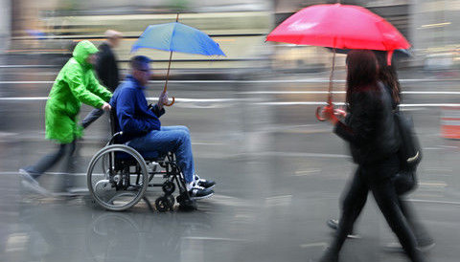
Through the assessments of multi-modal projects with a diverse team, my perspectives were challenged. I found that what I considered “acceptable” may in fact be “unacceptable” to another user.
Looking back, I realised that my “man-glasses” were tinted. This was not intentional, but rather reflected a view based upon my experiences. But this was not an individual issue, exploring this with colleagues, I found that we all had filters.
Lessons were learnt, and through this process, we were able to use a more informed position.
So, what did we learn?
Lesson number 1: was my personal sub-conscious bias affecting my assessment?
Yes, not through malicious intent, but because of me not knowing what I didn’t know. I had not been challenged to the level that would have enabled me to understand. Looking forward now, and incorporating a diverse team, I realise that we all carry some form of sub-conscious bias. Our challenge as a profession is to learn from what we have identified, and to empower others to also learn.
Lesson Number 2: How well did I actually understand the user?
I thought that I had an idea, I was wrong. I do not fully understand the issues that female users experience, purely because I have never been in their situation to learn. Similarly, do I fully understand the impacts of our designs for mobility groups, visually impaired, or elderly if I have not been in their shoes?
..because of a whole bunch of little things that lots of men don’t ever see or hear about
However, by asking the right questions, of the people who have had the experiences I can learn, and through this learning, apply a more considered approach.
As a profession we should avoid assuming and start engaging with the end user. Take the time to hold workshops and discussions with the user groups, and ask, ask, ask. We will not get it right first time, but we will always get it better.
Lesson Number 3: Consider the perspective of others, ask!
Emma stated, “As a young woman, I don’t yet feel like Auckland provides or is a safe city for me.” Our challenge is to ask why. But of a much larger challenge is to have a culture that would enable Emma to vocalise her experiences and engage into a process where we address the fundamental issues prior to undertaking a design.
This begins with the perspective of others being included into our design standards, being willing to challenge our existing processes, and through this challenge be willing to change our guidance.
Through the work done utilising the SANF process we have been able to learn and continue to learn. Learning never stops, standards are never so set in stone that they cannot be changed.
As a profession we must ensure that our reviews and design challengers are inclusive and diverse. We must also enable development of members of our profession from diversity groups to grow into these challenge roles.
Through the development of the SANF process, we learnt how to apply the Emily Test. Let us as a profession learn and apply the Emily Test in all that we do. If we as individuals and as clients undertaking projects take the challenge, we will through time develop projects that are fit for purpose, are safe for all users, and are inclusive of everyone’s needs.

Declaration of competing interests
“The author declares no competing financial interests.”

Emily, our Urban Design / Landscape guru for multi-modal projects.
https://www.greaterauckland.org.nz/2017/10/12/designing-cities-women-thing/
https://hbr.org/2012/05/discover-what-you-need-to-know
Why “Designing Cities for Women” should be a thing: https://www.greaterauckland.org.nz/2017/10/12/designing-cities-women-thing/

