Operational Resilience of The Road Network

(ASM and South Island)

Siavash Aghababaei, Auckland System Management (ASM), Senior Transportation Engineer, Siavash.aghababaei@asm.nzta.govt.nz

Dan Lao, Auckland System Management (ASM), ASM Journey Optimisation Manager, dan.lao@asm.nzta.govt.nz

Prakash Ranjitkar, University of Auckland, Senior Lecturer, p.ranjitkar@auckland.ac.nz

Hajar Sarmadi, Manukau Institute of Technology, Senior Lecturer, hajar.sarmadi@manukau.ac.nz

Operational Resilience of The Road Network

(ASM and South Island)
Different incidents on the network can disrupt the transportation network, resulting in increased travel time, accessibility issues, and economic costs. The impact of incidents/disasters on a road network can be assessed based on the physical impact and/or the operational impact. The physical impact examines the effect of incidents/disasters on different assets such as pavements, structures, bridges, and tunnels, which in turn can disrupt the network, completely or partially. Therefore, the travel behaviour of the users will vary, causing increased travel time and travel cost, or even unsatisfied demand. This is referred to the operational impact of a(n) incident/disaster. Responding to incidents in a timely manner will reduce the recovery time and therefore, the delay on the network, resulting in saving the cost of congestion.
The operational resilience of the road networks is assessed using a Normalised Trip Resilience (NTR). It incorporates three different dimensions of resilient systems, namely, Robustness, Redundancy, and Recovery. The proposed measure reflects the impact of increased travel time (redundancy impact) and eliminated trips (robustness) on the resilience of trips, in percentage, averaged over the recovery period. To facilitate ranking of the post-disaster impact on districts, a new measure, namely the Equivalent daily number of Impacted Trips (EIT), is proposed. The proposed measure provides an opportunity for decision-makers to estimate and rank the trip resilience between each (group of) Origin-Destination pair(s) using pre- and post-disaster flow and travel time. Two case studies, a hypothetical Alpine Fault Magnitude 8 (AF8) scenario in the South Island of New Zealand and SH16 WB direction of Auckland Motorway System, were conducted to demonstrate the newly developed trip resilience measures.
Keywords: Trip Resilience, Robustness, Redundancy, Reliability, Natural Disasters, Road Network Performance, Impacted Trips, Recovery
Introduction
Natural disasters, such as flooding, earthquakes, tsunami, hurricanes, and volcanic eruptions, can disrupt transportation networks, potentially resulting in cities, towns and villages being isolated for a period of time. Such disruption causes post-disaster response issues, evacuation difficulties, accessibilities issues, increased travel costs, and economic losses. Consequently, understanding the resilience of transportation networks following a disaster is crucial for post-disaster operations, community resilience and business continuity. The resilience of transportation systems can be defined as the ability to reduce the loss of performance, or impacts in terms of disruption, and properly recover or adapt to a (new) original condition (Zhang et al., 2015, Mason and Brabhaharan, 2016).
The resilience of a road network following a disaster is typically assessed based on asset performance (Mitoulis et al., 2021, Wu et al., 2021, Argyroudis et al., 2020, Argyroudis et al., 2021, Misra et al., 2020, Dizhur et al., 2019, Herbert et al., 2018) and operational performance. Disasters cause damage to transportation assets such as bridges, tunnels, and roads, which in turn can influence the operational resilience of the road network, as measured by reduced capacity, increased travel time, and delay time. This research focuses on operational performance and resilience while recognising that the hazard assessment (e.g. probabilities of occurrence of seismic events) and performance assessment of the physical assets (e.g. using fragility models to assess the expected damage and losses for given seismic intensity measures) need to be undertaken before the operational resilience of the transport network can be assessed.
The performance of road networks in a post-disaster environment has typically been assessed using two main concepts in the literature; namely vulnerability and resilience. Other concepts reported in the literature to evaluate the impact of natural disasters on transport networks include risk, reliability, robustness, flexibility, and survivability (Faturechi and Miller-Hooks, 2014). Table 1 provides a list of traffic parameters and MOEs categorized based on the concepts of vulnerability and resilience to assess the operational performance of a road network.
Table 1: Applied traffic factors in natural disaster-related transportation studies
Studies | concept | Performance Measures
Zhang and Wang (2016) | Resilience | Reliable Independent Pathways (IPWs); node weighting factor (the shortest distance between a node and emergency response facility); IPW weighting factor (average daily traffic (ADT); length)
Pokharel and Ieda (2016) | Vulnerability | Population; shortest distance; detour ratio: alternative shortest path when one or more links fail/shortest path
Muriel-Villegas et al. (2016) | Vulnerability | Link weakness; link importance (% of traffic flow); link criticality (decreased flow)
Zhang et al. (2015) | Resilience | Flow, capacity, travel time, shortest distance, cost
Soltani-Sobh et al. (2015) | Resilience | Total travel time, flow, consumer surplus
El-Rashidy and Grant-Muller (2014) | Vulnerability | Flow, capacity, congestion density, free flow speed, link length
Balijepalli and Oppong (2014) | Vulnerability | Capacity, travel time
Omer et al. (2013) | Resilience | Travel time, CO₂ emissions, financial cost
Chen et al. (2012) | Vulnerability | Demand, travel time
Miller-Hooks et al. (2012) | Resilience | Post-disaster capacities; travel time; the cost of implementing recovery activities; implementation time of recovery activities; demand; the cost of implementation preparedness activities; given budget
Chen and Miller-Hooks (2012) | Resilience | Capacity; travel time; implementation recovery time; implementation cost; flow
Luathep et al. (2011) | Vulnerability | Demand, flow, capacity, travel time
Erath et al. (2009) | Vulnerability | Travel time costs, driving distance costs, accident costs
Jenelius et al. (2006) | Vulnerability | Travel cost, demand
Taylor et al. (2006) | Vulnerability | Change in travel cost; attractiveness of location (the number of opportunities available, population); a measure of remoteness (or accessibility to services)
Murray-Tuite (2006) | Resilience | Queue, travel time, speed, V/C
In order to determine which MOEs in Table 1 are likely to best represent the resilience of transportation networks, an adaptation of the four dimensions (robustness, redundancy, resourcefulness and rapidity) of physically and socially resilient systems proposed by Bruneau et al. (2003) is used to assess their suitability. Robustness and redundancy are considered as proposed, however, as resourcefulness and rapidity reflect the importance of resources and budget to achieve response and reconstruction goals in a timely manner, they can be represented by a single dimension in this study, namely recovery.
Robustness, usually measured as the impact of flow and demand variation on the post-disaster performance of the network, has been investigated by El-Rashidy and Grant-Muller (2014), Zhang et al. (2015), Soltani-Sobh et al. (2015), Chen et al. (2012), Miller-Hooks et al. (2012) and Jenelius et al. (2006). Redundancy, usually measured as the impact of disruption in terms of travel cost or travel time variation, has been examined in numerous studies. Recovery considers the impact of time and resources (i.e. finance, materials, and workforce) on the recovery of the disrupted network and, ultimately, the resilience of the network. The impact of recovery actions on the resilience of the network was investigated by Chen and Miller-Hooks (2012), Miller-Hooks et al. (2012), and Zhang et al. (2015). Omer et al. (2013) measured the travel time resilience over the recovery period. A short recovery time indicates the network returned to the (new) normal condition faster and, therefore, the resilience of the network would be higher.
To the best of the authors’ knowledge, based on a review of the relevant literature, the impact of eliminated trips together with increased travel time following a disaster has not been examined to date over the horizon of the post-disaster recovery phase in a single resilience measure. The proposed new measures integrate all three concepts of resilience to determine the impact of eliminated trips (robustness) and increased travel time (redundancy) over the horizon of the post-disaster (recovery) phase. The inclusion of the recovery element in the measure is critical in order to calculate a measure of resilience over a period of time, rather than at a point in time. In fact, it can be argued that the latter, point in time, estimate is not a measure of trip resilience at all, but of trip reliability.

Development of the Trip Resilience Measures
Generally, two issues arise when a disaster occurs on a road network. First, some traffic zones (TZs) can end up completely disconnected and, hence, trips cannot be completed to or from these TZs. Second, some TZs with alternative routes available can experience increased travel time due to increased travelled distance (typically in rural areas) or congested routes (typically in urban areas). A new resilience measure namely the Trip Resilience (TR) measure is proposed to assess the resilience of trips between TZs on a road network. The Bruneau et al. (2003) study provided a generic definition of the concepts of robustness, redundancy, resourcefulness, and rapidity and proposed a conceptual framework for resilience assessment of a community. Their work was only conceptual in nature (i.e. they did not define how to calculate such measures), and they were not referring to transportation resilience. However, these four concepts are regularly used across all areas of resilience assessment. The proposed measure incorporates the four dimensions of resilient systems; robustness, redundancy, resourcefulness, and rapidity. Resourcefulness and rapidity reflect the importance of resources and budget to achieve response and reconstruction goals in a timely manner, hence, they can be represented by a single dimension, namely recovery. TR is, therefore, a function of robustness, redundancy and recovery as expressed in Eq. (1).
TR = f (Trip Robustness, Trip Redundancy, Recovery)
It should be noted that robustness and redundancy can vary over time due to the recovery effort and, at any point in time, when taken together they represent the reliability of the network. The recovery determines a time scale whereby the network structurally, and therefore operationally, improves. Figure 1 graphically illustrates robustness, reliability and resilience in the event of a disaster.
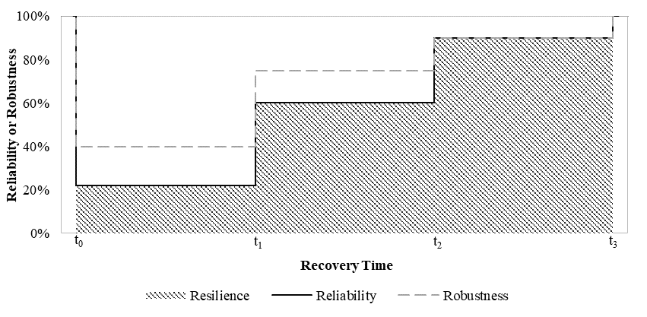
Figure 1: Conceptual Robustness, Reliability and Resilience of a Network
Robustness, in this study, relates to the structural and physical strength of the transportation network assets, where the impact of disruption following a disaster would be reflected in the total percentage of trips that can still be undertaken between an OD pair post-disaster. When a link or a group of links on the network are blocked or disrupted, some TZs might be disconnected from other TZs, which means trips between those TZs will not occur. In such cases, those trips are eliminated as their travel costs become infinite as demand is unsatisfied. Consequently, the robustness of trips between an OD pair (ij) during a recovery time ($t_{ζ}$) under post-disaster scenario $ζ$ can be calculated as expressed in Eq. (2), where Flow_{ij(ζ)} and Flow_{ij(BAU)} represent flow under post-disaster and BAU scenarios respectively. Eq. (2) can be used for an OD pair, a group of OD pairs, or the whole network.
${Robustness}_{ij}\left(t_{ζ}\right)=\frac{{Flow}_{ij(ζ)}}{{Flow}_{ij(BAU)}}$
Robustness_{ij} = 1 represents a scenario where no trips are eliminated after the disaster while Robustness_{ij} = 0 represents a scenario where no trips can occur, that is all the trips are eliminated due to either the respective origin or destination being blocked. Eq. (2) seeks to quantify the proportion of trips undertaken post-disaster compared to BAU. These are termed robust trips. Assuming 1000 trips between an OD pair in BAU decreases to 600 in a post-disaster scenario, then the robustness of trips between this OD pair will be 0.6 or 60%, meaning 40% of trips will be eliminated due to post-disaster accessibility issues. The remaining 60% of trips will be completed either using the same route as the BAU scenario or using an alternative route based on the accessibility of the network, most probably with an increased travel time.
Where trips can occur, disruption on a network can result in longer travel times on alternative routes. On a regional road network, the additional travel time is typically due to long detours because of a lack of equivalent alternative routes. In an urban situation, a number of alternative routes are typically available, with similar or equivalent distance travelled. In such cases, the increased congestion on these routes may result in longer travel times. Such an increase in travel time post-disaster causes a decrease in the general performance of a trip. Redundancy, in this study, is therefore defined as the impact of post-disaster trip assignment (new route choice, the shortest alternative route) on travel time, where infinite post-disaster travel time indicates no redundancy. Hence, redundancy can be estimated as the ratio of the average travel time between an OD pair (ij) in BAU and post-disaster scenarios as expressed in Eq. (3). Similar to Eq. (2), it can be used for an OD pair, a group of OD pairs, or the whole network.
${Redundancy}_{ij}\left(t_{ζ}\right)=\frac{Average {Travel Time}_{ij(BAU)}}{Average {Travel Time}_{ij(ζ)}}$
Redundancy, as defined in Eq. (3), decreases with an increase in post-disaster travel time but never reaches zero as long as a trip occurs. The redundancy, therefore, only impacts robust trips, the trips with finite post-disaster travel time. Redundancy_{ij} = 1 represents a scenario where the network yields the same average travel time for the BAU routes and the post-disaster routes. Assuming average travel time for an OD pair (ij) increased three-fold following a disaster, the redundancy will be 0.33 or 33% indicating a 67% drop in redundancy. Hence, following a disaster, trips are completely reliable if they can firstly be assigned to the network (Robustness_{ij} = 1), and then can travel with no increased travel time (Redundancy_{ij} = 1).
A combination of robustness and redundancy can be expressed as trip reliability. Following a major disaster, trip reliability deteriorates partly due to eliminated trips, reflecting the fact that a less robust network results in less robust trips (i.e. more eliminated trips) and, therefore, less reliable trips. The robust trips, however, may be assigned to different routes compared to BAU, potentially resulting in increased travel time (reflecting the redundancy concept). Trip reliability, as a result, is estimated in two stages, as presented in Eq. (4). Initially, the proportion of robust trips is calculated and, then, the lack of redundancy is deducted.
${Reliability}_{ij}\left(t_{ζ}\right)={Robustness}_{ij}\left(t_{ζ}\right)-\left({Robustness}_{ij}\left(t_{ζ}\right)*{(1-Redundancy}_{ij}\left(t_{ζ}\right)\right)$
This can be simplified to the product of Robustness and Redundancy as represented in Eq. (5) below. Reliability is therefore estimated at a point in time and, similar to both Robustness and Redundancy, is unitless and has a scale between 0 and 1.
${Reliability}_{ij}\left(t_{ζ}\right)={Robustness}_{ij}\left(t_{ζ}\right)*{Redundancy}_{ij}\left(t_{ζ}\right)$
Referring to Eq. (6), Trip Resilience (TR) is then estimated using the area under the trip reliability curve from recovery time of t_{ζm} to t_{ζn} where m represents the start time and n represents the end time of a stage of recovery. To estimate the TR for the whole period of recovery instead of a stage, m and n represent the impact time and the end of recovery, respectively.
$TR=\int_{tζ_{m}}^{tζ_{n}}{\left({Reliability}_{ij}\left(t_{ζ}\right)\right)}dt$
Given that the TR is unitless and, at least theoretically, has no upper bound, it was decided to normalise the TR during the recovery period to create a measure that is easily understandable to decision-makers. The resulting Normalised Trip Resilience (NTR) is estimated by Eq. (7) where an average of TR for a period of recovery (Δt) reflects the NTR, presented as a percentage. If the network is completely reliable, then the NTR returns 100% representing a resilient network. Typically, NTR is estimated for the whole period of recovery, starting from the time of impact to the end of recovery, although NTR can be calculated for any time interval, such as different stages of recovery.
$NTR=\frac{\int_{tζ_{m}}^{tζ_{n}}{\left({Reliability}_{ij}\left(t_{ζ}\right)\right)}dt}{Δt}*100$
Finally, in order to facilitate ranking of the impact on districts post-disaster, the Equivalent daily number of Impacted Trips (EIT) is proposed in Eq. (8). The measure seeks to rank by impact, and is, therefore, a measure of vulnerability rather than resilience. The vulnerability is calculated by subtracting the NTR from unity, and this in turn is multiplied by traffic flow. Traffic flow is used as a criterion for importance in transportation and is commonly used when ranking or prioritizing.
$EIT=\left(1-NTR\right)*{Flow}_{(BAU)}$
The EIT could potentially be used to facilitate resilience investment decision making on the network by ranking the impact on trips for different natural disaster scenarios and, subsequently, the reduced impact on trips under different investment options.

Demonstration Case Study

Alpine Fault Earthquake – South Island
The Alpine fault is the longest active fault in NZ, measuring more than 800km, with the largest average long term slip rate (Yetton, 2000). McCahon et al. (2006) stated that the effects of the AF8 earthquake will not be limited to only the West Coast and will, instead, influence the whole of the central South Island, including the main transportation corridors. The most recent study detailing the potential physical impact of an AF8 earthquake on different infrastructure, including energy, telecommunication, water and wastewater, and transportation, was undertaken by Davies (2019). The ten time-steps, measured from the initial event, were one day, one week (7 days), one month (30 days), six months (183 days), one year (365 days), two years (730 days), three years (1095 days), four years (1461 days), five years (1826 days), and ten years (3652 days). Five of the scenarios are represented in Figure 4, namely one day, one week, one month, six months, and beyond six months after the earthquake. To remove ambiguity in the time span it is assumed that the beyond six months scenario will occur one-year post-disaster. For this paper, it is also assumed that one-year post-disaster is the new normal and the end of the recovery process.
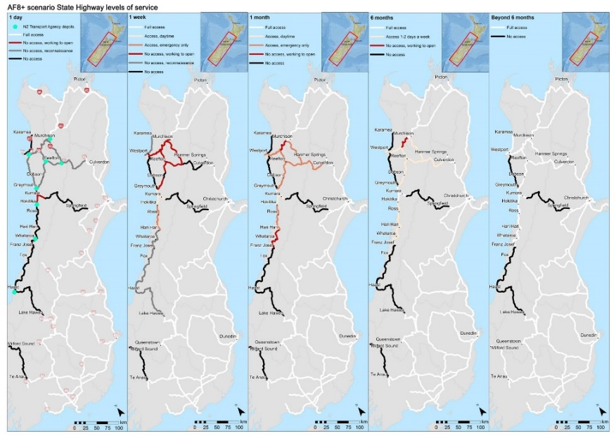
Figure 2: Expected Level of Services of the Road Network in Five Time Steps for AF8+ Scenarios (Davies, 2019)
Figure 3 shows the robustness, reliability, and resilience of trips on the whole network, as well as from the three most impacted districts, namely Grey, Buller, and Westland, to all other districts. To provide some context, the total number of BAU trips from all districts, Grey, Buller, and Westland are 637620, 12689, 5469, and 3223, respectively. The whole South Island road network resilience, presented in Figure 3a, considers all impacted and non-impacted trips on the network. It can be seen that the number of eliminated trips one day after the earthquake is around 2% of total BAU trips, and therefore, the network robustness drops to 98% followed by a further 1% reduction due to the lack of equivalent alternative routes, returning a reliability value of 97% for the whole road network. The reliability slightly rises to 98% after a week as more trips occur and robustness increases, with no further change for a month. With the reopening of SH65 and SH7 (Lewis Pass) six months post-disaster, almost all trips can occur. A negligible proportion of trips, compared to the total number of trips on the whole network, would occur with increased travel time. The reliability increases to 99% one year after the earthquake. Given that many local and inter-district trips network-wide (around 98%) will not be impacted by AF8, the TR and NTR of the whole network after one year of recovery are 357 units and 98%, respectively.
a)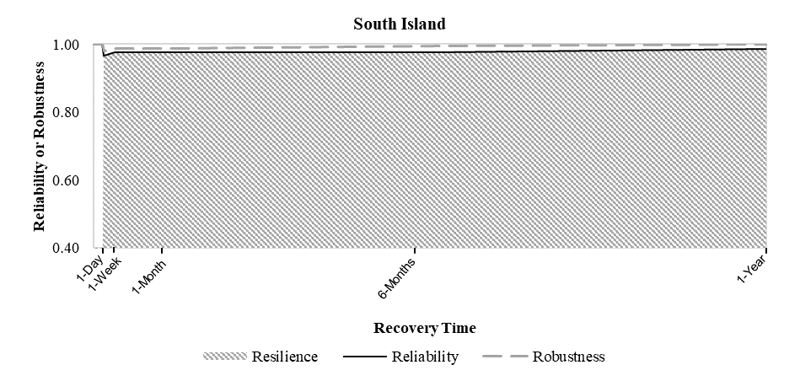b)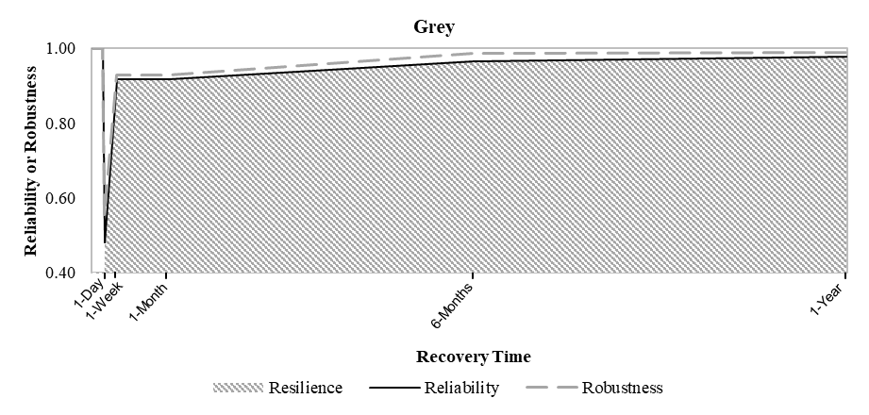
c)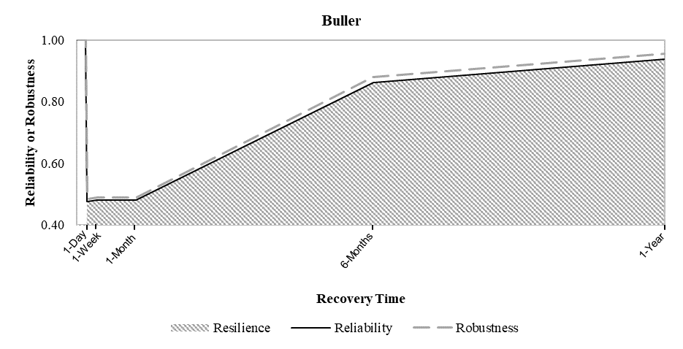 d)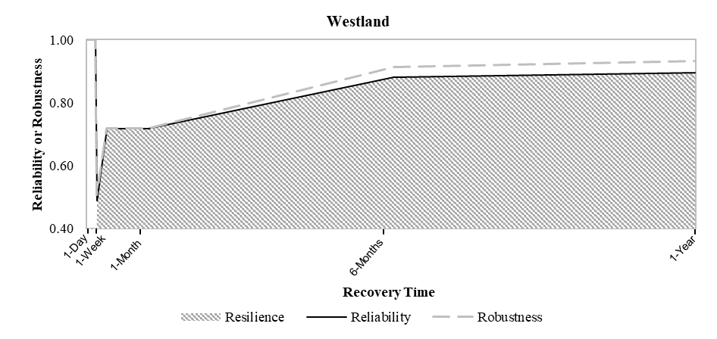
Figure 3: Robustness, Reliability and Resilience of Trips a) on the whole network b) from Grey District c) from Buller District d) from Westland District
Referring to Figure 3b, 5c, and 5d, the impact of eliminated trips is significant in the three most impacted districts immediately after the earthquake, where the reliability drops to around 50% in all cases. Most of the remaining trips, predominantly intra-district trips, would occur with no increased travel time and, therefore, the reliability would decrease primarily due to eliminated trips. Reliability for Grey and Westland districts increases after a week, due to increased accessibility, mostly within districts, with no further change for a month. However, the reliability for Buller remains relatively unchanged. With the reopening of SH65 and SH7 (Lewis Pass) after six months, the robustness increases for all three districts – significantly in the case of Buller and Westland. While this provides more accessibility for a number of TZs, a proportion of the regenerated trips will be required to take a longer alternative route, resulting in increased travel time and, therefore, reduced redundancy. This is evident in Figure 3, particularly for Westland, where the proportion of the impact on reliability due to increased travel time increases, relative to that from eliminated trips. This is particularly pronounced in Westland as trips outside of the West Coast Region are required to first head north on SH6 and then across on SH7 (Lewis Pass) due to the continued closure of SH6 south of Franz Josef and SH73 (Arthur’s Pass). After one year, the reliability improves further for Buller, in particular, with the opening of SH 67 linking Westport with Karamea and a section of SH63 East of Murchison.

Table 2: NTR and EIT of Three Most Impacted Districts Following AF8
Districts | Grey |  |  | Buller |  |  | Westland
 | BAU Trips (#) | NTR | EIT | BAU Trips (#) | NTR | EIT | BAU Trips (#) | NTR | EIT
Grey | 11,211 | 98% | 174 | 216 | 39% | 132 | 692 | 91% | 61
Buller | 213 | 35% | 138 | 4,267 | 86% | 611 | 294 | 38% | 181
Westland | 668 | 92% | 56 | 319 | 42% | 185 | 1,785 | 97% | 48
Christchurch | 296 | 53% | 139 | 308 | 56% | 136 | 201 | 47% | 107
Queenstown | 103 | 51% | 51 | 70 | 40% | 42 | 44 | 3% | 43
Marlborough | 77 | 61% | 30 | 145 | 51% | 71 | 72 | 62% | 27
Hurunui | 35 | 69% | 11 | 5 | 69% | 2 | 16 | 65% | 6
Nelson | 29 | 67% | 10 | 46 | 36% | 30 | 32 | 58% | 13
Selwyn | 22 | 41% | 13 | 23 | 44% | 13 | 21 | 34% | 14
Tasman | 12 | 65% | 4 | 24 | 39% | 15 | 19 | 63% | 7
Waimakariri | 7 | 55% | 3 | 15 | 54% | 7 | 15 | 52% | 7
Mackenzie | 2 | 36% | 1 | 2 | 52% | 1 | 8 | 46% | 4
Timaru | 7 | 71% | 2 | 4 | 65% | 1 | - | - | -
Kaikoura | 5 | 67% | 2 | - | - | - | 2 | 67% | 1
Southland | 2 | 25% | 1 | - | - | - | 10 | 11% | 9
Ashburton | - | - | - | 12 | 21% | 9 | 2 | 22% | 2
Otago | - | - | - | 7 | 19% | 6 | - | - | -
Dunedin | - | - | - | 4 | 12% | 4 | 1 | 47% | 1
Invercargill | - | - | - | 2 | 34% | 1 | - | - | -
Waitaki | - | - | - | - | - | - | 5 | 70% | 1
Overall | 12,689 | 95% | 635 | 5,469 | 77% | 1265 | 3,219 | 83% | 534

Referring to Table 2, NTR was estimated for trips from the three most impacted districts to all other districts over the one-year recovery period. It can be seen that most of the intra-district trips for these three districts (highlighted ones) would occur without increased travel time, resulting in high NTR. EIT was calculated to determine the most impacted OD pairs over the one year recovery period. Note that EIT is only estimated from the three most impacted districts to all other districts. In total, 635, 1265 and 534 equivalent daily trips from Grey, Buller, and Westland are impacted by the earthquake, returning 5%, 23%, and 16% of BAU trips, respectively.

Auckland Motorway Network – SH16 WB
The Auckland Anniversary flood and cyclone Gabrielle earlier last year put the network's resilience to the test. The general consensus is that flooding will occur more frequently, and the impact will be more severe. The main aim of this project is to investigate the operational resilience of the network following incidents to support the Network Operations team to make a better decision to prioritise their resources in case of several disruptions on the network. The final product was a dashboard with a high-level quick assessment of the network resilience (section level between interchanges) to provide a quick reliable resilience score as well as Equivalent Impacted Trips (EIT) for the selected closure on the network. It will help to reduce the recovery time by responding to incidents promptly and therefore, reducing the delay on the network, resulting in saving the cost of congestion.
As a proof of concept, the SH16 WB direction was selected to test the proposed resilience method in a dynamic network. The high-level queue model method was applied to estimate the additional delay and therefore the increased travel time due to the partial closure of the corridor. It was assumed all trips would occur due to short-term partial closure, so the robustness of the network was considered as 1. The BAU travel time was estimated using the flow-speed method. The resilience score and EIT were estimated for each segment between the onramps and offramps as the volume will remain consistent. The 5-minute time interval volume data was applied to estimate the delay on the network due to closure. In each scenario, depending on the day of the week, start time of closure, duration of closure and number of open lanes, the resilience score, equivalent impacted trips, and total delay are estimated. Figure 4 shows the Auckland Motorway Resilience Dashboard. When a closure is selected, the five worst sections of the network are shown in the map based on the highest impacted trips. The sections can be selected and added to the results panel to compare the results.
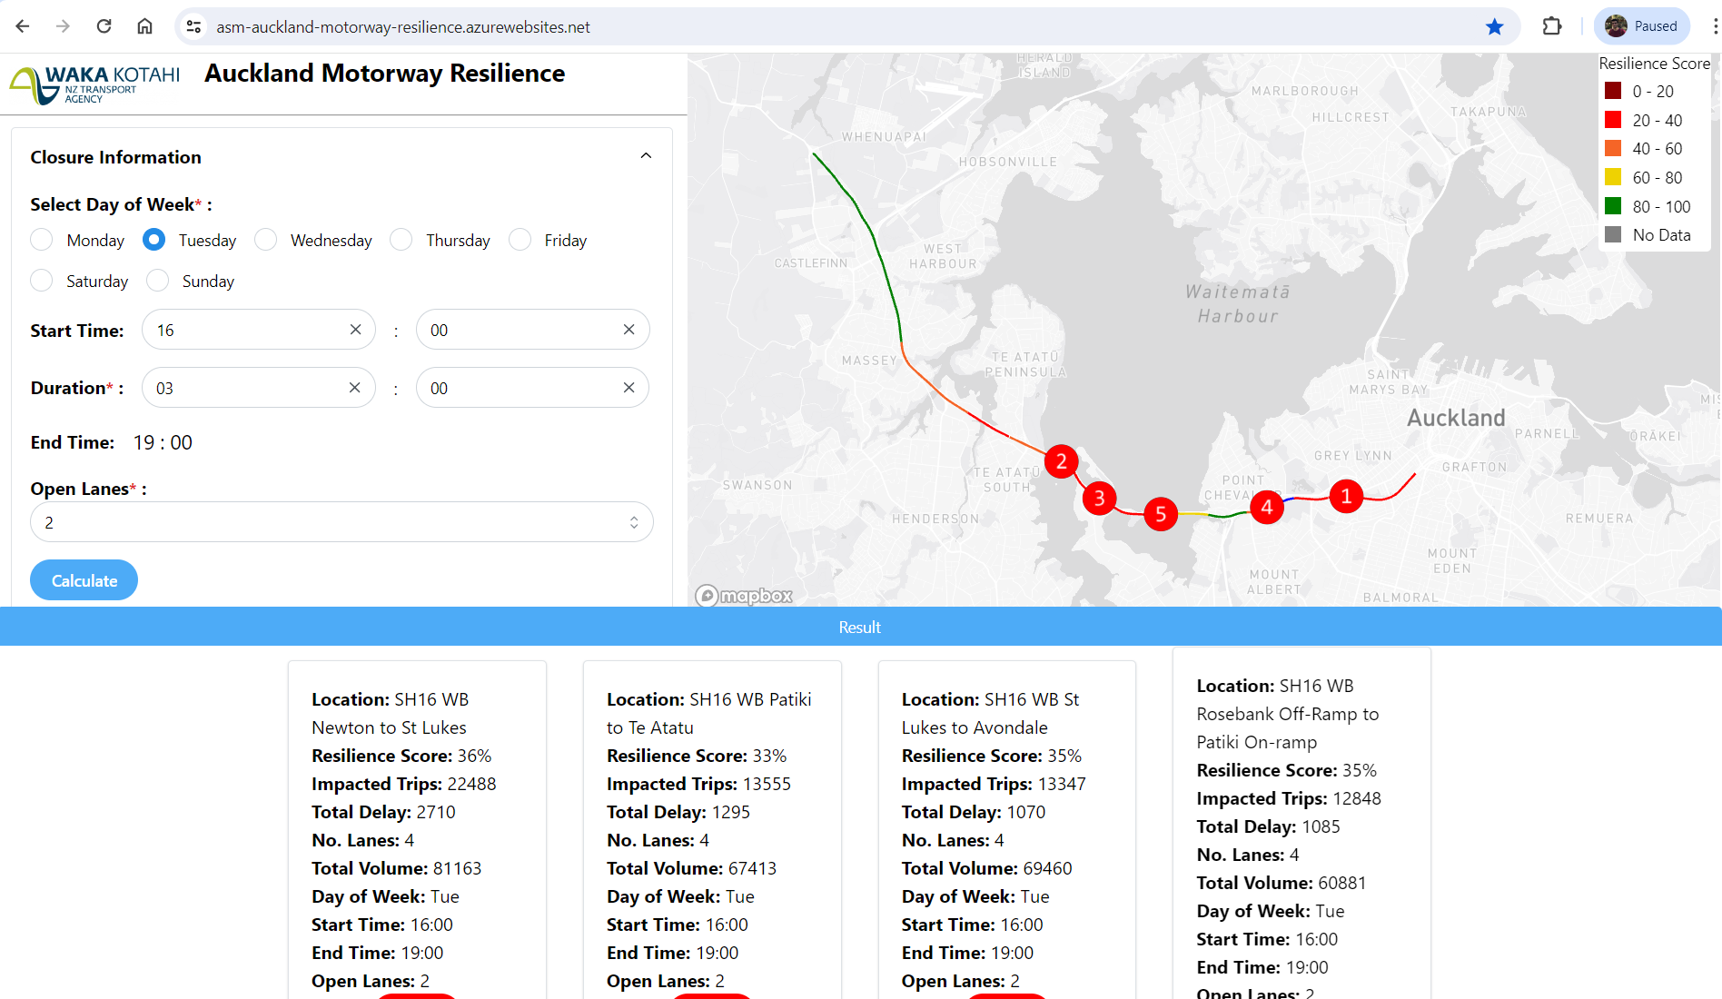
Figure 4: Auckland Motorway Resilience Dashboard – SH16 WB Direction
To validate the resilience assessment outputs, an incident in the SH16 WB direction was selected. The incident occurred on SH16 WB between WVT and Rosebank offramp on 2nd May 2023 around 7 pm and cleared out by around 9:30-9:45 pm. The incident had a significant impact on the network performance. The information recorded on the ASM platform indicated that only one lane was available. However, it was not clear how long one lane was open or any further details of the incident. Travel time and traffic volume were extracted for the incident day and compared to BAU data. Figure 5 shows travel time on the incident day and BAU (May 2023 Tuesdays excluding 9th May). It can be seen that the travel time increased by around 7 pm and returned to normal by around 9:45 pm. Therefore, for the validation results, it was assumed the start time of the disruption was 7 pm and a different opening time was tested, Scenario 1: fully open at 9:00 pm, Scenario 2: fully open at 9:15 pm, and Scenario 3: fully open at 9:30 pm.
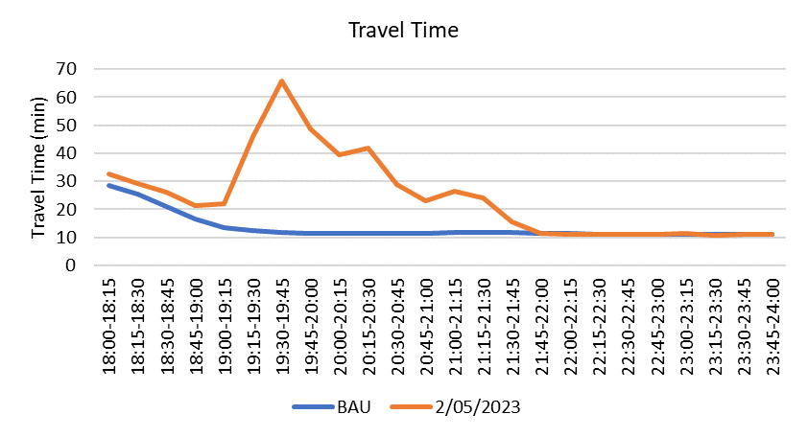
Figure 5: Travel time comparison of the incident day and BAU
Table 3 shows the resilience score, EIT, and dissipation time for the incident day as well as three scenarios. The proposed method was applied to the incident data and the results were compared to the scenario results. The dissipation time indicates that after opening time, it will take around 20-30 minutes for all queued vehicles to be released. The best result is for Scenario 2 where the dissipation time matches the incident data. However, the results of the other two scenarios are also close to the incident data.
Table 3: Resilience score results for incident day and scenario results
 | Incident | Scenario1 | Scenario2 | Scenario3
Resilience Score | 45% | 46% | 46% | 44%
EIT | 3852 | 3345 | 3752 | 4033
Dissipation Time | 9:45 pm | 9:25 pm | 9:45 pm | 9:55 pm
EIT Variation |  | 87% | 97% | 105%

Application of Proposed Measures
The proposed measures can be applied to support the increase of resilience in transport infrastructure in a number of ways. In terms of recovery planning following a natural hazard event, such as the AF8, or incidents on the motorway, the proposed measures can be used to objectively compare the impact of different emergency response plans on trip resilience. The measures include the impact on resilience due to eliminated trips and, for those trips that can occur, increased travel time. In particular, the impact is assessed over the horizon of the post-disaster recovery phase. Response plans can differ in terms of, for example, the order of reopening of blocked links or the re-distribution of resources to accelerate the reopening of particular links. As an example, two proposed emergency response plans with equal recovery periods can be objectively compared and the plan which results in the greater trip resilience over the recovery period can be selected for implementation. The measures were also designed to enable emergency plans with different recovery periods to be compared. In such a scenario, one plan may seem attractive because it has a shorter recovery period, however, the recovery plan with the longer recovery period may in fact result in less impact on trips.
It is also possible to use the measures to assist with the prioritisation of proposed resilience mitigation measures in a constrained financial environment, typical of most road agencies. Such mitigation measures could include earthquake strengthening of bridges, slope stabilisation, passive rockfall protection structures or, indeed, the construction of alternative, more resilient, transportation routes. The financial cost-based metrics (Argyroudis et al., 2021, Zhang et al., 2015) commonly used in such assessments, can be supplemented with pre- and post-mitigation scenarios to quantify the improvement in trip resilience for each proposed mitigation measure.
Finally, the measures can also be used to determine the relative criticality of particular road links. For example, taking a hazard agnostic approach, the impact on trip resilience of a link being “broken”, for whatever reason, can be determined. Such critical links could then be given priority in terms of resilience assessment and, if required, funding.

Conclusion
The resilience of transportation networks, one of the most critical infrastructures in post-disaster situations, will have a significant influence on post-disaster operations, community resilience and business continuity. A trip resilience measure, which incorporates all three dimensions of resilience, namely robustness, redundancy, and recovery, in a combined measure has not been reported in the literature to the knowledge of the authors. Such a measure is needed if the complete picture of the post-disaster impact on trips is to be understood. Similarly, such a measure should be understandable to decision-makers and be capable of ranking the impact on different areas post-disaster, if it is to be of practical use to the profession.
Two case studies were also conducted, to demonstrate the newly developed trip resilience measures, using a hypothetical Alpine Fault Magnitude 8 (AF8) scenario in the South Island of New Zealand and incidents on the Auckland Motorway network. The importance of including both robustness (represented by the number of eliminated trips) and redundancy (represented by increased travel time), over the horizon of the post-disaster recovery phase was highlighted. Eliminated trips contributed significantly in areas that were cut off and isolated post-disaster, due to a lack of alternative routes, and increased travel time contributed as more roads were reopened but the alternative routes resulted in increased travel distances and, consequently, travel time.
In urban areas, where a number of alternative routes are typically available with similar or equivalent distance travelled, redundancy is expected to be high. In such cases, the increased congestion on these routes may result in longer travel times and, therefore, increased travel costs. The Detour Route Resilience project is currently undertaking to assess the resilience of the detour route in case of full closure on the Auckland motorway which will provide a full picture of the resilience of the motorway along with the current resilience dashboard. Integrating other resilience dimensions and applying measures in different contexts can be investigated in future researches.

References:
AF8. 2020. AF8: Alpine Fault Magnitude 8 [Online]. Available: https://af8.org.nz/ [Accessed 2020].
Aghababaei, M. T., Costello, S. B. & Ranjitkar, P. 2020. Transportation impact assessment following a potential Alpine fault earthquake in New Zealand. Transportation Research Part D, 87.
Argyroudis, S. A., Mitoulis, S. A., Hofer, L., Zanini, M. A., Tubaldi, E. & Frangopol, D. M. 2020. Resilience assessment framework for critical infrastructure in a multi-hazard environment: Case study on transport assets. Science of The Total Environment, 714, 136854.
Argyroudis, S. A., Nasiopoulos, G., Mantadakis, N. & Mitoulis, S. A. 2021. Cost-based resilience assessment of bridges subjected to earthquakes. International Journal of Disaster Resilience in the Built Environment, Vol 12 No. 2, 209-222.
Balijepalli, C. & Oppong, O. 2014. Measuring vulnerability of road network considering the extent of serviceability of critical road links in urban areas. Journal of Transport Geography, 39, 145-155.
Benn, J., Todd, D. & Owens, I. 2002. West Coast Regional Council: Natural Hazards Review. DTec Consulting Ltd.
Berryman, K., Helm, P., Davies, B., Smith, R., Kingsbury, P., Markham, S., Manley, C., Adye, M., O’Meara, G., Chittock, D. & Sullivan, F. 2014. Managing natural hazard risk in New Zealand – towards more resilient communities. LGNZ.
Brabhaharan, P., Wiles, L. M. & Frietag, S. 2006. Natural Hazard Road Risk Management Part lll: Performance Criteria. Land Transport New Zealand Research Report 296.
Bradley, B. A., Bae, S. E., Polak, V., Lee, R. L., Thomson, E. M. & Tarbali, K. 2017. Ground motion simulations of great earthquakes on the Alpine Fault: effect of hypocentre location and comparison with empirical modelling. New Zealand Journal of Geology and Geophysics, 60, 188-198.
Bruneau, M., Chang, S. E., Eguchi, R. T., Lee, G. C., O’Rourke, T. D., Reinhorn, A. M., Shinozuka, M., Tierney, K., Wallace, W. A. & Winterfeldt, D. v. 2003. A Framework to Quantitatively Assess and Enhance the Seismic Resilience of Communities. Earthquake Spectra, 19, 733-752.
Chen, B. Y., Lam, W. H. K., Sumalee, A., Li, Q. & Li, Z. C. 2012. Vulnerability analysis for large-scale and congested road networks with demand uncertainty. Transportation Research Part A 46, 501-516.
Chen, L. & Miller-Hooks, E. 2012. Resilience: An Indicator of Recovery Capability in Intermodal Freight Transport. Transportation Science, 46(1), 109-123.
Davies, A. 2019. Increasing the disaster resilience of remote communities through scenario co-creation. Doctor of Philosophy, University of Canterbury.
Davies, A., Zorn, C., Wotherspoon, L., Beaven, S., Davies, T., Matthew, H. & Wilson, T. 2021. Infrastructure failure propagations and recovery strategies from an Alpine Fault earthquake scenario: Establishing feedback loops between integrated modelling and participatory processes for disaster impact reduction.
Dizhur, D., Giaretton, M. & Ingham, J. M. Damage Observations Following the Mw 7.8 2016 Kaikoura Earthquake. 2019 Cham. Springer International Publishing, 249-261.
Dowling, R. 2007. Traffic Analysis Toolbox Volume VI: Definition, Interpretation, And Calculation Of Traffic Analysis Tools Measures of Effectiveness. In: Report FHWAHOP- 08-054. Federal Highway Administration, W., D.C., (ed.).
El-Rashidy, R. A. & Grant-Muller, S. M. 2014. An assessment method for highway network vulnerability. Journal of Transport Geography, 34, 34-43.
Erath, A., Birdsall, J., Axhausen, K. W. & Hajdin, R. 2009. Vulnerability Assessment Methodology for Swiss Road Network. Transportation Research Record, No. 2137, 118-126.
Faturechi, R. & Miller-Hooks, E. 2014. Measuring the Performance of Transportation Infrastructure Systems in Disasters: A Comprehensive Review. Journal of Infrastructure Systems, 15.
Herbert, T., Fairclough, R., Tucker, S., Parr, G., Wotherspoon, L., Blake, D., Trotter, M. & Stevenson, J. 2018. An evaluation and lessons learned from responses to the Kaikōura earthquake. National Sceience Challenges, Resilience to Naturer's Challenges.
Hughes, J. & Healy, K. 2014. Measuring the resilience of transport infrastructure. NZ Transport Agency research report 546.
Jeannotte, K., Chandra, A., Alexiadis, V. & Skabardonis, A. 2004. Traffic Analysis Toolbox Volume II: Decision Support Methodology for Selecting Traffic Analysis Tools. The Federal Highway Administration (FHWA).
Jenelius, E., Petersen, T. & Mattsson, L. G. 2006. Importance and exposure in road network vulnerability analysis. Transportation Research Part A 40, 537-560.
Luathep, P., Sumalee, A., Ho, H. W. & Kurauchi, F. 2011. Large-scale road network vulnerability analysis: a sensitivity analysis based approach. Transportation, 38, 799-817.
Mason, D. & Brabhaharan, P. 2016. National State Highway Resilience. New Zealand Transport Agency (NZTA): Opus International Consultants Ltd.
McCahon, I., Elms, D. & Dewhirst, R. 2006. Alpine Fault Earthquake Scenario & Lifelines Vulnerability Assessment. West Coast Engineering Lifelines Group.
Miller-Hooks, E., Zhang, X. & Faturechi, R. 2012. Measuring and maximizing resilience of freight transportation networks. Computers & Operations Research, 39, 1633-1643.
Misra, S., Padgett, J. E., Barbosa, A. R. & Webb, B. M. 2020. An expert opinion survey on post-hazard restoration of roadways and bridges: Data and key insights. Earthquake Spectra, 36, 983-1004.
Mitoulis, S. A., Argyroudis, S. A., Loli, M. & Imam, B. 2021. Restoration models for quantifying flood resilience of bridges. Engineering Structures, 238, 112180.
MOT. 2017. Connecting New Zealand – A summary of the government's policy direction for transport [Online]. Ministry of Transport. Available: http://www.transport.govt.nz/ [Accessed 2018].
Muriel-Villegas, J. E., Alvarez-Uribe, K. C., Patiño-Rodríguez, C. E. & Villegas, J. G. 2016. Analysis of transportation networks subject to natural hazards – Insights from a Colombian case. Reliability Engineering and System Safety, 152, 151-165.
Murray-Tuite, P. M. 2006. A Comparison Of Transportation Network Resilience Under Simulated System Optimum And User Equilibrium Conditions. Proceedings of the 2006 Winter Simulation Conference.
Murray-Tuite, P. M. & Mahmassani, H. S. 2004. Methodology for Determining Vulnerable Links in a Transportation Network. Transportation Research Record, 1882, 88-96.
Omer, M., Mostashari, A. & Nilchiani, R. 2013. Assessing resilience in a regional road-based transportation network. International Journal of Industrial and Systems Engineering, 13, 389-408.
Orchiston, C., Davies, T., Langridge, R., Wilson, T., Mitchell, J. & Hughes, M. 2016. Alpine Fault Magnitude 8 Hazard Scenario.
Pokharel, R. & Ieda, H. 2016. Road Network Evaluation From A Reliability Perspective: An Accessibility And Network Closure Vulnerability Approach. Asian Transport Studies, Vol. 4, 37-56.
Scott, D. M., Novak, D. C., Aultman-Hall, L. & Guo, F. 2006. Network Robustness Index: A new method for identifying critical links and evaluating the performance of transportation networks. Journal of Transport Geography, 14, 215-227.
Soltani-Sobh, A., Heaslip, K. & Khoury, J. E. 2015. Estimation of road network reliability on resiliency: An uncertain based model. International Journal of Disaster Risk Reduction, 14, 536-544.
StatsNZ. 2018. Statistic Data [Online]. Statistic NZ. Available: https://www.stats.govt.nz/ [Accessed 2018].
Tamvakis, P. & Xenidis, Y. 2012. Resilience in transportation systems. Procedia Social and Behavioral Sciences, 48, 3441-3450.
Taylor, M. A. P., Sekhar, S. V. C. & D’Este, G. M. 2006. Application of Accessibility Based Methods for Vulnerability Analysis of Strategic Road Networks. Netw Spat Econ, 6, 267-291.
TRB 2010. HCM 2010: Highway Capacity Manual, National Research Concil, Transportation Research Board. Washington, D. C.
Wang, J. Y. T. 2015. ‘Resilience thinking’ in transport planning. Civil Engineering and Environmental Systems, 32:1-2, 180-191.
Wu, Y., Hou, G. & Chen, S. 2021. Post-earthquake resilience assessment and long-term restoration prioritization of transportation network. Reliability Engineering & System Safety, 211, 107612.
Yetton, M. D. 2000. The Probability and Consequencies of the next Alpine Fault Earthquake, South Island, New Zealand. Doctor of Philosophy in Geology, University of Canterbury.
Zhang, W. & Wang, N. 2016. Resilience-based risk mitigation for road networks. Structural Safety, 62, 57-65.
Zhang, X., Miller-Hooks, E. & Denny, K. 2015. Assessing the role of network topology in transportation network resilience. Journal of Transport Geography, 46, 35-45.

presenter

