POST-CRASH VICTIM TRANSPORT TO HOSPITAL DOOR

William Frith, MSc (Hons), MSc (Transport Engineering), BA, FCILT, AFACRS, MICADTS Research Manager, Road Safety, WSP│Opus Research, william.frith@opus.co.nz (Presenter)
Jared Thomas, PhD Principal Behavioural Scientist, WSP│Opus Research jared.thomas@opus.co.nz
Richard Jackett BSc(Hons) MInstP, MASNZ, Principal Scientist, WSP│Opus Research richard.jackett@opus.co.nz
Kai O’Donnell BA (Hons) Behavioural Scientist, WSP│Opus Research kai.o’donnell@opus.co.nz

ABSTRACT
Post-crash care of victims had been declared by the World Health Organization to be the fifth pillar of the safe system approach to road safety. The timeliness and quality of the transport of serious crash victims from the crash site to hospital door is a crucial element in medical outcomes. It is thus important that Road Controlling Authorities (RCAs) and Road Policing work together with Emergency Services to provide the best possible outcomes for the available resources.

This report looks at the roles of RCAs and Road Policing in facilitating the carriage of seriously injured crash victims from the crash site to the hospital door. Inputs to the paper include a literature and technology review, a crash analysis and estimates of the time from crash notification to hospital for a sample of crashes. Also considered are issues arising from a workshop of leading stakeholders and an online survey of front line staff from Road Policing, St John and Fire and Emergency New Zealand.

How RCAs and Road Policing can best assist is discussed and recommendations for future strategies and actions are made. Key areas included in recommendations are the place of post-crash care in road safety planning, crash location technology, agencies working together, the need for mobile networks, effective communications and traffic management including crash site management and emergency vehicle priority schemes. Recommendations are also made regarding the information available in crash reports related to post crash care.

INTRODUCTION
The post-crash care of crash victims is a key component of road safety. This has been evidenced in New Zealand by results from this study indicating that improved post-crash care may have affected the outcome in 11% of a sample of fatal crashes investigated by the Coroner.

Owing to its importance, post-crash response has been promoted by the World Health Organisation and United Nations as one of the five pillars of the Global Plan for the Decade of Action for Road Safety 2011-2020. This has also been adopted in Road Safety circles as the fifth pillar of the Safe System Approach to Road Safety.

This paper seeks to document what the Transport sector can do now and in the future (in partnership with the health and emergency services sectors) to improve its delivery. It is aimed specifically at the role of the Government Land Transport Sector, both local and central, in improving outcomes of crash victims by facilitating their journey from the crash site to the hospital door.

The Transport Sector can actively partner in initiatives that aim to improve the ability of paramedics and emergency services to reach crashes quickly, extract injured occupants, apply first aid procedures and transport them to hospital in time for trauma care to be applied effectively. It can also provide the most forgiving road environment possible to reduce the burden on overworked emergency services.

The paper discusses existing knowledge including technological developments and draws upon:
- An analysis of a sample of fatal crashes investigated by Coroners to gain knowledge of how outcomes may have been improved by actions of members of the transport sector.
- An analysis of 276 fatal crashes from 2016 to assess the accessibility of their sites to emergency services.
- A targeted online survey of frontline emergency workers from St Johns, Fire and Emergency NZ and Road Policing and a workshop of stakeholders and emergency services managers to capture expert knowledge and perspectives regarding the strengths and weaknesses of existing practices and directions for the future.
It then integrates these strands of information to produce a report that provides well-informed, practical recommendations for the transport sector road safety partners.

Existing Knowledge

The review of existing knowledge resulted in a classification of the work done into the following broad categories.

Timely and accurate notification of crashes - How to detect and characterise the problem, notify and dispatch help?
- Time to crash identification - Ability to notify (network coverage/technology); information accuracy (location, severity, patient access issues).

Fast, safe travel to and from the crash site - How to assist in swift, safe road and air travel of emergency services and extraction of casualties?

Working together - What strategies, planning, research and communications activities might support post-crash care?
- Post-crash care in road safety strategies and plans - Coordination between organisations (policy alignment/data sharing); communications (tools/equipment/internal processes); training/education (agency/public).

Among the influences on this classification were the following key pieces of information.
A SafetyNet report (2009) on post-impact care included the following among the key components of post impact care:

Notification of the emergency medical system;

Distance and time to appropriate treatment facilities;

Coordination between emergency services to ensure fast care and transport;

Training of emergency personnel;

Availability and response times of ambulances;

Data and information systems.

The SafetyNet report also cited a 2001 Swedish study of fatal road crashes which concluded that 48% had non-survivable injuries, but of those with survivable injuries, 5% were not located in time, 12% could have survived if transported more quickly to hospital, and 32% could have survived if transported quickly to an advanced trauma centre. Hakkert et al (2007) in a working paper for SafetyNet concluded that 35-50% of fatal cases could be considered treatable and therefore could be influenced by an improved trauma management system. A 2011 US study found 39% of 98 motor vehicle deaths were potentially preventable by optimal medical treatment being immediately available (Ray et al., 2016).

The importance of emergency response has also been indicated in differences in survival between crashes in rural and urban areas (International Transport Forum & OECD, 2016). Lu and Davidson (2017) looked at fatal motor vehicle crashes in Texas. They found that although fatal crashes were more concentrated in urban areas, the fatality rate was higher in rural areas. The total time from occurrence to hospital arrival and the component time segments (activation time, ambulance response time, hospital transport time) were longer in rural areas.

The New South Wales Road Safety Strategy 2012 – 2021 recommended these actions:
- Establish a whole-of-government approach to post-crash response that identifies areas for improvement;
- Investigate options for Automatic Collision Notification (ACN) systems;
- Educate drivers about the added risks of crashes in remote areas;
- Provide clearer advice to road users on what to do if they crash and on safety near incident sites.
The strategy also looked at better coordination between emergency retrieval and medical services and the Motor Accidents Authority. ( Wall, J. P., 2013; Wall, J, et al, 2014).

Statistical Analysis of Coroner Investigated Fatal Crashes

Introduction
The aim of this analysis was to draw conclusions from data, and provide recommendations on improving the post-crash response and data related to the post-crash response. To do this, it was necessary to:
- Identify data sources with information relevant to post-crash response
- Determine methods to link data sources
- Produce a dataset of crashes (fatal or serious injury) that contains information on the post-crash response
- Analyse data and identify any patterns that exist
The fatal crash dataset for this study is a sample of 85 fatal crashes from New Zealand public roads over the last 10 years on which coroners had reported. To this was added relevant data from Police Traffic Crash Reports, Police Serious Crash Unit reports and media reports. Only Coroner’s findings and media reports contained specific information on the emergency response and then only in some cases. Coroner’s findings are a sample of approximately 20 fatalities per year biased towards crashes involving multiple fatalities, topical crashes (e.g. cycle deaths, tourist crashes), and crashes where the cause of death was ambiguous.

Data Analysis
Six crashes were not relevant, either because they were not on public roads (5 crashes, mostly motorsport related), or because the death was not due to the crash (1 crash, involving a heart attack prior to the crash). 61% of the crashes in the dataset were single vehicle crashes (Figure 1A). In this classification a vehicle versus pedestrian crash is a multi-vehicle crash. The crashes were classified by the number of deaths caused, and the proportion of each classification is given in Figure 1 B. In nearly 3/4 of fatal crashes there was one death, in 18% there were two and 8% caused three or more deaths. Coroners’ decisions to investigate a crash could be influenced by the number of deaths, resulting in a dataset biased to higher severity crashes. This is supported by the data on all fatal crashes. An analysis of fatal crashes in New Zealand from 2000 to 2016 reveals that 90% of fatal crashes had one death, 8% had two, and just 2% caused three or more deaths, a different percentage breakdown from that in the Coroners’ data.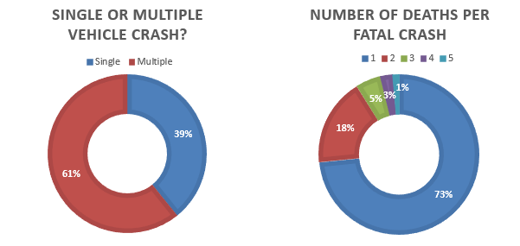
A B
Figure 1: General characteristics of fatal crash dataset
It was possible to categorise the place of death as being either at the crash scene or elsewhere (Figure 2A). Of particular interest is whether a victim died instantly (including very soon after the crash). As far as could be deduced from the data, 30% of the crashes probably resulted in instant death for victims, whereas in 57% of the crashes at least one person survived beyond the impact before later succumbing to injury (Figure 2B). For 13% of the crashes there was insufficient information to decide either way.
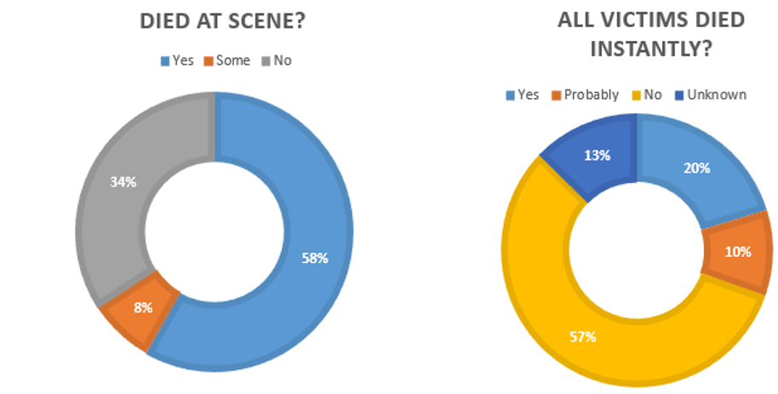

A B
Figure 2: Place and timing of death within fatal crashes dataset
Post-crash response is not relevant in crashes where all deaths occurred instantly or near instantly. Removing these crashes, as well as those classified as ‘unknown’, from the dataset left 45 road crashes where death was not instant (Table 1) and the post-crash response was relevant.
Category | Number of Crashes per Classification (out of 45)
 | Yes | Probably | Unlikely | No | Unknown
Crash Witnessed | 40 | 0 | 0 | 4 | 1
Received a slow response | 9 | 0 | 4 | 7 | 25
Access to scene difficult | 5 | 0 | 36 | 0 | 4
Response a factor | 7 | 2 | 15 | 7 | 14
Response time a factor | 6 | 2 | 13 | 9 | 15
Access to scene a factor | 3 | 0 | 17 | 16 | 9
Table 1: Classification of 45 fatal road crashes where death was not instantaneous
We see that about 90% of the non-instant death crashes were witnessed. The witnesses would probably have been capable of calling emergency services and include crash victims who were not seriously injured and third parties. Conversely, four fatal crashes (9%) were not witnessed. These four crashes did not receive a fast response from emergency services along with five more crashes that were witnessed (2nd row of Table 1). The assumption is that a significantly slow response will have been explicitly noted as such by one of the sources. Five crash scenes were identified as being difficult for emergency services to access. Aspects of the emergency response were likely to be a factor in nine crashes, with response time a factor in six and access to the scene a factor in three. There is some overlap between the sets. These results are illustrated pictorially in figure 3.

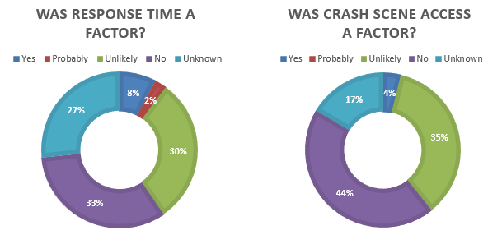

A | B
Figure 3: Proportion of all studied crashes (n=79) where aspects of the response may have affected the outcome. (Includes crashes where death was probably instantaneous)

Conclusions
It is notable that most of the crashes identified as having a sub-optimal post-crash response occurred on rural roads. In three rural cases the crash was not witnessed and was not discovered until it was already too late for the victims, who otherwise may have had a better outcome. Therefore, it appears that, aside from any other risk factors they introduce, remote rural roads present an additional risk of a crash going undiscovered until it is too late to help the victims.

In a further three cases the crash was witnessed and an attempt made to contact emergency services, but the remoteness of the location contributed to the poor outcome. While crashes in remote areas will often take longer to respond to, in these crashes the remote location contributed to an abnormally poor response.

In two crashes, 111 was not immediately contactable. In both cases this led to a delay in help arriving at the scene, in one case further complicated by emergency services being unable to locate the scene due to their computer system not recognising the colloquial name for the road.

In three crashes, two of which were remote, there may have been crash scene issues that led to a sub-optimal choice of transport to hospital. In two cases the coroner stated that using an ambulance to transport the patient to hospital, although taking longer, would have allowed paramedics to continue treatment en-route. In the third case airlifting was initially considered too dangerous, and the solution was unclear given that urgent treatment was required. The information that ambulance transport was preferred in all three cases may be relevant for the Transport Authority, in that it cannot be assumed that helicopters can replace ambulances for all callouts where road access is difficult.

CRASH SITE ACCESSABILITY TO TRAUMA HOSPITALS

This section looks first at the accessibility of the sites of 276 fatal road crashes occurring in 2016 in terms of emergency services travel time to the crash site. Three quarters of the crashes occurred on rural roads (> 70km/hr speed limit), with the remaindering on urban roads.

The analysis uses the point locations of crashes (from CAS) and Ministry of Health supplied locations of ambulance stations and helicopter rescue bases to estimate by GIS processing the distance and travel time from the nearest helicopter and land ambulance rescue services to the crash site. For helicopter rescue, straight line distance was used and road distance was used for land ambulance services. Helicopter or Air Rescue flight time was estimated using a cruising speed of 212.5 km/hr based on the average cruising speeds of the helicopters of Auckland Rescue Helicopter Trust and Westpac Rescue Helicopter. Seventeen helicopter rescue providers and 130 land ambulance stations were included.

This analysis is subject to the following approximations.
- All ambulance journeys are assumed to begin at an ambulance station. This is not always the case.
- It does not allow for the different speeds helicopters may travel at during take-off and landing.
- Ambulances using their sirens to gain priority is not considered.
- The analysis does not consider rescues that use both air and land modes.
- The analysis uses global average speeds for land rescues and thus does not allow for temporal variations.
- It refers only to travel time, and does not include the time between when the crash is advised to a call centre and the dispatch of the vehicle

For Air Rescue, on average, the estimated mean flight time from the base to the crash site was 14 minutes for rural road crashes and six minutes for urban road crashes. For Land Ambulance Rescue the estimated mean road travel time from the station to the crash site was 12 minutes for rural road crashes and 10 minutes for urban road crashes.

The median travel time for both air and road rescue was lower than the mean travel time for both urban and rural crash sites. This indicates a positive skew in the distributions. This was especially evident in the case of urban road crashes. The same can be said for times.

Overall, the results confirm that crash sites are more accessible to ambulance services in urban areas than in rural areas. The differences between land rescue and air rescue may relate to the much greater number and geographical spread of ambulance stations and the possibility that cases warranting a helicopter turnout may be more serious.

The same methods cannot be readily used for the journey to hospital from the crash site. These journeys are more complex. There are 20 major trauma hospitals where road crash patients may be taken. Of these 7 are tertiary major trauma hospitals where the most serious cases are taken. It is not possible to make a meaningful call from the crash data whether a case would go to a tertiary hospital or not and around 20% of all trauma cases are taken to a hospital and then transferred to another one. To get an idea of times to the first hospital (but only for all trauma cases, not just road crash victims we can use the figures from the 2016-206 Annual Report of the Major Trauma Network. The figures show that overall 55% of patients reach their first hospital within 1 hour and 85% within 2 hours. The major trauma network is working to reduce these figures and the transport sector can assist by acting to avoid congested travel conditions through active cooperation between the road controlling authority, road policing and emergency services to minimise any disruption to travel times related to the crash and where possible to prioritise the travel of the emergency vehicle, a potentially challenging task in major urban areas.

Stakeholder, Manager and Front-line Staff Opinions

The results of the existing knowledge review and the statistical analysis were used as input to the design of a workshop of Stakeholders and Emergency Service Managers and an online survey of emergency services front-line staff. Both the workshop and survey were based upon the three broad service areas and underlying qualities illustrated in Table 2.

Broad service areas | Service Qualities (with some examples)
Timely, accurate notification | Time to crash identification
 | Ability to notify (network coverage/technology)
 | Information accuracy (location, severity, patient access issues)
Fast, safe travel | Information needs (route planning tools/information to public/digital rescue data)
 | Emergency vehicle prioritisation (prioritised lanes/signals “green wave”/access for helipad locations)
 | Traffic management (Police and Road Controlling Authorities/Technology/Smart motorways)
Working together | Post-crash care in road safety strategies and plans
 | Coordination between organisations (policy alignment/data sharing)
 | Communications (tools/equipment/internal processes)
 | Training/Education (agency/public)

Table 2: Service areas and service quality categories

Workshop of Stakeholders and Managers
The workshop was split into two break-out groups for an interactive session discussing the three broad service areas and underlying qualities. In each group, stakeholders wrote two numbers (between 0 and 10) on a coloured Post-It note and placed it on a matrix. The first number indicated importance (with higher numbers indicating a greater ability to save lives). The second number indicated the existing service quality in New Zealand. The results for each service area were discussed first within the groups, and then between the groups. The resulting priority matrix (see Figure 4) was shown to help focus more in-depth discussions amongst workshop participants.
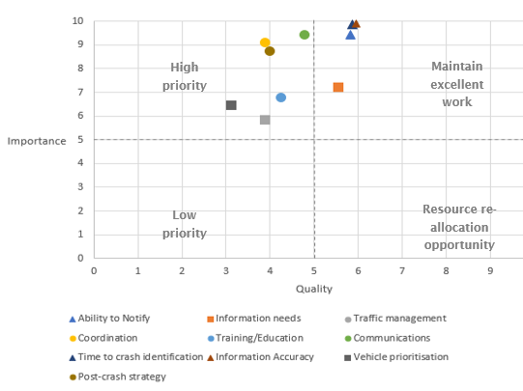
Figure 4: Priority matrix for indicating importance and existing quality of services

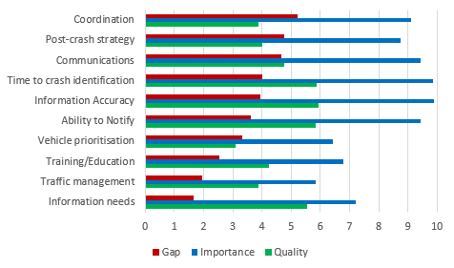
The perceived gap between importance and existing quality of delivery (calculated post-workshop) also enables a ranking of the services (see Figure 5).

Figure 5: Service qualities ranked by the perceived gap between the importance and existing quality of service (from largest gap to smallest gap).

Based on the gap analysis, coordination, post-crash strategy and communications were three most critical areas to improve.

On-line Surveys of Front-line Staff
On-line surveys carried out with front-line staff from St. John, Fire and Emergency New Zealand (FENZ) and the Road Policing division of NZ Police. For each of the service areas in table 3, three ranking questions were asked followed by an open-ended question regarding one thing the respondent would like to see done to improve the respective category. Finally, respondents were asked an open-ended question regarding what had already been done, in any category, that had resulted in improvement. These open-ended questions were designed to unearth their more specific concerns. An example is a concern regarding risk of electric shock from crashed electric vehicles. A total of 433 useable responses were received, 46.2% from Road Policing, 35.6% from St John and 18% from FENZ. Experience of emergency response to crashes was high. 61.0% declared more than 10 years’, 16.6% 6 to 10 years’ and 20.4% 1 to 5 years’ experience.

Learnings from the Workshop and Surveys
Overall, all service areas were consistently rated as important by both the stakeholder/manager group and the front-line staff. There was also agreement between the two groups that Timely, Accurate Information was a key area to focus improvements. Both groups placed high value on Working Together (including communications and data sharing).

Table 3 shows the relative ranks in terms of importance. Three of the top four factors were consistent across the different organisational levels, which indicates strong buy-in and desire for actions and interventions. In terms of coordinating organisations to improve post-crash care, these would-be areas to prioritise.
Rank | Front-line Group  Ability to reduce harm/death (if improved) | Stakeholder/Manager Group  Importance in saving lives
1 | Information accuracy | Information Accuracy
2 | Ability to notify there has been a crash | Time until a crash is identified
3 | Cross-agency working together | Ability to notify there has been a crash
4 | Emergency vehicle prioritisation | Cross-agency working together
5 | Traffic management | Post-crash care in road safety action plans
6 | Training for responders | Information needs
7 | Time until a crash is identified | Training/Education
8 | Information needs | Emergency vehicle prioritisation
9 | Post-crash care in road safety action plans | Traffic management
Table 3: Relative rank of service areas by frontline and stakeholder/manager groups
Note: The top four service areas are in bold, with green font where they are both listed consistently
Examining differences between the groups revealed that the front-line staff placed higher value on Efficient, Safe Travel (vehicle prioritisation, and traffic management). They also ranked inter-agency training for responders highly. The stakeholder/manager group valued post-crash care being embedded in road safety strategies and action plans, as well as improvements around travel and crash site information needs (such as route planning and digital rescue data). Their workshop involved in-depth interactions and knowledge sharing, including from international best practice, which may explain these differences. For example, a consistent digital rescue database that shows the safe, efficient way to extract trapped passengers from participating vehicle models does not appear to be used in New Zealand currently so the value of this measure was more apparent to the stakeholder/manager group.

It would be important to ensure front-line staff are involved in improving delivery around travel improvement technology and ITS solutions (such as the green wave for emergency vehicles) and to have their inputs to improve inter-agency responder training. Their experience provides detailed insights around constructive areas to focus on (e.g. around roles and responsibilities), emerging issues, and to enable faster knowledge-sharing around what is working that could be fast-tracked.

It must be remembered that these are perceptions by people of expertise ranking supplied options which were all generally considered important by participants. As all the options were considered important being relatively lowly ranked does not mean lack of importance.

DISCUSSION

Introduction
In New Zealand, the responsibility for Road Safety Strategy sits with the Ministry of Transport under the National Road Safety Committee which is the high-level body initiating and coordinating action between road safety partners. The Road Safety Strategy to 2020 “Safer Journeys” is produced by the Ministry on behalf of the Minister of Transport under the auspices of the National Road Safety Committee and in consultation with the public. There are action plans sitting beneath the Strategy which turn the higher-level aspirations in the strategy into actions.

The NZ Transport Agency is responsible for the operational side of road safety and has its own targets and action plans associated with operational outcomes it has identified. Road Policing is responsible for the smooth flow of traffic given the road infrastructure provided by the Road Controlling authorities, for Policing of road user behaviour, for traffic control and reporting associated with incidents on the road including crashes. Where the responsibility for specific actions related to post-crash care lies would be subject to negotiation between the Ministry, the Agency and Road Policing under the umbrella of the National Road Safety Committee to which they all belong.

This section will discuss post impact care priority areas for transport sector participants in the light of the learnings described earlier.

Crash Information Accuracy
This is obviously important in a wide variety of ways from accurate location of the crash, accurate information of the state of the injured parties, accurate information on the right routes for vehicles to take to and from the crash and accurate information on the crash risk of the network to allow prioritisation of measures to assist post-crash recovery to risk. The crash analysis, workshop and online surveys all indicate that improved accuracy of crash information would improve post-crash outcomes information on exact crash locations.

Ability to notify there has been a crash
This is particularly crucial and the crash data analysis showed the sad consequences of a crash not being found until help is too late. Various methods to improve this situation exist like automatic crash notification system, simple LED flares to attract the attention of passers-by (used in Japan) and improved cellular and trunk radio networks. Road user information on where in the network cellular networks exist to allow this to be considered in route choice is also a simple option.

Cross-agency working together
Very little work in the post-impact care area is the sole responsibility of any one agency. Therefore cooperative work between agencies is crucial to future progress. There is scope to improve this over a number of areas previously discussed in this document. It is now up to the agencies to get together and provide an environment in which working together can be enhanced in the interests of post-crash care. It is important that front-line staff are involved in these interactions.

Time until a crash is identified
This crucial component in the ability to reach a survivor in time to improve outcomes is highly related to ability to notify a crash and relates to the efficacy of communication networks which in turn is highly dependent on the availability of appropriate technology and on agencies working together.

Emergency vehicle prioritisation
This is a measure highly rated by operational personnel. However, it is to all intents and purposes non-existent in New Zealand apart from priority traffic signals outside some emergency vehicle stations and the ability of emergency vehicles to use special vehicle lanes at times of emergency and the ability to carefully cross an intersection at up to 20km/hr. Further work would be required to ascertain to what extent its extended use is justified in a New Zealand context.

Traffic management
This can mean traffic management at and around a crash site or the management of the progress of emergency vehicles to and from the site. Again, this requires a cooperative effort between all parties including a well-defined command structure at the site.

Training/ education for responders
There is an obvious need for this to streamline the operation of crash sites and traffic management in the vicinity and in specific cases like the need pre-empt electric shock risk in the case of crashed electric vehicles. Transport Sector candidates for training would be members of Road Policing and Road Controlling Authority field staff. There is also a need to consider the extent to which response to the occurrence of crash injury can be improved by perhaps included in driver education or overall road user education.

Information needs
This is a case of identifying exactly what information not available now is required and may be practically be acquired at reasonable cost and planning for its future acquisition. The statistical analysis identified a number of information needs associated with crashes.

Road Safety Action plans
This was not the highest ranked of the service areas discussed, but is in fact of crucial importance. That is because without an action plan nothing can really be done, so an action plan is crucial to the effective carrying out of any action. It may be that people are sceptical of action plans because they are aware of some cases where they have not actually been implemented.

Recommendations

The following Transport Sector Specific recommendations were submitted for consideration by the NZ Transport Agency and its partners. They have been selected as suitable for being considered and if agreed, implemented, at reasonable cost.
- Road Safety Strategies and action plans
- That the Road Safety Transport Sector, through the National Road Safety Committee consider including Post Impact Care in future Road Safety Strategies as a fifth pillar of the Safe System approach to road Safety.
- That the Road Safety Transport Sector, through the National Road Safety Committee, consider how post impact care, as the fifth pillar of the Safe System Approach to road safety, should be dealt with in the upcoming New Zealand Road Safety Strategy. This would include consideration of how action plans should be provided beneath the strategy for joint action with emergency services partners and integrated with the operational planning of Transport Agency and Road Policing.
- That the Road Safety Transport Sector, through the National Road Safety Committee note that at present post-crash care is considered as an informal adjunct to other work. If progress is to be made it must feature formally in the planning documents of the appropriate authorities and allocated time in the work programmes of appropriate staff.

- Working together
That the Transport Agency and Road Policing together explore opportunities to set up permanent regular channels of communication with Ambulance Services and Fire and Emergency New Zealand. This would be done in consultation with Ministry of Health and ACC and representatives of Road Controlling Authorities. There would need to be expeditious means for joint decisions to be implemented and funded. It is important that front-line staff are involved in these interactions.

Under this the areas of importance mentioned earlier in this report could be considered. These would include the following practical issues which appear capable of being dealt with at reasonable cost.
- Training of Road Policing and RCA staff in dealing with post-crash situations including chains of command at crash sites.
- Smoothness of communication between the agencies in the event of a crash. The quality of this communication can have a dramatic impact on the time between crash and presentation of the victim at hospital.
- Traffic management at crash sites and on routes to and from crash sites.
- Provision of road infrastructure which is as part of its design supports emergency services to carry out their work as efficiently and effectively as possible.
- Automatic crash notification devices are beginning to appear on vehicles in the New Zealand market. It is timely to discuss how best to deal with the notifications they provide and in what form to encourage their inclusion in New Zealand market vehicles including the place of smart phone related applications in this mix.
- How the landing requirements of helicopters can best be satisfied.
- To what extent post impact care (as a bystander) can be improved and by what mechanisms.

- Coordinated communications systems
That the Transport Agency explores with Road Policing and Emergency Services partners future possibilities around shared communications channels between the agencies around crash dispatch and between responders, for better coordination focussed on the event.

- Cellular networks
That the Transport Agency consider:
- Exploring with MBIE and the rural broad band initiative the notion of including a targeting to risk component to the rollout of cellular networks along highways. This is at present targeted only to tourist numbers and traffic volumes.
- Providing information to the public regarding where on the State Highway Network cellular networks exist. If this information is not available from network providers the technology exists to scan the network for cellular networks at the same time as other network scans (such as those for Kiwi Rap are carried out). A star rating similar to KiwiRAP could be considered. This would allow road users, where there is a choice, to choose a route where rescue was more probable in the event of a crash.
- Proactively joining with its partners to assist in planning for the inevitable rollout of cellular technologies with enhanced capabilities to improve crash notification.
- Discussing with operators interconnectivity of cellular networks and digital radio networks and the access of radio networks to 111 call centre operators

- Crash information
Existing data on the timeliness and effectiveness of the post-crash response is lacking, despite the Transport Agency’s previous efforts to improve this situation. It is recommended that the NZ Transport Agency consider:
- Reminding Coroners of the Agency’s interest in and usage of coronial findings, particularly as they relate to post-crash response.
- Reinforcing their interest in the post-crash response and victims’ injuries to the Police officers responsible for completing Traffic Crash Reports.
- Investigating data sharing between the NZ Transport Agency and Ministry of Health (particularly the Emergency Ambulance Services) so that the outcomes of non-fatal road crashes can be better investigated, including the quality of the post-crash response.

- Emergency Vehicle Prioritisation
That the Transport Agency consider, in consultation with Road Controlling Authorities and Emergency Services, whether there is a need to make more explicit provision in the Road User Rule (2004) for the use of emergency vehicle priority measures. Such a need would be predicated on the existence of locations where such measures would make a worthwhile improvement in emergency vehicle operations. This may require some trialling. If such a need was established the pertinent rules and the Manual of Traffic Control Devices may require some amendments.

- Inclusion of innovative emerging vehicle-related systems to facilitate rescue in ANCAP
That the NZ Transport Agency discuss with ANCAP how crash notification systems and the availability of digital vehicle data sheets might be included in ANCAP’s star rating system for vehicle safety.

- Electric Vehicle Post -Crash Electric shock risk
There is a risk of post-crash electric shock associated with electric vehicles. Japanese NCAP tests electric vehicles for this risk. It is recommended that the NZ Transport Agency discuss with ANCAP the possibility of including similar tests into ANCAP testing and discusses with emergency service partners methods to minimise electric shock risk to crash responders.

REFERENCES
Hakkert, A.S, V. Gitelman and M.A. Vis (eds.) (2007). Road Safety Performance Indicators: Theory. Deliverable D3.6 of the EU FP6 project SafetyNet. http://www.towardszerofoundation.org/wp-content/uploads/2016/10/Zero_road_deaths-SafeSystems.pdf
International Transport Forum, & OECD. (2016). Zero road deaths and serious injuries. OECD Publishing. https://doi.org/10.1787/9789282108055-en
Lu, Y., & Davidson, A. (2017). Fatal motor vehicle crashes in Texas: Needs for and access to emergency medical services. Annals of GIS, 23(1), 41–54. https://doi.org/10.1080/19475683.2016.1276102
Ray, J. J., Meizoso, J. P., Satahoo, S. S., Davis, J. S., Van Haren, R. M., Dermer, H., … Schulman, C. I. (2016). Potentially preventable prehospital deaths from motor vehicle collisions. Traffic Injury Prevention, 17(7), 676–680. https://doi.org/10.1080/15389588.2016.1149580
SafetyNet. (2009). Post impact care. Retrieved from http://ec.europa.eu/transport/road_safety/specialist/knowledge/postimpact_en
Wall, J. P. (2013). Post crash response: Low hanging fruit or just an after thought. In Proceedings of the 2013 Australasian Road Safety Research, Policing & Education Conference. Brisbane. Retrieved from acrs.org.au
Wall, J., Woolley, J., Ponte, G., & Bailey, T. (2014). Post crash response arrangements in Australia compared to other high performing road safety nations. Presented at the Proceedings of the 2014 Australasian Road Safety Research, Policing & Education Conference, Melbourne. Retrieved from digital.library.adelaide.edu.au

Acknowledgement
This work was funded by the Research Programme of the NZ Transport Agency which will publish a full report on the work. Views expressed in this paper are those of the authors and do not necessarily represent the views or the policies of the NZ Transport Agency. The authors thank the Agency for the opportunity to carry out the work.

These crashes all occurred between 2008 and 2016, when mobile phone ownership was common in New Zealand.
http://docs.wixstatic.com/ugd/bbebfb_28543150b87246fd959b10af996bb1ac.pdf Viewed 12/12/2017
Note that the sample size for the stakeholder group was small. Communications was only examined separately in the stakeholder workshop. Training included public education and agency training in the stakeholder workshop.

