THE QUARRYMAN'S TRAIL CYCLEWAY STORY

Ben Dodgshun, BE(Hons)(Civil), CMEngNZ, CPEng, IntPE(NZ)
Transportation Engineer, Stantec | Designer, Peloton MCR Delivery Team
ben.dodgshun@stantec.com

ABSTRACT

The Quarryman’s Trail Major Cycle Route (MCR) is a cycleway currently under construction in Christchurch. Once completed, the Quarryman’s Trail MCR will provide a connection from the Central City south-west to Halswell via Addington and Somerfield.

The route and facility type initially identified for the middle section of Quarryman’s Trail would have required the removal of all on-street parking, unless a significantly compromised and expensive solution was adopted. The route would have turned at a major signalised intersection, which would have resulted in a potentially confusing movement for cyclists, and a significant loss of capacity through the intersection if a protected cyclist phase was to be provided.

While the initial facility type was the appropriate treatment for the road environment under the Christchurch Cycle Design Guidelines – Design Principles Best Practice Guide (2016) (DPBPG), it was identified that an alternative was needed to minimise the impacts of the cycleway on the local community and road network, whilst maintaining high levels of safety and service for cyclists.

An alternative route was identified, which saw the proposed cycleway moved from an arterial road to a low-volume, local road as a ‘neighbourhood greenway’ shared street. This gave the opportunity for an easy connection onto a two-way separated cycleway for the remainder of the route, allowing parking to be retained on the side of the road opposite the cycleway. The key concern with the two-way cycleway option was that the traffic volumes along the route, at 15,000 vehicles per day (vpd), were significantly higher than the DPBPG guideline of 5,000 vpd.

This paper details how the project team assessed the relative safety of the different facility types and produced a design that maintained a high level of safety for cyclists, whilst minimising the impacts on the adjacent community.

INTRODUCTION

In 2012, the Christchurch City Council identified a proposed network of 13 high-standard cycleways to form its MCR network. The MCRs were to be the spline of the city’s cycle network, with a series of local connections to be constructed at a later date. Subsequently, the specific routes proposed for the 13 MCRs were identified, as shown in Figure 1:

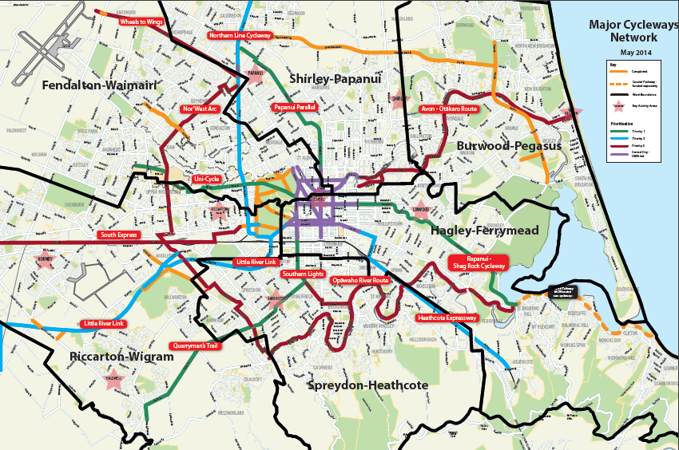
Figure 1: Proposed Major Cycle Route network (as at May 2014)

The Quarryman’s Trail MCR will provide a connection from the Central City south-west towards Halswell via Addington and Somerfield, a length of 7.5 km. The name “Quarryman’s Trail” arose from a public naming competition in 2014, and relates to the cycleway travelling towards the old Halswell Quarry. A preferred route for the Quarryman’s Trail was identified, which entailed using mostly Collector and Minor Arterial roads. Other routes were investigated, however these all would have resulted in a lack of directness, complicated manoeuvres, lack of Major Cycle Route coverage over certain areas, and would have been extremely expensive to construct due to the nature of some the roads on those routes. This led to an initial design being developed along the preferred route.

Engagement with emergency services revealed that a flush median was required on the Milton Street, Frankleigh Street and Sparks Road section of the route. As a key emergency access route to south-west Christchurch, emergency services vehicles needed to be able to pass traffic when responding to an emergency, something typically precluded with the narrower MCR road cross-sections. With traffic volumes of around 15,000 vpd, it was also important that drivers waiting to turn into properties and side roads could do so without holding up the flow of traffic, or feeling pressured to accept smaller gaps (especially when crossing the cycleway).

The DPBPG recommends one-way cycleways on Major Cycle Routes on roads with traffic volumes over 5,000 vpd, with a desirable width of 2.1-2.3 m and a minimum width of 1.8 m (narrower widths are possible for isolated lengths). The combination of this with the existing road width and location of services would have resulted in the loss of all on-street parking to fit the flush median and prescribed one-way separated cycleways, as shown in Figure 2.

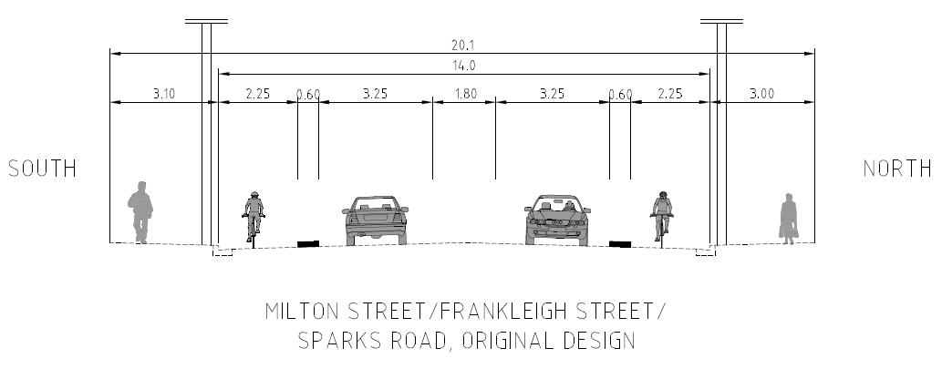
Figure 2: Original cross-section

Alternatively, a reduced-width cross-section could have been adopted, whereby the horizontal separation between cycleway users and parked cars is removed on one side, and some elements of the cross-section narrowed. Whilst this compromise has been applied on other MCRs in constrained situations, it was applied only to isolated sections. This option would also have required the relocation or undergrounding of power lines, the replacement of large lengths of kerb and channel, along with new stormwater infrastructure, making it a very expensive option. This is shown in Figure 3.

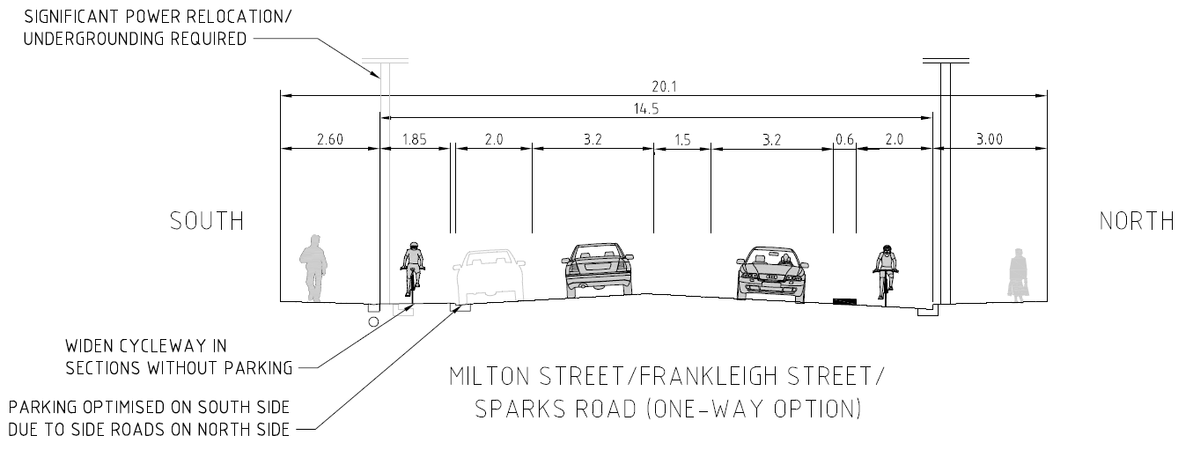
Figure 3: Reduced-width cross-section

Neither of these options were considered appropriate. The removal of parking would have met the requirements of the MCR and been appropriate for the Minor Arterial Road classification, however it would have likely met significant opposition from the community. The reduced-width option would have been less safe and comfortable for cyclists and vehicle drivers and passengers (especially as it would pass two primary schools), cost a significant amount of money, and still have resulted in parking loss of around 60-70% in midblock sections.

There were also drawbacks common to both options along this route. Both would have resulted in the removal of all on-street parking around a block of local shops located near an intersection, which included several takeaway shops. Furthermore, for an MCR to make a single-stage protected turn at a signalised intersection, almost all vehicle movements would need to be held for the duration of the cyclist phase. For the Milton Street/Strickland Street intersection, with around 2,500 vehicles passing through in a peak hour, this would have resulted in a significant drop in the level of service of the intersection, impacting cyclists as well as drivers. Alternatively, hook turns could have been used, however these may not have been intuitive or comfortable for the less confident ‘interested but concerned’ target audience.

The issues that would have resulted from either of these options along this route, along with the issues associated with the alternative routes initially investigated, led the design team to search for an alternative route or facility design that would meet the requirements of an MCR whilst minimising the impacts on businesses, the community, and the financial costs.

ALTERNATIVE ROUTE
An alternative route was identified, which continued south on Strickland Street beyond Milton Street, before crossing onto Roker Street. Roker Street is a low volume local road, running parallel with Milton Street, around 100 m to the south (see Figure 4). Roker Street would provide a similar alignment to the Milton Street section of the original route, without the issues associated with parking along that section, in particular outside the local shops, as well as the operation of the signalised intersections.

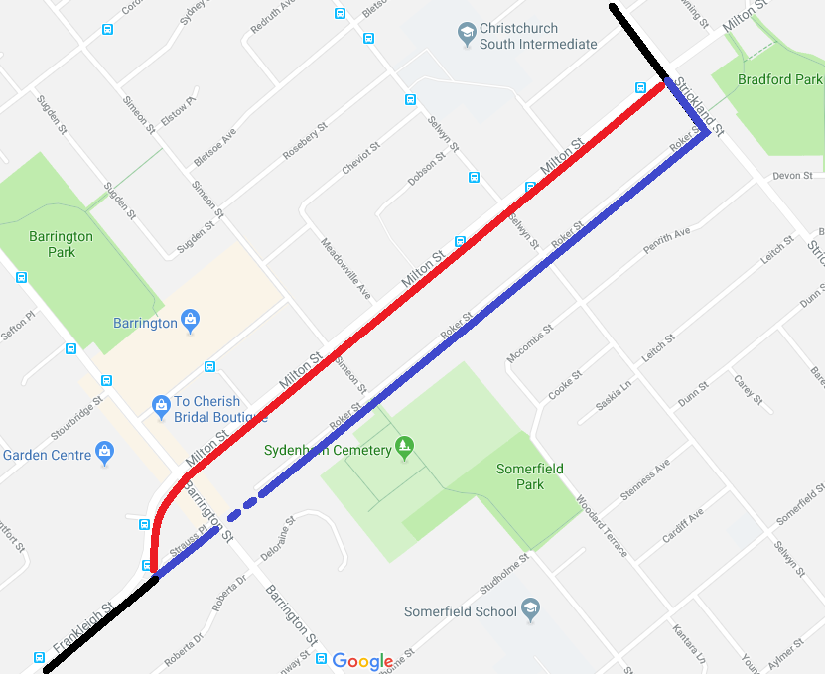
Property purchase
Alternative Route - Roker Street
Original Route – Milton Street
Figure 4: Alternative route alignment (map from Google)

The Roker Street option did rely on the purchase of two properties to connect the end of Roker Street through to Barrington Street, which is part of the reason this alternative was not considered in the original route assessment. However, when the impacts of the Milton Street route were fully known, this option became more attractive. There were several potential combinations of properties to make the connection, and engagement with the owners of the affected properties was carried out to determine if there were willing sellers.

As well as avoiding the issue of parking loss on a significant portion of the route, the Roker Street option had the advantage of avoiding the need for the MCR to make a turn at a signalised intersection. It also removed the need to make changes to the intersection of Milton Street/Frankleigh Street and Barrington Street, an intersection of two Minor Arterial roads, the operation of which would have been affected by the space and signal phasing required for an MCR.

This led to Roker Street becoming the preferred route, providing an appropriate cycle facility and connections onto the remainder of the route could be found, and the purchase of the properties completed (Subsequently, Council was successful in negotiating the purchase of the two preferred houses).

The Roker Street route had one further advantage: it allowed a two-way cycleway to be considered, which would facilitate the provision of on-street parking on one side of the road on Frankleigh Street and Sparks Road without requiring a costly and compromised design with reduced facility widths and the removal of horizontal separation next to parked vehicles.

ALTERNATIVE ROUTE FACILITY TYPE
A two-way separated cycleway had not been considered previously as the traffic volumes along the route of around 15,000 vpd were far in excess of the 5,000 vpd stipulated in the DPBPG. However, the Roker Street option would mean that a two-way cycleway would transition neatly onto the southern side of Frankleigh Street and Sparks Road, the side on which there are fewer property entrances and side roads, and which avoided a busy service station. This meant that the safety risks associated with contraflow cycling could potentially be offset by a decreased crash risk resulting from fewer conflict points. The urban extents of the section of the route where a two-way cycleway was considered is highlighted in Figure 5, showing also the layout of side roads and some adjacent land use.

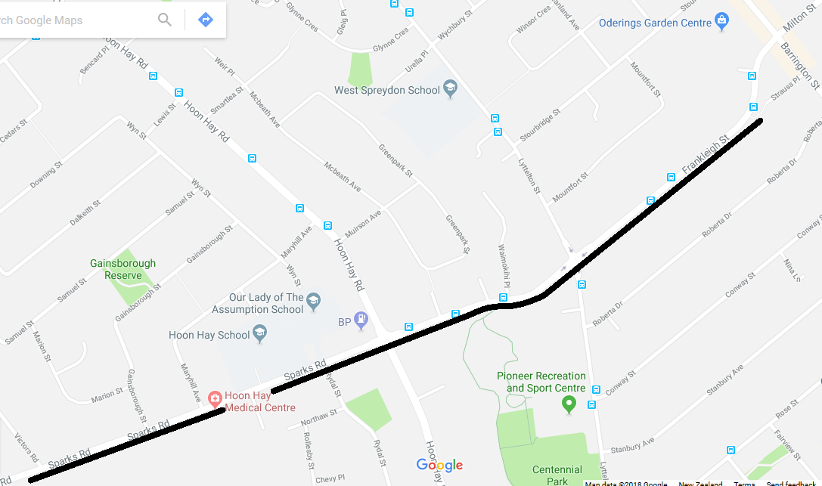Figure 5: View showing intersections and adjacent land use along urban extent of potential two-way cycleway section (map from Google)
Rydal Street
A proposed layout for a two-way cycleway was developed, as shown in Figure 6. This option provides a cycleway of comfortable width, generally unaffected parking on the opposite side of the road (apart from around intersections and crossings), and a usable flush median space.

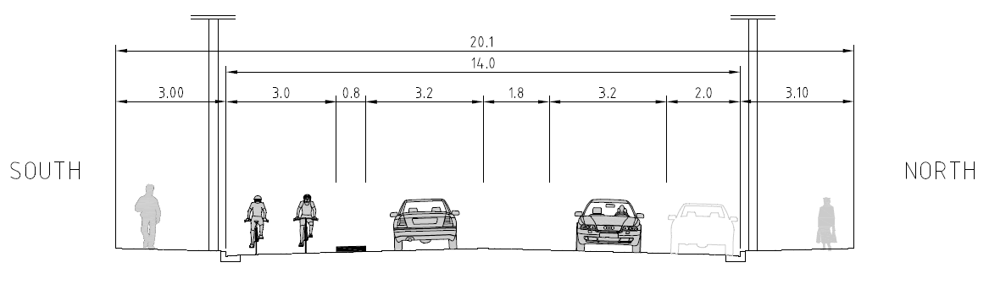
Figure 6: Two-way cycleway cross-section (Frankleigh Street shown)
A robust assessment was still required to determine if a two-way cycleway was a suitable facility type for these streets, in particular given that the traffic volumes were significantly in excess of the DPBPG maximum. This was achieved by a qualitative multi-criteria option assessment, and a quantitative crash risk assessment focussing on the crash risks associated with contraflow versus with-flow cycling.

Multi-Criteria Option Assessment
A multi-criteria analysis process had been developed earlier in the MCR programme. This assesses the key criteria for cycling alongside drivers for the community as well as project cost and risk, as shown in Table 1:
Table 1: Major Cycle Route option assessment criteria
Cycling | Community | Project
- Safety | - Local business impact | - Ease of construction, and costs
- Comfort | - Local resident impact | - Land requirements/ easements/other agreements
- Coherence | - Operational and network impact
- Directness and connectivity

This assessment was applied to three options:
- the original design that removed all parking,
- the compromised design that retained some parking, and
- the two-way option, which retained the most parking.

The detailed option assessment can be found in the Quarryman’s Trail MCR – Addendum to Scheme Assessment Report (2016).

In summary, the options assessment found that the two-way cycleway option had the least impacts on residents, businesses, the road network and costs, whilst still providing a good facility for cyclists, if the typically higher crash risk of a two-way cycleway crossing intersections and accesses could be addressed.

Crash Risk Assessment
In most cases, two-way cycleways are less safe than one-way cycleways at side roads and accesses. This is due to drivers not expecting cyclists to be approaching in the contraflow direction, and when they are aware of them, the mental load (and likelihood of making mistakes) at decision-making points increasing due to the requirement to check for the approaching contraflow cyclists in addition to the usual approaching traffic. This increases as traffic volumes increase.
A quantitative tool has been developed, and accepted by NZTA, for use in assessing the relative crash risk of one-way versus two-way cycleways for a particular section of road. The Separated Cycleway Option Tool (SCOT) is available on the NZTA Cycling Network Guidance website and is described in NZTA Technical Note TN001: Separated Cycleway Option Tool (SCOT) (2016).
The SCOT provides an output that should be used as part of a multi-criteria assessment to determine the most appropriate facility for a route, and is not intended to be used as the sole deciding factor regarding the form of a separated cycleway.

As inputs, the SCOT requires movement counts at accesses (residential and commercial) and intersections, cyclist volumes, and parking occupancy adjacent to a cycleway (where relevant). Traffic counts were obtained from a range of sources, including actual counts, strategic modelling, and Trips Database Bureau data. Strategic modelling was used for cyclist counts, and a parking survey for parking occupancy.

A SCOT assessment was undertaken for the route between the beginning of the cycleway on Frankleigh Street and the intersection with Hendersons Road. This is the length over which the cycleway would be either a one-way or two-way facility; the MCR would become a shared path beyond Hendersons Road. During the course of the SCOT assessment, it became apparent that the crash risks associated with the two-way cycleway were higher than with the one-way cycleways, despite the fewer side roads and accesses. An opportunity to reduce the crash risk was identified in the potential implementation of a closure or turning restrictions at a local side road, Rydal Street.

When completed, the SCOT assessment yielded the following results shown in Table 2:

Table 2: SCOT crash risk predictions
Predicted crashes/year for cycleway options
 | Crash risk source
Option | Residential driveways | Non-residential driveways | Side roads | Total
One-way cycleways – original design (no parking on either side) | 0.60 | 0.18 | 0.39 | 1.17
One-way cycleways – compromised design (parking one side) | 0.79 | 0.18 | 0.39 | 1.37
Two-way cycleway – full closure at Rydal Street (parking one side) | 1.06 | 0.23 | 0 | 1.29
Two-way cycleway – no closures (parking one side) | 1.06 | 0.23 | 0.39 | 1.68

It can be seen from Table 2 that the cycle facility with the lowest crash risk for cyclists would be the one-way cycleways with all parking removed. However, as stated earlier, this design would be highly unlikely to gain community acceptance; the compromised one-way cycleway design would be the more likely of the two to be implemented following public consultation. The compromised one-way cycleways are shown to have a higher crash risk than the two-way cycleway with a full closure at Rydal Street.

Whilst a full closure of Rydal Street would have been preferable, allowing left turns in only removed the higher-risk movements, whilst maintaining good local access. Restrictions of certain movements cannot be modelled in the SCOT tool; however, reviews of crash statistics reveal that approximately 10% of crashes at T-intersections involving cyclists are of the left-turn sideswipe type. This suggests that the crash risk of the two-way cycleway with left-in movements only allowed at Rydal Street would have a lower crash risk than the one-way cycleways with parking adjacent.

It is noted that signalised intersections were not included in the SCOT analysis, although the tool allows for them to. This decision was made on the basis that both signalised intersections would have protected phases for cyclists, meaning any increased risk of one facility type over the other would mostly be due to non-compliance with the signals.

It is noted in the SCOT Technical Note that there are few models available that can be used to compare signalised intersections with priority intersections (which the tool is based on), especially with respect to cycling. The crash risk factors in the SCOT Tool for contraflow cycling at signalised intersections are assumed as being three times that of with-flow cycling, as with priority intersections, which doesn’t take into account the fact that safety no longer relies primarily on human judgement.

As the two-way cycleway in this case allows for more width to be allocated to traffic lanes, and isolates the protected cyclist movement to one side of the intersection, a two-way cycleway at these intersections would allow the intersection to operate at a higher LoS. As compliance at signalised intersections is often proportional to the LoS of the intersection, the two-way option could be considered as the safer option in that regard.

The results of the SCOT assessment showed that there was potential for a two-way cycleway to provide as safe an outcome as a realistically implementable one-way cycleway; there was little actual difference in the predicted number of crashes between some of the options. Therefore, engineering judgement, taking into the results of the SCOT assessment as well as factors outside of it, should be used to decide on the most appropriate facility type.

FACILITY TYPE SELECTION
The SCOT analysis does not include crash severity; it is purely a crash risk prediction tool. Most of the crash risk for the two-way cycleway option comes from residential driveways; the two-way cycleway with restrictions at Rydal Street would have a lower crash risk at side roads than the one-way cycleway options. Driveway crashes would be expected to be of lower severity than intersection crashes, so whilst the two-way facility may have a higher overall crash risk, factoring in the severity of the crashes could make the actual risk (likelihood x severity) of crashes on the two-way facility lower than the one-way facility.

Several types of crashes are not included in the SCOT analysis, which could support the cases for both one-way and two-way cycleways on this project. For example, the one-way cycleway with parking adjacent outside the schools could lead to an increase in conflicts between school pupils and cyclists as the compromised cycleway would be adjacent to parking. Whilst the standard one-way cycleway design with no parking adjacent would not have this same problem, it would lead to more school traffic crossing the cycleway to access side road parking. Furthermore, this option would have attracted significant community opposition at this location. Conversely, the two-way cycleway would require more people to need to cross busy roads to access the cycleway, due to it being located opposite the side roads. The risks arising from this could be mitigated by providing improved crossing points along the route.

Therefore, with the two-way cycleway providing the most balanced solution in the multi-criteria assessment, and providing a very similar level of safety for cyclists to one-way cycleways, a two-way cycleway was selected as the best overall facility type for use on this section of the Quarryman’s Trail MCR.

CONCLUSION
This project is an example of how applying engineering judgement and following the principles of design, rather than purely following design guidance, can deliver the best outcome on a cycling project. This is important to avoid unnecessary community resistance on what are inherently controversial projects. Whilst there was still some public objection to the construction of the Quarryman’s Trail MCR, the levels of support were higher than other similar projects, and it was approved by elected representatives without significant changes being made.

The final outcome will be a facility that stands out as a flagship cycleway, whilst minimising its impacts and providing benefits to the wider community beyond its primary objective of providing a safe and comfortable cycling environment.

REFERENCES
Christchurch Cycle Design Guidelines – Design Principles Best Practice Guide, Part B, Revision B, (2016), viewed 10/12/2017, < https://www.nzta.govt.nz/assets/Walking-Cycling-and-Public-Transport/docs/cycling-network-guidance/Major-Cycleway-Design-Guide-Best-Practice-Guide-Chch-City-Council.pdf>

NZTA Cycling Network Guidance (n.d.), viewed 10/12/2017, <https://www.nzta.govt.nz/walking-cycling-and-public-transport/cycling/cycling-network-guidance/designing-a-cycle-facility/between-intersections/separated-cycleways/>

NZTA Technical Note TN001: Separated Cycleway Option Tool (SCOT) (2016), viewed 10/12/2017, < https://www.nzta.govt.nz/assets/Walking-Cycling-and-Public-Transport/docs/cycling-network-guidance/tech-notes/TN001-separated-cycleway-options-tool-april-2016.pdf>

Quarryman’s Trail MCR – Addendum to Scheme Assessment Report (2016), Peloton, viewed 10/12/2017, <http://ccc.govt.nz/assets/Documents/The-Council/HYS/2016/october/Quarrymans-Trail-SAR-Addendum.pdf>

ACKNOWLEDGEMENTS
The author wishes to acknowledge the inputs of the wider Peloton MCR Delivery Team (staff from Beca, GHD and Stantec) in developing this Major Cycle Route design, and Christchurch City Council elected representatives and staff for their leadership in and commitment to implementing the Major Cycle Route network.

The material in this paper is based on Quarryman’s Trail MCR – Addendum to Scheme Assessment Report (2016), which was prepared by the author of this paper.

