Residential driveways & footpath cycling
Axel Downard-Wilke
BE(Hons), ME(Civil)
Director, ViaStrada
027 2929 810
Axel (at) viastrada.nz

Abstract
Meet Marjon. She’s 80 (or thereabouts). Walking isn’t easy any longer, but she has a very active life; out and about every day. The most terrifying thing for her is to leave her driveway because she can’t see. Nothing wrong with her eyes; it’s the driveway that’s blind. By the time the bonnet of her car fully blocks the footpath, she still cannot see any of the footpath. And the other month, she hit a child cyclist leaving her driveway. Or the child hit the side of her car – I didn’t ask. The rules are clear; you must give way to footpath users. So, she got dragged in front of a judge to explain herself.
I don’t condone failing to give way to footpath users. I also don’t condone that we are building driveways that give you no chance to see footpath users. This paper, which is an amended version of the affidavit presented to the court, explores why we are doing this. And then considers what this means for government’s proposal to allow footpath cycling for all ages.

Introduction and background
In June 2020, I prepared an affidavit for a district court case. A friend’s elderly mother and a child had collided while she drove out of her driveway. She cannot see the footpath when she leaves her driveway. There is nothing wrong with her eyes; it is the driveway that is blind. When the bonnet of her small car fully blocks the footpath, she still cannot see any of the footpath (see Figure 6 and Figure 7 of the affidavit; note that identifying details have been removed from the text).
The affidavit explains that the council’s district plan allows for a driveway to be built like this – completely blind. Driveway movements a magnitude higher than what the three dwellings in this location generate are needed before planning rules are triggered that require some visibility splay. This is based on RTS 06, a guidance document produced by the Land Transport Safety Authority in 1993 with the express purpose of giving guidance for district plans. The rules allow us to build infrastructure that is fundamentally unsafe.
With this background, it is of concern that the consultation document for the Accessible Streets Regulatory Package 2020 considered the option of allowing footpath cycling to people of all ages. This is inappropriate if, at the same time, we allow driveways to be built that are blind. This is the exact opposite to a safe system, and this was one of the reasons why I submitted that the proposal should not proceed. Macbeth (2003) presented that for a 30 km/h cycling speed, a cycleway needs to have a 7 m offset to a property boundary to be safe. With a speed limit for footpaths imposed, this offset can be reduced, but many footpaths do not have offsets at all (as is the case here).

Conclusions and recommendations
I suggest that the guidance used by territorial authorities to develop district plans should say that any new driveway should be laid out so that drivers can safely interact with footpath users and give way to them as required by the Road User Rule. The guidance should provide the parameters within which these aims can be achieved. Until such guidance has found its way into the majority of district plans it is possibly inappropriate to allow footpath cycling by all age groups. For the time being, I suggest that the status quo for footpath usage should remain.

References
Macbeth, A. (October 2003). The Case against Cycle Paths. New Zealand Cycling Conference. North Shore City.

Declaration of competing interests
The author declares no competing financial interests.

In the matter of Marjon xxxxxx xxxxxx
18 xxxxxxxxxxx
xxxxxxxxx
Christchurch

Affidavit of Axel Wilke

Senior Traffic Engineer and Transport Planner

25 June 2020

Introduction

My full name is Axel Peter Carl Wilke. I hold the position of Director at ViaStrada Limited. I have been in this position since May 2007.

I hold a Bachelor of Engineering (Hons) – Civil Eng. (1997) and Master of Engineering (Civil Eng) (2003), both awarded by the University of Canterbury.

I have been active as a transport planner and traffic engineer in New Zealand since 1998. My specialisations include sustainable transportation, urban traffic engineering, traffic signals, and road safety. With a nation-wide focus, I have developed (and continue to develop) technical guidance, train my peers (since 2003), and was a member of the 2014 Cycling Safety Panel.

I was employed by Christchurch City Council from 1998 to 2005 and have been self-employed since (there are ten staff in our consultancy).

I have been asked by the defendant’s son to provide some input to the matter before you.

Description of locality

The three dwellings (units 1 to 3) at 18 xxxxxxxxxxx were built by Housing New Zealand and opened in 2013 (Figure 1). The dwellings are located on the north side of the section and the driveway is along the southern boundary (Figure 2).
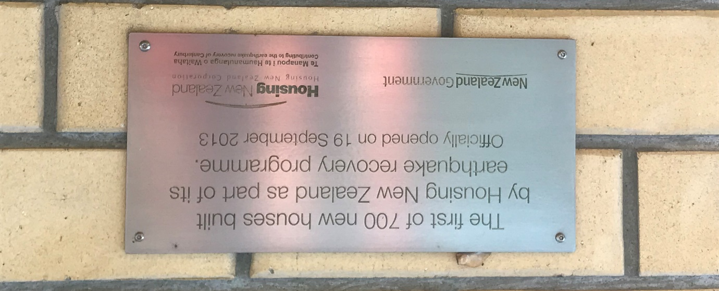
Figure 1: plaque commemorating the opening of the dwellings
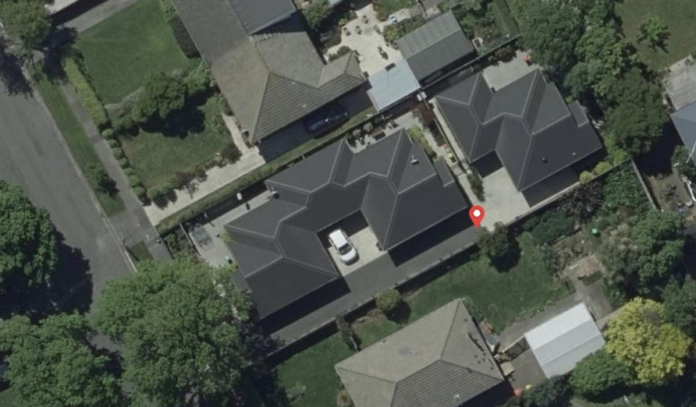
3/18
2/18
1/18
Figure 2: layout of the dwellings at 18 xxxxxxxxxxxx

It is noted that the dwelling that was replaced by the development had its driveway along the northern boundary.
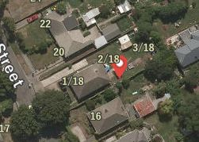
Figure 3: layout of previous dwelling

The reason that is of relevance is that the road and footpath slopes towards the xxxxxxxxx River at the northern end of 18 xxxxxxxx (Figure 4). Footpath users on wheeled devices are thus travelling faster in a northbound (downhill) direction than in a southbound (uphill) direction.
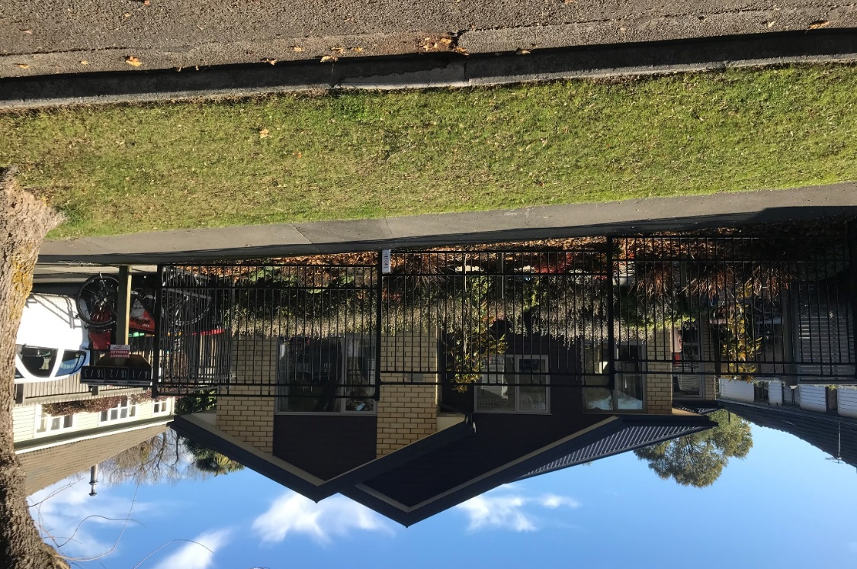
Figure 4: footpath at xxxxxxxxxxx sloping down towards the left (north) side

The berm area has a footpath hard against the property boundary and a row of mature trees (Figure 5) between the footpath and the carriageway.
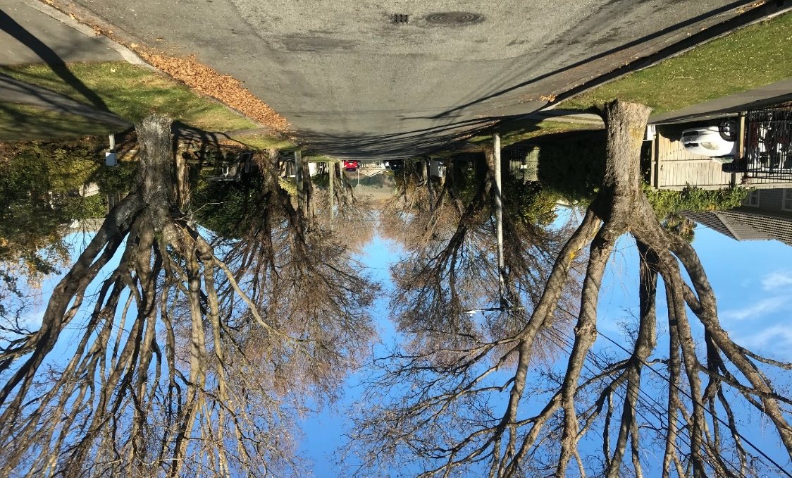
Figure 5: view south along xxxxxxxxxxxx

There is a 6 ft paling fence separating numbers 18 and 16 xxxxxxxxx that extends to the footpath / property boundary. The neighbouring property has a dense hedge along the property frontage.

Visibility at driveway

There is manoeuvring space on the property. All tenants can leave the property at 18 xxxxxxxxxxx driving forward; they do not have to reverse.

There is no visibility of the footpath to the south (left) due to both the fence and hedge described in paragraph 10 above. The photo in Figure 6 is taken from the driver’s seat simulating the driver leaning forward. As the photo shows, from this position only the grass berm beyond the footpath can be seen.
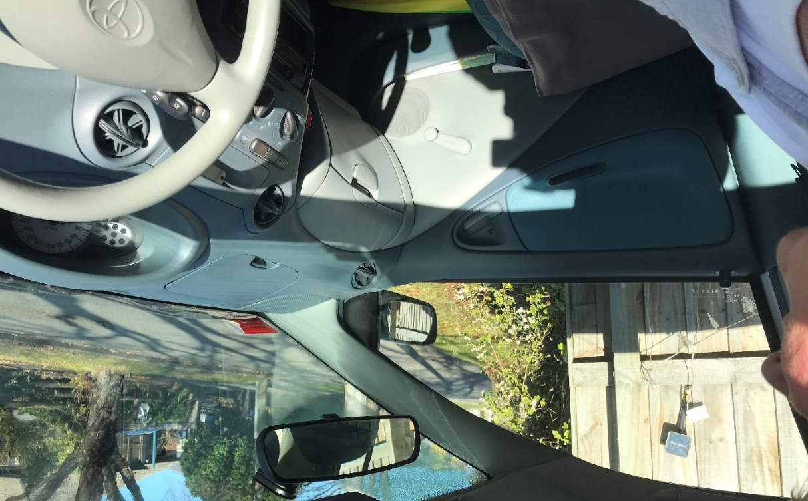
Figure 6: view to the left if the driver were leaning forward – no footpath visible

The photo shown in Figure 7 shows the car in the same position from which Figure 6 was taken. Although the driver cannot see the footpath at all, the front of the car completely blocks the footpath already.
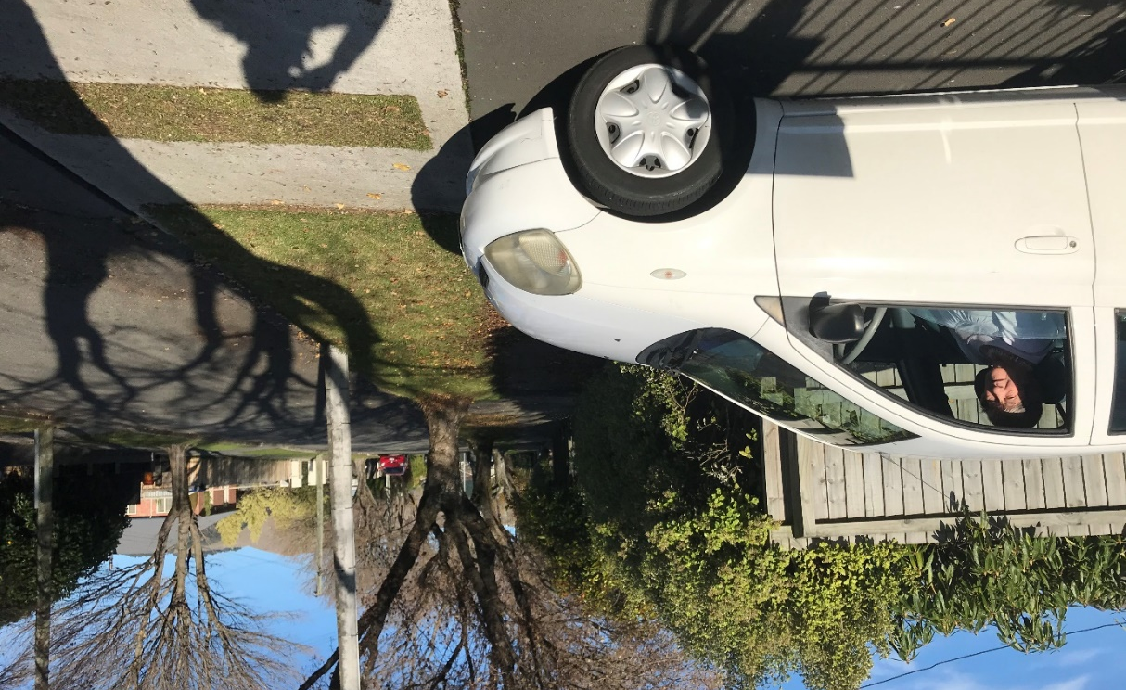
Figure 7: position of the car is same as in Figure 6

A property owner can talk to their neighbour about a shared fence and if both parties agree, the fence may be lowered or set back from the boundary to increase visibility at the driveway. A property owner does not have a say on other matters located on a neighbour’s property that restrict visibility, for example a hedge.

Planning rules

A district plan sets the rules that must be applied at a time a property is developed. The Christchurch City Plan that was in force at the time the development was consented outlines the requirements for “pedestrian safety” in part 3 of the plan in section 2.4.14. The requirement for a visibility splay to increase pedestrian safety is triggered “where a vehicle access serves more than 15 car parking spaces or more than 10 heavy vehicle movements per day”. The development at 18 xxxxxxxxxxx does not trigger the requirement for a visibility splay. The district plan allows there to be nil visibility of a footpath and its users for drivers leaving a driveway.

The source of this district plan guidance is a document known as RTS 06 developed by the Land Transport Safety Authority (now part of the NZ Transport Agency) in 1993. RTS 06 was “intended to give guidelines which could be incorporated into district plans”. The visibility splay is incorporated as a drawing and “should be considered for high volume driveways crossing footpaths in areas with high pedestrian activity” (Figure 8). Elsewhere in RTS 06, a high-volume driveway is defined as having more than 200 access manoeuvres per day (one magnitude higher than what the residents of 18 xxxxxxxxxxx would generate). It is not defined what constitutes high pedestrian activity.
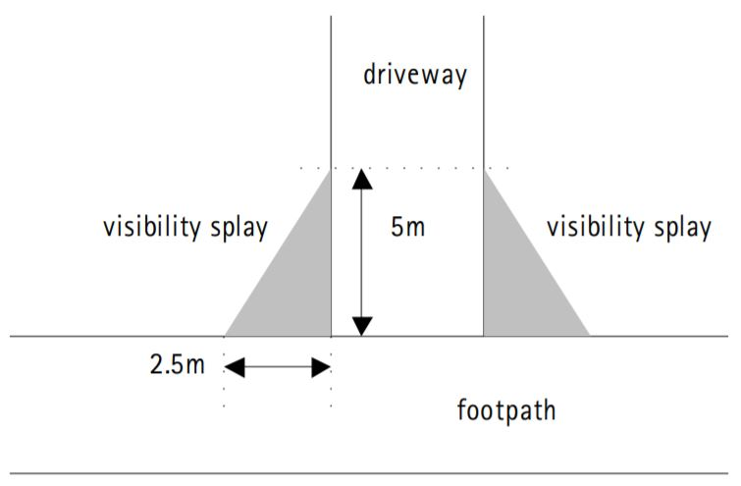
Figure 8: visibility splay from RTS 06 (1993)

From a first principles approach, a sloping footpath would see a driveway placed at the lower side of a section so that the property owner can control visibility towards footpath users in a downhill direction, as wheeled users are faster in a downhill direction. The district plan does not contain a rule that covers this aspect.

Regulatory environment

When the Land Transport (Road User) Rule 2004 came into force and replaced the Traffic Regulations 1976, it was first made clear that a driver “must give way to a road user on a footpath” (clause 4.4).

As defined in clause 1.6 (Interpretation), the legal users of footpaths are pedestrians. The users of “wheeled recreational devices” come under the definition of pedestrians, and that include bicycles with wheels up to 355 mm in diameter (i.e. a child’s bike). The only legal users of footpaths on an adult’s bike are those “in the course of delivering newspapers, mail, or printed material to letterboxes” (clause 11.11).

It is noted that the government finished consultation on the “Accessible Streets Regulatory Package 2020” in May 2020. Should the proposal be accepted, cycling on footpath will become legal for everyone with a 15 km/h speed limit.

Commentary

Drivers must always have the mental and cognitive capacity to make complex decisions. Some footpath users are too young or too old or will not have the cognitive ability to make sound decisions. It is therefore entirely appropriate that the onus is on drivers to give way to users of footpaths.

It is permissible under current regulations for the layout of residential driveways to be fundamentally unsafe. The guidance given in the city plan, based on national guidance, can result in layouts where exiting drivers have nil visibility of a footpath before the bonnet of their cars enters it.

The resulting risk to footpath users is a function of their speed. The lower their speed, the higher the chance that they can stop when a car appears. With an increasing gradient along the street, speed of wheeled footpath users increases in a downhill direction.

Of significant concern is the current government proposal to allow cycling on footpaths. This will result in an increasing number of conflicts where visibility at driveways is poor or non-existent.

Suggested mitigation

Mrs xxxxxxx told me that she wants to see the situation improved by mitigating the risk. She is caught between a landlord (Kāinga Ora) that is disinterested, a city council as road controlling authority that is unwilling to help, and a district plan based on guidance from a central government agency that establishes a fundamentally unsafe situation.

Mrs xxxxxxx informed me that she has, after consulting with neighbours, started to use her car horn before she leaves her driveway. Whilst that is a commendable initiative, I do not consider this to be sufficient. It effectively reverses the onus of giving way back to footpath users and as outlined in paragraph 21, they may not always have the mental or cognitive ability to register or interpret the sound.

I suggest that the most appropriate mitigation measure is a convex safety mirror as shown in Figure 9. Such a safety mirror would usually be installed in the berm on a pole.
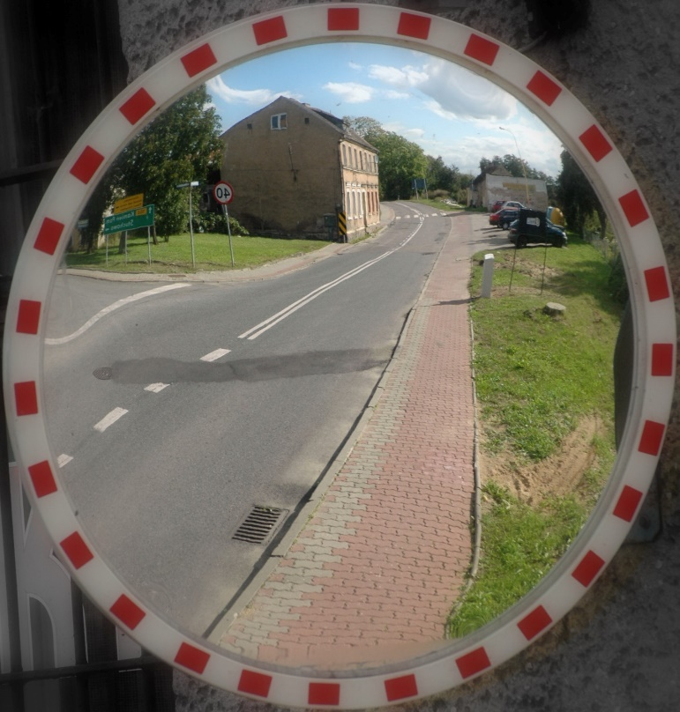
Figure 9: convex safety mirror

Christchurch City Council is unlikely to want to establish a precedent by installing the safety mirror on Mrs xxxxxxx’ behalf. I therefore suggest that the city council give permission to have the mirror installed by a suitable contractor under the supervision of council’s arborist so as to not damage the tree roots.

Mrs xxxxxxx informed me that Christchurch City Council is unwilling to accommodate a safety mirror. If this is true, maybe a guiding word from a judge could unlock some meaningful action.

