Placemaking – if you are not doing it for people then you are doing it wrong

**Wednesday 13 November, 9:15am**

Placemaking is rapidly becoming one of those words that is heard and used a lot, and also one that is starting to carry a lot of highly variable definitions.

But at its very core, and from the roots of its origins, it is a practise based on people and place – and the relationships that should exist between the two.

This talk will focus on some of the good ways, and some of the bad ways, of approaching the topic – from hard won experience and enthusiastic research.

Frith Walker, Panuku Development Auckland

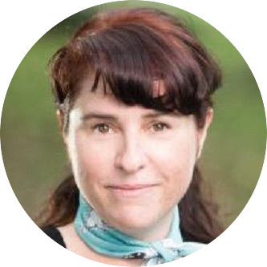Having spent her former life in the theatre business, as a stage manager/producer type, Frith is now very proud to be an advocate of the UN ratified New Urban Agenda global standard for urban development, and a New Zealand representative for the international network Placemaking X.

As Manager, Place Making at Panuku Development Auckland she works within the Design and Place Directorate on the creation of successful public space networks, supporting the programming and activation of Auckland’s public spaces, and champions the difference a healthy public realm can make in terms of creating liveable cities.

Web: www.panuku.co.nz

LinkedIn: https://www.linkedin.com/feed/