3,000,000kms to Bluff - Tour Aotearoa 2020
Richard Young
MICE, MBA, MSc, Bsc
SmartSense Ltd.
Jonathan Kennett
BSc
Kennett Brothers (Tour Aotearoa)

Abstract
In February and March 2020 one thousand cyclists from around the world left Cape Reinga heading for Bluff, taking part in the 3,000km 2020 Tour Aotearoa Brevet (TA2020). The TA2020 Brevet was a non-competitive Adventure Cycling journey that required each participant to follow the same fixed course, with no external support. Riders solely relied on locally available facilities, the generosity of the communities they cycled through, and the support of their peers.
This paper presents the results of several comprehensive post-event surveys, providing insights into many areas of cycling policy, economics, community engagement and best practice cycling provision in Aotearoa.
The positive economic benefits of long-distance cycle tourism are assessed and presented. As would be expected, the riders also provided considered views on the wide range of cycling provision along the whole route - a 1,000 strong 3,000km long benchmarking exercise. The results may surprise and certainly stimulate debate, there are also candid comparisons between seven of the Great Rides that formed part of the route.
Perceptions and realities of cycling safety were gathered, with early indicators showing that that environmental factors and the rider’s own experience all influenced safety.
No event in 2020 was untouched by the COVID-19 pandemic, and whilst a proportion of riders were obliged to end their ride due to the Lockdown, more withdrew for other reasons. These reasons are presented along with lessons for riders, organisers, the wider cycling community and infrastructure providers.
Co-authors Richard Young (SmartSense Ltd), Jonathan Kennett (Tour Aotearoa)
Keywords
Community, economics, international, understanding the customer, safety.

Introduction
Tour Aotearoa is one of the world’s great bikepacking trips: stretching 3,000 km from Cape Reinga to Bluff it follows a combination of cycle trails, tracks, paths and lanes connected by the most enjoyable country roads available. The route was/is designed by Jonathan Kennett, a New Zealand cycling guidebook writer. This paper is a summary of the more comprehensive report written by Richard Young for the Kennett Brothers that collates responses from over four hundred riders and businesses along the route.
TA2020 is the 2020 Tour Aotearoa adventure cycling event with a start date between 17th February and 8th March following the course detailed in the Tour Aotearoa Official Guide (Kennett Brothers, 2019) and riding in accordance with the 2020 Brevet Rules (Kennett, 2020).

The Riders

Riders and Survey Respondents
There was no entrance fee to take part in TA2020 but riders were required to register on the Tour Aotearoa web site (Kennett, 2020), offset their carbon emissions and make a $100 donation to a charity.
- 1010 riders registered and offset their Carbon and made the charity donation
- 921 started the event, a 91% starting rate.
A total of 347 riders completed the TA2020 survey giving a response rate of 37.5% so results are considered to be accurate ±4% at the 95% confidence level. 83% who were New Zealanders, Figure 1 shows the overall geographic split.

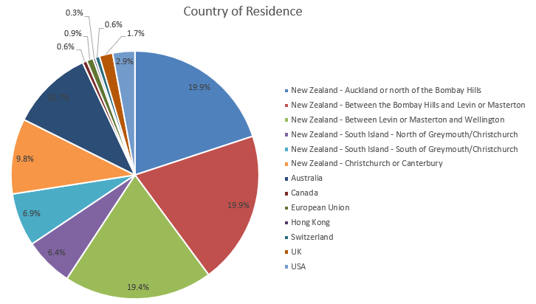
Figure 1 Geographic split of riders

Demographics
Table 1 shows that for riders from New Zealand the most common age band was 51-60 (43%) with the 41-50 (21%) and 61-70 (23%) each being about half that size of largest band. Those under 30 comprised only 4%. Australian riders had a similar age profile to New Zealand riders.
The smaller Rest of the World Group (24) had 13% under 30 with the largest single group being 61-70 (38%). This may be reflective of the prevalence of young travellers visiting New Zealand and joining TA as a way to see the country and also of a high value older international cyclists who travelled to New Zealand specifically to join TA.
Table 1 Split by Age and Country
Country | Under 30 | 31-40 | 41-50 | 51-60 | 61-70 | Over 71 | Grand Total
New Zealand | 4% | 6% | 21% | 43% | 23% | 1% | 100%
Australia | 5% | 11% | 22% | 38% | 24% | 0% | 100%
Rest of the World | 13% | 13% | 17% | 21% | 38% | 0% | 100%
Combined Total | 5% | 7% | 21% | 41% | 24% | 1% | 100%

From New Zealand, females made up 21% of riders compared to 13% of visiting riders being female.
The riders age profile by gender (Table 2) showed that 29% of males were over 61 compared to 10% of females with the 51-60 group being the most common for both genders. 10% of female riders were under 30 compared to only 5% of male riders.
Table 2 Gender split by Age Band
Age band | Female | Male
Under 30 | 10% | 5%
31-40 | 9% | 7%
41-50 | 18% | 22%
51-60 | 53% | 38%
61-70 | 10% | 28%
Over 71 | 0% | 1%

Fitness and Prior Experience
TA2020 was the largest of the three tours run to date and anecdotally there did appear to be a wider range of skills and fitness than in previous years.
- 16% of riders reported that ‘they knew they should have been fitter at the start of the ride’, but despite this 76% of them reached Bluff.
- 12% of riders considered themselves to be exceptionally fit with 85% of them reaching Bluff.
- The remainder (‘reasonable fit at start’ 72%) had the highest reaching Bluff rate of 88%.
Table 3 indicates that 10% of riders considered themselves highly experienced bikepackers, this group had the lowest reaching Bluff (completion) rate of 78%. 44% of riders reported they had no previous bikepacking experience but had an 87% completion rate, the same as the modestly experience bikepackers.
Table 3 Rider Experience and completion rate
Bikepacking Experience | % of Riders | % of that group who reached Bluff
None | 44% | 87%
Modest experience | 46% | 87%
Very Experienced | 10% | 78%

The Bikes and Equipment
The TA2020 survey gathered some basic information on the type of bikes used. More extensive information on equipment was gathered on is provided in insync’d Bikepacking survey (insync, n.d.) and in the full survey report (Young, 2020)

Types of bike
It is recognised that bicycles and riders are unique and there is no universally agreed standards to categorise bikes by either form or function.
The most common overall bike set up was a 29” wheel, tubeless tyred, carbon framed, hardtail (front suspension) with straight handlebars and aerobars, loaded it weighed in at 21-26kg.

The Journey
The TA2020 journey is 3000km, but is not a race. There were a few clear rules (Kennett, 2020) mainly related to safety. Following feedback enhanced safety guidance has been provided for future riders to fully understand the course and associated risks.
Whilst the TA2020 event was organised with specific start days any Tour Aotearoa rider is at liberty to start at any time and follow the books (Kennett Brothers, 2019); all the route is on publicly accessible land.
Some key TA2020 requirements are to follow the published routes and compete the journey within thirty days with no external support, using only facilities along the route with occasional stays and meetings with friends being permitted.

Completion Rates
Of the 347 respondents to the survey 38% reported that they did not finish the TA2020 event. The largest single stated reason for this was COVID-19 concerns and the lockdown that came into place on March 25th. This effectively prevented a significant number of riders completing the ride within the prescribed 30 days. A total of 280 riders could have been affected by lockdown, this is 30% of all riders.
Figure 2 provides the cumulative record of the last stage that riders completed prior to withdrawing with Figure 3 providing the profile with COVID-19 removed.
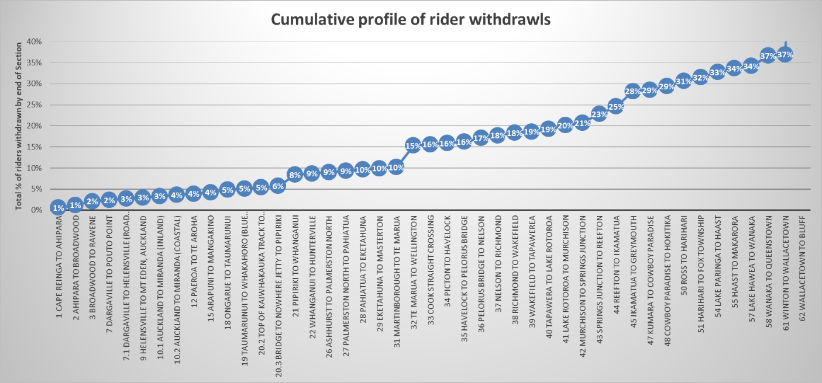
Figure 2 Cumulative profile of rider withdrawals (all reasons)
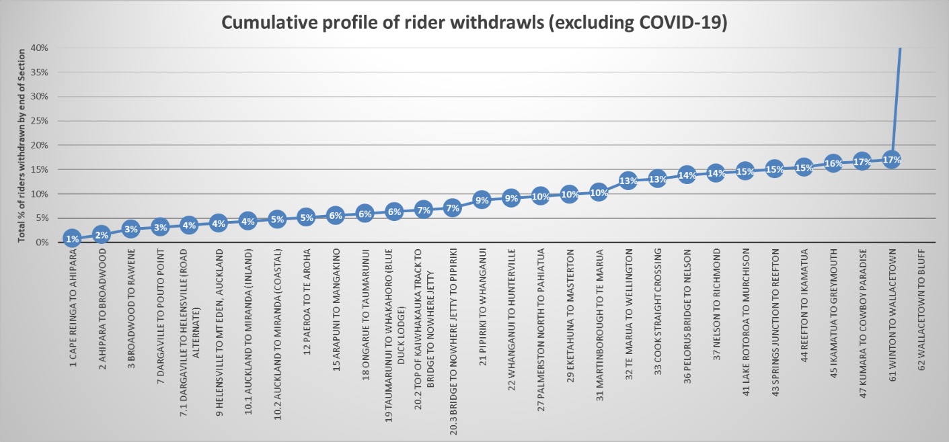
Figure 3 Cumulative profile of rider withdrawals (excluding COVID-19)

Completion Durations
The TA2020 course needed to be completed within 30 days, whilst riders were tracked these results are self-reported. Riders who did not finish or took longer than 30 days or did not travel the whole distance are not included. There were some different route options which some riders used, these are all included in Figure 4 and Table 14.
Table 4 Completion information (Days)
Days to complete | Male | Female
Fastest | 10 | 16
Median (50%) | 23 | 26
Mode (most common) | 21 (11% of riders) | 27 (23% of riders)

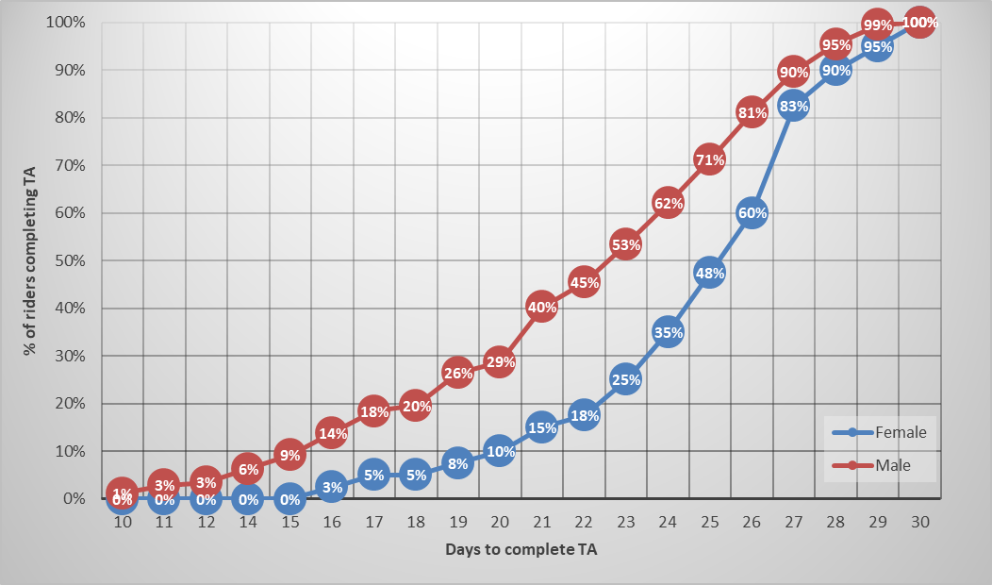
Figure 4 TA 2020 Completion profile
Table 15 provides the percentage of days that riders did not ride with 28% taking one or more rest days, a figure the underlies the non-competitive nature of TA2020. 5% took time off due to illness/injury and 4% pausing due to adverse weather or route closure.
Table 5 Full days lost by riders to planned breaks and unplanned events
Days lost to | 0 | 1 | 2 | 3
Rest Days | 71% | 20% | 7% | 1%
Injury / Illness | 94% | 4% | 0% | 1%
Route Closure/ adverse weather | 96% | 4% | 0% | 0%

The TA2020 event was significantly affected by restrictions caused by the COVID-19 pandemic. Table 16 shows that 25% of survey respondents cited COVID-19 as the prime caused of not completing TA2020. In total 36% of TA2020 riders who responded to the survey did not complete their ride to Bluff with medical, health and medical evacuation/rescue accounting for a further 5%.
Table 6 Completion rate and reasons for non-completion
Reason for non-completion | % of survey respondents
COVID-19 concerns / Lockdown event | 25%
Medical issues - I decided or was advised to withdraw | 4%
Home / Work related | 3%
I had not planned to complete the whole of the ride. | 2%
Crash / Medical Issues - requiring emergency services assistance | 1%
I wasn't enjoying the ride | 1%
Grand Total | 36%

Route Keeping
The TA2020 event is designed as a brevet (Kennett, 2020), a set route with minimum and maximum durations. The Official Guide (Kennett Brothers, 2019) does however list numerous alternates which are to be used for bikes unsuited to some of the more challenging sections. Whilst these alternates are generally described in the guide it was anticipated by the organisers that riders would choose the primary brevet route unless their bike wasn’t suitable for the alternate or the primary route was closed. Of the 347 survey respondents there were 343 self-reported detours from the brevet route
Respondents were asked to provide their reasons for deviations from the main brevet route with Figure 7 summarising the key responses. Other responses covered night riding risks, finding accommodation, mechanical issues, reaching planned travel provider, health concerns, perceived lack of required skills, and a desire to avoid walking. On reviewing these responses to missing some Brevet route section, the book’s (Kennett Brothers, 2019) co-author Jonathan Kennett described many of them as ‘lame’.
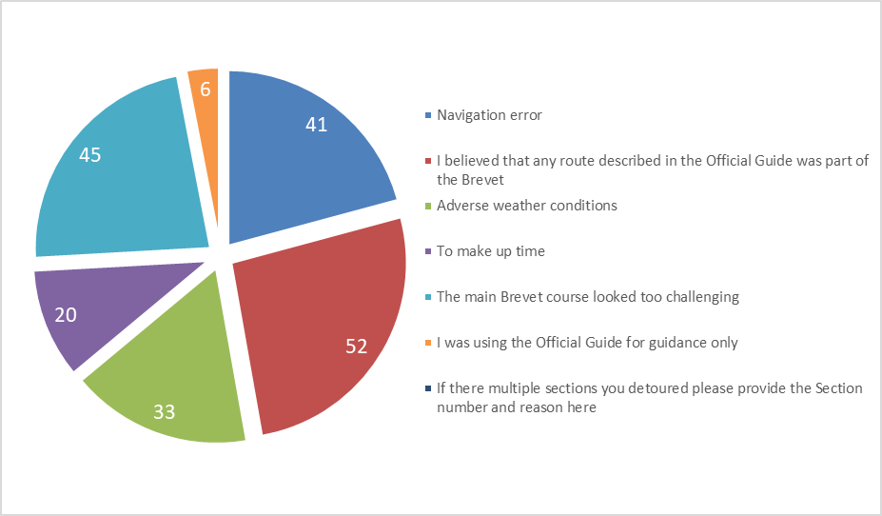
Figure 7 Reasons for detours

Group Dynamics
The Brevet started with waves of up to 100 riders from Cape Reinga, and of the survey respondents 45% indicated that they were solo riders. Whilst the 3-4 sized groups had the lowest group cohesion, they did report (Table 19) the highest individual completion rate.
Table 7 TA2020 Completion by rider group size at start (exc. COVID-19 withdrawls)
Group size at start | Completed TA2020
1 | 85%
2 | 82%
3-4 | 95%
5+ | 89%

Economics Benefits of TA2020
Each rider was requested to provide a general break down to the costs they incurred in participating in TA2020 and isolate only those sums that were spent in three specific regions:-
- Between Auckland and Cape Reinga
- Auckland and Wellington (Picton)
- South Island
The analysis has been complicated as some riders included the pre-TA2020 costs such as travel and equipment purchase and maintenance. Whilst these would have made a significant contribution to the New Zealand economy, they have either value to the rider that extended beyond TA2020 or were primarily air fares. The breakdown of riders spend by category and region is provided in Table 20 with the average spend along the route being $4,182.

Table 8 Breakdown of rider spend
Category | North of  Auckland | Auckland –  Picton | South  Island | Total
Travel | $ 231 | $ 149 | $ 176 | $ 555
Accommodation | $ 228 | $ 483 | $ 509 | $ 1,220
Food | $ 231 | $ 587 | $ 607 | $ 1,426
Bike Repairs | $ 21 | $ 167 | $ 67 | $ 256
Bike - other | $ 93 | $ 69 | $ 52 | $ 215
Other | $ 46 | $ 271 | $ 193 | $ 510
Total | $ 850 | $ 1,726 | $ 1,605 | $ 4,182

Travel from Auckland to Cape Reinga and cycling back to Auckland
This regional spend of $850 per rider was of significant interest. All riders stayed in accommodation and shopped north of Auckland, they used locally operated boats and the vast majority of riders (>750) utilising a Northland based transport providers to transfer from Auckland. With 921 riders confirmed by the organisers this represented a cash spend of $780,000.
A significant part of was spent with Real Far North Tours a Maori owned Northland company who provided transport from Auckland and tented accommodation near Cape Reinga. With the Kaipara harbour crossing from Pouto Point to was facilitated by Kaipara Harbour Cruises.

Auckland to Picton.
The average spend in the rest of North Island was $1,726 per rider, injecting over $1.5M into the economy. On average $1,071 was spend on food and accommodation in predominantly rural areas of New Zealand. This equates to close to $1.0M in towns no larger than Matamata, Whanganui or Masterton.

South Island
Factoring the South Island average rider spend of $1,605 per rider requires the reduction of riders whose ride was curtailed by the COVID-19 Lockdown. Based on survey responses we are aware that 15% of the 921 riders withdrew on North Island. The remaining 22% of withdrawals were on South Island. This equates to 74% of starting riders (921) completing at least half of South Island (Greymouth).
With the exceptions of Queenstown, Wanaka and Nelson TA2020 avoided the largest towns on South Island resulting in much of the rider spend being in the rural areas. Around $1M was spent in these areas with over $760k on locally provided accommodation and food.

Food
The 347 survey respondents provided details on over 14,000 meals consumed along the TA2020 route. Table 21 indicates that close to two thirds of all meals were purchased from vendors along the route with the remainder of meals self-catered using food purchased along the route.
Scaling this up to the whole TA2020 event it would equate to over 16,670 prepared daytime and evening meals purchased along the route and sufficient food purchased in local retailers for a further 14,200 meals.
Table 9 Spilt of catered and self-catered meals
Source of food | Daytime | Evenings
Cafes/ Accommodation / etc. | 64% | 67%
Self-catered | 36% | 33%
Despite the obviously high food consumption during the event 61% of riders reported losing over 2kg, with 20% reporting a loss in excess of 5kg.

Accommodation
During TA2020 each rider was required to arrange their own accommodation; this could be a self-carried tent or staying in a motel en-route. It was not permitted to have a following vehicle providing support or accommodation. Records were provided on 7,289 bed nights across the 347 responders to the survey (Table 22). 60% of bed-nights were spent in indoor paid accommodation, with a further 24% in paid camp sites. The remaining 15% of bed nights were in unofficial (freedom) camping areas or where riders stayed with friends along the route.
Table 10 Accommodation preferences
Accommodation Type | Bed Night | % of responses
Nights in indoor paid accommodation | 4,381 | 60%
Nights in Official Camp | 1,772 | 24%
Nights in Unofficial Camp | 398 | 5%
Nights with friends | 739 | 10%
Total bed nights | 7,289
Scaling up the survey for all TA2020 and making a conservative allowance of $75/night for indoor accommodation and $20/night for camping, TA 2020 contributed close to $1M in revenue to the NZ hospitality industry along the TA2020 route.

Supplier feedback
An event like TA2020 would be impossible to run without the support of a multitude of local businesses along the route. To solicit feedback from businesses a second targeted survey was issued to over two hundred establishments that riders had identified. In total some 76 businesses responded.

Business sentiment towards Tour Aotearoa
Figure 12 shows that 71% of businesses considered their interactions with TA2020 riders to be overwhelmingly positive, with on 5% saying they were similar or worse that other clients. This high positive sentiment is a strong indication that the Tour Aotearoa event has a positive impact on the communities it passes through.
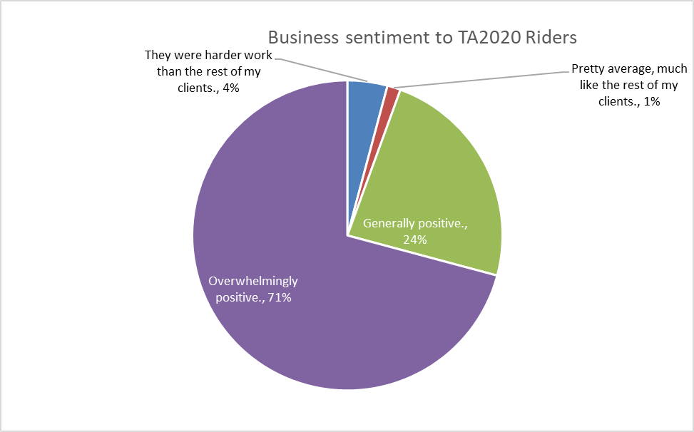
Figure 12 Overall sentiment from businesses to TA2020 Riders

Interactions with Riders
Figure 13 shows how businesses reported forward bookings from TA riders. Camping had the lowest advanced booking with 68% of rider only contacting them earlier than 2 days before of arriving. 29% of indoor accommodation was booked more than a week ahead.
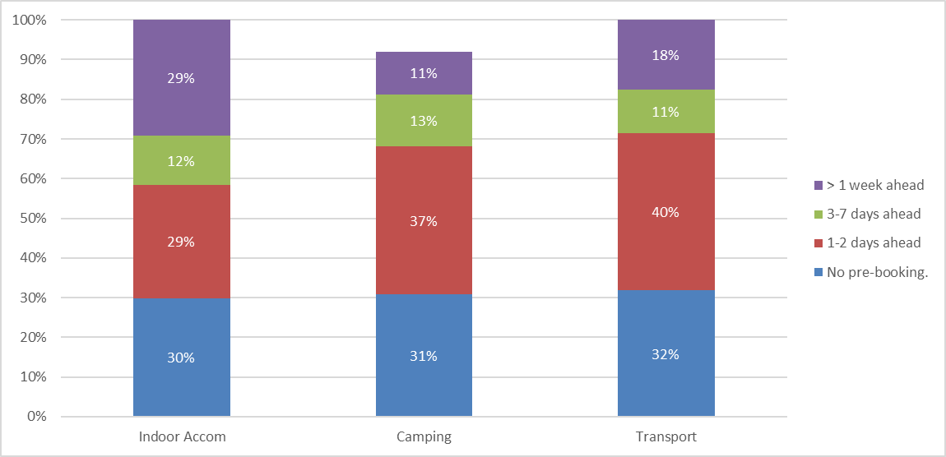
Figure 13 Riders booking ahead with businesses
Whilst 80% of riders did arrive at accommodation the had booked 6% were reported as being late. Cancellation rates of 5% were also reported.

Safety, Injuries and Medical Issues
It is not surprising that with close to 1,000 riders attempting to cycle 3,000km each that there will be a range of medical issues that occurred. The survey (Table 24) indicates that a third of riders experienced significant numbness with 20% reporting saddle sores sufficient to affect their ride. In the survey there were 4 reported events resulting in hospital stays.

Table 11 Medical events reported by riders
Medical Event | Riders | % of riders
Numbness in hands or feet, saddled area. | 114 | 33%
Fall / crash - not requiring medical attention. | 77 | 22%
Saddle sores, that affected my ride. | 70 | 20%
Muscular/tendon/joint soreness or cramps. | 65 | 19%
Fall /crash / medical incident - requiring medical attention. | 18 | 5%
Foot Digestion related | 5 | 1%
Incident requiring an overnight hospital stay. | 4 | 1%

Safety Perception
Riders identified sections of the TA2020 routes that their felt unsafe. This was split into external threats (other people and vehicles) and track condition. The percentage of riders who reported feeling unsafe on each of the 66 TA2020 sections is provided in Figure 12.
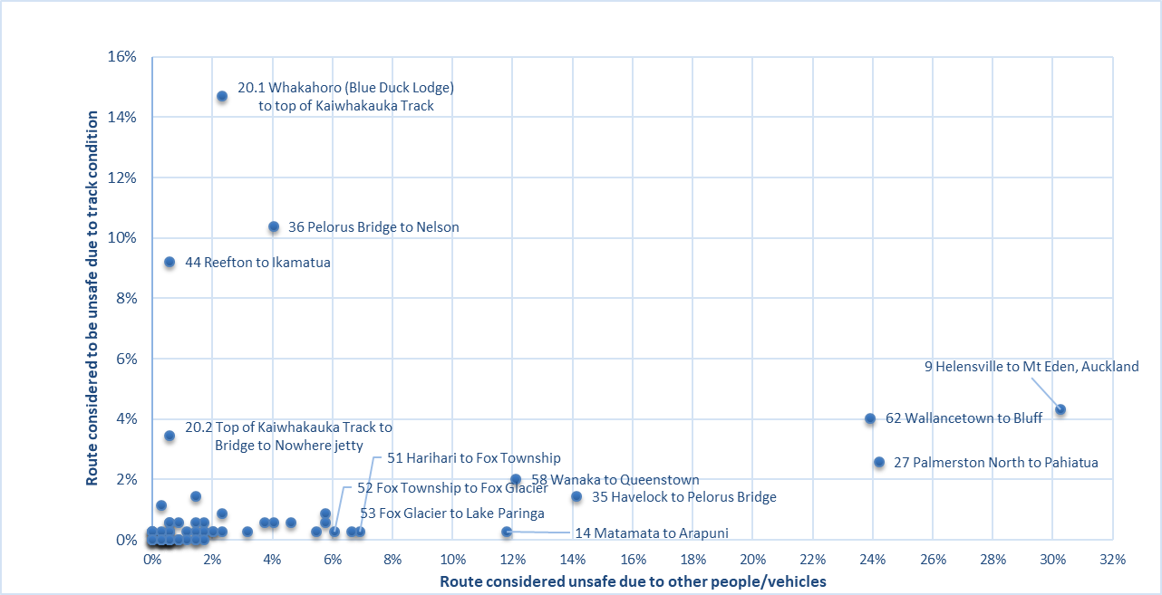
Figure 16 Perception feeling ‘unsafe’ by % of riders split between risk from track condition and risk from other people/vehicles.

Highest perceived risk from other people / vehicles

Section 9 Helensville to Auckland
In particular the segments north of Auckland, the urban cycling through Auckland and the route to Clevedon received specific negative feedback.

Section 27 Palmerston North to Pahiatua
With the SH3 Manawatu Gorge closed most State Highway road traffic is using this route (the remainder using Saddle Road). During TA2020 there was shoulder widening work in progress, but the incomplete state of the work did attract numerous negative comments.

Section 62 Wallacetown to Bluff
The section of the TA2020 route that was on State Highway 1 did attract significant negative comments, primarily relating to lack of edge strip and large numbers of heavy vehicle movements.

Other comments
There were over 860 rider records of sections and locations that individuals felt unsafe. Figure 17 provides an illustration of common themes that were mentioned. The State Highway from Fox to Haast is regularly mentioned albeit with acknowledgements that there is no alternate.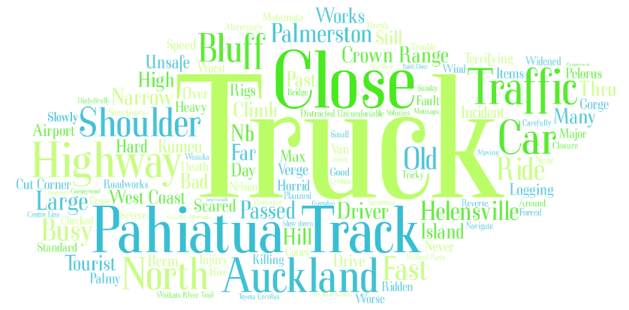
Figure 17 Word cloud of common words used to describe areas where riders felt unsafe due to 3rd Parties

Highest perceived risk due to track condition
Whilst not recording as many rider comments as risk caused by others, four sections of the TA2020 course recorded significant perception of the track being unsafe.

Section 20.1 Kaiwhakauku Track from Whakahoro (Blue Duck Lodge) to the summit
On this short section of the TA2020 results there were at least four falls resulting in helicopter evacuations and the organisers did mandate later riders to walk around 5km of the narrowest and slippery track. 15% of riders considered this section unsafe with several reporting falls or choosing to detour around it. This report’s author walked through the most challenging part of the track and although marginally slower than attempting to ride did not consider it to be unduly dangerous.

Section 36 Pelorus Bridge to Nelson
11% of riders recorded feeling unsafe, especially on the descent from the Mangatapu summit, with some choosing to ride on the highway.

Section 44 Reefton to Ikamatua
Of the 347 respondents, 32 riders (9%) recorded feeling unsafe about this section, with some 77 choosing to ride on the highway instead. As with the Kaiwhakauku Track there were considerable stretches after the saddle where walking may have been safer than riding. Unlike in previous years there were very few days on TA2020 when rain would have made the Big River section impassable or especially high risk.

Section 20.2 Top of Kaiwhakauku Track to Bridge to Nowhere
This section has been considerable improved in the previous 12 months, 3% of riders did however consider themselves at risk due to the track’s challenges, or their own equipment/personal capabilities.

Other areas of concern about track safety and rider skills.
Many riders who recorded sections of track that they felt unsafe on also commented that they make a decision to dismount and walk rather than seek a detour. This decision-making approach is highlighted in the word map of common terms (Figure 14) used by riders.
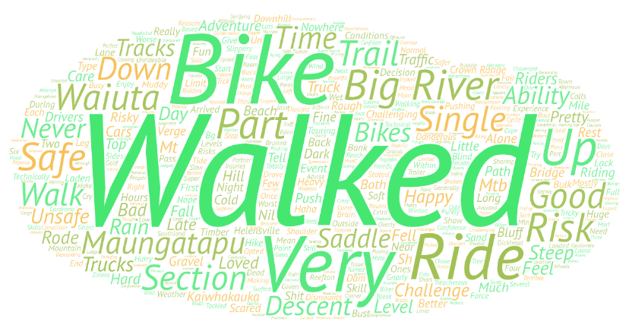
Figure 18 Word cloud of common words used to describe areas where riders felt unsafe due to their equipment, skills or track.
44% of the time riders opted to remain on a road (Table 26) rather than an adjacent cycle track with the reasons for remaining on the road related to perception of risk in the road and a speed advantage.
Table 12 Rider choices where a road was next to a cycle track
Reason of riding on cycle track next to road | Where there was a separate cycle track next to the road. When did you use that cycle track?
Almost all the time | 56%
When I thought that the track was a safer option | 22%
When the track's surface allowed me to go as fast as staying the road | 22%

Enjoyment

Desire to return to different areas
Riders were asked about the likelihood of returning each area along the TA2020 route, as this survey was undertaken during the COVID-19 Level 3 & 4 Lockdown it is considered that these would be aspirational statements of intent.

Table 13 Desire to repeat riding in different areas.
Section | % of riders
Central North Island (Sections 16-22) | 54%
The West Coast (Sections 45-55) | 50%
Nelson / Tasman (Sections 34-40) | 36%
Otago (Sections 56-59) | 31%
Waikato (Sections 11-15) | 23%
Buller (Sections 41-44) | 22%
The Manawatu and Wairarapa (Sections 23-31) | 19%
Wellington (Section 32) | 18%
Southland (Sections 60-62) | 16%
Auckland (Sections 9-10) | 8%
The Central North Island and West Coast (Table 26) each scored 50% or more riders wanting to return. 11% of the expressions of desire to return to ride in all these areas were from riders living outside New Zealand.

Great Ride Sections
The TA2020 course included elements of nine Great Rides and riders were asked to rank these in order of enjoyment. Table 27 identifies that that Timber Trail scored the highest with 39% of riders voting it into first place, the West Coast Wilderness was voted into second place with 29% of riders preferring it.
Table 14 Ranking of the Great Rides in order of enjoyment by TA2020 riders (* full ride in TA2020)
Great Ride | Rank
The Timber Trail* (Section 17) | 1
West Coast Wilderness* (Sections 46-49) | 2
Mountains to the Sea (Sections 19-21) | 3
Remutaka Rail Trail (Sections 31-32) | 4
Waikato River Trail (Section 14-15) | 5
Tasman’s Great Taste Trail (Sections 37-39) | 6
Queenstown Trail (Section 58) | 7
Round the Mountain (Sections 59-60) | 8
Hauraki Rail Trail (Sections 11-13) | 9

Desire to repeat ride Tour Aotearoa
Some 70% of riders (Figure 19) indicated that they wanted to participate in an organised Tour Aotearoa event in the future.
92% of all riders would recommend to others to participate in a future Tour Aotearoa event.

Overall Comments from riders
Over 240 riders provided detailed comments in the survey with Figure 20 providing a word cloud of the most popular sentiments. The predominance of positive sentiment to the event and gratitude to the Organisers is clearly visible.

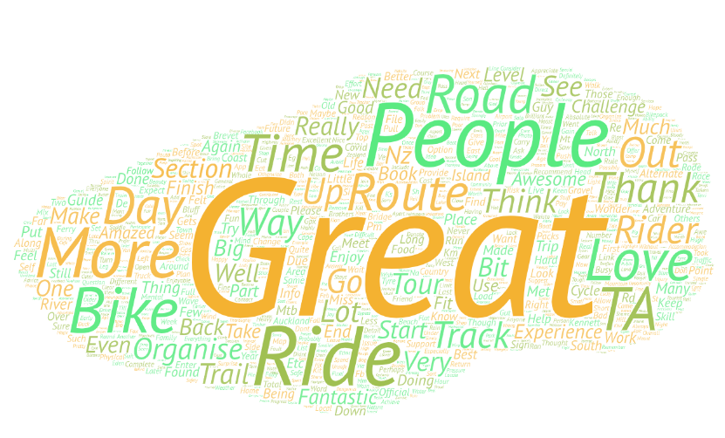
Figure 24 Overall comments – frequency of words

Conclusions
Many findings and details have been identified in the relevant section above, but some more general conclusions are:
- With close to 1,000 riders starting the event and a spend of over $4,000 TA2020 was a major contributor to the rural economy along the route.
- TA2020 riders received a 95% positive sentiment from local businesses.
- Three common locations were identified as presenting significant risks from traffic and another three had a high perceived risk due to the route itself and rider experience.
- The most significant cause of withdrawing (other than COVID-19 restrictions at 25%) was medical / injury (5%).
- Prepared or ingredients for over 30,000 main meals were purchased along the route, but 20% of riders lost over 5kg.
- The median completion duration for men was 23 days, 26 for women
- 60% of bed nights were spent in paid indoor accommodation.
- 28% of riders took at least one rest day.
- 44% of riders would remain on a road rather than a parallel cycleway unless it perceived as safer or faster.
- The Timber Trail was voted the most popular Great Ride on the TA route.
- 92% of riders would recommend TA to others.

Acknowledgements
The authors gratefully acknowledge all the participants of the TA2020 surveys.

References
insync. (n.d.). Bikepacking Survey. Retrieved from https://accounts.insyncsurveys.com.au/Account/Login? (individual login required)
Kennett. (2020, February 1). Tour Aotearoa, 11 Rules for riding the 2020 Brevet. Retrieved from Tour Aotearoa: http://www.touraotearoa.nz/p/rules_27.html
Kennett Brothers. (2019). Tour Aotearoa Official Guide 3rd Edition, North Island and South Island books (Vol. North Island and South Island). Wellington: Kennet Brothers.
Kennett Brothers. (2020). https://www.facebook.com/groups/touraotearoa. Retrieved from Facebook Tour Aotearoa General Forum.

Declaration of competing interests
The authors declare no competing financial interests.

Appendices
Map and height profile of the Tour Aotearoa Route
North Island length 1681.6km, elevation climb 20,375m
South Island length 1370.0km, elevation climb 16,721m
Total length 3,051.6km, elevation climb 37,096m
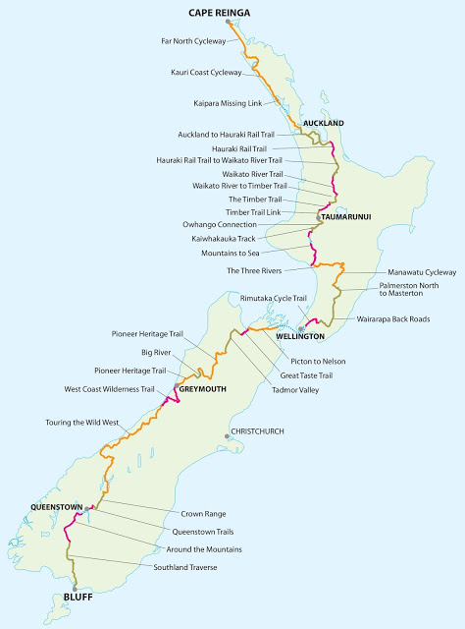

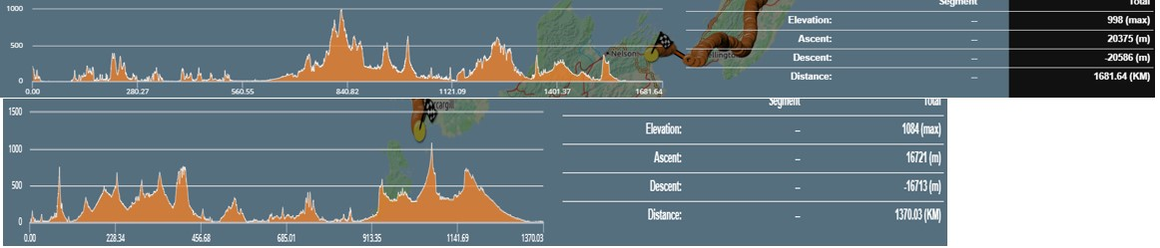

Reaching Bluff is a self-reported arrival, people withdrawing because of COVID-19 are excluded from the stats.

