Traffic Management Plans for Inspections
ENZ Transportation Group 2018 Conference
Queenstown
21 – 23 March

Eranga Dasanayaka
BEng, MemberENZ
Transportation Engineer
Abley Transportation Consultants
eranga.dasanayaka@abley.com

Abstract

The Code of Practice for Temporary Traffic Management (CoPTTM) manual is applicable to any activity that varies the normal conditions of any road and applies to the total road reserve. The purpose of Temporary Traffic Management (TTM) is to manage road users through or past a closure in a safe manner with minimal delay and inconvenience. It ensures the safety of road workers and road users while maintaining reasonable access to the road corridor. This aligns with the New Zealand Transport Agency's Zero Harm legislation and their goal by 2020 is to have "all our people go home safe and healthy, no exceptions". CoPTTM also requires that all staff members conducting work on the road reserve are appropriately trained and qualified for the level of road they are working on.
Many inspection and non-invasive activities are conducted on the footpath or where the person undertaking the inspection activity is not affecting the normal operating conditions of the road. This includes activities such as making observations, traffic counts and taking photographs. With numerous public and private Road Controlling Authorities around New Zealand, the process for submitting and approving a Traffic Management Plan (TMP) or a Generic TMP (GTMP) can be costly and inefficient for both the organisation undertaking the work and the Road Controlling Authority (RCA). Providing training for staff so that they are appropriately qualified can also be a great expense for a company. An all of industry approach will need to be taken to ensure the guidelines for inspections and non-invasive works are followed. This will help ensure a consistent approach towards safe practices, standards and responsibilities on road work sites throughout New Zealand.
This paper will explore the practicality and financial implications of preparing TMPs and acquiring the correct qualifications for conducting inspections and non-invasive works.

- Introduction
The New Zealand Transport Agency (NZTA) has developed the Code of Practice for Temporary Traffic Management (CoPTTM) manual to help manage construction and maintenance programmes on the road network. As part of NZTAs commitment to the continual improvement of road safety, Temporary Traffic Management (TTM) is an important aspect of ensuring the safety of road workers and road users at roadwork and event sites. The CoPTTM manual establishes best practice for the safe and efficient management and operation of TTM on all roads throughout New Zealand. The intention is to apply TTM measures to any activity that varies the normal conditions of any road and applies to the total road reserve.
Under the New Zealand Health and Safety Work Act 2015 (Worksafe, 2017), “any person conducting a business or undertaking (PCBU) in connection with or pursuant to temporary traffic management (TTM) and the CoPTTM, has a 'duty of care', so far as is reasonably practicable, that the health and safety of workers who work for the PCBU or whose activities in carrying out work are influenced or directed by the PCBU, are not exposed to health and safety risks arising from that business or undertaking. A PCBU must ensure, so far as reasonably practicable, that the health and safety of other road users are not exposed to health and safety risks arising from any TTM and CoPTTM business or undertaking.” Therefore, under legislation, appropriate health and safety measures must be implemented by the industry including the Road Controlling Authority (RCA), public and private companies to ensure the health and safety of road workers and road users.
New Zealand roads are classified into various levels by the respective RCA to reflect the demand and associated risk of the road. Designation of a road to a level generally depends on the Annual Average Daily Traffic (AADT) and speed limit. Assigning a road level also influences the amount of TTM measures required to ensure the safety of road workers and road users. In addition, all persons carrying out supervising responsibilities must be adequately trained and qualified depending on their role and the level of road that they are working on.
Inspections and non-invasive works are activities where the inspector(s) are on foot and conducting simple tasks such as observation, audits, traffic counts and taking photographs. The inspector(s) must move to avoid traffic on the road and must not expect traffic to move or slow down for the inspection activity taking place. It is expected that inspectors are adequately trained for conducting such activities depending on the type of work required and level of road. Each individual RCA may request a Traffic Management Plan (TMP) or Generic Traffic Management Plan (GTMP) be provided depending on the level of road, type and frequency of the activity taking place.
For organisations that regularly carry out inspection and non-invasive works totally outside of the edgeline and where the activity does not vary the normal conditions of the road, providing adequate training and a TMP or GTMP can be considered excessive. Additionally, preparing relevant TMPs or GTMPs for each road network under the management of its respective RCA can be a time-consuming process and result in a high cost to the organisation.
This paper will explore the practicality and financial implications of preparing TMPs and acquiring the correct qualifications for conducting inspections and non-invasive works.

- Temporary Traffic Management
Temporary Traffic Management is defined in CoPTTM (2017) as ‘The process of managing road users through or past a closure in a safe manner with minimal delay and inconvenience.’ The design, implementation, maintenance and removal of TTM is conveyed through a TMP document. A TMP must be provided for any activity that varies the normal operating conditions of the road reserve including the carriageway, footpath or road shoulder. An activity that is outside of the road reserve may also require a TMP if it affects the normal operating conditions of the road.
RCAs throughout New Zealand have different submission processes, conditions and costs associated with getting TMPs approved prior to commencing any road works or events. Additionally, the person responsible for developing and/or approving the TMP must have an appropriate Sight Traffic Management Supervisor (STMS) qualification depending on the level of the road on which the activity is taking place.
Section A7.5 Generic traffic management plan (GTMP) of the CoPTTM manual states that repetitive activities may use a GTMP where the repetition is in the form of the same type of activity at similar locations or returning to the same worksite to carry out the same activity. GTMPs must also be approved by the relevant Traffic Management Coordinator (TMC) prior to commencing any works. GTMPs may be approved for a maximum time period of 12 months but may need to be resubmitted if additional hazards are identified, statutory changes are made or is there is a lesser degree of protection.
- Inspections and Non-Invasive Works
Planned inspection and non-invasive works are activities where the inspector(s) are on foot and undertaking simple tasks such as:
- Observation, using a measuring wheel, surveys and traffic counts.
- Installing traffic count equipment.
- Road maintenance activities such as the removal of litter, cleaning signs or taking photographs.
As a general principle for inspection activities, the person(s) undertaking the inspection must move to avoid traffic on the road and must not expect traffic to move or slow down as part of the inspection activity. Complex inspection activities, including activities that cannot immediately move off the live lane, require mobile or static TTM. Any inspection activity on the live lane of a Level 3 road is also not permitted without the appropriate mobile, semi-static or static closure in place.
Conducting inspections and non-invasive works requires the use of an approved TMP or GTMP and depending on the level of road the activity is taking place. The inspector(s) must also be appropriately qualified for conducting the activity, which also depends on the level of the road. Section D7.7 in the CoPTTM manual provides a summary of requirements for inspections as shown in Figure 1.
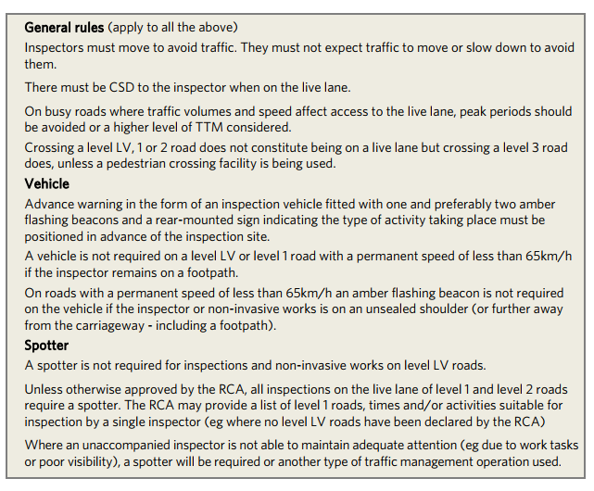
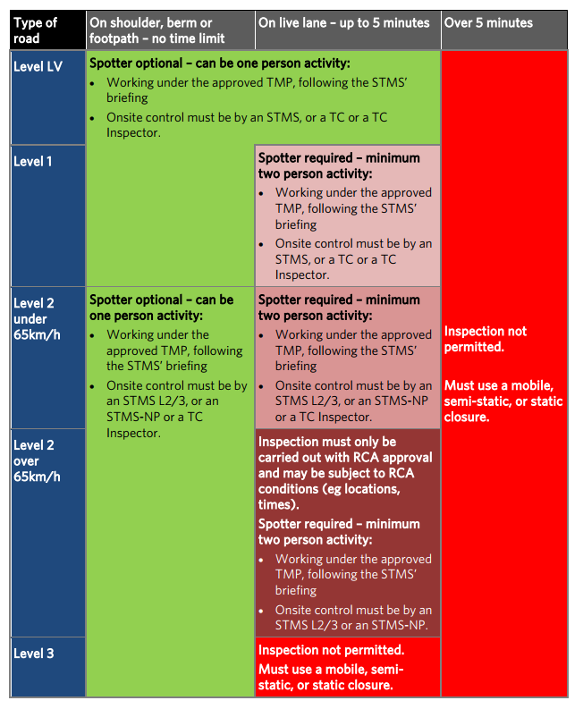
Figure 1: Summary of requirements for inspections and non-invasive works in CoPTTM.
.

- Training Requirements for Inspections and Non-Invasive Works
All persons with supervising responsibilities are required to be trained to the appropriate standard depending on the level of road and tasks that they are required to perform. The intention of training, as stated in the Health and Safety Work Act 2015, is primarily to protect all persons from risks to their health and safety resulting from the work being carried out. For inspection and non-invasive activities, the appropriate standard of training for the level of road is as follows:
Level LV and Level 1 Roads
- Traffic Controller (TC)
- Traffic Controller – Inspector (TC-I)
- Site Traffic Management Supervisor Level 1 (STMS Level 1)

Level 2 or Level 3 Roads
- Traffic Controller – Inspector
- Site Traffic Management Supervisor Level 2/3 Non-Practising (STMS Level 2/3 N-P)
- Site Traffic Management Supervisor Level 2/3 (STMS Level 2/3)

A TC qualification allows the holder to carry out inspection and non-invasive activities on Level LV and Level 1 roads only. This includes activities on the shoulder, berm or footpath and on the live lane for up to five minutes. However, a TC-I qualification is required to carry out inspection and non-invasive activities, totally outside of the edgeline, on Level 2 and 3 roads. Additionally, the TC-I qualification may be inadequate depending on how frequently the inspector(s) are required to carry out inspections on the live lane of Level 2 roads. As CoPTTM (2017) states, if the inspector(s) are required to carry out inspections more frequently (e.g. more than 4 times per annum) then a higher qualification may be required such as STMS Level 2/3 NP or STMS Level 2/3. Inspections on the live lane of Level 3 roads require a mobile, semi-static or static closure.
Students and casual workers who are employed to carry out a study are also required to hold a TC-I qualification if they will be working on a Level 2 and/or Level 3 road. Studies can include a traffic count from a safe location or carrying out visual inspections of an asset such as a sign or guardrail.
- Implications to the Industry
Inspections and non-invasive works are carried out by industry on a regular basis throughout New Zealand. CoPTTM states that an approved TMP is required for carrying out inspection and non-invasive activities on all levels of road, even if the inspector(s) are not required to use the live lane. Additionally, the inspector(s) must be appropriately qualified for the level of road on which the activity is taking place.
The process of acquiring TMPs or GTMPs can be both time consuming and costly for companies or organisations that conduct work on the road corridor. Small to mid-sized organisations may only have one or two offices in New Zealand but conduct inspections in multiple regions. Therefore, a TMP or GTMP will have to be created and approved by the relevant RCA for each region the organisation wishes to operate. If a GTMP can be used, then this document will have to be renewed every 12 months, again, for each region. Depending on how many appropriately qualified STMS staff the organisation has, the process of producing or renewing a GTMP can be time consuming, especially for multiple regions. This will also add further costs to the business, depending on how many different regions they will operate in. Larger organisations who have offices in multiple regions may not experience the negative implications of this process to the extent that small to mid-sized organisations will. It is likely that each regional office will have an appropriately qualified STMS staff member that can prepare the TMP or GTMP for the region in which they operate. Staff members from the same organisation visiting from other regions can then conduct work activities under the relevant regions TMP or GTMP.
Providing training for staff will promote safe working practices, standards, operating procedures and responsibilities on the road reserve. However, some inspections and non-invasive works can be completed on foot totally outside of the edgeline on either the road shoulder, berm or footpath. In addition, no additional safety hazards are created by the inspector(s) and no additional delays are experienced by all road users. The activity can generally be limited to making observations and taking photographs. If an inspector is limited to such activities, then a company or organisation may not be inclined to have their staff members attend courses to ensure they are appropriately qualified. This can be justified by some organisations if they have an appropriate internal health and safety procedure in place for conducting inspections and non-invasive works.
Some industry professionals view the inspector(s) as being no different to normal pedestrians on the footpath. For example, the general public can walk on the footpath and make observations and take photographs without any formal qualifications. On the other hand, there are industry professionals who argue that wearing a high visibility vest while carrying out the inspection activity may distract some road users, hence changing the normal operating conditions of the road. Additionally, there are some activities such as discreet behavioural surveys where it is not desirable to wear a high-visibility vest. If a company or organisation does not have any staff members who are knowledgeable in CoPTTM, then they may not be aware of the qualification requirements for inspection and non-invasive works. This can include companies and organisations that work within the road reserve such as landscape gardeners, furniture removals, street traders, photographers and journalists.
RCAs have a responsibility to ensure that all persons or business conducting work on their road network is complying with the requirements of CoPTTM such as working under an approved TMP and the road workers are appropriately qualified. RCAs must also provide an induction to all TC-I qualified persons to their Level 2 and Level 3 road network if it is not covered in the TC-I course. This can create additional work for the RCA and put a strain on existing resources. It may be challenging for RCAs to enforce the TC-I qualification requirement, although they are responsible for Level 2 and 3 roads under their network.
The set requirements for all inspections and non-invasive activities on the road network should be clearly established and enforced. A shared knowledge base should also be established within the industry to ensure consistency in terms of TMP and training for all PCBU participating within a particular region, area and even the whole of New Zealand. This can be achieved through industry newsletters, magazines, conferences and other industry events. This will help eliminate how CoPTTM is interpreted by various individuals and organisations.
- Financial Implications of TMPs and Training
The process of preparing a TMP/GTMP and providing adequate training for staff members can have a large financial implication to a company or organisation. If the staff member responsible for preparing TMPs has a rate of $150 per hour and it takes one day (eight hours) to prepare the relevant documents and drawings, a cost of at least $1,200 will be incurred to the business. Providing training for staff will promote safe working practices, standards, operating procedures and responsibilities on site. Enrolling all staff members who work on the road corridor can result in an excessive cost to an organisation. The cost of basic Traffic Controller training is typically between $250 to $300 for one staff member and is a one-day course. If the staff member has a rate of $150, then the business will incur another $1,200 cost for time spent out of the office. A total of around $1,450 to $1,500 will be incurred by the business to train one staff member.
The cost of conducting an inspection, depending on the activity, may be less than the cost of preparing the TMP/GTMP and the cost of providing training. Therefore, the company or organisation will need to ensure that an adequate work stream, that requires the use of the TMP/GTMP and qualified staff member, is provided to offset the expenses.
Hiring students or casual workers for carrying out activities such as traffic counts is commonplace within the industry. The cost of providing TC-I training to ensure the student or casual worker is qualified to carry out the work can cost approximately $300. This can be an excessive cost to the company or organisation, especially as there will be a high turnover rate for this type of activity. On the other hand, a student or casual worker may not want to personally pay for the cost of training as there is a risk that they will not be provided with enough work to cover the cost of training.
Worksafe NZ is the primary regulator for the workplace health and safety system in New Zealand. Their roles and responsibilities include ensuring New Zealand workplaces are appropriately managing health and safety, prevent harm by targeting critical risks at all levels and lead the health and safety system to improve health and safety outcomes. Worksafe inspectors can audit an organisations health and safety policies and procedures to ensure all risks have been properly managed. If the inspector believes that the Health and Safety Work Act has been breached in connection with or pursuant to TTM and the CoPTTM, an infringement notice can be issued or duty holders can face prosecution. Failure to comply with the health and safety duties can result in five years in prison or up to $3 million in fines, depending on the seriousness of the breach. Penalties can be implemented at an individual, officer or organisation level.
- Conclusion
The New Zealand Health and Safety Work Act 2015 and CoPTTM manual have been established to ensure the health and safety of all road workers and users in and around a road work site. CoPTTM is applied to any activity that varies the normal operating conditions of the road, through the use of TTM, so that road users are guided through or past a closure in a safe manner and efficient manner. This process is documented using a TMP or GTMP.
Inspection and non-invasive works are activities where the inspector(s) are on foot and undertaking simple tasks such as making observations, traffic counts and taking photographs. Some inspection and non-invasive works do not vary the normal operating condition of the road in which road users do not need to be guided through a work site. This can include activities conducted entirely on the footpath where the inspector(s) are making observations or taking photographs. Such activities are theoretically no more dangerous and impose no greater risk to either inspectors or the travelling public than would be imposed by any pedestrian on the footpath. This can lead to confusion as to the requirements for TMP, GTMP and staff member qualifications within the transportation industry. Some businesses such as landscape gardeners, furniture removals and street traders may also not be operating under the requirements of CoPTTM as they may not be aware of the document or its necessities.
The process of producing a TMP, GTMP and sending staff to relevant courses to acquire the correct qualifications can be a time consuming and costly process. Depending on the rate of the staff member, the preparation of a TMP or GTMP can cost the company or organisation approximately $1,200 plus a fee of $50 to $100 for the approval process. In addition, a TMP/GTMP is required for each region the company or organisation wishes to operate. The cost of providing training and time away from the office can also cost a company or organisation approximately $1,500 per staff member. However, the cost of conducting an inspection may be significantly less, depending on the activity.
Worksafe regulates the workplace health and safety system in New Zealand. Worksafe inspectors can audit an organisations health and safety policies and procedures so that any risks have been adequately managed. If the Health and Safety Work Act has been breached, the inspector may fine the individual or organisation. Fines can include five years prison time or up to $3million depending on the severity of the breach.
A pragmatic all of industry approach to the guidelines set out by CoPTTM needs to be taken and enforced by RCAs, consultants, contractors and all PCBU on the road reserve. This will result in a consistent approach to how CoPTTM is implemented throughout the industry for inspections and non-invasive works throughout New Zealand. The industry can be updated on CoPTTM requirements through the use of industry newsletters, magazines, conferences and other industry events.

References
Code of Practice for Temporary Traffic Management (2017), Sections A to H – Combined Sections, viewed 1 December 2017,
< https://www.nzta.govt.nz/assets/resources/code-temp-traffic-management/docs/2017/Sections-A-to-H-combined-copttm-4th-ed-feb2017.pdf>
Worksafe (2017), Introduction to the Health and Safety at Work Act, viewed 11 December 2017,
<https://worksafe.govt.nz/managing-health-and-safety/getting-started/introduction-hswa-special-guide/>
Traffic Management NZ (n.d.), Traffic Management Training, viewed 13 February 2018, <https://www.trafficmanagementnz.co.nz/TC_STMS_traffic_management_training_nz.htm>
McAdams (n.d.), Traffic Controller, viewed 13 February 2018,
<http://copttmtraining.co.nz/workshops/traffic-controller/>
McAdams (n.d.), TC-Inspector, viewed 13 February 2018,
<http://copttmtraining.co.nz/workshops/tc-inspector/>
Traffic Management Academy (n.d.), TC1 – Inspector, viewed 13 February 2018, <http://www.tmacademy.co.nz/courses/tc-inspector/>

Acknowledgements
I would like to acknowledge Josephine Draper for providing me with the guidance and ideas for this report. I would also like to thank her for reviewing the report and providing feedback.

