**A pathway to creating healthy streets.**

Putting people at the heart of transport planning and design practice, NZ Transport Agency/ Waka Kotahi have developed national street planning and design guidelines. This brings together multi-modal design, the adaptive, staged, and permanent phases of street change to support good transport outcomes for well-functioning urbanism for all modes.

The guide promotes a holistic approach for street change and creates a permission slip for the sector to consider not only the way a street is planned under the One Network Framework (ONF) and how they function for each mode, but also, the quality of the environment as a place where people want to be, walk, cycle and access public transport. The guide development aligns with wider road safety considerations such as safe and appropriate speeds and safe system principles.

NZTA are now bringing to the sector this information and sharing the guidance through training and webinars. Supporting capability building in this space. NZTA now offers a range of learning and web resources supporting the guidance, which is available for engineers, urban designers, built environment and transport professionals.

The journey towards this Streets for the 21st Century training, started in 2021 with the development of multi-modal learning resources and specialist guides. These are now part of a collective ‘community of practice’ spanning both adaptive urbanism, multi-modal, road safety, street planning and design.

The poster presentation and discussion will focus on the guide (movement and place, the street guide, adaptive urbanism, and multi-modal guidance), the journey to date and the next steps in shaping these resources alongside the way national guidance is used and applied. The presentation will reflect the end-to-end processes for streets illustrate the resources available. We seek to stimulate feedback on what the sector needs going forward. In this work we also recognise council partners and the advances made in urban mobility over the last decade. We look forward to hearing your views on key challenges and opportunities ahead.

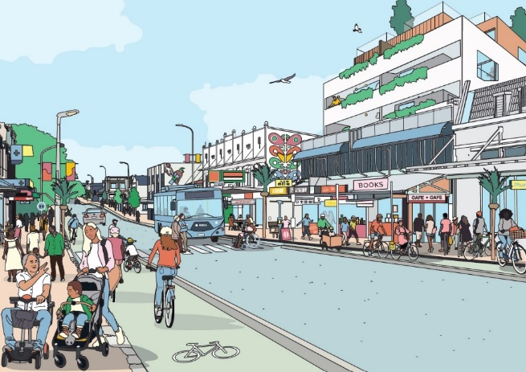

Image: Artist Emma McInnes, part of the healthy street design check tool pilot project