Working with Communities to Develop Infrastructure for People
Twan van Duivenbooden

MSc (Civil Engineering, Transport)

Active and Shared Modes Design Specialist, Auckland Transport Email: twan.vanduivenbooden@at.govt.nz

ABSTRACT

Developing cycling cities very often encounter the same difficulty: how to sell a cycling infrastructure project to local residents and businesses, when a majority of them don’t think they will use it. We are getting more used to dealing with cycling advocacy groups and with vocal cycling opponents. They are however only a small part of the wider community. A bigger focus needs to be on the group in between: the group that does not mind cycling infrastructure but is not necessarily supportive of changes to their area.

Taking this group along on the journey, understanding what its concerns are for its community, and incorporating those concerns – even if they are not cycling related – into projects helps to create a wider support base. Rather than aiming to deliver active mode infrastructure, it is focusing on delivering infrastructure for people – with active mode infrastructure part of the solution to the concerns. This does require a change in approach from the more traditional ‘make a detailed plan and consult widely’ to ‘listen to people, understand the issues, and provide solutions’.

A change of skill-sets in projects is needed. Projects require better management of the ‘project environment’, incorporating three main aspects: information, integration, and participation. Early engagement through regular discussions and workshops with stakeholders and local residents has shown to get projects ‘on the road’ better, with support from other than just cycle-minded people.

The learning curve for working with communities has been steep, learning on the way what works and what does not work in discussions. However, the overall response is positive and working with communities, rather than just consulting communities, has helped with the delivery and acceptance of active mode infrastructure.

INTRODUCTION

The role of communities in planning, design and delivery of projects is changing. Complex cycleway projects tend to get quite significant push-back, resulting in delays, cost increases and even cancellation of projects. Working with communities is becoming more important, but community engagement is proving to be a struggle (Ciclocivica, 2016).
Local authorities recognise the need to better engage with their communities and encourage community participation (e.g. Auckland Transport (2019)). The draft GPS for Land Transport also supports improved engagement (Ministry of Transport, 2020). To enable better community participation, projects will have to adapt and work more closely with local people from the start (Cronwright, 2016) (Sustrans, n.d.) (Wanningen, et al., 2011).
This paper explores how projects can move from a more technical focused project set-up to a people focused set-up, based on the own experiences of the author and theory and practice from around the world. The main suggestion is that a complex project is not framed in the same way by different stakeholders, and that a traditional project set-up cannot deal well with this challenge.
This paper identifies what changes and discussions help to address the difficulties and create a more participatory project environment, with communities engaged and more supportive of changes to their neighbourhood.

CHANGING ENVIRONMENT

Part of the challenge of delivering walking and cycling infrastructure is the changing environment in which projects operate. Setting up a project well is becoming more important to avoid delays, budget issues or even cancellation of projects. A few key factors of the changing environment can be identified.
Changing role of local authorities
Local authorities have less operational funding and resources available, requiring them to rely more on external parties. Usually this external resource is project based with a limited, pre-defined brief. As a consequence, the focus for local authorities is shifting towards project/programme direction and assurance (Krocké & Verhees, 2019).
Effect of online communication
In the current world, social media makes it a lot easier for stakeholders and residents to vent their opinions. This can be a real challenge for projects when negative feedback is taking over the conversation. However, it is also an opportunity to reach and communicate with a wider audience when e-participation is done well (Haas Lyons, 2017) (Le Blanc, 2020).
Complexity of projects
The shift in focus to sustainability and safety adds complexity to projects, e.g. due to space constraints or modal priority conflicts. The natural tendency of people to counteract any change and retain the status quo needs to be carefully managed.
Local initiatives
Initiation of projects by local stakeholders is more common nowadays, e.g. by Local Boards, including a different funding arrangement. This introduces a new perspective with goals that may differ from a local authority’s organisational goals.

PROJECT MODELS

How working with stakeholders is incorporated with projects largely depends on the project model used.
Krocké & Verhees (2019) identify three main project models: a traditional linear approach, a more diverging inclusion approach and a flexible participation approach. Figure 1 depicts these three models.
Traditional
Traditionally, projects are managed linearly with a business case based on organisational strategies and objectives (A) and a fixed outcome (B). The expectation is that the benefits and dis-benefits for end-users are in line with the organisational objectives. During projects there is little involvement of stakeholders and communities, except for statutory consultation and limited ‘one-way’ communication to inform stakeholders. In the changing environment this is proving more challenging to manage, leading to loss of support and negative press.
Inclusion
Projects can also start with an organisational objective (A) and include stakeholder inputs along the way. The relative interest and weight of stakeholders is considered to prioritise those inputs. The more complex a project is, the higher the risk that conflict resolution and additional outcomes cause delay and inability to meet original budgets. This approach results in multiple outcomes, one of which would be the original project outcome (B1), the others stakeholder outcomes to achieve acceptance (B2, B3, etc)
Participation
In highly complex projects, capturing stakeholder views at an early stage identifies potential problems early on, and projects can be set up and budgeted accordingly. In this participatory environment a more continuous engagement is happening, from setting the scope to implementation. This recognises that views may change along the way requiring a project team to be flexible to accommodate these changes. For example in the early stages of a project, multiple objectives could be set – one of which would be the original project objective (A1), the others community objectives (A2, A3, etc.); analogous to the inclusion approach, projects would achieve multiple outcomes.
Table 1 summarises the characteristics of each of the approaches.

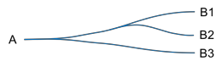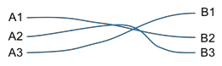
Traditional Inclusion Participation

Figure 1: Project models for traditional, inclusion and participation projects (based on Krocké & Verhees (2019))

Table 1: Characteristics of the different project models

Traditional Inclusion Participation Starting point One project goal One project goal Multiple project goals End point Fixed outcome Multiple outcomes Multiple outcomes Process Linear Somewhat flexible Very flexible

Communication One-way Share and align Continuous
discussion

Project risk No support for project, cancellation
Conflict resolution leads to added delay, cost
Tension between organisational goals and community initiatives

Some projects would still benefit from a more traditional approach, e.g. because they are not very complex or with a low impact on stakeholders. Identifying the complexity, the effects on (potential) stakeholders, and the local support for change is an important step when choosing a project model.

STAKEHOLDER ANALYSIS

To counteract the challenges of a changing project environment, project teams will need to understand the ‘playing field’ very early on and build trust. This requires a move from a project- centric perspective to a people-centric perspective.

“[Participatory development] needs to take stakeholder needs seriously, drawing in the experience, ambitions and consent of diverse people, and respecting their viewpoint.” (High & Nemes, 2009)

Identification of specific stakeholder groups, assessment of their needs and requirements, and recognition and inclusion of their views are important in a participatory environment. Rather than talking about what the main goal of a project is and what benefits it can bring, it is about asking, listening and understanding what the local stakeholders consider to be important (De la Mata, 2014).

Project perspective

- Main goal
- Benefits
People perspective

- Concerns
- Perceptions
- Local vision
- Expectations

Example
A local authority has an organisational objective to create new cycling facilities that are suitable for less experienced riders. They also would like to improve pedestrian connectivity in projects.
Early engagement has identified that one of the stakeholders supports the cycling goal, but also would like to see more green space and trees. Another stakeholder is not very interested in cycling and walking but would like to see the local shops flourish and enough parking space to be provide for visitors.
Even though the project team only had two goals in mind, through stakeholder input five objectives are identified to be included in a project. Table 2 shows this more clearly.

Table 2: Example – Project objective analysis

Project team
objectives
Safe cycling infrastructure
Pedestrian connectivity
Stakeholder A
objectives
Safe cycling infrastructure
Stakeholder B
objectives
More green space and
trees
Project
objectives
Safe cycling infrastructure
Pedestrian connectivity
More green space and trees
Vibrant shops Vibrant shops
Enough parking space Enough parking
for visitors space for visitors

TRANSLATING GOALS INTO DESIGN

Projects do not have an infinite scope with an infinite budget and infinite road widths. Achieving all identified goals within a project may therefore be a challenge. Usually, stronger stakeholders (e.g. vocal, political) define what goals are more likely to be taken into account in a project, and the extent of efforts to satisfy these strong stakeholders (De la Mata, 2014). However, this may skew a design towards those stakeholders, potentially excluding a silent majority. Participatory design however aims to equalise power and look to find compromises that are acceptable to all stakeholders instead (van der Velden & Mörtberg, 2014).
Understanding the minimum requirements to reach each of the identified goals is needed to get to a successful outcome. Some of the goals may already have design standards in place that help to quantify goals for design, other goals may have to be quantified ‘from scratch’, e.g. with the help of research. In a participation environment, an important task is to identify the acceptable range for a design to meet goals. Not all stakeholders may be able to have their preferred solution but will hopefully still end up with a solution that is acceptable to them, which should avoid significant opposition to a project. Most criticism would come from a reduction below expectations – i.e. towards not meeting project goals. However, it is also important to not provide infrastructure that is over-dimensioned – over-design or over-supply would lead to inefficient use of resources and therefore also negative public perception. Figure 2 shows this degree of acceptability in graphic form, and Table 3 an example of quantification of the acceptability range.

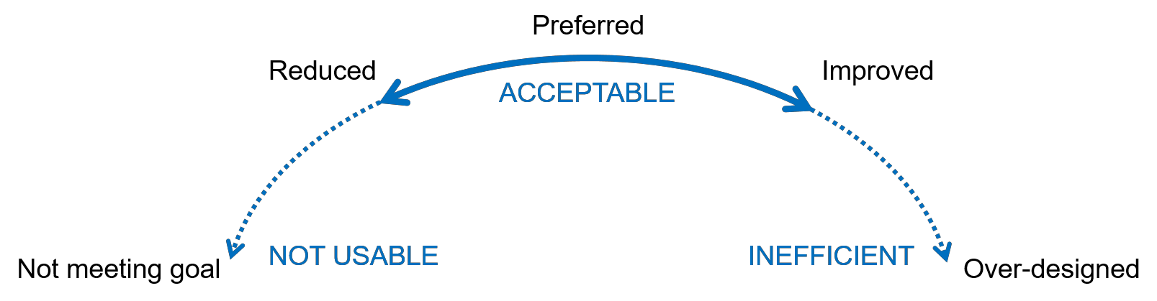

Figure 2: Degree of acceptability

A difference can be made in location: some goals are more ‘global’ (e.g. safe cycling infrastructure), others may be more local (e.g. parking space). The locality of goals can have an influence on what is acceptable in a certain location (e.g. a reduction of parking space where there is less demand).

Table 3: Example - Quantification of acceptability

Reduced |  | Preferred | Improved
Cycleway width | 1.8m | 2.0m | 2.5m
Pedestrian crossing | Raised zebra crossing within 25m from the desire line | Raised zebra crossing within 10m from the desire line | Raised zebra crossing right on the desire line
Trees  Parking | Replace some existing trees with native species | Keep all existing trees | Keep all existing trees and add new native ones
 | Loading zone within 20m from the shop | Some P30 spaces in front of the shop | Some unlimited parking in front of the shop

DELIVERY OF THE PROJECT

Participation does not end with design. The actual delivery of a project will also affect stakeholders and local residents. Although more operationally focussed, a project team will still need to incorporate the concerns, perceptions and expectations of the community. These can be summarised by four aspects: accessibility, liveability, safety and communication (Wanningen, et al., 2011).
Accessibility
Getting communities involved with the strategic planning of traffic management, phasing of works and alternative arrangements.
Liveability
Discussing the construction effects, such as noise and dust with local stakeholders. Agreeing timing of works, e.g. no loud works next to a coffee shop during the morning coffee run.
Safety
Assuring the works are appropriately fenced off and that alternative routes are appropriate and safe to use for all stakeholders. Understanding the stakeholder needs is necessary to enable assessment of alternative arrangements, e.g. undertake regular audits with community.

Communication
Being visible and approachable. Participation is relying on two-way communication. A project team will therefore need to be reachable by the community and able to address concerns.

CONCLUSION

Working with communities is not as easy as one may think. More complex projects – and most cycleway projects are very complex – should include community input in the whole life cycle of a project.
Participatory projects aim to get agreement with the identified stakeholders and residents on the ‘why’: why is the project undertaken and what goals need to get in included to get support; ‘what’: what design elements are necessary and can be accepted; and ‘how’: how does the delivery phase of the project impact the stakeholders and how can any adverse effects be mitigated. Figure 3 shows where in the project life cycle these aspects are discussed.

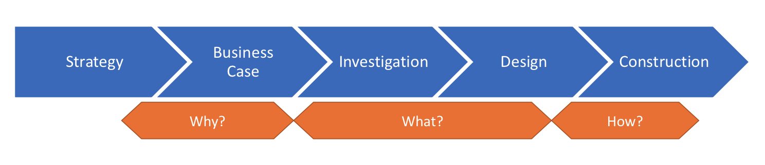

Figure 3: Project life cycle with community input

Understanding at an early stage what is acceptable to a community and what is not assures less friction and better ability to plan budgets and time. However, the front loading of engagement does lengthen the initial stages.
Including stakeholders from the start is still fairly uncommon in New Zealand, as it requires a change of the set-up of projects and requires the inclusion of new skills in project teams. A greater emphasis on project environment management will help merge technical knowledge with consideration of the needs of people and communities.

REFERENCES

Auckland Transport, 2019. Statement of Intent 2019/2020-2021/2022, Auckland Transport. Ciclocivica, 2016. Share Hub: Final Report, Wellington: Ciclocivica Ltd.
Cronwright, S., 2016. Public engagement guidelines, New Zealand Transport Agency.
De la Mata, G., 2014. Do you know your stakeholders? Tool to undertake a Stakeholder analysis.
[Online]
Available at: innovationforsocialchange.org/en/stakeholder-analysis/
Haas Lyons, S., 2017. Digital Engagement, Social Media & Public Participation, International Association for Public Participation Canada.
High, C. & Nemes, G., 2009. Purpose and perspective: using soft systems methods in stakeholder analysis. Budapest, Hungary.
Krocké, V. & Verhees, F., 2019. Omgevingsmanagement 3.0, Platform Omgevingsmanagement (in Dutch).
Le Blanc, D., 2020. E-participation: a quick overview of recent qualitative trends, United Nations - Department of Social and Economic Affairs.

Ministry of Transport, 2020. Draft Government Policy Statement on Land Transport: 2021/22 –
2030/31, New Zealand Government.
Sustrans, n.d. How we do community-led street design. [Online] Available at: https://www.sustrans.org.uk/for-professionals/our-approach/how-sustrans-does- community-led-street-design/
van der Velden, M. & Mörtberg, C., 2014. Participatory Design and Design for Values. In: Handbook of Ethics, Values, and Technological Design: Sources, Theory, Values and Application Domains, pp. 1-22.
Wanningen, A., Schipper, W., Haak, M. & de Hoog, A., 2011. Omgevingsmanagement, Gemeente Amsterdam (in Dutch).

