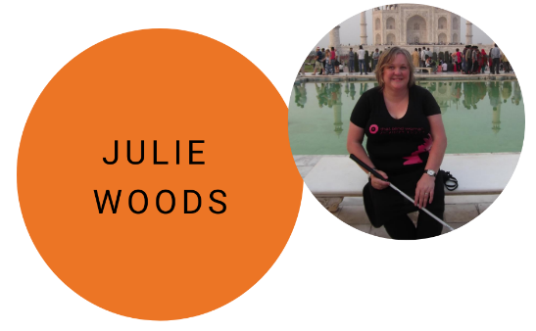
Friday 18 September,
1:15pm – 1:45pm
When Julie Woods went blind in 1997, she thought her life had ended, little did she realise it had only just begun. Whether it's been single blind parenting, walking 10 half marathons or visiting the Seven Wonders of the World, Julie has probably said why not to doing it. "How can you sight see when you can't see?" people would ask. Find out what Julie said to them and how she really did see the Seven Wonders through her senses, and how she ended up 3,300 metres above sea level after her husband said "tomorrow we're going for a walk." Julie now has a dream to write 1 million names in braille, so she'll share with you what a young Indian porter in a hotel near the Taj Mahal said to her that inspired her to chase this dream.

Visiting the Seven Wonders of the World after going blind
Julie Woods will focus on visiting the Seven Wonders of the World after going blind. She will read in braille from her sensory diary entries at the Seven Wonders of the World, giving one thing she smelt, heard, tasted and touched there. She will also tie that into 1 million names in braille.

