TITLE: GEOGRAPHIC ECONOMIC ACCESSIBILITY (GEA) FOR FREIGHT TRANSPORT

Authors:

- Patricio Gallardo (Presenter)
  - PhD Candidate at the University of Canterbury
- Paúl León
  - Analyst at Instituto Nacional de Eficiencia Energética y Energías Renovables (INER)
- Dr. Rua Murray
  - Associate Professor from the Mathematics and Statistics Department at the University of Canterbury
- Dr. Susan Krumdieck
  - Professor from the Mechanical Engineering Department at the University of Canterbury

GEOGRAPHIC ECONOMIC ACCESSIBILITY (GEA) FOR FREIGHT TRANSPORT

ABSTRACT

Freight transportation has always been essential for trade and prosperity. The geographic economic accessibility to trade has expanded with modern use of fossil fuels. Geographic economic accessibility (GEA) is a measure of the tonne-kilometre (tkm) dispersion for production and supply chains using the existing transport networks, intermodal connections and available energy. The non-renewable nature of transport fuel, carbon emissions from fossil fuels, and price volatility mean that the outlook for trade will involve pressures for change. The question is: what are the most economically efficient infrastructure investments, operational changes and technology developments to achieve high geographic economic accessibility to trade while adapting to the 80% reduction in fossil fuel which is expected over the lifetime of networks and vehicles?

In this paper, we focus on the first part of the GEA trade analysis scheme, where travel demand is estimated upon the execution of a Random Utility Based Multiregional Input Output Model. Given the mathematical representation of the New Zealand Freight Transportation System, we assess the response of mode share and freight flow dispersion to changes in transportation costs.

We explore freight activity and energy consumption under different infrastructure and network configurations, as well as under different assumptions about travel patterns and logistic dispersion. Such a scheme can be used for the identification of transportation infrastructure that has the potential to enhance a smooth transition of the freight transportation system towards a more resilient configuration that allows for the consolidation of freight flows and for the deployment of more energy efficient modes of transportation. Furthermore we propose the adoption of essentiality metrics over the transportation demand in order to identify what sectors are at higher risk due to lack of capacity to adapt to lower energy consumption.

INTRODUCTION

Energy demand has tripled in the last 43 years; in 2016 the total energy consumption reached 9464.69 Mtoe (Million tons of oil equivalent) and the transportation sector was responsible for 27.87% of the world’s energy demand (International Energy agency, 2016). The outlook for the transport sector is critical since almost all means of transport are heavily dependent on fossil fuels like gasoline and diesel; therefore, decoupling Gross Domestic Product (GDP) growth from GHG emissions might be more challenging in contrast to other sectors like industry which already counts on feasible alternative technologies and cleaner fuels. In spite of the recent developments in energy efficient vehicles, Greenhouse (GHG) emissions from the transport sector were 7 Gt CO2eq in 2010 and they have been increasing at a faster rate than any other sector (Sims et al., 2014). Advancement towards low carbon transportation systems will not only depend on technological progress but also on behavioural changes and major investments in infrastructure.

Additionally, the strong reliance that this sector has on the oil market, poses an additional threat to future accessibility to essential activities and commodities, taking into account the finite nature of this non-renewable resource and its high price volatility. There is a need to devise integrated models for the analysis of freight transportation systems so that their configuration can become more competent in overcoming environmental constraints and potential limitations on the use of energy resources. There is also insufficient comprehension of the repercussions that potential constraints on fuel supply will have on freight transportation systems and consequently on the accessibility to essential commodities. These issues have also been endorsed in a report from the Intergovernmental Panel on Climate Change (IPCC) which points out that there is a poor understanding of the economic implications related to the decarbonisation of freight transportation systems (Sims et al., 2014). Furthermore, the report states that contemporary models lack the ability to interpret the impact of behavioural and infrastructural changes (Sims et al., 2014).

Historically, the field of transportation system analysis has focused on the interactions between the socioeconomic and transportation systems within a region. The theory has been based on the idea that flows or volumes moving through the system are subject to changes in the transportation system, like the introduction of a new highway port or railway, so that the level of service follows these transportation options. Furthermore shifts in demand can either be induced by exogenous factors such as population growth or by the transportation service level itself. For instance the expansion of suburban residential areas may succeed the development of a new highway. These changes or options have been incorporated into the models as decision variables. The core of the analysis has relied on the prediction of flow patterns, that is, anticipating the impacts associated with service and demand functions that are defined through decision variables (Manheim, 1979). Much of the research efforts have been put onto passenger transportation; the main reason for this is that the mechanisms underlying freight transportation demand are considerably more complex than those for passenger demand (Cascetta, 2009). To a certain extent both fields, passenger and transportation, share the same foundations; however commodities in freight transport are immensely heterogeneous and its movement involves more actors than the movement of passengers.

The traditional approach to deal with transportation systems is the four step aggregate demand model (Ortuzar and Willumsen, 2011) and more sophisticated freight demand models incorporate macroeconomic analysis to the traditional methodology, that is, origin destination freight flow matrices are derived through mathematical formulations that define patterns of economic exchanges between regions and economic sectors. State of the art models within this category include Multiregional Input Output (MRIO) and Computable General Equilibrium (CGE) Models.

A new generation of MRIO models incorporate functional forms from random utility theory, allowing trade flows to respond to changes in transportation costs. Kockelman et al. (2005) describe the calibration and application of a Random Utility Based MRIO model for Texas; the model was further applied to study the effects of export demand changes on industry distributions and on regional trade flows. Even though the variable trade coefficients feature accounts for the impact of transportation costs, MRIO models still lack the capacity to respond to changes in prices and are purely demand driven.

CGE models stand as a good alternative for IO models since they preserve their modelling capacities and compensate for their drawbacks. The structure of CGE model is based on a set of equations that represent the behaviour of the agents involved (households, government, and businesses) and a set of technological and institutional constrains (Ivanova, 2014). In a CGE model, technical coefficients and final demand vectors are endogenously determined through the specification of trade functions with constant elasticities of substitution; hence overcoming the fixed technical coefficients assumption from MRIO models (Brocker, 1998). Bröcker et al. (2010) applies a Spatial CGE to evaluate an initiative that aims to promote the development of trans-European networks for the reinforcement of economic and social cohesion in the region. The model is based on a household and a production sector with two industries and trade costs depend on the state of the infrastructure; upgraded links represent lower trade costs and consequently, higher welfare of households in the region (Bröcker et al., 2010).

The linkage between economic activity and commodity flow patterns is a feature that has been conveniently exploited to forecast freight activity under distinct socio economic scenarios. Furthermore freight activity can be further analysed and processed in order to estimate the energy (fuel) that is needed to run the system. Traditional approaches have focused on the characterization of flows and corresponding use of resources; however, they lack the ability to consider the effects of fuel prices and mode shifts (Grenzback et al., 2013).

On the other hand transport emission and energy consumption models follow approaches that are similar to life cycle assessment and national accounting methodologies so that emission intensities are aggregated into indicators that are later applied to the transport performance (tonne-kilometres or passenger kilometres) of every transportation mode (Mattila and Antikainen, 2011); these models rely primarily on general factors and statistics, so that they are not able to reflect the impacts of changes in freight flow patterns.

The existing bridge between transportation demand and energy accounting methodologies, suggests the need for the development of more integrated operational tools that are capable to determine freight transport demand and enhance the identification of systemic carbon-reducing policies (Grenzback et al., 2013, Tavasszy and de Jong, 2013, Sims et al., 2014). In this paper we attempt to address this gap, through the formulation of a Random Utility Based Multiregional Input Output Model (RUBMRIO). The main feature behind this state of the art approach is that trade coefficients are specified through a discrete choice formulation, so that trade volumes respond to changes in regional prices and transportation costs. Our analysis focuses on the effect that fuel prices have on transportation costs and subsequently on the overall dispersion of the freight flow pattern of New Zealand.

BACKGROUND

In the first part of this section we go over the basic foundations behind input output analysis. In the second part, we specify the conventional notation and model formulation for the multiregional approach.

Single Region Input Output Analysis

Input-output analysis is a macroeconomic approach where the interactions or flows $x^{mn}$ between sectors ($m$ is a producing sector, $n$ is a purchasing sector) are endogenously determined upon business expenditure’s patterns. For a single region economy, the total output for any given sector $X^{m}$ is expressed as:

$$X^{m}=\sum_{n}{x^{mn}}+Y^{m} ∀m$$ | (1)

Where $Y^{m}$ is the total demand for the output of sector $m$.

Eq. (1) can be also expressed as:

$$X^{m}=\sum_{n}{a^{mn}X^{n}}+Y^{m} ∀m$$ | (2)

Where $a^{mn}$ is a technical coefficient that represents the amount of product $m$ required to produce one dollar of product from sector $n$. The set of technical coefficients define the production technology and it is assumed that it remains fixed for the period of model application; this feature implies that there is no substitution between the factors of production.

The solution for the production levels vector expressed in matrix notation is:

$X={\left(I-A\right)}^{-1}Y$ | (3)

Where $Y$ represents the vector of final demand, $I$ is the identity matrix and $A$ is the technical coefficients matrix. The equilibrium solution is found given that the $\left(I-A\right)$ matrix is non-singular.

Random Utility Based Multiregional Input Output (RUBMRIO) model description

Notation

$$m$$ | producing sector
$$n$$ | purchasing sector
$$i, j, k=1,2,…,J$$ | regions
$$X_{i}^{m}$$ | total output of sector m in region i
$$Y_{j}^{m}$$ | final demand of sector m in region j
$$a_{i}^{mn}$$ | technical coefficient for production (input m, output n) in region i
$$x_{ij}^{m}$$ | flow in monetary units of sector m from region i to region j
$$C_{j}^{m}$$ | total consumption of commodity m in region j
$$u_{ij}^{n}$$ | utility of purchasing one monetary unit of commodity n in region i for use as input in region j
$$v_{ij}^{n}$$ | systematic utility of purchasing one monetary unit of commodity n in region i for use as input in region j
$$b_{i}^{n}$$ | production price of n in region i
$$d_{ij,t}$$ | transportation cost between regions i and j by mode t
$$c_{j}^{n}$$ | average cost of input n in region j
$$β_{t}^{n}$$ | mode choice parameters for mode t and sector n
$$β_{0}^{n}$$ | alternative specific constant for sector n
$$λ_{n}$$ | dispersion parameter for sector n

Formulation

Early practical formulations for Multiple Region Input Output (MRIO) models were derived upon the conceptualization that commodities that are produced in a region are merged into a supply pool and all commodities that are consumed are merged into a demand pool; hence, all inter-sectoral flows can be visualized as shipments from regional supply to regional demand pools of a specific commodity (Leontief and Strout, 1963). The balance condition (4) requires that the total production from sector m is equal to the intermediate consumption and final demand from all regions, taking into account that a region is allowed to acquire inputs locally.

$$\sum_{i}{x_{ij}^{m}}=\sum_{n}{a_{j}^{mn}}\sum_{k}{x_{jk}^{n}}+Y_{j}^{m} ∀j,m$$ | (4)

Where $x_{ij}^{m}$ represents the flow of sector $m$ from region $i$ to region $j$, $a_{j}^{mn}$ is the technical coefficient that represents the fraction of production from commodity $m$ that is used in the production of commodity $n$ and $Y_{j}^{m}$ is the final demand for commodity m in region j. Trade flows were estimated upon gravity type formulations where the impedance for trade was expressed as a function of transportation costs (Leontief and Strout, 1963).

An alternative and more recent multiregional framework contemplates variations in trade coefficients through a discrete choice model; models that have been developed upon this concept are known to belong to the Random Utility Based MRIO (RUBMRIO) category (Cascetta et al., 2013); TRANUS and MEPLAN are the most prominent software packages that have embodied the RUBMRIO approach in order to deliver transport-land use interaction models (Hunt and Simmonds, 1993). Random utility is adopted to describe the choices that different sectors follow in order to purchase their inputs in a utility maximizing, or cost minimizing, way. This feature enables the model to respond to changes in transportation costs, so that, commodity prices are updated and may induce a change in the overall trade pattern; however, new prices do not affect the final demand which is exogenous to the model. The set of equations (6-11) have been adapted to the algorithm proposed initially by Hunt and Simmonds (1993); more details on the algorithm will be provided at the end of this section.

The disutility function has the following form:

$$-u_{ij}^{n}=b_{i}^{n}+d_{ij}^{n}+ε_{ij}^{n} ∀i,j,n$$ | (5)

Where $u_{ij}^{n}$ is the utility of each region trading with each other region, $b_{i}^{n}$ is the selling price of commodity $n$ in region $i$, $d_{ij}^{n}$ is the transportation cost between region $i$ and $j$, for commodity $n$. These two attributes (price and transportation costs) represent the systematic or representative part, $v_{ij}^{n}$. The term $ε_{ij}^{n}$ is a random element that encompasses particular features that have not been considered in the systematic portion, together with measurement and observational errors. It can be assumed that the residuals $ε_{ij}^{n}$ are random variables that follow a specific probability distribution with mean equal to 0; different assumptions about the distribution of residuals result in different representations of the model used to describe and predict choice probabilities (Ben-Akiva and Lerman, 1993).

The assumption of a normal distribution leads to the formulation of a Multinomial Probit (MNP) model. Even though, this assumption is intuitively reasonable, a probit model does not have a closed form solution, since choice probability is expressed as an integral, which makes it difficult to estimate, interpret and predict. The Gumbel distribution is similar to the normal distribution and is analytically more convenient since it produces a probabilistic model that can be calculated without resorting to numerical integration (Koppelman and Bhat, 2006). In this particular case, if $ε_{ij}^{n}$ are assumed to be identically and independently Gumbel distributed across alternatives and observations, then trade volume of sector $n$ from $i$ to $j$ is given by:

$$x_{ij}^{n}=C_{j}^{n}\frac{e^{λ_{n}v_{ij}^{n}}}{\sum_{k}{e^{λ_{n}v_{kj}^{n}}}} ∀i,j,n$$ | (6)

Where $λ_{n}$ is a dispersion parameter and $v_{ij}^{n}$ is the systematic utility. $C_{j}^{n}$ is the total consumption (intermediate and final) of commodity n in region j, and is given by:

$$C_{j}^{m}=\sum_{n}{a_{j}^{mn}}X_{j}^{n}+Y_{j}^{m} ∀j,m$$ | (7)

And,

$$X_{i}^{m}=\sum_{j}{x_{ij}^{m}} ∀i,m$$ | (8)

Transportation costs $d_{ij}^{n}$ and final demand $Y_{j}^{m}$ are exogenous to the model. Alternative specifications for the utility function consider origin and mode choice through a Nested Logit structure. The disutility function for the model described in this paper (9) follows the same structure as the function proposed for a similar study that was based on data from the state of Texas (Kockelman et al., 2005).

$${-u}_{ij}^{n}=b_{i}^{n}+λ_{n}\ln\left[exp\left(β_{road}^{n}d_{ij,road}\right)+exp\left(β_{0}^{n}+β_{rail}^{n}d_{ij,rail}\right)\right] ∀i,j,n$$ | (9)

The parameters for these logit type models are estimated a priori upon trade observations from Commodity Flow Surveys.

The cost of input $n$ in region $j$, $c_{j}^{n}$, is calculated as a weighted average (across all origins) of purchase prices ($b_{i}^{n}$) plus the transportation prices from region $i$ to region $j$; this corresponds to the logsum term from Equation (9).

$$c_{j}^{n}=\frac{\sum_{i}{x_{ij}^{n}}(b_{i}^{n}+\ln\left[exp\left(β_{road}^{n}d_{ij,road}\right)+exp\left(β_{0}^{n}+β_{rail}^{n}d_{ij,rail}\right)\right])}{\sum_{i}{x_{ij}^{n}}} ∀j,n$$ | (10)

It is assumed that the selling price of commodity $n$ in region $j$ is equal to the production cost, which is calculated by:

$$b_{j}^{n}=\sum_{m}{a_{j}^{mn}c_{j}^{n}} ∀j,n$$ | (11)

Algorithm

The solution for prices and monetary flows between sectors and regions is obtained through an iterative fixed point algorithm; Zhao and Kockelman (2004) demonstrated that the algorithm converges to a unique solution. The final demands $Y_{j}^{m}$, technical coefficients $a_{i}^{mn}$, and transportation costs $d_{ij,t}$, are given exogenously. Choice coefficients $β_{t}^{n}$, and origin choice dispersion coefficients $λ_{n}$ are estimated a priori. Before the iterative process begins, all $x_{ij}^{n}$, $b_{j}^{n}$ and $c_{j}^{n}$ are set to zero. The utilities are then calculated, given the transportation costs and selling prices at the origins. The total output from each sector in every region, $X_{i}^{m}$, is also updated at this stage.

Then, total consumption $C_{j}^{m}$ of sector $m$ in each region is calculated as the sum of the sectors intermediate consumption and final demand. Trade flows $x_{ij}^{n}$ are then distributed considering utility variations. Acquisition costs $c_{j}^{n}$ are calculated and utilized to update new prices $b_{j}^{n}$ for the next iteration. The convergence criteria considers that the difference between calculated flows from the last two iterations is extremely small.

METHODOLOGY

The model studied in this paper requires a substantial amount of data, which is actually a major limitation that was tackled at the expense of several assumptions. In this section, we describe the generation of geographic and economic data. We also provide the details behind the estimation of coefficients for the origin/mode nested logit model.

Geographic Data

Origin – Destination cost matrices were created using the shortest route road distance between each node as the cost parameter. The nodes represented each one of the fourteen regions considered on the present case study, and its location corresponds to the region centroid. Intraregional distances were assumed to be equal to the radii of a circle with an area equivalent to the actual region.

The geographic information datasets for highway and railway layers were obtained from the koordinates1 web site (koordinates, 2015b, koordinates, 2015a); the regions demarcation layer was obtained from the Stats NZ website (Stats N. Z., 2013) (Stats NZ, 2013).

The acquisition of the matrices was made with the “OD Cost Matrix” tool from the Network Analyst extension of the ArcMap Software. Networks for the aforementioned cases were created, with a prior process of topology inspection and correction for the arcs datasets. Furthermore, it’s worth noting that some arcs were incorporated to both networks to represent the maritime connection between the North and South Islands. Figure 1 shows the representation for regional boundaries and transportation networks.

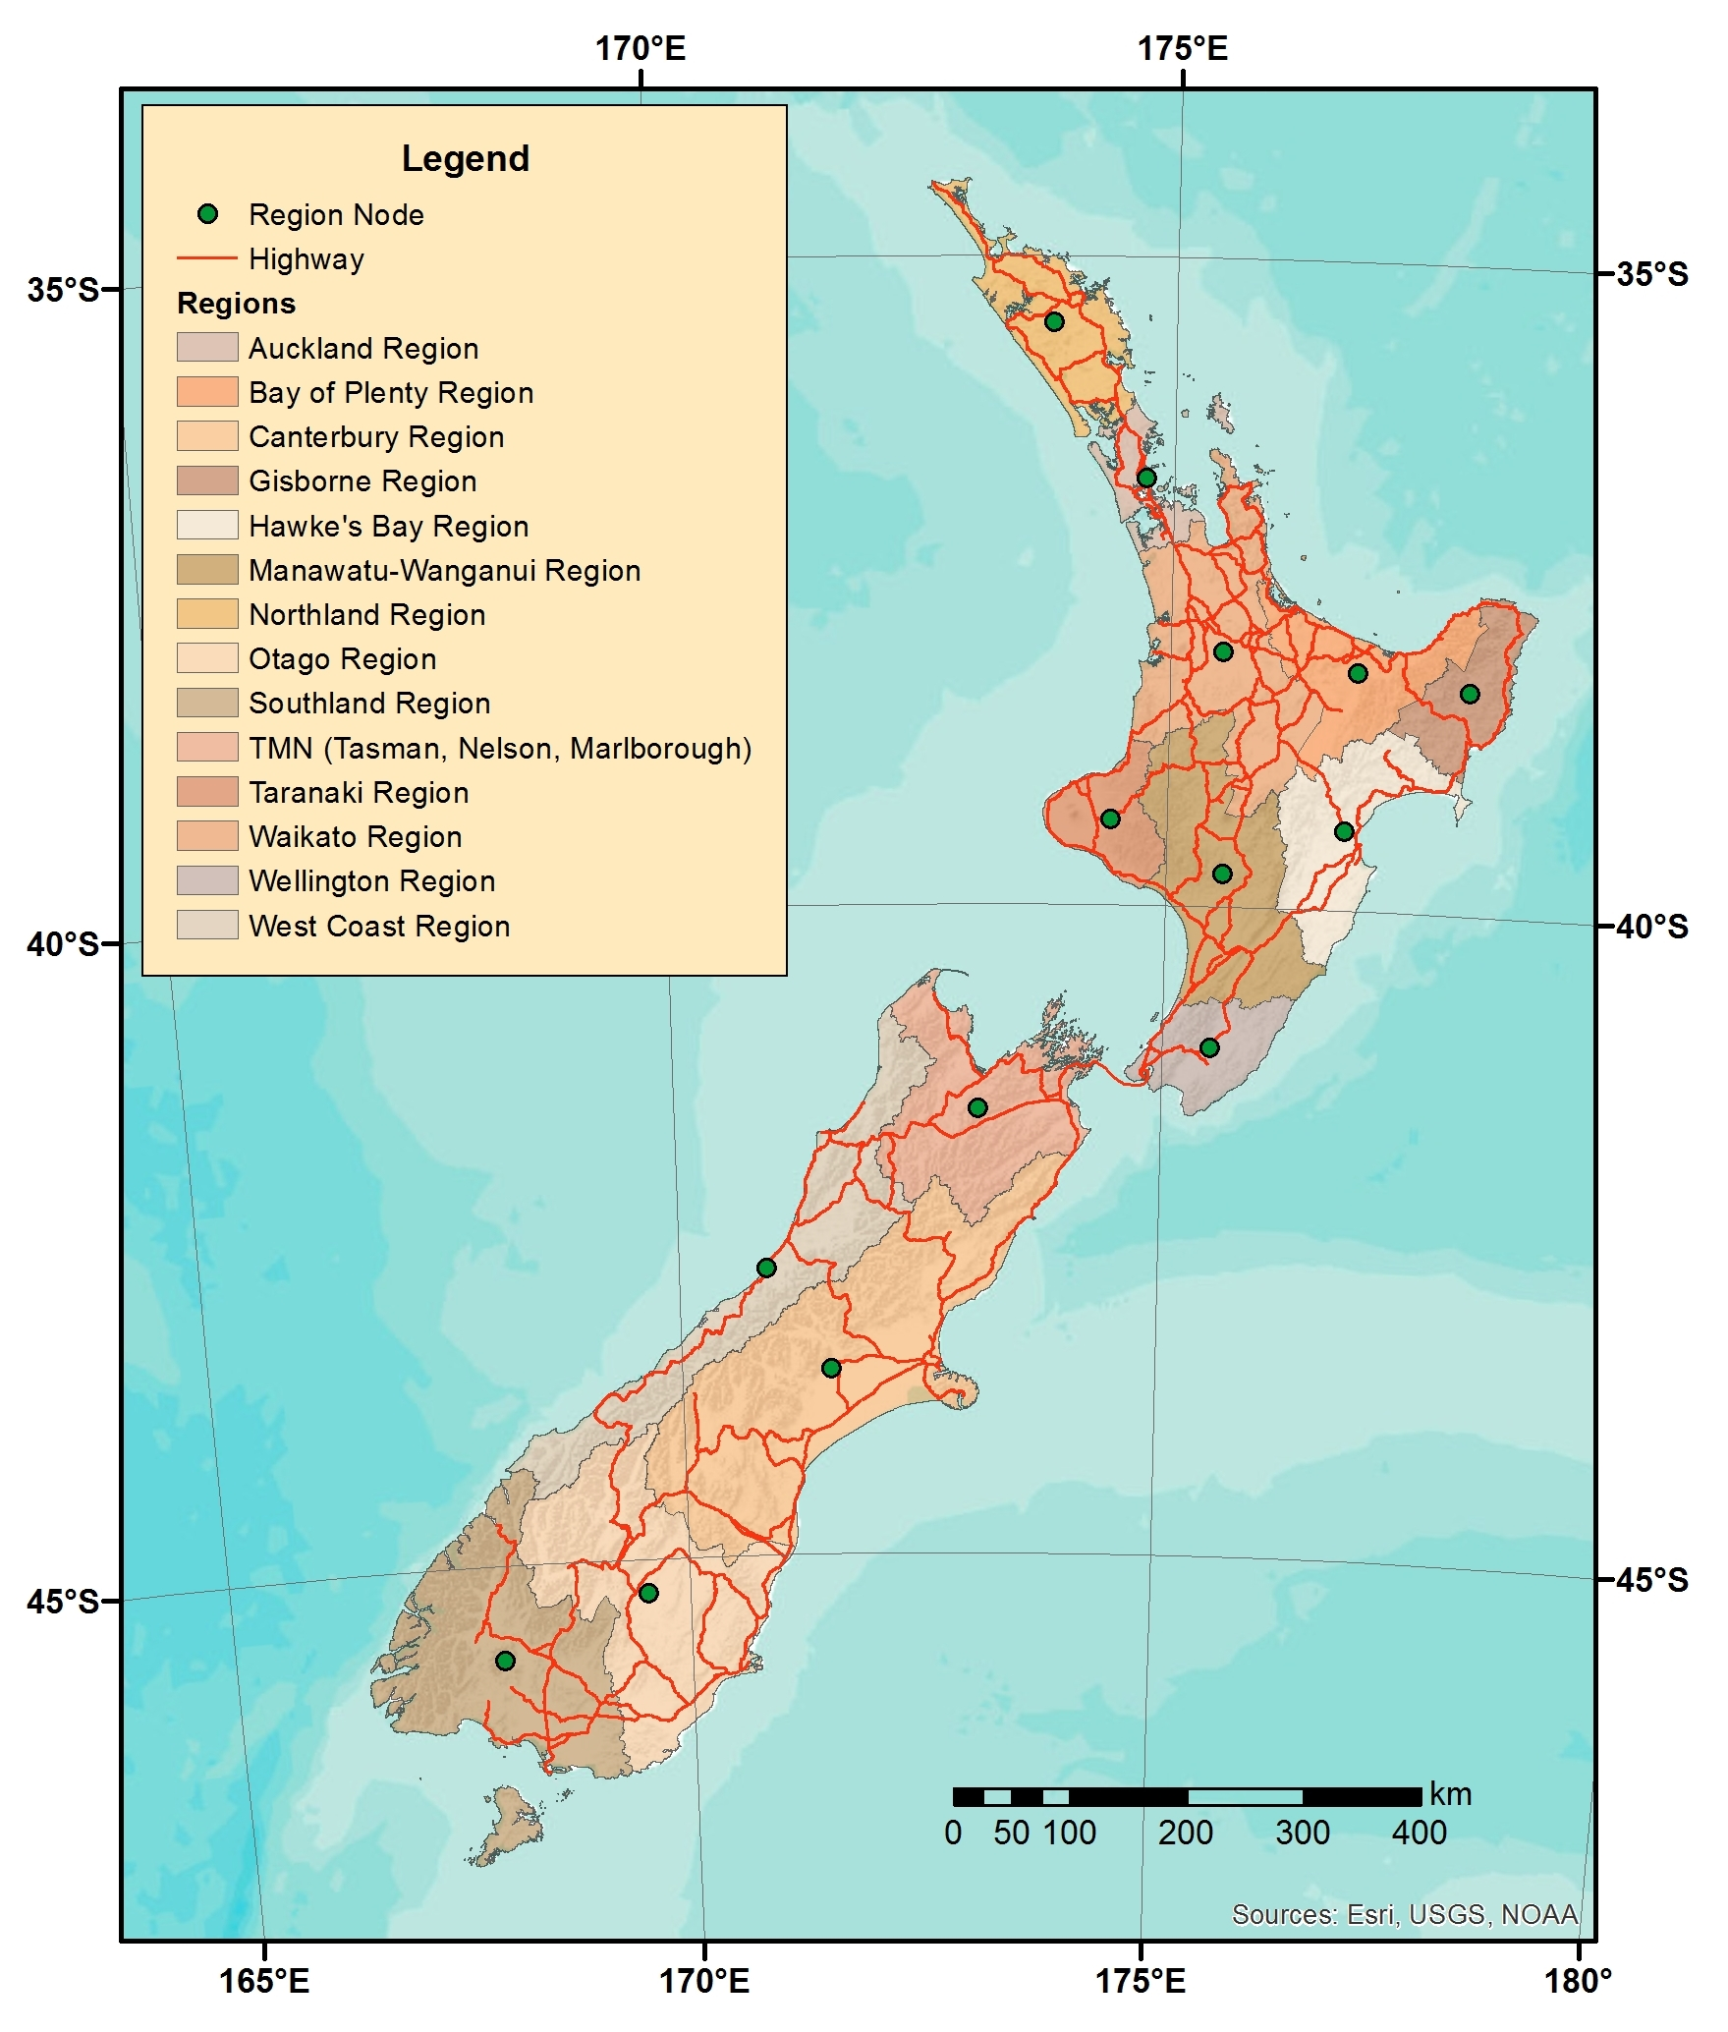  New Zealand Road Network | 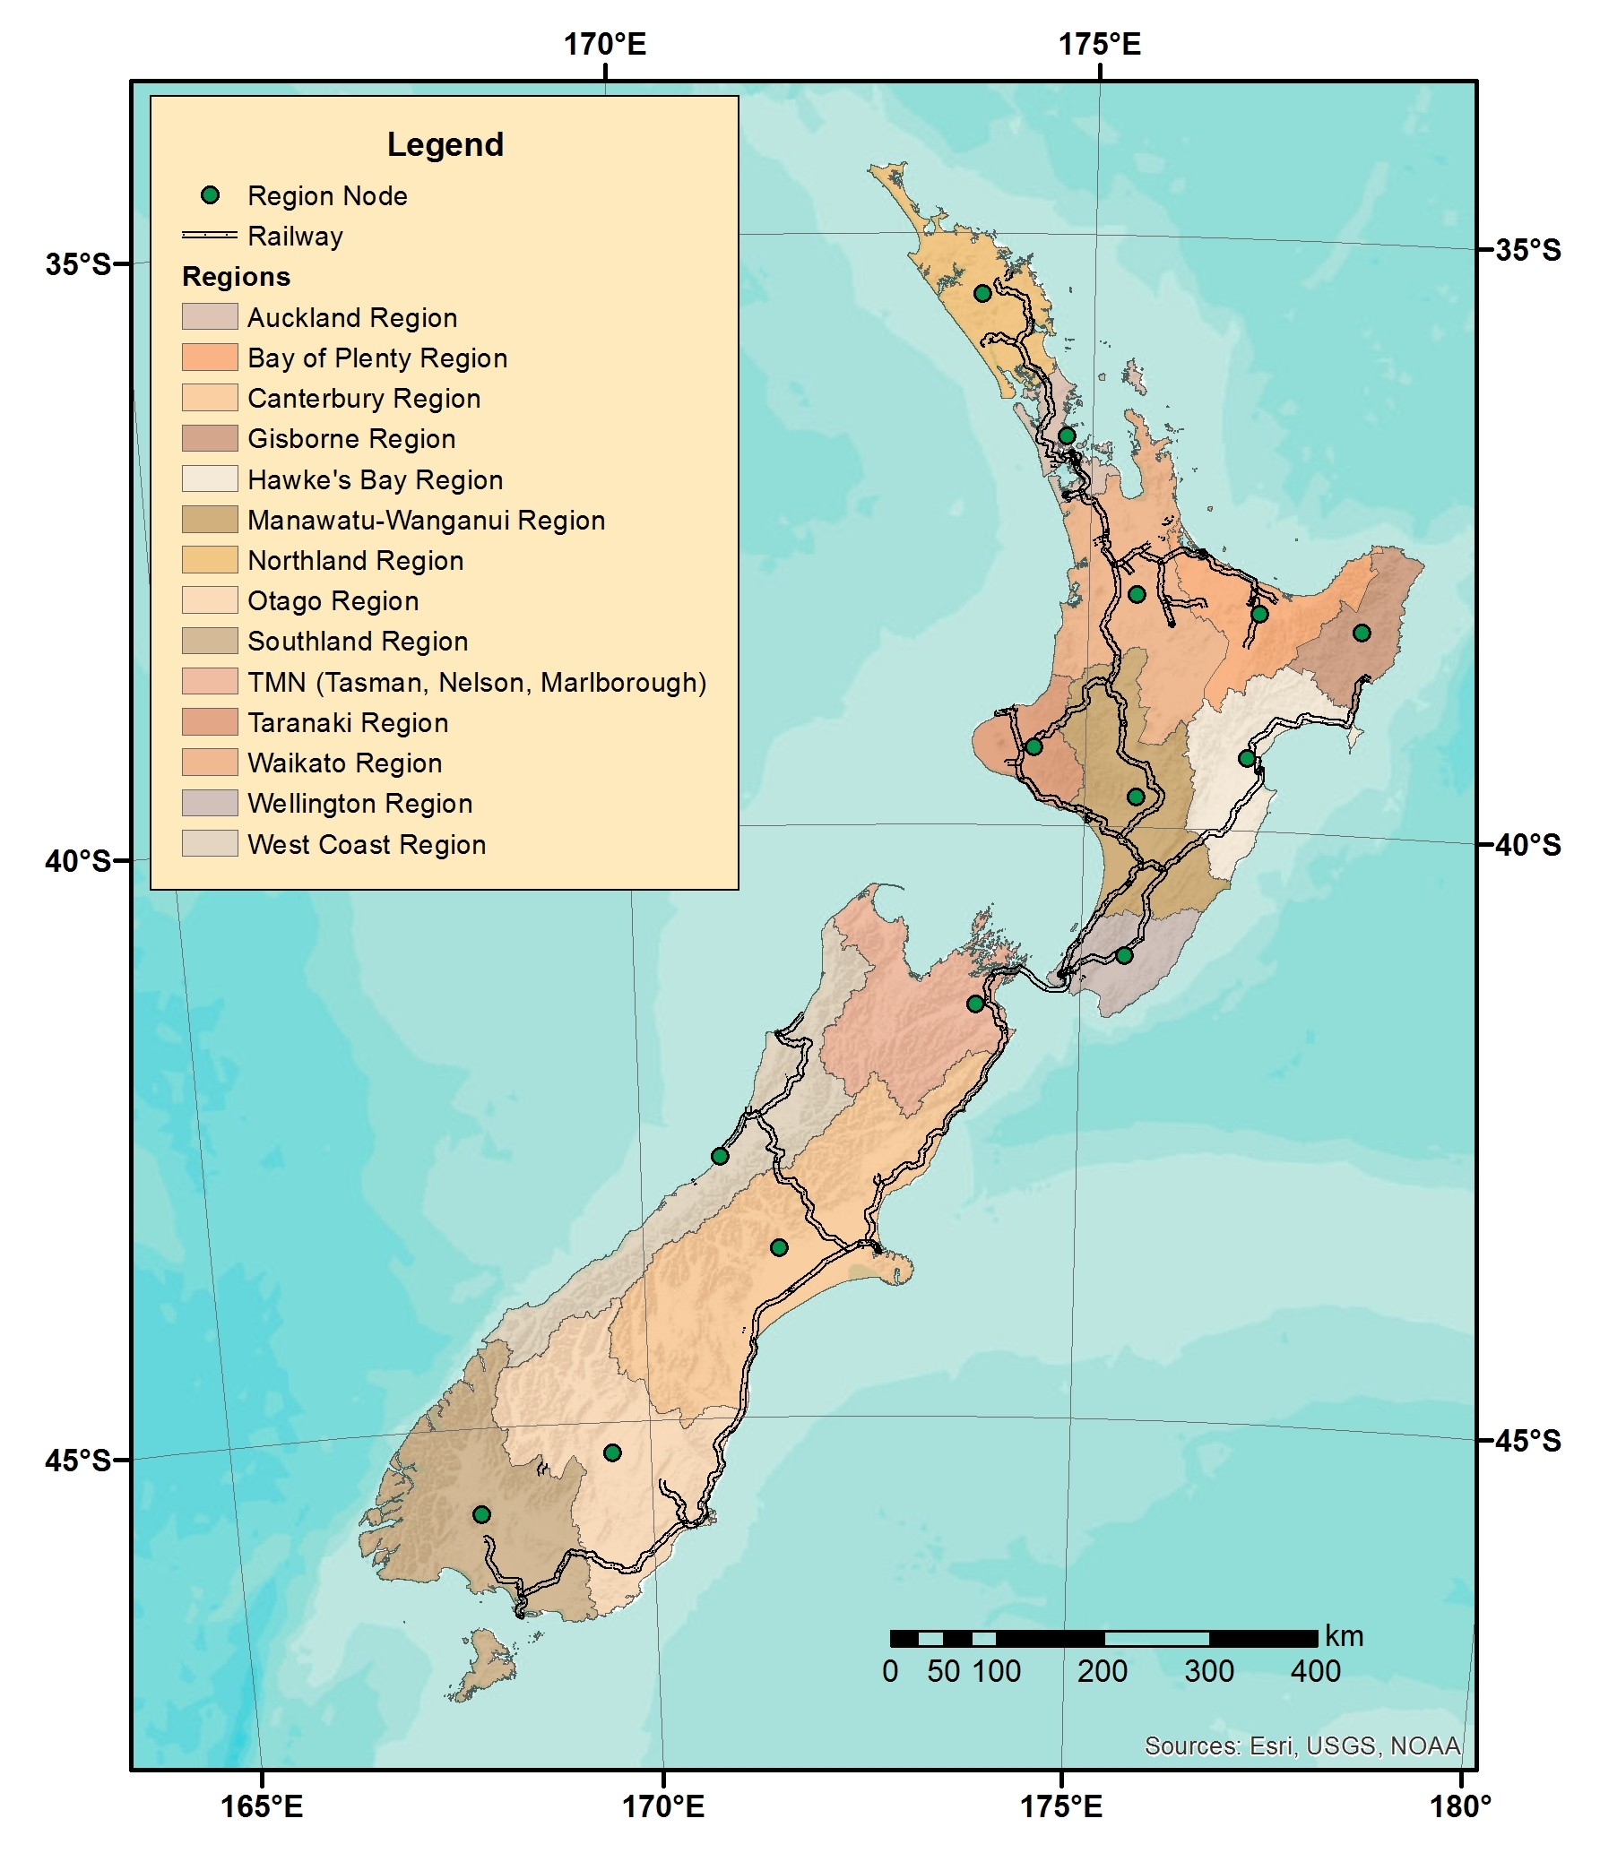  New Zealand Railway Network

Figure 1 Representation of New Zealand Regions along with Road and Railway Networks

Technical Coefficients

Lang (2016) proposed a methodology to assess fuels shortages through explicit modifications of the coefficients of input output models and through a monetary constraint analysis that was based on fuel price fluctuations; the methodology contemplated the application of the RAS technique to update the national input output table for New Zealand. Once the updated table was obtained, it was further used to generate regional input output tables through a non-survey method known as Location Quotients (LQ). A LQ refers to the proportion of a region’s output that is contributed by a specific sector; the practicality of the method resides on the possibility to employ economic activity indicators such as employment, instead of total output (Miller and Blair, 2009).

Sixteen regional tables generated from Lang’s work were inputs to the model described in this paper; the total New Zealand economy was aggregated into fifty one sectors. In this paper, we carried out a further aggregation procedure. This step was required given that the other source of information for this model is based on the National Freight Demand Study for New Zealand, which only considers twenty nine sectors that are further aggregated into twenty three. The final demand from every sector in every region was also obtained from these tables, it was estimated to be the sum of public and private consumption and total exports.

Parameter estimation for Nested Logit Model

The RUBMRIO formulation addressed in this paper considers modelling freight flows, where the choices or decisions made are defined by both the origin of the flow and the mode used to reach a particular destination. Buyer’s decisions or choices follow a random cost minimization, so they will tend to obtain inputs from the regions that offer the cheapest prices. As it can be seen from Equation (10), prices depend on transportation costs, which in this case are based on distance. Dispersion parameters ($λ_{n}$’s) reflect how some commodities are more sensible to distance than others. Mode choice parameters ($β$’s) are associated to the lower level of the nest and they are specific to transportation modes (rail and road) and to commodities as well. Coastal shipping was not considered in our model since it has a very small share nationwide, approximately 2% (Deloitte et al., 2014).

The nested logit model is appropriate in this particular model, since it is based on the assumption that some choices share common attributes in their random terms, so that, the random term of nested choices can be decomposed into a portion specific to each alternative and a portion associated to a specific set of alternatives (Koppelman and Bhat, 2006). The datasets used to estimate origin and mode choices for freight flows were derived from the 2014 National Freight Demand (NFD) Study that was published by the Ministry of Transport. The NFD study provides trade flows between regions for each type of commodity. The study also contemplates fourteen regions for New Zealand; the Tasman, Nelson and Marlborough regions are aggregated into one (TMN) (Deloitte et al., 2014).

In the lower level of the nested model, mode choices were estimated for each sector. The explanatory variables are the network distances associated to each mode. Unfortunately, the NFD study only provides mode choice observations for total freight movements, so mode choice parameters that were estimated upon these observations were assumed to apply for all commodity types. The conditional probability of choosing mode $n$, for a given $ij$ pair is given by:

$$P_{\left.t\right|ij}^{m}=\frac{exp\left(V_{ij,t}^{m}\right)}{\sum_{s}{exp⁡\left(V_{ij,s}^{m}\right)}}$$ | (12)

Where the systematic utility $V_{ij,t}^{m}$ is:

$$V_{ij,t}^{m}=β_{0,t}+β_{t}d_{ij,t}$$ | (13)

The Alternative Specific Constant (ASC) for road ($β_{0}$) was set to zero, in order to permit statistical identification of other parameters. The parameters for mode choice were estimated using larch, which is an open source python library for estimation of logit-based discrete choice models. The estimates and statistics obtained for mode choice are shown in Table 1.

Parameter | Value | Standard Error | t-statistic
$$β_{0,rail}$$ | -3.32 | 0.154 | -21.5
$$β_{rail}$$ | 0.000957 | 0.00156 | 0.613
$$β_{truck}$$ | -0.00102 | 0.00162 | -0.634
No. of observations |  | 1388
Rho-squared w.r.t null parameters |  | 0.719

Table 1 Mode Choice Multinomial Logit Model Parameter Estimates and estimation statistics

The upper level refers to the choice probability that buyers will acquire inputs from origin $i$; it is given by the following expression:

$$P_{ij}^{m}=\frac{exp\left(V_{ij}^{m}\right)}{\sum_{k}{exp⁡\left(V_{kj}^{m}\right)}}$$ | (14)

The systematic utility $V_{ij}^{m}$ refers to the expression previously defined in Equation (9).

For the two level model described, the parameters were estimated using the sequential procedure proposed in Ben-Akiva and Lerman (1993). The idea behind this technique is that parameters from the lower nest are estimated first; then, given the coefficients estimated in the previous step (lower level choice) and the interregional distances associated to each mode, the logsum term from Equation (9) is calculated for each $ij$ pair,. The logsum’s are considered as costs for the estimation of the dispersion parameters ($λ_{n}$). The estimates and statistics obtained for origin choice are shown in Table 2.

Sector | $$λ_{n}$$ | (R-square)
Milk | 13.80 | 0.7304
Dairy products | 6.28 | 0.3955
Timber | 10.00 | 0.5952
Wood and paper | 2.47 | 0.1012
Livestock | 6.63 | 0.4211
Meat | 14.74 | 0.7387
Horticulture | 11.66 | 0.6474
Other agriculture (grain) | 4.25 | 0.2459
Wool | 2.14 | 0.0856
Fish | 15.94 | 0.7866
Coal | 6.12 | 0.4640
Petroleum | 3.06 | 0.1474
Aggregate | 11.40 | 0.6486
Limestone, cement and concrete | 9.99 | 0.5941
Steel and aluminium | 4.62 | 0.2688
Manufactured goods | 2.96 | 0.1394
Supermarket | 3.54 | 0.1862
Post, courier | 1.34 | 0.0321
Imported cars | 4.76 | 0.2504
Other minerals | 4.40 | 0.2604
Waste | 29.67 | 0.9338
Services | 9.04 | 0.5527

Table 2 Origin Choice Multinomial Logit Model Dispersion Parameter Estimates and estimation statistics (1390 observations for each sector)

Energy intensity for every sector and mode

The first step is to actually convert monetary flows to tonnes. For each sector, total monetary flows estimated through the execution of the RUBMRIO model were divided by the total tonne flows that were reported in the NFD study; hence, we obtained twenty one factors that are sector specific. The sector service was no longer considered for further calculations as they do not represent physical flows within the territory. These factors were applied over each matrix of monetary flows; in total, there were forty two matrices, each one of them being sector and mode specific. A second conversion procedure contemplates the translation of tonnes into units of energy consumption. The factors utilized for the calculations are also sector specific. Andrés and Padilla (2015) analysed the determinant factors behind energy intensity of road freight transport; in their study, they provide road transport energy intensities for twenty four commodities. In this paper we assume that the intensity values provided by Andrés and Padilla (2015) match the intensities of the road transportation sector in New Zealand. We also use these intensities to estimate a factor that can reflect load utilization. This factor is then applied over the energy intensity reported in the LIPASTO database for a diesel driven mixed freight train (LIPASTO, 2017). The energy intensity values employed in our calculations are specified in Table 3.

Sector | Road (MJ/tkm) | Rail (MJ/tkm)
Milk | 0.580 | 0.340
Dairy products | 1.000 | 0.586
Timber | 0.990 | 0.580
Wood and paper | 0.740 | 0.434
Livestock | 1.470 | 0.862
Meat | 1.000 | 0.586
Horticulture | 0.880 | 0.516
Agriculture (grain) | 0.720 | 0.422
Wool | 1.310 | 0.768
Fish | 1.000 | 0.586
Coal | 0.740 | 0.434
Petroleum | 1.200 | 0.703
Aggregate | 0.650 | 0.381
Limestone and cement | 0.930 | 0.545
Steel and aluminium | 1.350 | 0.791
Manufactured goods | 1.250 | 0.733
Supermarket | 1.250 | 0.733
Post and courier | 1.250 | 0.733
Imported cars | 1.350 | 0.791
Other minerals | 0.650 | 0.381
Waste | 0.650 | 0.381

Table 3 Energy Intensity by sector and by mode

RESULTS AND DISCUSSION

Our main goal was to study the impact of transportation costs on the overall dispersion of the freight flow pattern and on mode share. It has been estimated that in average fuel costs represent up to 21% of the total costs for road transportation and 14% for rail transportation (Bureau of Transportation, 2016); these values were incorporated to our calculations, since the utility functions in our model are based on transportation costs. For instance, a 100% increase in oil prices will be reflected in a 7% and 11% increase in rail and road transportation costs, respectively. These values were applied as factors to the transportation cost matrices for each mode. The RUBMRIO model was executed and it delivered a new flow pattern that corresponds to the updated transportation costs. This process was carried out for a Business As Usual (BAU) scenario that represented the system with the current oil prices. The process was also performed for four alternative scenarios where oil prices were doubled, tripled, quadrupled and quintupled. The OD flow matrix for the BAU scenario matches the configuration that is reported in the NFD study, where flows are not disperse (located on the matrix diagonal) and there is not a sign of major trade between islands. According to our results, modal shares are 6.3% and 93.7%, for rail and road respectively. This distribution is very similar to the modal share reported in the NFD study (7% rail, 91% road); this fact suggests that the origin and mode coefficients that were estimated in this study, closely reflect the behaviour of freight operators in New Zealand.

Richard Paling Consulting (2009) conducted a survey with industry participants to explore what were the main determinants for freight mode choice in New Zealand. From most to less important, with 5 being the highest possible score, the ranking obtained was: reliability (4.75), product care (4.64), safety (4.58), timeliness (4.31) and cost (4.23) (Richard Paling Consulting, 2009). We considered an Alternative Specific Constant (ASC) in our model and according to our estimations, this coefficient is statistically significant (p<0.01). It seems that the ASC ($β_{0,rail}$) appropriately allows for statistical identification of mode choice preference criteria not considered in our model. Furthermore, the mode coefficient estimated for rail is positive and small, suggesting a higher preference for this mode over longer trips.

Data availability is a major limitation for the development of MRIO models. Ideally, the model requires a social accounting matrix for every region that is considered in the analysis. In our case, we had to use regional technical coefficients that were previously estimated upon a national accounting matrix and regional statistics. Additionally, mode and origin choice parameters were calculated upon the execution of a logistic regression package over a dataset that corresponded to the observations reported in the NFD Study. Consequently, we were forced to base our analysis on observations made for the entire freight sector, that is, the study did not present sector specific observations for mode choice. Furthermore, sectors such as livestock and waste, operate entirely through road transportation. Given these circumstances, we decided to include these sectors for the analysis assuming that they are based on the same coefficients as the remaining sectors. Each sector will most likely be characterized by its own set of coefficients, given that their physical characteristics appeal for choice determinants that may have more weight or importance than transportation cost. The assumption that all sectors follow the same estimated mode coefficients certainly reduces the reliability of the model in terms of predicting travel demand. Nevertheless, the main goal of our approach was not to provide a precise estimation of travel demand, but rather, understand the impact of transportation costs on the overall freight dispersion and the importance of relying on a strategic network that allows for modal shift given a critical and highly possible scenario.

The omission of coastal shipping as an alternative mode is also a feature that may underestimate the overall reliance of the New Zealand freight transportation network. Data availability is a recurring limitation that forced us to incur in the two mode formulation. According to the NFD study, the current modal share for coastal shipping is approximately 2% and it is almost entirely exclusive to petroleum shipments, hence it was infeasible to provide proper coefficients that will reflect sector specific preferences for this mode. Our methodology considers that transportation costs are proportional to travelled distances, however, freight logistics are far more complex than that. We estimated mode choice coefficients for coastal shipping. The estimation was also based on general observations from the entire freight sectors. The obtained coefficients were not statistically significant and the overall dispersion overestimated the share for coastal, therefore coastal shipments were not included in the analysis. This phenomenon can be explained by the complexity of the logistics, since our costing methodology is solely based on geographic data and does not account for other fees like transhipment and storage.

It can be evidenced from Figure 2, that as prices increase, rail starts becoming a more attractive option. Rail’s tonnage modal share (58%) supersedes that of truck transport (42%) in the last scenario (400% fuel price increase); we also observed that given an extreme high price for oil, the Canterbury region starts becoming an important centre of trade between islands.

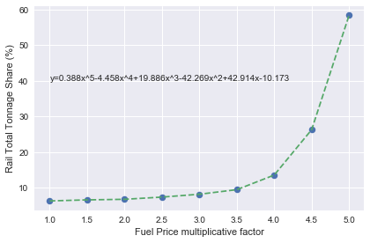
Figure 2 Rail Tonnage Share as a function of fuel price multiplicative factor
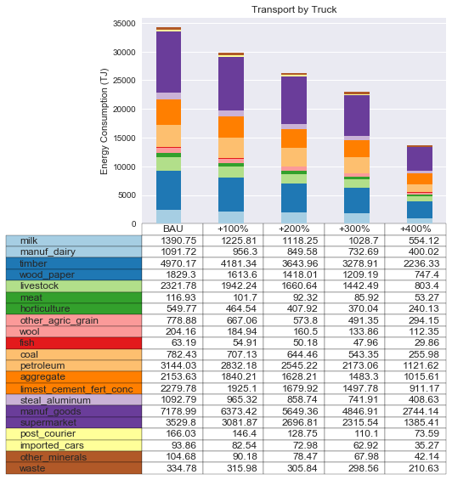 | 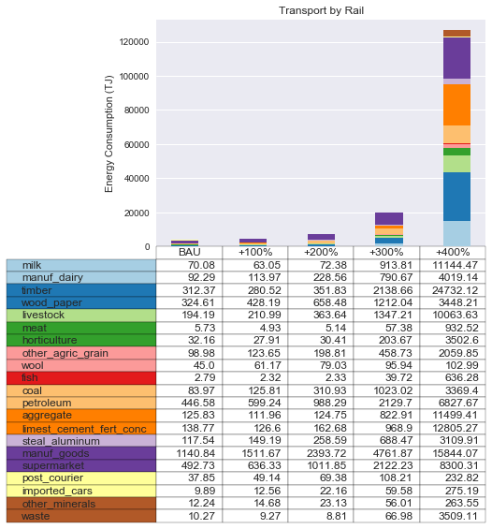

Figure 3 Freight Transportation Energy consumption for different fuel price scenarios

The last step of the analysis refers to energy consumption calculations. It can be seen from Figure 3 that commodities from the retail sectors are mainly shipped by road.
This behaviour may follow the preference for modes that are flexible enough to respond to just on time deliveries while preserving product care features during transportation. It can be deduced that when fuel prices exceed the 300% increase threshold, rail starts becoming the driving force behind trade. Even though, rail is a more energy efficient mode of transportation than trucks, the energy consumed by the entire transportation systems rises abruptly after the aforementioned threshold. This peculiarity can be explained by the ability that railways have to develop economies of scale. In this particular case, the Canterbury region becomes a major centre for inter-island trade. Given the case that the national rail infrastructure connects the entire country, the differences for input prices between regions start dropping and it starts becoming more economically feasible to purchase products from other regions.

CONCLUSIONS

A recent report by the International Monetary Fund (IMF) suggests that the current era of prolonged oil prices is likely to be followed by a period where oil prices may abruptly overshoot their long term upward trend (Arezki et al., 2017). This statement is based on the idea that recent low oil prices have caused a decline in investments for oil exploration and extraction technologies. Subsequently, this behaviour contributes to a reduction in oil supply that can led to an accelerated escalation of prices. Our results suggest that beyond the 300% fuel price increase threshold, the national freight system will become vulnerable if there is not an adequate railway system to support economic trade within the region. Not so long ago, we experienced a drastic escalation of oil prices. In June of 2003, the price of an oil barrel was approximately 40.49 USD, and five years later the oil barrel reached a record price of 157.73 USD (Macrotrends, 2017).

Multiregional Input Output Models have been used in the past to estimate transport demand and assess the impact of new transportation infrastructure. In this paper, we are not focused on the precise estimation of travel demand, but rather on understanding how vulnerable the current system is, taking into account that our freight transportation system is highly dependent on road transport and on the fossil fuels that are consumed by this mode. It is worth noting that, as it is the case with any other model, it is complex to incorporate all the dynamic feedbacks that occur in reality. For instance, it would be important to analyse the impact that a drastic mode shift will have on the configuration of the entire economy. Our model relies on the assumption that technical coefficients remain constant during the period of analysis. However, a drastic mode shift to rail, will definitely imply that less resources will be assigned to the construction and maintenance of new roads. Furthermore, less resources will be assigned to import new vehicles from overseas. Under these circumstances, it may be appropriate to consider complementary methods to incorporate essentiality metrics over the products that are being transferred within and outside the country.

According to our calculations, beyond the 300% price increase, energy use skyrockets for the entire freight transport system. Apparently, the model has the capability to mimic what is known as the rebound effect. In other words, the introduction of energy efficient technologies leads to an overall energy demand that offsets the potential energy savings. This is a particular issue that strengthens the idea to include metrics for essentiality in the analysis. Besides realizing the finite nature of fossil fuels, we need to acknowledge that our economy is subject to physical and biological laws and the assumption of unconstrained mobility is pushing our planet’s resources to the limit.

REFERENCES
ANDRÉS, L. & PADILLA, E. 2015. Energy intensity in road freight transport of heavy goods vehicles in Spain. Energy Policy, 85, 309-321.
AREZKI, R., JAKAB, Z., LAXTON, D. & MATSUMOTO, A. 2017. Oil Prices and the Global Economy.
BEN-AKIVA, M. & LERMAN, S. 1993. Discrete choice analysis: theory and application to travel demand. books.google.com.
BROCKER, J. 1998. Operational spatial computable general equilibrium modeling. Annals of Regional Science, 32, 367-387.
BRÖCKER, J., KORZHENEVYCH, A. & SCHÜRMANN, C. 2010. Assessing spatial equity and efficiency impacts of transport infrastructure projects. Transportation Research Part B: Methodological, 44, 795-811.
BUREAU OF TRANSPORTATION, S. 2016. Transportation Economic Trends. Washington D.C.
CASCETTA, E. 2009. Transportation Systems Analysis Models and Applications.
CASCETTA, E., MARZANO, V., PAPOLA, A. & VITILLO, R. 2013. A Multimodal Elastic Trade Coefficients MRIO Model for Freight Demand in Europe. In: BEN-AKIVA, M., MEERSMAN, H. & VAN DE VOORDE, E. (eds.). Bingley: Emerald Group.
DELOITTE, RICHARD PALING CONSULTING, MURRAY KING, FRANCIS SMALL CONSULTING & COOPER ASSOCIATES 2014. National Freight Demand Study. Ministry of Transport.
GRENZBACK, L. R., BROWN, A., FISHCER, M. J., HUTSON, N., LAMM, C. R., PEI, Y. L., VIMMERSTEDT, L., VYAS, A. D. & WINEBRAKE, J. J. 2013. Freight Transportation Demand: Energy-Efficient Scenarios for a Low-Carbon Future. Washington.
HUNT, J. D. & SIMMONDS, D. C. 1993. Theory and application of an integrated land-use and transport modelling framework. Environment and Planning B: Planning and Design, 20, 221-244.
INTERNATIONAL ENERGY AGENCY 2016. Key World Energy Statistics 2016.
IVANOVA, O. 2014. Modelling Inter-Regional Freight Demand with Input–Output, Gravity and SCGE Methodologies. 13-42.
KOCKELMAN, K. M., JIN, L., ZHAO, Y. & RUIZ-JURI, N. 2005. Tracking land use , transport , and industrial production using random-utility-based multiregional input – output models : Applications for Texas trade. Journal of Transport Geography, 13, 275-286.
KOORDINATES. 2015a. NZ Railway Centrelines (Topo 1:50K) [Online]. Available: https://koordinates.com [Accessed 1/11/2017].
KOORDINATES. 2015b. NZ Road Centrelines (Topo 1:50K) [Online]. Available: https://koordinates.com [Accessed 1/11/2017].
KOPPELMAN, F. S. & BHAT, C. 2006. A self instructing course in mode choice modeling: multinomial and nested logit models. US Department of Transportation, Federal Transit Administration, 31-31.
LANG, A. E. 2016. Assessment of Fuel Constraint Impacts on Freight Transport in New Zealand.
LEONTIEF, W. & STROUT, A. 1963. Multiregional Input-Output Analysis. In: BARNA, T. (ed.). Toronto: Palgrave McMillan.
LIPASTO. 2017. Unit Emissions [Online]. Available: lipasto.vtt.fi/en/index.htm [Accessed 10/11/2017].
MACROTRENDS. 2017. Crude Oil Prices – 70 Year Historical Chart [Online]. Available: www.macrotrends.net/1369/crude-oil-price-history-chart [Accessed 8/11/2017].
MANHEIM, M. L. 1979. Fundamentals of Transportation Systems Analysis: Basic Concepts, MIT Press.
MATTILA, T. & ANTIKAINEN, R. 2011. Backcasting sustainable freight transport systems for Europe in 2050. Energy Policy, 39, 1241-1248.
MILLER, R. E. & BLAIR, P. D. 2009. Input - Output Analysis: Foundations and Extensions.
ORTUZAR, J. D. D. & WILLUMSEN, L. G. 2011. Modelling Transport.
RICHARD PALING CONSULTING 2009. Coastal Shipping and Modal Freight Choice.
SIMS, R., SCHAEFFER, R., CREUTZIG, F., CRUZ-NUÑEZ, X., D AGOSTO, M., DIMITRIU, D., FIGUEROA, M., FULTON, L., KOBAYASHI, S., LAH, O., MCKINNON, A., NEWMAN, P., OUYANG, M., JAY, J., SPERLING, D. & TIWARI, G. 2014. Transport. In: DEAKIN, E. & KAHN, S. (eds.) Climate Change 2014: Mitigation of Climate Change. Contribution of Working Group III to the Fifth Assessment Report of the Intergovernmental
Panel on Climate Change. Cambridge: Cambridge University Press.
STATS N. Z. 2013. Regional Council 2013 [Online]. Available: https://datafinder.stats.govt.nz [Accessed 10/11/2017].
TAVASSZY, L. & DE JONG, G. 2013. Introduction. Modelling Freight Transport. Elsevier.
ZHAO, Y. & KOCKELMAN, K. M. 2004. The random-utility-based multiregional input-output model: Solution existence and uniqueness. Transportation Research Part B: Methodological, 38, 789-807.

