**Streets that support life - The Helsinki experience**

Risto Jounila

M Sc. in Civil Engineering, Traffic and Transport

Technical Director

WSP Opus

[Risto.Jounila@wsp.com](mailto:Risto.Jounila@wsp.com)

Mobile: +64 27 492 8808

1. **Streets supporting neighbourhood life**

Imagine a city where you can meet your every day-to-day need within your own neighbourhood. Your home is in a place that is safe and attractive. You can walk and cycle to schools, shops, cafes and jobs. In less than a block, you can get a haircut or go to the dentist. You can meet your friends at many nearby places and it’s easy for you to move around your neighbourhood, or to travel further.

This city that you are imagining has frequent, comfortable and safe transport facilities and services are available on neighbourhood roads: bike lanes, trams, buses, taxis etc. You can also drive a car to and from your home, but you don’t have to own a car. Your neighbourhood is vibrant and there is an urban buzz that keeps the economy moving.

The City of Helsinki hasn’t just imagined it. They have built it. The land use pattern and transport solutions, like you have imagined, are in Helsinki inner city. Growth in Helsinki, i.e. urban densification, is constrained by the current disconnect between transport and land use. The city planners have identified an opportunity to promote growth through copying the inner city structure of today and expanding it along current arterial motorway-like roads. This also includes changing these arterials into typical city streets that are surrounded by buildings. These streets are called city boulevards.

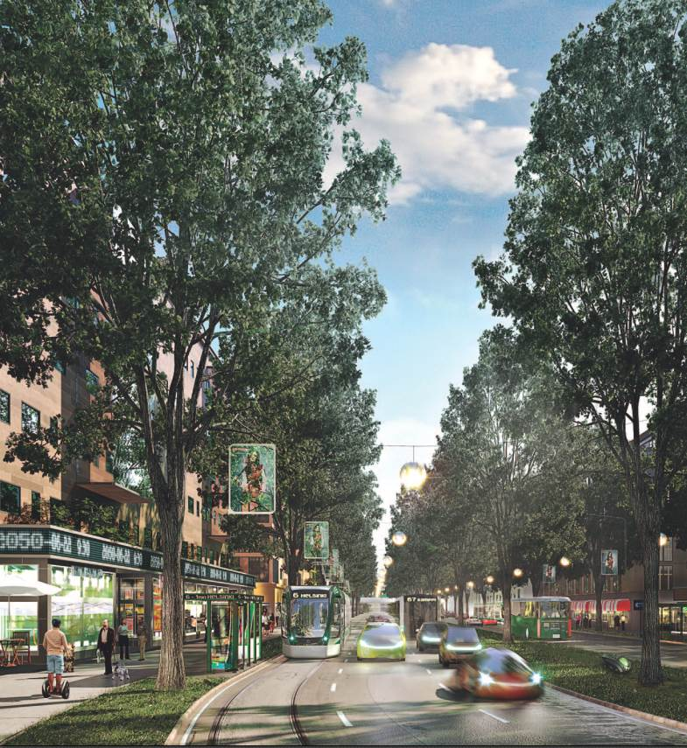

*Picture 1. City boulevards create urban “buzz” and serve pedestrians, cyclists, public transport users and motorists (Photo: Helsinki city).*

Transforming motorway-like roads is not a new invention. There are global examples in which motorway-like environments have been transformed into more urban and pleasant areas. Such neighbourhoods exist in cities like Copenhagen, Lyon, Milwaukee and Seoul.

The trigger for change has normally been the poor condition of the routes and the approaching need for streetscape rejuvenation or urban densification. For example, in Milwaukee 1.5 km elevated motorway was replaced with a boulevard in 2003. This freed up 10.5 hectares of land for private development.

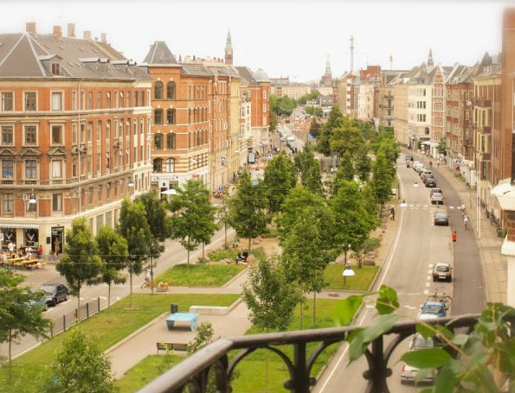

*Picture 2. Copenhagen: Sonder Boulevard was rebuilt in 2007 and today is one of the most popular meeting places, as the Vesterbro district features ample shopping and great cafés. (Photo: Copenhagen apartments)*

These boulevard neighbourhoods are often also the most profitable areas in the city, because they attract all kinds of people, services and companies. There is great potential for this phenomenon to be recreated in growth areas in New Zealand.

1. **Why Helsinki has chosen boulevards**

**2.1 Growth opportunity**

Growth of metropolitan Helsinki over the next 30 years is predicted to be significant. It has been estimated that there will be a total population of 2 million in Helsinki metropolitan region by 2050. That means about 600,000 new people.

In addition, Helsinki’s area isn’t expanding, so the city will need to become denser than it is today. The new urban structure will require the re-use of existing city space. This means transforming what is currently there. The transformation of existing motorways is a major opportunity for urban densification and effective re-use of city space. Roughly one third of Helsinki´s predicted growth will be located alongside the city boulevards. This demonstrates the growth potential created by boulevard-style streets. The development of boulevards is primarily about the extension of central Helsinki.

**2.2 Basic concept of a boulevard**

The current Helsinki boulevards consist of (<https://www.hel.fi/hel2/ksv/julkaisut/esitteet/esite_2015-4_en.pdf>):

* A speed limit of 40-50 km/h
* Intersections with traffic signals
* Wide pedestrian areas on both sides, zebra crossings at every intersection
* Separated cycle lanes
* Public transport lanes – bus/tram
* General traffic lanes
* Amenities – trees, “city green”, artworks, benches etc
* Buildings on both sides; 5-7 stories, terrace-style
* Lower levels for services, shops, businesses
* Upper levels for residentials (less noise and other pollution like exhaust fumes or dust from the street caused by winter maintenance)

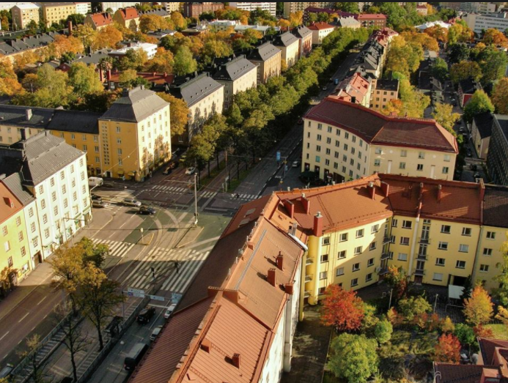

*Picture 3. Today’s typical Helsinki city boulevard, Makelankatu Street (Photo: Helsinki City)*

**2.3 Keeping up commercial productivity**

Helsinki city centre is the most important commercial centre in Finland and is one of the most productive areas in the country. Keeping the Helsinki centre vibrant supports the strength of the Finnish economy. Versatile urban form has attracted increasing activity in the city centre. People are employed in a wide range of areas such as: cafes, groceries, shops, services, offices, schools, hospitals, sport venues, hotels etc.

Helsinki will need to provide about 560,000 jobs by 2050 to support the predicted population growth. A varied city space promotes innovation, well-being and economic growth. The economies created around such an agglomeration of land use are an important concept for urban productivity. Boulevards give opportunities for new enterprises, through the variety of land use, which in turn create employment opportunity.

**2.4 Urban density calls for sustainable transport system**

A dense urban structure and sustainable transport system play a key role in Helsinki’s goal to be a carbon neutral city by 2050. Sustainable modes of transport are part of this future. This means that Helsinki’s order of transport priority looks like:

1. Pedestrians
2. Cyclists
3. Public transport
4. City logistics (i.e. trucks, deliveries)
5. Private vehicles.

As the urban structure becomes denser, the need for mobility increases, whereas the space available for traffic does not increase. A dense urban structure needs an efficient transport system, capable of moving maximum of people and materials in limited space.

1. **How boulevards are implemented**

**3.1 The City Plan guides the change**

Helsinki City Plan 2050 was approved in December 2016. It provides the basis for urban planning in Helsinki. One aim of the plan is to create vibrant, cosy, densely built city boulevards with new neighbourhoods alongside them. The plan includes housing, ample business premises, shops, restaurants, cafes, small and medium sized companies alongside the city boulevards (<https://www.hel.fi/hel2/ksv/julkaisut/esitteet/esite-2017-1-en.pdf>, <https://www.hel.fi/hel2/ksv/julkaisut/yos_2013-23_en.pdf>).

The boulevards must support the whole transport system. Without effective connections, Helsinki cannot serve businesses that operate in global markets, or attract international labour and students. Transformation of current motorways into city boulevards is only made possible where conditions for walking, cycling and public transport are improved simultaneously.

The transformation into boulevards requires significant investments in public transport. The implementation of a comprehensive light rail (or similar mass transit) network is equally important. The light rail lines will extend radially from the city centre primarily along boulevard corridors.

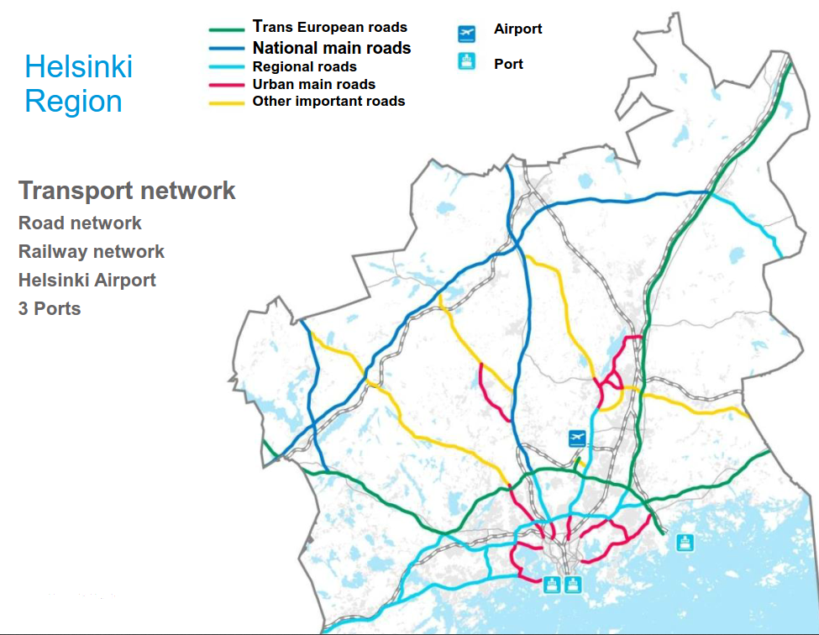

*Picture 4. The transport network in Helsinki Region (Photo: Helsinki City)*

**3.2 Motorways are transformed**

Motorways within the city structure were planned at a time when the city was much less dense than it is now, and spread over the same area. Nonetheless, the motorways were never extended into the city centre itself. Many of them don’t fulfil their original purpose - as quick connections into the city centre. So, as the city grows, the typical path of development is to reduce the significance of these city highways and remove their influence further from central areas. This has the clear aim to reduce car usage. The expansion of the city centre into these former motorway-like areas offers an opportunity to further urbanise the city structure and accommodate growth.

The transformation of motorway-like thoroughfares into boulevards requires investment in public transport and solutions for increasing the attractiveness of walking and cycling. These modes must be presented as genuine alternatives for getting around the city. Streets must also allow some space for those who need to drive their own cars. The aim is to develop a functional and safe traffic system that emphasises sustainable modes of transport rather than forcing private cars out of Helsinki.

The change from motorways into boulevards means that fast automobile traffic must now share streets with multiple modes of transport. City boulevards will serve public transport, pedestrians and cyclists; and motorists as a secondary priority.

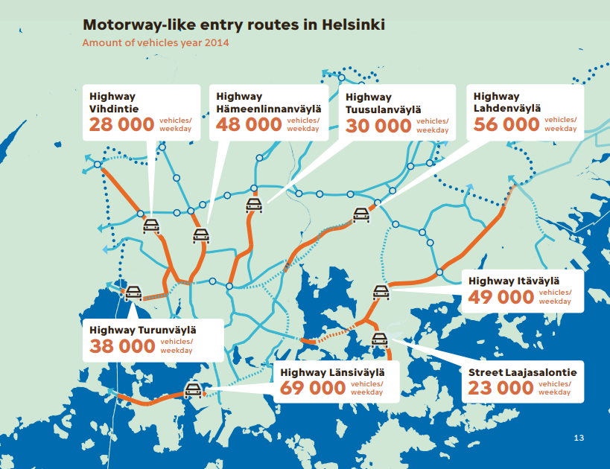

*Picture 5. Motorway-like entry routes Helsinki that could be transformed into boulevards, length varies between 1-3 km. (Photo: Helsinki city).*

Some interchanges will be replaced with level intersections. It is important, however, to be able to utilise interchanges at certain points where the traffic is particularly heavy as this eases congestion which might also affect public transport.

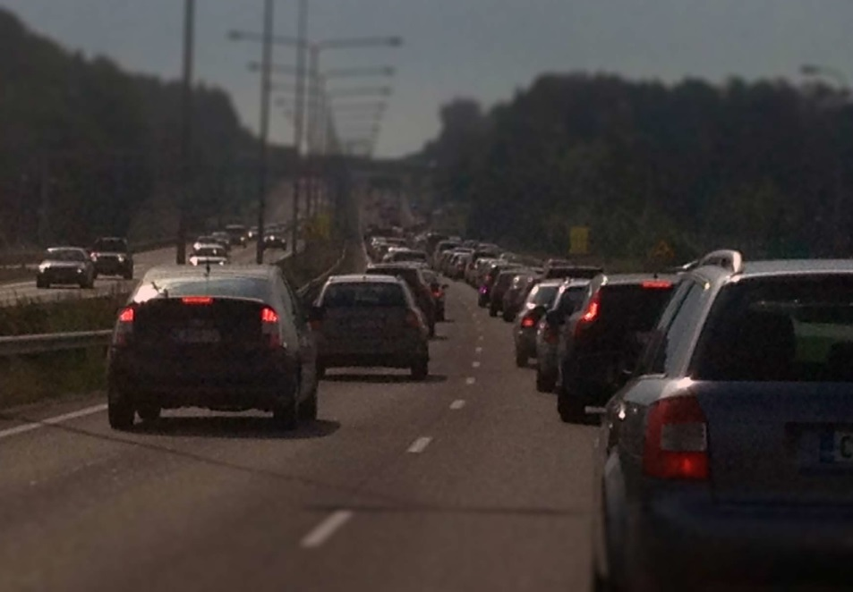

*Picture 6. Typical motorway entry route at morning peak (Photo: WSP).*

1. **The impacts of boulevards**

The boulevards do not encourage through car traffic, thus travelling into the city centre by car should not increase. The congestion levels will remain more or less the same as they are today, despite the significant population growth and job number increase in Helsinki City. The car-dependency will decrease.

The economic effects of the resultant shift in mode of travel are significant; more people can reach the city centre by convenient and regular modes. Less time is spent travelling to work, and productivity is improved.

**4.1 Impacts on transport**

The effects of transforming the motorways have been assessed through various surveys completed during the City Plan process (<https://www.hel.fi/hel2/ksv/julkaisut/esitteet/esite-2017-1-en.pdf>):

* The Target Impact Assessment (TIA) of city boulevards (2014) used the actual ’visualised’ strategic goal as the starting point, casting back to the current situation.
* The Assessment of Regional Effects of City Boulevards studied the effects on regional traffic patterns but also on the city structure and the economy.

The effects of boulevards on traffic are moderate. Simplistically, the actual change is only to transform 1 to 3 km sections of the motorway-like roads into city boulevards. Depending on the approach, travel times to CBD increase by a couple of minutes (1-3 minutes). As the entry routes are already quite congested, the effect on travel times is quite minor during rush hours. The congestion will remain more or less the same as now. During day-time, however, lower speed limits and traffic lights will slow down boulevard car traffic compared to the current situation. This creates a more human-centric atmosphere, rather than car-centric.

All entry routes tend to differ in characteristics. The future boulevards will be planned accordingly. For instance, the driving times can be affected by the different planning solutions, such as the number of junctions and lanes. As such, the impacts on traffic will vary according the desired characteristics of boulevard.

**4.2 Time to stop talking past each other?**

Current thinking recognises the importance of combining land use and movement concepts in city planning. Yet it remains seldom that the results of today´s process satisfy city planners. The cities have grown through urban sprawl during the last decades. During the City Plan process, Helsinki started to develop a common approach for assessing land use and movement concepts (<https://www.wsp.com/en-GL/projects/boulevard-development-impact-assessment>). This approach led to developing a method that was named “urban capacity”.

Traffic engineers measure traffic capacity (vehicle and people throughput). Architects measure residential capacity (quality of living) when planning land use. Both groups have developed their own tools to measure the performance of any given solution for many decades. Traditionally, they have tended not to work together or speak the same language when planning and assessing the options.

Traffic engineers tend to end up traditionally with car centric solutions, which they can prove with reliable assessments. And architects have to accept their solutions as given, because the reasoning behind these solutions it is based on a method that has been developed for many decades. Traffic engineers and architects haven´t developed a common method for assessments. This way the car continues to dominate the thinking around urban planning.

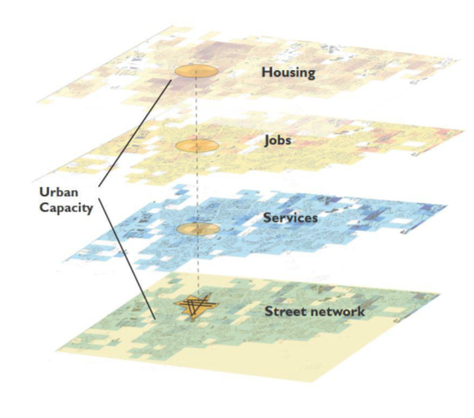

*Picture 7. The key variables in urban capacity assessment. Key destinations should be within 700 m walking distance to create high urban capacity.*

During the Helsinki City Plan process, a combination of assessing transport capacity and land use capacity was required, i.e. an assessment of “urban capacity”. This achieved more reasonable impact assessments for urban form.

In Helsinki, the desired urban form was considered similar to the current city centre structure. In the city centre, urban diversity creates resilient and vibrant society. This diversity calls for proximity and connectivity, or “reachability”. The methodology for measuring urban capacity considers the possibilities for people to interact. People, jobs, properties and services within a neighbourhood (area within walking distance of a given location, 700 m) are measured and define this urban capacity.

Urban capacity is highest in areas that are densely built up, where mixed land use creates high levels of activity within a highly connected street network. Features that diminish urban capacity include highways and massive shopping centres, because they limit neighbourhood interactions and accessibility.

Urban capacity has a great impact on traffic. The number of trips per person does not change, but the modes people choose do change. The change happens because a neighbourhood with good urban capacity provides many services within walking distance. This creates walking and cycling trips as they are the most convenient way of moving within the urban structure. High urban capacity also calls for public transport services.

1. **Lessons learned**

The journey to acceptance of urban boulevards as a solution was challenging. Perhaps the most challenging element was to encourage understanding amongst stakeholders and authorities about the positive effects of transforming motorways to a “less efficient” transport corridor. This process is still going on in Helsinki. During the City Plan process, there was and still is significant opposition for boulevards. A very broad range of various interactive methods were employed during the planning process to ensure that citizens were closely involved.

The experts/planners will change the planning philosophy from current demand-following into supply-leading philosophy. People tend to behave according to the environment and opportunities that are available. This also applies to transport. The sustainable modes will be the most attractive choice, if street space is prioritised for active transport and public transport.

The boulevards need adequate adjacent urban capacity and vice versa. It is not enough that a street and its immediate proximity is planned as boulevard. Urban capacity and the effectiveness of a boulevard is also defined by the urban form and transport options in the surrounding area. This is about creating transport options and destinations within walking distance from homes. In addition, the adjacent city structure must support high density development.

**5.1 A comprehensive transport network solution is needed**

Boulevard transformation is made possible by simultaneous action to reduce car traffic and usage. Such action includes, for example, implementing a road user pricing structure for car traffic and increasing the price of parking. Boulevard transformations are also supported by a mass transit network (such as light rail) and well-functioning park and ride arrangements. Through these measures, public transport as well as walking and cycling will become competitive alternatives to cars. These actions are expensive, but they help significantly with reducing congestion issues.

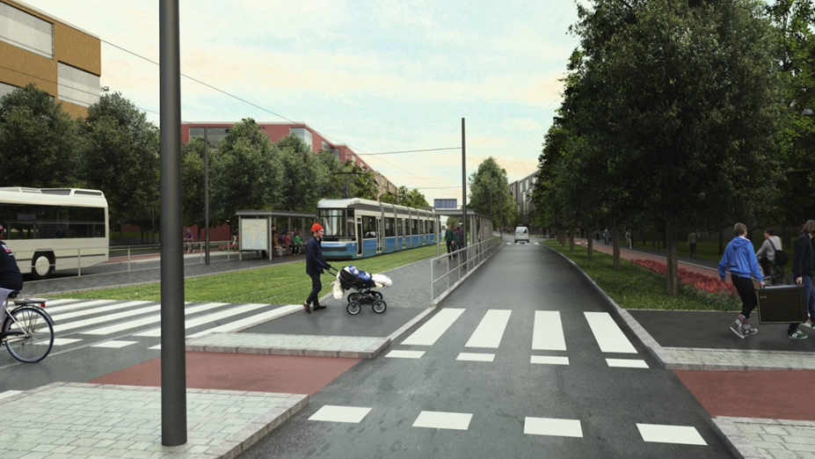

*Picture 8. A comprehensive light rail network is being planned*

The expansion of the city centre is a great opportunity for Helsinki. It is important to succeed in creating genuinely interesting, urban and varied boulevards with neighbourhoods full of character. The streets must also be interesting to pedestrians, the architecture of the buildings must be of high quality and public space needs to be pleasant and attractive

**5.2 Traffic safety requires lower speeds**

The city boulevard vision proposes that considerable volumes of new, dense developments are placed alongside the main streets. Developments must consider improved road safety as well. The boulevard plans must also include functions that naturally attract pedestrians and cyclists such as schools, day-care centres and nearby services.

Where city centre-like operations are planned alongside city boulevards, speed calming should be used to decrease driving speeds to make the routes suitable for pedestrian and bicycle traffic. A lower speed limit alone is not adequate. The boulevards should create a traffic environment which supports the observation of the speed limit.

**5.3 Challenges to overcome**

The challenge in the construction of boulevards is how to create a safe and pleasant street space that supports personal wellbeing. Street space can be unattractive for living, i.e. for meetings, walking and interacting with others. However, neighbourhoods designed for these functions are vibrant places and encourage living.

Due to current traffic emissions, all the planned city boulevards are at risk of exceeding the annual threshold value for nitrogen dioxide. In addition, the daily threshold value for airborne and fine particulates may be exceeded if street dust maintenance is neglected. Canyon-like streets are not easily ventilated and as traffic volumes increase, street dust also increases.

Business premises could be located on the ground and at first floor levels instead of apartments to minimize the impacts of emissions on inhabitants. Fresh air filtering solutions can be used to improve the air quality indoors.

1. **City boulevards are the clear solution for Helsinki**

Roughly one third of Helsinki´s predicted growth will be located alongside city boulevards. This demonstrates the growth potential of boulevard style streets. A dense urban structure and sustainable transport options play a key role in Helsinki´s future. The transport objective is to ensure that every part of the city can be easily reached by public transport. Walking and cycling will be given top priority among the different modes of transport.

The impacts of boulevards are mainly positive; they support life, by improving amenity, convenience and safety. Boulevards make streets more liveable and human compared to motorway-like roads. The impacts on car traffic are moderate.

In principle, Helsinki’s boulevardisation is straight forward; the key is only to transform 1 to 3 km sections of the motorway-like roads into city boulevards and build the supporting urban form alongside the boulevards.

Perhaps the most challenging issue is transforming current thinking from car-centric, reactive planning practice to the future-thinking transport and land use planning. Another key change is for transport planners and agencies to focus on supply-led planning. If we continue planning the traditional way (demand reactive), current trends show that we will not reduce car dependence – we will likely increase it.

Let’s imagine how we can transform New Zealand’s cities with boulevards. Better still, let’s get building. Let’s work together to create cities that support life.

**References:**

1. Helsinki City Plan, brochure:

<https://www.hel.fi/hel2/ksv/julkaisut/esitteet/esite-2017-1-en.pdf>

1. Vision 2050: Urban plan – the new Helsinki city plan: <https://www.hel.fi/hel2/ksv/julkaisut/yos_2013-23_en.pdf>
2. City Boulevards in Helsinki, brochure:

<https://www.hel.fi/hel2/ksv/julkaisut/esitteet/esite_2015-4_en.pdf>

1. Boulevard development impact assessment, project presentation:

<https://www.wsp.com/en-GL/projects/boulevard-development-impact-assessment>