**TRANSPORT OUTLOOK: FUTURE STATE**

Author/Presenter: **Ralph D. Samuelson**

Ph.D (Engineering-Economic Systems), MA (Economics),

MS (Transportation Systems), BS

Professional Memberships: IPENZ Transport Group, IEEE, NZAE

Principal Data Analyst, Ministry of Transport

e-mail: r.samuelson@transport.govt.nz

**ABSTRACT**

This paper introduces what we at the Ministry of Transport hope will be a useful new resource for transport planners and policy analysts in New Zealand: the *New Zealand Transport Outlook: Future State* report and its associated models. The report, which was released in November 2017, aims to identify some of the key trends and uncertainties that will influence the development of the transport sector to 2042/43 and to offer an initial set of alternative scenarios for how the future might unfold. The results, which are the product of a significant modelling effort, cover local ground travel by all modes, air travel, and freight by road, rail and coastal shipping.

This paper briefly examines the motivations for the project and the models behind it. The models are designed for transparency, and are available for downloading from the Ministry’s website.

It then discusses key trends and uncertainties in the context of a sample of results from the Transport Outlook models for five alternative future scenarios. The results of the Transport Outlook scenarios suggest that New Zealand will face significant transport challenges over the next 25 years, including difficulties meeting its Paris emission reduction commitments in the transport sector, growing traffic congestion in Auckland, and high numbers of deaths from diseases of inactivity. The results from one of the scenarios suggest that demand management road pricing is a policy that could help to address these challenges fairly quickly and at modest cost.

**INTRODUCTION**

Our transport sector is experiencing a period of rapid technological change and is influenced by many uncertain factors such as consumer preferences, technological improvements, and the future size and make-up of our population. The ways in which we travel and move our freight around the country constantly change and will no doubt look much different in 25 years. That’s why it’s important to understand the drivers of change and what the future for transport may look like as we head into the mid-21st Century.

The *Transport Outlook: Future State* (Ministry of Transport, November 2017) aims to identify some of the key trends and uncertainties that will influence the development of the sector and to offer an initial set of alternative scenarios for how the future might unfold. The report aims to provide an information resource for anyone who participates in the transport policy and planning process. It is intended to provide a base of common information, assumptions, and projections that others in the sector can use for future planning, policy-making and investment.

The report is intended as a starting discussion for a continuing process of engagement with stakeholders and researchers, leading to a better understanding of the future opportunities and choices that we face in the New Zealand transport sector. It does not represent government policy proposals or plans.

The new report forms part of the Transport Outlook resource kit. An earlier publication, the *Transport Outlook: Current State 2016* (Ministry of Transport, June 2017), provided information on the current state of the transport system.

This paper first looks briefly at the motivations behind the *Future State* project and the models that were developed to support the project. Then it discusses the assumptions and selected findings of the Base Scenario, and finally some key findings from four alternative scenarios. This paper is necessarily a short summary of a complex piece of work. However, the full report, all of the *Future State* model results, most of the underlying models, and their complete accompanying documentation, are available for downloading from the Ministry’s website. Our general philosophy is to make everything we are doing open and available, in order to ensure maximum value to our stakeholders.

**HOW THE *TRANSPORT OUTLOOK; FUTURE STATE* MEETS A NEED**

Almost all planning and policy analysis requires projecting the future, such as:

* Travel demand and traffic volumes;
* Fuel use/emissions;
* Public health and safety.

Our initial observation was that if policy analysts in the Ministry do not have modelling resources available to them, they either develop their own little spreadsheet models or, if the question they are examining is a complex one, hire a consultant to develop a one-off model for them. In either case, the work of various analysts in the Ministry may be inconsistent and each new analysis often ends up reinventing the wheel, rather than building on what has been done previously.

The not-so-hidden agenda of the *Future State* project is to develop an in-house modelling capability at the Ministry of Transport. By having such an in-house modelling capability, we can ensure that our models are consistent with each other, and can be continually improved over time. We hope the result will be a set of products that is useful not only within the Ministry, but also to planners and policy analysts in other central, regional and local government agencies, and in the private sector.

**THE TRANSPORT OUTLOOK MODELS**

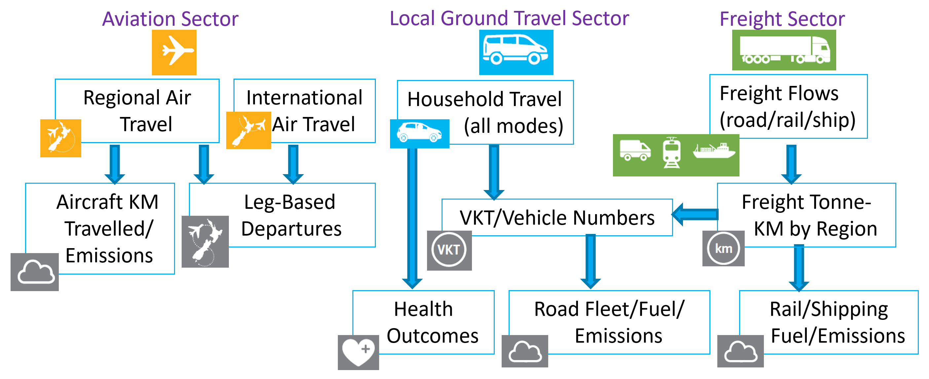

Figure 1: The Transport Outlook Modelling Suite

For the *Future State*, we have developed a suite of models, as shown in Figure 1, covering all sectors and all modes. All the models are designed to give results consistent with each other, and with projections of other government agencies, especially the Stats NZ population projections and the Treasury’s economic projections. The models cover three sectors: aviation, local ground travel and freight. All of the models operate at a fairly high level of aggregation, with regions of New Zealand being the lowest level of geographic detail considered. This is appropriate for models that are national in scale, and because the Ministry does not wish to duplicate the modelling work done by regional and local governments.

**Aviation Sector Models**

In the aviation sector, there are models projecting inter-regional domestic air travel and international air travel. The aviation models are based heavily on data from the Sabre database; Sabre is one of the major airline reservations systems, and collects data from all significant airlines serving New Zealand.

The regional air travel model projects passenger travel by region-to-region combination, based on the true origin and true destination of the passengers. It is a gravity model taking into account variables including projected regional populations, distances, and whether a ferry would be required for ground travel (see Hazledine, 2016). The international air travel model, which is mainly econometric, projects departures for overseas destinations by the true origin of the passenger.

These true origins and true destinations should be distinguished from leg-based departures, which correspond to the number of passengers travelling through airports, including connecting passengers. There is also a leg-based departures model, which infers airport departures from the true origin and true destination projections, assuming New Zealand airlines continue to maintain a hub-and-spoke network structure similar to what is used today.

For domestic travel, there is also an aircraft kilometres travelled and emissions model, which projects aircraft kilometres travelled and the resulting emissions by aircraft type. These models simulate the aircraft fleet and flights needed to meet the demands projected by the regional air travel model.

**Local Ground Travel Models**

In the local ground travel sector, there is a model projecting household trips, distance travelled and hours of travel in each region of New Zealand by ten modes (pedestrians, cyclists, light vehicle drivers, light vehicle passengers, taxi/vehicle share, motorcyclists, local train, local bus, local ferry and other). This model is based heavily on data from the New Zealand Household Travel Survey and takes into account projected demographic changes. Conceptually, the model grows the weight of each sampled trip in the Household Travel Survey according to the projected growth of the demographic ‘cell’ (household income, household type, age and region) containing the person who made it. Demographic projections come from Stats NZ.

There is also a vehicle kilometres travelled (VKT)/vehicle numbers model, which projects VKT and the size of fleet for five vehicle types (cars/SUVs, vans/utes, heavy trucks, heavy buses and motorcycles). Growth of travel by household cars/SUVs, household vans/utes, public transport buses and motorcycles are driven by the results of the household travel model. Travel by commercial cars/SUVs and commercial vans/utes is assumed to grow with regional GDP. Heavy truck travel grows with the freight tonne-kms from the road freight tonne-km model described below, with an adjustment for an assumed growth in load per truck. A simple tourism growth model is used to project the growth of travel by tour buses. A split of car/SUV and van/ute travel between private vehicles and taxi/rideshare is exogenously specified as an assumption of the scenario.

The VKT/vehicle numbers model results feed into a road fleet/fuel/emissions model, which projects VKTs, fuel use and emissions for an even more detailed breakdown of vehicle types, including fuel type, new vs. imported used vehicles, various engine sizes and, for heavy trucks, several weight classes. This model was developed from the Ministry’s previously-existing Vehicle Fleet Emissions Model (VFEM) (McGlinchy, 2017), which has now been integrated into the Transport Outlook modelling framework.

**Freight Models**

In the freight sector, the freight flows model projects region-to-region freight flows by road, rail and coastal shipping, in tonnes, for 19 different commodity groups. The model is based on growing the flow estimates from the 2014 National Freight Demand Study (NFDS) (Deloitte, et al, 2014) into the future. The model allows the freight flow projections to vary with projections of regional population and economic growth. The freight flow model was developed in cooperation with Murray King and Richard Paling, who were co-authors of the NFDS. Given the interest in scenarios around the future of New Zealand ports, they also extended the NFDS results to include additional detail on export flows from region of origin to port of export and of import flows from port of import to region of destination.

The projected region-to-region freight flows in tonnes feed into freight tonne-KMs by region models for road and rail, which project the number of tonne-KMs flowing on the roads and railways of each region, based on assumed region-to-region highway or rail routings. There is also a similar coastal shipping tonne-KMs model that gives results at a national level. For rail and coastal shipping, these freight tonne-KM projections feed into a simple rail and coastal shipping fuel and emissions model, based on assumed fuel and emissions intensity per tonne-km.

**THE BASE SCENARIO**

The *Future State* examines five scenarios. The starting scenario is the Base Scenario. The Base Scenario projects where current demographic and economic growth trends alone are likely to take us, assuming no disruptive changes in technology or consumer behaviour.

The Base Scenario does not generally take into account investments that may be made in new and improved transport infrastructure, and their impact on demand. A key exception here is the local ground travel model assumptions around public transport in Auckland and Wellington. In these two cities, the improvements to public transport currently in progress, especially the City Rail Link in Auckland, are too large to ignore and are far enough along that they may be regarded as part of business as usual. Since our regional-level models are not capable of projecting the effect of individual projects on demand, we used projections from the Auckland and Wellington regional councils for public transport in their regions, rather than our own.

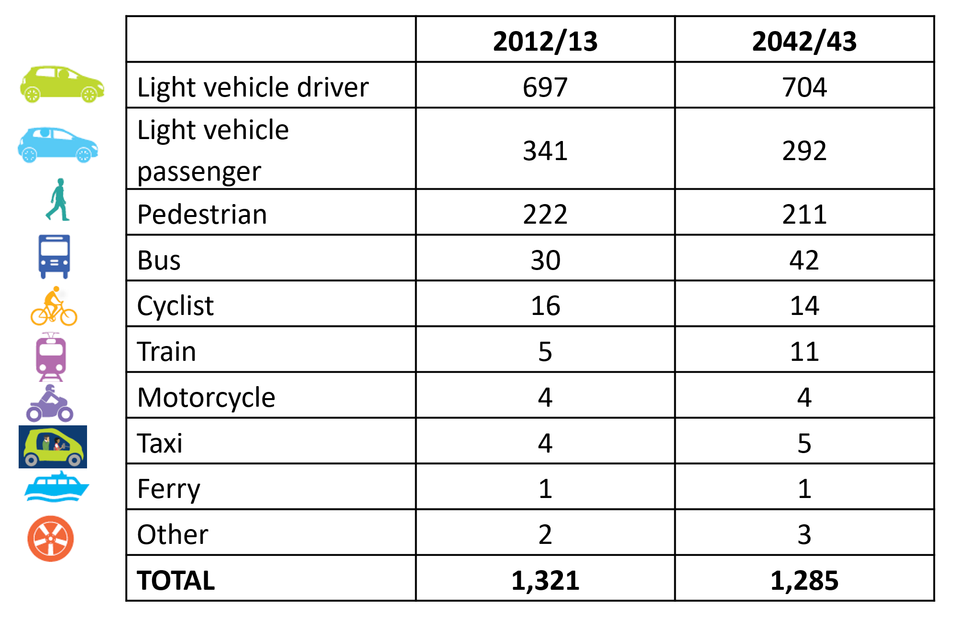

Figure 2: Base Scenario Number of Household Trips per Capita per Year by Mode

Looking at the projected Base Scenario per capita household trips by mode shown in Figure 2, we see that, in general, the changes are not extreme. In absolute numbers, the most significant change is a decline in the number of light vehicle passengers. This is primarily a consequence of the ageing population and the resulting decline in number of children, who constitute a large share of light vehicle passengers. In percentages, the most significant change is the growth in travel by public transport, mainly reflecting public transport improvements in Auckland.

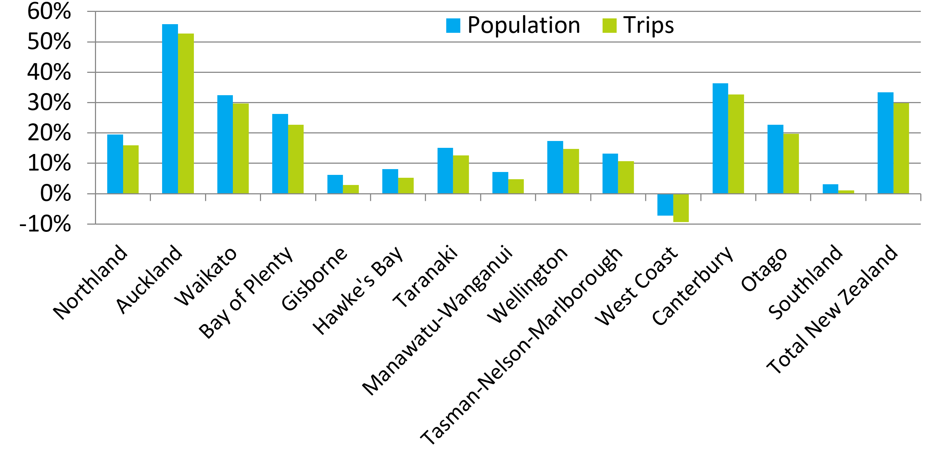

Figure 3: Base Scenario Change in Population and Household Trips by Region from 2012/13 to 2042/43

Looking at the projected Base Scenario populations and household trips by region, shown in Figure 3, reveals a similar pattern of change in transport demand: growth in total number of household trips in each region is similar to, but slightly less than the growth in population. This is consistent with the total results just discussed, which show a slight decline in per capita household trips. The pattern of regional population growth is based on Stats NZ medium population projections and reveals an interesting overall pattern: projected population growth is almost perfectly correlated with the urbanisation of the region. The Auckland region population is projected to grow the fastest, and Canterbury grows the second fastest, while the rural regions grow the slowest.

It is worth noting that the projections shown in Figures 2 and 3 above represent household trips, not VKTs. The latter must also include commercial travel and road freight. In particular, rental vehicle travel is considered commercial travel, not household travel, and may be a significant fraction of VKTs in some tourist-oriented rural regions, especially the West Coast and Southland. The VKT/Vehicle Numbers model discussed above does seek to include commercial travel in VKTs, and does show significantly faster growth in VKTs compared to household trips in the West Coast and Southland. However, our modelling work has been hindered by significant gaps in data regarding tourist travel and long-distance ground travel generally. The Ministry is currently working with stakeholders to explore how this gap might be addressed.

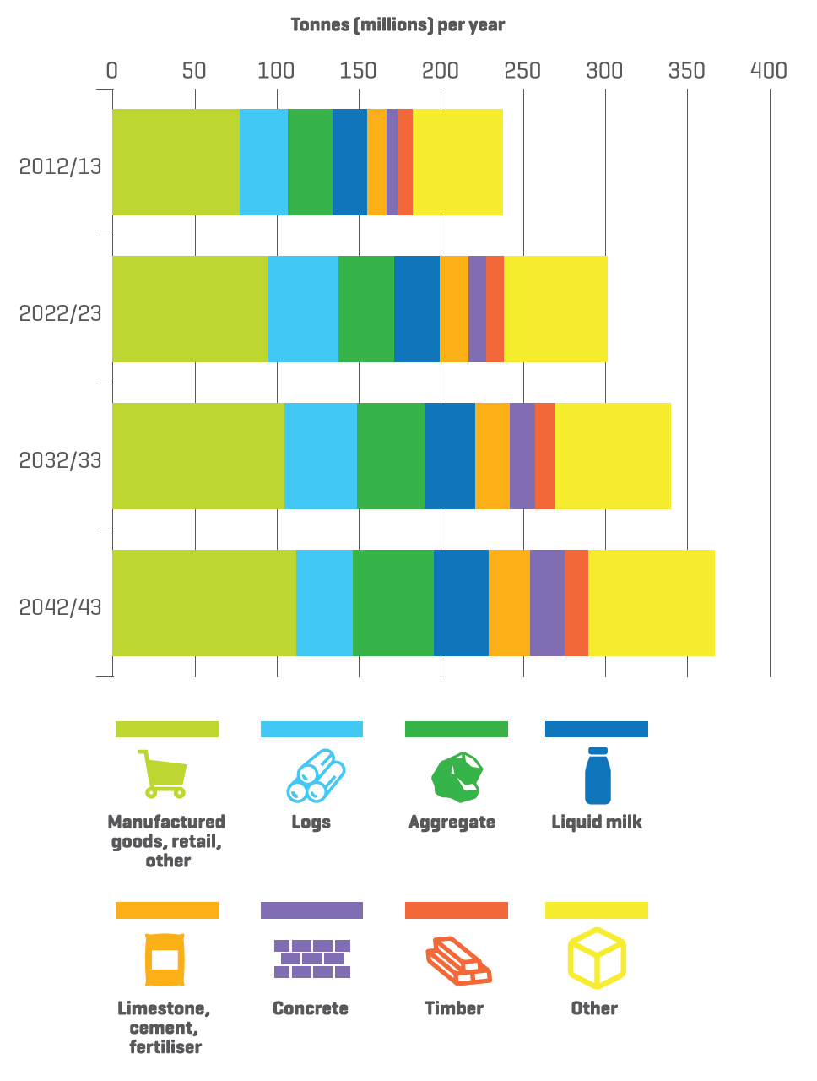

Figure 4: Base Scenario Projected Freight Tonnage by Commodity Group

Turning to freight, overall tonnage handled is expected to grow in the Base Scenario by about 50% by 2042/43. As shown in Figure 4, manufactured/retail/other goods contribute most to the absolute growth of projected freight tonnage. However, the share of these products in the freight mix is projected to fall. The tonnage of all product classes is expected to increase, except for coal, which is projected to fall slightly.

Log shipments undergo an interesting rise and fall, with the maturation and harvesting of the ‘wall of wood’ in the 2020’s and 2030’s, followed by a slowdown of harvesting in the 2040’s. This result is, however, subject to an extra large amount of uncertainty, as forest owners have considerable discretion over when to harvest.

Freight handled by all three modes—road, rail and coastal shipping—is projected to grow. Road remains the dominant form of freight transport, with a roughly 93% market share by tonnage in 2042/43, compared to 91% today. Rail and coastal shipping mode share declines slightly, not because of any competitive disadvantage, but because of projected slow (or negative) growth in production of three key rail and coastal shipping commodities: logs, coal and petroleum products.

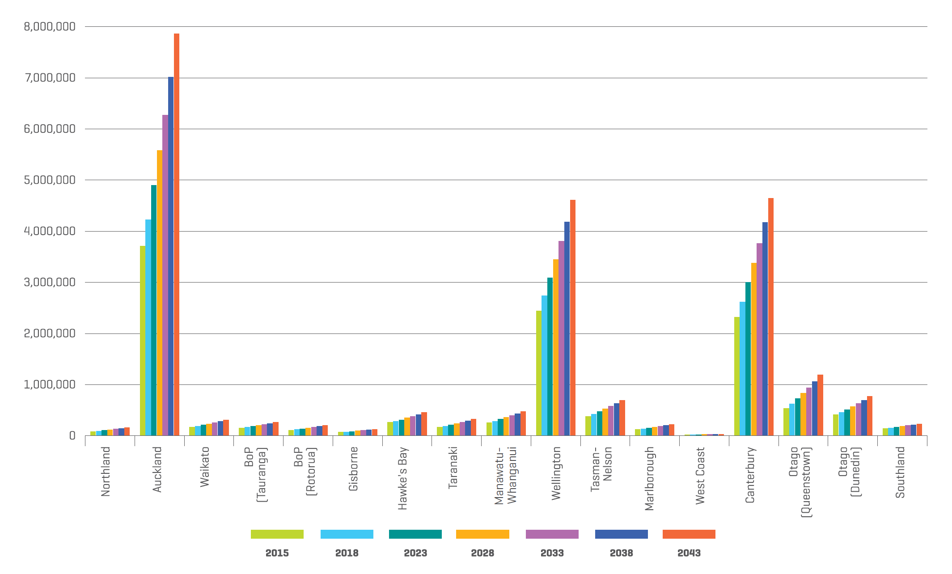

Figure 5: Leg-Based Departures by Region of Airport

Turning to air travel, as shown in Figure 5, our leg-based departures model suggests that passenger numbers travelling through New Zealand airports will roughly double by 2042/43. Queenstown will have the largest growth in percentage terms—about 120%, followed by Auckland with about 110% growth. Auckland, Wellington and Christchurch airports will continue to account for about three-quarters of the departures given the many travellers making connections through these airports.

**THE FIVE TRANSPORT OUTLOOK SCENARIOS**

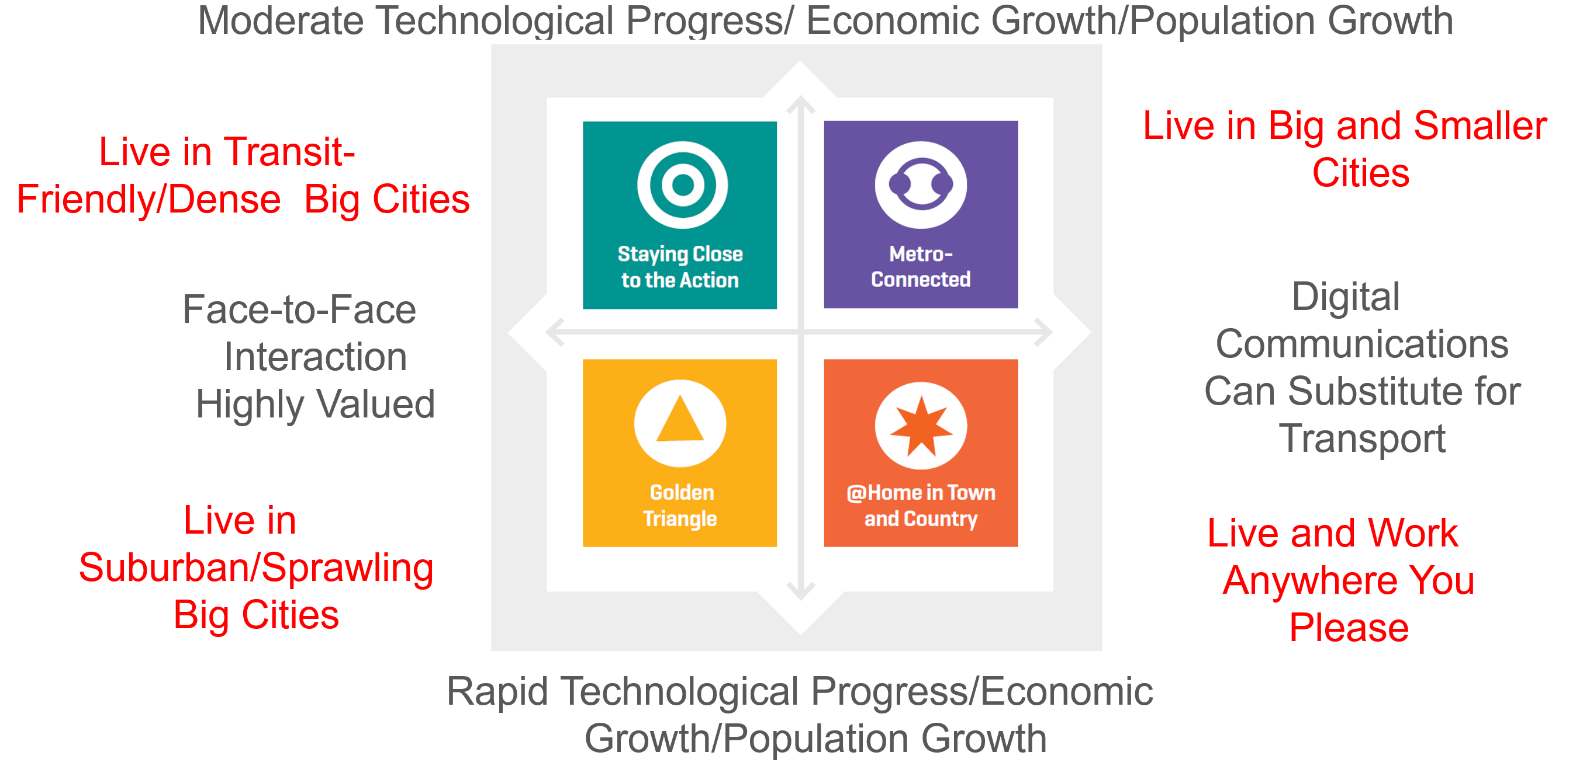

Figure 6: Transport Outlook: Future State Scenarios

In addition to a Base Scenario, we examine four alternative scenarios, spanning a range of outcomes, as shown in Figure 6. We take no position as to which scenario is more desirable or more likely. The scenarios are designed to focus on what we considered to be the two biggest uncertainties facing the transport sector in New Zealand:

1. How quickly will technological progress advance? This is an important question not only because it impacts on the transport sector directly, but also because technological progress drives productivity improvement, which, in turn, drives economic growth. In addition, economic growth is likely to produce a tight labour market, which we assume will keep New Zealanders in New Zealand and create demand for skilled migrants. So rapid technology advance is likely to be associated with rapid economic and population growth.
2. How do people prefer to connect: through face-to-face interaction or digital communications? The answer to this question will determine whether people want to travel more or travel less as communication technologies improve. It is also important because if people prefer face-to-face interaction, then large cities, especially Auckland, will continue to offer agglomeration benefits, and attract population. If people prefer to interact through digital communications, then large cities, with their high real estate costs, would be less attractive to both people and businesses, and population growth might be spread more evenly around the country.

Our scenarios vary assumptions around these two uncertainties. At the one extreme, the “Staying Close to the Action” scenario assumes moderate technological progress and that people value face-to-face interactions. As a result, Auckland continues to boom, but growth is focused on the central city and inner suburbs. Because this scenario would otherwise produce an unacceptable level of traffic congestion, we have also assumed that demand management road pricing is implemented in Auckland and Wellington in this scenario, which limits traffic to the free-flowing road capacity.

At the other extreme, the “@Home in Town and Country” scenario assumes rapid technological progress and that people are willing to substitute digital communications for travel. Thus, people become more capable of working, shopping and socialising from home or places near home, and many people find themselves free to live wherever they choose. The result is growth not just in big cities, but also in smaller cities and rural areas.

In the ‘Golden Triangle’ scenario, as in the ‘Staying Close to the Action’ scenario, greater Auckland continues to boom, but improved transport technology, especially self-driving vehicles, makes travel easier and allows us to relax the assumption that growth focuses on the central city and inner suburbs. Instead, growth spreads over the entire ‘Golden Triangle’ of Auckland, Waikato and Bay of Plenty.

In the ‘Metro-Connected’ scenario, as in the ‘@Home in Town and Country’ scenario, a willingness to substitute digital communications for transport removes some of the imperative for people and businesses to locate in greater Auckland. However, employers still have to locate their employees somewhere, because communications technology has not advanced fast enough to allow people to do most things from home. Many employers choose to reduce costs and satisfy their employees’ life-style preferences by spreading their operations across multiple locations, resulting in other cities growing at the same rate as Auckland.

**KEY FINDINGS**

This section summarises a few of the more interesting results of the alternative scenarios in the *Future State* report.

**Growth in Local Ground Travel Passenger Kilometres by Mode**



Figure 7: 2042/43 Passenger Kilometres by Mode by Scenario

In comparing 2042/43 passenger kilometres by mode, as shown in Figure 7, several trends are apparent. Growth is lowest in the ‘Staying Close to the Action’ scenario, which assumes moderate growth focused on Auckland, and that Auckland becomes a relatively dense, transit-friendly city. Growth is fastest in the ‘Golden Triangle’ scenario, which assumes growth is fast, that self-driving vehicles make travel easy, that people value face-to-face interactions, and that the Upper North Island develops a suburbanised low-density land-use pattern. Interestingly, distance travelled in the ‘@Home in Town and Country’ scenario is similar to the ‘Staying Close to the Action’ scenario, despite being a fast growth scenario with a dispersed population. This is because improved technology and an acceptance of digital communications as a substitute for transport allows a good deal of substitution of communications for transport.

Another trend is the growth of vehicle sharing as a mode in all the alternative scenarios, especially in the rapid technology progress scenarios. This outcome is consistent with a good deal of recent literature (see, for example, International Transport Forum, 2015). The logic here is that self-driving vehicles are a game-changer for vehicle-sharing services. Vehicle sharing services already exist today without self-driving vehicles, but to use a vehicle-sharing service, one must go to the place where vehicle-sharing vehicles are available to pick-up or drop-off a vehicle. Once self-driving vehicles become available, the vehicle can drive itself to you, making vehicle sharing hugely more convenient; it would become essentially an automated taxi service. Once volume of use reaches a critical level, the response time to service requests could be very fast; in fact, with no time required to search for parking, vehicle-sharing could even be faster than driving a private car. In addition, it would likely be considerably cheaper than owning a private car overall, since the vehicle ownership costs could be shared by many users. Consequently, we assume that once fully self-driving vehicles become available in large numbers, many people will cease owning their own vehicle and switch to vehicle-sharing services.

A third trend is the growth of public transport. Although public transport remains small in mode share, the percentage growth is quite significant, especially in the ‘Staying Close to the Action’ scenario, which assumes that Auckland develops into a relatively dense, transit-friendly city.

**Leg-Based Airport Departures**

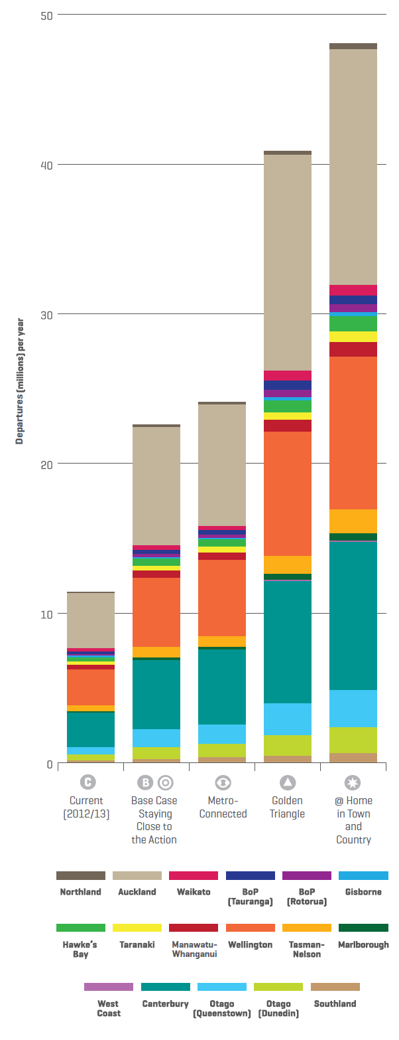

Figure 8: Projected Leg-Based Domestic Departures by Region of Airport in 2043

As shown in Figure 8, the difference in number of airport departures between the scenarios is quite large. The ‘@Home in Town and Country’ scenario shows especially large growth, more than doubling the Base Scenario numbers by 2042/43. This scenario not only features faster economic growth, but also a dispersion of the population as more and more people work from home and gain the freedom to live where they choose. We assume that these people will still occasionally need to meet their work colleagues or customers face-to-face and, given their dispersed locations, may need to travel by air to do so.

**Growth in Vehicle Kilometres Travelled (VKT)**

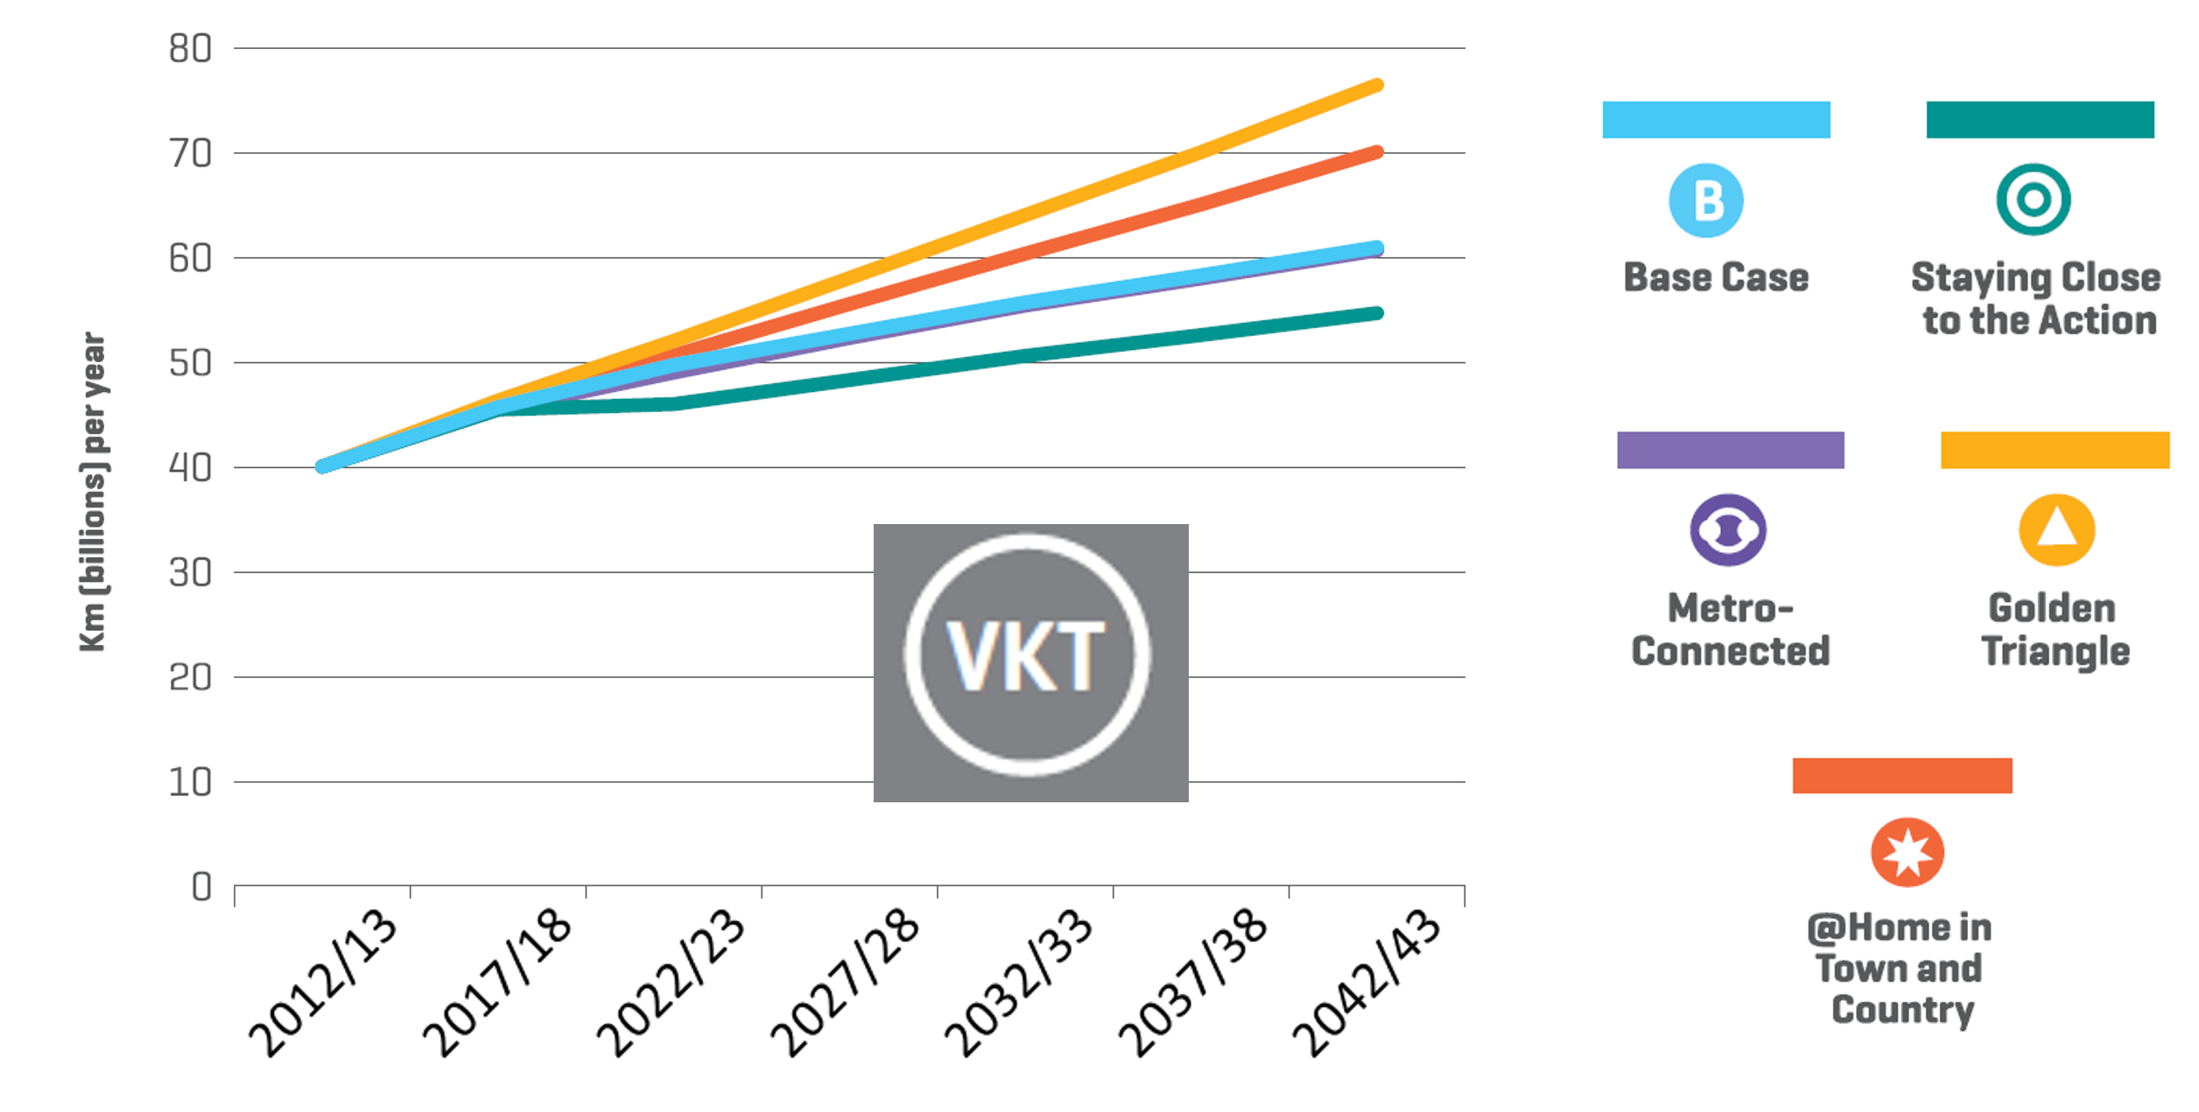

Figure 9: New Zealand Vehicle Kilometres Travelled by Scenario

As shown in Figure 9, total VKT grows in all scenarios, mainly due to population increases. However, there is quite a difference in rates of growth between scenarios. Growth in VKT is lowest in the ‘Staying Close to the Action’ scenario, which assumes population growth centred on a dense, transit-friendly Auckland. It is highest in the Golden Triangle scenario, which assumes fast growth and a suburban-style development of the Upper North Island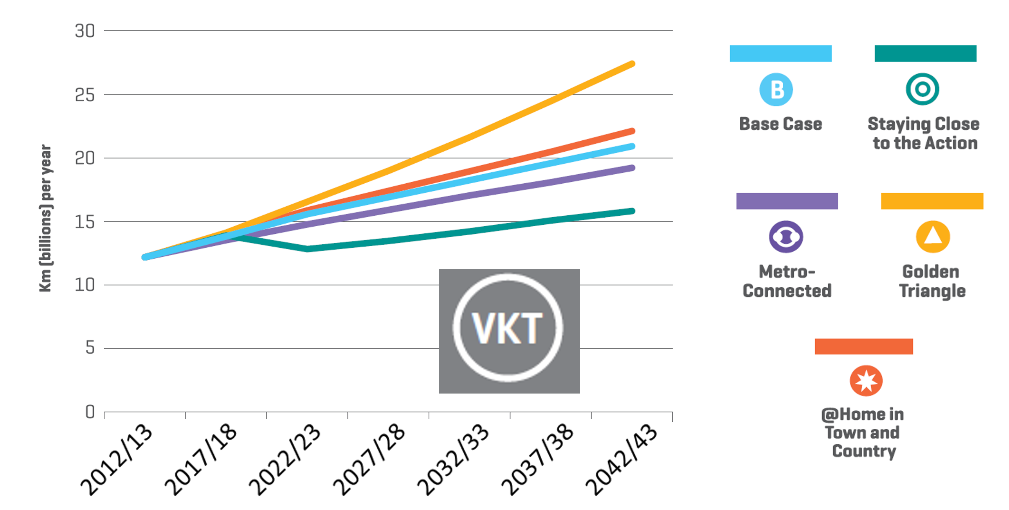

Figure 10: Auckland Region Vehicle Kilometres Travelled by Scenario

Figure 10 presents the same chart for the Auckland Region only. It shows an even wider variation in VKTs between scenarios. The effect of demand management road pricing in Auckland in the ‘Staying Close to the Action’ scenario is especially apparent, with a kink in the curve for this scenario indicating the assumed implementation of demand management road pricing in 2022/23. We assume a ‘smart’ form of road pricing, which allows prices to be adjusted road segment by road segment, and hour by hour, to keep traffic free-flowing on every road segment, while at the same time not charging for driving on road segments that would otherwise be uncongested (see Crampton, 2018). This is an emerging transport technology that has been little discussed compared with others such as self-driving vehicles and electric vehicles, but perhaps equally important. Due to historically limited technical capabilities, all of today’s road pricing schemes in Europe and Asia use much cruder methods, although Singapore is planning to implement something like this over the next few years.

The net impact of demand management road pricing in Auckland is to hold traffic to a level compatible with the capacity of the road network, which is assumed to grow slowly over time. The other scenarios, on the other hand, show traffic levels that are probably not compatible with the capacity of the network. This suggests that traffic congestion in Auckland is likely to be an increasingly serious challenge to the Auckland region under these scenarios. Re-examining these scenarios under road pricing is an interesting area for further work.

Demand management road pricing has not yet been tried in an automobile-oriented city like Auckland, so there is considerable uncertainty as to how the market will respond. Given that road pricing would substantially increase the cost of driving alone, and given the relatively undeveloped state of the public transport system in Auckland, we assumed that a major response to demand management road pricing would be a shift to ride-sharing. Specifically, we assumed that 45% of the drivers who choose to no longer drive due to road pricing, along with their accompanying passengers, become passengers in some other driver’s vehicle. This shift would be facilitated by entrepreneurs, who would likely offer a range of apps for matching drivers with passengers desiring to make similar trips. Given that the average vehicle occupancy in Auckland is only about 1.5 passengers, and only about 1.3 passengers during the morning peak, the potential passenger carrying capacity of ride-sharing in Auckland would be huge.

It is important to note that ‘ride-sharing’ needs to be distinguished from ‘vehicle-sharing’, discussed earlier. We define vehicle-sharing to be the sequential use of a vehicle by multiple parties, most likely one at a time, whereas ‘ride-sharing’ involves multiple parties riding together in the same vehicle at the same time. Our observation has been that the distinction between the two is often muddled, especially in the popular media. The growth of vehicle-sharing would significantly reduce the need for parking, and could thereby have a significant impact on urban design, but, by itself, would do little to relieve traffic congestion; the VKTs would simply move from private vehicles to vehicle-share vehicles. Ride-sharing, on the other hand, could significantly reduce VKTs and traffic congestion, if people could be persuaded to use it, since it could significantly increase the passenger-kilometres per vehicle-kilometre.

We have assumed that people will need some extra inducement to take-up ride-sharing beyond simply being offered the service. Demand management road pricing would provide this inducement. In our scenarios, only in the ‘Staying Close to the Action’ scenario, which includes demand management road pricing, would there be a significant take-up of ride sharing.

**Health Benefits of Walking and Cycling**

Physical activity through walking and cycling may reduce the number of deaths from diseases of inactivity. In order to examine these impacts, we worked with the University of Otago School of Public Health to develop a model that could project the impacts of our scenarios on deaths and years of life lost from diseases of inactivity (Keall, et al, 2016). The model is based on one that was originally developed at the University of Cambridge in the United Kingdom, which has been adapted for use in a number of countries.

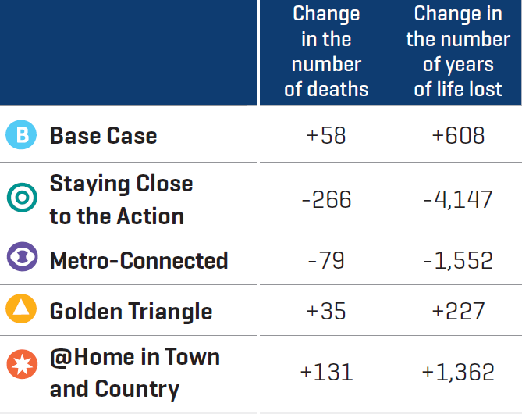

Figure 11: Health Impacts by Scenario in 2042/43 Compared to 2012/13

The differences in rates of walking and cycling between our scenarios are relatively small. For example, the average distance walked per person per day in the ‘Staying Close to the Action’ scenario in 2042/43 is about 600 metres, compared to about 400 metres in the Base Scenario, while the difference in the average distance cycled per person per day in the ‘Staying Close to the Action’ scenario is about 600 metres compared to about 200 metres in the Base Scenario. Yet, as shown in Figure 11, even these small differences produce about 300 fewer deaths per year and about 5000 fewer years of life lost to diseases of inactivity. This change in number of deaths is comparable to the total New Zealand road toll from road vehicle crashes.

**Electric Vehicles and Emissions**

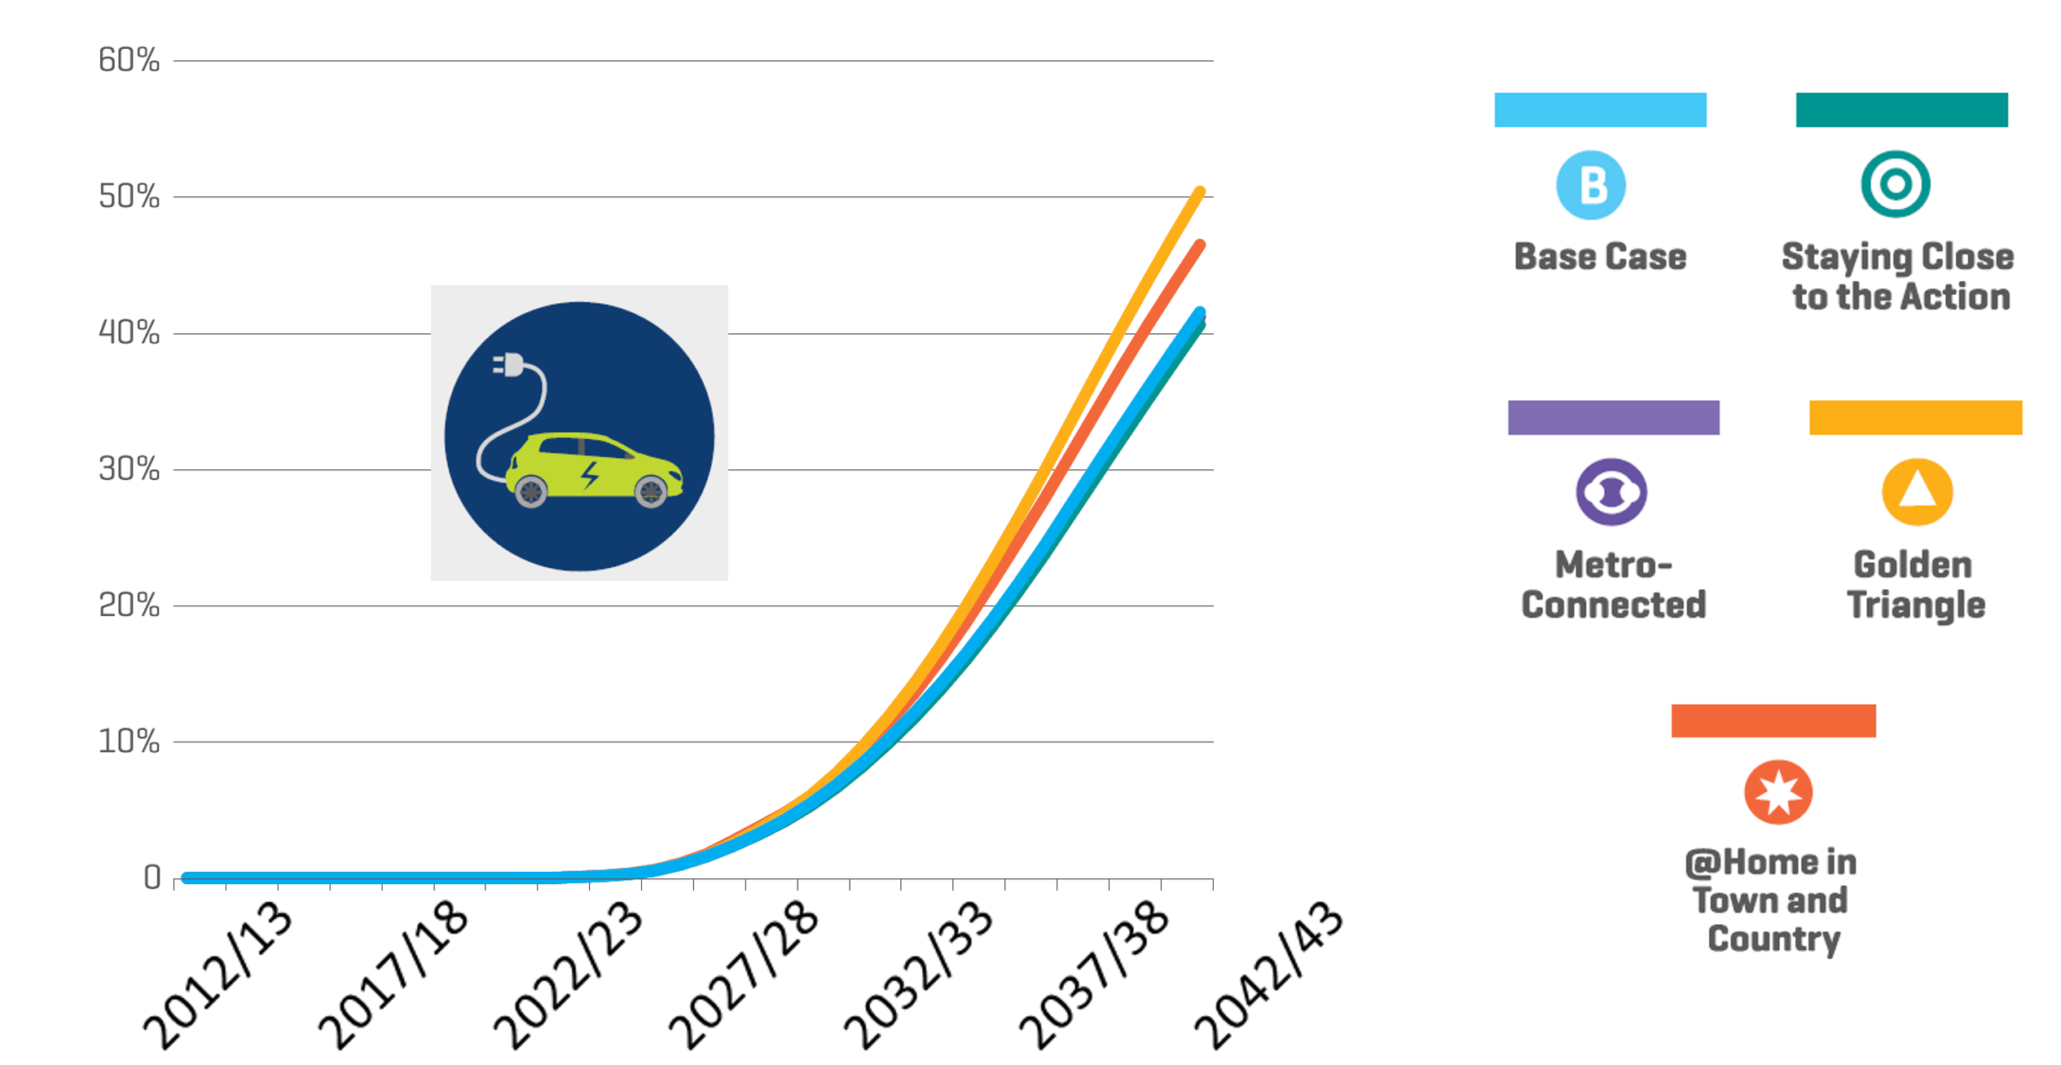

Figure 12: Electric Vehicles as Percent of Vehicle Fleet by Scenario

New electric vehicles are projected to reach cost of ownership parity (vehicle cost, fuel, road user charges, repairs, and insurance) with conventional vehicles in the mid 2020s. Thereafter, as shown in Figure 12, in all scenarios the number of electric vehicles increases to approach about half of the vehicle fleet by the early 2040’s. (The Base Case, Staying Close to the Action and Metro Connected scenarios are so similar that they are difficult to distinguish in the chart.) However, because of the slow turnover of the vehicle fleet, the transition to electric vehicles will take some time, especially given New Zealand’s historically heavy reliance on used imported vehicles.

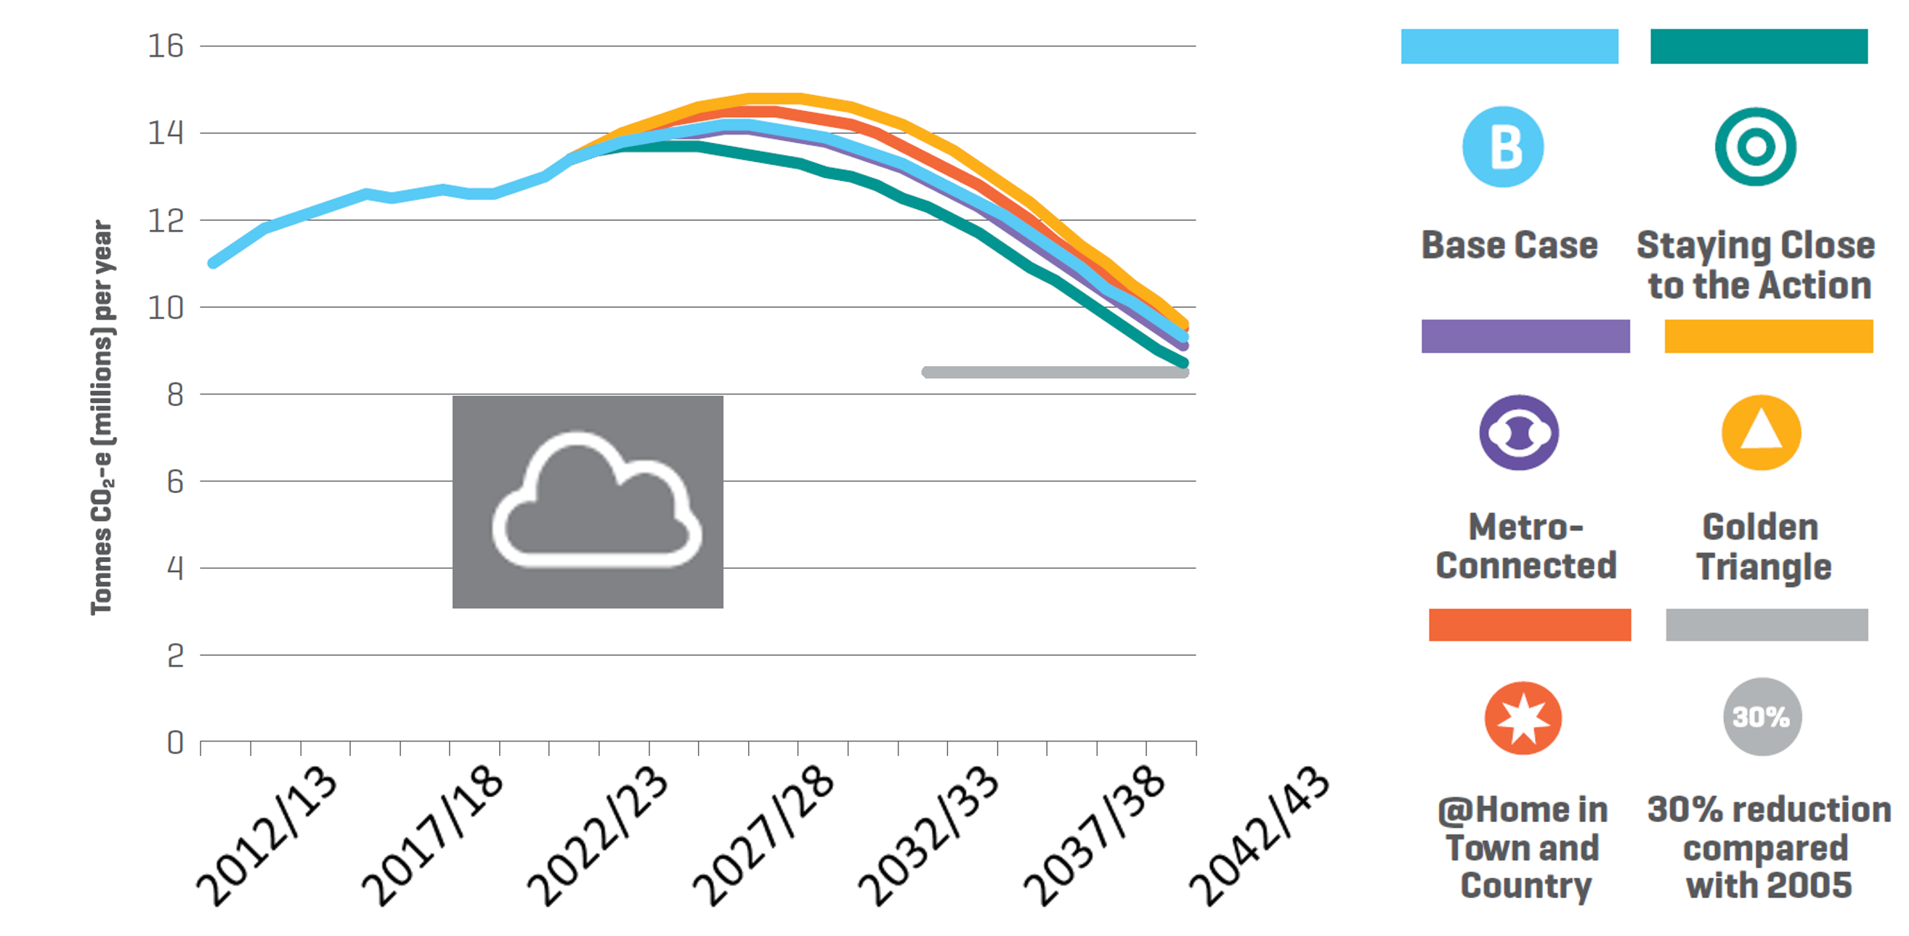

Figure 13: Road Transport CO2-e Emissions by Scenario

Consequently, as shown in Figure 13, road vehicle emissions continue to rise into the mid-2020’s with rising VKTs, before falling off sharply thereafter with the growing take-up of electric vehicles. Unfortunately, this decline will not be fast enough to help meet New Zealand’s commitments under the 2016 Paris Agreement, which is to reduce emissions to 30% below 2005 levels by the year 2030.

Although New Zealand has made no commitments specific to transport, it is a sector that almost certainly needs to achieve considerable reductions by 2030 if the national commitment is to be met. After all, reducing emissions in transport should be easier than reducing emissions in some other key sectors, especially agriculture. The grey line in Figure 13 indicates a 30% reduction in road transport emissions compared to 2005; it can be seen that in none of our scenarios would New Zealand achieve this level even by 2040. Clearly, if New Zealand is to meet its Paris commitments, at least in the transport sector, more actions will be required.

**CONCLUSION**

The results of Transport Outlook scenarios suggest that New Zealand will face significant transport challenges over the next 25 years, including difficulties meeting its Paris emission reduction commitments in the transport sector, growing traffic congestion in Auckland, and high numbers of deaths from diseases of inactivity. The classic transport policy approaches for dealing with these challenges are ‘avoid’ (reduce the need for motor vehicle travel, usually through better urban planning), ‘shift’ (provide better facilities for public transport, walking and cycling), and ‘improve’ (reduce vehicle emissions through technological improvements, such as electric vehicles). Each of these approaches needs to be pursued, but it must be recognised that they will require a significant amount of time, as well as money, to implement.

Fortunately, the *Transport Outlook: Future State* ‘Staying Close to the Action’ scenario suggests one policy approach to dealing with these challenges that could be implemented fairly quickly and at modest cost: demand management road pricing. A well-designed implementation of demand management road pricing could quickly reduce the demand for vehicle travel, thereby dramatically cutting emissions and traffic congestion, while generating revenue that could be used to improve facilities for public transport, walking and cycling. Although demand management road pricing would make driving alone considerably more expensive, especially during peak hours, travel times and travel time reliability would improve significantly for those travelling by car (including ride-sharing passengers) or bus. Ride-sharing apps could minimise the inconvenience for those who would choose not to drive, even in places where public transport is not readily available. These and other options can be explored in more detail using the freely-available modelling package accompanying the *Transport Outlook: Future State* report.

The Transport Outlook project, and the *Future State* work has not ended with the publication of the report and the underlying models. We subtitled the report the “Start of a Conversation”, since we view it as the beginning of a stakeholder consultation process. We plan to continually improve the models, and add to their capabilities in a way that will meet the needs of our stakeholders. Although 25 year outlooks do not change that much in a single year, we think they do need updating perhaps every two or three years. So we expect to produce further editions of the *Future State*, reflecting both the needs of our stakeholders and new developments in the transport sector.

**REFERENCES**

Cramton, P., et al, *Markets for Road Use: Eliminating Congestion through Scheduling, Routing, and Real-Time Road Pricing*, Working Paper, University of Cologne, January 2018, <http://www.cramton.umd.edu/papers/transport/>.

Deloitte, et al, *National Freight Demand Study*, Ministry of Transport, March 2014, <http://www.transport.govt.nz/assets/Import/Documents/FreightStudyComplete.pdf>.

Hazledine, T., *Projections of regional air passenger flows in New Zealand 2018-2043,* Ministry of Transport,May 2016, <http://www.transport.govt.nz/assets/Uploads/Research/Transport-Outlook/Documents/MOT-HAZLEDINE-FINAL-REPORT.pdf>.

International Transport Forum, *Urban Mobility System Upgrade: How shared self-driving cars*

*could change city tra­ffic*, 2015, <https://www.itf-oecd.org/sites/default/files/docs/15cpb_self-drivingcars.pdf>.

Keall, M., et al, *Health outcomes projected from Transportation Modelling for the New Zealand Transport Outlook*, Ministry of Transport, August 2016, <http://www.transport.govt.nz/assets/Uploads/Research/Documents/Keall-et-al-Health-Outcomes-from-Transport-Documentation-201608.pdf>.

McGlinchy, I., *MVR and VFEM*, Ministry of Transport, July 2017, <http://www.transport.govt.nz/assets/Uploads/Research/Documents/2017-Transport-Knowledge-Presentations/MVR-and-VFEM.pdf>.

Ministry of Transport, *New Zealand Transport Outlook: Current State*, June 2017, <http://www.transport.govt.nz/assets/Uploads/Research/Documents/Transport-Outlook/MoT-Transport-Outlook.pdf>.

Ministry of Transport, *New Zealand Transport Outlook: Future State*, November 2017, <http://www.transport.govt.nz/assets/Uploads/Research/Documents/GOTO-Future-State-A4.pdf>.