Inclusive Streetscapes: a bridge over troubled water

**Tuesday 12 November, 9:00am**

The co-benefits of active travel for our personal and planetary health are well-established. But when these benefits are inequitably enjoyed by some and not others, we are obliged to consider how enabling or disabling our transport systems are, from a population health perspective.

The Inclusive Streetscapes Project funded by the Health Research Council of New Zealand provides unique insights on the ‘lived experiences’ and aspirations of disabled people and kaumātua/older citizens navigating urban street environments and transport options. This presentation will discuss these findings alongside the perspectives shared by transport professionals to consider the implications for planning processes, tools and designs that leave no one behind.

Prof Shanthi Ameratunga, University of Auckland

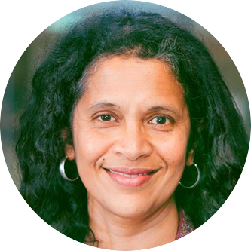Shanthi is a Professor of Public Health at the Faculty of Medical and Health Sciences at the University of Auckland. A pediatrician by training, Shanthi undertook postgraduate studies in public health at the Johns Hopkins University before returning to New Zealand to lead a multi-disciplinary research program focusing on injury prevention, trauma care, transport systems, and disability.

An enduring theme throughout her career has been the desire to reduce inequities in population health through addressing barriers in physical and social environments. Collaborating widely in New Zealand, Australia, the Asia-Pacific region and further afield, Shanthi’s award-winning research crosses traditional boundaries of scholarship to stimulate changes in policy and practice.

She has published over 300 scientific papers, serves on multiple international research advisory groups including the WHO, and is passionately committed to coaching and mentoring the next generation of scholar-activists. She was awarded the Te Manaia Leadership Award by the Injury Prevention Network of Aotearoa in 2013.