STREET HIERARCHY
&
THE POWER OF DESIGN

Observations & Analysis from Cycle Study Tour in 2016
to North America & Europe
Recipient of Transportation Group Study Award

Presenter:
Claire Graham BLA, NZILA Registered
Principal Walking & Cycling Specialist, Auckland Transport
claire.graham@at.govt.nz

ABSTRACT
Can better defined street hierarchy, provide us with a more connected cycling network in our New Zealand cities?
In June 2016, I was privileged to visit several cities in North America and Europe to explore cycling infrastructure. A particular focus of the trip was looking at how separated cycling facilities moved through un-signalised intersections. The comparison between Copenhagen and Auckland’s intersection layouts where a local street connects into an arterial road highlight some substantial differences for all modes. The experience of riding through and observing these intersections in ten different cities revealed some simple design approaches which could be applied to intersections in New Zealand. These included simplifying movements and layout; using materials to communicate expected behaviour and being consistent.
An outcome of looking so closely and interrogating the layout and designs of these intersections triggered my thinking around the role and value of street hierarchy in cities. This paper explores the legibility of streets in Auckland compared to Copenhagen, and also discusses how Vancouver has cleverly added an additional layer to their local street hierarchy through the elements that make up their local street bikeways.
There are significant opportunities to clarify the hierarchy of our streets in Auckland and by doing so create safer more comfortable and accessible places to ride bikes. While we are often constrained through legislation or slow government agencies from officially altering speeds or priorities on a street, projects such as Self-Explaining Streets completed in Point England in Auckland in 2006 have proven these outcomes can be achieved simply through design.

INTRODUCTION
Designing for people on bicycles in the Auckland context never seems to occur without complexity and compromise. Intersection design is often where all the demands, requirements and different modes conflict. In 2015 a gap was identified that at both a national (Bridget Southey-Jensen, et al. 2015) and city-wide level, there was very little guidance around how to design both signalised and un-signalised intersections which incorporated protected cycling infrastructure; this led to two study trips being awarded by IPENZ. Megan Fowler was the other successful recipient of the Study Tour Award in 2016 and investigated signalised intersections for cycling, so my complementary focus was un-signalised intersections encompassing side streets, driveways and pedestrian and cycle path intersections.
A focus of this paper is looking in-depth at how an arterial road containing cycling provision interacts with a local street, comparing a typical Copenhagen intersection with one in Auckland and discussing the different user experiences and images to highlight how varied these interactions could be.
Both Vancouver and Copenhagen showed great examples of how careful and considered street design can provide depth and clarity to their street hierarchy. The results of the clarity in hierarchy almost definitely contributed positively to shaping a connected and comfortable cycling experience and network in those cities, something we want to strive to achieve here in Auckland.
The opportunity for New Zealand to define our street hierarchy further though design is ‘low hanging fruit’, ripe for the picking and will most certainly contribute to creating a more connected and comprehensive cycle network though our city. Last year Auckland Transport launched The Road and Streets Framework (Auckland Transport 2017). This framework will result in easier decision making, as the role and function of streets are clearly outlined early in the design process.
UN-SIGNALISED SIDE STREET DESIGNS
Observing and riding through hundreds of un-signalised side street intersections on separated cycling paths in a number of cities revealed a range of design interventions and approaches. Although widths and materials varied, the basic concepts remained constant. Driveway layouts and designs had many commonalties with the intersection designs in these cities.
Figure 1 illustrates images from several cities, note the key elements
- Footpath and cycle path remaining continuous and along the desire line
- Change in materials and paint markings
- Minimal level change for pedestrians and people on bikes
The design of these intersections provided a clear message to all road users including who has priority and where and what is important at this point in the street, i.e. movement along the arterial for all modes is highest priority.
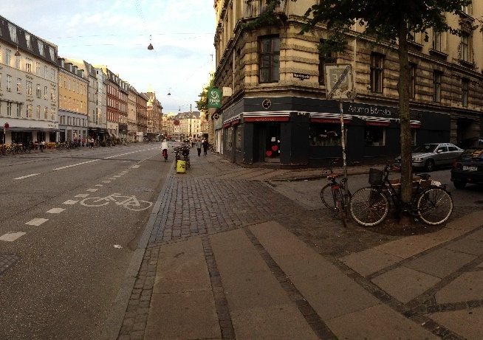  Copenhagen, Denmark | 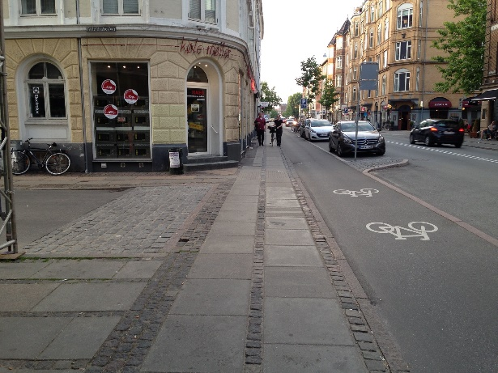  Copenhagen, Denmark
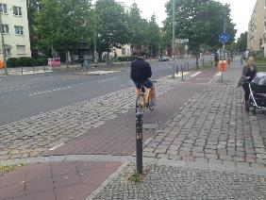  Berlin, Germany | 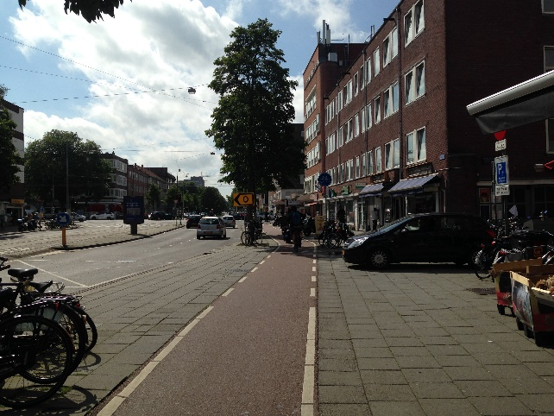  Utrecht, Netherlands
Figure1. Cycle paths moving across local street intersections in Europe
Table 1 below highlights some of the elements that make up these un-signalised intersections and compares how these pieces of the road network look and function in Copenhagen and Auckland. While the Auckland example in Figure 2 isn’t a protected cycle lane, the intersection is very typical of how a protected cycle lane would move past a local street.
Table 1 - Element attributes where an Arterial Street intersects with a Local Street
Elements | Auckland | Copenhagen
Arterial/ Distributor Road  width & notes | - 2-4 vehicle lanes wide  - often have a flush median  - bus lanes sometimes  - at the least, off peak parking, sometimes more | - 2-3 lanes vehicle lanes wide  - Bus lane sometimes  - no parking
Local Road  width & notes | - 9- 10m wide  - parking both sides  - always two-way operation | - 7.0m with parking both sides  - 5.0m parking one side  - Often one-way operation
Kerbs -  Corner radii | - Corner radii is greater than 6m  - Crossing distance at side street entrance is 14-20m | - No distinct corners  - Designed like a driveway entrance
Footpath | - Footpath ends  - Drop kerb down to road level | - Footpath treatment continues at same grade  - Changes in pattering of pavers or material
Pedestrian priority | None | Yes
Cycle path | - Green surfacing sometimes white dashed line  - Cycle symbol  - No protection | - Surface and width remain constant  - Cycle path still raised with short ramp provided beside cycle path or whole section of path slightly dropped
Bicycle priority | Yes if remain at road level | Yes
Movements into or out of Local Rd control | - Give way or stop control applies to vehicles exiting local road  - All turning movements into the local road allowed  - For pedestrians and people on bikes all movements allowed but not provided for | - Access for vehicles is restricted to either in or out due to common one-way operation  - No official markings or signage control are used but give way is implied through design.  - Pedestrians can move in any direction and remain at the same level and on what appears to be footpath. Bicycles can travel in or out of the local road but no specific bike facilities exist.
Deviation from desire line for pedestrians and bicycle | - Several metres of deviation for pedestrians  - None for bikes | None for either mode
Other markings | NSAA lines, limit line | - Bike symbols sometimes used  - Continuity lines
Exposure distance / length for peds and bicycles | Often between 15-20m | Up to 10m but often less

Auckland  Dominion Rd & Charles St | 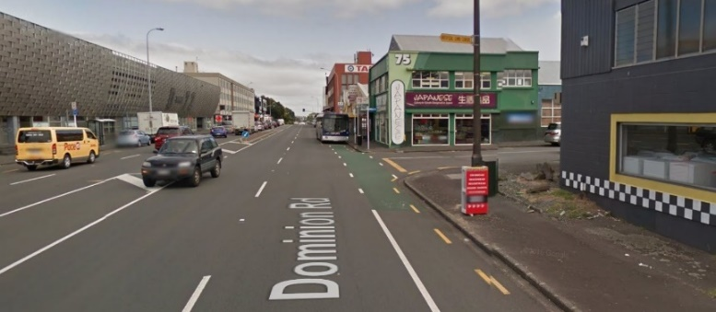
Copenhagen  Jagtvej & Kronborggade | 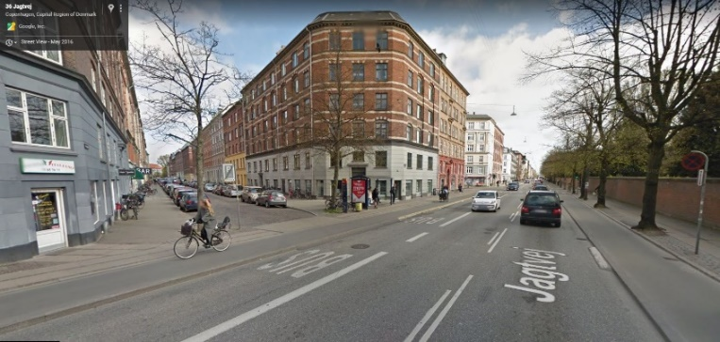
Figure 3. Arterial Rd meets a Local Rd with cycling provision in Auckland and Copenhagen
Table 2 Different User Experiences at a Typical Intersection of Local Street with Arterial Street
User Experience | Auckland | Copenhagen
Walking along Arterial/ Distributor Road | - Move off desire line to find pram ramp set a few meters back from local street  - Check if any traffic is entering or exiting before crossing  - Drop down to road level  - Hurry across  - Ramp up again to footpath level | - Remain walking along the street on the desire line  - For a short distance the texture of the paving changes  - Footpath grade remains constant
Riding a bike along Arterial/ Distributor Road | - Riding along on the desire line  - Cycle protection from vehicle traffic stops at local road entrance  - Turn to check behind me for cars that might turn into side street  - Follow green paint encased in a dashed white line  - Then back to protection on other side | - Riding along on the cycle path following the desire line  - Check to see if anyone is exiting the side street as it’s one-way road  - White cycle symbols are painted on asphalt  - Cycle path grade and material remains constant across intersection
Driving a car- into Local Road | - Slow down and move into the flush median  - Stop and indicate  - Check for cars coming in opposite direction, check for pedestrians and bicycles  - Accelerate into the local road when there is a gap | - Slow down, stop and indicate  - Check for pedestrians or bicycle crossing or about to cross local road  - It’s a busy road but drivers in the opposite direction wait to let me enter the local road  - Slowly enter, bumping gently over the ramps as I cross the cycle path and footpath
The value these cities place on access for the different modes is clearly communicated in these typical designs. For Auckland, motor vehicle access is very important, the road surface for cars is continuous, smooth and kerb radii is large, significantly reducing speed while turning into or out of the local street is not required. In comparison Copenhagen’s vehicle access is often limited, through one-way operation or just physical space, and levels and material changes communicate they are guests. For pedestrian access, Copenhagen definitely wins, providing a continuous experience in surfacing, levels and priority. In Auckland pedestrians are made to drop 150mm down to road level, with no priority and then try and cross. Access for bicycles across a local road is again much safer in Copenhagen than in Auckland. The un-hierarchical designs in Auckland mean both the local and the arterial streets have been prioritised for motor vehicles, which work fantastically for cars but no one else.
The reason these comparisons between the two cities have been made are to highlight that side street design for cycling is not a standalone piece that we can simply copy and paste into any Auckland street. While certainly there are elements and design ideas we can replicate I think we need to try to consider the streets as whole pieces as well as utilising street hierarchy to help steer key decisions around the use of elements such as parking and flush medians.
Key Design Concepts/ Approach when Integrating Separated Cycling Infrastructure at Un-signalised Intersection:
Keep it Simple - Simplicity was an overriding theme in the cities where cycling had been successfully integrated. Observing cycling infrastructure operating in many different cities confirmed my suspicions that as designers we should give humans much more credit for the way they may behave in particular situations. Often the default when we are not sure how people will behave is to overcomplicate and over design a site, particularly at intersections. An incredibly effective approach used in Vancouver and Copenhagen was simplifying,by removing some of the vehicle movements from an intersection thereby reducing the amount of conflicts possible.
Design to create the behaviour you want – ensure layout of intersections are providing safe, direct movements which provide a high level of service and experience. For example: offsetting the cycle path away from the arterial - while we may think this may be a ‘safer place’ for people on bikes to cross it may not be used by all due to the delay and indirect nature of the facility therefore you will get a range of behaviours from people on bikes which leads to confusion for other road users as to where to expect bikes.
Create a street where expectations are clear – This is both at the higher street level, to ensure the function of the street is understood, through the use of elements, materials and layout and therefore what type of users are likely to be encountered on the street. But this also applies at the intersection level, ensuring the design communicates through layout and materials who had priority and how to behave. Of course creating ambiguity certainly does present itself as a useful tool, through installations like Ponsonby Road raised pedestrian tables, or the raised table entrances into the shared spaces down Queen street. However, with these designs you could argue it is designing to indicate pedestrians have priority (which technically they don’t currently under our Road User Rules) but just shows how we can use design to our advantage.
Create Consistent Designs and therefore Behaviours – While consistency is often impossible to achieve in any roading context for various reasons, being consistent about how cycling infrastructure interacts with local roads at intersections will help to familiarise drivers and people on bikes as how to behave. Rather than having several different ways to integrate cycling infrastructure depending on turning movements etc.

STREET HIERARCHY
Role of Value of Street Hierarchy and Design
If we simply look at the different categories used for road hierarchy structures in both Copenhagen and Auckland it would appear from the descriptions, there would be a variety of different types of roads and streets. Unfortunately, the categories in Auckland are not translated onto the ground and identifying what type of road you are on is often impossible. Knowing which category of road classification is not critical to going about your daily life; knowing how to behave, navigate and what to expect from particular streets is really important and affects all road user’s safety and experience. Both the elements and the layout of roads and streets provide us with cues as to who the street is for, what the role/function of the street is, who to expect to find on the street and how to behave.
 | Auckland | Copenhagen
Local street | 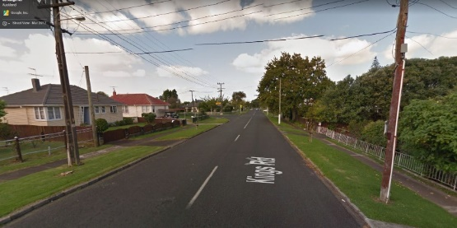 | 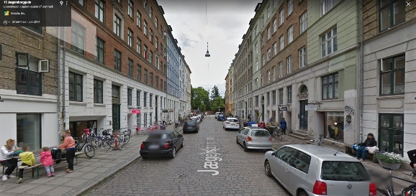
Collector | 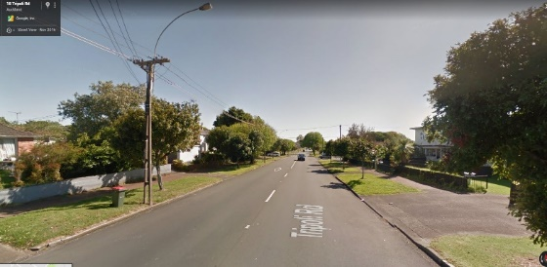 | 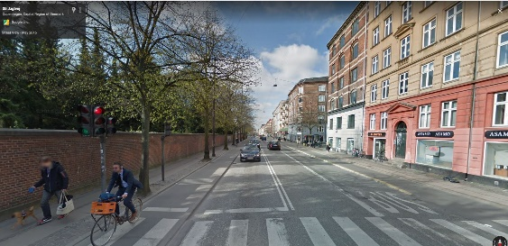
Secondary Arterial | 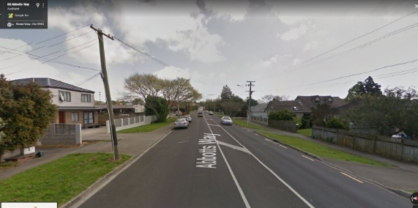 | 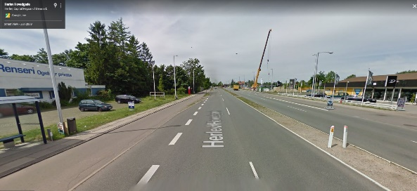
Primary Arterial | 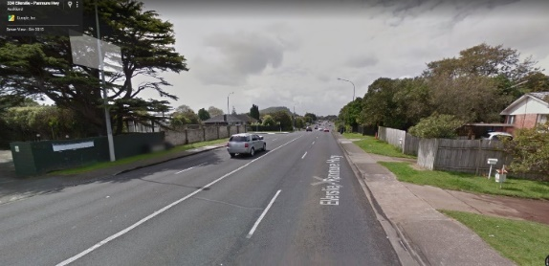 | 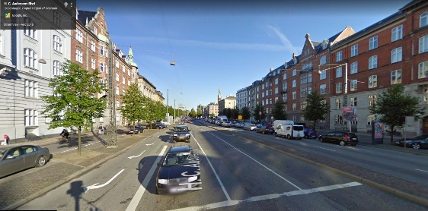
Motorway | 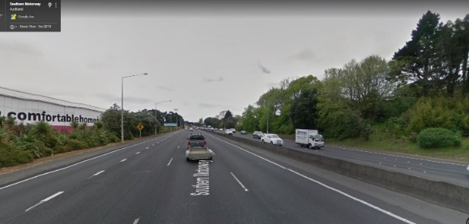 | 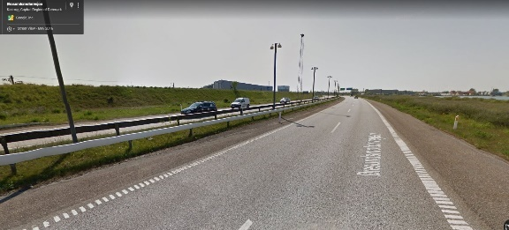
Figure 5. Poor Legibility of Auckland’s Streets, Compared to Copenhagen
The streets in Figure 5 in the Auckland column are from my local area, Panmure in east Auckland. Many of these roads I travel on frequently in my car, by bicycle and by foot. It was only when I arrived back in Auckland after my study trip and as I rode my bike to work daily it became so obvious to me how similar all the roads I travelled on to work looked and felt. All had kerbs and channels, asphalt carriageway, white paint markings, footpath, grass berm, parked cars, two-way operation and a 50km speed limit. While Auckland does have some better streets than these pictured, in the CBD and perhaps around Ponsonby, on the whole the images above of un-hierarchical streets are predominantly what makes up the bulk of the Auckland street network. Motorways are really the only quite distinct road type, with no parking and no access for pedestrians and a much higher speed limit.
The role and value that street hierarchy could play and contribute to a city is shown successfully by a city like Copenhagen. While Copenhagen actually might have one less official road classification, the depth and difference between their road types is distinctive and powerful and the street environments created as a result on some roads have not only become welcoming places for people on all modes but also become conducive and attractive to commercial and community activities/business.
The lack of depth in Auckland’s roads contributes to behaviours and expectations which are not conducive to any mode other than the car in regard to feeling safe, comfortable or welcome. We do need to recognise and resist the historical approach of applying highway type design guidance to all road typologies in our network; unfortunately, many current proposals still contain some of these approaches.
Vancouver
While aspects of Vancouver’s streets were certainly similar to our New Zealand streets, rear loading (where vehicle parking is provided via a rear lane behind the house) was more common. But like many other American cities, property frontages were designed to proudly address the street, which unfortunately seems to be vanishing in Auckland now, with many tall impermeable fences. While the bi-directional cycle facilities Vancouver had built in the CBD were great, it was the local street bike network which was super impressive. The value of this network, the ‘safety in numbers effect’ and the ease as a result of these routes to navigate around the suburbs of Vancouver on a bike and still feel comfortable was very compelling. There were often several people moving along the street at the same time during peak times and even off peak, because these routes were essentially gathering up cycle movements and consolidating them onto a single street. The basic premise/ approach of consolidating bicycle movements rather than just investing on every street to make it safer for riding worked and there was an immense sense of enjoyment and safety riding with others.
In terms of street hierarchy these ‘local street bikeways’ added an additional layer of hierarchy to the local street networks. The elements that created these routes were low cost, but consistent across the city and simple to understand. Here are a few examples:
- Controlled vehicle access
  - One-way access at one end of road, with bicycle and pedestrian access in both directions
  - Cul de sac/ dead ended a local street (often in the middle- splitting a street in half) –with pedestrians and bicycle access through, this also enables a social, gathering type space to be created at some of these points.
  - Restricted entrances - a raised concrete island used to remove what would be right turns(in NZ) into a side road, creating a left in left out operation for motor vehicles the local street bicycle route. As shown in image below the concrete islands contained cut-throughs to allow bicycle movements to continue along
- Elements
  - Simple green signage
  - Street trees, planted islands and berms- particularly distinct were the beautifully planted mini roundabouts
Controlled Vehicle Access One-way access  Cul de sac/ dead ended a local street | 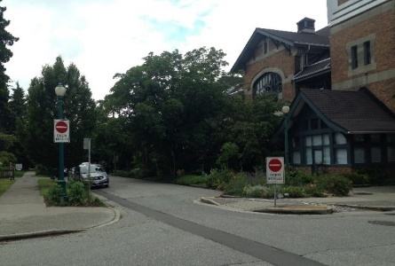 | 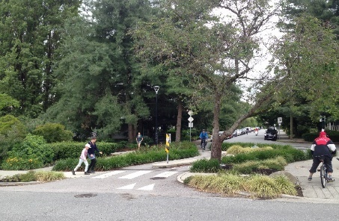
Controlled Vehicle Access  Restricted entrances | 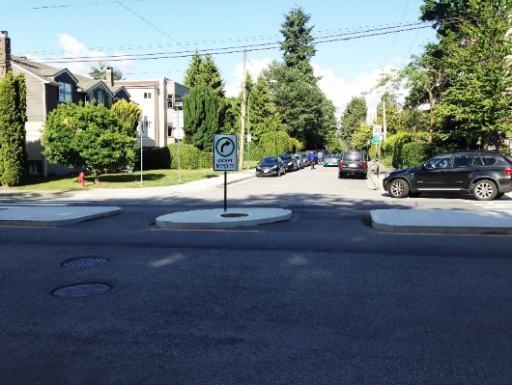 | 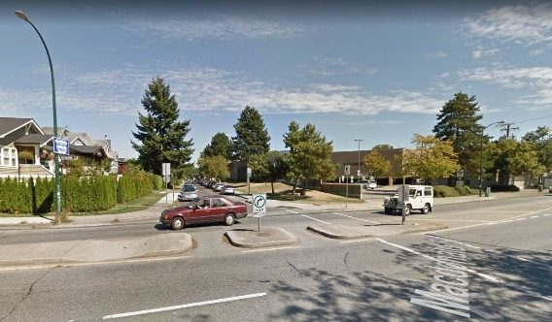
Elements  Simple green signage  Planted mini roundabouts | 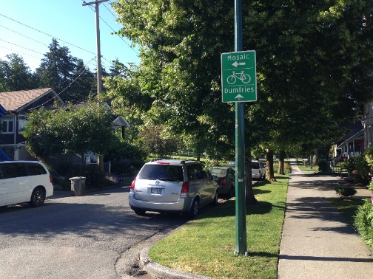 | 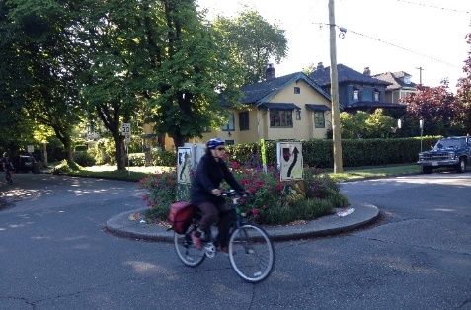
Figure 6. Designs & elements used to create Vancouver’s local street bikeways
While the simple signage and plantings added to enjoyment and effortless navigation of these routes, the true success of the local street bikeways came through considered control of where vehicles could travel. These local streets reflected the people who lived there, provided car parking, large street trees and a safe and easy place to ride a bike. The methods which Vancouver had used to gain control of the vehicle movement on these routes was not costly nor complicated which gave me considerable hope that we could borrow these ideas and implement them in New Zealand.
The local street bikeways formed the fine grain cycling network for the city and were spread across the whole city and suburbs, while the AAA network (All ages and abilities) was limited to coastal edges and roads in the CBD. By only having a couple of different types of bicycle facilities, using the bicycle to get around the city was simple and straight forward.
Copenhagen
In Copenhagen whether you were walking, riding a bike, sitting in a bus or driving a car it was obvious what type of street you were on. The basic elements that made up a street were either present in some form or another, or not. The differentiations were further highlighted once I began looking more closely at side street designs; it was the combination of materials and elements used, which so successfully communicated who the street was for, what the role of the street was, which users you would expect to find on the street and therefore how to behave.

Local
Typical Street | 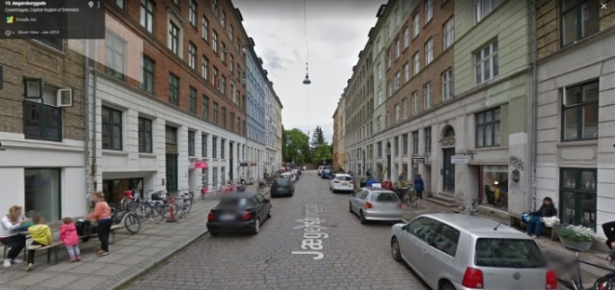 | Parking and planters | 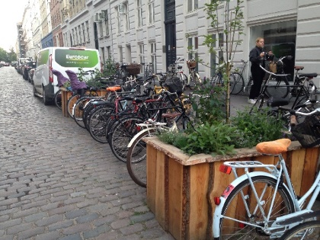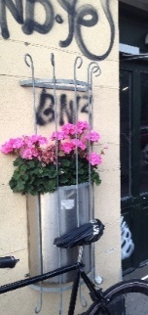
Places for gathering | 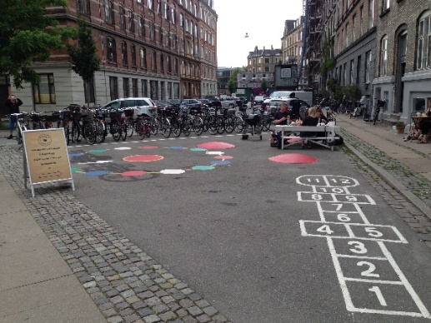 | Speed control | 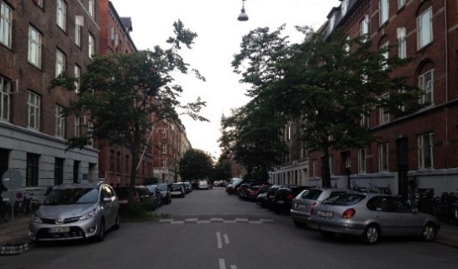
Local Roads: Most local roads were busy with parked cars, parked bikes and sometimes the odd planter boxes filled with herbs or flowers. These streets were clearly a place, a destination, an end and beginning point for locals and that was all they attempted to be. Speed on bikes or in cars was not important and was impossible to achieve, either due to cobbled street or speed calming devices. Trees were often squeezed in where the local street met a collector or arterial type road. Materials were textural and fine grained, limited paint markings were used and there often wasn’t space for street trees, but small pockets of green were squeezed in where they could.
Figure 7. Local Street designs and elements in Copenhagen
Distributor / Arterials: These roads were about movement, movement for all modes. Parking for motor vehicles did not generally exist and infrastructure running along these roads continued through past side roads, indicating these movements had priority and were important. Where constraints existed or a busy town centre was located, sometimes measures such as ‘bus only’ sections were implemented. Paint and coloured surfacing was used on these roads, albeit sparingly, so when blue was used for cycling it was highlighting a place where all road users need to expect and be aware bicycles will be. Asphalt was the common surface treatment for both bike paths and vehicle lanes. The footpath paving was a mixture of square pavers bordered with rough stone sets – this layout of footpath paving was repeated around the whole city and it was rather incredible how they had managed to retain such a consistent approach.
Distributor
Bus only section | 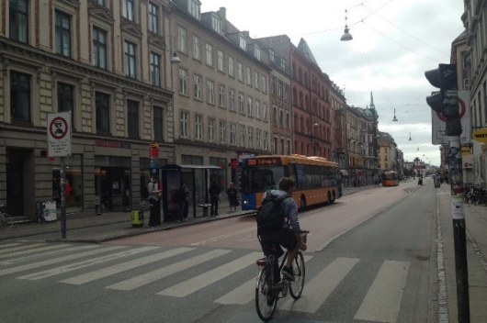 | Simple predictable layout | 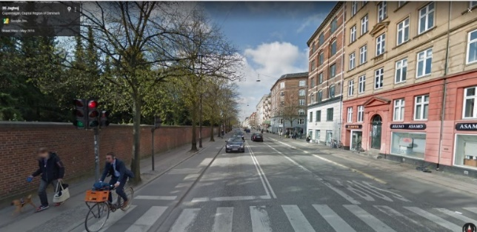
Sparing use of paint | 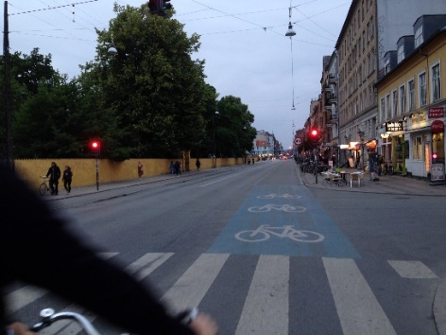 | Side street | 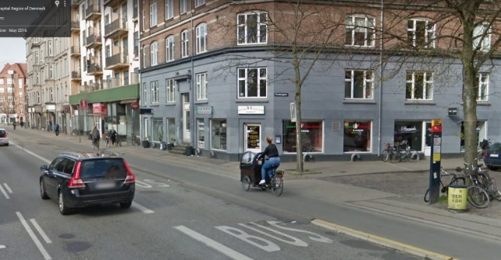
Figure 8. Distributor/ Arterial Street designs and elements in Copenhagen
Copenhagen’s streets, just like Auckland’s, seemed often to be constrained spaces where everything could not be squeezed in. Cleverly on many streets, due to the presence of tall buildings, the street lighting was fixed on wire between buildings; eliminating light poles from the street surface. The choices of what elements remained on the streets revealed the city’s priorities, the role that the street should play and how the city would like the street to perform.
The Roads and Streets Framework (Auckland Transport 2017)
The purpose of the framework was to fill a gap in guidance that was needed to guide both Council and external parties e.g. developers, to successfully design their roads and streets to better relate to their surrounding context and to serve users and the surrounding community. It describes, balances and integrates the intended strategic and local place and movement functions of roads and streets, as well as the levels of service for all transport modes.
The framework aims to provide a better way to take into account the wider social, cultural, economic and environmental outcomes than current approaches and uses nine different typologies. The typologies have been adapted from global best practise and take into account scale, density, quality of space, diversity of destinations as well as significant of movement by different modes.
This framework brings together place and movement considerations and has been developed together with the Transport Design Manual (Auckland Transport 2018), which provides the design and technical specifications for capital improvement and operational expenditure. Completed this year, new projects are beginning to apply this framework so it will be exciting to see these designs evolve.

Self-Explaining Roads in Point England
This is one of the few projects I know of that specifically attempted to address the lack of hierarchy in our streets. This project treated 7km of road with physical interventions to make the roads safer and more user friendly for all road users. A target design speed of 30km/hr, increased landscaping, reduced forward visibility through planting and removal of road markings were key interventions completed for the local street designs. For collector roads, an increase in delineation was implemented which included cycle lanes and priority crossing for pedestrians. A collaborative effort, this project’s design, monitoring and analysis was undertaken by TERNZ, Waikato University, Auckland City Council and Hamish Mackie. Significant speed reductions were achieved on the local roads and homogeneity of speeds were seen across both local and collector local, clearly showing the power of design to influence behaviours.
Maybury Street and Erima Ave in Point England
Local Rd | 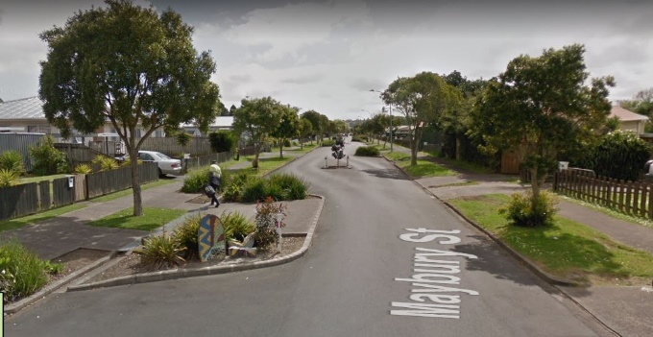 | Collector Rd | 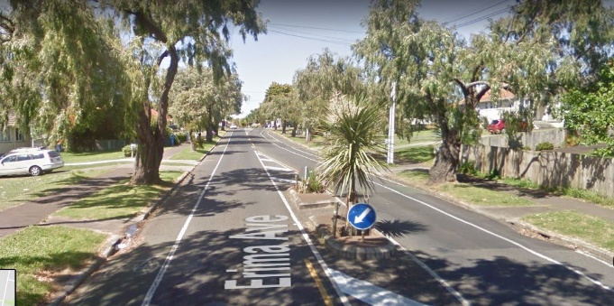
Figure 9. Reinforcing street hierarchy through design: Examples of streets that were treated in this project from Point England
SUMMARY
The number of people on bikes is increasing as more infrastructure and safe and attractive routes are created throughout New Zealand. While funding is being provided and infrastructure is built the guidance for cycling infrastructure and street design hugely influences what we will see on the ground. Currently many of the guidance documents and sources stay safely within the realms of what is legal and able to be ‘enforced’. Design as I experienced in many countries (even while bikes and pedestrians had modal priority) was very powerful in the way it influenced behaviours and networks. This is a tool we have in New Zealand we can use, so let’s reflect this in the cycling and walking guidance that is produced. When we are building new streets let’s build them to create the behaviours and speeds we want, when we are retrofitting let’s consider the whole street and how it fits into the network and always challenge the movements of motor vehicles at un-signalised intersections and ensure those movements are absolutely necessary.
A huge challenge ahead is that many New Zealanders have grown up with our roads and streets looking and feeling like they do now. Most New Zealanders then feel that we should have the right to park anywhere, on any road, never have to wait behind a bus as it picks up passengers and never have to wait behind a vehicle on an arterial that wants to make a right turn into a side road or driveway. Suggesting the removal or exclusion of the elements on a road that allow these expectations to exist makes complete sense in terms of being strategic, efficient with space and achieving some distinction in our street hierarchy; however, it will not be something that happens overnight or without a fight. Consultation is a key aspect to getting many new designs approved so this needs particular focus and care. But as public personally experience the positive outcomes that will happen as a result of these simplifications for all modes, many will be asking for more changes and faster. It has begun in Auckland though, as mentioned, raised tables following the desire line of pedestrians have been installed in Ponsonby, Queen Street and Newmarket.
This paper captures one aspect of a huge amount of learning and invaluable experiences from my Study Tour in 2016. The cycling design chapter, which will be part of the Auckland Transport Design Manual is currently being compiled and I am providing a range of input into this document. A more in-depth whole chapter on intersections is due to be developed in 2018.

ACKNOWLEDGEMENTS:
This study trip was possible due to the financial support from the Transportation Study Award that I received in early 2016 with some additional support from Auckland Transport.
Many people gave up their time to meet with me and show me around their city these people were, Kyle Rowe & Dongho Chang from Seattle, Mike Zipf from Vancouver, Erik Kjaergaard in Copenhagen, Lennart Nout in Rotterdam, Divera Twisk and Gert Jan Wijlhuizen in The Hague.

REFERENCES
AUCKLAND TRANSPORT (2017). The Road and Streets Framework. https://at.govt.nz/media/1974904/item-111-roads-streets-framework-and-transport-design-manualfinalcompressed.pdf
AUCKLAND TRANSPORT (2018). The Transport Design Manual.
BRIDGET SOUTHEY-JENSEN, et al. (2015). National Cycle Network Design Guidance
Stage 1 Report – Best Practice Review. NZ Transport Agency
https://www.nzta.govt.nz/assets/Walking-Cycling-and-Public-Transport/docs/national-cycle-network-design-guidance-stage-1-report-best-practice-review.pdf

