**HOW IS ROAD WIDTH RELATED TO HARM?**

**This paper has been peer reviewed**

**By Dean R Scanlen**

dean@e-outcomes.co.nz

BE(Hons)(Civil), CPEng, IntPE(NZ), CMEngNZ

Independent specialist traffic engineering and road safety practitioner;

**ABSTRACT**

This study correlated road width and harm resulting from midblock crashes over a range of speed limits. It was carried out to test the relevant guidelines in Waka Kotahi’s *Crash Estimation Compendium* because previous, much smaller, studies had not supported those guidelines.

Key inputs were publicly available road transport-related datasets, with mapping software used to identify crashes reported on the various study roads. The standardised social cost of crashes (SSCC) was calculated using the crash costs in Waka Kotahi’s *Monetised Benefits and Costs Manual* with standardisation by vehicle-kilometres travelled.

Key findings include: The SSCC on rural roads is several times that on urban roads. With sealed rural roads, SSCC increases with width on roads between 4.5 metres and 8 metres wide, then decreases with width on roads wider than 8 metres. Within a given width range, SSCC is generally higher on rural roads with lower traffic volume, often significantly higher. The results do not support the guidelines in the *Crash Estimation Compendium*.

On urban roads with more than a single effective lane, there is no obvious trend in SSCC by width. On unsealed roads, SSCC increases steadily with width. The *Crash Estimation Compendium* does not provide predictions for these roads.

A large majority of SSCC was due to a loss of control of a single vehicle, with head-on crashes also significant. Less than 10% of SSCC accrued from other crash types including those involving pedestrians.

The road data currently do not readily enable refinements such as the impacts of terrain and/or the presence of common road safety measures. The accuracy and ease of use of some data could also be improved. Future research should examine the suitability of the parameters used, especially SSCC, the use of vehicle-kilometres travelled for standardisation and statistical confidence.

**GLOSSARY**

AADT – the annual average rate of flow of vehicle movements on a section of road over a given time period; always 24 hours in this study.

CAS: The database of crashes on public roads that are reported and/or known to the Police.

MCBM: *Monetised Benefits and Costs Manual* version 1.6.1 (Waka Kotahi, June 2023).

Midblock: Sections of priority road route between intersections. It includes priority routes through both public side roads and private vehicle crossings.

Priority routes: Sections of roadway on which the vehicles have priority, so are not required to give way to other vehicles on other (side) roads, onramps or private accesses that connect to the priority route.

SSCC: “standardised social cost of crashes”. That is, the total social cost of crashes on a road dataset of specified characteristics, divided by the total VKT for the dataset. The social cost of crashes is calculated from the costs per injury crash in the MCBM. SSCC has been developed specifically for this study.

VKT: Vehicle-kilometres travelled – the length of a road section multiplied by the AADT over a specified time period.

**DEFINITIONS**

Rural roads: those having speed limits of 80 km/hr or more.

Urban roads: those having speed limits of 70 km/hr or less, although this study has only investigated urban roads with speed limits of 50 km/hr.

**INTRODUCTION**

This study correlates the harm caused by “midblock” injury-causing road crashes with the carriageway width of roads. It has been carried out because other studies, previously carried out by the author using much smaller datasets, have not yielded results consistent with current guidelines, especially section 3 of the Waka Kotahi *Crash Estimation Compendium[1]*. Furthermore, such predictions are currently only available for rural sealed roads[2] whereas a significant number of people, including many of our most economically deprived, rely on urban and/or unsealed roads.

Harm is defined by SSCC. This is a departure from previous methods, which generally considered harm in terms of the number or rate of injury-causing crashes. SSCC is considered a more accurate measure because, with recent[3] amendments to the social costs of crashes of various severity, there is a very large variation in social costs across the three injury crash categories. In particular,,an average fatal crash now has nearly 19 times the social cost of a serious-injury causing crash and close to 175 times that of a minor-injury causing crash.

The study considers three types of roads: Rural sealed, urban sealed and unsealed.

In addition to the determining an overall SSCC for each sealed road category and width range, the study has also considered SSCC by:

* the AADT within some sealed rural road width ranges; and
* the contribution of each crash type for the most common sealed rural width range considered – 6.5 to 7.9 metres.

These additional factors were considered because the data readily enables their analysis and they potentially also provide additional focus to both future additional research and economic analyses of options for road midblocks.

The results for sealed rural roads have been compared with the guidelines in Table 5 of the Crash Estimation Compendium, which have been converted into SSCC.

SSCC has not yet been considered by other potentially important factors including terrain or the presence of popular road safety measures such as barriers, wide centrelines and/or traffic calming. The public datasets do not include such information and obtaining it was not feasible in the time available.

**METHODS**

This study analysed publicly available road transport-related datasets to determine recent historic correlations between the carriageway widths of roads and SSCC on the midblock over a range of speed limits[4].

Width ranges include roads that provide only a single effective lane (defined as those with carriageways less than 4.5 metres wide). With sealed roads that provide two or more effective lanes, the study has considered five width ranges: 4.5 to 5.4 metres, 5.5 to 6.4 metres, 6.5 to 7.9 metres, 8.0 to 9.4 metres and 9.5 metres or wider. With unsealed roads, only three width ranges have been considered: less than 4.5 metres; 4.5 to 5.4 metres and greater than 5.4 metres. Each width range is considered to represent roads that most drivers would likely perceive similarly, while also providing an adequate sample size.

Applicable crashes are defined, for the purpose of this study, as midblock crashes in which the width of the road is likely to have at least some influence. That is, those coded in *CAS* in movements A (overtaking), B (head-on), C and D (loss of control of single vehicles), E (hit object), F (collision with the rear of other, slower, vehicles), N (pedestrian crossing), P (pedestrian other than crossing) and QE (equestrian) involving all vehicles and vulnerable road users. Crashes at intersections, in which the vehicle at fault has either missed the intersection or collided with another vehicle that is travelling on the same route, have been included but care has been taken to assign them to the route on which they were travelling. Crashes with factors such as impairment/intoxication, distraction, fatigue or excessive speed (other than during a Police pursuit) are also all included. The following crashes have been excluded:

* those that occur shortly after a vehicle has set off/is still accelerating (including intentional loss of traction); and/or
* those in which primary factors are given as assault with a vehicle, domestic disputes, medical events and/or a police pursuit.

The record of such crashes that result in injury or death, over a recent five full calendar year period (2018 to 2022), has been obtained from the *CAS* crash database. Other inputs include spatial speed limit data from the National Speed Limit Register and the National Road Centreline Dataset. The speed limit data have not been checked against the limit in place at the time of the crash. This is because the “when applied” dates in the National Speed Limit Register are incomplete. This gap in the data has been mitigated by only analysing roads with the most common speed limits[5]. Those have mostly also been in place well before the five-year period of the crash history used in the study and those roads also provide the largest datasets by far.

The crashes have been plotted spatially, using coordinates given in *CAS*. Those crashes that occurred on roads within each width range, and speed limit of interest, were then identified using a range of methods[6], isolated and the additional relevant parameters assigned to them[7].

The “social costs” have been calculated from the rates in the MCBM based on the severity of each crash[8]. Finally, SSCC was arrived at by standardising the costs – by vehicle-kilometres travelled as calculated from the AADT data included in the road centreline dataset.

The statistical confidence associated with the road datasets has generally been judged by the number of fatal crashes on each, not any statistical analysis. This defers to, and relies on, the guidelines for crash redistribution given in the MCBM.

The crash analysis methods in the MCBM, Appendix 2, include a “crash-by-crash” method for estimating crash costs. That uses the recent history of crashes reported to the Police and, inter alia, specifies the re-distribution of fatal and serious injury-causing crashes to average ratios also provided in the MCBM. However, such re-distribution is not required if three or more fatal crashes have been reported at a site. On this basis, a minimum of three fatal crashes has been taken as one indicator of an adequate sample size.

An exception was made with samples that have a similar VKT to other samples in the same types of road and on which 3 or more fatal crashes are reported. Another exception was made for urban roads narrower than 6.5 metres because only two fatal crashes have been reported on all of those roads in the entire North Island in which data are available. Samples that yielded fewer than three fatal crashes are noted with the results.

The study was commenced in the author’s home region of Tai Tokerau Northland but, to ensure adequate sample sizes, it was necessary to extend that dataset with all urban and some sealed rural road categories[9].

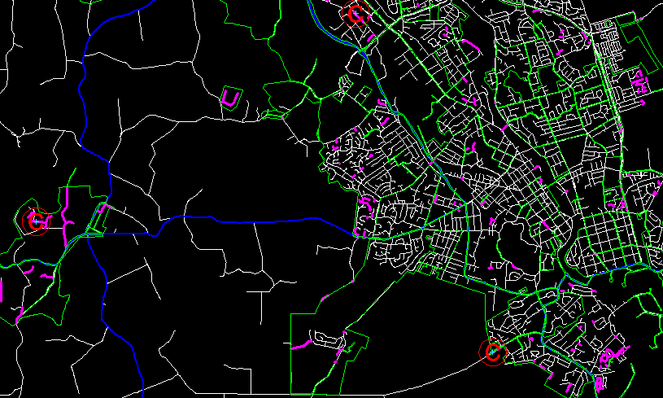

**Figure 1.** An example of the spatial data that has been isolated using the methods described, specifically in Hamilton City and land to its west. Magenta strings are public roads with 50 km/hr speed limits in the width range 5.5 to 6.4 metres; red Cs (in circles) are injury-causing midblock crashes reported on those roads in the period 2018 to 2022; blue strings are State highways, white strings represent all other public roads and the green polygons enclose roads with speed limits of 50 km/hr.

**RESULTS**

These are provided primarily in the form of charts with a brief commentary attached to each.

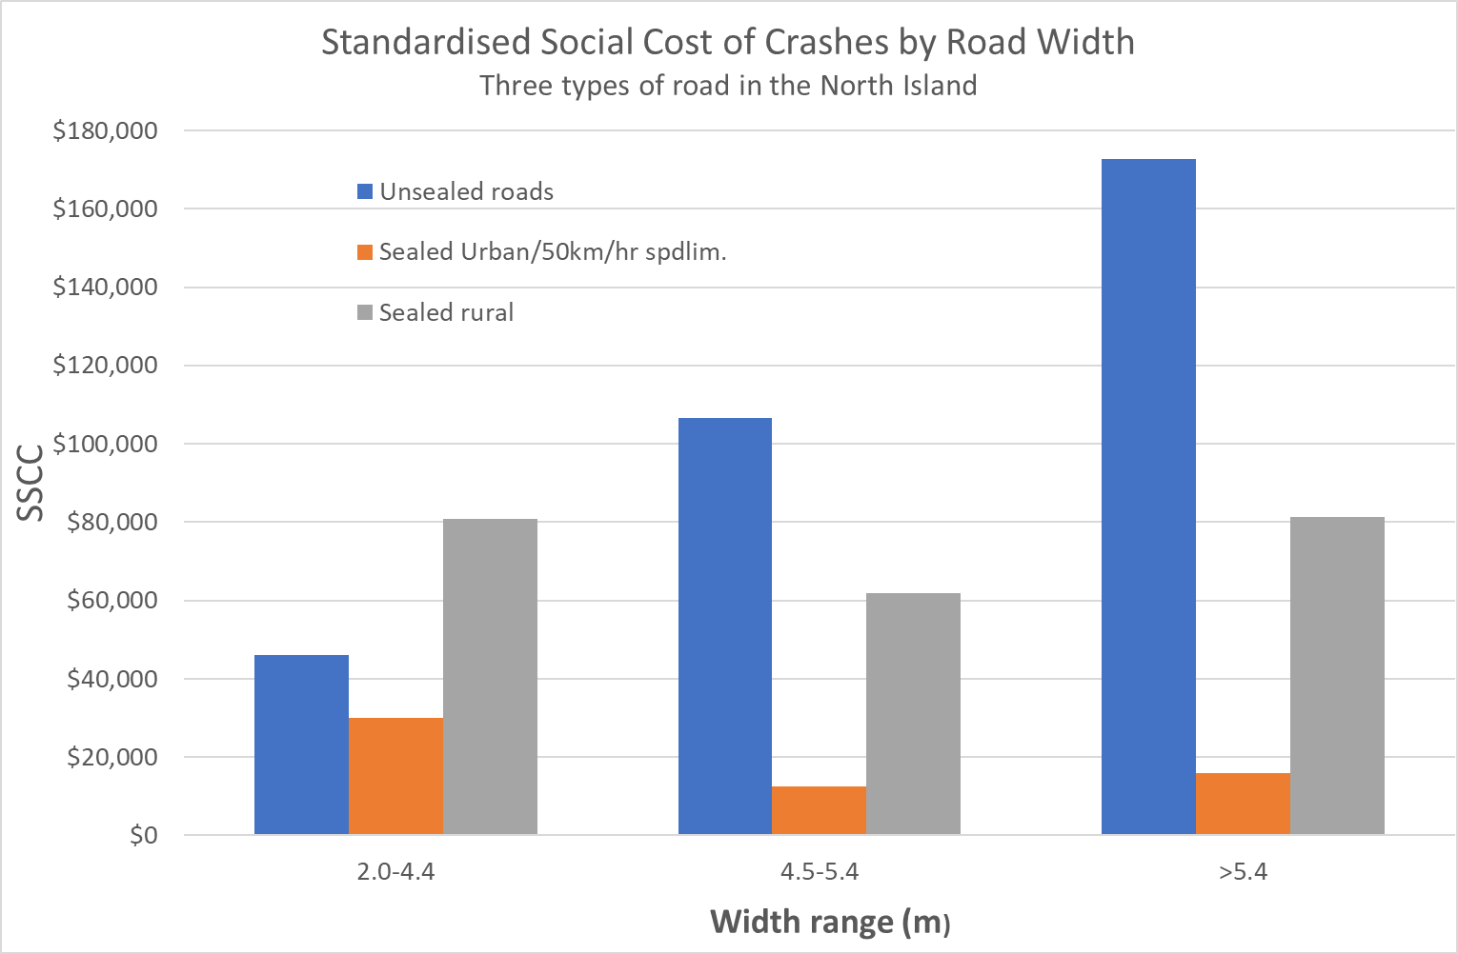

**Figure 2.** SSCC for all three road types over three width ranges. On unsealed roads, only one and two fatal crashes were reported on the two narrower width ranges respectively, but the total VKT over both ranges are very similar to that for the widest range in which five fatal crashes occurred.

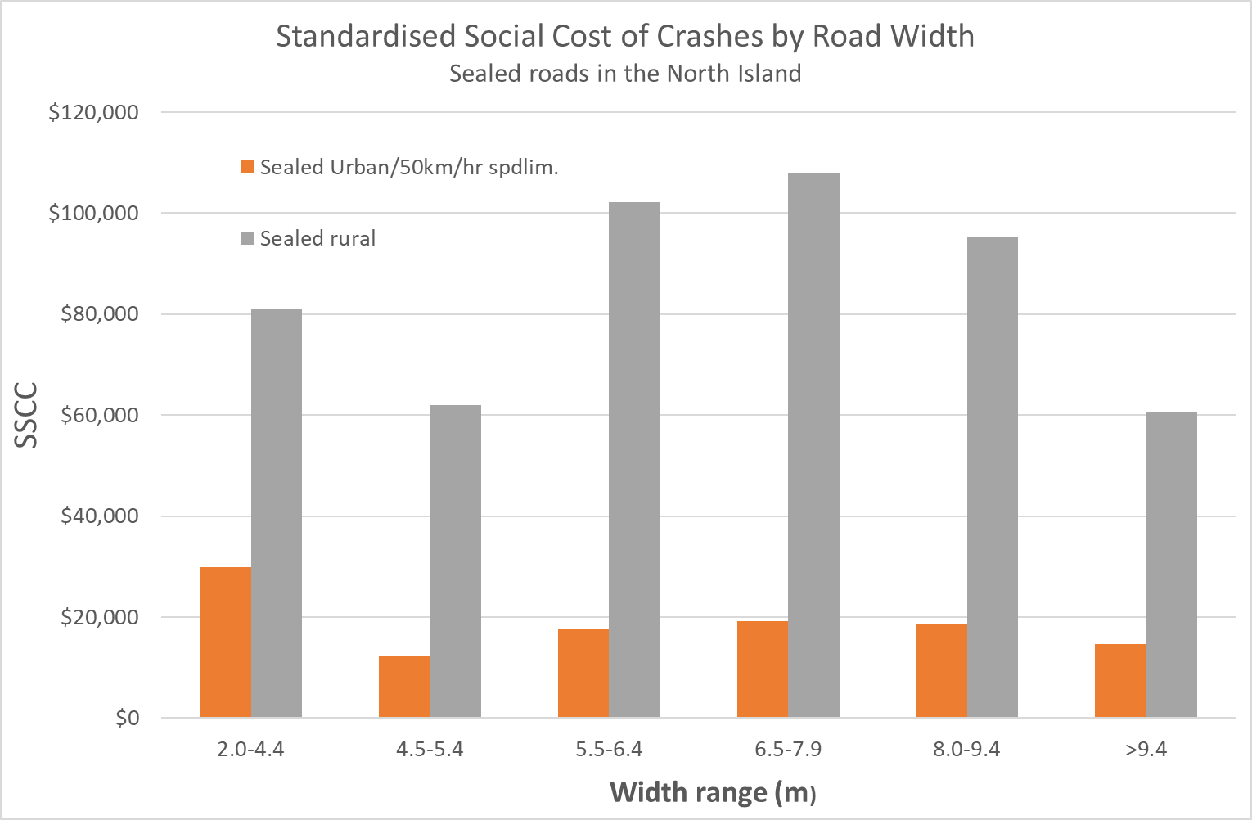

**Figure 3.** Afiner breakdown of width ranges on sealed roads only. For urban roads narrower than 5.5 metres and rural sealed roads that provide only a single effective lane, the datasets are likely significantly smaller than ideal despite being expanded to all available north island authorities. Further expansion of those datasets was not possible in the time available.

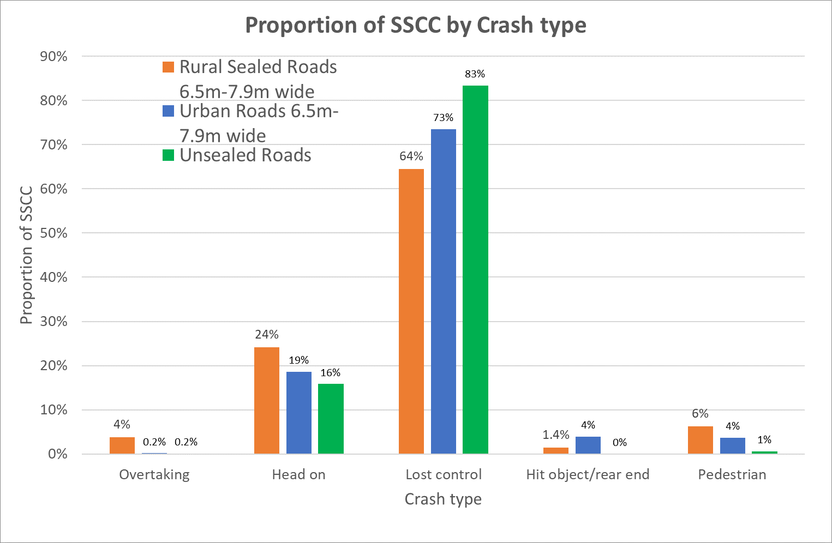

**Figure 4.** The proportion of SSCC for each of the crash and road types considered[10]. With sealed roads, this is only on the most common width range – 6.5 to 7.9 metres.

Figures 5 to 8 are the SSCC for the four most common width ranges on sealed rural roads, split into two ranges of AADT. With all but the widest range, the split is by the median of the VKT. These consistently show a higher SSCC for the less busy roads, usually significantly higher. For Tai Tokerau/Northland roads only unless stated otherwise.

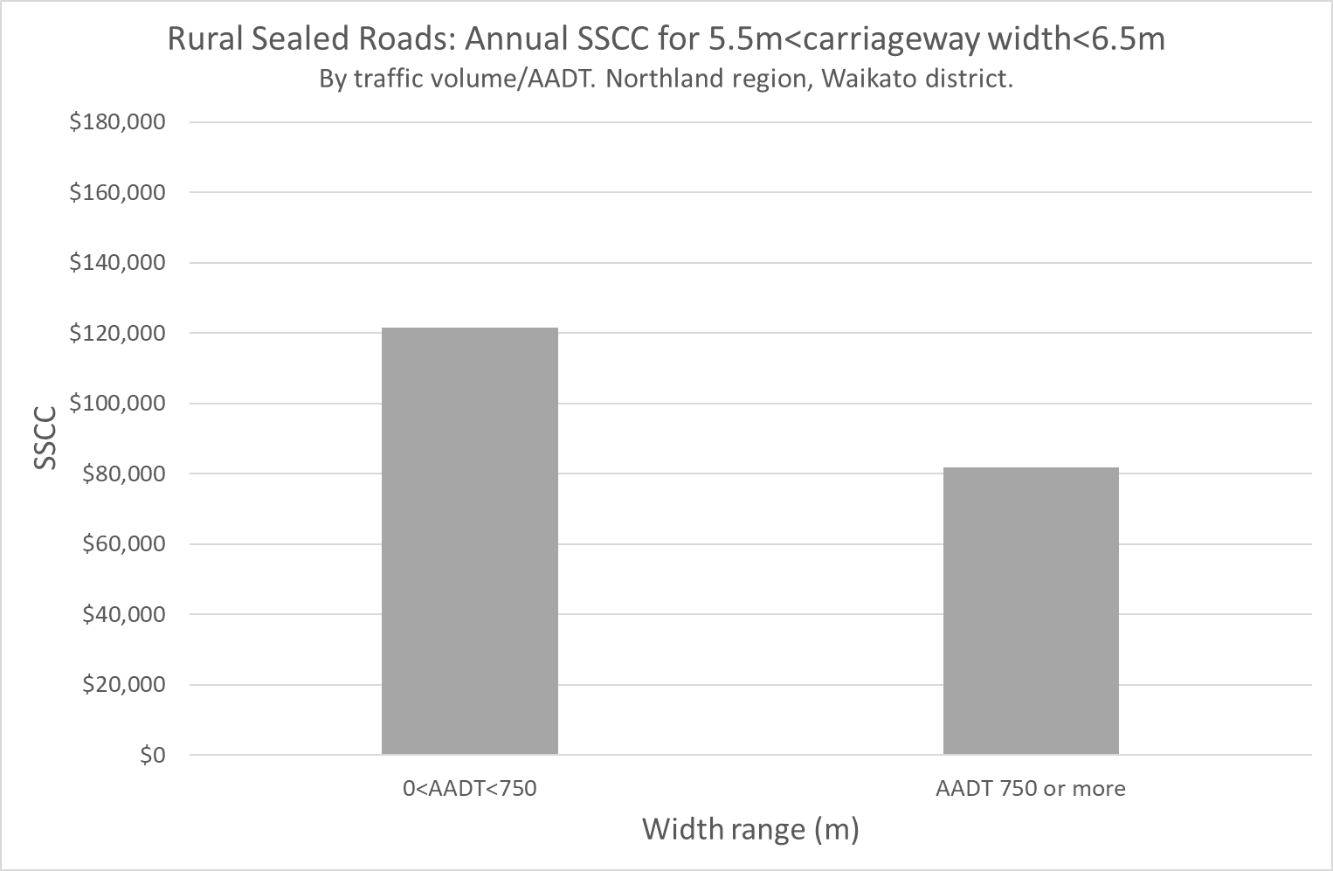

**Figure 5.** Annual SSCC by two ranges of AADT; rural sealed 5.5 – 6.4m wide

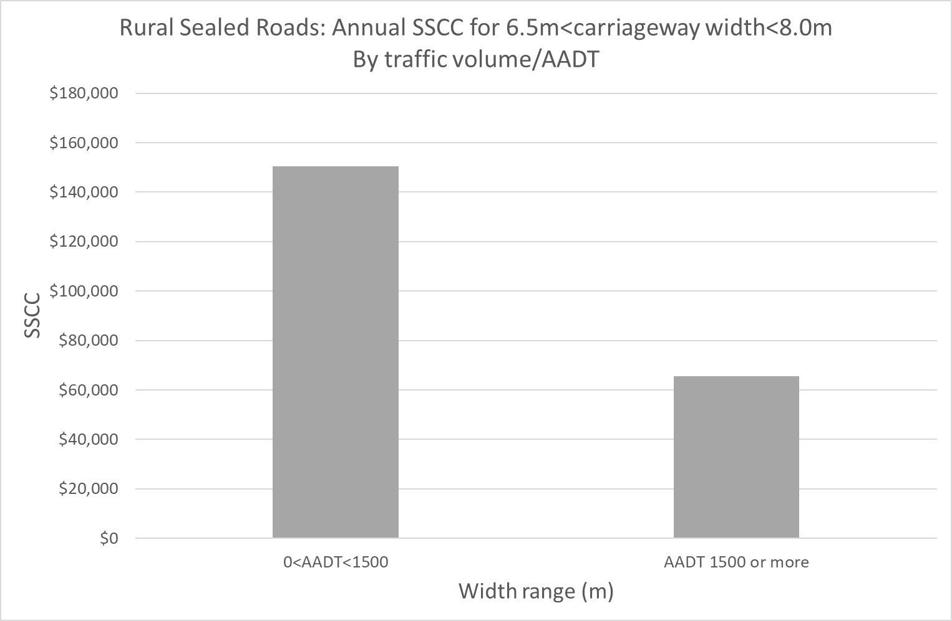

**Figure 6.** Annual SSCC by two ranges of AADT; rural sealed 6.5 – 7.9m wide

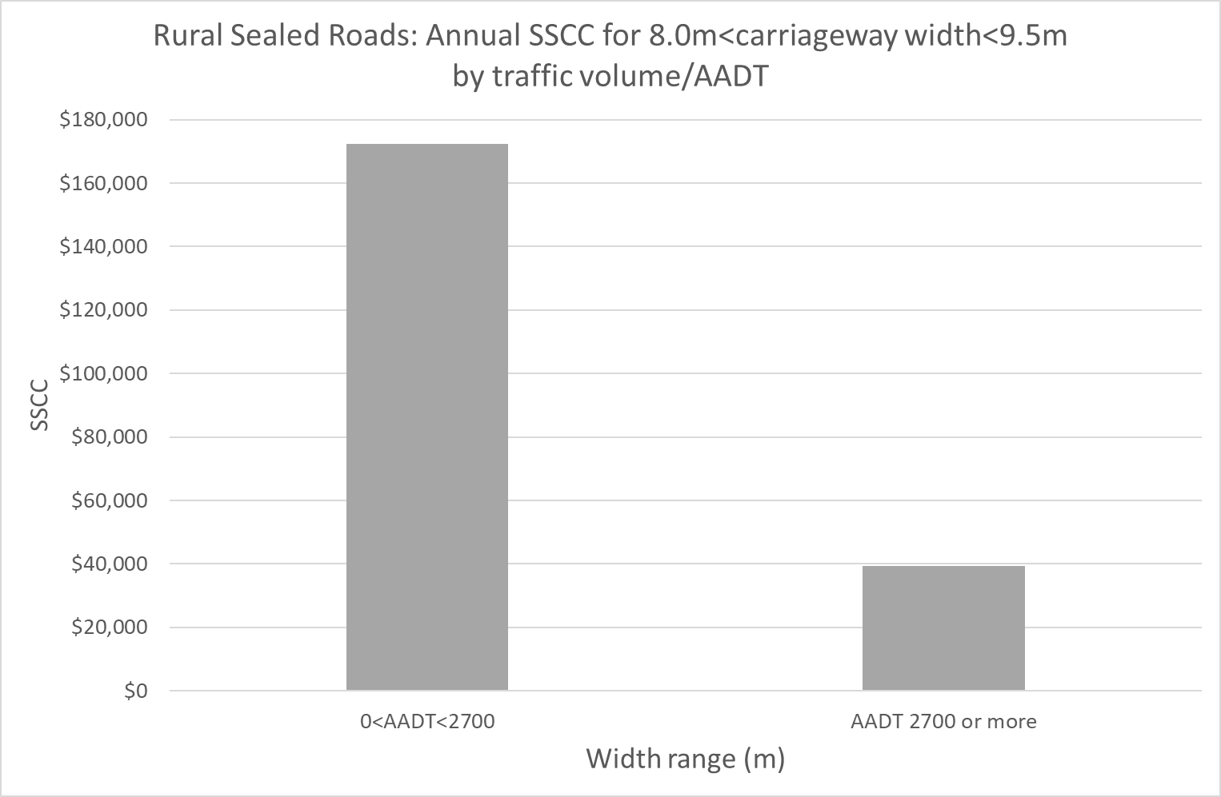

**Figure 7.** Annual SSCC by two ranges of AADT; rural sealed 8.0 – 9.4m wide

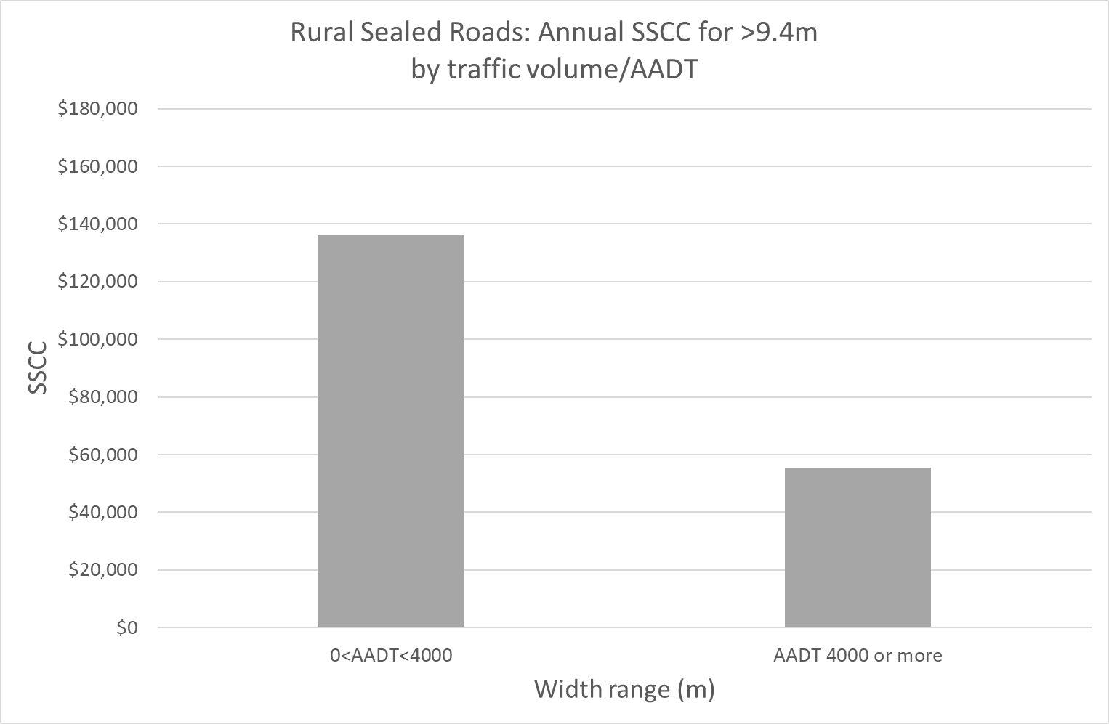

**Figure 8.** Annual SSCC by two ranges of AADT; rural sealed >9.4m wide

**COMPARISON WITH THE WAKA KOTAHI CRASH ESTIMATION COMPENDIUM**

The crash estimation compendium (“the compendium”) has models for crash estimation in sections 3 (rural sealed) and 4 (urban). Those include a “crash modifying factor” (CMF), but only for rural sealed roads, so this comparison is necessarily restricted to those roads[11]. Conversion to SSCC has been achieved using the cost per crash in the MCBM Table A36[12] and the full range of values of the coefficient b0[13].

Figure 9 is a comparison of the results of this study with the guidelines in the compendium and generally shows large differences. In particular, the compendium yields significantly higher values of SSCC for arterial and strategic roads, with the maximum values significantly higher even for “local” roads.

The compendium does not allow the calculation of SSCC for urban roads and has no guidelines for unsealed roads.

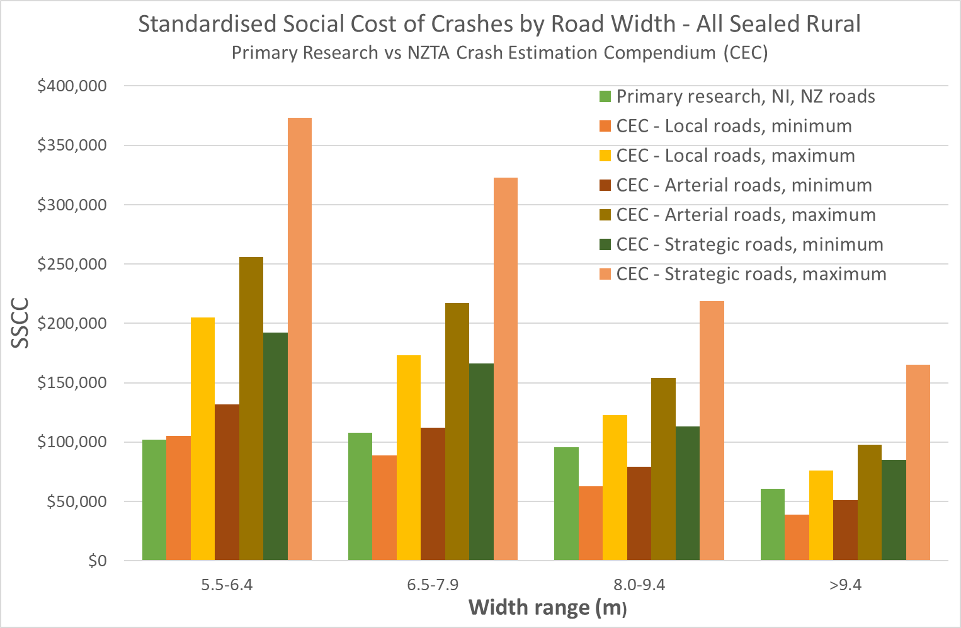

**Figure 9.** A comparison of the results of this study (“Primary Research”) with the guidelines in the Crash Estimation Compendium (Waka Kotahi, June 2018)

**NOTES ON DATA AVAILABILITY, EASE OF USE AND QUALITY**

The currently available road data do not readily enable refinements of the results produced by this study by other important parameters. This is because the data are limited in both their content and ease of use. In particular, the road data do not include terrain or proven safety measures such as the presence of barrier systems and/or traffic calming and/or wide centrelines. The influence of those measures should be investigated in more detailed if/when the data has been refined to enable them. A small number of site checks of some data also calls into question its overall accuracy.

The use of separate polygons for speed limit data required many hours of additional work to isolate the roads to each speed limit. This would have been unnecessary had the data simply been bolted to the road centrelines in the same way as all other data (that is, as metadata/string attributes).

Errors were regularly found in the coding of crashes. This is not likely to have affected this study because of the need to review the original reports, especially for serious crashes close to intersections. However, it is a potential issue for other studies.

High data quality and sophistication are important because of increasing pressure from the Government for the use of economic analysis to justify most improvements to our roads including safety measures. Data that is accurate, comprehensive and easily accessible is vital to this endeavour.

**CONCLUSIONS**

The key conclusions from the study are:

* SSCC on rural roads is several times that on urban roads.
* With sealed roads, SSCC is highest on roads in the width range 6.5 to 7.9 metres. On unsealed roads, SSCC increases consistently with increasing width.
* On all roads, SSCC is heavily dominated by crashes involving the loss of control of a single vehicle. Head-on crashes are also significant although some of those also start with a loss of control. Taken together, those two crash movements account for close to 90% of the harm on the midblocks of our roads. SSCC is likely to have a significant influence on the economic benefits of work on road midblocks, so this study strongly suggests that the focus in investigations of safety measures in midblocks needs to be on those two crash types (even in urban areas).
* For the most common sealed rural road width ranges, SSCC is higher on the less busy roads. This leads to a conclusion that is likely to be both surprising and potentially controversial – that the narrowing of less busy roads within given width ranges is likely to result in safety benefits. More research is necessary to confirm this conclusion and also to arrive at suitable traffic volume triggers and methods for any narrowing but, in this respect, the data analysed for this study yield a remarkably consistent pattern across a large range of rural sealed road widths.
* This study finds that the crash estimation compendium generally over-estimates SSCC on sealed rural roads, often significantly so. The compendium does not provide estimates of the crash rate, or SSCC, for either urban roads or unsealed roads and this is considered a significant information gap with it.
* Ongoing work to improve the quality and sophistication of data are important because of increasing pressure from the government for the use of economic analysis to justify most improvements to our roads, including safety measures, and for which accurate and comprehensive data is a vital input.

**RECOMMENDATIONS**

1. That the data used as inputs to this study be refined to include terrain and common safety measures such as the presence of barrier systems and/or traffic calming and/or wide centrelines.
2. That speed limit data be included with the road centreline dataset as metadata.
3. That future research examines the suitability of the parameters used in this study, especially SSCC and the use of vehicle-kilometres travelled for standardisation. Statistical confidence, especially of datasets based on lower numbers of serious crashes, also warrants attention.

**ACKNOWLEDGMENTS**

The study was made possible by the public availability of relevant data. The effort and commitment involved in obtaining and shaping the data[14], then making it publicly available online, is acknowledged.

**REFERENCES AND BIBLIOGRAPHY**

Waka Kotahi: National Road Centreline Dataset. Obtained through <https://www.nzta.govt.nz/about-us/open-data/national-road-centreline-data-request>. The data used in this study were downloaded in January 2023.

Waka Kotahi: National Speed Limit Register. Obtained through https://opendata-nzta.opendata.arcgis.com/datasets/NZTA::national-speed-limit-register-nslr/about

Waka Kotahi: *Crash Analysis System.* Accessed online using an approved license. The crash data used was for the 5 years to the end of 2022.

Waka Kotahi (April 2023). *Monetised Costs and Benefits Manual.* Especially Appendix 2. Available online at <https://www.nzta.govt.nz/resources/monetised-benefits-and-costs-manual/>

Waka Kotahi (June 2018). *Crash Estimation Compendium.* Section 3. Available online at <https://www.nzta.govt.nz/assets/resources/monetised-benefits-and-costs-manual/crash-risk-factors-guidelines-compendium.pdf>.

Turner, S., Singh, R., and Nates, G. (2012) *The next generation of rural road crash prediction models: final report.* Waka Kotahi Research Report 509.

Chadfield E (1992). *Review of cross section guidelines for two lane rural roads.* A Transit NZ internal file note marked “draft for discussion”.

1. Waka Kotahi is in the process of updating this compendium, but the more recent version has not been released at the time of writing this.
2. The Crash Estimation Compendium has a section on urban roads, but does not provide one of the factors in the key equation (“Crash Modifying Factors”). The Compendium is silent on unsealed roads.
3. April 2023 with the release of version 1.6 the *Monetised Costs and Benefits Manual* by Waka Kotahi. Version 1.7 was released shortly before this paper was submitted. The crash costs in it have not changed sufficiently to significantly influence the results of this study.
4. Only North Island data have been used. Standardisation was by vehicle-kilometres travelled.
5. 50 km/hr with urban roads, 80 to 100 km/hr with rural roads. All unsealed roads have been included irrespective of their speed limit, a large majority having speed limits of 100km/hr.
6. Most commonly visually from the maps.
7. Road width and AADT, neither of which are generally included in crash reports in *CAS*. The “Metaconnex” function on 12d Model software was used to extract the additional metadata.
8. $80,000 (urban) and $85,000 (rural) for crashes that result in minor injuries; $760,000 (urban) and $840,000 (rural) for crashes that result in serious injuries; $14.2 million (urban) and $14.9 million (rural) for crashes that result in fatalities.
9. Some datasets were extended to all but two North Island authorities that had provided data to the National Road Centreline Dataset by January 2023. The exceptions are Auckland and Taupo district.
10. With hit object and rear-end crashes combined because of their low total SSCC. No injury-causing equestrian crashes have been reported on any of these roads.
11. The relevant “crash modifying factors” vary from 0.41 to 2.11. The compendium provides factors for both lane and sealed shoulder width. Those have been combined for the purpose of this comparison.
12. $1.46 million per crash on rural roads.
13. Which relates to the horizontal alignment and varies from 18 to 37.
14. By all road transport authorities but led by Waka Kotahi.