IPENZ TRANSPORTATION GROUP 2018 CONFERENCE

WHERE THE STREETS HAVE NO NAME

Authors: | Chris Baker (Presenter)  BE(Hons), MEngNZ  Transport Engineer  WSP Opus  Chris.baker@opus.co.nz
 | Matt Evis

MSc, BSc(Hons)

Transportation Planner

WSP Opus

Matthew.evis@opus.co.nz

Phil Harrison

MSc, NZCE

Project Director Transportation

WSP Opus

Phil.harrison@opus.co.nz

ABSTRACT

Fiji's transport network faces many challenges, which fit in both the "Now" and "Tomorrow" categories. This paper covers the study with the objective of developing strategies to address both existing and forecast problems, issues and opportunities along four key road corridors, each of which has similar problems but also unique features. Common to all were road safety problems, poor journey time reliability, lack of capacity to cater for forecast growth, and poor network resilience, including against forecast sea level rise.

We will cover the obstacles that we needed to overcome to establish a sound evidence base. Traffic count information was sporadic, maps and aerial photographs were often out of date and many of the roads intersecting the main corridors had no names, or sometimes more than one! On the planning side, there were several gaps in available knowledge about future zoning and planned developments.

We will outline the range of data capture exercises undertaken, including drone and vehicle mounted videos taken along the routes. We will cover how we worked with the FRA, Councils and Town and Country Planning in compiling future land use scenarios for 10 and 20-year planning horizons.

Consulting effectively with local Councils, developers, utilities authorities and regional Government departments was crucial and we will discuss the different approaches we used to maximise the level of engagement with these stakeholders in problem identification and objective setting workshops.

We will describe how options were developed and evaluated, and how we again engaged with the stakeholder groups to obtain endorsement of the action plan, which will see these corridors transformed into safe, efficient and resilient connections between communities, industries and attractions over the next 20 years.

Finally, we will ask delegates whether they agree with the approach to build more road capacity to address growth, or whether alternatives are appropriate in the Fiji context.
- INTRODUCTION

The Fiji Roads Authority Transport Studies were undertaken in 2016 and were commissioned to identify existing and future problems and opportunities on four critical transport corridors in Fiji.

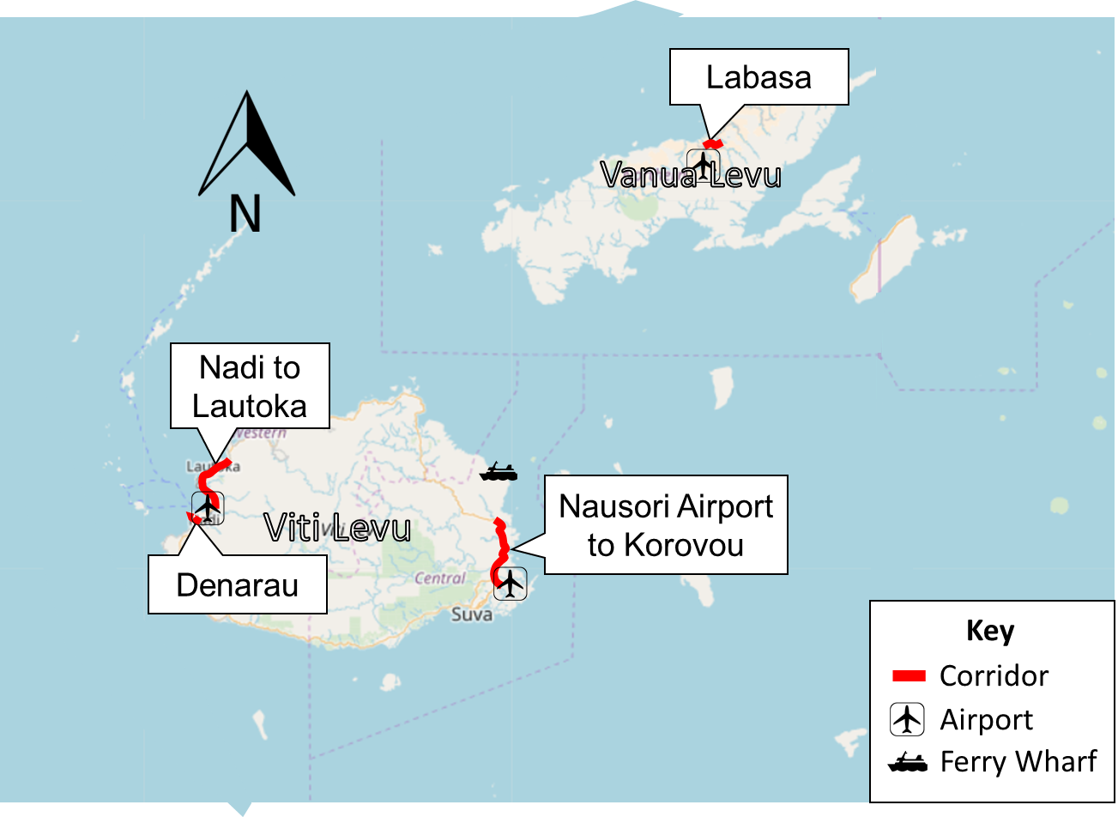
Figure 1 Context Map

As shown in Figure 1, the corridors are spread across the two main Fijian islands of Viti Levu and Vanua Levu. Common to all corridors was economic dependency on the main road, a lack of route resilience and poor road safety. Key elements of the study corridors are:

- The 27 km Nadi - Lautoka corridor connects the international airport and tourism hub at Nadi with Fiji’s second largest city and major port at Lautoka. Catering for projected growth (tourism in the south, commercial in the north), route resilience and safety were major drivers.
- The Denarau Road corridor connects Nadi Airport and town with the tourist resorts on Denarau Island, a distance of 6 km. Identified issues were resilience to flooding events, lack of provision for active modes and capacity to cater for expected growth.
- The Nausori - Korovou corridor (34km) connects Suva and its airport with the northern provinces and ferry wharves. Resilience is a major issue as the alignment closely follows the Rewa River with constant threats of dropouts/undercutting and passes through a hilly, geotechnically unstable environment. Traffic capacity through Nausori town centre and road safety were also issues.
- The Labasa Transport Study focussed on improvements to capacity, safety and removing cane trucks from the main shopping street, and resolving issues with the bus station.

- PROJECT APPROACH

The approach adopted for the project was generally in line with NZ Transport Agency’s Business Case Approach. Work on each corridor was developed through two Working Papers (Problem Identification, Option Development) and a Final Report (including implementation strategies and financial forecasting).

A six-stage process based on the NZ Business Case Approach ensured that problems were understood before options were developed, decisions were made and confirmed at several stages and that solutions were evidence-based and aligned with FRA strategies.

Effective stakeholder engagement was critical to the success of the project, due to the need for project buy-in, and local knowledge or gaps in available data.

- Data Collection

The project team found that much of the data readily available to transport planners and engineers on projects in New Zealand was limited or non-existent in Fiji. While there was access to strategic documents from governing bodies, historical traffic counts, crash records and planning documents, they were dated and did not necessarily align with local or regional strategies, or stakeholders’ understanding of existing issues.

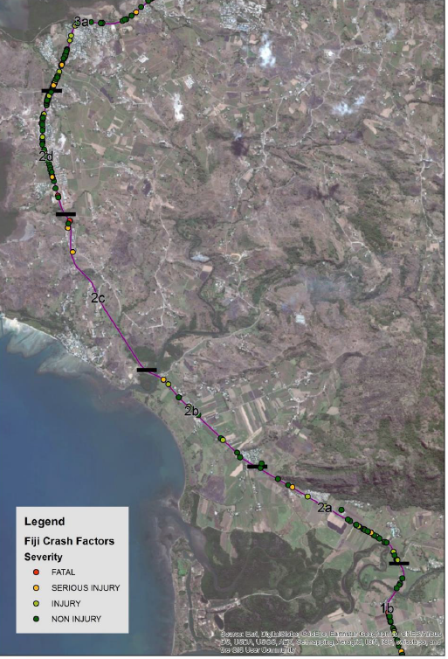
Fiji has a GIS-based national crash analysis software interface that has vastly improved in recent years (there was previously just one computer that could access the crash database). Having accessible crash data provided insight into the broad road safety issues facing each corridor; however, detailed categorisation of recorded crash data within the system was limited and the project team had to classify crashes based on crash report comments alone. It was assumed that underreporting of crashes was higher in Fiji than in New Zealand; anecdotal evidence of fatal crashes on some corridors was not reflected in the data, so care was used when drawing conclusions.

Additionally, data was missing from sections of the corridors (Figure 2), suggesting an issue with geo-referencing. Crash data was therefore used to broadly describe the corridor-wide road safety issues and themes, rather than to identify blackspots and localised improvements.

Historical traffic count data was scarce; partly due to the lack of a nationally structured traffic counting programme. Traffic turning count survey data was available in the main urban areas from historical projects, but was largely outdated (5+ years old). Camera surveys were undertaken with number plate recognition software, which provided a basic understanding of regional origin-destination movements and travel times along corridors.
Figure 2 Crash Map illustrating apparent data gap

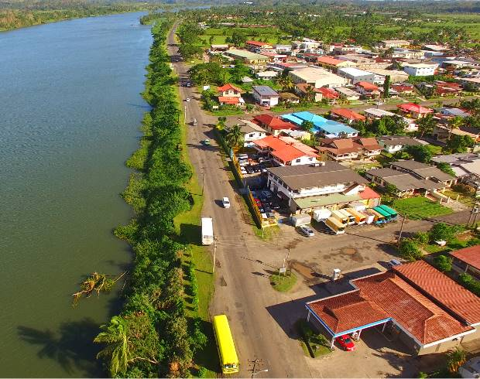
Ubiquitous in modern transport planning projects, online maps and satellite images make it possible for practitioners to familiarise themselves with road corridors without leaving the office; particularly useful for a New Zealand based project investigating Fijian roads. However, village and road names were found to be inconsistent between sources, or not named at all, on maps and on the ground. Aerial images were outdated and elevation data was coarsely grained. The project team needed a thorough understanding of the local area when engaging with stakeholders. To combat inconsistencies across maps, the project team compiled corridor drive-over videos and commissioned drone flyovers of study areas (Figure 3).

Making up approximately 8% of Fiji’s exports and 1.7% of GDP, sugar (and its efficient transport) is critical to the country’s economy. Raw sugar cane is transported to the country’s four mills by a combination of rail and road. Despite contributing a significant proportion of the freight on Fiji’s roads, little data on the transport of sugar was publicly available. The Fiji Sugar Corporation provided tonnage and rail/road split data, but no traffic volume data. Some of the traffic surveys described above differentiated between cane trucks and heavy vehicles, which helped to identify key sugar movements.
Figure 3 Drone Footage, Nausori

- Forecasting

Where a corridor spanned the jurisdiction of two or more local councils, it was found that information or enforcement differed between organisations, increasing the uncertainty in forecast future trip generation and traffic volumes.

Stakeholder engagement became critical to understanding the future (and current) form of the corridors. There were no existing strategic traffic models of areas outside Suva, so corridor models were created in SATURN to assess future performance, based on an understanding of land use proposed along the route. SATURN was chosen as it enabled a cost-efficient model build at an appropriate level of detail to assess the impact of the do minimum situation and of larger scale interventions such as bypasses and four-laning.

- Initial Engagement Workshops

Internal workshops were set up with FRA and their asset management consultants to establish the authority’s strategic visions and objectives for each of the corridors, and identify the issues and problems along each corridor from the owner’s perspective.

- ISSUES AND OBJECTIVES

Fundamentally the transport issues facing Fiji are much the same as anywhere else in the world - road safety, resilience, traffic congestion and facilitating growth. It is the cause of the issues and the way in which they manifest themselves that is unique to Fiji.

- Road Safety

Roads in Fiji are generally of lower standard than New Zealand, with 95% rated below 3-stars in the International Road Assessment Programme (as of 2013). There are 59 fatalities per 100,000 vehicles on Fiji roads per year, seven times the figure in New Zealand. Nationally, attitudes to road safety are relatively relaxed, however the Land Transport Agency run extensive billboard campaigns promoting issues such as safe speeds, seat belt use and courteous driving. During site visits, the project team observed examples of dangerous driving, low standard of vehicle safety and dilapidated roads.

Common to all corridors in the study were a high frequency of crashes involving pedestrians and crashes caused by speed and fatigue. Identifying and combating road safety issues will contribute to Fiji Government’s target of halving the number of fatal crashes by 2020.

The study found that surprisingly few crashes were alcohol-related, with just 0.5% of crashes recorded as having alcohol as a factor (compared to 27-33% of crashes in New Zealand). Under-reporting is expected to contribute to these figures. Additionally, we do not know whether systematic alcohol testing is undertaken after a crash but suspect it is not.

At stakeholder workshops, kava (a traditional beverage with soporific properties) was suggested as a cause for the high frequency of fatigue-related crashes. Indeed, driving following kava use has been associated with a four-fold increase in the odds of crash involvement. As no in-situ test is available for detection, there are no prosecutions against driving under the influence of kava.

Outside the main urban areas, provisions for active modes are lacking or substandard; footpaths and lighting are generally limited to town centres and retail areas. Even the major trip attractors, such as sugar mills and schools, can be disconnected from residential areas; as a result, many pedestrians walk on the carriageway. Despite the lack of safe facilities, walking retains a large mode share, particularly in areas of lower socio-economic standing.

Some road safety improvements commonly applied in New Zealand have not been successful in Fiji:
- Raised reflective pavement markers (cat’s eyes) - attempts to find a method of adhesion capable of withstanding the conditions have so far been unsuccessful.
- Variable speed signs - a trial installation was not maintained and stopped working when it rained.
- Edge marker posts - the posts were soon chopped down with machetes (commonly carried by agricultural workers) - there are examples of villages creating their own, that doubled as placemaking features (Figure 4).

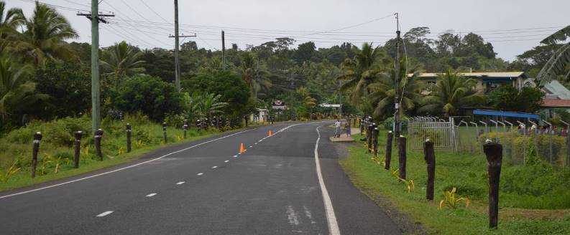
Figure 4 Village Implemented Placemaking Edge Marker Posts

- Growth

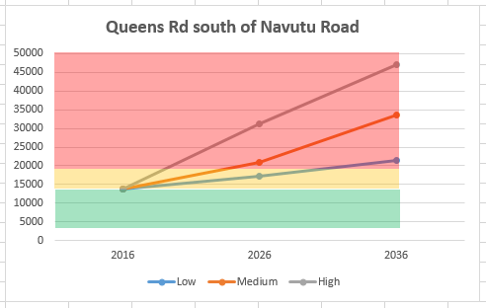
Intensive localised population growth is forecast as Fiji’s economy develops and urbanisation continues. The Greater Suva Region is forecast to see a 3.3% annual linear growth rate up to 2021. Coupled with rising car ownership, the Nausori area is forecast to experience traffic volumes in the order of 45,000 vehicles per day (more than existing volumes on Hobson Street in Auckland) on some roads under the high growth forecast (Figure 5).

As the tourism industry develops, both of the country’s international airports are expected to significantly increase the number of flights operated; Nausori airport plans to double the number of passengers served annually in the near future. Key to developing solutions on all corridors was the ability to facilitate expected growth without detriment to other objectives.
Figure 5: Example of Traffic Growth Forecasts

- Resilience

Simplistically, Fiji’s national road network can be considered as a series of single island loop roads with limited connecting links (for example, Kings Road / Queens Road around the circumference of Viti Levu). Providing route resilience on the corridors has proved to be cost-prohibitive due to low population density away from the main towns and geographic constraints due to the mountainous interior. There has been little need for additional routes from a capacity perspective and investment has mainly been reactionary, targeting short-term issues.

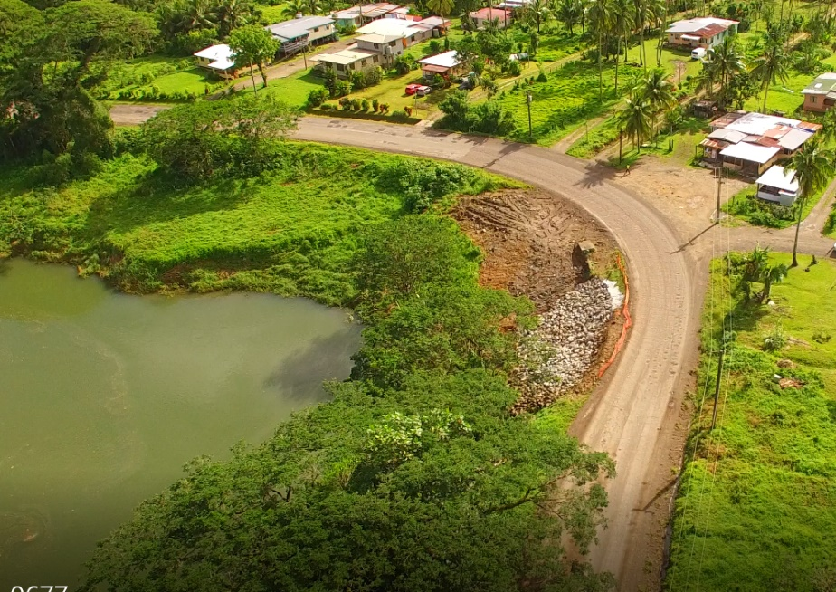
Regular slips on Kings Road during 2016 closed the main route between Suva and the wharf hosting the ferry connecting the other Fijian islands. The resulting detour added 5 hours travel time to a journey that typically takes 2 hours. Thus, the lack of resilience is restricting the national economy and, in the case of natural disaster recovery, could cost lives. Now and tomorrow, Fiji is facing the prospect of climate change, which is predicted to bring about an increase in rainfall and sea level. On a corridor level, existing assets need to be protected and new ones need to be considered.

Kings Road north of Nausori follows the Rewa River for about 5 km. At some points the road is adjacent to the river and regularly suffers from slips, which due to the lack of an alternative route, cut off the hinterland until repairs can be made (Figure 6)
Figure 6 Kings Road Nausori, Rewa River and recent slip

- Freight

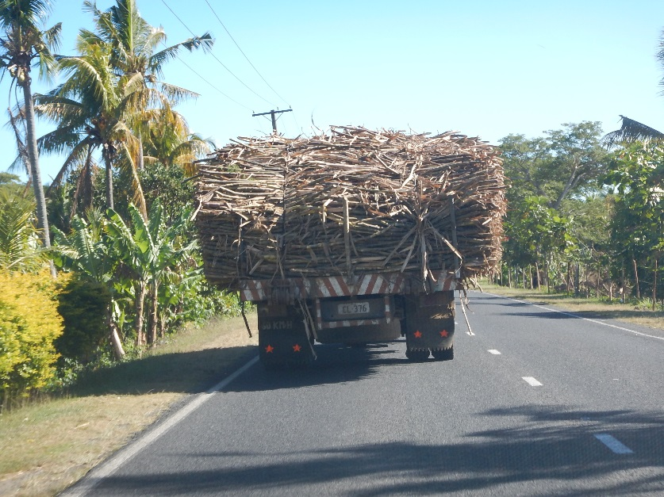
The sugar industry is seasonal, with cane being harvested and transported typically over a 24-week period. Despite an extensive rail network (732km of track and 76 locomotives) dedicated to transporting sugar cane, the majority (77% at the Lautoka Mill) is transported by road. As documented above, there are typically no alternative routes to the mills, which means trucks must travel through town centres, competing for road space with general traffic.

The fleet of 9,800 trucks is ageing and overloaded trucks frequently break down, causing severe congestion in town centres and safety hazards in rural areas. As shown on Figure 7, the load is permitted to overhang the truck by up to 0.5 metre either side, so the total vehicle width can be 3.5 metres. There are documented cases of pedestrians being hit by sugar cane overhang. A key consideration for the Labasa project was separating cane traffic from urban areas and the benefits that could be provided both economically and socially. The sugar industry has been in decline over the past 10 years and most investment is concentrated on improving yields at the mills themselves. Similarly, farmers do not have the financial resources to invest in their own vehicles.
Figure 7 Cane truck with overhanging load

- Public Transport

Buses are an integral part of the transport network. They are relatively cheap, frequent and have a wide coverage, but are not well regulated. There is little infrastructure provided outside of bus stations in major towns, which themselves are variable in quality, safety and the ability to cater for the number of buses in use. Dwell times can be very long as drivers often wait until the bus is full before moving off. Along many routes, drivers will pick up and set down passengers wherever requested, causing safety and road shoulder maintenance issues.

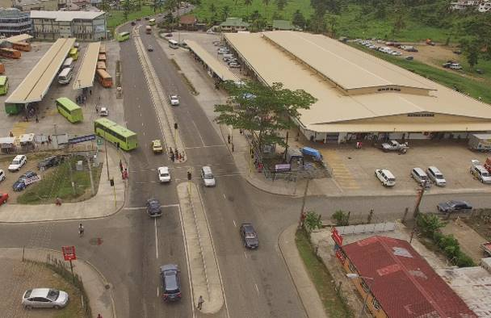
In Nausori, a relatively recent town four lane bypass has been followed by the development of a new bus station on one side of the new road, and of a new large produce market on the other, resulting in a very high number of people walking across the road between the two (Figure 8). A signalised crossing has subsequently been installed, but is often ignored. This example of poor land use and transport integration is not unique to Fiji, but is typical of the response to development pressure in a growing economy.
Figure 8: Nausori Bypass, Bus station and Market

In Labasa, the bus station and market are again adjacent but at least situated on the same side of the main road. However, the bus station suffers from poor layout, insufficient capacity and a lack of safe walking routes. Due to the lack of capacity (and the tendency for drivers to wait within the bus station until their vehicle is full before departing) buses regularly queue back onto the main road (Figure 9).

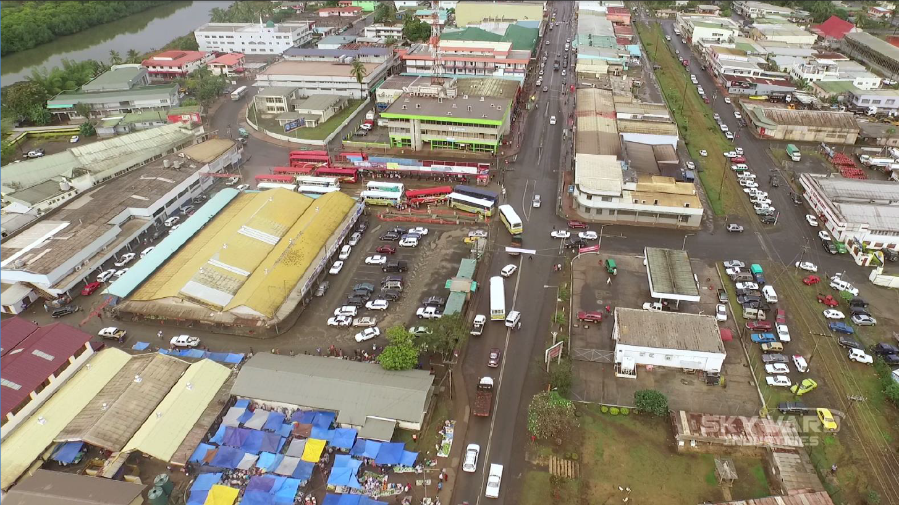
Figure 9 Labasa Bus Station and Market

- Issue Identification and Objective Setting Workshops

External workshops with local councillors, businesspeople and interest groups were carried out to challenge and expand on objectives identified by FRA in the earlier workshop. Not only did the consultation fill gaps in the evidence base but it provided insight from the people using the corridors.

Fijians have a high awareness of social standing that was reflected in some of the behaviours at the first workshop. It was noted that several participants would defer to the highest ranking official to respond to questions, thus the views of all participants were not equally represented.

This was addressed in the second part of the first workshop, and continued in subsequent workshops, by splitting attendees into small groups and encouraging them to write their issues, problems and visions for the corridors on post it notes to stick on corridor maps (Figure 10). This approach improved the participation levels markedly.

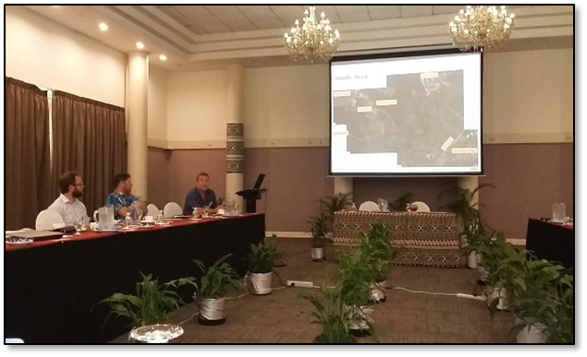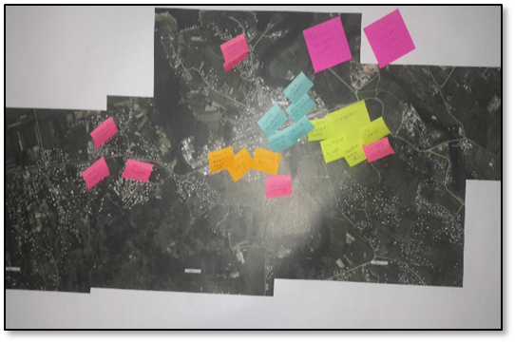
Figure 10 External Stakeholder Workshop and Outputs

- OPTION IDENTIFICATION AND EVALUATION

For each corridor, a long list of options was drawn up through internal workshops and stakeholder engagement.

Options included a very wide range of interventions, from simple delineation and signage improvements, through to four laning of strategic roads and significant bypasses of villages and towns. Common options identified included providing footpaths, intersection improvements, street lighting, village gateway treatments, guardrails, formalised bus stops, passing lanes and right turn bays.

Some more novel solutions were also proposed. Given the underutilisation of the existing cane rail network, particularly outside of cane crushing season, the potential of adapting it as a commuter or tourism railway was investigated. The trains operate on a 0.6m foot gauge railway, typically unsuitable for public transport. A passenger rail service using this gauge was found in North Wales. However, the alignment and poor maintenance of the cane rail track, which requires an operating speed of about 5 km/h, and the fact that the track is owned by the Fiji Sugar Corporation, make this option unlikely.

A multi criteria analysis was used to refine the list, from which the most strategically viable, beneficial and quick wins were developed. The initial MCA screen evaluated the long list options against 15 criteria as follows:
- Implementation Cost (high level)
- Maintenance costs (indicative)
- Property Impacts
- Journey time improvements
- Travel time reliability improvement
- Crash reduction potential
- Enabling Economic Development
- Local economic effects (eg on roadside vendors)
- Network resilience
- Environmental impacts
- Social Impacts
- Supporting Tourism (contribute to more beautiful / safe Fiji)
- Policy Alignment
- Supporting Public Transport
- Ease of Implementation

Four sensitivity tests were undertaken which applied weightings to the criteria to consider the relative importance of the following focus areas:
- Transportation Benefits (higher weightings for Journey time improvements, Travel time reliability improvement, Crash reduction potential, Network resilience and Supporting Public Transport criteria)
- Planning and Land Use Effects (higher weightings for Enabling Economic Development, Environmental impacts and Social Impacts criteria)
- Whole of Life Cost (higher weightings for Implementation Cost, Maintenance costs and Property Impacts criteria)
- Impacts and Opportunities: (higher weightings for Enabling Economic Development, Local economic effects and Supporting Tourism criteria)

Following the presentation of the initial evaluation results to the FRA team, the client requested that fewer criteria be used to lessen the risk of “regression to the norm”. As a further check, options were re-evaluated using only the following eight criteria:
- Journey Time Improvements
- Travel time reliability
- Crash reduction
- Resilience
- Enabling Economic Development
- Property Impacts
- Implementation Cost
- Social Impacts

The sensitivity tests and the reduced criteria assessment made only a small difference to the ranking of the projects which became part of the recommended Quick Win, Short Term and Long Term packages.

- RECOMMENDATIONS

Based on the evaluation results, the team developed recommended packages of quick win interventions, short term improvements and long-term upgrade strategies for each of the four study areas for consideration by the FRA and local Councils.

The Nadi-Lautoka recommended packages comprised a F$260 Million Long Term package that involved the four laning of 17 km of Queens Road between Nadi Airport and Navatu. The upgrade also included a shared use path, road realignment and a bypass, recommended for implementation in stages between 2020 and 2030. We also recommended a F$11 Million short term package (including turning bays, passing lanes and bus stop formalisation) and a F$8M Quick Win package of safety and footpath improvements.

The Denarau Road recommended packages comprised a F$340,000 Quick Win package, while the F$50 Million long term package (Figure 11) included raising up and widening Denarau Road with a 1200m realignment along with provision of shared paths, landscaping, lighting and intersection upgrades, recommended for implementation in 2020/21.

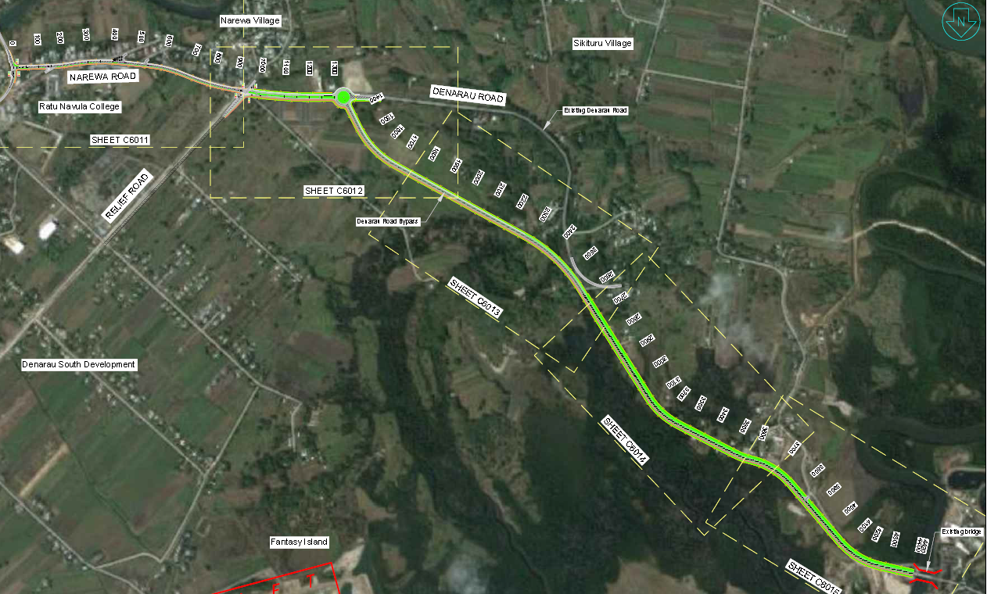
Figure 11 Denarau Road widening and realignment

The Nausori - Korovou recommended packages comprised a F$3.8 Million Quick Win package including formalising intersections and upgrading footpaths, a F$8 Million short term package (including replacing a one lane bridge, introducing right turn bays and passing opportunities) and a F$98 Million long term package, which involved a 7-km bypass to increase resilience and capacity (Option 2 in Figure 12).

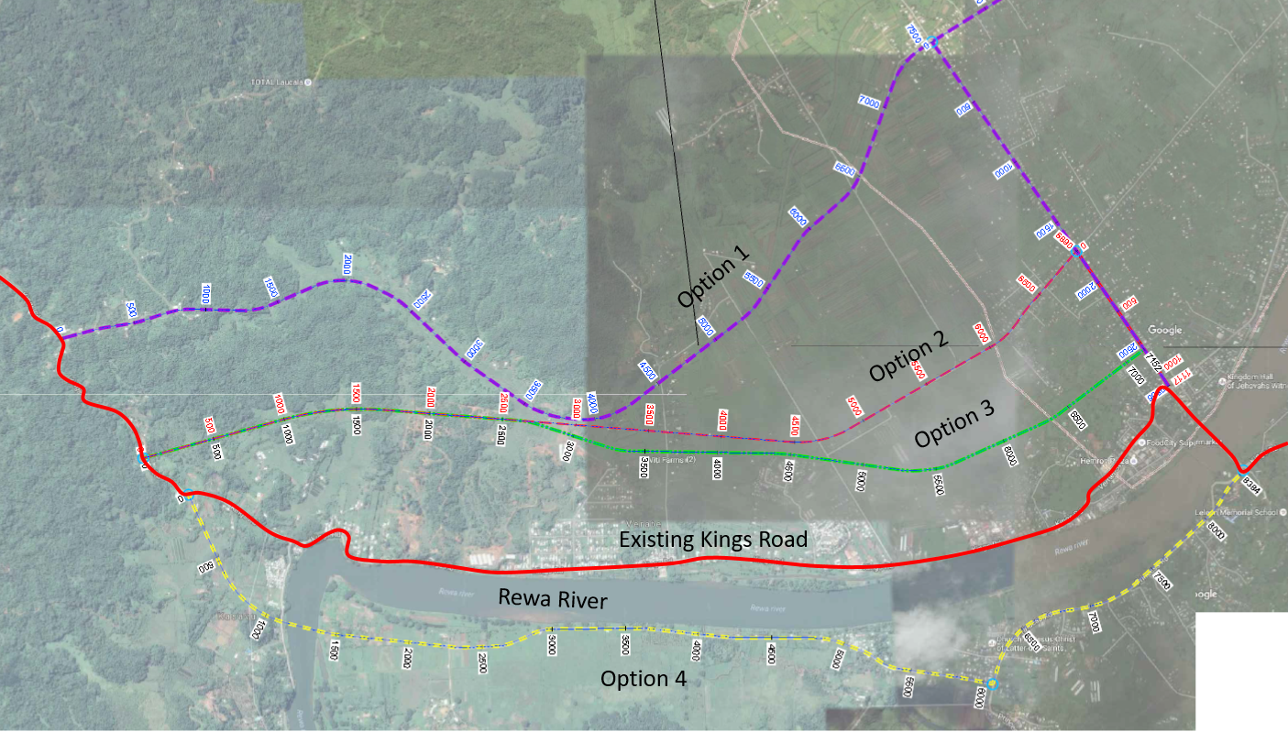
Figure 12 Nausori Bypass Options

The Labasa recommendations included a northern bypass around the town, allowing cane trucks (in particular) to avoid the need to drive along the main shopping street, in addition to upgrading of the town bus station and streetscape improvements through the town centre (Figure 13).

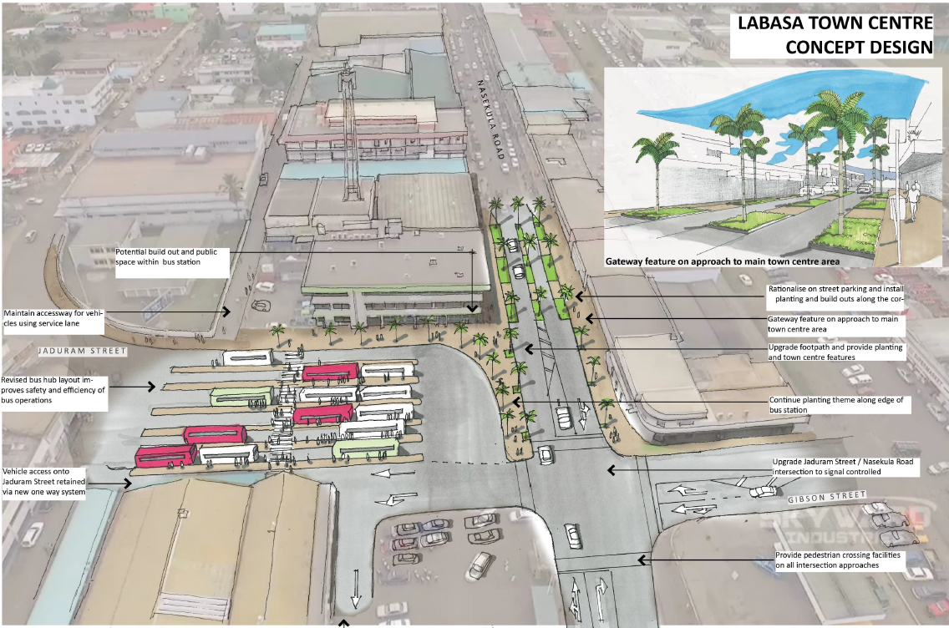
Figure 13 Labasa Bus station and town centre recommendations

In total, the implementation cost of all packages amounts to approximately FJ$520 Million ($NZ350 Million) over 20-30 years, including FJ$13 Million of “Quick Win” packages of road safety improvements recommended for implementation in 2018/19. For comparison, the FRA annual budget for 2016/17 for capital works was just over FJ$500 Million.

In addition to physical infrastructure interventions, the final recommended package included the following policy and strategy improvements designed to assist in addressing potentially unconstrained growth, managing the network and monitoring the transport system:

- Councils and the Department of Town and County Planning (DTCP) define the future rural/urban boundaries (RUB) to identify the limits of urban development along the corridors.
- FRA work with DTCP and Councils to update and co-ordinate spatial planning for the future development of the corridor to identify the land use patterns expected over the next 30 years.
- FRA designate the strategic corridors as limited access roads such that new developments can only access the corridor via side roads or service roads.
- FRA, local Councils and the Land Transport Authority (LTA) undertake corridor-wide strategic bus planning including upgrading of lay-bys and shelters at stops, and reviewing locations in relation to suitable spacing and co-ordination with passenger origins and destinations.
- FRA take steps to manage unauthorised roadside stalls and billboards.
- FRA / LTA determine a destination and tourist signing strategy for Fiji.
- FRA / LTA work to improve enforcement of overweight and over dimension vehicles.
- FRA commissions annual traffic count monitoring to determine changes in traffic flows over time.
- The corridor plans are reviewed every five years to check that development forecasts remain valid and review implementation programme accordingly

The recommended strategies for each corridor, and the recommended policy and governance improvements, were presented to the FRA executive team and the same stakeholder groups as were involved in the objective setting workshops in October 2017; they were very well received. It remains to be seen whether the FRA, other Government departments and local Councils are committed to delivering the strategies over the next 20-30 years.

- LESSONS LEARNED

As a developing pacific island nation, Fiji faces multiple natural hazards and human threats. Fiji as a nation must understand and adapt to climate change, and particularly the effect of flooding, unstable soils and coastal inundation on its transport networks. Social changes including steadily-increasing urbanisation, an increase in car ownership and a lack of spatial planning regulation may see traffic volumes on already-congested key corridors treble by 2036.

Proposed large scale tourist developments are widely publicised and aimed at potential investors, often with optimistic scale and timeframe targets. There is a long history of stalled large-scale tourism development projects in Fiji, which makes forecasting the transport effects of such developments difficult. To address this, traffic growth forecasts were developed with low, medium and high scenarios to capture the risk of developments not occurring within the published time frames.

Engagement with external stakeholders faced initial issues, but a change of approach yielded success. Including native Fijians within the project team assisted in enhancing stakeholders’ willingness to participate and share ideas, and a great deal of useful information was shared during lunch breaks. Afterwards, several stakeholders expressed their gratefulness at being listened to, and one workshop concluded with a “surprise” kava ceremony organised by the locals to acknowledge the success of the day.

The project sought to provide innovative but realistic solutions for a developing transport network. For example, the provision of cycle facilities, which began with the road upgrade between Nadi and Nadi Airport that is nearing completion, may be seen as a white elephant given the minimal existing levels of cycling in Fiji. However, stakeholders agreed that providing such facilities could be the start of a watershed in Fiji, where cycling is typically considered unrealistic due to safety and the climate, but could be an attractive low-cost transport option. The potential increased availability of affordable electric bicycles could reduce the disincentive of heat and topography, both for locals and tourists, and play a real part in Fiji’s transport future.

The client was the Fiji Roads Authority. As their name implies, they are focussed heavily on providing and maintaining the road network. The public transport network is regulated (loosely) by the Land Transport Authority and permits for buses (and taxis) are issued by town councils. Overall, our team considers that Fiji would benefit from a strategic transport planning authority, which could investigate how better public transport, more cycling or the better use of the cane rail network, for example, could play a larger part in meeting the transport needs of Fiji alongside improvements to the resilience and safety of the road network. What do you think?

World Health Organisation, (2015). WHO Report 2015: Data tables
Ministry of Transport (2016). Alcohol and drugs crash facts
Wainiqolo I, et al. (2016). Driving following Kava Use and Road Traffic Injuries
Nausori Greater Suva Region Urban Growth Management Plan (2004)

