**AUCKLAND’S REVISED APPROACH TO PLACE AND MOVEMENT**

**This paper has been peer reviewed**

**Authors: Andrew McGill; Head of Integrated Network Planning, Auckland Transport (presenter)** andrew.mcgill@at.govt.nz; BA, BBusMan, MURP, Member ENZ

**Nick Renton; Transport Planner, Integrated Network Planning, Auckland Transport** nick.renton@at.govt.nz; BUrbPlan, Int.NZPI, Member ENZ Transportation Group

**Lucy Millier; Principal Transport Planner, Mott MacDonald**

**(presenter)**

lucy.millier@mottmac.com; MSc, Member INZ, Member ENZ Transportation Group, IAP2

**AUTHOR CONTRIBUTION STATEMENT**

Each author has made a contribution to this paper and the work behind it.

**ABSTRACT**

The purpose of this paper is to update the industry on the review of Auckland Transport’s Roads and Streets Framework (RASF), discuss the changes made and rationale for them, and explain how it is being applied across the entire Auckland region.

The RASF is a strategically aligned method and approach to establish the role of a transport corridor. It is a planning tool and an application of strategy. It takes a holistic and contextual view of roads and streets and the role they play alongside land use, by considering their relative ‘Place’ and ‘Movement’ functions and significance.

**The RASF needed to evolve.** Over the past year Auckland Transport, along with Auckland Council’s Design Office and support from engineering and transport planning consultancy Mott MacDonald, has been reviewing the original 2017 Roads and Streets Framework. Overall, the review sought to allow Auckland Transport to better plan and manage their roads and streets and reflect the full range of modes, activities and functions that occur on them. The review has been focussed on ensuring the RASF is fit for purpose, aligned to Auckland Transport’s strategy, more user friendly and is simplified to ensure consistent results. Better alignment was also needed with Auckland Transport’s new Transport Design Manual (TDM) which provides design guidance and engineering requirements for the development and delivery of projects.

**Now endorsed, the RASF is ready to shine.** Auckland Transport and partners at Auckland Council are currently piloting the RASF as part of a regionwide assessment of the Auckland transport network, with the intention of every road and street in the region being assessed. This has included using the RASF on a variety of urgent and high priority projects and business cases.

**Why does this matter to the transport community?**

The revised RASF focuses the framework on what is important to the strategic functioning of Auckland from a ‘Place’ and ‘Movement’ function. It will provide project teams with better guidance to support project development, help deliver better outcomes for projects, and support integrated transport planning.

1. **THE PURPOSE OF THE ROADS AND STREETS FRAMEWORK**

More than 1.6 million people live in Auckland. Over the next 30 years this is expected to increase by another 720,000 people to reach around 2.4 million. This would mean that another 313,000 dwellings and 263,000 jobs are required over this period. The combination of this growth and the development of new residential and commercial areas is placing increasing pressure on the transport network. To manage this, roads and streets need to do more than just provide for traffic movement.

Through the RASF, all roads and streets in Auckland will eventually be classified as one of nine typologies based on the relative significance of Place and Movement (see Section 4 for explanation and definition). This will be assessed for both the existing and future situation to reflect future changes in land use and modal networks. The specific modal priorities along each road and street will also be defined for:

* the observed situation (how modes are prioritised on street today),
* the current optimal situation (how modes should be prioritised according to current networks and land use demand), and
* the planned future situation (how modes should be prioritised in the future to reflect any changes in land use or networks), i.e. existing optimal plus future change.

1. **WHAT PROMPTED THE REVIEW OF THE ROADS AND STREETS FRAMEWORK?**

The RASF was initially developed in 2017. The update in 2019 was designed to reflect comments received from stakeholders on its usability and to refocus it on the core elements of Place, Movement and modal priority. The document was previously over 130 pages long and now stands at around 30 pages, making it much more legible to users.

There was also a recognition that the framework needed to better reflect Auckland Transport policy and needs whilst concisely articulating the vision and principles as a starting point for projects, providing clear direction to stakeholders.

Auckland Transport established a Foundation Group with key representatives from Auckland Transport’s Planning and Investment team and the Design Standards team as well as from Auckland Council’s Design Office. They commissioned consultants Mott MacDonald to lead the review and provide technical advice and guidance. The review involved an extensive critique of other similar frameworks from across the world such as in London[1], Birmingham[2], Adelaide[3], New South Wales[4] and Tauranga[5], to replicate good elements whilst determining the most appropriate approach for Auckland.

The key outcomes for the review, which the Foundation Group expressed at the beginning of the review were:

* fit for purpose and robust;
* consistent with policy;
* better situated within the wider capital planning process;
* able to support the new TDM;
* more inclusive of value for money elements and not inadvertently driving scope and costs;
* streamlined and focused on its core objective, with supportive document elements;
* used widely by Auckland Transport and its stakeholders to inform the design of the transport network.

1. **WHERE THE ROADS AND STREETS FRAMEWORK FITS IN WITHIN THE WIDER AUCKLAND PLANNING CONTEXT**

The RASF is one of the first steps in project development and enables modal conflicts to be identified early on and thus informs the business case and design process. It informs the prioritisation of uses of a road or street but does not provide the definitive solution for a project, such as design guidance, cross-sections or typical treatments. This is an important point to emphasise in the RASF update - previously, elements of design were included within the RASF which led to confusion when there wasn’t enough space available to produce the cross sections shown. Design development takes place after the RASF assessment, through the business case process where strategic priorities and design considerations are weighted against available funding and the TDM.

The RASF supports the aspirations of the Auckland Plan and the Regional Land Transport Plan (RLTP) through considering both the Place and Movement functions of roads and streets. These documents feed into the RASF assessment as is shown in **Error! Reference source not found.**Figure 1 and help develop the vision for a project. It is designed for use on both existing and new roads and streets, including undeveloped parcels of land within Auckland.

Auckland Transport is committed to achieving Vision Zero – the complete removal of deaths and serious injuries on the transport network – and safety is a fundamental part of the RASF. Safety is often seen as a design issue and so through the update there was a desire to ensure that Vision Zero principles were considered early on and formed part of the RASF. Within the RASF mandate (the output document), there are key requirements for information on safe and appropriate speeds and existing (and forecast future) safety risks to road users to supplement the significance of Movement and Place functions.

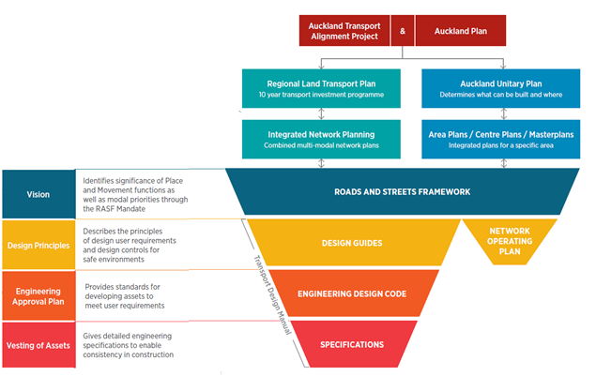

Figure 1: Where the RASF fits into Auckland's wider planning context

1. **THE CORE ELEMENTS OF THE FRAMEWORK AND WHAT HAS CHANGED**

In the context of the RASF, roads and streets have two primary functions: Place and Movement. They are often destinations in their own right and support the adjacent land use, as well as providing for the movement of people, goods and services (Jones *et al*., 2009). The relative importance of these functions varies depending on context. Understanding these functions in the context of Auckland as a whole is an important first step in ensuring that roads and streets meet the needs of the people who use them.

#### 4.1 Defining Place Function

After much discussion amongst the Foundation Group, it was agreed to refine the definition of Place to represent the catchment of a road or street and its adjacent land use as a destination in its own right, i.e. how far people are prepared to travel to go there. It was acknowledged that there are many other factors which influence Place, such as heritage, landscape values, amenity and the number and diversity of people. However, it was important to keep it relatively focussed with other aspects being taken account of during the design phase, following the RASF assessment.

By understanding Place significance, informed design decisions can be made, ensuring the design better reflects the needs and demands of the road or street. For the purposes of the RASF, Place is assessed as one of three categories, according to its strategic role as shown in Figure 2.

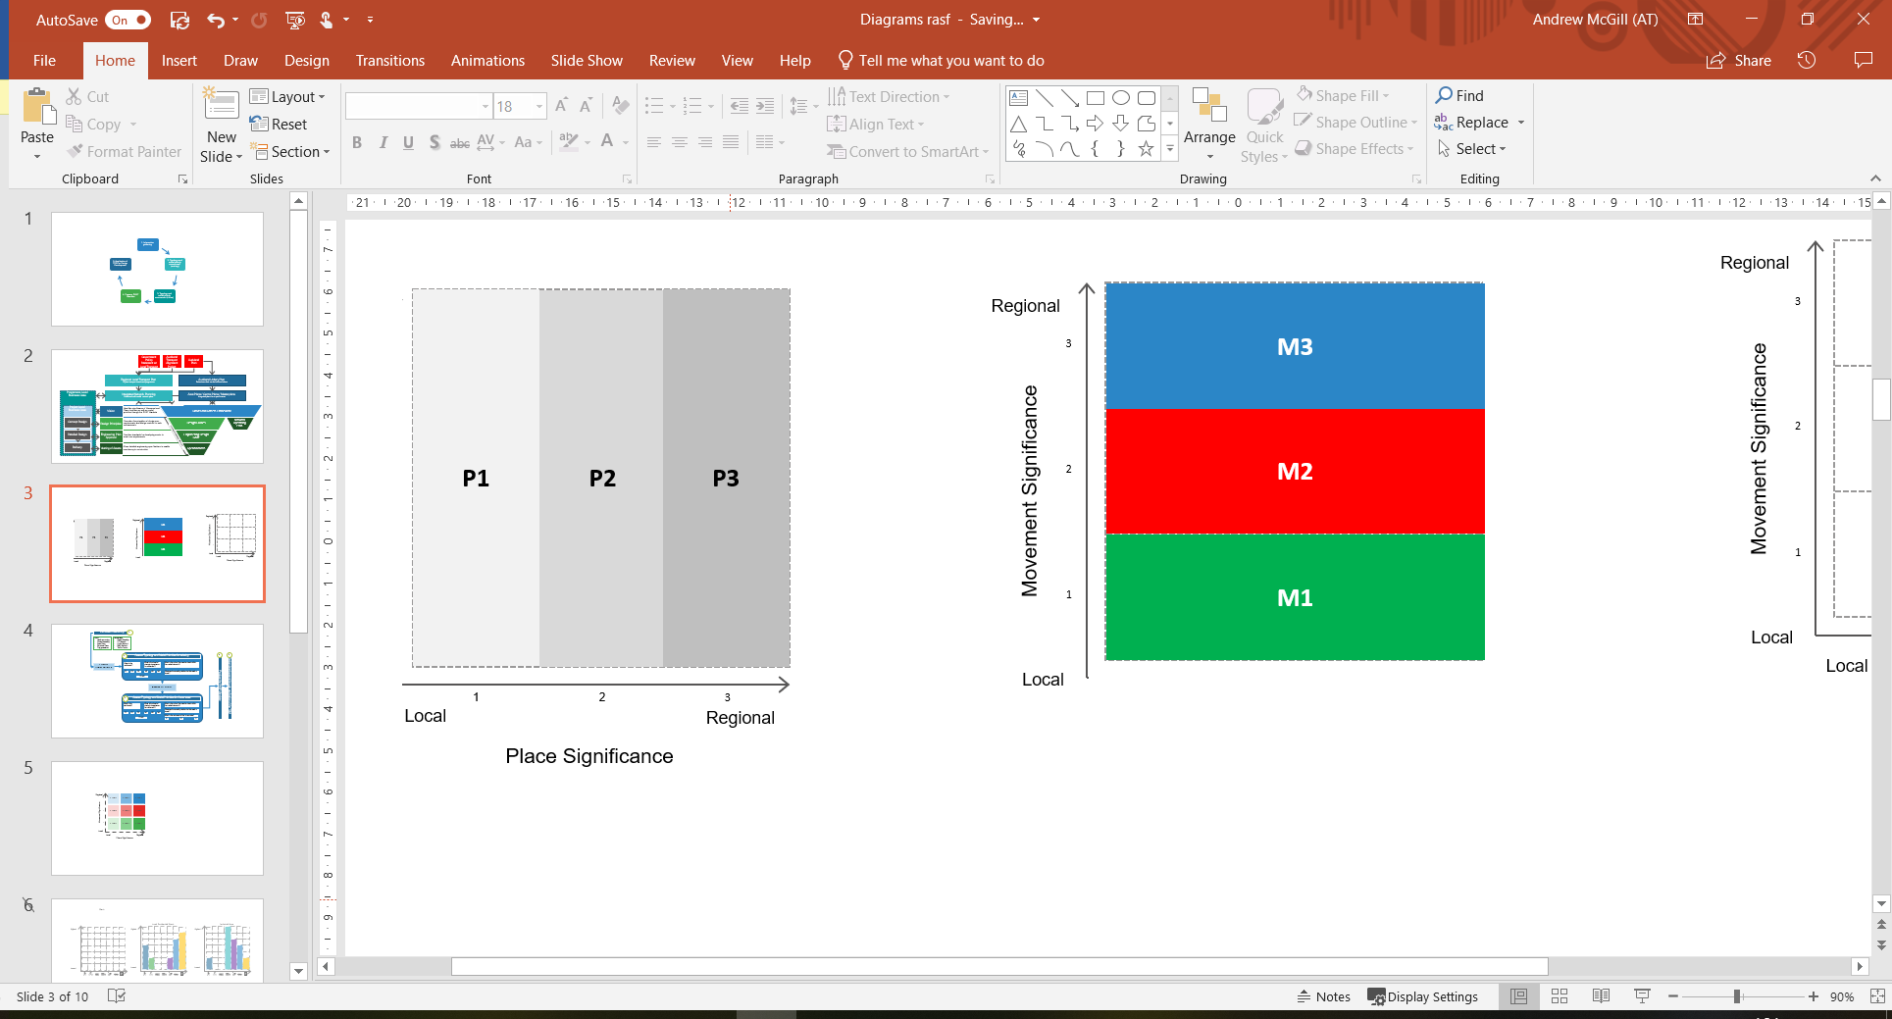

|  |  |
| --- | --- |
| **P1** | Predominantly local function, with a small catchment of users (number and distance travelled). |
| **P2** | Attracts activity from across a subregion or neighbouring local board area. Greater density and variety of land uses. |
| **P3** | Attracts activity from across the region and even from across New Zealand and internationally. These locations generally have higher densities and activity levels. |

Figure : The three levels of Place significance

As a guide, most roads and streets in Auckland will have a local Place significance and therefore be P1. It was important that the RASF highlighted that Place significance should not be confused with how people feel about the road or street as people will always put a high significance on the streets they live on. However, in the context of the whole of Auckland, in most cases a residential street will have a local strategic significance (P1) in terms of Place function.

#### 4.2 Defining Movement Function

The Movement function of a road or street is defined within the RASF as its level of strategic importance within the transport network, measured in terms of moving people, goods and services safely and efficiently between locations and accessing key destinations. The RASF stresses that this assessment should be undertaken for all modes, including people travelling on foot, by bike, by public transport, by car and the movement of freight and service vehicles. Auckland Transport’s strategic modal networks are an important input into this and Auckland Transport is currently developing a GIS platform where they will all be stored.

Regardless of the mode of travel, the priority for the Movement function is about moving people, goods and/or services safely, efficiently and reliably. For the purposes of the RASF, Movement is assessed as one of three categories, according to its strategic role. This is shown in Figure 3.

|  |  |
| --- | --- |
| **M1** | Low strategic network significance. Provides predominantly local access for people, goods and services. |
| **M2** | Medium strategic network significance with increasing volume of users. Provides connection within and between subregions as well as connecting to strategic routes (which are generally M3). |
| **M3** | High strategic significance with higher volume of users. Key connections across Auckland linking between subregions, key centres and other parts of New Zealand. This will also include nationally significant connections, including the motorway network. |



Figure : The three levels of Movement significance

Most roads and streets in Auckland will have an M1 significance, providing access to adjacent land uses, whereas roads and streets with a regional or national significant Movement function (M3) will play a critical role in the movement of people, goods and services in Auckland. They will often be the only connection between two destinations for a particular mode and there would be major network-wide impacts if they were removed as there are no alternative routes available.

It was important for the RASF to note that all modes should be assessed as, for example, a road or street may have a low significance (M1) for the movement of people in cars but may be regionally significant for the movement of people in buses (M3). In this case, M3 should be selected to represent the Movement significance.

#### 4.3 Street Typology Matrix

The street typology matrix in the updated version of the RASF is quite different from the previous version as it doesn’t differentiate between rural and urban roads as this is accounted for through the Place and Movement significance. This creates a 3 x 3 matrix with nine typologies, which is easier to follow. Coding was chosen as the naming convention rather than text names as used previously. This reflects the outcomes from the best practice review of other street typology matrices used internationally.12345 It also removes any preconceived ideas people may have with how a road or street should look if well-known names were used, such as ‘local connector’ or ‘arterial’. Figure 4 shows the previous street typology matrix and the updated one.

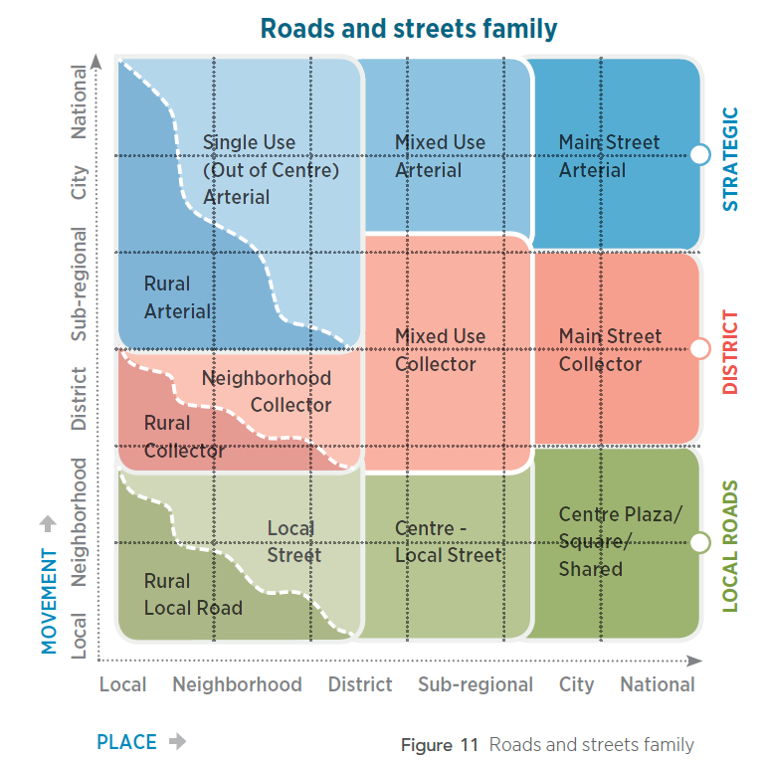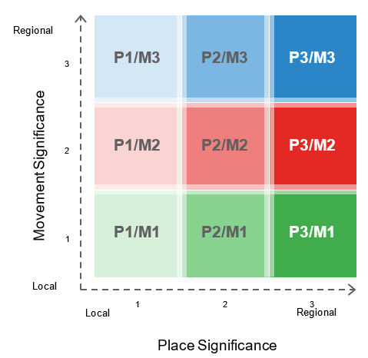

Figure : Street typology matrix from the previous RASF (left) and the updated one with nine street typologies (right)

#### 4. 4 Modal Priority Assessment

Throughout the review it was agreed that the ability to provide further guidance on modal priority was very valuable to project development and ensuring the right outcomes were achieved. The previous version of the RASF introduced this approach and the review has developed this further by creating three scenarios for assessment. This enables the existing prioritisation of modes (in both time and space) to be assessed (#1 – existing observed assessment), along with what it should be (#2 – existing optimal assessment) plus any changes that are anticipated in the future (#3 - future assessment).

Unlike the previous version, there is not a particular starting priority for each typology, reflecting the fact that there may be many different priorities within each typology. For example, a P1/M1 typology may be a residential street and therefore be important for general vehicles and parking. However, a P1/M1 may also be an industrial area and important for freight movement and loading and servicing, or a laneway and be important for pedestrian movement above all else. All are the same typology but have different modal priority assessments (see Figure 5).

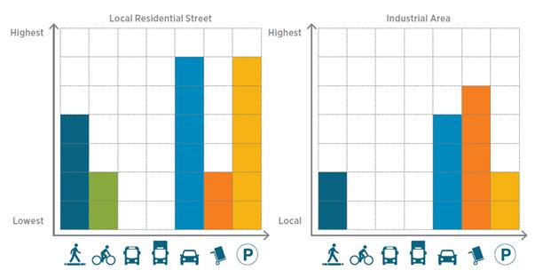

Figure 5: Two different modal priority assessments for a P1/M1 typology

The existing observed assessment is a new concept for the revised version of the RASF but was an important addition to demonstrate the difference or gap analysis between what is currently provided on street, and what should be provided (existing optimal assessment) based on networks and land use demand.

#### 4. 5 Modal Priority Descriptions

Existing observed assessment (based on capacity attributes)

The existing observed modal priority of a road or street is the current prioritisation of modes as on display ‘out the window’. When identifying the existing observed modal priority, it is vital to understand the existing relative capacity attributes for the entire road reserve (i.e. fence to fence). This should take into consideration all the hard and soft measures that Auckland Transport uses to prioritise a mode, including:

**Time allocation** – The amount of time prioritised to the mode through operational management. For example, a mode could be given priority of movement at traffic signals, or parking could be allowed in priority lanes in off-peak hours.

**Infrastructure** – The physical design elements that prioritise the mode, including treatments such as crossings or footpaths for people on foot; cycle lanes or separation for people on bikes; bus lanes or borders for people using public transport; priority lanes for trucks and freight; kerbside features for loading, servicing and parking; and slip lanes, traffic lanes or grade separation for general traffic.

If a mode has no capacity attributes allocated to it within a road corridor, it will not appear on the modal priority chart. This is important when considering buses, freight and cycle movement, as well as loading and servicing. Priority for these modes should only be shown in the assessment where either carriageway or footpath space, time or prioritisation (capacity attributes) are specifically allocated to that mode.

Existing optimal assessment (based on current strategic network and land use requirements)

The next step is to identify the existing optimal modal priority as it is currently planned in relation to Auckland’s existing strategic networks and facilities (i.e. freight network, public transport network, cycle network, road network). The purpose of undertaking this step is to understand what the modal priority should be compared with how a corridor is currently providing for priority.

When assigning the existing optimal modal priorities (based on strategic networks and land use demands), it is important to take note of a corridor’s role in the wider Auckland Transport network and whether any of the specific modal networks feature on it. The specific strategic modal networks contain different levels of priority, such as the public transport network, which differentiates the strategic network by level of service.

Some of the modes do not have a specific network that can be relied upon to inform the existing optimal priority (e.g. loading and servicing, and parking). In this case where a strategic modal network is not present, the relevant policy or strategy, adjacent land use and adjoining networks should be used to inform the relative priority a mode has in a road or street.

Future assessment (based on known changes in strategic networks or land use demands)

The future assessment outlines the change from the existing optimal assessment in relative priorities for the road or street section due to the future strategic networks and land use. Arrows can be used to demonstrate the desired change from the existing observed assessment to illustrate the degree of change that should be considered by the project manager or designer during later design phases.

There are several principles which should be considered when assigning a future modal priority for a road or street. These principles include strategic network status, Place and Movement significance, level and quality of service and safety.

It is important to note that existing optimal and future modal priority assessments do not indicate design requirements for the allocation of space, level of service or movement volumes. These will be specific to each context and determined in later design phases in alignment with the TDM. However, where modal priority increases the most from existing observed to existing optimal, or from existing optimal to future, the designer should consider more of the hard and soft measures (i.e. capacity attributes) available to ensure that mode is given the right amount of priority.

The graphs below in Figure 6 illustrate the three modal priority assessments for an example street.

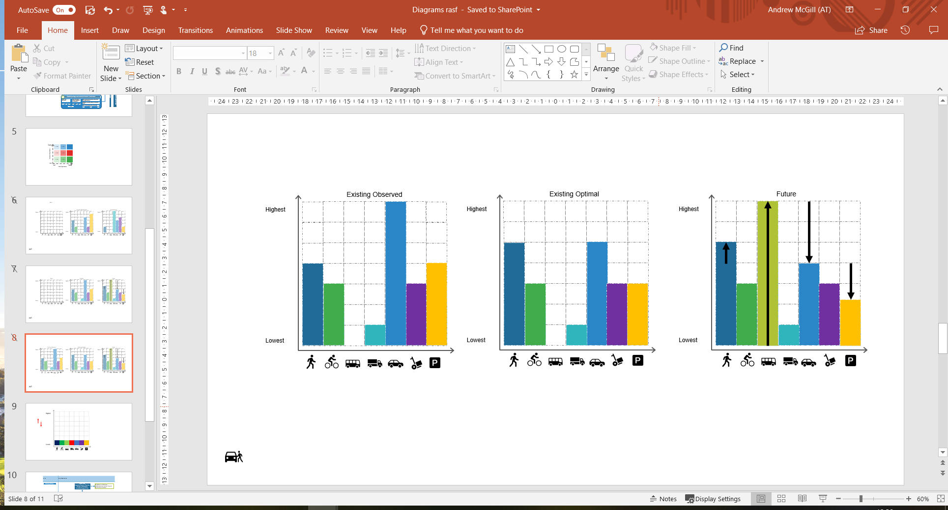

Figure : Modal priority assessment for an example street

In the example shown in Figure 6, the existing observed modal priority for the road or street has general traffic as the highest priority, with parking and pedestrians having a medium priority, above cycling and loading & servicing. There is barely any provision for freight and no provision for public transport. In the existing optimal assessment, there is a slightly higher pedestrian priority, lower general traffic and parking priority. In the future, a rapid transit project is planned to be implemented, resulting in public transport having the highest priority, with other modes adjusting to more broadly align with the new needs of the road and the strategic intent. It is important that assumptions for the future assessment are clearly stated in the RASF mandate, so if things change, the assessment can be revisited.

1. **NEXT STEPS IN APPLYING THE FRAMEWORK**

With the review of the RASF complete, Auckland Transport alongside project partners at Auckland Council have started to apply the Framework across the entire Auckland region.

This process has started with key projects and will be applied to all of Auckland’s major centres and arterial roads over the next six months.

Workshops to date have involved location and project specific stakeholders from within Auckland Transport, Auckland Council and Panuku Development and where necessary, further stakeholders will be involved.

Auckland Transport plans on formally publishing the RASF in early 2020 following a series of roadshow presentations to Auckland Council Local Boards and interest groups. It also plans to publish the GIS map showing the assessment of each street.

1. **REFERENCES**

Birmingham City Council (2014) Birmingham Mobility Action Plan

The City of Adelaide (2012) Smart Move: Transport and Movement Strategy

Jones, P, Boujenko, B & Marshall, S. (2009) Link & Place: A Guide to Street Planning and Design

Tauranga City Council (2019) Streetscape Design Guide *(Draft)*

Transport for London (2013) Roads Task Force Report. London’s street family: Theory and case studies.

Transport for New South Wales (2017) New South Wales Road Planning Framework *(Draft)*

1. Transport for London (2013). Roads Task Force Report. London’s street family: Theory and case studies.
2. Birmingham City Council (2014) Birmingham Mobility Action Plan
3. The City of Adelaide (2012) Smart Move: Transport and Movement Strategy
4. Transport for New South Wales (2017) New South Wales Road Planning Framework *(Draft)*
5. Tauranga City Council (2019) Streetscape Design Guide *(Draft)*