**KIWIRAIL LEVEL CROSSING SAFETY INITIATIVES**

Authored by Eddie Cook, CMEngNZ, CPEng

Project Engineer, Level Crossings

KiwiRail

[Eddie.cook@kiwirail.co.nz](mailto:Eddie.cook@kiwirail.co.nz)

**ABSTRACT**

KiwiRail is one of a number of stakeholders who collectively have responsibility for level crossing safety.

As well as KiwiRail, level crossing users, road controlling authorities, the NZ Transport Agency, the Police, among others, all have a role in improving level crossing safety. A combined voice advocating for level crossing safety, backed up by a commitment to communicate effectively and to make demonstrable physical improvements is needed to make best progress.

Level crossings are intersections between the rail corridor and roads and / or footpaths. As an authorized crossing point over the rail corridor, level crossings need to be capable of safe use. It is the responsibility of the rail and road authorities to, so far as is reasonably practicable, ensure that the level crossing is capable of safe use. Equally, level crossing users are responsible for ensuring they use level crossings safely by obeying the controls in place.

KiwiRail plays an active role as a partner in leading level crossing safety improvement, and is committed to delivering initiatives and physical works within its area of responsibility that contribute to improving level crossing safety. Kiwi Rail’s focus is on reducing fatalities and serious injuries at level crossings.

This paper outlines KiwiRail’s progress over the last three year period in reducing the risk of serious harm and injury at level crossings within New Zealand.

**1) BACKGROUND**

KiwiRail is one of a number of stakeholders who collectively have responsibility for level crossing safety.

As well as KiwiRail, level crossing users, road controlling authorities, the NZ Transport Agency, the Police, among others, all have a role in improving level crossing safety. A combined voice advocating for level crossing safety, backed up by a commitment to communicate effectively and to make demonstrable physical improvements is needed to make best progress.

Level crossings are intersections between the rail corridor and roads and / or footpaths. As an authorized crossing point over the rail corridor, level crossings need to be capable of safe use. It is the responsibility of the rail and road authorities to, so far as is reasonably practicable, ensure that the level crossing is capable of safe use. Equally, level crossing users are responsible for ensuring they use level crossings safely by obeying the controls in place.

KiwiRail plays an active role as a partner in leading level crossing safety improvement, and is committed to delivering initiatives and physical works within its area of responsibility that contribute to improving level crossing safety. Kiwi Rail’s focus is on reducing fatalities and serious injuries at level crossings.

**THE MAJOR RISKS**

Level crossing collisions are a low probability, high consequence event. This is due to the potential for a passenger train or a passenger vehicle to be involved. This is low in the context of total road fatalities/injuries. This presents a challenge in undertaking any risk review due to the low volume of actual incident data available.

Figure 1 Crash factors for serious and fatal injuries at level crossings (2010 to 2014 Source CAS)

Figure 1 does not include pedestrian and cyclist injuries outside of the road corridor and level crossing as CAS does not monitor this. Figure 1 show’s how inattention, which closely aligns with complacency, comprises over 40% of the factors involved in fatal and serious level crossing injuries involving motor vehicles. Regular level crossing users get used to the daily train schedule and are not expecting to see trains at certain times of the day. This low expectancy of trains can be the key factor in incidents at other crossings where scheduling of trains is different and headways are more frequent.

**PEDESTRIAN AND CYCLIST RISK**

Pedestrians and cyclists are by their nature more vulnerable to the consequences of an error in judgment at a level crossing.

Trends that are increasing this risk for these users include:

* Increased numbers of metro trains in both Auckland and Wellington
* Changes in the operations in Auckland such as quieter / faster trains
* Increasing number of people with disabilities accessing public transport
* Increasing population density expected for Auckland
* Increasing number of distractions for pedestrians from mobile technology
* Growing cycle way network throughout New Zealand

Figure 2 NZ Level Crossing Fatalities – January 2000 to May 2016

Figure 2 shows how pedestrian and cyclist fatality numbers have outnumbered motor vehicle fatality numbers from 2010. Fourteen active user fatalities occurred during this period compared to eleven fatalities involving motor vehicles. From 2000 to 2009 the number of motor vehicle fatalities (49) greatly outnumbered active user fatalities (17).

The increased usage of headphones and mobile devices by active users at level crossings is a major cause of these fatalities. Six out of the last seven active user fatalities have involved the use of headphones and mobile devices. The warning bell is the traditional form of protection for active users at level crossings. The bell warns the active users that trains are approaching. This form of audible warning is rendered ineffective by the use of headphones. Mobile devices are also a great cause of inattention for active users.

**HEAVY VEHICLE RISK**

Heavy vehicles present a particular risk due to the characteristics of the vehicle involved. The weight, length and in some cases low clearance, introduces additional risk factors that light road vehicles do not have.

Key risk elements are:

* Short stacking - insufficient room at some crossings for trucks to safely enter from or exit to an adjacent road junction without blocking or overhanging the railway line.
* Road vertical alignment - some crossings are located on a hump or dip in the road which can cause vehicles with low ground clearance to become stranded on the crossing.

**PUBLIC CROSSINGS WITH PASSIVE CONTROLS**

|  |  |  |  |
| --- | --- | --- | --- |
| Passive Crossing | Active Crossing | Passive Crossing | Active Crossing |
| Serious injury | Serious injury | Fatal injury | Fatal injury |
| 23 | 9 | 9 | 2 |

Table 1 Number of serious and fatal injuries at NZ level crossings- 2010-2014 - Source CAS

Table 1 shows how the serious and fatal injuries at passive level crossings (32) outnumber the serious and fatal injuries at active crossings (9) for the period 2010 to 2014. Passive crossings are not equipped with train detection technology and are reliant on the driver obeying the controls and checking for trains in both directions before crossing. Passively controlled crossings also tend to have fewer daily train numbers and this low train expectancy of drivers can lead to high complacency and inattention levels which also contribute to the greater risk profile of passive level crossings.

|  |
| --- |
|  |

**POOR BEHAVIOUR BY USERS IN URBAN AREAS**

The interface of road and rail is most acute in the urban areas where a combination of commuter trains, high peak vehicle traffic, freight trains connecting to the main markets and ports, creates congestion in this part of the transport system. Rail has the right of way which causes some vehicle drivers to take unnecessary risks in order to beat the signals and the train.

Key risk elements are:

* Combination of increasing commuter train services and increasing road traffic volumes in Auckland, and freight services timing with peak traffic volumes in major cities leading to vehicles queuing at level crossings.
* Increasing numbers of rail commuters.
* Introduction of faster and quieter trains in Auckland.

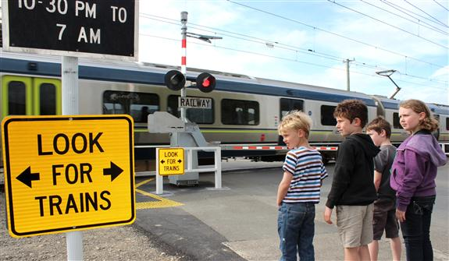

Figure 3 Users at a level crossing in Auckland Metro area.

**2) LEVEL CROSSING INITIATIVES**

**OBJECTIVES AND METHODS**

KiwiRail’s objective is:

To manage and operate level crossings on the national rail system in a safe manner that:

* Reduces fatalities and serious injuries at level crossings.
* Acknowledges that responsibilities for level crossings are shared with other stakeholders and seeks to work in partnership with them to achieve best outcomes.
* Is appropriate for the NZ transport and social environment and compares favorably with international benchmarks.
* Is informed by relevant standards, research and innovation, and stakeholder input.

Initiatives by which KiwiRail will achieve this are:

* Developing a risk based understanding of level crossing hazards and associated risks, leading to systematic approaches to level crossing safety improvement.
* Developing and delivering work programmes across 5 strategy pillars being:
* Knowledge and Risk Assessment.
* Compliance and Interface Agreements.
* Infrastructure and Technology.
* Awareness and Communication.
* Partnerships.

KiwiRail has developed or is in the process of developing the following initiatives aimed at achieving the stated objectives.

**LEVEL CROSSING SAFETY IMPACT ASSESSMENTS (LCSIA)**

To help objectively assess level crossings and ddevelop a risk based understanding of level crossing hazards and associated risks, a new assessment process called the Level Crossing Safety Impact Assessment (LCSIA) has been developed by KiwiRail. A key component of this is a new risk scoring system called the Level Crossing Safety Score (LCSS).

The Australian Level Crossing Assessment Model (ALCAM) is used to prioritise KiwiRails annual level crossing safety improvement program and to assess the effect that a change in use activity such as a nearby proposed development or increase in milk tankers will have on crash risk. The ALCAM risk score is a product of the infrastructure factor, exposure factor and consequence factor, and is expressed in terms of an expected number of equivalent fatalities per year. It is this figure that allows comparison of all level crossings in New Zealand against each other and allows a priority listing to be produced. - *NZTA TCD Manual Part 9 Level Crossings – Appendix D – Australian Level Crossing Assessment Manual (ALCAM)*

Together with the traditional ALCAM level crossing risk model score, the LCSS also looks at three additional data sources associated with crash risk:

* historical crash and incident data,
* safety observations made by locomotive engineers and road controlling authority (RCA) engineers,
* and a more detailed site assessment of the impact of the existing level crossing layout on crossing users and their interaction with it and the surrounding transport network.

KiwiRail requires that an LCSIA is completed for all level crossings that are along or adjacent to a new cycleway or shared path, even when they do not explicitly cross over the rail corridor. Such new facilities would increase the volume of users crossing the rail corridor. This will help determine whether level crossings need to be upgraded and the appropriate treatments required. Prescribed minimum risk band criteria are defined for new and existing level crossing change in use situations. The safety mitigation prescribed by the LCSIA needs to achieve these minimum risk level criteria. A LCSIA is also required prior to the completion of any planned upgrade to a level crossing. In a similar vein, a new facility installed nearby to a rail corridor that would likely increase the crossing user volume over a level crossing location, would constitute a ‘change in use’ activity for the crossing location and require an LCSIA.

The ALCAM risk score will still be used in isolation to derive KiwiRails annual level crossing protection upgrade program as reliable safety observation information by locomotive engineers and RCA engineers is not available for the complete dataset of over 1400 public level crossings.

**PEDESTRIAN AND CYCLIST DESIGN GUIDANCE**

This guide has been recently developed by KiwiRail, NZTA and the RCA Forum and provides urban designers and planners, and traffic and rail engineers, with principles, design considerations and standard designs for level crossings located on footpaths, shared paths or cycle paths. The guide was developed from September 2016 to June 2017 in response to the increased demand for pedestrian and cycle path treatments running adjacent to and across railway lines. The design reference guide at that time was NZTA TCD Part 9 Level Crossings which was silent on many of the key safety issues prevalent at that time for active users. It is intended that this new guidance will eventually be placed into TCD Part 9 at the time of its next review. Many of the principles discussed should also be applied when considering providing for cyclists using on-road cycle lanes. It asks users to consider all types of rail crossing options, including grade separation and the potential to remove a rail level crossing completely; however, the design guidance only covers treatments at rail level crossings.

This guide will enable the road and rail sectors to put more emphasis on safety of pedestrians and cyclists at level crossings in light of the upwards trend in incidents for cyclists and pedestrians with rail. This document has been developed based on an initial interim guide, related workshops, and subsequent industry feedback.

This guide is endorsed by KiwiRail, the NZ Transport Agency and the Road Controlling Authorities’ Forum and is consistent with the mandatory requirements of the NZTA Traffic control devices manual part 9.

**ACTIVE EXPECT TRAINS SIGNS TRIAL**

Those who work in the rail and road safety level crossing environment are well aware of the risks of injury and death to drivers who are in mind states of complacency, distraction or inattentiveness. These drivers and pedestrians can either intentionally or unintentionally travel through a passive level crossing, without observing first for any oncoming trains. With this rationale in mind, KiwiRail developed and trialled an active ‘Expect Trains’ sign that is activated by vehicles approaching a passive level crossing. The signs objective was to reduce driver complacency and inattention at level crossings.

The NZ Transport Agency's TCD committee have advised that the trial results were inconclusive as only two crossings were trialled. Also some persons surveyed construed the wrong meaning from the initiative and thought that the flashing lights meant that a train was approaching the crossing. Some very positive findings were also concluded and KiwiRail have supplied NZTA with a list of suitable Stop sign controlled level crossings as it is their intention to further trial the use of a passive level crossing advanced warning sign with the wording‘ Stop Ahead’. This new message is hypothesised to present a clearer message to all drivers as to the correct meaning of the sign. KiwiRail will work collaboratively with NZTA on the continuation of this level crossing safety trial.

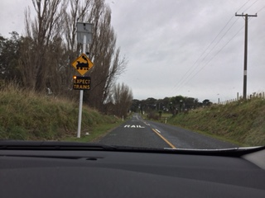

Figure 4 Vehicle activated ‘Expect Train’ sign, Williamsons Line Level Crossing, Marton - New Plymouth Line

**SHORT STACKING TRAIN – HEAVY VEHICLE COLLISON PREDICTION SYSTEM**

KiwiRail are currently trialing a safety system that preactivates level crossing alarms when a train and over length vehicle are predicted to be on a collison course to a short stacking level crossing. A short stacking level crossing is any level crossing in New Zealand that has less than 26 meters of length between the limit line of the main road after the crossing and the nearest rail. Heavy vehicles are legally allowed to be 26 meters in length in New Zealand. There have been many near miss recordings between very long vehicles and trains at these crossings. There are many crossings in New Zealand that have less than 10 meters stacking distance. These crossings are commonly found along the State Highway networks where it is common to have the highway running very close to the rail way line.

KiwiRail have undertaken peak time heavy vehicle delay analysis at a trial site in the Waikato region known for its short stacking risk. The delay analysis will be used to estimate time of day peak and off-peak delay time trigger values. The system will continuously monitor train approach positions relative to over length vehicle approach positions. Over length vehicles are detected at the safe stopping distance location on the road approach. Trains are detected at the equivalent vehicle delay location on the track approach. For example, the measured peak time morning delay for over length vehicles equals 24 seconds. The maximum line speed for trains at this crossing is 100km/hr. A train at this velocity will travel 667 meters in 24 seconds. The crash prediction system will continuously monitor the position of approaching over length vehicles and trains. When a train is detected within the 667 meter mark and an over length vehicle is located at the safe stopping distance point, the system will activate the crossing alarms early to prevent the potential collison path.

Figures 5, 6, 7 and 8 show how close near miss incidents between heavy vehicles and trains can be. In this example the train light can be seen in the distance but the driver has decided to proceed over the crossing. It is assumed the driver has moved forward into a position where the vehicle is fouling the tracks, because the crossing alarms have not activated .Subsequently, the alarms activate whilst the vehicle is stationary at the main road limit line and fouling the railway tracks. The vehicle eventually clears the crossing with 8 seconds to spare before a collison with the approaching train. Had there been greater traffic flow on the main road with fewer acceptable gaps, this near miss incident could have been a lot closer than what eventuated. It would seem that an element of good fortune is associated with these near miss incidents. The short stacking system is designed to remove the ‘element of good fortune’ from the equation. In this scenario, if the proposed heavy vehicle collision prediction system had have been installed, the signal alarms would have activated for this driver at the safe stopping distance location on the road approach, thus advising this driver that it was unsafe to proceed.

KiwiRail plan to undertake a soft trial of the system from February 2018. Favorable results from the trial will eventuate in this system going live at this crossing in July 2018.

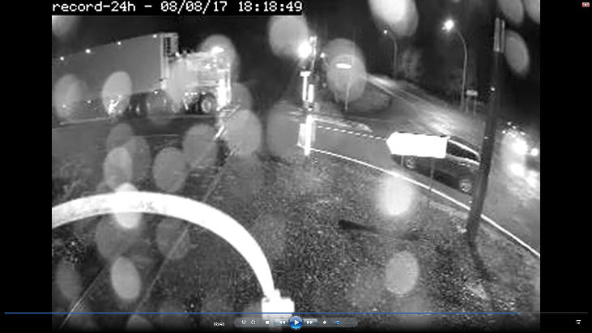

Figure 5 O/L truck committs to intersection , train light approaching.

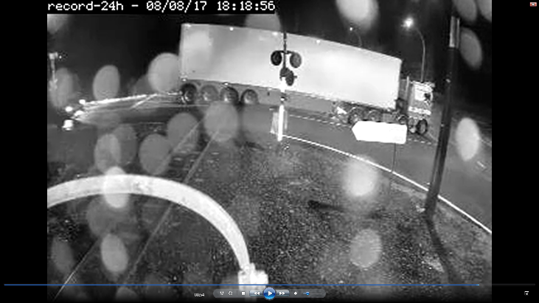

Figure 6 O/L truck at limit line, stacking over the rail line. Flashing lights and bells activate at 18:18:59 (while truck at limit line)

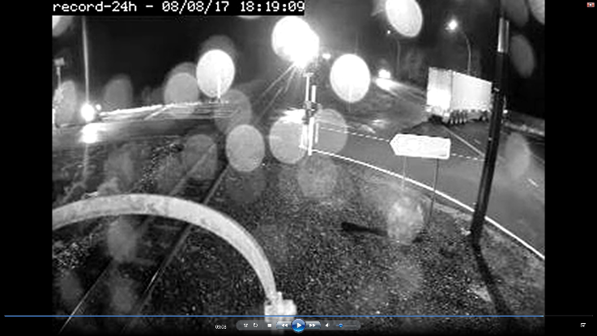

Figure 7 Truck clears intersection

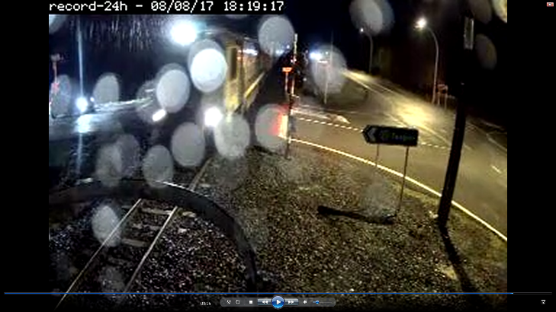

Figure 8 Train arrives 8 seconds from when the truck clears the crossing.

**PEDESTRIAN INGROUND LED TRIALS**

KiwiRail are currently trialing the use of in ground LED units which are activated either by the detected presence of active users approaching a passive level crossing or the detected presence of a train approaching the level crossing.

The LEDs in the pathway are designed to mitigate the identified problem of headphone use and mobile device usage at level crossings. The last 6 out of 7 fatalities have involved the use of these accessories. Their use detracts from the task at hand, looking for trains. The traditional warning bell for pedestrians at level crossings cannot be heard when headphones are worn. Many of these users walk with their head down which also renders the flashing alarm light ineffective, if in place.

Focus groups were conducted in Wellington and Auckland involving regular and non-regular users of the train service from a range of demographic groups. The workshops assisted in the development of the final trial prototype products for both the passive and active crossing scenarios. Prototypes were on display at the workshops and the user groups thought that the LEDs were very eye catching. This finding was very encouraging for the development team as this is one of the key design attributes required from the product. Figure 9 shows the range of responses from the group participants.

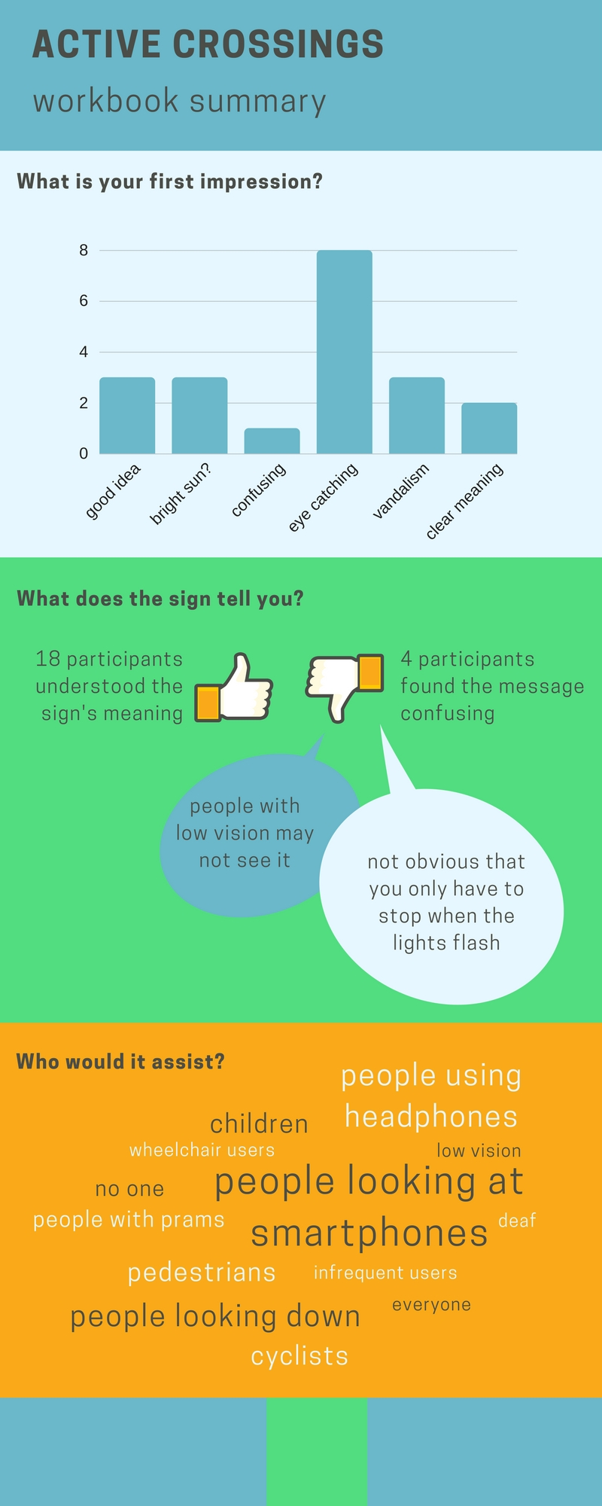

Figure 9 Focus group participants first impression of the in ground LED’s.



Figure 10 Focus groups opinion of who the LEDs would most assist.

Figure 10 shows that the focus group participants thought the LEDs would mostly assist people looking at smartphones, people looking down and people using headphones. (The larger font size comments indicate a greater group consensus.) Again this feedback was very encouraging for the product development team.

Trials of the passive in ground LEDs are planned for New Plymouth, commencing in Christmas 2017. Trials of the active in ground LEDs are planned for Napier and Fielding, commencing in January 2018. These active crossing trials are being undertaken in collaboration with NZTA and the Safer Roads Alliance projects. Figure 11 shows the LED in ground tiles destined for Fielding and Napier, at their origin of manufacture in Auckland.

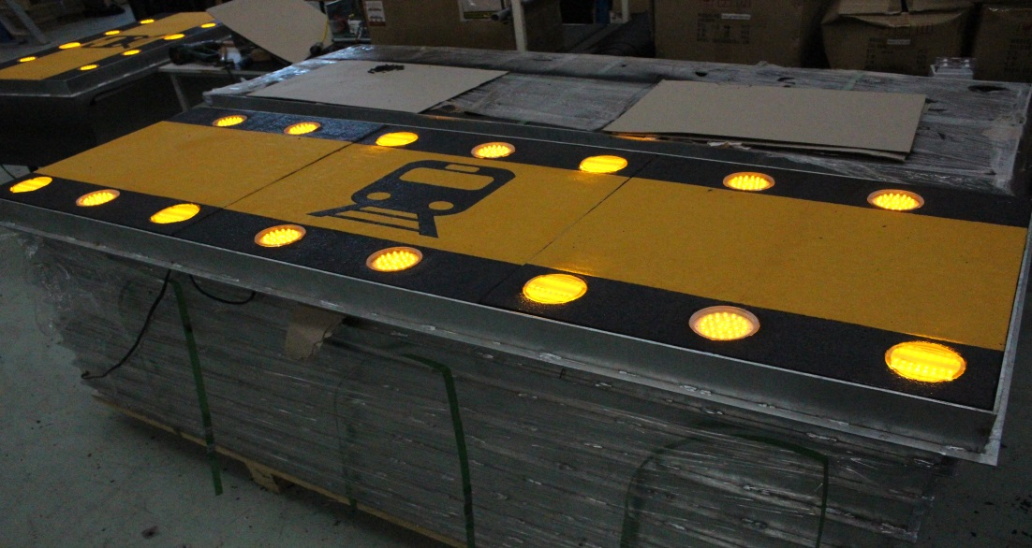

Figure 11 In ground LED tiles developed for active level crossing trials in Fielding and Napier.

**REGIONAL LEVEL CROSSING SEMINARS**

6 seminars were held throughout NZ during the period 27 Oct to 4 November 2016. Representatives from the Automobile Association, Road Safety Co-ordinators, Local Councils, Regional Councils, NZTA, KiwiRail, Heavy Haulage Association, Road Transport Association, Steam rail groups, Consultants, Road and Rail contractors, SafeRoads Alliance, Transdev , TAIC, TrackSAFE and Auckland Transport were in attendance.

152 delegates attended in total over the 6 seminars. KiwiRail level crossing, planning, cycle ways, property, regional Locomotive Engineers and Track and Signals staff presented at each seminar. NZTA Planning and Investment and Highway Network Operations staff also presented at each meeting. 45 Local and Regional Authorities were represented as well as NZTA staff from all regions.

61 feedback forms were collected and every respondent thought that the seminar met their expectations as the worst comment. Some very good comments were received and these comments will be used to enhance future seminars.

The seminar started off with a Seminar vision which was the same for all 6 venues. The vision being,

‘To work together to produce safer systems for our level crossings’

The seminars provided an effective platform to meet with all level crossing partners under the one roof and discuss current level crossing issues with a longer term view to addressing them.

It is planned to conduct these seminars annually. The next rounds of seminars are planned for February and March 2018.

**3) CONCLUSIONS**

The various level crossing risk assessment, design review, stakeholder collaboration and safety initiatives that KiwiRail have developed and produced during the last two years have lifted the profile of level crossings amongst the relevant stakeholders within New Zealand. The recent LCSIA and design guidance training workshops and last year’s Regional Level Crossing Seminars have assisted in this raised profile.

Level crossings are a shared responsibility. They are not KiwiRails responsibility alone. This message is now being realized in many of the new level crossing ventures that are occurring throughout New Zealand. At the time of writing these papers there were 52 LCSIA reports being prepared by certified LCSIA assessors. The new transportation acronym ‘LCSIA’ will soon become synonymous with level crossing risk assessment and planning amongst our practitioners.

I recall in my last traffic engineering role as thinking that the level crossings in my area were KiwiRails responsibility. I took them for granted and assumed that all was well. I assumed that the Stop signs in place would prevent collisions between trains and crossing users. I assumed that blind persons would easily negotiate a level crossing. I assumed level crossings to be safer than road intersections because there were fewer crashes at level crossings. They are a rare event and because of this I assumed that level crossings were safe. Having worked in the level

crossing and railway world for a little time now, I realize that my assumptions were unfounded. Level crossings are a real risk and a shared responsibility for all stakeholders. I think that this message is now beginning to filter through to the wider Transportation profession, and this can only mean positive future outcomes for the safety and wellbeing of our level crossings and their many users.

**4) REFERENCES**

NZTA Traffic Control Devices Manual Part 9 Level Crossings 2012, Appendix D -Australian Level Crossing Assessment Manual