Loading dock delivery label for Melbourne Convention Centre (MCC)
This label must be attached to every item delivered
to the loading dock.
Entry to the Convention Centre loading dock is via Normanby Road, South Wharf.
For further information, please contact our Logistics team on 03 9235 8386.
Melbourne Convention and Exhibition Centre staff will only sign for deliveries between
8am–4pm, Monday to Friday. We will not accept responsibility for items left at the
loading dock outside of these times.
EVENT ORGANISER FREIGHT

Contact information
Contact name  (Person responsible for delivery) | McGraw, Julie
Contact phone number  (Person responsible for delivery) | 0418 889 221

Event information
Event name | 6th Global Adolescent and Young Adult Cancer Congress 2024
Event number | 114269
Event dates | Tuesday 03 Dec 2024 - Friday 06 Dec 2024
Room/area for delivery | Organiser Office 101

Items
Item number
Total number of items

General information
The dock is managed and controlled
by MCEC’s Logistics team and is located
on the lower ground level of the
Convention Centre.
- Total size of 2,000sqm.
- Clear working height of 4.4m.
- Fully weather protected.
- Three dock levellers allow vehicles
to load and unload at floor level.
- A 30 minute parking limit applies for drop-off/pick-up of goods during the move in/move out process. Vehicles
are not permitted to park on the loading dock at any other time.
- Children under 15 and animals are not permitted during move in and move out.
- Vehicles and contents are the responsibility of the owner while
on the loading dock.

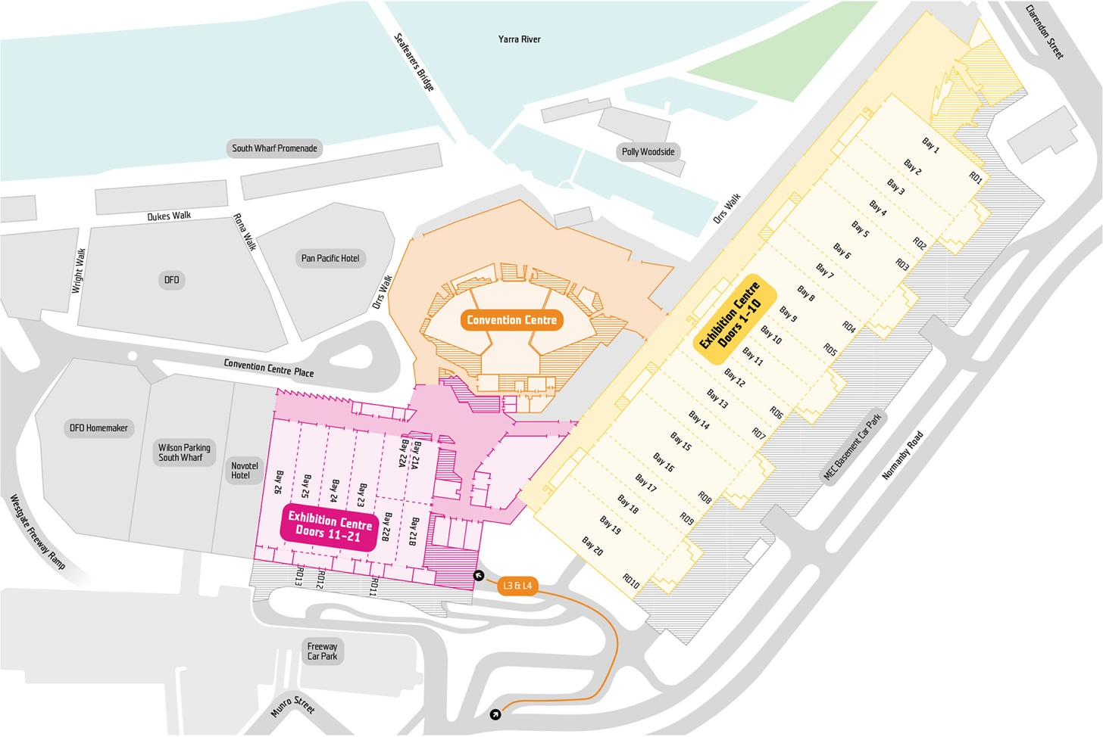
Truck and vehicle lifts
There is one truck lift at the Convention Centre with access via the loading dock. The lift allows for large deliveries and equipment to be transported directly to
all levels. The truck lift is large enough
for a vehicle to fit inside. The maximum weight load for the truck lift is 13.9 tonne.
A vehicle lift is located behind Melbourne Room 1 with access via Rona Walk. Large deliveries and equipment can be brought directly to Levels 1 and 2. The maximum weight is 10 tonne.

Lift | Length | Width | Height
Truck lift | 9.5m | 3.5m | 4m
Vehicle lift | 8.1m | 3m | 3m
Eureka lift | 3.5m | 1.6m | 2.4m

