EXCELLENCE IN EMERGING/NEW BUSINESS

(Less than 2 Years Trading)

Please ensure you save your document regularly as you work through the form.

All sections must be completed (excluding optional - section 6). Your entry will be judged in the appropriate Excellence in Business categories and in addition, at the time of judging, your entry will be considered for the additional Awards categories.

Supporting Documentation
Remember – you must provide evidence to support your claims.

Please include any supporting documentation in digital form as part of your online entry. This could include general financial overview - possibly showing changes as percentages rather than actual numbers, performance reports, strategic/ operational plans, examples of quality process or regulatory forms, data tables, graphs, images, or other forms of media (video, sound bites, etc.).

Please ensure you retain a copy of your complete entry with all supporting information.

SECTION 1: Executive Summary
Maximum 500 words, not including graphs or images, and two pages of supporting evidence as speciﬁed on the online entry form.

The purpose of this section is to help the judges establish a quick, yet succinct overview of your business, and to act as the starting point for your self-assessment. This information may be used for publicity purposes if you become a ﬁnalist or winner.

What the judges are looking for:
★ A brief history and description of your business
★ A description of what makes the business unique to the market and excellent in business
★ A summary of key business achievements and results

The box below will adjust in size as you enter your content into it. It is not indicative of the maximum 500-word count.

SECTION 2: Deﬁne your competitive edge
What makes this business special?

- Provide a maximum of 500 words of text demonstrating your unique selling points, and why you believe your business stands out from your competitors. A maximum of two pages of supporting evidence can be attached.

What the judges are looking for:
★ Evidence of an understanding of your organisation’s unique selling points and competitive diﬀerentiation.

The box below will adjust in size as you enter your content into it. It is not indicative of the maximum 500-word count.
SECTION 3: Community Contribution
Demonstrate how your organisation, including staﬀ, are proactively involved in your local community, and what criteria and process do you use to determine those areas that you become involved with. (Maximum
1000 words, plus supporting evidence)

• Explain what social initiatives the organisation has adopted related to its own staﬀ and the local or wider community (e.g., training, family friendly work practices, contributions of time or money to the community)
• How does this contribution beneﬁt your organisation?

What the judges are looking for:
★ Evidence of community contribution
★ Evidence how this is encouraged and supported

The box below will adjust in size as you enter your content into it. It is not indicative of the maximum 1000-word count.

SECTION 4: Innovation and Adaptation Award
- Describe the innovation or adaptation within your organisation (Maximum 500 words plus supporting documentation)
• Describe any innovative products or services created, processes or technology developed or used, and/or people employed in an innovative role to further business excellence or performance (Maximum 500 words plus supporting documentation).

What the judges are looking for:
★ Use and implementation of innovation and knowledge to enhance business excellence and organisational performance
★ New ideas, systems, procedures, or technology that have increased eﬃciency and/or resulted in the introduction of improved services, products, or business sustainability.
★ Details of results gained from new ideas and innovations

The box below will adjust in size as you enter your content into it. It is not indicative of the maximum 1000-word count.

SECTION 5: Digital Strategy and E-commerce Award
Demonstrate how your organisation has utilised digital technology throughout your business (Maximum 1000 words plus supporting evidence)

• Explain how you have applied digital technology for the beneﬁt of customers, staﬀ, suppliers,
and business performance.

• Demonstrate how these innovations have been applied and measured within the business.

What the judges are looking for:
★ Use of speciﬁc technologies and digital innovation
★ Evidence of how you have enabled your business through the use of the digital tools, the internet or use of cloud-based technology.

The box below will adjust in size as you enter your content into it. It is not indicative of the maximum 1000-word count.

SECTION 6: Contribution to Tourism or Hospitality Award (*Optional)
Demonstrate how your organisation contributes to tourism in Waipa, activities could include; accommodation, activities, events, support industries or similar. (Maximum 1000 words plus supporting evidence).

• Describe your customer experience – explain your process from customer awareness through to bookings and feedback loop. Show how this has enabled you to ﬁne tune and adapt your practices.
• Tell us about your marketing and brand presence – explain how you developed your brand, who your target audience is and how you reach them through your marketing initiatives.
- Provide details of your health and safety plans.
- Share your successes.

What the judges are looking for:
★ A clear understanding of your business and its position and oﬀering within the Waipa tourism industry.
★ Evidence of researched and targeted branding and marketing.
★ Details of successes and how you measure these.

The box below will adjust in size as you enter your content into it. It is not indicative of the maximum 1000-word count.

SECTION 7: Waste Minimisation Environmental Award

Demonstrate how your organisation and its people are actively involved in implementing practices and achieving waste minimisation both within and outside your business (Maximum 1000 words plus supporting evidence).

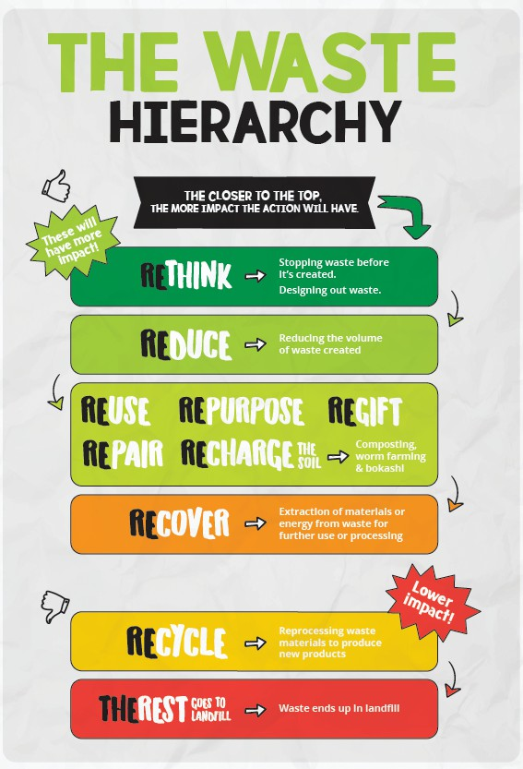
The waste hierarchy (right) is a useful framework to think about how we create waste and what we do with it. The closer to the top, the more impactful the action.

• Describe an action your organisation has taken that is closest to the top of the hierarchy and how that helped you reduce waste.
• Tell us what inspired you to make a start and outline the journey you have taken to minimise waste in your organisation.
• Provide details of waste types reduced, and volumes, if known.
• Share a waste minimization success you are most proud of, and a challenge you faced on your waste minimization journey and how you overcame it.

What the judges are looking for:
★ Evidence of action/s which make an impact in actively reducing and minimising waste in your organisation.
★ A demonstration of understanding of business relevant waste minimization practices.
★ Supporting documentation or information

The box below will adjust in size as you enter your content into it. It is not indicative of the maximum 1000-word count.

IMPORTANT INFORMATION FOR ALL CATEGORIES AND TERMS AND CONDITIONS:

The application process has been simpliﬁed signiﬁcantly to enhance accessibility, engage a wider audience and to encourage submissions to completion.

EXCELLENCE IN BUSINESS AWARDS
We strongly encourage you to complete as many sections as possible (Section 6 being optional), to give the judges a good overview of your business. At the time of judging, the judges will also consider your entry for the additional Awards categories.

This year the judges panel interview will be more important than ever so the more information or context you provide the better. Elements such as: Health and Safety / Quality & Systems / Strategic Planning and People Management will be evaluated verbally.

All applications and supporting documentation can be uploaded into the entry portal online, PLUS we would love to see you in your natural environment.

*Optional: Send us a short video just 30 - 60 seconds long, ﬁlmed on your smartphone. Tell us who you are, what you do and why you are entering the awards this year. Make it as entertaining as possible and please do not worry about your ﬁlming skills, we are not expecting a polished video. We will be using this for promotional purposes, so by submitting your video you are agreeing to the sharing of this video via our various channels.

SUPREME AWARD
The Supreme Award will be chosen by our judges from one of the four Excellence in Business Award winners after judging and finalist visit occur.

PRIVACY OF DATA
Personal and business information provided will be held in confidence for the purpose of your Awards submission only. You will be asked to accept the data consent policy as part of your submission.

Chamber Member includes Cambridge Business Chamber and/or Te Awamutu Chamber of Commerce.

ENTRIES CLOSE
Entries can be submitted until the closing date of Wednesday 15 February 2023 at 5.00pm.

Any concerns or queries? Please contact: paula@fp2.co.nz or 027 649 2081 or jaimee@fp2.co.nz or 027 320 7981

