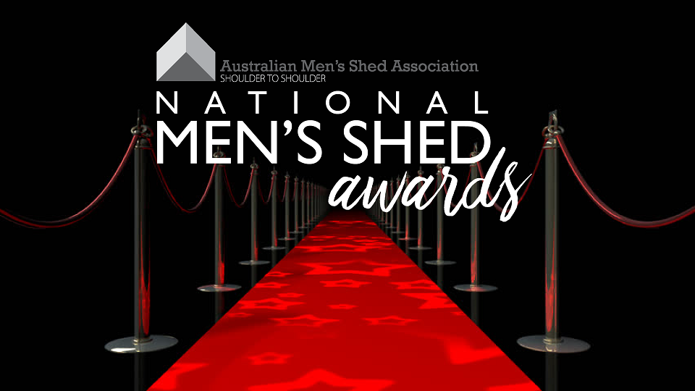
The AMSA National Men’s Shed Awards give the Men’s Shed network an opportunity to recognise the outstanding work of Men’s Sheds around Australia.
Nominations fall into five (5) categories:
- Unique fundraising activity – most sheds undertake fundraising activities (Bunnings BBQ’s, market stalls etc), what’s the most unique fundraising activity your shed has seen?
- Unusual shed activity – Men’s Sheds are not just about wood work and metal work.
- Best shed garden – does your shed have an impressive flower or produce garden?
- Outstanding recycling/up-cycling activity – shedders are all about recycling, what does your shed do?
- Shed of the year – do you love the time spent at your shed enough to nominate it for the best shed in Australia?
Nomination guidelines:
- Nominated Men’s Sheds must be a member of AMSA
- One nomination form per nomination
- Specific activities must have been undertaken in 2018/2019
Completed nomination forms and photos can be emailed amsa@mensshed.net or posted to
AMSA
PO Box 793
The Junction NSW, 2291
Nominations close Friday 9th August.
Nominations will be reviewed by the National Men’s Shed Awards Committee - comprised of at least one AMSA employee, AMSA Board representative and AMSA member shed representative.
Award winners will be announced alongside the recipient of the Ted Donnelly Lifetime Contribution Award at the 8th National Men’s Shed Conference Dinner, Wednesday 11th September 2019.
Contact us at amsa@mensshed.net or 1300 550 009 for any questions.

2019 National Men’s Shed Awards Nomination Form
Please circle the relevant award nomination category.
Unique fundraising activity
Unusual shed activity
Best Shed garden
Outstanding recycling/up-cycling activity
Shed of the year

Nominated Men’s Shed
Nominated Men’s Shed Address
Category Nominating for?
Position of nominating person
Committee or other?
Contact number of nominating person
For further information (if required)
Will you or others from the nominated Men’s Shed be attending the 8th National Men’s Shed Conference (10 – 12 September) to accept the award if selected? | Yes / No / Not sure
Please note: Winners from 2017 cannot nominate in 2019

Tell us a bit about the nominated Men’s Shed –

Tell us about the shed’s activity and/or work under the category you are nominating for –

