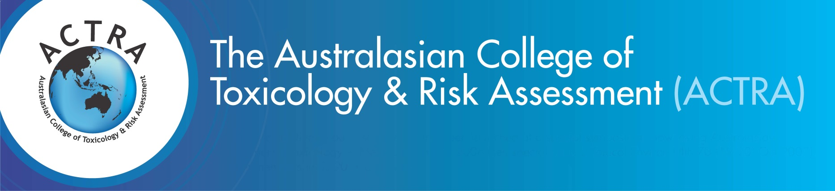**Abstract Submission 2023  
Application Form - Closing Date: 10 July 2023**

**Name _____________________________________________________________________________________**

**Position _____________________________________________________________________________________**

**Institution _____________________________________________________________________________________**

**Address _____________________________________________________________________________________**

**Contact No ___________________________Email address:** **______________________________________________**

**IMPORTANT - Please ensure all sections of this application are completed**

**Section 1: Abstract Submission Instructions**

Although topics directly related to the ASM theme are preferred, abstracts relating to or dealing with the fields of toxicology, ecotoxicology, exposure science and/or risk assessment are most welcome.

* Your abstract submission to the 15th Annual Scientific Meeting (ASM) can be up to one A4 page in length
* Your abstract must not exceed 300 words
* Your abstract must clearly state the objectives and content of your proposed contribution
* Your abstract should spell out any acronyms in the first instance
* Your abstract may include figures, tables, diagrams and illustrations but no photos
* Upon submission, your abstract file must not exceed 2MB
* All abstracts must be submitted in Microsoft Word
* All abstracts must adhere to the template formatting requirements (see Abstract template)

**Section 2: Checklist**

I have completed and attached an abstract which adheres to the requirements above

I have also submitted an application for the Student Travel Grant (please tick if yes)

I am submitting my abstract for oral presentation ; poster presentation ; either

**Section 3: Notification of Acceptance – 17 July 2023**

Accepted Abstracts will be allocated a poster presentation or time to orally present their work at the ACTRA ASM after the notification date listed above. Presentation requirements will be sent individually to each presenting individual closer to the ASM date.

**Please note -** If presenters cannot attend on the day of the ASM due to unforeseen circumstances, the ACTRA ASM Managers must be notified IMMEDIATELY. For more information please visit the ACTRA ASM registration page.

**Return the completed application form before 10 July 2023 via email to:**

ACTRA Conference Managers

Email: [actraconference@theassociationspecialists.com.au](mailto:actraconference@theassociationspecialists.com.au) I Phone: +61 2 9431 8600