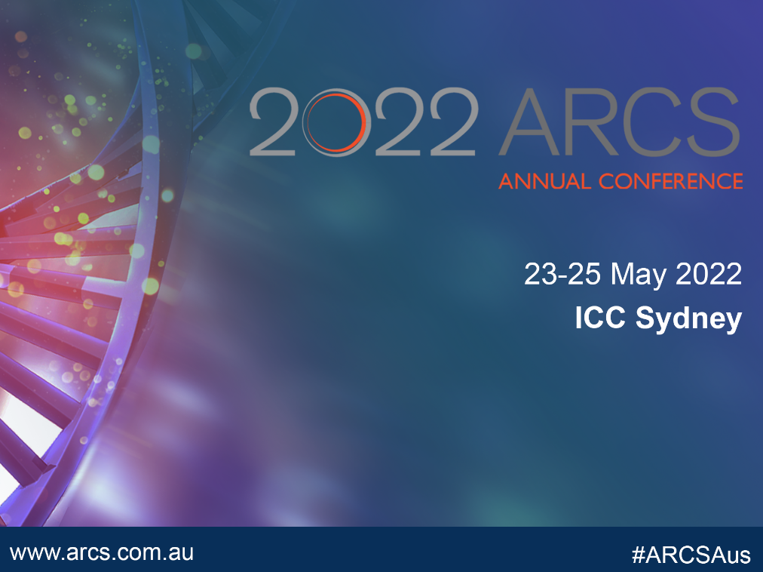
Sponsor and Exhibitor Social Media promotional toolkit
The promotional toolkit has been created and designed to help you promote your company online at the ARCS Annual Conference – working for success, on 23-25 May 2022, ICC Sydney.
This toolkit will provide you with:
- 2022 ARCS Annual Conference’s background and objectives
- Suggested social media posts for both LinkedIn and Twitter
- Links to digital customizable visuals for web and social media

- Background and Objectives
Overview
For over 35 years, ARCS Australia has been bringing together a vibrant and diverse community of professionals working in academia, government, biotech and pharmaceutical companies, hospitals and healthcare settings and other organisations to showcase and support the development and regulation of therapeutic goods. Delegates attend from a cross-section of the healthcare sector including clinical research, regulatory affairs, pharmacovigilance, medical affairs/MSLs, medical technology, health economics and quality/ GMP. They include senior executives through to recent graduates
2022 conference theme – Working together for success
Due to the COVID-19 pandemic, Australians have experienced firsthand how changes can be incorporated into our daily routines in a very short time. Initially, we came together with a common goal, to survive and manage the pandemic. We implemented the changes through necessity and valued each other’s input. The next step is to continue this collaboration by understanding that working together with a common purpose benefits all of us. These changes are the results of three key actions.
A common purpose.
Ensuring all are ‘on the same page’, brings a clear focus on what we are trying to achieve. If there are roadblocks to having a common purpose, we need to address and ensuring our policies, standards and guidance’s are fit for our purpose. This common purpose underpins our ability of working together for success.
Technology as an enabler.
Accelerating the adoption of digitalisation is enabling major shifts in clinical trial design and operations, regulatory strategies and therapeutic area asset and portfolio management, just to mention a few. The pandemic has fast tracked this implementation it is already having an enormous impact on the utilisation of information.
Stakeholder inclusiveness.
Including the voices of all stakeholders is starting to revolutionised the way we look at innovation. Patients, investigators, sponsors, manufactures and governments have a role in the development of innovative therapies. These voices ensure that otherwise silent issues are brought to the fore, ensuring our deliverables meet the needs of all our customers.
By embracing a common purpose, technology as an enabler and stakeholder inclusiveness, we can work together for success.
- Date: 23-25 May 2022 ( Monday – Wednesday (AEDT)
- Location: International Convention Centre Sydney
- Online registration link: https://arcs.eventsair.com/2022-arcs-annual-conference/registration
- Website link: https://arcs.eventsair.com/2022-arcs-annual-conference/
2. Suggested social media posts
Please find below social media templates that we encourage you to use as part of the 2022 ARCS conference. If you wish to get your posts shared on ARCS Australia social media accounts, do not forget to tag/ mention us in your publications.
- Conference link: 2022 ARCS Annual Conference (eventsair.com)
- ARCS Conference hashtags: #ARCSAus #ARCS2022
- Arcs Australia Twitter ID: @ACRSAustralia
- Arcs Australia LinkedIn ID: @ARCS Australia
- Arcs Australia Instagram: @arcsaustralia
- Hashtags to use on social media: #ARCSAus #ProfessionalDevelopment #2022ARCS #ARCSAnnualConference #Healthcare #ClinicalResearch #Medicines #MedicalDevices #Pharmacovigilance #Leadership #MedicalAffairs #RegulatoryMedicines #Entreprenuership #Manufacturing #WorkforceAndCapacity #DigitalHealth #ClinicalTrials #MedicalInnovation

For Twitter
- Thrilled to be [A SPONSOR]/[PARTNER]/[EXHIBITOR] at this year’s ARCS Annual Conference. Come join us! 23-25 May 2022, #ICCSydney! @ARCSAustralia #ARCS2022 #Healthcare #ARCSAus
- Proud to partner with @ARCSAustralia at the 2022 ARCS Annual Conference. Register now and meet us at stand [X] in the exhibition space. @ARCSAustralia #Partnership #healthcare #ARCSAus
- [COMPANY NAME] will be part of the 2022 ARCS Annual Conference in ICC Sydney, 23-25 May. Register now and joins us! @ARCSAustralia #Partnership #Healthcare #ARCSAus
- Visit our stand at the ARCS Annual Conference – Working together for success!. @ARCSAustralia #Partnership #Healthcare #ARCSAus

- We’re looking forward to the #ARCSAus conference next week in Sydney. If your company is considering [TOPIC] in 2022 & beyond, Connect with us! @ARCSAustralia #Partnership #Healthcare #ARCSAus #ARCS2022
- We’re going to be at @ICCSydney tomorrow for @ARCSAustralia 2022 Annual Conference tomorrow! Come visit our booth & say Hello! We would love to connect with you! @ARCSAustralia #Partnership #Healthcare #ARCSAus #ARCS2022
- Todays the day! Looking forward to seeing everyone at the 2022 ARCS Annual Conference today! @ARCSAustralia #Partnership #Healthcare #ARCSAus #ARCS2022

For LinkedIn
- The 2022 ARCS Annual Conference kicks off next week! Visit our stand and find out more about [BUSINESS]. Hope to see you there! #ARCSAus by @ARCS Australia http://ow.ly/1t2g50IesJp

- Proud and excited to be [THE MAJOR SPONSOR]/ [SPONSOR]/ [PARTNER]/[EXHIBITOR] at the 2022 ARCS Annual Conference – Working together for success. Come and say Hi and connect with us!

- Looking forward to #ARCSAus conference next week in Sydney 23-25 May – A not to miss event bringing together healthcare sector professionals over three big days! If your company is considering [TOPIC] in 2022, let’s connect! Come visit booth [X].
- Very proud to be part of the largest #Healthcare conference on regulatory affairs, clinical research, digital health in Australia/ New Zealand region. Are you attending? Meet the team at the ARCS Annual Conference on 23-25 May at ICC, Sydney. #ARCSAus by @ARCS Australia http://ow.ly/1t2g50IesJp
- We are excited to be joining hundreds of healthcare sector professions dedicated to improving the quality of life for patients and healthcare consumers all around the world at the @ARCSAustralia 2022 ARCS Annual Conference!

- Digital editable Social Media share tiles
- Download your preferred visual below
- Edit text with your company name, logo (and booth number if applicable)
- Share with your networks and @ARCS Australia #ARCSAus #ARCS2022
- Click below to download your social media share pack, which includes:
- Social Media share graphics (Includes editable files)
- Editable email signatures
- Customizable photo templates
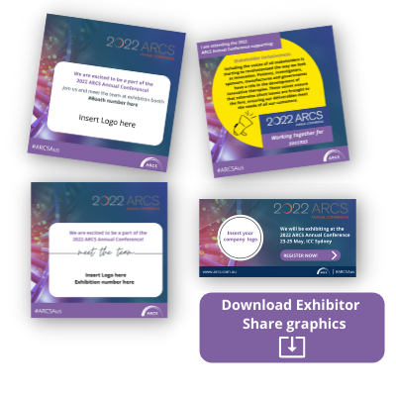
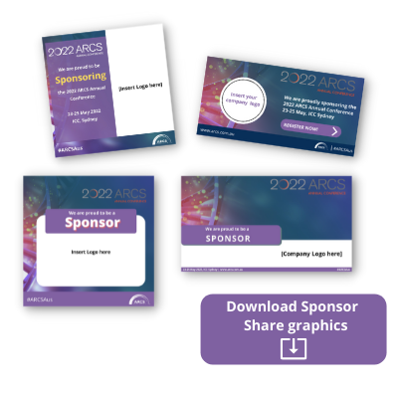

- Download Exhibitor Share graphics
or copy link into browser: http://www.arcs.com.au/public/153/files/Events/Annual%20conference/2022/Exhibitor-Social-Sharegraphics.zip
- Download Sponsor Share graphics
or copy link into browser:
http://www.arcs.com.au/public/153/files/Events/Annual%20conference/2022/Sponsor-Social-Sharegraphics.zip

